GISC training and capacity development

WIS Training
- ET-WISC identified training and capacity development as key areas and expected GISCs to take a leading role in their areas of responsibility.
- The WMO Monitoring and Evaluation (Summary of Mid-Term Performance Assessment Report 2016-2017) shows that the knowledge of WIS and level of its implementation nationally indicates that a significant number of Members (31% globally) have insufficient knowledge of WIS and even a greater number (42% globally) have not started implementation of WIS. This situation has not improved, and it is recognized that Regions need to take responsibility for ensuring that all Members have adequate knowledge of WIS and have it implemented, at least with the GISC web services
- Each region is now demanding the those GISCs serving the region commit to training schedules to fix the problem.
- RA II and VI have competed this, and a sample is shown in the Annexes to this paper.
- It is essential that GISCs respond and record their commitment in the tables to the decisions/resolutions as done in RA II and VI. At the moment RA III and V are awaiting commitments from the GISCs to completed their decisions.
- All GISCs are requested to note this need and make it a priority to commit prior to a session to a WIS training programme at Regional Sessions.

Training content
- The training should focus on the WIS competencies, especially those associated with metadata management and enabling the Members to register national information services and content. The WIS competencies are available in the Manual on WIS (WMO No 1060) and training guides in the Guide to WIS (WMO No 1061).
- GISCs should include competencies for attendees to be able to train other staff on their return. It is recommended that GISCs work with Regional Training Centres in their AOR to get support for train the trainer content.

WIGOS
- Another emerging aspect has been the focus on WIGOS development, mostly at enabling political and organizational support, so targeted to a different level of participants. However WIGOS now has infrastructure in the form of OSCAR and the management of station metadata, especially allocation of WIGOS station identifiers. As with WIS, WIGOS has national focal points that need to understand about metadata and the links between WIS and WIGOS.
- Unfortunately, in many countries the WIGOS national focal points are different people to the WIS national focal points. Thus, simply training people in WIGOS and WIS elements becomes quite expensive in terms of travel for each country. It is therefor relevant that the train the trainer be a priority for WIGOS as well as WIS. In fact, it could be that the WIS national focal points be trained in WIS competencies as well as those relating to WIGOS metadata and equipped with training skills, and then they can return home and teach both WIGOS and WIS competencies relating to metadata.
- The alternative is to bring extra people to these training events.
- TT-GISC is requested to consider its ability to take on this joint training, and to indicate what additional resources would be needed.

Conclusion
- GISCs have a responsibility to train and lead in the capacity development of WIS competencies to centres in their area of responsibility. Regional Associations are now requesting GISCs to commit to training programs over the next inter-sessional period to solve the problem of the lack of uptake of WIS by NMHS and other potential centres. This is being done through GISCs completing a table of training commitments for their AOR as an annex in the Regional Association decisions or resolutions.
- WIGOS now has a need to train people in the WIGOS competencies relating to WIGOS metadata and to the management of station identifiers. Noting that WIS is promoting train the trainer concepts for WIS national focal points utilizing Regional Training Centres experience and material, GISCs are now being asked to consider covering
- TT-GISC is being made aware of the requirement to provided advance commitment of training schedules and activities. It is also being asked to consider incorporating related WIGOS competencies in GISC training courses and activities
…

References
[1] Decision 15 (RA II-16) - Regional Association II (Asia) - Sixteenth session: Abridged final report with resolutions and decisions. .(https://library.wmo.int/doc_num.php?explnum_id=3549) 17Sep2018
[2] Resolution 12 (RA VI-17) - Regional Association VI (Europe) - Seventeenth session: Abridged final report. (https://library.wmo.int/doc_num.php?explnum_id=4559) 17Sep2018

Recommended Text
TT-GISC noted the trend of Regional Associations to require GISCs and RTCs to commit to training schedules in order to address the lack of national uptake of the new functionality of WIS. It agreed that it is essential for all GISCs to do this, and that ET-WISC should be advised to incorporate this in the ET-CAC assessment of GISCs commitment and progress.
TT-GISC further noted that WIGOS had a similar issue now that OSCAR was operational in having its experts understand metadata, its connection to WIS and for the allocation of WIGOS station identifiers. It agreed to …

Annex 1 Decision 15 RA II-16 “WIS”
Decision 15 (RA II-16)
THE WMO INFORMATION SYSTEM
REGIONAL ASSOCIATION II (ASIA),
Recalling Resolution 27 (Cg-XV) that called for all NMHSs to have implemented WMO
Information System (WIS) functionality by 2015,
Recognizing the initiatives of GISCs Beijing, Jeddah, Seoul, Tehran and Tokyo in conducting
training on WIS for RA II Members including on using GISC interfaces,
Acknowledging that access to operational and time critical information through the WIS is a
fundamental necessity for all NMHS basic functions; and supports Priorities 1 and 4 of the
Sendai Framework relating to “Invest in, develop, maintain and strengthen people-centred
multi-hazard, multisectoral forecasting and early warning systems, disaster risk and
emergency communications mechanisms, social technologies and hazard-monitoring
telecommunications systems”,
Having examined the RA II WIS Implementation Plan (V1.1 of 2015),
Noting that:
(1) A NMHS can be considered to have implemented WIS once it has taken on management
of its Discovery Metadata and the metadata are published in the WIS metadata
catalogue,
(2) The 2016 survey of National WIS focal points showed positive progress in implementing
WIS nationally with 70 per cent of RA II responses reporting that at least some WIS
functionality had been implemented and 75 per cent of responses indicated some
corporate knowledge of WIS,
(3) Developing and sustaining WIS competencies in NMHSs is essential for enabling both
completion of WIS implementation and WIS operations at the national level,
(4) The Guide to WMO Information System (WMO-No. 1061) paragraph 6.2.3 states that
“Each GISC should develop and provide training courses with reference to the WIS
competencies and the WIS Training and Learning Guide to meet the capacitydevelopment
requirements of the countries in the centres area of responsibility”,
(5) Appendix B of Volume I (WMO-No. 49) General Meteorological Standards and
Recommended Practices describes Regional Training Centres as “Providing education
and training opportunities for WMO Members, particularly staff of National
Meteorological and Hydrological Services (NMHSs)”,
(6) Resolution 33 (Cg-17) requested CBS to lead in developing guidance and standards to
support good information management practice,
Decides that the completion of WIS implementation at all NMHSs is a regional priority under
Expected Result 4;
Endorses the initial training programme as listed in the Annex to this decision;
Requests GISCs and RTCs serving Members in the Region to support the development of
WIS competencies through the provision of WIS-related training, including “train the trainer”
competencies to allow trainees to pass on their WIS knowledge and skills to their colleagues;
Requests the RA II Expert Group on WIS:
(1) To update the RA II WIS Implementation Plan and to monitor progress on WIS
implementation by NMHS including issues of certification of WIS national centres;
(2) To update the training programme as part of the RA II WIS Implementation Plan, to
facilitate the implementation, monitoring and planning of training activities;
(3) To liaise with CBS on the regional needs and aspects of information management
relevant to the development and implementation of WIS Part C;
Requests the Secretary-General to support the work of RA II management group and expert
group on WIS in their activities;
Urges Members:
(1) To complete WIS implementation and to work with each other and their Principal GISC
to assist those NMHSs that have not been able to do so to implement WIS;
(2) To review their nominated focal points as listed in the Country Profile Data Base or at
http://wis.wmo.int/page=RA2-WIS relating to WIS in the light of the terms of reference
provided in the annex to Decision 3.4(1)/1 (CBS-16);
(3) To encourage the participation of their national WIS focal points in the development of
WIS Part C in line with Decision 38 (EC-68) to ensure national and regional
requirements are incorporated;
Reminds Members that their systems and processes have to work with Table Driven Code
Forms (TDCF) and that some operational weather information will only be available in TDCF.
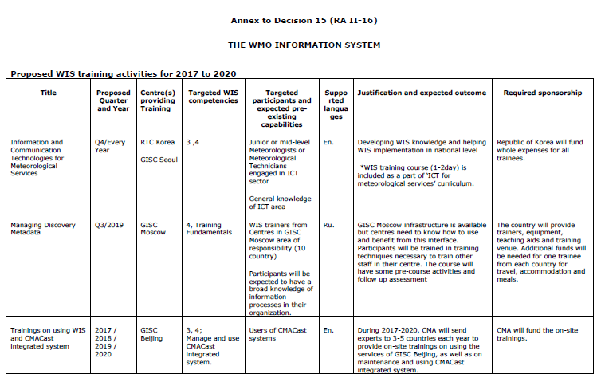

Annex 2

--------------------

