Status report GISC Tokyo
GISC Tokyo is connected to the RMDCN, MPLS provided by NTT com, and two dedicated communication lines to exchange meteorological information. GISC Tokyo is also connected to the internet at 100Mbps (with SLA) speed. And also Osaka backup site has independent 100Mbps (best effort) internet connection. Those internet access links are used only for WIS data exchange.
GISC Tokyo holds the following metadata sets:
GISC | metadata sets
Beijing | WIS-GISC-BEIJING
Brasilia | WIS-GISC-BRASILIA
Exeter | WIS-GISC-EXETER
Jeddah | WIS-GISC-JEDDAH
Melbourne | WIS-GISC-MELBOURNE
Moscow | WIS-GISC-MOSCOW
Offenbach | WIS-GISC-OFFENBACH
Seoul | WIS-GISC-SEOUL
Tehran | WIS-GISC-TEHRAN
Tokyo | WIS-GISC-TOKYO
Tokyo | WIMMS dataset  WIS-TOKYO-VCCC (Colombo)  WIS-TOKYO-VGDC(Dacca)  WIS-UNASSOCIATED
Toulouse | WIS-GISC-TOULOUSE
Casablanca (plan) | WIS-GISC-CASABLANCA

Area of responsibility
GISC Tokyo covers the following 18 centres:
Country | Type of Centres | Function
Cambodia | NC | NMC
Japan | NC | NMC
Japan | GISC | GISC (Tokyo)
Japan | DCPC | WDC-GHG
Japan | DCPC | Satellite Centre
Japan | DCPC | RTH (Tokyo)
Japan | DCPC | RSMC-Geographical
Japan | DCPC | RSMC-Activity-TC
Japan | DCPC | RSMC-Activity-ATM
Japan | DCPC | RCC (Tokyo NCC, RA II)
Japan | DCPC | NICT (Space Weather)
Japan | DCPC | GPC/LRF
Lao People's Democratic Republic | NC | NMC
Myanmar | NC | NMC
Philippines | NC | NMC
Thailand | NC | NMC
Thailand | DCPC | RTH (Bangkok)
Viet Nam | NC | NMC

AMDCN connectivity
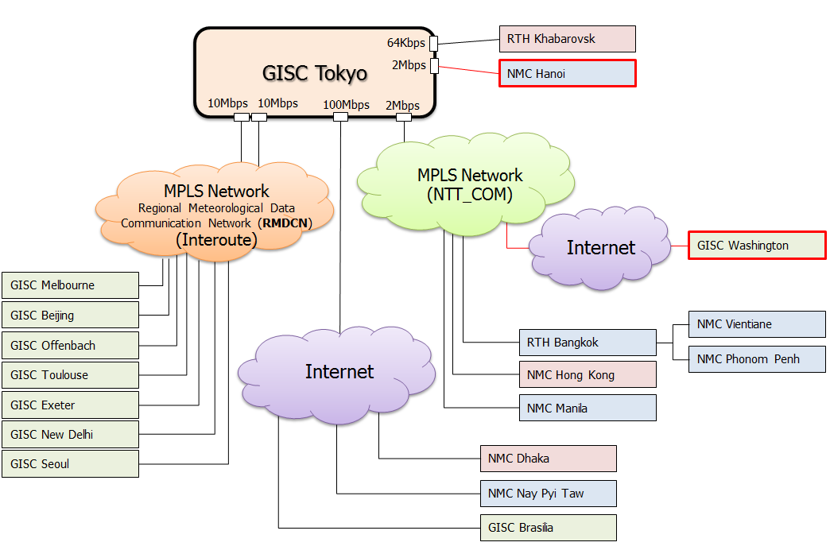
The communication line between NC Hanoi and RTH Tokyo was established in this September. Currently both centres are doing a connectivity test. We plan to start full operation from the middle of September.
Tokyo plans to connect to Washington server on the internet via MPLS network which is capable of connecting to internet. Nowadays, Washington and Tokyo are preparing for starting pre-operational; full operation will be started by the end of September.
Tokyo plans to increase the connection speed of MPLS provided by NTT from 2Mbps to 6Mbps by the end of this year.

Training - Capacity building activities
The 1st WIS workshop was held in 2010. Since then GISC Tokyo has taken place the workshop for capacity building every 2 years. In 2019 spring, the 5th workshop plans to be held. GISC Tokyo’s AoR member and Tokyo will mainly discuss about establishment AMDCN connections, management metadata and operational matters.
GISC Tokyo has also continued to be held onsite technical meeting at each centres in GISC Tokyo’s AoR. In November 2017, Tokyo visited Thailand and in April 2018, Lao PDR and Vietnam to discuss about metadata quality issues and establishment AMDCN. Tokyo will continue to provide opportunities to have onsite meeting at couple of counties every year.

Operational issues in last period
GISC Tokyo system was renewed for system performance improvement and security enhancement on 1st March. Since then, there have been some network performance issues on GISC Tokyo. In order to fix system issues, Tokyo is investigating our system and network equipment. These issues will be fixed in the near future.

GISC backup activities

Backup connection between GISC Beijing and GISC Tokyo
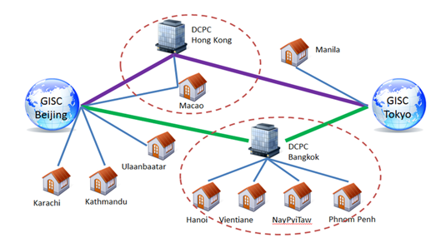
GISC backup connection between GISC Beijing and Tokyo is in operational by using GTS and DAR service. Beijing and Tokyo take advantage of an opportunity to have face to face meeting is held every year, have been exchanging a list of backup bulletins, reviewing backup procedure documents since the backup operation was started.

Backup connection between GISC Melbourne GISC Tokyo
Signed letters on GISC backup were officially exchanged in March 2012. Tokyo has 2 options to implement GISC backup for GISC Melbourne’s AoR. Since then, Melbourne and Tokyo have had face to face meeting to move forward with backup project.
- Option1: GTS connectivity
- Option2: Internet backup method (HTTPS upload and FTP)

Backup connection between GISC Offenbach GISC Tokyo
GISC backup between GISC Offenbach and Tokyo is in operational stage by using internet. Offenbach and Tokyo have had teleco meeting to discuss backup project and metadata management every month.
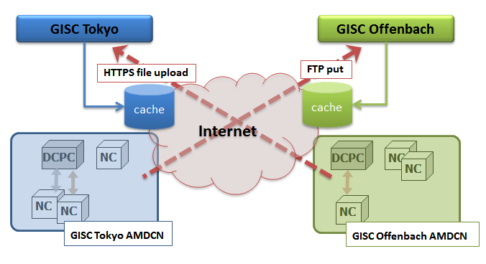
Thanks to GISC Offenbach and Jordan, the backup connection between Jordan and Tokyo was established in May 2018.

Monitoring activity
GISC Beijing and Tokyo are serving Common Dashboard (WCD) web site. The WCD is used as GISC Watch monitoring tool, all GISCs are monitoring GISC status and reporting some issues. GISC Tokyo performed GISC Watch from 1st to 15th May 2018.

Traffic size and volumes, uptime, user registration

Traffic volume of GISC Tokyo

Uptime
There might be a 10 minutes brake at the WIS portal system replacement on 1 March 2018. We continue using the same URL, but IP address was changed. Until flowing around new DNS information globally, some users might have a few minutes break or difficulties when they access GISC Tokyo portal.
Just after the system replacement we had several hardware troubles in March. Thanks to redundant system and network architecture, our services were transferred to other server (failover) with 2-3 minutes beak at each failover.
Totally, we might have had 30 minutes service break within nine months, from TT-GISC-2017 (Nov.2017) to TT-GISC-2018 (Sep.2018). The uptime was 99.99%.

User registration

Changes in GISC
GISC Tokyo system was renewed for system performance improvement and security enhancement on 1st March. GISC Tokyo backup system was also introduced in Osaka at the same time. In association with the system replacement, Tokyo changed web communication protocol from HTTP to HTTPS for secure access.
GISC Tokyo's portal site was updated for security enhancement and improvement of system performance on 26th July. With this update, GISC Tokyo terminated "Warning" and "KML" services.

Progress on action items
-

Outlook (planned changes/improvements)
-

References
[1] GISC Tokyo portal site: https://www.wis-jma.go.jp/cms/

Recommended Text
Shuichi Ikeda reported the current status of GISC Tokyo. GISC Tokyo system still has network performance issues. Tokyo is seeking a way to solve issues. If other GISCs face with problems caused by GISC Tokyo performance issues, please feel free to contact us (wis-jma@met.kishou.go.jp).
--------------------

