Problem Management for upper air BUFR reports

Background

- The migration from Traditional Alphanumeric Codes (TAC) to Table Driven Code Forms (TDCF) has not been completed yet. Progress of the migration is particularly slow for the upper air reports for which 25% of reports are still in TAC and 33% are not properly encoded (see fig. 1). This provides a total of 55% of reports that cannot be used in BUFR format for data assimilation purposes.
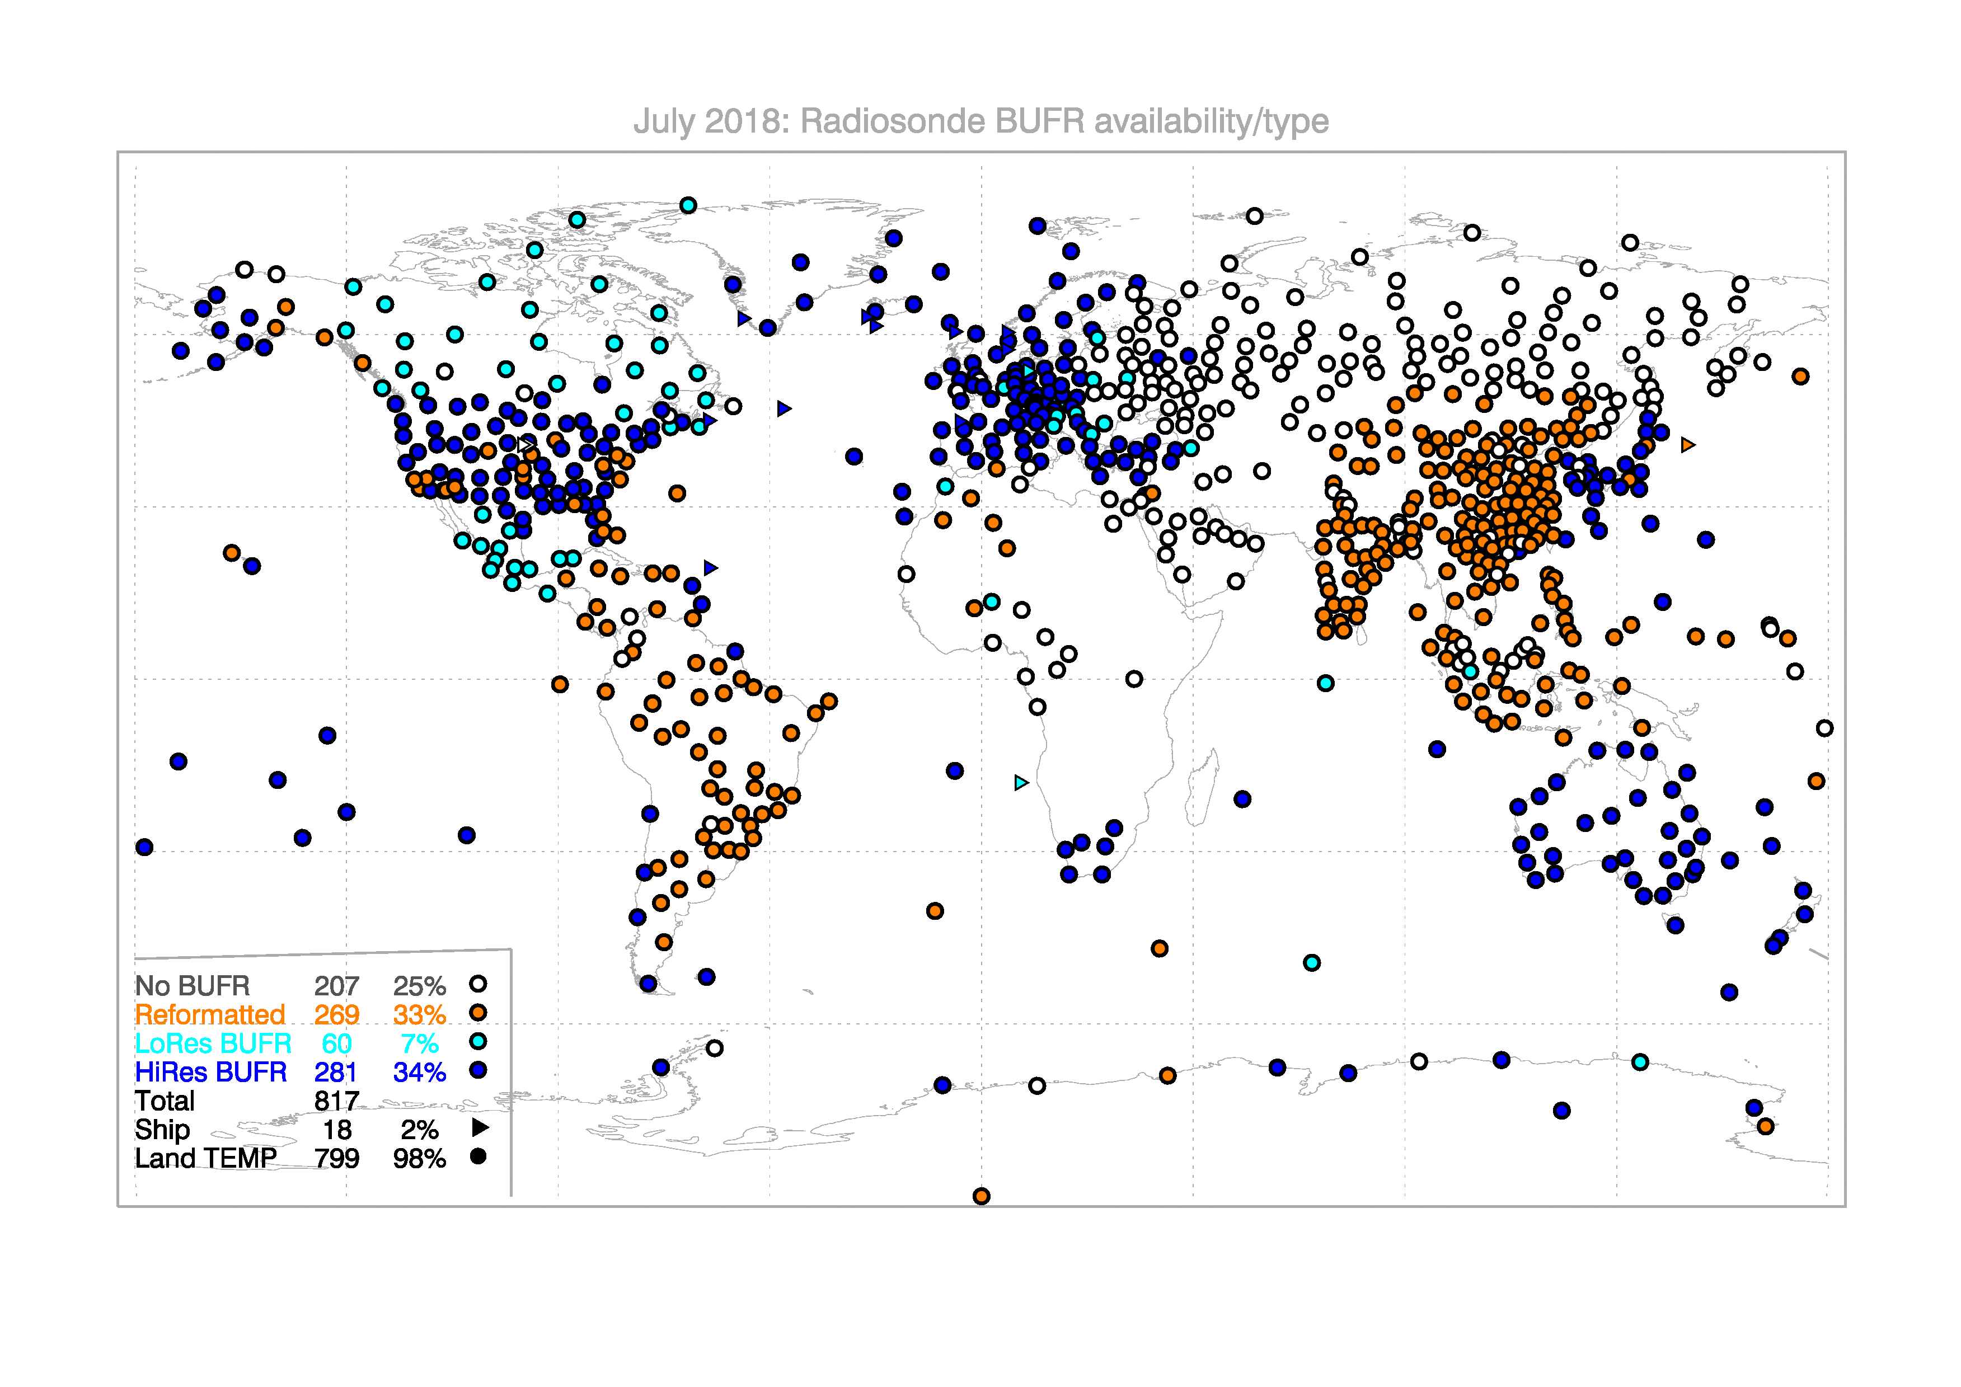
Figure 1: availability statistics for upper air observations courtesy of ECMWF
- During the TT-GISC meeting in 2017 the problem of managing issues with BUFR upper air reports was presented ( http://wis.wmo.int/tdoc=274 ). A possible way of resolving the problems is reported in the document as elaborated by the Task Team on Upper Air BUFR which was established by CBS Management Group to address the upper air BUFR issues.
- TT-GISC 2017 meeting decided that
D19 Where problems in the encoding of upper air reports in BUFR occur (e.g. due to the migration from TAC to BUFR), the GISC affiliated with the originating centre shall liaise with originating centre to rectify the issues.

Proposal
A detailed process is proposed for the management of issues involving upper air BUFR reports. The process is graphically described using Business Process Management Notation 2.0 (BPMN 2.0) which is a consolidated standard developed by the Object Management Group (see www.bpmn.org). A useful reference to the graphical symbols used can be found here https://camunda.com/bpmn/reference/
The diagram describing the process can be accessed online at https://cawemo.com/share/4d19c7a5-f86f-4168-b172-b60d397b67fa and is provided in attachment.
The process is involving the following participants:
- Issue generator. This is an NWP Centre using the upper air reports for their operational assimilation system. It has the responsibility of checking that the issue experienced is not related to an internal processing problem. The NWP Centre has also to offer expertise in resolving the problem when requested by the data producer.
- GISC. The GISC has a role of issue resolution facilitator and has the responsibility of managing the problem resolution and updating the issues tracking system with
  - All the information necessary to describe the issue at the level of detail that is required to the data producer to reproduce and resolve the problem.
  - The status of the issue as per task in the issue resolution diagram
  - A summary of the communication with other participants.
The GISC also has the responsibility of following up the issues and making available to the other participants the access to the tracking system.
- Data producer. This is the originator of the BUFR message. The responsibility of the producer is to resolve the problem utilising the expertise provided by the expert body and the issue generator.
- Expert body (IPET-CM). The role of the expert body is to support the process with expertise regarding the data format.
- WMO Secretariat is facilitating the overall issue resolution process by nominating the responsible GISC for a specific issue and managing the escalation of issues that for some reason cannot be solved by the other participants.
TT-UAB has reviewed the process and recommends its prompt implementation to resolve the outstanding upper air BUFR issues
TT-GISC is invited to review this document and to implement a process for addressing the issues identified.

Recommended Text
- TT-GISC reviewed a process for the management of BUFR upper air issues. The process would require a responsible GISC to take the task of facilitating the resolution of the issue by engaging with the data provider and managing the problem resolution. The GISC would utilise a common issue tracking system to register the status of the process and to communicate with the other parts. The issue tracking system would evolve as a valuable resource for when a new issue is encountered.
- The meeting agreed on process based on TT-UAB recommendation as represented in the attached diagram.
- It further agreed to implement this process by [provide target starting date]

--------------------

