INFORMATION NOTE FOR PARTICIPANTS

1. VENUE OF THE MEETING
The meeting of the WMO Expert Team on Centre Audit and Certification (ET-CAC) will be held at the Meteorological Service of New Zealand Ltd (MetService) headquarters, in Wellington, New Zealand.
The addresses of the venue are as follows:
30 Salamanca Road
Kelburn
Wellington 6012
New Zealand

Google : https://goo.gl/maps/CYigtCvW3pM2

The meeting will commence at 09:00 on Monday 1 October 2018 and will close at approximately 17:00 on 4 October 2018.

- WORKING LANGUAGE
The working language of the meeting will be English only.
- HOTEL INFORMATION
A selection of modern, well-appointed hotels is available in the central city area. Suggested hotels are:
- Ibis Hotel, Featherston Street.
- Rydges Hotel, Featherston Street,
- Novotel Wellington, The Terrace
- Quest Atrium, The Terrace.
- Hotel Mercure Wellington Abel Tasman. Willis Street.
- LOCAL TRANSPORTATION
Information on access between Wellington Airport and the city centre is available at https://www.wellingtonairport.co.nz/transport/
MetService offices are located in the Botanic Garden above the city. It is recommended that meeting participants use the Wellington Cable Car to travel to and from the meeting each day. https://www.wellingtoncablecar.co.nz/English/Home.html
The office is a short walk from the Kelburn cable car terminus through the gardens to the north.
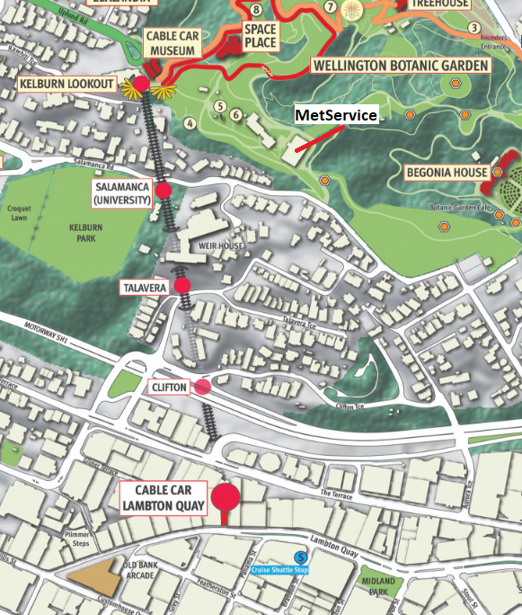

- ENTRY VISA REQUIREMENTS
Some participants may require an entry visa. Please check your requirements at https://www.immigration.govt.nz/new-zealand-visas or with your nearest New Zealand embassy.

- CURRENCY EXCHANGE
New Zealand currency is the New Zealand Dollar. Currencies can be exchanged at banks and in foreign exchange offices. Exchange rates are available at: https://www.xe.com/currency/nzd-new-zealand-dollar
Cash dispensing machines (ATMs) are available at the airport and throughout Wellington. Electronic payment systems are widely available in almost all shops and restaurants.

- LOCAL CLIMATE IN OCTOBER
Wellington has a temperate maritime climate, and as such the temperatures rarely get above 25 C or below 5 C. The city is known for its windy conditions, which usually preclude the use of umbrellas when it rains. The climate summary for Wellington in October are as follows:
Mean daily maximum : 15.0 °C
Mean daily minimum : 8.8 °C
Mean total precipitation : 110.2 mm
No. of days with precipitation > 1.0mm : 11.4 days
Number of days with wind gusts>=33kt : 16.8 days
Mean monthly sunshine : 191.5 hours
Webcam: http://www.takeabreak.co.nz/webcams/101/wellington_city_webcam

- OTHER USEFUL INFORMATION
New Zealand switches to Summer time in late September. As a result, the local time in October is UTC+13 hours. Electricity in New Zealand is 230 V / 50 Hz.


9. Local OrganiSer

Mr Kevin Alder and Mr James Lunny are the local organisers.
Kevin Alder  Tel.: +64 4 470 0720 (Direct) or  +64 4 470 0700 (Main switchboard)  E-mail: kevin.alder@metservice.com | James Lunny  Tel.: +64 4 470 0782 (Direct) or  +64 4 470 0700 (Main switchboard)  E-mail: james.lunny@metservice.com

