  World Meteorological Organization  COMMISSION FOR BASIC SYSTEMS  Steering Group on Radio-Frequency Coordination  SG-RFC 2018 meeting  Honolulu, 12-15 February 2018 | SG-RFC-2018/Doc 15.1  Agenda item: 4.6
Submitted by:
Eric Allaix
30.Jan.2018
Restricted access: N

radiometer

INTRODUCTION
- An action was initiate in 2016 to elaborate a new ITU-R recommendation on ground based passive sensing in ITU-R WP7C.
- After some discussions, WP 7C concluded that it would be most appropriate to first compile information on ground based sensors in a preliminary draft new Report which was progressed since April 2017 meeting of WP 7C.
- All administrations and sector members were encouraged to provide input contributions to the forthcoming WP 7C meetings with information on technical and operational characteristics of ground-based passive sensors in the 22 and 1 000 GHz frequency range.

action needed
- The output of the last WP7C meeting in October 2017 is provided in the Annex. It can be pointed out that at this stage only information on two ground based sensors operating in two frequency bands is reflected in this this working document. WP7C considered that, due to the large frequency range (22 to 1 000 GHz), there is a need to provide more information.
- SG-RFC members are invited to propose any new material regarding radiometer systems in order to allow the next WP7C meeting in May 2018 to progress in the elaboration and approval of this ITU-R report.

_____________

Radiocommunication Study Groups
Source: Documents 7C/TEMP/76 | Annex 15 to  Document 7C/200-E
Source: Documents 7C/TEMP/76 | 6 November 2017
Source: Documents 7C/TEMP/76 | English only
Annex 15 to Working Party 7C Chairman's Report
Working document toward a preliminary draft new
rePORT ITU-R RS.[Ground_pass_sensors]
Technical and operational characteristics of ground-based passive radiometers operating in 22 to 1 000 GHz frequency range

1 Introduction
This Report provides technical and operational characteristics of ground-based passive radiometers in the range 22-1 000 GHz, used for observations of the atmosphere. Usages of these radiometers concerns the meteorological applications, study of the parameters of the atmosphere, long term evolution of these parameters in the context of the climate change and stratosphere evolution, ground-based radiometers could be used for local atmosphere observations or in the framework of worldwide observational networks.
Microwave radiometers are very sensitive receivers designed to measure thermal electromagnetic radiation emitted by atmospheric gases. They are usually equipped with multiple receiving channels in order to derive the characteristic emission spectrum of the atmosphere or extraterrestrial objects.

2 Meteorology/climatology usages
Microwave radiometers are utilized in a variety of environmental and engineering applications, including weather forecasting, climate monitoring, radio astronomy and radio propagation studies.
Vertical profiles of temperature and humidity worldwide can be provided by several types of satellites (polar-orbiting satellites equipped with microwave sounding instruments, geostationary satellites can measure wind velocity in the tropics by tracking clouds and water vapour, …) but meteorologists making detailed local forecasts or scientists investigating the planetary boundary have requirements for atmospheric sounding with better vertical resolution than can be provided by the satellite radiometers.
This information can be provided by using an upward-looking passive remote sensing, with a radiometer mounted at the Earth’s surface.
Passive microwave radiometry is a tool of fundamental importance for the Earth observation and radiometers are designed to receive and measure natural emissions produced by the Earth’s surface and its atmosphere. Ground-based radiometers are well suited to measure humidity and temperature profiles in the troposphere of the earth, as well as integrated quantities like the integrated water vapour (IWV) and liquid water path (LWP).
These natural emissions characterize the type and the status of a number of important geophysical atmospheric and surface parameters (land, sea, and ice caps), which describe the status of the Earth/atmosphere/oceans system, and its mechanisms:
– Earth surface parameters such as soil moisture, sea surface temperature, ocean wind stress, ice extent and age, snow cover, rainfall over land, etc.; and
– three-dimensional atmospheric parameters (low, medium, and upper atmosphere) such as temperature profiles, water vapour content and concentration profiles of radiatively and chemically important trace gases (e.g. ozone, nitrous oxide and chlorine).
This all-weather capability has considerable interest for the Earth observation because more than 60% of the Earth’s surface is usually covered with clouds. In addition to this all-weather capability, passive microwave measurements can also be taken at any time of day as they are not reliant on daylight. Passive microwave sensing is an important tool widely used for meteorological, climatological, and environmental monitoring and survey (operational and scientific applications), for which reliable repetitive global coverage is essential.
Commercial ground radiometers are now available for meteorological operational applications.

2.1 Frequency aspects
Channels between 22 GHz and 28 GHz are used to provide information on the variation of water vapour in the vertical, a window observation in the region of 30 GHz is used for cloud identification and a selection of channels in the oxygen band between 50 GHz and 58 GHz are used to produce a measurement of temperature structure. Measurement of water vapour in the future also benefit from additional observations in the lower wings of the water vapour absorption band at 183 GHz.
The frequency and the strength of these natural emissions characterize the type and the status of a number of important geophysical atmospheric and surface parameters (land, sea, and ice caps).
Other frequencies are also used for these ground-based microwave measurements: 111, 142, 208 and 273 GHz for ozone (O₃), 204 and 278 GHz for chlorine monoxide (ClO), 201 and 276 GHz for nitrous oxide (N2O), 203 GHz for hydroperoxyl radical (HO2), 203.4 GHz for isotopic water vapour (H₂¹⁸O), 206 and 269-270 GHz for nitric acid (HNO₃), 115 and 230 GHz for carbon monoxide (CO) and 266 GHz for hydrogen cyanide (HCN).
Figures 1 and 2 show the sensitivity of millimeter and sub-millimeter frequencies to atmospheric temperature and water vapour variations between 1 and 1 000 GHz operated by satellites Earth observations. The water vapour and oxygen resonance spectral lines are indicated in the figures as well. The figures show the increasing atmospheric attenuation at higher frequencies and the sizable variability of the attenuation due to water vapour:
– Frequencies below 200 GHz are the most suitable for vertical nadir measurements of the lower layers of the atmosphere.
– Frequencies between 200 and 600 GHz are better suited for vertical nadir measurements of the higher layers of the atmosphere.
– Above 600 GHz the oxygen lines are only visible over regions with very dry atmosphere. Measurements at these frequencies are therefore typically from limb sounders and, in any case, exclusively for the top atmospheric layers.
The retrieval of atmospheric properties (e.g., ice cloud content, ice cloud altitude, rain rate, rain profiles, etc.) requires the use of simultaneous multiple frequency observations for better accuracy. Some important considerations among these bands:
– Frequencies around the water vapour resonance at 325 and 380 GHz and oxygen at 424 and 487 GHz are unique in their opacity and high enough in frequency to permit practical antennae to be used at geosynchronous altitudes, yet low enough for technology to provide practical, sensitive instrumentation.
– Use of the 380 GHz water vapour band helps avoid false alarms over super-dry air masses. Adding channels in the 380 GHz band to operational polar-orbiting satellites allows the retrieval of precipitation over snow-covered mountains and plains and in the driest polar areas where even the most opaque 183 GHz channels become transparent. The only remedy for transparency is a more opaque water vapour band and 380 GHz is the only suitable choice.
– Cloud ice and water vapour are two components of the hydrological cycle in the upper troposphere, and both are currently poorly measured. A number of missions have been proposed that focus on this technique to measure cloud ice water path, ice particle size and cloud altitude to US and European Space Agencies. Currently, these measurements focus on the 183 GHz, 243 GHz, 325 GHz, 340 GHz, 380 GHz, 425 GHz, 448 GHz, 664 GHz and 874 GHz bands. The vertical water vapour and oxygen sounding measurements are typically performed using a set of channels, composed of so-called “wings” and associated “windows”.
– The vertical sounding measurements along the “wings” of the resonance curve under investigation are performed in frequency slots (with a given bandwidth BW) at symmetrical distance (Offset) from the central resonance frequency. This allows characterizing the resonance curve slope at the various atmospheric heights and providing therefore the water vapour and oxygen vertical profiles. The required total frequency band can be defined as the maximum bandwidth (BW) plus twice the maximum offset, centred on the resonance frequency.
Figure 1
Zenith opacity of the atmosphere due to water vapour and dry components
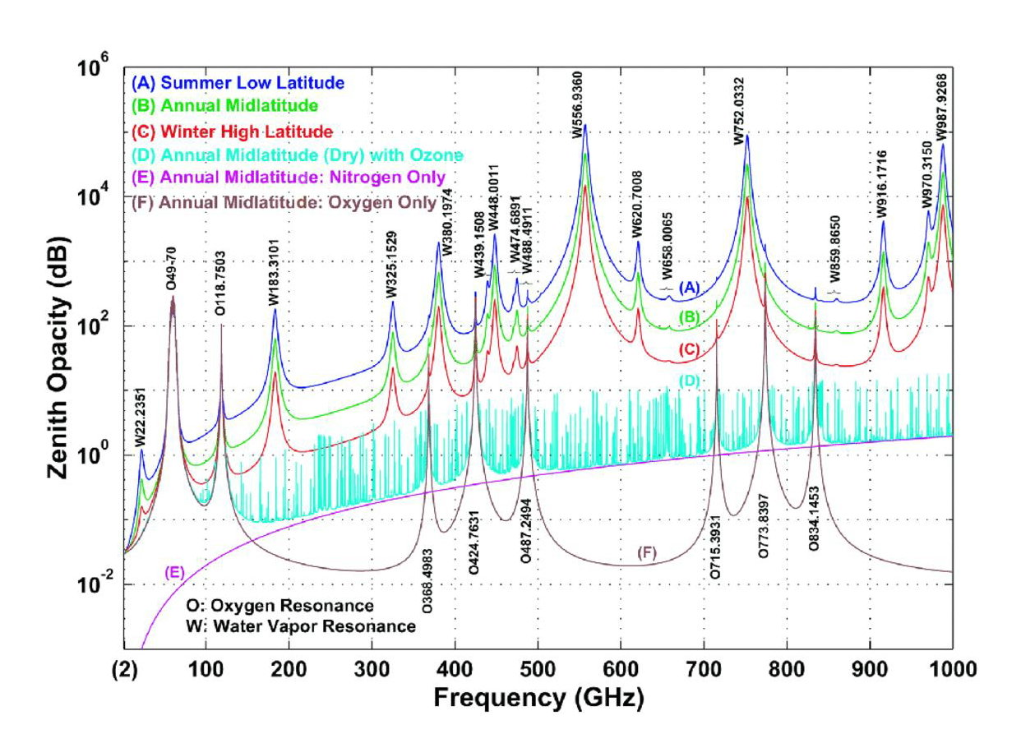

Although the channels for ground based remote sensing of temperature and humidity are in a similar region to passive satellite remote sensing, they are not identical to those used by satellites. At some frequencies, satellite remote sensing can safely share with terrestrial services, but ground-based radiometers may need protection. The number of ground-based radiometers in operation is still small, but if current developments are successful, larger numbers may be deployed in the future.

2.2 Typical characteristics
Table 1 below shows some typical characteristics of commercial ground-based passive radiometers deployed in the frequency range 22-31 GHz and 51-58 GHz. Scientific radiometers could have less system temperature in case of cooled receiving system.
The sensitivity of these radiometers is dependent of the operational integration time. To specify the interference threshold level, the error rate compared to sensitivity has also to be defined.
By considering a low noise state of the art cooled system and a long integration time of more than 30 minutes, the sensitivity of scientific ground radiometer could meet those of the radiometers used in radio astronomical applications.
Table 1
Two typical characteristics of ground-based passive radiometers
Characteristics | System A | System B
Platform type (airborne, ship borne, ground) | Ground | Ground
Channel center frequencies | 22.24 GHz, 23.04 GHz, 23.84 GHz, 25.44 GHz, 26.24 GHz, 27.84 GHz, 31.4 GHz | 51.26 GHz, 52.28 GHz, 53.86 GHz, 54.94 GHz, 56.66 GHz, 57.3 GHz, 58.0 GHz
Antenna type (reflector, phased array, slotted array, etc.) | Corrugated feedhorn + reflector | Corrugated feedhorn + reflector
Antenna diagram | Gaussian beam | Gaussian beam
Antenna sidelobe level (dB) | <-30 | <-50
Antenna main beam gain (dBi) | 33 | 40
Antenna height (m) | 1.2 | 1.2
Receiver noise figure (dB) | 2 | 2.5
System noise temperature (°K) | 400 | 600
Receiver RF 3 dB bandwidth (MHz) | 230 | 600-2 000
Geographical distribution | worldwide | worldwide
Fraction of time in use (%) | 100 | 100

2.3 Worldwide deployments
At that time around 200 ground-based passive radiometers are deployed in the frequency range 22-31 GHz and 51-58 GHz on a worldwide basis.
The figure below shows the location of these systems.
FIGURE 2
Location of ground-based passive radiometers in the 26 and 55 GHz
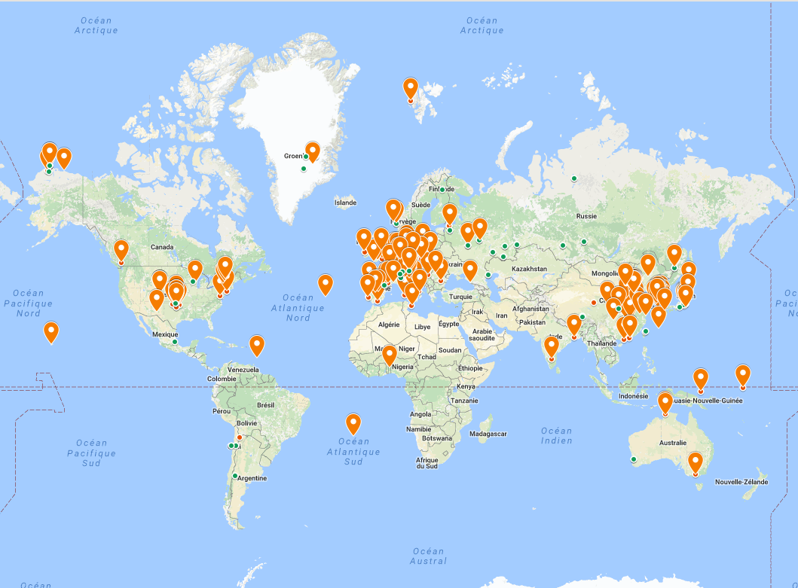

3 Radio astronomy usages
First passive radiometers and associated calibration techniques have been developed by radio astronomy. A radiometer is a receiver used to measure the average power of the noise coming from a radio telescope in a well-defined frequency range. 22 GHz or 183 GHz water vapor radiometers are used in millimetre radio telescope for the correction of the atmospheric phase fluctuations. Several frequencies around the line are used to cover the H₂O profile. The cooling of the radiometer, a large receiver bandwidth and long integration time could be used to increase sensitivity and thus the calibration precision.
Considering state of the art cooled radiometer, the sensitivity and protection criteria are given by the Recommendation ITU-R RA.769-2. In this recommendation, considering a 0 dBi antenna gain, Table 1 is used for water vapour radiometers to give the threshold levels of interference detrimental to radio astronomy continuum observations.

4 Summary
There is an interest in ground-based passive radiometers in the range 22-1 000 GHz, used by meteorological and climate change communities. This report presents the usage of such systems in particular regarding the need to obtain better vertical resolution near the ground in order to provide more detailed local forecasts.
Characteristics of ground-based passive radiometers operating in the frequency range 22-31 GHz and 51-58 GHz have been developed.
A section is also presented regarding the radio astronomy usages in order to avoid any confusion between these specific usages and the ground based radiometers detailed in this report, in particular regarding the application of the sensitivity and protection criteria given in the Recommendation ITU-R RA.

