BOG A: Project plan for climate data access in context of WIS
Albert Klein Tank, Omar Baddour, et al.

Objectives:

Global level: authoritative, trusted data sets for informing on key climate indicators (5-10) for global policy users of climate change information. (reference to ongoing work in WMO, GCOS, IPCC)

Regional and national level: trusted data sets and value added products such as on climate extremes; process for registering data sets in the WIS

National level: WMO Members commitment for data exchange, how to develop a WIN-WIN approach

Activities:

Assemble inventories / catalogues of relevant and (potentially) trusted data sets

Adopt a mechanism for assigning data set/system maturity scores

Adopt a mechanism for assigning application performance scores

Include (guidance on) uncertainty representation in 1-3

Make recommendations how to deal with trade-off between NMHS data and voluntary data

Absorb future developments

Assemble inventories / catalogues of relevant and (potentially) trusted data sets
Available high quality data sets (both ECVs and derived data/indicators and sources)

Also include reanalysis, satellite, model data and merged datasets
Importance of discovery metadata and simple tools/registries to generate and harvest metadata
Encourage each Regional Climate Centre to become a DCPC
Describe data license/policy and push for implementation of WMO resolutions
Acknowledge cultural differences between weather and climate community with sense of ownership in climate community resulting in restricted data sharing
Raise awareness of data sharing and provide something in return, e.g. climate change projections, s2d forecast, etc.
Liaise with Copernicus C3S for point 1, 2 and 3
Recommend open data formats for future sustainable access

Adopt a mechanism for assigning data set/system maturity scores
Available good practices and evaluation studies (such as in EU-Core-Climax)

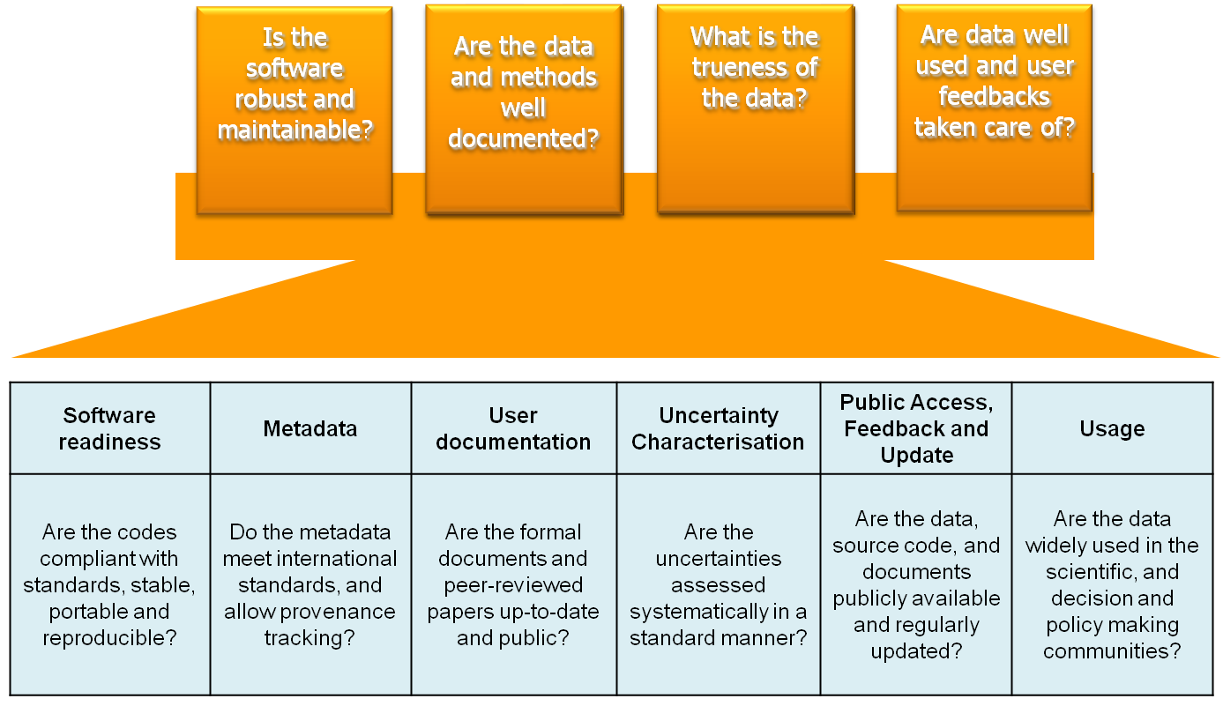

Importance of metadata about quality of data
Learn from good examples, e.g. WIS, GDPFS for climate data processing and data access similar to the WWW
Re-instate the role of IPET-MDRD for guiding on format and coding
Define logical data models and involve external users in the identification of data models
Identify trusted source institutions for the data sets

Adopt a mechanism for assigning application performance scores
User application dependent advise

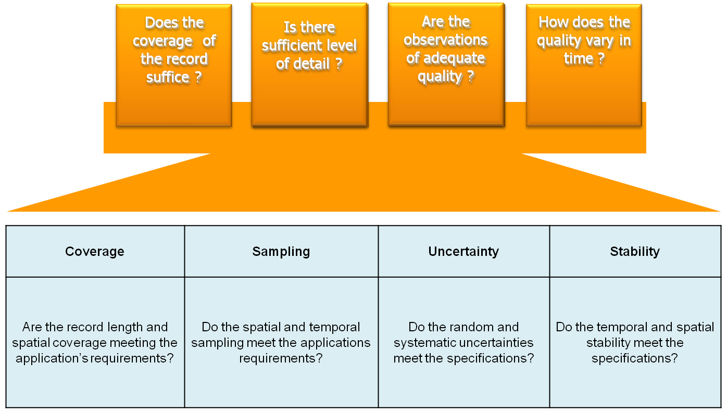

Categorize data sets based on their performance and utility
Make plans for communication and management of changes for users including notification mechanism on new versions, decaying ones, etc.

Include (guidance on) uncertainty representation in 1-3
Practice of using multiple data sets

Develop training material including good practice examples
Advise how data gaps issue affect performance in climate monitoring

Make recommendations how to deal with trade-off between NMHS data and voluntary data
Improved coverage versus lower data quality

Address data quality for data from non-NMHSs, such as from farmers, weather amateurs
Recommend how lower data quality can be used in NMHS services/operations

Absorb future developments
Emerging data issues (Internet of Things, Crowd sourcing)

Discussed but existing other WMO team dedicated to this

