  World Meteorological Organization &  Intergovernmental Oceanographic Commission (of UNESCO)  Satcom Forum  12 April 2018 | 
Satellite Data Telecommunication Handbook
A draft of the Satcom Handbook is provided in the Annex. The handbook is intended to provide decision makers within environmental monitoring projects with the information necessary to evaluate the suitability of the available satellite communications systems on the market for their needs.
_____________
Annex: Draft Satcom Handbook
Explanatory note: The Satcom Handbook is largely complete, apart from the directory of suppliers in Chapter 4.

Table of contents
1. Introduction and overview 3
1.1. Introduction 3
1.2. Why satellite communication? 4
1.3. Connectivity options for remote instruments 4
1.4. Types of satellite orbit 5
1.5. Antenna issues 7
2. Satellite systems currently in service 9
2.1. Introduction 9
2.2. Argos (information updated April 2018) 10
2.3. DCS (information updated April 2018) 11
2.4. Globalstar (information updated April 2018) 12
2.5. Gonets (information updated April 2018) 13
2.6. Inmarsat (information updated April 2018) 14
2.6.1. Land services 14
2.6.2. Marine services 15
2.6.3. Aeronautical services 15
2.7. Iridium (information updated April 2018) 16
2.7.1. Short Burst Data (SBD) 16
2.7.2. Circuit Switched Data (CSD) 17
2.7.3. Iridium Burst 17
2.7.4. Pilot 17
2.8. O3B (information updated April 2018) 18
2.9. Orbcomm (information updated April 2018) 19
2.10. Thuraya (information updated April 2018) 20
2.11. VSAT (information updated April 2018) 21
3. How to purchase and install a satcom system 22
3.1. Deciding on your priorities 22
3.2. Coverage 23
3.3. Power supplies 23
3.4. Look angles 24
3.5. Airtime contracts 24
3.6. Internet access 24
4. Directory of industry contacts 25

Introduction and overview

Introduction
This is the first edition of the WMO-IOC Satcom Handbook. It is intended for scientists and managers who are considering the use of satellite communications for collecting data from remote instrumentation – which could be on land or at sea. It aims to provide an overview of the state of the market at the time of writing (April 2018) so that you can quickly identify which satellite services are appropriate to your needs. Since the market moves quickly, an online version will be made available via the WMO website (https://wiswiki.wmo.int/Satcom-Guide) and kept up to date as new systems come on the market and older ones are retired.
This is the first publication from the joint WMO-IOC International Forum of Users of Satellite Data Communications, better known as Satcom Forum, a relatively new international body that aims to provide clear information about satellite communications to scientific users, and to liaise with the industry to provide appropriate new technical features and suitable pricing structures for scientific users. For more details about Satcom Forum, please see https://wiswiki.wmo.int/Satcom
The editorial approach has been to work with publicly available information only, such as: marketing brochures, manuals and other published documents. This handbook only considers systems that were in service at the time of writing (April 2018). Several satellite networks had new services in development, but their final specifications would not be known until they were in service. The online version includes clearly-marked sections that are contributed by the satellite operators, giving more details about their product offerings.

Why satellite communication?

Satellite communication is now more than sixty years old; the Soviet Union launched Sputnik I on October 4th, 1957. The first communications satellite was launched the following year by the United States. Since then, satellite has become firmly established as one of three basic techniques for long distance telecommunications, alongside cables and terrestrial wireless.

Satellite communication’s key strength is its independence from infrastructure on the ground. This is particularly valuable in hazardous and isolated regions of the world (such as oceans, deserts and the polar regions) and in places where conflict or natural disasters have destroyed terrestrial infrastructure. For those in need of reliable emergency communications, satellite communications can literally save lives.

For scientific users; particularly meteorologists, hydrologists and marine scientists, satellite communication offers a convenient way to collect data in real time from instruments in the field. Marine science was an early adopter of remote instrumentation, and satellite services made it possible to collect data reliably from the open oceans in real time. Satellite communication is also used for tracking marine creatures and larger birds.

Connectivity options for remote instruments

There are a range of options for connectivity for equipment installed in remote locations:

- Physical retrieval. The instrument stores the data locally (e.g. on a memory card, USB stick or local hard drive) and the operator visits it periodically to retrieve the data. You may have to wait months or years for the data, but there is no ongoing cost apart from the site visits. This option is often used if a regular visit needs to be made to do maintenance work on the instrument;

- Cable/wireline/landline. Using a wired connection; typically a copper or fibre optic cable, such as a phone line. This generally offers the highest data rates, and can be reliable provided that the infrastructure is not disrupted; cables can be cut by construction work, or damaged by high winds or storms. Power failures at the telephone exchange or router sites can also disrupt communications. In some countries the landline network offers a poor quality of service and can be expensive. If you are in a genuinely remote region, a wireline option is usually out of the question;

- Terrestrial wireless. Terrestrial networks include common services like cellphone and point-to-point microwave, and more esoteric techniques like packet radio, meteor burst, ionospheric scatter, tropospheric scatter and HF (high frequency, also known as short wave) radio. Low-power wide area networks (LPWANs) are being deployed commercially in some countries (SigFox and LoRaWAN are two examples) and are designed specifically to offer low data rates for telemetry and remote control applications at low operating cost. The cellular networks are also starting to offer similar long-range low-data rate services (e.g. LTE Cat NB1, also called NB-IoT) to cater to this market. Terrestrial wireless systems are still very dependent on fixed infrastructure, which can be disrupted by natural disasters, commercial failure or civil unrest;

- Satellite communication. Assuming that your terminal can get a clear view of the sky, satellite services allow connectivity from anywhere in the world, with no dependence on ground-based communications infrastructure. If your system includes its own independent power supply (batteries, solar, wind, etc) then you can be assured that your communications will not be disrupted unless the terminal itself is disabled or destroyed. The drawbacks to satellite communication are the relatively low data rates from small terminals when compared with terrestrial wireless, and it may have higher cost per bit transmitted.

Types of satellite orbit

Communications satellites are commonly classified by their type of orbit. There is a huge variety of possible orbits, but in practice only a small number of orbit types are used for communications systems:

- Geostationary orbit (GEO): this is the type of orbit used by the majority of communications satellite operators. Geostationary satellites sit directly above the Earth’s equator, and have an orbital period of 24 hours. This means that they are stationary relative to the Earth’s surface, which has the considerable advantage that a single satellite can cover a large, constant area of the Earth’s surface. Terminals do not require any active steering - the can be pointed at the satellite at the time of installation and then fixed. There are two key drawbacks to geostationary orbits: they cannot provide coverage to the polar regions beyond 80 degrees latitude, and they introduce an unavoidable latency in communications. Geostationary orbits are at 35,000km altitude, and the speed of light means that there is an end to end latency of about a quarter of a second. For a two-way link (such as a telephone call) this results in an apparent half-second delay on the line;

- Low Earth Orbit (LEO): this is a broader classification of orbit, meaning satellites that are placed much closer to the Earth. 300km altitude is the lowest practical orbit, and typically LEO satellites are between 600 and 2000km altitude. The low altitude offers much lower latency when compared with GEO. LEO satellites move rapidly with respect to the Earth’s surface - a typical LEO satellite will be in view of a ground station for ten minutes on each pass. Providing real-time global coverage requires a large fleet of satellites (called a constellation) in slightly different orbits. Iridium and ORBCOMM both take this approach; Iridium had 66 active satellites in its original constellation. There are also networks that use smaller constellations (such as Argos and Gonets); in this case you may have to wait for a satellite to come into view (called a “waiting for a pass”) before you can send your message. The message is often stored on the satellite and downlinked when it passes over a ground station. This type of network design is called store and forward and can introduce minutes or even hours of delay between the message being transmitted to the satellite and it being delivered. Many LEO satellites are in polar orbits, meaning that they pass over both poles and can thus “see” the whole surface over the earth over the course of their orbital cycle. A key drawback to LEO is that the satellites are subject to small amounts of drag from the Earth’s upper atmosphere, and thus tend to have a shorter service life than GEO satellites. The drag slows the satellites down, and eventually they will re-enter the atmosphere and burn up. Positioning thrusters are used to keep the satellites in the correct orbit, but once they are out of fuel, the satellite is either boosted into a higher “graveyard orbit” or put into a re-entry trajectory where it will burn up safely over the Pacific Ocean;

- Medium Earth Orbit (MEO): This term is used to describe orbits with altitudes between 2000 km and 35000 km altitude. GPS, Glonass and Galileo navigation satellites are MEO, but it is not commonly used for communications satellites because the terminals require a tracking antenna. However, O3B operate a constellation of 12 MEO satellites that provide high speed, low-latency broadband to equatorial countries and to ships at sea.

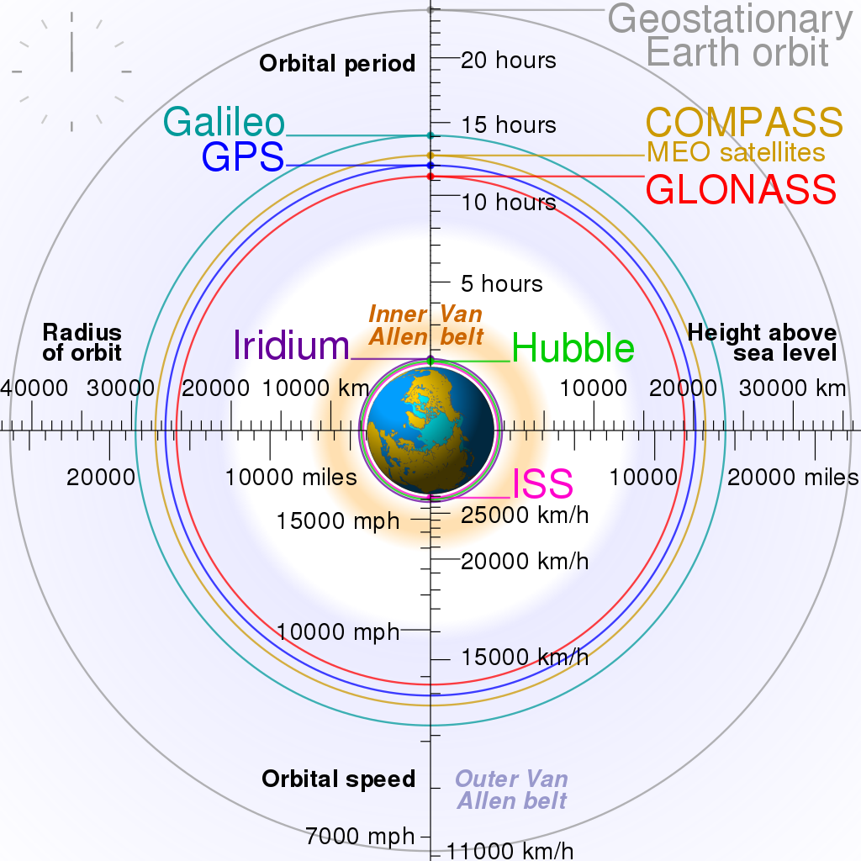
Figure 1. Satellite orbit altitudes. Placeholder image.

Antenna issues

All radio systems experience path loss, which is caused by the spreading out of radio signals from the transmitter. The further you are from the transmitter, the weaker the signal becomes; just as light becomes fainter as you move away from a lamp. It is an inverse-square law; the signal power drops according to the square of the distance. A radio signal to a LEO satellite needs to travel at least 300km; and to reach a GEO satellite it must travel 35000km. Overcoming path loss is key to satellite communications.
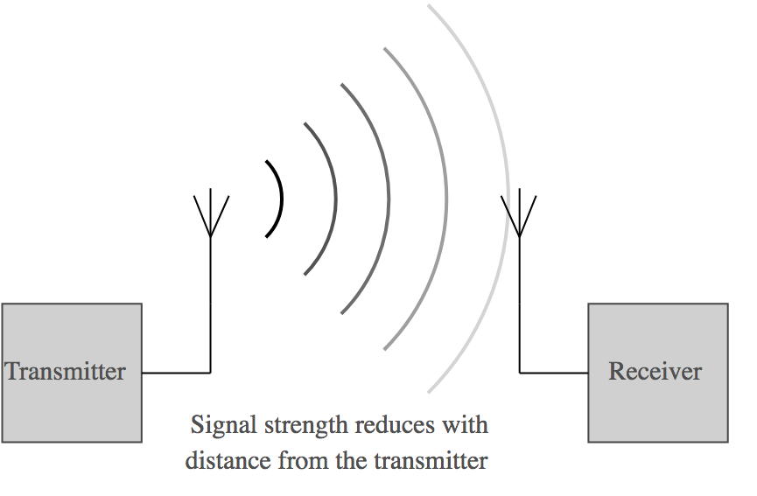
Figure 2. Free space path loss. Placeholder image.
There are three approaches to overcoming path loss:
- Increase the transmitter power;
- Increase the receiver sensitivity;
- Use directional antennas.

Increasing the transmitter power is practical up to a point. Satellites are solar powered, and their performance is usually constrained by the amount of electrical power available for the transmitters. On the ground, it is possible to use very powerful transmitters at the expense of electrical efficiency; provided that you have access to mains power or generators.

Receiver sensitivity likewise has improved as electronics technology has advanced. The first generation of satellite receivers in the 1950s were cooled with liquid nitrogen to improve their noise performance, whereas now we have sensitive solid-state electronics with superior performance.

Antenna design allows the radio signal to be directed into a narrow beam, rather than radiating equally in all directions. Think of the beam of a searchlight rather than a bare light bulb; concentrating the wave into a beam effectively increases the power of transmission in the direction of the beam. The classic parabolic dish antenna design produces a narrow beam; the larger the dish, the narrower and more powerful is the beam. This is known as “antenna gain”, the effective amplification of the signal in the beam direction when compared to an omnidirectional antenna.


Figure 3. Just as a spotlight produces a beam of light, a directional antenna produces a beam of radio waves. Placeholder image.
There is, however, always a trade-off; a directional antenna needs to be pointed accurately towards the satellite. This is what makes geostationary satellites so attractive; because the satellite appears “fixed” in the sky, a highly directional antenna can be lined-up on the satellite and then fixed in position. For other types of orbit, either the antenna must track the satellite (with consequent cost and complexity) or we must forego the gain of a directional antenna and operate with a simpler wide-beam antenna with little or no gain. Note that an antenna used on a moving vehicle, ship or aircraft needs to be of the tracking type anyway.

Tracking antennas for ships are bulky and expensive because of the need to constantly correct for the ship’s motion. Traditionally they were gyro-stabilised with large rotating flywheels, but modern control electronics can sense the ship’s motion and automatically point the antenna. However, this requires powerful motors to move the heavy antenna rapidly as the ship pitches and rolls.

Satellite systems currently in service

Introduction
This section only describes systems that were operating and taking on new users at the time it was updated. A number of companies were proposing to launch new satellite constellations, and these will be covered in future revisions once they enter service. Where possible, all descriptions of satellite systems are based on information that was publicly available at the time of update. Where information has been supplied directly by the satellite industry (and is not otherwise published) then this is highlighted clearly in the text.

Data rates (speed of transmission) are given in bits, kilobits, or megabits as appropriate. Message sizes are given in bytes (8 bits = 1 byte). SI prefixes are used for bytes, so 1 kbyte (1 kilobyte) referesto 1000 bytes and not to the binary kibibyte (1 024 bytes).

The satellite systems considered in this handbook are: Argos, DCS, Globalstar, Gonets, Inmarsat, Iridium, O3B, Orbcomm, Thuraya andVSAT.

Argos (information updated April 2018)

Website: | http://www.argos-system.org/
Type of orbit: | LEO, polar orbit
Number of satellites in operation: | 6
Coverage: | Global

Argos is a satcom system developed for use in environmental science. It was established as a French-American joint project - the original partners were CNES (France) and NOAA and NASA (USA). The service became operational in 1978. Argos does not operate its own satellites - it is carried as part of the payload on meteorological observation satellites. As of 2015, the Argos constellation consists of three United States (NOAA) satellites (NOAA-15, 18 and 19), two European (Eumetsat) ones (MetOp-A and B) and one Indian one (SARAL). A third European satellite (MetOp-C) was due for launch in 2018, and a further launch was planned for 2020.

Argos downlinks data from the satellites through a network of ground stations. Messages received by the satellites are stored until in range of a ground station (“store-and-forward”). The service has global coverage but can have relatively long latency.

Argos’s key feature is that it allows the use of extremely small, low powered terminals. It is the only satellite system with terminals that are light enough to be used for tracking birds. For tracking applications, Argos can also estimate the position of the terminal based on the Doppler shift of the radio signal, which eliminates the need for a separate positioning system like GPS.

Argos service is offered in two ways: there is a commercial service at market rates, and a special cheaper tariff for scientific users. The latter tariff is determined by an organisation called the Joint Tariff Agreement (JTA), which is a subprogram of Satcom Forum. http://www.argos-system.org/argos-jta/

Argos offers two types of service, known as Argos-2 and Argos-3. Argos-2 is available on all six satellites, and operates at 400 bits per second, with the maximum message size being 32 bytes. The newer Argos-3 service is available on the four newer satellites in the constellation, and offers a 4 800 bits per second “high rate” service, allowing the transmission of larger messages of up to 576 bytes. Argos-3 also offers the option for error corrective coding of messages.
A new service, Argos-4, was in development but specifications had not been announced.

Argos is primarily a unidirectional service, intended for collecting data from remote terminals. Argos-3 brought in a two-way service, but it is presently only offered by three satellites. The downlink data rate is 400 bits per second, and is mainly used to acknowledge receipt of messages.

DCS (information updated April 2018)

CGMS website: | http://www.cgms-info.org/
CMA website: | http://www.cma.gov.cn/en2014/satellites/
EUMETSAT website: | https://www.eumetsat.int/website/home/Data/MeteosatServices/MeteosatDataCollectionServices/index.html
ISRO website: | https://www.isro.gov.in/applications/climate-environment-0
JMA website: | http://www.jma-net.go.jp/msc/en/general/system/dcs/index.html
NOAA website: | http://www.noaasis.noaa.gov/DCS/
Roshydromet website: | http://www.meteorf.ru/
Type of orbit: | Geostationary
Number of satellites in operation: | 10
Coverage: | Global excluding poles

DCS “Data Collection Service” is a unidirectional service designed exclusively for the collection and redistribution of environmental data. It is commonly used to collect data from static automatic weather stations, but has a range of other applications. Its free-to-use nature makes it very popular with less wealthy countries.

The service is offered by geostationary meteorological satellites from the following agencies:
- NOAA (GOES-E and GOES-W satellites, covering the Americas),
- EUMETSAT (Meteosat-8 and Meteosat-11 satellites, covering the Atlantic Ocean, Europe, Africa and Indian Ocean),
- JMA (Himawari 8 satellite, covering East Asia and the western Pacific Ocean),
- ISRO (Insat satellites, covering India),
- Roshydromet (Elektro-L satellite, covering Russia),
- CMA (Feng Yun satellites, covering China).

NOAA, EUMETSAT and JMA coordinate their DCS activities through a joint body called the Coordinating Group for Meteorological Satellites (CGMS). The Indian, Chinese and Russian satellites offer DCS service only to users within their own countries. However, the other five satellites are available for use free of charge for meteorological, hydrological or geological data collection and redistribution, subject to the approval of the satellite operating agency. The free service is provided on the basis that the data collected is made publicly available via the WMO Information System (WIS).

The basic DCS transmission is common across all the operators. The transmissions are allocated to different users based on an allocated timeslot. The length of the slot depends on the bit rate of the transmission, which depends on both the user’s terminal and the satellite used. DCS transmitters are unidirectional and rely on an accurate clock to remain within their allocated timeslot. There is typically a 15 s guard period either side of each slot to allow for clocks being too fast or too slow, making the total slot time 30 s longer than the maximum permitted transmission.

The original DCS protocol operated at 100bits per second but is now considered to be very old and slow, and the transmitters are quite power-hungry. Newer satellites have allowed the operators to offer higher data rates, but unfortunately these higher-rate services are not standardised:

- NOAA offers 300 bits per second and 1 200 bits per second DCS on their GOES satellites in the Americas. These benefit from error corrective coding to protect against errors in transmission;

- EUMETSAT offers 100bits per second “Standard Rate” and 1 200bits per second “High Rate” services on their satellites. The High Rate service also has error corrective coding and is more power-efficient than the NOAA system. It has a flexible timeslot allocation scheme, allowing large messages of up to 65 kilobytes or allowing more frequent, shorter transmissions; for example to collect data every 5 minutes rather than every hour;

- JMA offers 100bits per second and 300bits per second DCS on its Himawari series satellite in East Asia and the western Pacific Ocean. JASA’s Himawari satellite offers a 300bits per second service.

Globalstar (information updated April 2018)

Website: | http://www.globalstar.com
Type of orbit: | LEO
Number of satellites in operation: | 24
Coverage: | North America, Europe, Middle East, East Asia, Australia. Limited coverage in Southern Hemisphere. No permission to operate in China or India. Little or no oceanic coverage.

Globalstar is a commercial service originally intended as a mobile phone system. The present constellation of satellites is the second generation, launched between 2010 and 2013. Unlike some of the other LEO systems, Globalstar’s satellites do not have any on-board processing for calls and messages; all the processing is carried out by ground stations. Consequently, Globalstar can only provide good coverage where it has ground stations in operation. This means it has limited coverage at sea and in the polar regions. At the time of writing the coverage maps showed limited coverage in South America, very little coverage of Africa and no coverage of China, India and central Asia. Globalstar’s traditional focus has been on the North American market, and more than 50% of their customers are in the United States. Since their coverage is more limited, their strategy has been to compete on price, so their equipment and airtime tends to be cheaper than their competitors.

Globalstar’s “duplex” service (their voice service) can be used to provide a circuit-switched data service at 9 600 bits per second. There is no packet-switched service; charges are per minute regardless of whether the use is voice or data.

Globalstar also offers a “simplex” service (a unidirectional service) that can be used for collecting data from low power terminals. Simplex has rather better coverage than duplex, and in principle claims coverage on all continents except Antarctica, but with the caveat that Globalstar does not have permission to operate in every country.

A simplex message carries only nine bytes of data, and the service is billed per message. Multiple messages can be grouped together into a “message burst” to send larger amounts of data. The transmitter will send each message burst several times in order to make sure that it is received, since it cannot receive an acknowledgement from the satellite. By default the transmitters send each message burst three times, with an average of five minutes between transmissions (the spacing is randomised to reduce the risk of collisions with other transmissions). Duplicate messages are discarded at the ground station, so the customer is not billed more than once.

Gonets (information updated April 2018)

Website: | http://www.gonets.ru/
Type of orbit: | LEO (polar orbit)
Number of satellites in operation: | 12
Coverage: | Global

Gonets is a Russian system with polar-orbiting satellites that operates using store-and-forward messaging. It has four gateway stations, all located with Russia. The service operates in the low UHF band, just below 400MHz. It markets itself very much towards Russian customers. Geonets hasan English-language version of its website, so it is clearly interested in international business.
Gonets provided more technical information about their system in response to a direct request:
- messages are formed from one or more 1.5 kilobyte packets;
- multiple packets can be used for sending larger payloads;
- the maximum message size depends on the location of the terminal relative to the satellite orbits.

Inmarsat (information updated April 2018)

Website: | http://www.inmarsat.com/
Type of orbit: | Geostationary
Number of satellites in operation: | 11
Coverage: | Global excluding poles

Inmarsat is a commercial service provider that grew out of the marine communications market. It now offers services to land, marine and aeronautical terminals, and operate three different constellations of satellites.

Inmarsat’s older satellites (Inmarsat-3 and Inmarsat-4 constellations) serve communications in L-band (~1.5GHz) supporting the backbone of Inmarsat’s business. The newer Inmarsat-5 series operates in Ka-band (26-30GHz) and is used to provide higher data rate services, which Inmarsat call “Global Xpress”.

Inmarsat offers a very large number of different services. Marine services are mostly branded “Fleet” and aeronautical services are mostly branded “Swift”.

Land services

IsatHub is a lightweight, portable terminal that offers data rates up to 384 kbits per second. The terminal includes a wifi hotspot and is designed to be used with laptops and smartphones. It incorporates an internal battery and can operate for 2.5 hours on battery power.

BGAN is Inmarsat’s medium data rate land service. There are a range of terminals, some of which can be vehicle mounted. It offers data rates of up to 492 kbits per second.

BGAN HDR is a high data rate version of BGAN that’s intended for TV news. It claims to offer a maximum data rate of 650kbit/s. It is possible to “bond” two terminals together and obtain speeds of more than 1Mbit/s.

BGAN Link is a BGAN service sold for use by corporate IT departments. It offers 492 kbits per second Internet Protocol service, with a 30 GB per month data cap. There is also a version called “BGAN Link Backup” that is a tariff designed to be attractive for business continuity, that is for use only when a terrestrial system fails.

BGAN M2M is a BGAN service plan designed for use in remote monitoring applications. It offers data rates of 448kbit kbits per second. BGAN M2M terminals are data only and cannot make voice calls.

IsatM2M is a low-data rate messaging service that can be used on both land and sea. It is typically used for tracking and telemetry applications. Terminals can send messages of 10 or 25 bytes, and receive messages of up to 100 bytes. IsatM2M is an older service, and may be retired in favour of the newer IsatData Pro.

IsatData Pro is a low-data rate messaging service, offering messages of up to 6.4 kBytes transmitted, and up to 10 kBytes received. Marine-grade terminals are available for use at sea.

Marine services

FleetBroadband is a medium data rate marine service. There is a choice of three terminals of different sizes:

- FB150 - 150kbit/s
- FB250 - 250kbit/s
- FB500 - 432kbit/s

All three terminals also offer voice and SMS capability. The FB250 and FB500 terminals incorporate a GSM base station to allow voice and SMS forwarding from ordinary mobile phones.

FleetOne is a service intended for occasional marine use. It is sold with very flexible airtime terms, and can be activated and de-activated whenever you like. A low-cost service called “FleetOne Coastal” is available for vessels under 500 tonnes operate in coastal waters. FleetOne offers 100kbit per second packet data.

Inmarsat-C is a low data rate messaging service designed for marine safety applications. It offers 600bit per second packet data communications from a compact, low cost terminal. There are two versions - “Inmarsat C” and “Inmarsat Mini C”. Mini C uses a smaller, lower power terminals. Inmarsat C is more than 25 years old, and is likely to be replaced with a new type of service.

Fleet-77 is Inmarsat’s higher-end marine safety service. It will be retired in 2020, but in the meantime offers 64kbits per second data services. The lower-bandwidth Fleet 33 and Fleet 55 services will be retired in 2018.

Fleet Xpress is a high data rate service for the marine market, using the Global Xpress satellite network. It can offer up to 8 Mbit/s downlink, and 4Mbit/s uplink.

Aeronautical services

Swift64 is an aeronautical service based around providing a 64kbit per second ISDN-style circuit. Up to four circuits can be bonded to create a 256kbit per second channel. It can also offer a packet data service at the same data rates (billed by the byte, rather than by the minute).

SwiftBroadband is the aeronautical equivalent of FleetBroadband, with data rates of 200-700 kbit per second depending on the terminal used.

JetConneX is a high data rate aeronautical service, using the Global Xpress satellite network. It can offer data rates of up to 50Mbit per second to aircraft in flight.

Iridium (information updated April 2018)

Website: | http://www.iridium.com/
Type of orbit: | LEO (polar orbit)
Number of satellites in operation: | 66
Coverage: | Global
Iridium is a commercial satellite operator, using a large constellation of LEO satellites to provide voice and data services. Their original constellation dates from the 1990s, and is presently being replaced by new satellites. As of mid-March 2018 they have had four successful launches out of a planned total of eight, with the remaining launches due to complete during 2018. The new constellation is known as Iridium Next, and the services that will operate on it will be branded “Iridium Certus”. These services are not yet on commercial sale. The services discussed in this article are the ones on sale as of March 2018, which are all operated by the original 1990s constellation.
Iridium’s network design is much more complex than most of its competitors. Every satellite is cross-linked to its neighbours by microwave links, allowing calls and data to pass between the satellites. An Iridium-to-Iridium phone call is handled entirely by the satellites and never goes via a ground station. Iridium’s ground stations are used as gateways to terrestrial networks, either to the phone network or to the Internet.
Because the Iridium satellites are in low Earth orbit, they move rapidly with respect to the ground, and are only in view for ten minutes at a time. The network is designed to hand over calls automatically to another satellite, but this is not entirely reliable and it is quite common to have your call cut off after four or five minutes. This effect is more noticeable if you are in a valley or on a mountainside, where terrain may obstruct the view of the “next” satellite. The Pilot service accesses multiple satellites at the same time using multiple antennas within the module, and doesn’t suffer from this handover problem.
Iridium offer several types of data service:
- Short burst data (SBD) - a two-way message-based service,
- Iridium Burst - a one-way broadcast message service,
- Circuit Switched Data (CSD) - a 2.4 kbits per second dial-up data service,
- Pilot - a medium data rate service, offering up to 134 kbits per second Internet Protocol connectivity

Short Burst Data (SBD)
SBD is a message-based service, intended for applications which need relatively small amounts of data, a small terminal and low power consumption. SBD messages are relatively small (270 bytes for messages from the network to the terminal, or 340 bytes for messages sent by the terminal), and are charged by the byte, usually with a minimum charge per message. They are passed through the Iridium network with a latency of under 20 seconds, and Iridium’s network centre then delivers them using email or a simple IP socket interface. SBD modems are typically integrated into scientific instruments and consumer products (Garmin’s InReach communicators, for example) and you can integrate them with your own equipment if that suits your application. Iridium do sell a fully-weatherproofed SBD modem, branded as Iridium Edge, that can be attached to a PC or datalogger.

Circuit Switched Data (CSD)
CSD is the data equivalent of an Iridium voice call - offering a 2.4kbits per second full duplex stream. This is extremely slow by modern standards but still usable for basic data exchange. CSD can be used to provide extremely slow internet access (“Iridium Direct Internet”), and can also be used to access private networks. Iridium’s RUDICS service allows hundreds or thousands of CSD calls to be routed to and from a private network, and is intended for customers with large numbers of devices deployed in the field. Iridium sell a portable terminal, “Iridium GO”, which is designed to share a single CSD connection with a computer, tablet or smartphone over Wi-Fi. CSD is also available on Iridium’s handsets, or using a modem that is designed for integration into your own equipment.

Iridium Burst
Iridium Burst is a broadcast service intended for sending the same message to many field terminals. It is designed primarily as an alerting service, and could be used to send urgent messages, such as tsunami warnings, to large numbers of different locations. Because it is a broadcast service, the terminals do not incur airtime charges while waiting for an alert to arrive.

Pilot
Iridium’s highest-bandwidth service is Pilot, which was originally sold in the marine market and now also has a land variant. One Pilot terminal can connect up to three simultaneous voice calls and provides internet access at up to 134kbits per second. The Land Station version has the same specification as the marine version. Data is charged by the megabyte, and can be bought as bundled deals for applications that require large amounts. Pilot works by steering multiple beams from the antenna to access several Iridium satellites at once, so having a clear line of sight in all directions around the antenna will help to ensure good performance. As a marine terminal it has the key advantage that there are no moving parts; no mechanical tracking, unlike a geostationary system, and so is cheaper and lighter. However, it can only deliver a fraction of the data rate of a geostationary system. Pilot is powered from 11-32V DC (although an AC adaptor is supplied) and consumes around 30W when connected.

O3B (information updated April 2018)

Website: | http://www.o3bnetworks.com/
Type of orbit: | Medium Earth Orbit (MEO)
Number of satellites in operation: | 12
Coverage: | Equatorial coverage to around 45 degrees latitude north and south
O3B is a wholesale satellite operator whose main market is the provision of high bandwidth, low latency internet connectivity to telecom providers in less-developed countries. Its constellation is unusual in operating with MEO satellites, meaning that a tracking antenna is required at the terminal. The use of MEO allows for lower latency and higher data rates than would be possible on an equivalent geostationary satellite.
O3B was originally an independent company but is now owned by SES of Luxembourg (best known for the Astra series of broadcast satellites). O3B also provide services to the marine market, particularly for cruise ships where a large amount of bandwidth is needed. O3B states that itoffers up to 1Gbits per second to ships. O3B terminals typically comprise two or more large tracking dish antennas (typically 1.8 or 2.4m diameter); two antennas are used to ensure continuous coverage as satellites drop below the horizon.

Orbcomm (information updated April 2018)

Website: | http://www.orbcomm.com/
Type of orbit: | LEO (inclined orbits – no polar orbits)
Number of satellites in operation: | 16 (OG2 constellation), 25 (OG1 constellation)
Coverage: | Global excluding poles
Orbcomm operate its own satellite networks (known as OG1 and OG2) and also sell terminals and airtime for Inmarsat’s IsatData Pro network. This entry concentrates on OG1 and OG2. The Orbcomm OG1 constellation was launched in the mid-1990s and used marine-band VHF radio to communicate with data terminals. It is a strictly message-based service and operates using store and forward to a series of gateways. OG1 operates at an uplink speed of 2.4kbits per second and a downlink of 4.8kbits per second to the user’s terminal. Message sizes are not fixed, but are typically a few tens of bytes.
The second-generation OG2 constellation became fully operational in 2016, and Orbcomm states that it allows larger message sizes and higher throughput. It offers 4.8kbits per second uplink and 7.2kbits per second downlink. Orbcomm publishes relatively little information about how their system works; you will need to speak to the company directly if you want to see technical datasheets.
Orbcomm’s modems often combine satellite connectivity with cellular, which is particularly valuable if they are mounted on a platform that moves between populated and remote areas, allowing the use of the cheaper cellular service where it is available but retaining the satellite as a backup.

Thuraya (information updated April 2018)

Website: | http://www.thuraya.com/
Type of orbit: | Geostationary
Number of satellites in operation: | 2 (all services) + 1 offering M2M service only in North America
Coverage: | Full services cover Europe, most of Africa (Angola and northwards), the Middle East, central and East Asia (but not Siberia), Australia. Very limited oceanic coverage, confined to areas of the east Atlantic close to Europe, the northern part of the Indian Ocean and parts of the western Pacific between Japan and Australia.  M2M services are additionally available in central and North America, excluding Alaska and arctic Canada.
Thuraya is a Dubai-based satellite provider that provides telephony and data services. It offers a range of terminals from handheld satellite phones to larger self-pointing units that can be mounted on vehicles or ships.
Thuraya’s data services consist of:
- Circuit switched data (essentially a voice channel used for data) 9.6 kbits per second,
- GmPRS - packet switched data, 60 kbits per second downlink, 15 kbits per second uplink,
- “Streaming IP” at guaranteed speeds of 384 kbits per second,
- Conventional IP at peak data rates of up to 444 kbits per second downlink, 404 kbits per second uplink.
The CSD and GmPRS services are available on Thuraya’s voice handsets and XT-Hotspot (a portable Wi-Fi hotspot). The high rate IP services need a dedicated terminal about the size of a laptop computer.
There is also the Thuraya M2M service, currently only available on the dedicated FT2225 terminal. Thuraya does not publish the data rates offered by this service, although they are described as “low”, “medium” and “high” at different price points. The M2M service is the only Thuraya service that operates in North America, because it is operated in partnership with Ligado and ViaSat.
Thuraya also offers a range of modem modules for integration into other equipment or commercial products. http://thuraya.com/developer-zone

VSAT (information updated April 2018)
Most of the services described in this handbook are fully integrated: you buy a terminal, install it, buy an airtime contract and then you’re ready to go. This is “retail” satellite communication (satcom); you can buy a single terminal and not have to worry about the rest of the system. However, there is also a “wholesale” satcom business, as used by telecom companies, broadcasters and other big companies with complex communications requirements.
In wholesale satcom, you rent some bandwidth on one or more geostationary satellites, typically agreeing a long-term lease, and then provide your own terminals. These could be owned by you (typically on your own building, vehicle or ship) or supplied under contract from a service provider. One very common arrangement is to use a service provider to act as the hub of the network (from a dedicated earth station or teleport with lots of antennas serving different customers), that can also provide routeing to the Internet, telephone network or private corporate networks. The high-end satcom industry views any terminal using an antenna 2m in diameter or less as a “very small aperture terminal” (VSAT); these are “very small” by comparison with the 10m or larger antennas used by telecom providers.
VSAT ideally suits a situation where you have a continuous need for communication with a remote location. It can be customized to suit your needs, but is necessarily more complex to plan and install. There are dedicated service companies that will do this for a fee.
There is a version of VSAT that is more suitable for retail customers. This is known as “Shared VSAT”, and is typically sold by a service provider that leases the satellite bandwidth and provides a suitable terminal. These systems are typically used to provide internet access to rural areas, and often use contention to share bandwidth between multiple users, meaning that the service slows down as more and more users log on.

How to purchase and install a satcom system
This section gives some general principles which may be helpful when planning or specifying a satcom system. It is not intended to be exhaustive, but to provide helpful prompts.

Deciding on your priorities
With such a diverse range of satellite systems on the market, it is important to consider your priorities carefully. It is likely that you will have to compromise between the data rate available, the size and power consumption of the terminal and the cost of the airtime. Important questions to consider include:
- Where in the world do you need to operate?
- Will the terminals be static or will they move around?
- Do you need it to work in the polar regions (specifically at latitudes higher than 70 degrees)?
- Do you need to use it on a ship, aircraft or other moving vehicle?
- How much data do you need to transmit?
- Are the data continuous or bursty?
- Can you accept occasional data loss in transmission, or is it vital that every message gets through reliably?
- Do the data need to be available in real time, or can you accept some delay in receiving them?
- Do you need bi-directional communication (i.e. sending commands to your remote installation as well as receiving data back from it)?
- How long will the system be deployed for?
- How often will the remote sites be visited?
- What are the environmental conditions at your remote sites? Some services are more robust to the effects of poor weather than others: heavy rain or snow can sometimes disrupt transmissions;
- How sensitive are you to operating cost? A simple messaging service sending a few bytes a day can cost around $30 (USD) per month. A high data rate service sending several gigabytes per month may cost as much as $5000 (USD) per month;
- How sensitive are you to capital cost? Small terminals can be a few hundred US dollars, whereas a large VSAT installation might cost millions;
- Would you be happy to pay for any value-added services? Some providers can process your data for you and put it into suitable formats that meet your needs. Some can deliver your data automatically to networks like WIS. Some provide management portals to manage data products or billing;
- Would you benefit from a dual-mode terminal? It is possible to buy terminals that combine satellite with cellular phone modems, using primarily the cheaper cellular service and only using satellite as a backup. It is also possible to implement two different satellite modems for different applications.
Draw up a specification for the service that you need and then compare the systems on the market against it. You may find that you need to compromise because your initial specification is too demanding, being either too expensive or technically not feasible.

Coverage
The first topic to check for any candidate system is coverage. The network operators publish coverage maps, but it is helpful to check directly with them if there are any coverage issues with any places that you intend to deploy terminals.
The first key question is: do you need polar region coverage at latitudes higher than 70 degrees? If you do, this limits you to the following networks:
- Argos
- Gonets
- Iridium
There is a slight grey area; some geostationary networks may work at up to 75 degrees latitude with careful antenna siting, and with appropriate (expensive) equipment can be made to work as high as 79.99 degrees (as is done at CFS Eureka in the Canadian Arctic with two very large antennas on mountaintops), but beyond 80 degrees the curvature of the Earth prevents the terminal from seeing the satellite.
If you do not need polar coverage, you should then look at what regions of the world you are operating in. Networks that offer only regional coverage (e.g. Globalstar and Thuraya) generally offer lower prices than those that offer global coverage.
If you are operating at sea, check the oceanic coverage. Globalstar and Thuraya both have limited ocean coverage, but may still be acceptable: for example, Thuraya has full coverage of the Mediterranean Sea but does not cover the whole of the Atlantic Ocean.

Power supplies
If your remote site is completely isolated, you will need to provide your own power supply in the form of solar panels, wind generators, batteries and/or generators. In this situation ensuring that your communications system has a relatively low power consumption will avoid the cost and expense of transporting too much equipment to the site. Note that most systems have a high peak power consumption when transmitting, and if you only send one or two messages per day then the average power consumption will be much lower than if the system is communicating continuously.
Message-based and low-bandwidth systems have relatively low power consumption and are thus more suited to fully autonomous deployments than high-bandwidth systems.
If you are using satellite communication because you want a high-reliability data collection service, or one that is resilient to failures of terrestrial infrastructure (such as a flood or tsunami warning system), then you need to consider the reliability of your power supply. Using an uninterruptible power supply unit (UPS) or having a backup power system that can run autonomously from solar power or batteries will help to ensure that your messages get through even if the public electricity supply fails.

Look angles
For geostationary satellites, it is vitally important that the terminal has a clear line of sight to the satellite. On open terrain or hilltops, this is straightforward, but in narrow valleys or urban areas the line of sight can be blocked by hills, mountains or large buildings. Given the latitude and longitude of your intended site, you can calculate the “look angles” to the satellite, the compass bearing (azimuth angle) and elevation angle to which that the dish must be aligned. A site visit or some careful use of a topographic map can help you determine if your intended satellite is going to be in view. One common remedy to issues with look angles is to raise the terminal antenna on a pole, mast or tower so that it can see over the obstruction. In extreme cases it may be necessary to site the satellite terminal remotely; on a nearby hillside, for example, and run a cable or use a terrestrial radio link to communicate with it from your measurement location.
For satellites in low or medium earth orbit, the issue with look angles and terrain is less critical but still important. The satellites will appear to move relative to the terminal, moving from horizon to horizon. If part of that arc is blocked by terrain or buildings, the available communication time for that satellite pass will be reduced. A clear line of sight will help to ensure that communications are reliable and that messages are sent and received on the first available satellite pass. Deep valleys or canyons give particular problems with polar orbiting satellites, as only one or two satellites in the constellation will have orbits that align with the valley. Siting your terminal as high as possible mitigates the problem.

Airtime contracts
Many of the satellite networks started out in the business mobile telephony market (including Globalstar, Iridium and Thuraya) and so it is common for the tariff to be billed monthly, usually with a standing charge (“line rental”) and a usage charge based on minutes, bytes or messages used. Some tariffs include a monthly allowance for data. It is common for the providers to ask for a minimum contract length (typically 12 months), which may not be convenient for systems that are deployed for a shorter period.
Many government institutions find the monthly billing inconvenient (as it generates many small invoices to be paid) and so you may prefer to ask your provider to quote you for a pre-paid option as an alternative. This is particularly attractive for remote instrumentation that reports regularly, as you should know quite accurately how much data you will use in a given period. Pre-payment reduces the providers’ billing costs too, so they should offer you a better tariff. If you are running a large number of satellite terminals, it is best to have them all on a single contract with a single provider. This reduces the administrative overhead, and may prove more cost-efficient. Many providers will allow you to pool data allowances between multiple terminals.
Satcom Forum aims to work with the industry to ensure that tariffs are suitable for scientific users, so if you have particular issues with your tariff structure or have comments or suggestions for how they may be improved, please do get in touch with the Secretariat at the WMO (wis-help@wmo.int) and they will try and help you.

Internet access
Certain satellite systems offer full internet access, systems like Inmarsat’s BGAN, Iridium’s Pilot and Thuraya’s Streaming IP. You can connect the terminal to a PC and access internet services (such as the web or email) just as you would over a landline or cellular connection. However, there are some significant issues that you should be aware of with internet access:
- Security: depending on your terminal and service provider, you may be connected directly to the internet without any firewall or other similar protection. You are strongly advised to take security advice and to use an appropriate firewall (hardware or software) to prevent malicious hackers from accessing your remote sites. It is also wise to avoid sending your data over the open internet, and you may want to look into the use of a VPN or other similar encryption technique to link your remote sites with your data servers.
- Data usage: most modern operating systems (including Mac OS and Windows 10) by default assume that they have constant access to a free, high-bandwidth internet connection. The operating system and any applications running may check for and download software updates or synchronise large amounts of data with cloud servers (OneDrive, iCloud, Dropbox, etc), both of which will result in large amounts of traffic flowing over the satellite link. This will make the link appear slow, as the amount of usable bandwidth for your intended application will be restricted by the large flow of data to and from the cloud servers. If you are being charged per minute or per byte for your data connection, this will also run up a significant bill. In addition to configuring the operating system to treat the satcom connection as a metered connection, you should arrange for your firewall to block all outgoing requests for internet traffic except for your wanted data traffic. Using a non-standard TCP or UDP port number will help segregate your own traffic from unwanted internet traffic.

Directory of industry contacts

[Explanatory note: This chapter will contain a directory listing contacts (ideally named salespeople) for companies selling equipment and airtime. A disclaimer will make it clear that WMO does not endorse the companies on this list, but they have requested to be listed and are therefore interested in supplying the scientific market. A contact form will be available for any supplier wishing to be added to the directory.]
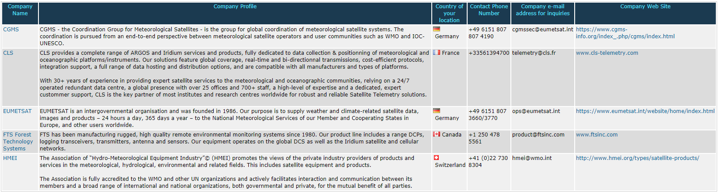
Figure 4 Sample of what a directory listing might look like

Use of geostationary satellites between 60 and 80 degrees latitude requires special care and attention, and should be discussed with the supplier. When approaching 80 degrees latitude you may require multiple large antennas in order to obtain a strong enough signal. The world’s highest latitude earth station is at Eureka in Canada, at 79.9 degrees N.
The previous version of Pilot was known as Iridium OpenPort. Now Iridium use Pilot to refer to the terminal, and OpenPort to the data service. The terms are often used interchangeably.
“Virtual Private Network” – an encrypted network connection that keeps your traffic private as it passes through the public internet

