This document is in two parts
Part I – WIS Governance & escalation process (ICTT-WIS2016 Doc04a)
Part II – WMO Security incident process (ICTT-WIS2016 Doc04b)

Part I - WIS Network Governance & Decision Escalation Process

1. Introduction
1.1 The governance of WIS is outlined in the Technical Regulations Basic Documents No.2, Volume I, General Meteorological Standards and Practices, Part II (WMO No.49), referred to as Tech Reg 49. Responsibilities and particular practices and procedures are describe in Sections 1.2 and 1.4 as follows:

1.3 Responsibilities
1.3.1 Members operating Global Information System Centres, Data Collection or Production Centres, and National Centres shall ensure that all appropriate measures are taken for the installation and good functioning of their centres and of the required data communication systems and services, in relation to their needs and the roles which they have accepted.
1.3.2 Members shall ensure that their national information collecting systems allow not only national but also international needs to be met.
1.4 Practices, procedures and specifications
1.4.1 The WMO Information System data management and information exchange functions shall be established and operated in accordance with the practices, procedures and specifications set out in Annex VII (Manual on the WMO Information System (WMO‑No. 1060)).
1.4.2 The Global Telecommunication System shall be operated in accordance with the practices, procedures and specifications set out in Annex III (Manual on the Global Telecommunication System (WMO‑No. 386)).
Note: The Manual on the WMO Information System (WMO‑No. 1060) complements the Manual on the Global Telecommunication System (WMO‑No. 386). The latter will eventually be replaced by the Manual on the WMO Information System which will incorporate the relevant material
1.2 Thus TechReg49 combined with the Manual on WIS (WMO No.1060), the Manual on GTS (WMO No.386) along with their guides describe the working mechanisms of WIS. In addition, many other aspects of WIS, such as what should be shared and how to represent information are defined in other manuals and guides such as the Manual on GDPFS (WMO No.485) and Manual on Codes (WMO No.306). In addition we have Congress resolutions such as Res 40 (Cg-12), Res30 (Cg-13) and Res60 (Cg-17) which also define content. However, none these define a decision process for centres adding or removing data streams which impose costs to WIS infrastructure providers, eg. ICT processing, storage and communications systems capacity management.

2. The problem
2.1 Exchange between GTS centres was originally managed on a bilateral agreement between any two centres, taking into consideration the list of basic information exchange, as described in the Manual on GDPFS (WMO No.485), and the needs of their downstream and upstream users. For instance RTHs only needed to subscribe to information needed by the centres that they supported. Thus, the capacity of RTHs was linked to their regional obligations and national needs. Similarly, RTHs on the MTN or WMCs needed to maintain larger and more sophisticated infrastructures.
2.2 An important aspect for considering new traffic was its impact on the processing capacity of the centre’s systems and the bandwidth or data exchange capacity. Many RTHs used a combination of technologies including GTS and non-GTS links with associated centres, satellite distribution systems and the Internet. Large data or non-time critical data were often sent via alternative methods (non-GTS links, Internet, etc) so as not to interfere with the performance of the registered GTS links and to avoid having to upgrade the links or systems at smaller GTS nodes (i.e. NMHSs in SIDS, LDCs,etc).
2.3 Under WIS, GISCs have to share with all other GISCs all data from their Area of Responsibility that is identified in the WIS discovery metadata record by the keyword “globalExchange” (See Table 17, Manual on WIS reproduced in the Annex to this document). This meant that if one GISC approved a data stream to be identified with “globalExchange”, then all GISCs had to ensure the capacity to send and receive all data from that stream and to make it available in their 24 hour cache even if none of the NCs or DCPCs connected to the GISC subscribed to that data stream. This meant that agreements needed to be multilateral if all GISCs were to have some control in their capacity planning.

3. The solution proposed by GISCs
Precondition – DC provider or user requests data be kept or removed in cache and distributed globally

3.1 TT-GISC 2014 considered the problem and recommended the following, extracted from the report of TT-GISC 2014 (http://wis.wmo.int/file=759)
1) The GISC representatives (ie TT-GISC) should, based on discussion with the providers (DCs) and users, be the group to advise[decide] whether a data stream should go in or out of the 24 hour cache and be routinely distributed
a) that all GISCs have to maintain (eg GlobalDistribution flag)
b) that a number of GISCs have to maintain (eg regionalExchange).
Note The flag “Originating Centre” does not effect cache
2) Starting decision to add a new or to remove an existing data stream will be by consensus of GISCs representatives in line with normal operational collaboration.
3) If unable to get reach consensus or the requester is not satisfied with the decision, the answer should default to no and the problem should be escalated to CBS [ICTT-WIS].
a) ICTT-WIS should then make its recommendations based on information from requesters’ and GISCs
b)4) The President of CBS can override will make a any decisions based on theICTT-WIS recommendation made by the group, utilising fast track procedures as appropriate.
5) Decisions should have a fixed timeline and have to be quick (e.g. less than 2 weeks)
4)6) It recommended Note that issues may be escalated by a GISC either in response to events, either occurred or planned, where it is anticipated it might impact on the functioning of WIS.
3.2 Review by ET-WISC and OPAG-ISS considered that this might be counterproductive for new needs by WIS users because GISCs might be reluctant to upgrade network or system capacity when the need is not as strong in their area of responsibility or if it is a programme that they are not familiar with. CBS and EC-68 have asked the ICTT-WIS to look for an appropriate decision process, taking into consideration the TT-GISC recommendation and to provide guidance on a solution that will be satisfactory to all WIS data suppliers, users, TCs and RAs as well as to the GISCs.

4. ICTT-WIS action
This issue is not anticipated to be complex. ICTT-WIS is asked to consider the TT-GISC proposal and how to address ICT-ISS concerns expressed in para 3.2 above.

5. References
[1] WMO Technical Regulation No.49 - http://wis.wmo.int/TechReg49 (17/08/2016)
[2] Manual on WIS (WMO No.1060) - http://wis.wmo.int/wis-manual (17/08/2016)
[3] Manual on GTS (WMO No.386) - http://wis.wmo.int/gts-manual (17/08/2016)
[4] Report of TT-GISC 2014 - http://wis.wmo.int/file=759 (17/08/2016)
[5] Links to other manuals and guides affecting WIS data flow - http://www.wmo.int/pages/prog/www/WIS/manuals_guides_techregulations_en.html (17/08/2016)

6. Recommended Text
x.1 ICTT-WIS reviewed possible governance processes for authorizing the use of the globalExchange key word that would enforce that all GISCs should cache information streams described by the metadata record that included that keyword. It noted the recommendations of TT-GISC 2014 taking into consideration the concerns raised by OPAG-ISS. Noting that there would most likely be occasions where the GISCs consensus might not be the best solution for WIS information providers or users. It agreed to the following modification of the TT-GISC recommendations: …
x.2 It noted that a similar problem might apply to the use of “RegionalExchange” key word and recommended the following: …

--------------------

Annex: Table 17. WMO_DistributionScopeCode «CodeList».
 | Name | Domain code | Definition
1. | WMO_DistributionScopeCode | WMODisScoCd | Scope of distribution for data published for exchange within WIS.
2. | GlobalExchange | 001 | Data are published for global exchange via WIS. Data shall be incorporated into the GISC cache.
3. | RegionalExchange | 002 | Data are published for regional exchange via a GISC.
4. | OriginatingCentre | 003 | Data are published for exchange directly via the originating centre.

Part II - Proposed Security Incident Process for WMO Member States (Draft 0.2)
Open Programme Area Group in Information Systems and Services (16 August 2016)

Contents

Proposed Security Incident Process for WMO Member States
For ET-CTS
Date 29th March 2016
Author P. Chamberlain
Version draft 0.4
Proposed Security Incident Process for WMO Member States 1
Disclaimer 2
1. Purpose of Document 3
2. What questions is this document addressing? 3
3. Background – Increase in WMO system IT Security risks 3
4. Does WMO need a Security incident & Response Process? 4
5. Will the process be followed? 4
6. Brief description of the process – Action of WMO member states 5
6.1 What process should I follow if I think I have an IT Security incident? 6
6.2 What process should I follow if I hear that another WMO member has had a possible IT Security incident? 7
6.3 What process should I follow if am contacted by my GISC? 8
6.4 What process should the WMO IT Security Contact Point follow? 9
6.5 What process should the GISC follow? 10
7. Brief description of the process – Action of WMO Contact Point 11
8. Brief description of the process – Action of WMO GISC 11
9. How can the community share IT Security best practise? 11
10. Recommendations 12
11. Follow-on Actions if the paper is accepted: 14
Appendix A - WMO IT Security Incident Risk Analysis 15
Appendix B - Glossary of Terms 18

Disclaimer
Regulation 43
Recommendations of working groups shall have no status within the Organization until they have been approved by the responsible constituent body. In the case of joint working groups the recommendations must be concurred with by the presidents of the constituent bodies concerned before being submitted to the designated constituent body.

Regulation 44
In the case of a recommendation made by a working group between sessions of the responsible constituent body, either in a session of a working group or by correspondence, the president of the body may, as an exceptional measure, approve the recommendation on behalf of the constituent body when the matter is, in his opinion, urgent, and does not appear to imply new obligations for Members. He may then submit this recommendation for adoption by the Executive Council or to the President of the Organization for action in accordance with Regulation 9(5).
© World Meteorological Organization, 15 August 2016
The right of publication in print, electronic and any other form and in any language is reserved by WMO. Short extracts from WMO publications may be reproduced without authorization provided that the complete source is clearly indicated. Editorial correspondence and requests to publish, reproduce or translate this publication (articles) in part or in whole should be addressed to:
Chairperson, Publications Board
World Meteorological Organization (WMO)
7 bis, avenue de la Paix Tel.: +41 (0)22 730 84 03
P.O. Box No. 2300 Fax: +41 (0)22 730 80 40
CH-1211 Geneva 2, Switzerland E-mail: Publications@wmo.int

NOTE:
The designations employed in WMO publications and the presentation of material in this publication do not imply the expression of any opinion whatsoever on the part of the Secretariat of WMO concerning the legal status of any country, territory, city or area or of its authorities, or concerning the delimitation of its frontiers or boundaries.

1. Purpose of Document
1.1 The WMO currently lacks a formal (or informal) security incident response process, as well as any practical way of sharing Security information.
1.2 This paper considers the risks (see Appendix A for risk assessment). The paper then answers pertinent questions which arise from analysis of the risks, and makes a number of proposals for adoption by WMO.

2. What questions is this document addressing?
2.1 Originating as an action from a real (but “false positive”) incident, these are the questions which this paper answers:
- What should a member state do if they think they have a security problem?
- What should a member state do if they hear that someone else has a security problem?
- How can we reduce misinformation about IT security incidents?
- How can we share IT security best practice?

3. Background – Increase in WMO system IT Security risks
3.1 WMO member states have historically had IT systems connected to each other over both private and public networks over many years.
3.2 In the past, standard data formats and single-purpose protocols reduced the risk of one member state affecting another. Protocols were non-standard and locked-down to a single purpose function, accessed by bespoke applications written specifically for meteorological use, probably by member state organizations themselves. Communications were over point-to-point serial links which had a degree of physical protection.
3.3 Our systems and organizations have since become increasingly interconnected – from GISC capability exchanging global observations data, to other data exchange via FTP or web services, to close collaboration projects between WMO member states (in some cases jointly operating systems or services), whether this is via private or public networks, on premise or in the cloud. These data pass though infrastructure which is shared globally.
3.4 Today here are more connections and a greater number of protocols and applications used than ever (e.g. point-to-point use of http protocols), and many have multiple purposes. An increase in use of encrypted protocols and sophisticated security solutions mitigates this risk, but not fully.
3.5 Responsibility for IT Security is clearly with the member state organization. Though all member states should implement best IT Security practice, not every member state will have the same IT Security requirements, nor adopt the same standards.
3.6 There is therefore a small but tangible risk that any single WMO member organization may pose an IT Security risk to another.

4. Does WMO need a Security incident & Response Process?
4.1 It is the member state organizations, not WMO, who implement IT security.
4.2 WMO can however promote best IT Security practices, such as having an IT Security Incident Response Process.
4.3 Operating centres will talk to each other, but there has never been a formal process or mechanism for alerting member states when a single member has had a security incident – nor a process for when it is reported that someone else has a security incident.
4.4 If an IT Security Incident were to happen today (without an agreed process), the communication is likely to be informal, and lead to increased IT Security risks to member states without them being aware of this, or to inappropriate actions being taken which could affect operations (as happened in a recent incident).
4.5 Even if the risk had not increased (see above), most modern organizations have an IT Security Incident Response Process in place, as it is part of IT Security good practice. Since there is no existing mechanism within WMO, it is proposed that a simple but effective mechanism (outside normal “operational meteorology” data transmission) is implemented across WMO member state organizations.
4.6 This process is not intended to resolve IT Security problems, but is intended to allow a single authoritative voice to remove confusion and reduce misinformation following a possible incident.

5. Will the process be followed?
5.1 There is a great likelihood that some WMO member state organizations will not be able to report any such security incidents to other partners. Many are state-owned with links to their own government commercial or security departments. There is therefore likely to be sensitivity around the release of any information about IT Security Incidents, and formal release of information is likely to be sanctioned at a very high national government (or supranational) level, if it is sanctioned at all.
5.2 It is therefore expected that some WMO member state organizations may be able to share information about security incidents, but not all. This is why the process will start with the option of “Can I report this?” which will allow everyone to follow the process.
5.3 Due to the differing IT Security experience of all member state organizations, the processes should be collaborative - a shared challenge in maintaining effective operation. The processes should also be simple to follow, which will encourage their use. See the process diagrams below.

6. Brief description of the process – Action of WMO member states
6.1 The processes are shown below, summarised here for member state organizations:
(a) If a member state thinks it has an IT Security incident, and if it is allowed to, will report this to WMO 24 x 7 helpdesk (and WMO IT Security Collaboration Tool if allowed), keeping WMO regularly updated and after incident resolution will report that the incident is over. Lessons learned from the incident can, where allowed, be shared on the WMO IT Security Collaboration Tool.
(b) If a member state organization hears there is an IT Security Incident, check with their GISC helpdesk and take appropriate actions.
(c) If the member state organizations IT Security contact is contacted by the GISC helpdesk about an IT Security incident, then take appropriate action in discussion with the GISC.

6.1 What process should I follow if I think I have an IT Security incident?
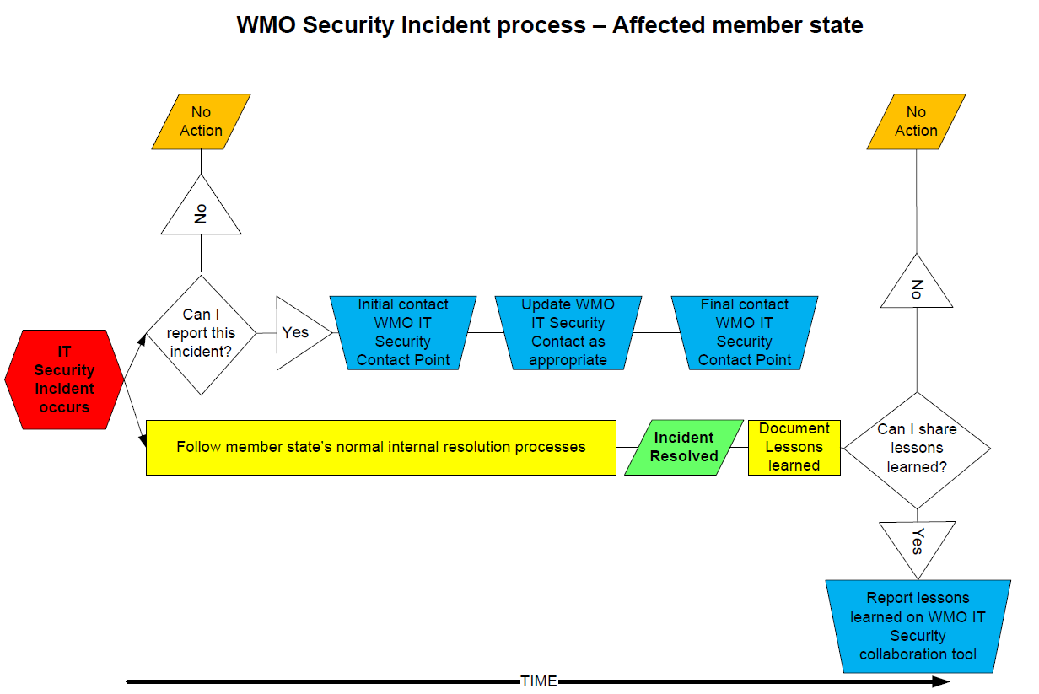

6.2 What process should I follow if I hear that another WMO member has had a possible IT Security incident?
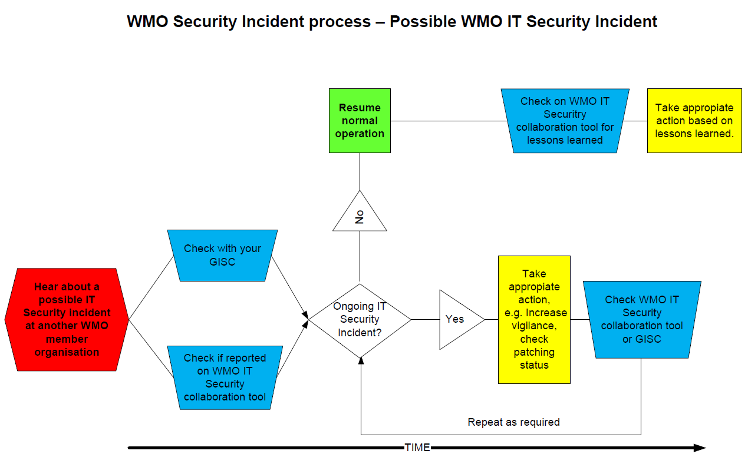

6.3 What process should I follow if am contacted by my GISC?
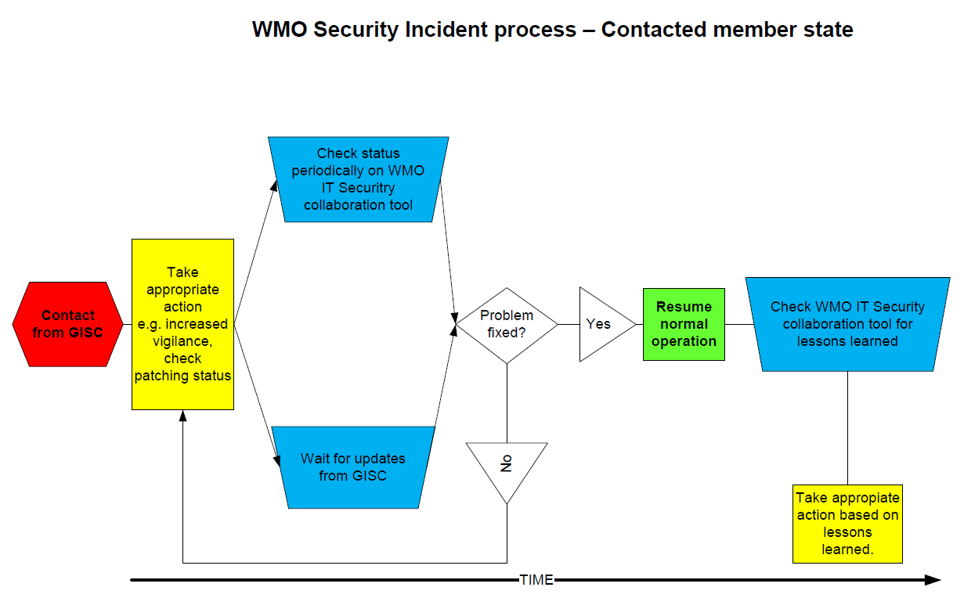

6.4 What process should the WMO IT Security Contact Point follow?

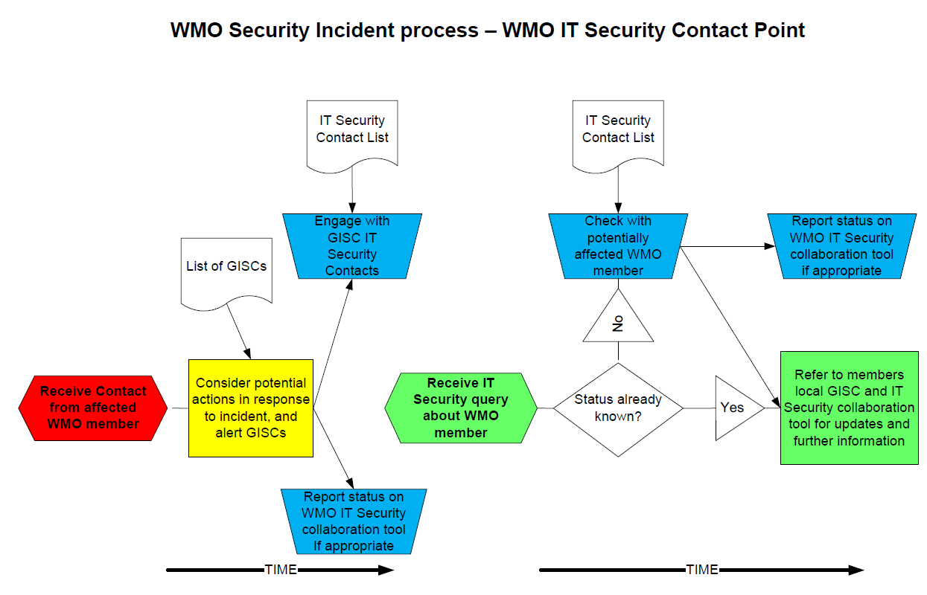

6.5 What process should the GISC follow?
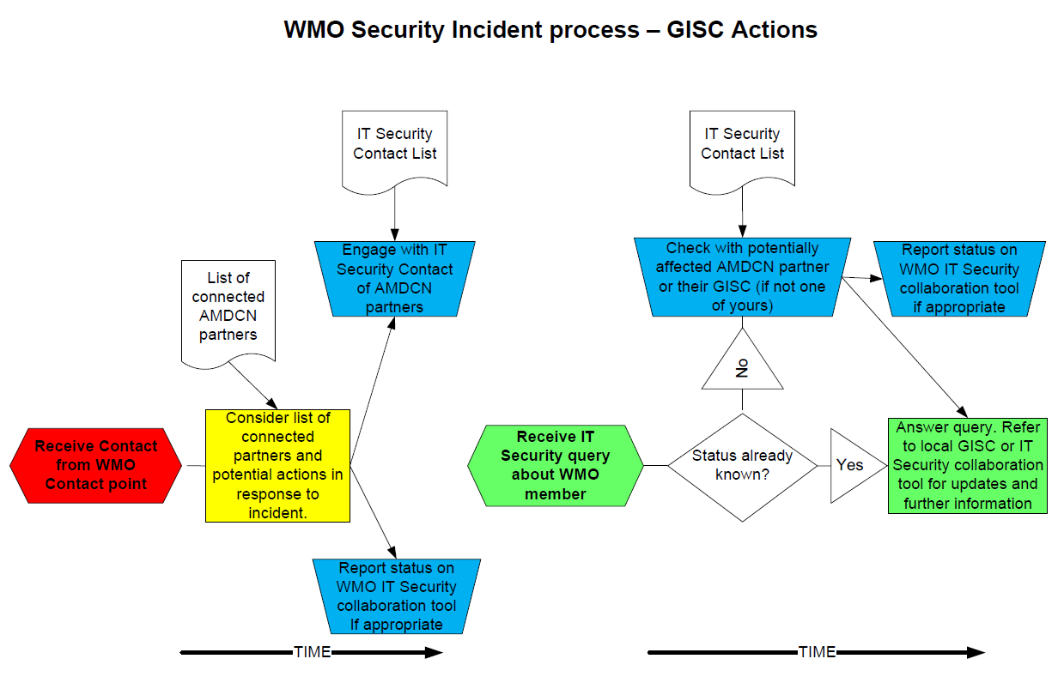

7. Brief description of the process – Action of WMO Contact Point
7.1 The processes are shown below, summarised here for member state organizations:
(a) The WMO contact point will receive information from a WMO member state who has reported an IT Security Incident.
(b) They will inform the relevant affected GISCs and discuss potential impacts and remedial actions.

8. Brief description of the process – Action of WMO GISC
8.1 The processes are shown below, summarised here for GISC’s:
(a) The GISC will receive information from WMO contact point about security incidents which it has been made aware (initial contact, updates and resolution).
(b) The GISC will determine potential impacts and remedial actions for its AMDCN (Area Meteorological Data Communication Network) responsibility.
(c) The GISC will henceforth act as a contact point within their AMDCN for the IT Security incident, answering queries. If they receive a query about a member in another AMDCN, and where the information is not known, then refer to the responsible GISC for an answer.

8.bis Confidentiality – Detailed information on security alerting process, incidents and communications between WMO/Reporting Member States/GISCs

8bis.1 Detailed information about the security alerting process shall not be made publicly available and shall remain confidential.

8bis.2 Detailed information on the security incidents as well as the corresponding communications between the WMO Contact Point, the reporting Member State/s and the GISCs on them, shall not be made publicly available and shall remain confidential, unless otherwise agreed by the involved party/ies. Notwithstanding, such information might be used in the development of IT Security best practices whilst safeguarding the identity of those affected.

9. How can the community share IT Security best practise?
9.1 There are already some international mechanisms in place between member states, e.g. ECMWF’s Security Forum, who meet annually at ECMWF. This however, is a reasonably closed group of predominantly region VI countries. There may be similar groups in other regions, but there is currently no global facility to share best IT Security practice amongst WMO member organizations.
9.2 It is recommended that a common WMO IT Security collaboration capability is adopted. This will be used to encourage the free exchange of information within WMO about IT Security best practices, as well as existing and common threats. Where this can be reported, it will also include the sharing of practical experience gained from managing security incidents.
9.3 This collaboration capability can also be used (where appropriate) to update the status of ongoing IT Security Incidents reported by an affected WMO member state organization (to reduce misinformation).

10. Recommendations
10.1 The following table lists the recommendations, their intended outcome and how to achieve the desired outcome.

Number | Recommendation | Intended Outcome | How to Achieve it
1 | Adopt a common Security Incident management process | Member state organizations can follow a common process. | A lightweight simple process is proposed (see above) to accommodate requirements of all WMO member state organizations.
2 | Adopt a central WMO IT Security contact point | This is to encourage a centralised and definitive view on security incidents, reducing misinformation and prevent individual member states from undue queries. | There is a single point of contact for reporting IT Security incidents, or checking the status of a specific member state. The WMO central point can offer advice, and will prevent the affected or potentially affected site from being overwhelmed by contacts from other member states.  This contact point will also appear on the WMO IT Security Contacts List (see below).  Exactly how this WMO central point of contact is to be operated is to be decided (see Actions)
3 | Make the GISC role clear in this process | Reinforce the duties and responsibilities of GISCs operators in regard to this process. | Educate the GISC and RTH operators in these processes, underlining that this is a normal part of discharging their GISC, RTH and AMDCN responsibilities.
4 | Adopt & maintain a list of IT Security contacts (email/phone) for each WMO member state. | They will be the contact who the central WMO contact point will contact.  This will be a single and definitive contact point for security incidents which will have the authoritative voice for that organization, increasing clarity and reducing misinformation. | A contact list of Operational IT Security contacts containing email addresses and phone numbers should be maintained. These are groups or individuals who are responsible for the operational security of the Member State’s Meteorological department. This might for instance be a helpdesk, or a 24/7 Security Operations Centre, or an individual on-call for such events.  The IT Security contact point does not need to be a named individual (but does need a phone number and email address). Member states need to be able to share this information freely without concern.  Ideally, the list should be “self-service” where member states can amend their own information directly.  The contact list should be held centrally by WMO, but how this is to be done and who will maintain it is to be determined (See Actions)
5 | Adopt a mechanism (a collaboration capability) for sharing IT Security information and good practice. | Increase knowledge and awareness of IT Security, including best practice. | This could be used to inform the WMO community about current Security Incidents, or to share information about how these have been overcome. It could also be used to share information including hints and tips on IT Security.  This could take the form of a “newsgroup”, “forum” or other (to be defined) social media application where information can be posted (privately) by any Member State and can be read by any other member state organization (but not the public).  The collaboration capability should be managed/moderated centrally by WMO, but how this is to be done and who will maintain it is to be decided (see Actions)

11. Follow-on Actions if the paper is accepted:
11.1 The following table suggests a way forward should CBS agree to the need for a security incident and response process.

Number | Action | Actionee
1 | Proposals in this paper to be adopted. | ET-CTS Escalated to CBS for adoption.
2 | Agree mechanism, costs etc for enabling a WMO single point of contact. | ET-CTS initially, in discussion with WMO Secretariat.
3 | Agree that GISC operators will be trained to enact these processes. | ET-CTS initially, in discussion with WMO Secretariat.
4 | Agree mechanism, costs etc for hosting the contact list | ET-CTS initially, in discussion with WMO Secretariat.
5 | Choose the collaboration mechanism, and agree costs etc for hosting and maintaining the mechanism | ET-CTS initially, in discussion with WMO Secretariat.

Appendix A - WMO IT Security Incident Risk Analysis

Risk | Impact | Mitigation
There is no common IT Security Incident process within WMO | Without common processes, confusion and misinformation is likely to arise, leading to unwarranted operational disruption, or too few precautions being taken. | Adopt the recommended IT Security Incident process.
Misleading information about a WMO member organization IT Security status may cause problems | This could lead to undue operational disruption and loss of reputation of the WMO member organization. | Adopt the recommended IT Security Incident process.
It is not clear who to contact in which WMO member state in the event of an IT Security incident. | Difficulty in contacting other member states may make them unaware that they are running at higher risk. | Adopt the recommendation to establish a central WMO IT Security Incident reporting point, and a contact list.
Some member states may choose not to report such incidents (either directly or on the forum) as it might have non-technical implications for their organization | Other member states are unaware that they are running at higher risk. This is the situation before these recommendations are adopted. | This is expected behaviour, either because incidents are purely internal, or because WMO member states do not want to advertise their security status more widely.  Though we strongly encourage reporting of incidents, we cannot mandate this.
Too many (or too few) incidents being reported (either directly to likely affected member states, or to the WMO IT Security forum) | The process fails to be effective, or is ignored because occurrences are too frequent. | The effectiveness of the process should be reviewed periodically (say annually).
Some Security Incidents may purely be “internal” to that organization, and pose no threat outside – so may not get reported. | As long as the Member State affected has done due diligence, there should be no additional risk to other member states. | None needed. Members are encouraged to share their IT Security experiences via the WMO IT Security collaboration tool.
Some member states are more connected than others, and some are more vulnerable than others. | Other member states are unaware that they are running at higher risk. This is the situation before these recommendations are adopted. | When reporting to the WMO IT Security contact point, there will be a discussion about agreeing who the contact point should pass this information to. The WMO IT Security Contact Point will be best placed to help make this decision from an Operational GISC and RTH perspective.
Incorrect decisions could be made from wrong assumptions about the IT Security status of a member state – including disconnection from other member states. | Disconnecting member states will have impacts – possibly severe ones – on the meteorological community, and should only be done in extreme circumstances. | Individual Member States should be able to make their own decisions (balancing risk and benefit).  However, the centralised WMO IT Security Contact Point will provide an authoritative voice, so that any decisions are based on the correct information.
There is no WMO global “threat watch” capability to assess the general IT Security threat level at any one time. | WMO member states may be unaware of current threat levels, so may not take appropriate Security action. | This sounds like a useful idea, but is likely to be beyond the capability of many WMO Member States.  If the information and insight might be useful, it could be offered by member states and shared amongst the community via the WMO IT Security collaboration capability.
The WMO IT Security contact point does not exist. | To achieve the above risk mitigations, this will need to be agreed, staffed and available 24/7 for the benefit of the community. | See Actions section.
24 x 7 WMO operations exist to manage the existing RTH’s. GISC operators may not understand their role in this new IT Security process. | If the GISC operational support staff do not understand their role in this process, it will fail. | See Actions section.
The WMO IT Security contact list is not maintained and not centrally held | To achieve the above risk mitigations, this will need to be maintained and available 24/7 for the benefit of the community, with a self-service update feature. There is likely to be a need for more than a single contact per WMO member. | See Actions section.
The WMO IT Security collaboration capability becomes unmanaged and un-usable. | To achieve the above risk mitigations, this will need to be established, maintained, funded and moderated for the benefit of the WMO community. | See Actions section.

Appendix B - Glossary of Terms
WMO Member State or WMO member state organization | The WMO Member State meteorological organization e.g. Deutscher Wetterdienst – or non national WMO contributory body, e.g. ECMWF, EUMETSAT.
WMO IT Security Incident Reporting Point | A central contact point which will act as an authoritative voice in all queries about member states IT Security Incident status.
Security Incident | “A change in the everyday operations of an information technology service, indicating that a security policy may have been violated or a security safeguard may have failed”
WMO IT Security Contact List | A list of email addresses, phone numbers and identities (or job titles) of IT Security contacts for each member state, to be used by the WMO IT Security Reporting Point.
GISC | Global Information System Centres. Part of the World Meteorological Organization (WMO) Information System (WIS).
AMDCN | Area Meteorological Data Communication Network – a communication network connecting a GISC to centres in its area of responsibility.

