Contents

Proposed Security Incident Process for WMO Member States
For ET-CTS
Date 29th March 2016
Author P. Chamberlain
Version draft 0.4
Proposed Security Incident Process for WMO Member States 1
Purpose of Document 2
What questions is this document addressing? 2
Background – An increase in WMO system IT Security risks 2
Does WMO need a Security incident & Response Process? 3
Will the process be followed? 4
Brief description of the process – Action of WMO member states 4
What process should I follow if I think I have an IT Security incident? 5
What process should I follow if I hear that another WMO member has had a possible IT Security incident? 6
What process should I follow if am contacted by my GISC? 7
What process should the WMO IT Security Contact Point follow? 8
What process should the GISC follow? 9
Brief description of the process – Action of WMO Contact Point 10
Brief description of the process – Action of WMO GISC 10
How can the community share IT Security best practise? 10
Follow-on Actions if the paper is accepted: 14
Appendix A - WMO IT Security Incident Risk Analysis 15
Appendix B - Glossary of Terms 18

Purpose of Document

The WMO currently lacks a formal (or informal) security incident response process, as well as any practical way of sharing Security information.
This paper considers the risks (see Appendix A for risk assessment). The paper then answers pertinent questions which arise from analysis of the risks, and makes a number of proposals for adoption by WMO.

What questions is this document addressing?
Originating as an action from a real (but “false positive”) incident, these are the questions which this paper answers:
- What should a member state do if they think they have a security problem?
- What should a member state do if they hear that someone else has a security problem?
- How can we reduce misinformation about IT security incidents?
- How can we share IT security best practice?

Background – An increase in WMO system IT Security risks

WMO member states have historically had IT systems connected to each other over both private and public networks over many years.

In the past, standard data formats and single-purpose protocols reduced the risk of one member state affecting another. Protocols were non-standard and locked-down to a single purpose function, accessed by bespoke applications written specifically for meteorological use, probably by member state organisations themselves. Communications were over point-to-point serial links which had a degree of physical protection.

Our systems and organisations have since become increasingly interconnected – from GISC capability exchanging global observations data, to other data exchange via FTP or web services, to close collaboration projects between WMO member states (in some cases jointly operating systems or services), whether this is via private or public networks, on premise or in the cloud. These data pass though infrastructure which is shared globally.

Today here are more connections and a greater number of protocols and applications used than ever (e.g. point-to-point use of http protocols), and many have multiple purposes. An increase in use of encrypted protocols and sophisticated security solutions mitigates this risk, but not fully.

Responsibility for IT Security is clearly with the member state organisation. Though all member states should implement best IT Security practice, not every member state will have the same IT Security requirements, nor adopt the same standards.

There is therefore a small but tangible risk that any single WMO member organisation may pose an IT Security risk to another.

Does WMO need a Security incident & Response Process?

It is the member state organisations, not WMO, who implement IT security.
WMO can however promote best IT Security practices, such as having an IT Security Incident Response Process.

Operating centres will talk to each other, but there has never been a formal process or mechanism for alerting member states when a single member has had a security incident – nor a process for when it is reported that someone else has a security incident.

If an IT Security Incident were to happen today (without an agreed process), the communication is likely to be informal, and lead to increased IT Security risks to member states without them being aware of this, or to inappropriate actions being taken which could affect operations (as happened in a recent incident).

Even if the risk had not increased (see above), most modern organisations have an IT Security Incident Response Process in place, as it is part of IT Security good practice. Since there is no existing mechanism within WMO, it is proposed that a simple but effective mechanism (outside normal “operational meteorology” data transmission) is implemented across WMO member state organisations.

This process is not intended to resolve IT Security problems, but is intended to allow a single authoritative voice to remove confusion and reduce misinformation following a possible incident.

Will the process be followed?

There is a great risk that some WMO member state organisations will not be able to report any such security incidents to other partners. Many are state-owned with links to their own government commercial or security departments. There is therefore likely to be sensitivity around the release of any information about IT Security Incidents, and formal release of information is likely to be sanctioned at a very high national government (or supranational) level, if it is sanctioned at all.

It is therefore expected that some WMO member state organisations may be able to share information about security incidents, but not all. This is why the process will start with the option of “Can I report this?” which will allow everyone to follow the process.

Due to the differing IT Security experience of all member state organisations, the processes should be collaborative - a shared challenge in maintaining effective operation. The processes should also be simple to follow, which will encourage their use. See the process diagrams below.

Brief description of the process – Action of WMO member states
The processes are shown below, summarised here for member state organisations:

If a member state thinks it has an IT Security incident, and if it is allowed to, will report this to WMO 24 x 7 helpdesk (and WMO IT Security Collaboration Tool if allowed), keeping WMO regularly updated and after incident resolution will report that the incident is over. Lessons learned from the incident can, where allowed, be shared on the WMO IT Security Collaboration Tool.

If a member state organisation hears there is an IT Security Incident, check with their GISC helpdesk and take appropriate actions.

If the member state organisations IT Security contact is contacted by the GISC helpdesk about an IT Security incident, then take appropriate action in discussion with the GISC.

What process should I follow if I think I have an IT Security incident?
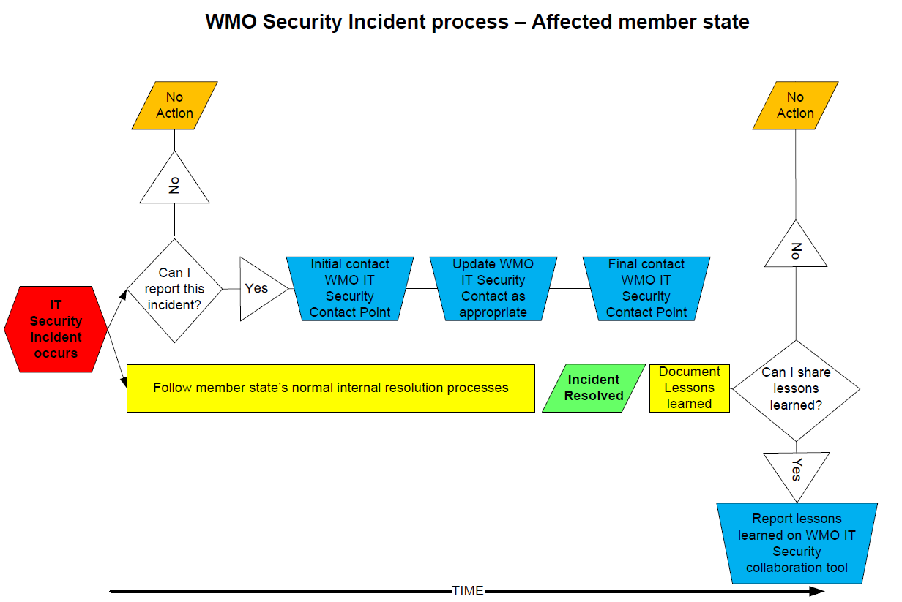

What process should I follow if I hear that another WMO member has had a possible IT Security incident?
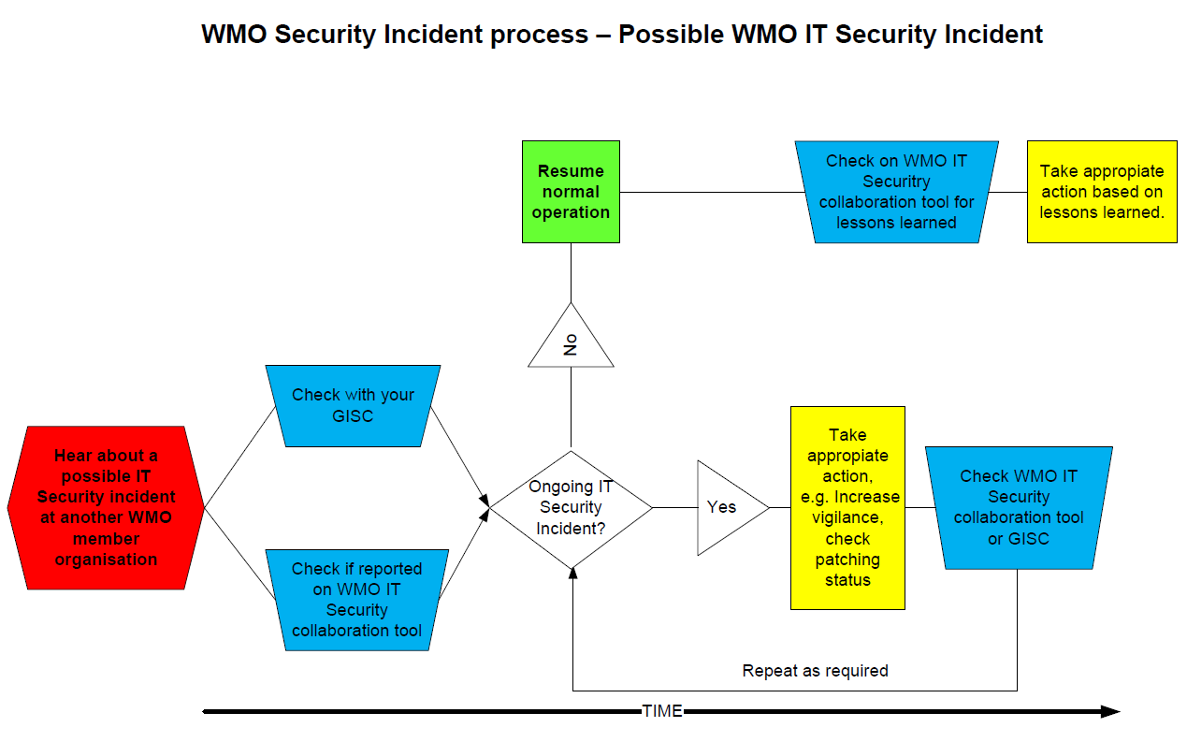

What process should I follow if am contacted by my GISC?
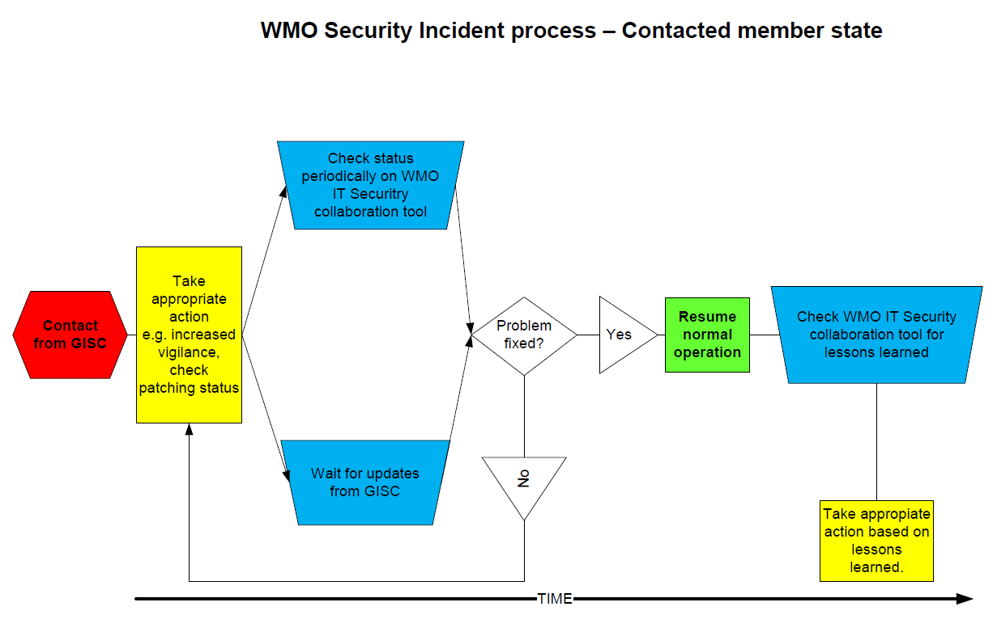

What process should the WMO IT Security Contact Point follow?

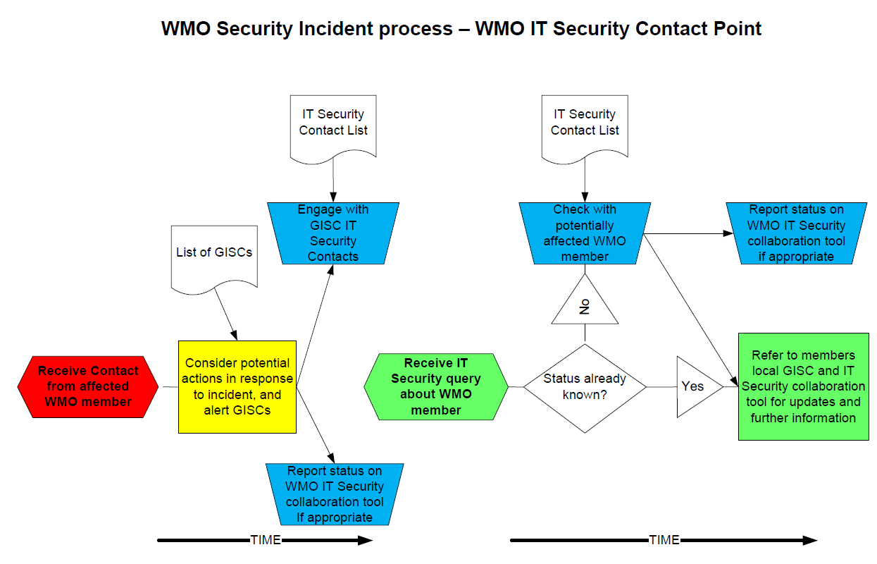

What process should the GISC follow?
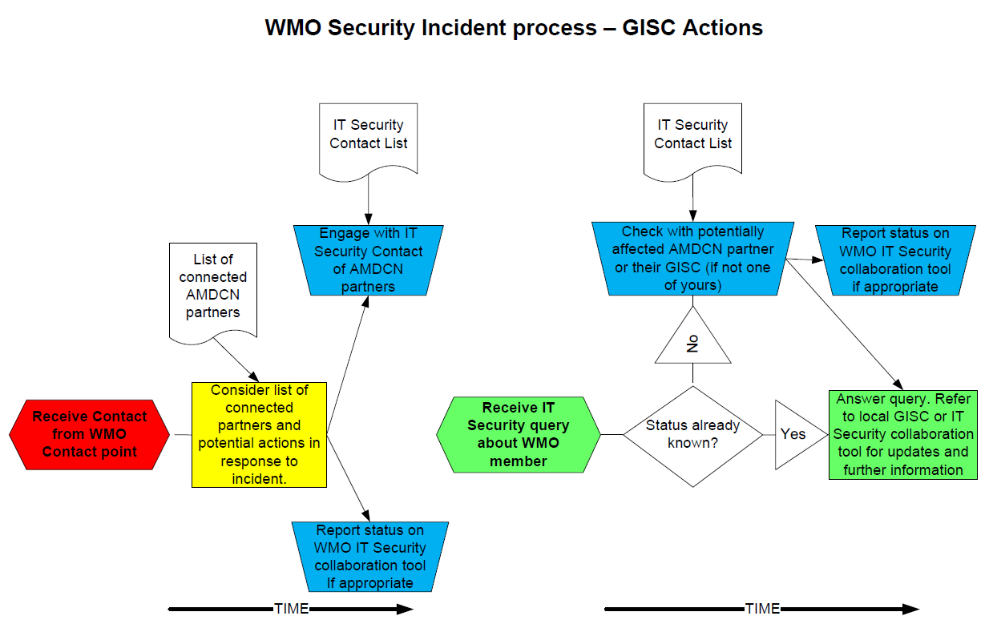

Brief description of the process – Action of WMO Contact Point
The processes are shown below, summarised here for member state organisations:

The WMO contact point will receive information from a WMO member state who has reported an IT Security Incident.
They will inform the relevant affected GISCs and discuss potential impacts and remedial actions.

Brief description of the process – Action of WMO GISC
The processes are shown below, summarised here for GISC’s:

The GISC will receive information from WMO contact point about security incidents which it has been made aware (initial contact, updates and resolution).
The GISC will determine potential impacts and remedial actions for its AMDCN (Area Meteorological Data Connection Network) responsibility.
The GISC will henceforth act as a contact point within their AMDCN for the IT Security incident, answering queries. If they receive a query about a member in another AMDCN, and where the information is not known, then refer to the responsible GISC for an answer.

How can the community share IT Security best practise?

There are already some international mechanisms in place between member states, e.g. ECMWF’s Security Forum, who meet annually at ECMWF. This however is a reasonably closed group of predominantly region VI countries. There may be similar groups in other regions, but there is currently no global facility to share best IT Security practice amongst WMO member organisations.

It is recommended that a common WMO IT Security collaboration capability is adopted. This will be used to encourage the free exchange of information within WMO about IT Security best practices, as well as existing and common threats. Where this can be reported, it will also include the sharing of practical experience gained from managing security incidents.

This collaboration capability can also be used (where appropriate) to update the status of ongoing IT Security Incidents reported by an affected WMO member state organisation (to reduce misinformation).

Number | Recommendation | Intended Outcome | How to Achieve it
1 | Adopt a common Security Incident management process | Member state organisations can follow a common process. | A lightweight simple process is proposed (see above) to accommodate requirements of all WMO member state organisations.
2 | Adopt a central WMO IT Security contact point | This is to encourage a centralised and definitive view on security incidents, reducing misinformation and prevent individual member states from undue queries. | There is a single point of contact for reporting IT Security incidents, or checking the status of a specific member state. The WMO central point can offer advice, and will prevent the affected or potentially affected site from being overwhelmed by contacts from other member states.  This contact point will also appear on the WMO IT Security Contacts List (see below).  Exactly how this WMO central point of contact is to be operated is to be decided (see Actions)
3 | Make the GISC role clear in this process | Reinforce the duties and responsibilities of GISCs operators in regard to this process. | Educate the GISC and RTH operators in these processes, underlining that this is a normal part of discharging their GISC, RTH and AMDCN responsibilities.
4 | Adopt & maintain a list of IT Security contacts (email/phone) for each WMO member state. | They will be the contact who the central WMO contact point will contact.  This will be a single and definitive contact point for security incidents which will have the authoritative voice for that organisation, increasing clarity and reducing misinformation. | A contact list of Operational IT Security contacts containing email addresses and phone numbers should be maintained. These are groups or individuals who are responsible for the operational security of the Member State’s Meteorological department. This might for instance be a helpdesk, or a 24/7 Security Operations Centre, or an individual on-call for such events.  The IT Security contact point does not need to be a named individual (but does need a phone number and email address). Member states need to be able to share this information freely without concern.  Ideally, the list should be “self-service” where member states can amend their own information directly.  The contact list should be held centrally by WMO, but how this is to be done and who will maintain it is to be determined (See Actions)
5 | Adopt a mechanism (a collaboration capability) for sharing IT Security information and good practice. | Increase knowledge and awareness of IT Security, including best practice. | This could be used to inform the WMO community about current Security Incidents, or to share information about how these have been overcome. It could also be used to share information including hints and tips on IT Security.  This could take the form of a “newsgroup”, “forum” or other (to be defined) social media application where information can be posted (privately) by any Member State and can be read by any other member state organisation (but not the public).  The collaboration capability should be managed/moderated centrally by WMO, but how this is to be done and who will maintain it is to be decided (see Actions)

Follow-on Actions if the paper is accepted:

Number | Action | Actionee
1 | Proposals in this paper to be adopted. | ET-CTS Escalated to CBS for adoption.
2 | Agree mechanism, costs etc for enabling a WMO single point of contact. | ET-CTS initially, in discussion with WMO Secretariat.
3 | Agree that GISC operators will be trained to enact these processes. | ET-CTS initially, in discussion with WMO Secretariat.
4 | Agree mechanism, costs etc for hosting the contact list | ET-CTS initially, in discussion with WMO Secretariat.
5 | Choose the collaboration mechanism, and agree costs etc for hosting and maintaining the mechanism | ET-CTS initially, in discussion with WMO Secretariat.

Appendix A - WMO IT Security Incident Risk Analysis

Risk | Impact | Mitigation
There is no common IT Security Incident process within WMO | Without common processes, confusion and misinformation is likely to arise, leading to unwarranted operational disruption, or too few precautions being taken. | Adopt the recommended IT Security Incident process.
Misleading information about a WMO member organisation IT Security status may cause problems | This could lead to undue operational disruption and loss of reputation of the WMO member organisation. | Adopt the recommended IT Security Incident process.
It is not clear who to contact in which WMO member state in the event of an IT Security incident. | Difficulty in contacting other member states may make them unaware that they are running at higher risk. | Adopt the recommendation to establish a central WMO IT Security Incident reporting point, and a contact list.
Some member states may choose not to report such incidents (either directly or on the forum) as it might have non-technical implications for their organisation | Other member states are unaware that they are running at higher risk. This is the situation before these recommendations are adopted. | This is expected behaviour, either because incidents are purely internal, or because WMO member states do not want to advertise their security status more widely.  Though we strongly encourage reporting of incidents, we cannot mandate this.
Too many (or too few) incidents being reported (either directly to likely affected member states, or to the WMO IT Security forum) | The process fails to be effective, or is ignored because occurrences are too frequent. | The effectiveness of the process should be reviewed periodically (say annually).
Some Security Incidents may purely be “internal” to that organisation, and pose no threat outside – so may not get reported. | As long as the Member State affected has done due diligence, there should be no additional risk to other member states. | None needed. Members are encouraged to share their IT Security experiences via the WMO IT Security collaboration tool.
Some member states are more connected than others, and some are more vulnerable than others. | Other member states are unaware that they are running at higher risk. This is the situation before these recommendations are adopted. | When reporting to the WMO IT Security contact point, there will be a discussion about agreeing who the contact point should pass this information to. The WMO IT Security Contact Point will be best placed to help make this decision from an Operational GISC and RTH perspective.
Incorrect decisions could be made from wrong assumptions about the IT Security status of a member state – including disconnection from other member states. | Disconnecting member states will have impacts – possibly severe ones – on the meteorological community, and should only be done in extreme circumstances. | Individual Member States should be able to make their own decisions (balancing risk and benefit).  However, the centralised WMO IT Security Contact Point will provide an authoritative voice, so that any decisions are based on the correct information.
There is no WMO global “threat watch” capability to assess the general IT Security threat level at any one time. | WMO member states may be unaware of current threat levels, so may not take appropriate Security action. | This sounds like a useful idea, but is likely to be beyond the capability of many WMO Member States.  If the information and insight might be useful, it could be offered by member states and shared amongst the community via the WMO IT Security collaboration capability.
The WMO IT Security contact point does not exist. | To achieve the above risk mitigations, this will need to be agreed, staffed and available 24/7 for the benefit of the community. | See Actions section.
24 x 7 WMO operations exist to manage the existing RTH’s. GISC operators may not understand their role in this new IT Security process. | If the GISC operational support staff do not understand their role in this process, it will fail. | See Actions section.
The WMO IT Security contact list is not maintained and not centrally held | To achieve the above risk mitigations, this will need to be maintained and available 24/7 for the benefit of the community, with a self-service update feature. There is likely to be a need for more than a single contact per WMO member. | See Actions section.
The WMO IT Security collaboration capability becomes unmanaged and un-usable. | To achieve the above risk mitigations, this will need to be established, maintained, funded and moderated for the benefit of the WMO community. | See Actions section.

Appendix B - Glossary of Terms

WMO Member State or WMO member state organisation | The WMO Member State meteorological organisation e.g. Deutscher Wetterdienst – or non national WMO contributory body, e.g. ECMWF, EUMETSAT.
WMO IT Security Incident Reporting Point | A central contact point which will act as an authoritative voice in all queries about member states IT Security Incident status.
Security Incident | “A change in the everyday operations of an information technology service, indicating that a security policy may have been violated or a security safeguard may have failed”
WMO IT Security Contact List | A list of email addresses, phone numbers and identities (or job titles) of IT Security contacts for each member state, to be used by the WMO IT Security Reporting Point.
GISC | Global Information System Centres. Part of the World Meteorological Organisation (WMO) Information System (WIS).
AMDCN | Area Meteorological Data Connection Network – a regional structure of WMO member states which connect to a GISC. WMO region VI is more complex owing to the shared nature of some GISC operations.

