  World Meteorological Organization  EXECUTIVE COUNCIL  Sixty-Eighth Session  Geneva, 15 to 24 June 2016 | EC-68/Doc. 5.2(1)
Submitted by:
Secretary-General
18.IV.2016
DRAFT 1
AGENDA ITEM 5: OBSERVATIONS AND DATA EXCHANGE
AGENDA ITEM 5.2: WMO INFORMATION SYSTEM (WIS)

SUMMARY

DECISIONS/ACTIONS REQUIRED:
(a) Adopt draft Decision 5.2(1)/1 — Amendments to the Manual on Codes and to Appendix C of the Manual on WMO Information System (WIS);
(b) Adopt draft Decision 5.2(1)/2 — Development of strategy for the WMO Information System;
(c) Adopt draft Resolution 5.2(1)/1 — Amendments to Appendix B of the Manual on WMO Information System.

CONTENT OF DOCUMENT:
The Table of Contents is available only electronically as a Document Map*.

DRAFT DECISIONS

Draft Decision 5.2(1)/1 (EC-68)

Amendments to the Manual on Codes and Appendix C of the Manual on WIS
THE EXECUTIVE COUNCIL,
Recalls that fast track procedures are in place to allow amendments to regulatory material, such as WMO data codes and WIS discovery metadata, that are required to allow practical evolution of operational standards and that amendments made under “fast track” procedures are to be reported to Executive Council;
Recalls the provisions for code tables in the Manual on Codes (WMO-No. 306, Volume I.2) and the Manual on the WMO Information System (WMO-No. 1060) to be updated by the “fast track” and “between sessions” procedures between sessions of the Commission for Basic Systems (CBS);
Acknowledges that:
(1) Two sets of amendments to codes lists in the Manual on Codes and two sets of amendments supporting the WMO Core Profile of the ISO 19115 Geographic Metadata Standard had resulted in amendments to each of these Manuals since EC-67;
(2) One application of the “between sessions” procedure had resulted in an amendment to the Manual on Codes since EC-67;
Requests the Secretary-General to take appropriate actions to update the Manual on Codes and the Manual on the WMO Information System to conform to the fast track changes and the between sessions procedure made since EC-67.
__________

Draft Decision 5.2(1)/2 (EC-68)

Development of Strategy for the WMO Information System
THE EXECUTIVE COUNCIL,
Recalls that Cg-15 (paragraph 3.1.2.9) approved the implementation of the WMO Information System (WIS) in two parts: Part A being the evolution of the GTS, and Part B being the new functionality of WIS;
Recalls also that Cg-17 (Resolution 33) requested the Commission for Basic Systems (CBS) to develop “Part C” of the WIS that would provide assistance to Members in matters concerning all stages of management of information;
Having considered:
(1) Resolution 2 (CBS-Ext.(2014)) that asked for an Inter-Commission Task Team on WIS to be established;
(2) Resolution 33 (Cg-17) that requested CBS to develop Part C of the WMO Information System;
(3) Resolution 65 (Cg-17) that addressed the WMO approach to emerging data challenges;
(4) Resolution 66 (Cg-17) on WMO support to evolving aeronautical meteorological services;
(5) Resolution 68 (Cg-17) on establishing a WMO cross-cutting urban focus;
Acknowledges that the Commission for Basic Systems, in order to ensure a continued user focus, would like to work with other technical commissions to resolve present governance issues impacting on the operation of the WIS and to establish how WIS should evolve over coming decades together with the approach to achieving this;
Endorses:
(1) The preliminary findings of the Commission for Basic Systems on the WMO Information System (WIS) strategy study;
(2) The proposal of the Commission for Basic Systems for the establishment of an Inter-Commission Task Team on WIS (ICTT-WIS) to develop a governance structure for the operation management of WIS and to facilitate stakeholder input into the WIS strategy and the development of Part C of WIS;
Requests the Commission for Basic Systems to present a proposal for governance structure and strategy for the evolution of WIS to EC-69.
__________

DRAFT RESOLUTION

Draft Resolution 5.2(1)/1 (EC-68)

Ammendments to Appendix B of the Manual on The
WMO Information system
THE EXECUTIVE COUNCIL,
Recalls that Appendix B of the Manual on the WMO Information System (WMO-No. 1060) records those centres that are approved WMO Information System (WIS) centres;
Recalls also that the Executive Council reviews Appendix B taking into consideration recommendations of the Commission for Basic Systems (CBS) on the compliance of WIS centres with the technical specifications defined in Part IV of the Manual on the WMO Information System;
Recalls also Resolution 31 (Cg-17) - Report of the extraordinary session (2014) of the Commission for Basic Systems relevant to centres and networks of the WMO Information System, that extended conditional designation of specified WIS centres until the sixteenth session of CBS;
Notes that the Commission for Basic Systems had:
(1) Worked with Members to ensure continued compliance of centres contributing to WIS;
(2) Endorsed the centres listed in Table 1 and Table 2 of the Annex to this resolution as compliant with the Technical Specifications laid out in the Manual on the WMO Information System (WMO-No. 1060);
Decides to:
(1) Approve CBS endorsement of WIS Data Collection or Production Centres (DCPCs) as listed in Table 1 of the Annex to the present resolution;
(2) Designate as WIS DCPCs those centres listed in Table 2 of the Annex to the present resolution;
Requests the Commission for Basic Systems to:
(1) Facilitate conditionally designated centres to complete their compliance with the Manual on WIS;
(2) Report to EC-69 on the continued compliance of existing WIS centres with the agreed standards and practices;

Requests the Secretary-General to:
(1) Take appropriate actions to update the list of centres in the Manual on the WMO Information System to conform to the present decision;
(2) Assist the Commission for Basic Systems in monitoring and ensuring the compliance of new and existing centres in WIS;

Urges Members who have yet to do so to:
(1) Work with their Principal Global Information System Centre (GISC) to gain CBS endorsement of their Data Collection or Production Centres (DCPCs) and to complete the certification process for their National Centres;
(2) Inform the Secretary-General of compliance of their National Centres with the requirements of the Manual on WIS.
__________

Annex: 1

Annex to draft Resolution 5.2(1)/1 (EC-68)

AMMENDMENTS TO APPENDIX B OF THE MANUAL ON WIS (WMO-No. 1060)

Table 1 – CBS Endorsement of WIS Data Collection or Production Centres conditionally designated under Resolution 51 (Cg-16)

WMO Member  or Contributing  Organization | Name | Centre location region/city |  | Principal GISC | Const. Body
Finland | Finnish Meteorological Institute–Arctic Research Centre (FMI-ARC) | RA VI | Helsinki | Offenbach | CBS
Italy | REC-MMO-MED  RSMC–Marine and ocean products | RA VI | Rome | Offenbach | JCOMM
Netherlands | RCC–De Bilt | RA VI | De Bilt | Exeter | CCl
Netherlands | Satellite Centre | RA VI | De Bilt | Exeter | CCl
Sweden | BALTRAD (Weather radar network for the Baltic Sea Region) | RA VI | Norrköping | Offenbach | CBS
United States of America | Global Observing Systems Information Center (GOSIC) | RA IV | Asheville, NC | Washington | CCl
United States of America | National Centers for Environmental Prediction (NCEP) | RA IV | Washington DC | Washington | CBS
United States of America | National Center for Atmospheric Research (NCAR) | RA IV | Boulder, CO | Washington | CBS
United States of America | National Geophysical Data Center (NGDC) | RA IV | Washington DC | Washington | CBS
United States of America | National Oceanographic Data Center (NODC) | RA IV | Washington DC | Washington | JCOMM
United States of America | Environmental Satellite, Data, and Information Service (NESDIS) | RA IV | Washington DC | Washington | CBS
United States of America | WAFC | RA IV | Washington DC | Washington | CAeM

Table 2 – Proposed additions to Appendix B, Manual on WIS list of WIS Data Collection or Production Centre

WMO Member  or Contributing  Organization | Name / Function | Centre location  region/city |  | Principal GISC | Const. Body
Indonesia | Transboundary Forest Fires | RA V | Jakarta | Melbourne | CBS
Indonesia | TCWC | RA V | Jakarta | Melbourne | CBS
Indonesia | NWP Atmospheric Transport - SE Asia | RA V | Jakarta | Melbourne | CBS
Indonesia | Indian Ocean Tsunami Warning Centre (IOTWC) | RA V | Jakarta | Melbourne | CBS
Kenya | RTH (Nairobi) | RA I | Nairobi | Offenbach | CBS
Kenya | RSMC-Geographical | RA I | Nairobi | Offenbach | CBS

__________

BACKGROUND INFORMATION SUPPORTING DECISIONS/RESOLUTION

NOT TO BE INCLUDED IN THE SESSION REPORT

References:
1. National implementation of WIS (http://wis.wmo.int/WISCentresDb)
2. Regional implementation of WIS (http://wis.wmo.int/page=Regional-Implementation)
3. Development of a WIS Strategy (http://wis.wmo.int/page=ICT-ISS-2016-1)
4. WIS Operational Monitoring (http://wis.wmo.int/page=WIS-Status)
5. Quantity Monitoring datasets and analysis (http://www.wmo.int/pages/prog/www/ois/monitor/index_en.html).
6. Manual on WIS (WMO No 1060), including fast track changes (http://wis.wmo.int/page=ManualWIS)
7. Manual on Codes (WMO No 306), including fast track changes (http://wis.wmo.int/page=ManualCodes)

Introduction
1. The WMO Information System (WIS) has been operational since 2012. Although it has not met the target of being fully operational in all NMHSs by 2016, progress is evident at national, regional and global levels as summarized below. The results of the latest World Weather Watch quantitative monitoring are included below for information (see section 2).
2. The Council is asked to consider three draft decisions related to WIS. The first is to note amendments made to the Manual on Codes and to the Metadata part of the Manual on WIS (Appendix C) made under the fast track procedures; further information on these changes is available from references 5 and 6. The second decision relates to the future of WIS including the new Part C of WIS covering information management across WMO activities, how WIS should look in coming decades and what strategy will ensure WIS evolves effectively, and background information on this is provided in section 3. The third decision concerns the Council reviewing the recommended changes to the list of approved WIS centres in Appendix B of the Manual on WIS, for which section 4 provides additional information.
3. Seventeenth World Meteorological Congress asked CBS to establish a SATCOM users’ forum. Information on this is provided in section 5.

World Weather Watch Monitoring results
4. Four times a year, the World Weather Watch (WWW) quantitative monitoring records the number of observations being exchanged on the GTS. For stations in the Regional Basic Synoptic Networks (RBSN) and Regional Basic Climate Networks, the number of reports received is compared with the number of reports that are required from network stations during the period (four a day for surface synoptic reports, two a day for upper-air reports). Monitoring only counts reports for the main synoptic hours (00Z, 06Z, 12Z and 18Z for surface reports, 00Z and 12Z for upper-air reports). Reports for other times are not counted, so that if, for example, a station reports upper-air observations at 02Z and 14Z it is recorded as not distributing its observations.
5. Figure 1 (Annex 1) shows the time evolution of the percentage of required reports recorded in the October WWW Annual Global Monitoring exercises between 2004 and 2015.
6. Figures 2 to 4 (Annex 1) show the percentages of reports received from stations in the period 1 to 15 October 2015.

WIS Strategy Development
7. Resolution 33 (Cg-17) tasked CBS to lead a cross-cutting activity that involves all technical commissions to coordinate development of guidance for Members in relation to all stages of the effective management of information throughout its lifecycle, and to include this guidance, associated standards and procedures in Part C of the WMO Information System. In order to complete the implementation of WIS at national levels while allowing WIS to evolve, CBS determined that it was necessary to have a clearly defined strategy in place identifying what still needs to be done, where WIS should evolve to, and how to get there.
8. In 2015 the CBS Open Programme Area Group on Information Systems and Services (OPAG-ISS) initiated its study on the development of a WIS strategy. Preliminary findings, including the initial vision for the evolution of WIS and possible options to reach it, were presented to the CBS Management Group in February 2016. The study shows:
(a) Although WIS is operational since 2012, the global data exchange traffic pattern remains much the same as that of the traditional GTS, which limited the benefits of WIS. The Global Information System Centres (GISCs) need to play a key role in this paradigm shift;
(b) Uptake of WIS by users that did not participate in the World Weather Watch is still limited. To make WIS the one-stop shop for meteorological information, significant enhancement to the WIS services are needed, especially to the quality of WIS metadata and effectiveness of data discovery;
(c) WIS operation management, which would be different from that of GTS, needs an intercommission coordination mechanism;
(d) Performance monitoring WIS is crucial to ensure the quality of service provided by WIS to Members and users, and therefore should be a priority in future WIS development;
(e) Further development of WIS should benefit as much as possible from commercially available supporting service and industry standards. For example, managed network services with committed service level, which are more cost-effective; cloud technology, which will enable a simplified WIS traffic pattern, especially among GISCs; Web services, including cooperation with general search engines.
9. OPAG-ISS will continue this study and seek inputs from other technical commissions, including their requirements on the full life cycle information management, i.e. Part C of WIS, to develop a draft global strategy for the evolution of WIS, to be submitted to the CBS session in November 2016 for consideration.

Status of WIS Implementation

National implementation of WIS
10. WIS, like the GTS, operates almost totally at the national level creating a global infrastructure from this collective of interoperable components. The procedure for designating WIS centres is now well established, as are the compliance specifications and supporting discovery metadata standards. The current status of each centre’s identification and final designation by Executive Council is available at http://wis.wmo.int/WISCentresDb. [Clicking on the FUNCTION (for example RTH) will take you to the centre’s landing website.] The current database has 373 centres registered, 336 of them having been endorsed by EC or Congress.
11. Despite the progress in implementing WIS infrastructure, there are many countries that although a part of WIS, have yet to develop national WIS implementation plans, or have not reached a stage where they can benefit fully from WIS nationally. This is a problem that is being addressed at the regional level.

Regional implementation of WIS
12. All Regions now have Regional WIS Implementation Plans. They can be accessed by the regional implementation page of WIS at http://wis.wmo.int/page=Regional-Implementation and selecting the Region of interest. GISCs play a major role in the regional implementation through provision of training and guidance to Members in their area of responsibility. From the Secretariat side, the WIS branch is working closely with Regional Offices to help in their support of Members. The WIS Branch is also working closely with the National WIS Focal Points to monitor their national implementation of WIS and to provide guidance. Each country’s national WIS focal point is listed on the Regional Implementation page or their Country Profile Database page (http://www.wmo.int/cpdb).

Global implementation of WIS

13. As noted above, WIS is a collection of national components. All operate under the framework defined in the Manual on WIS (WMO-No. 1060) and the Guide to WIS (WMO-No. 1061) as well as other regulatory material (WMO Technical Regulations No. 49, its Parts and Attachments). A major effort is now underway to put in place a real-time monitoring system that was demonstrated at Cg-17. WIS real-time monitoring Common Dashboards (operated by Brazil, China and Japan) and experimental monitoring sites can be accessed from http://wis.wmo.int/wis-status.

Satellite Data Telecommunication Systems (SATCOM)
14. The interim SATCOM executive committee has arranged to hold the first IOC/WMO international forum of users of satellite data telecommunication systems (SATCOM 2016) in Madrid, Spain from 27 to 29 September 2016. The meeting will be co-located with the CIMO Technical Conference (CIMO-TECO 2016) on Meteorological and Environmental Instruments and Methods of Observation at the Meteorological Technology World Expo 2016 (Madrid, Spain, 27-30 September 2016).
15. The theme of SATCOM 2016 is to “Bring the right data, in the right format, to the right people, at the right time for the right price,” where satellite communications are involved in at least one part of the process. SATCOM 2016 will achieve this through bringing together representatives from satellite communications (satcom) users, satcom network operators and those involved in the design, manufacture and sales of satcom terminals.
16. The aim of SATCOM 2016 will be to encourage ongoing commitment and participation of stakeholders, to formally establish the Satcom Forum, including electing the Committee, adopt the working arrangements and to set in place a work plan.
17. In addition to the WMO/IOC partnership, HMEI are also supporting SATCOM 2016 through encouraging their members to participate in the forum and in sharing their Meteorological Technology World Expo booth where Expo attendees will be able to find out more about SATCOM and register.

Annex 1 to Section 2
Figure 1a. Time trend of the percentage of observations received during the Annual Global Monitoring during the period 2004 to 2015. (a) Surface reports

Figure 1b. Time trend of the percentage of observations received during the Annual Global Monitoring during the period 2004 to 2015. (a) Upper air reports

Figure 1c. Time trend of the percentage of observations received during the Annual Global Monitoring during the period 2004 to 2015. (c) Surface climate reports

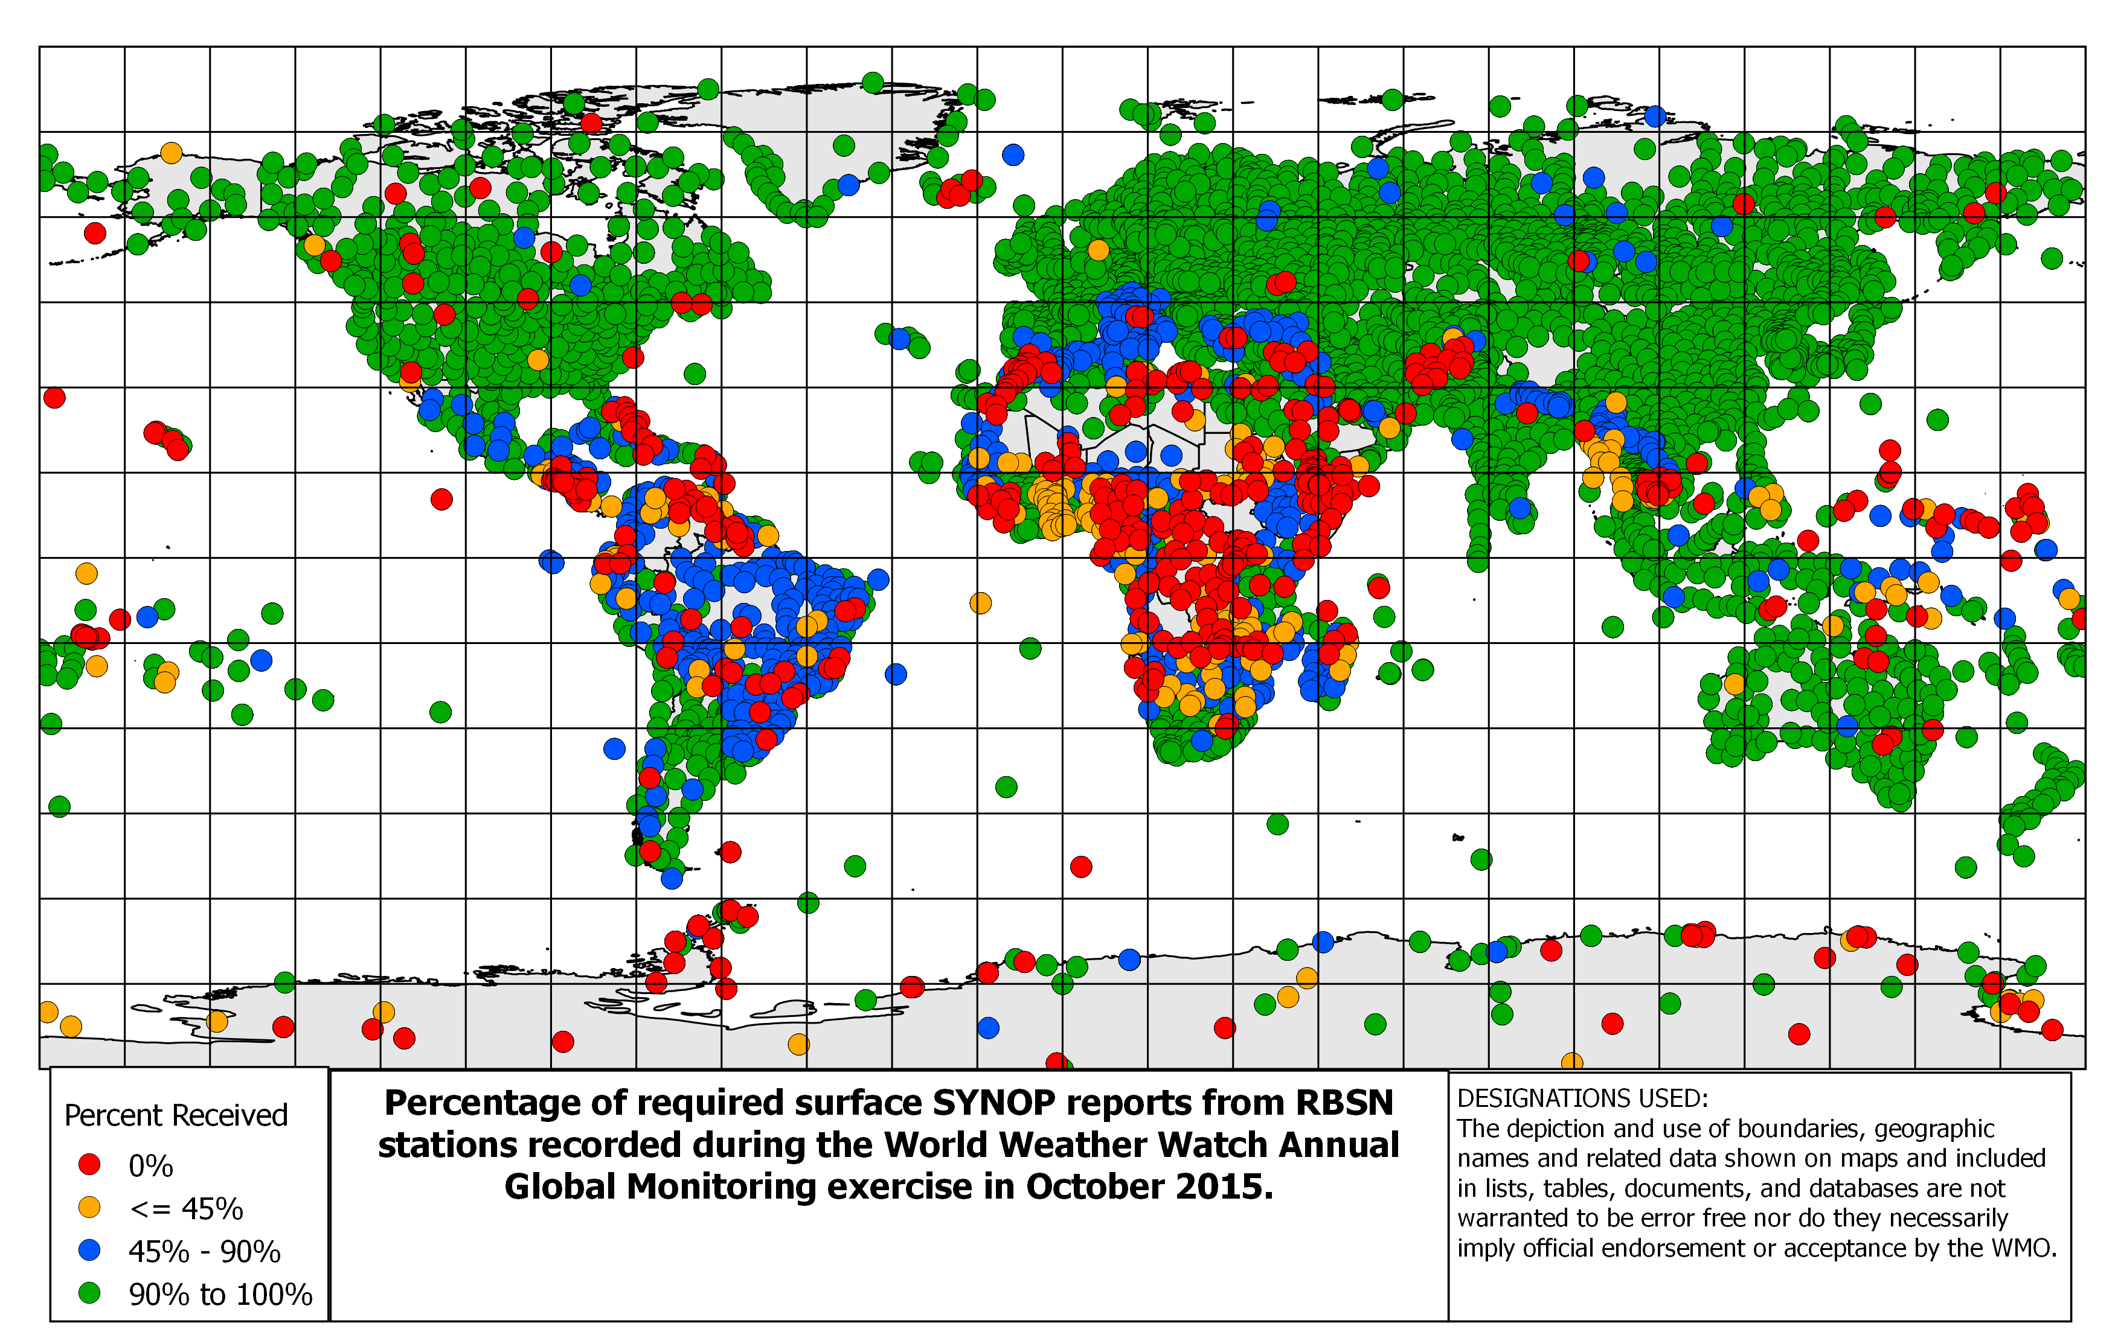
Figure 2. Percentage of required reports received during the October 2015 WWW Annual Global Monitoring period. (a) Surface synoptic reports
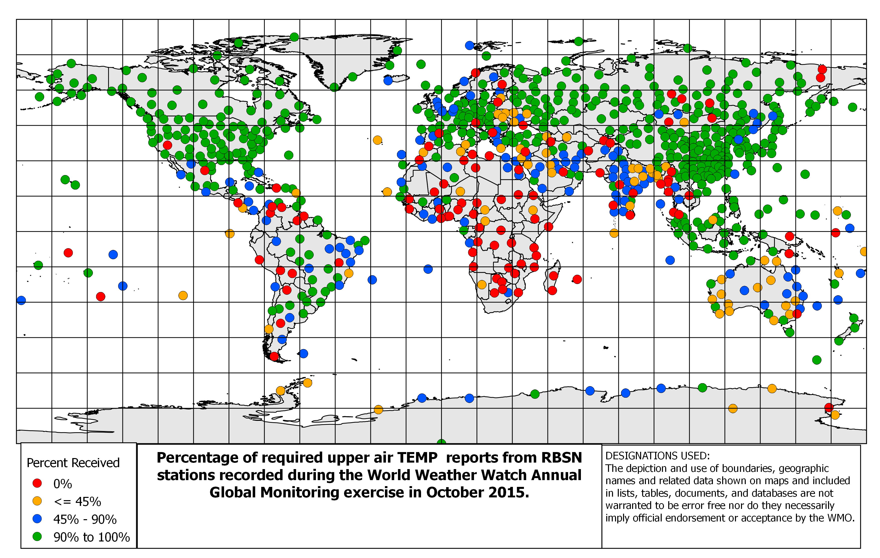
Figure 3. Percentage of required reports received during the October 2015 WWW Annual Global Monitoring period. (a) Upper-air reports
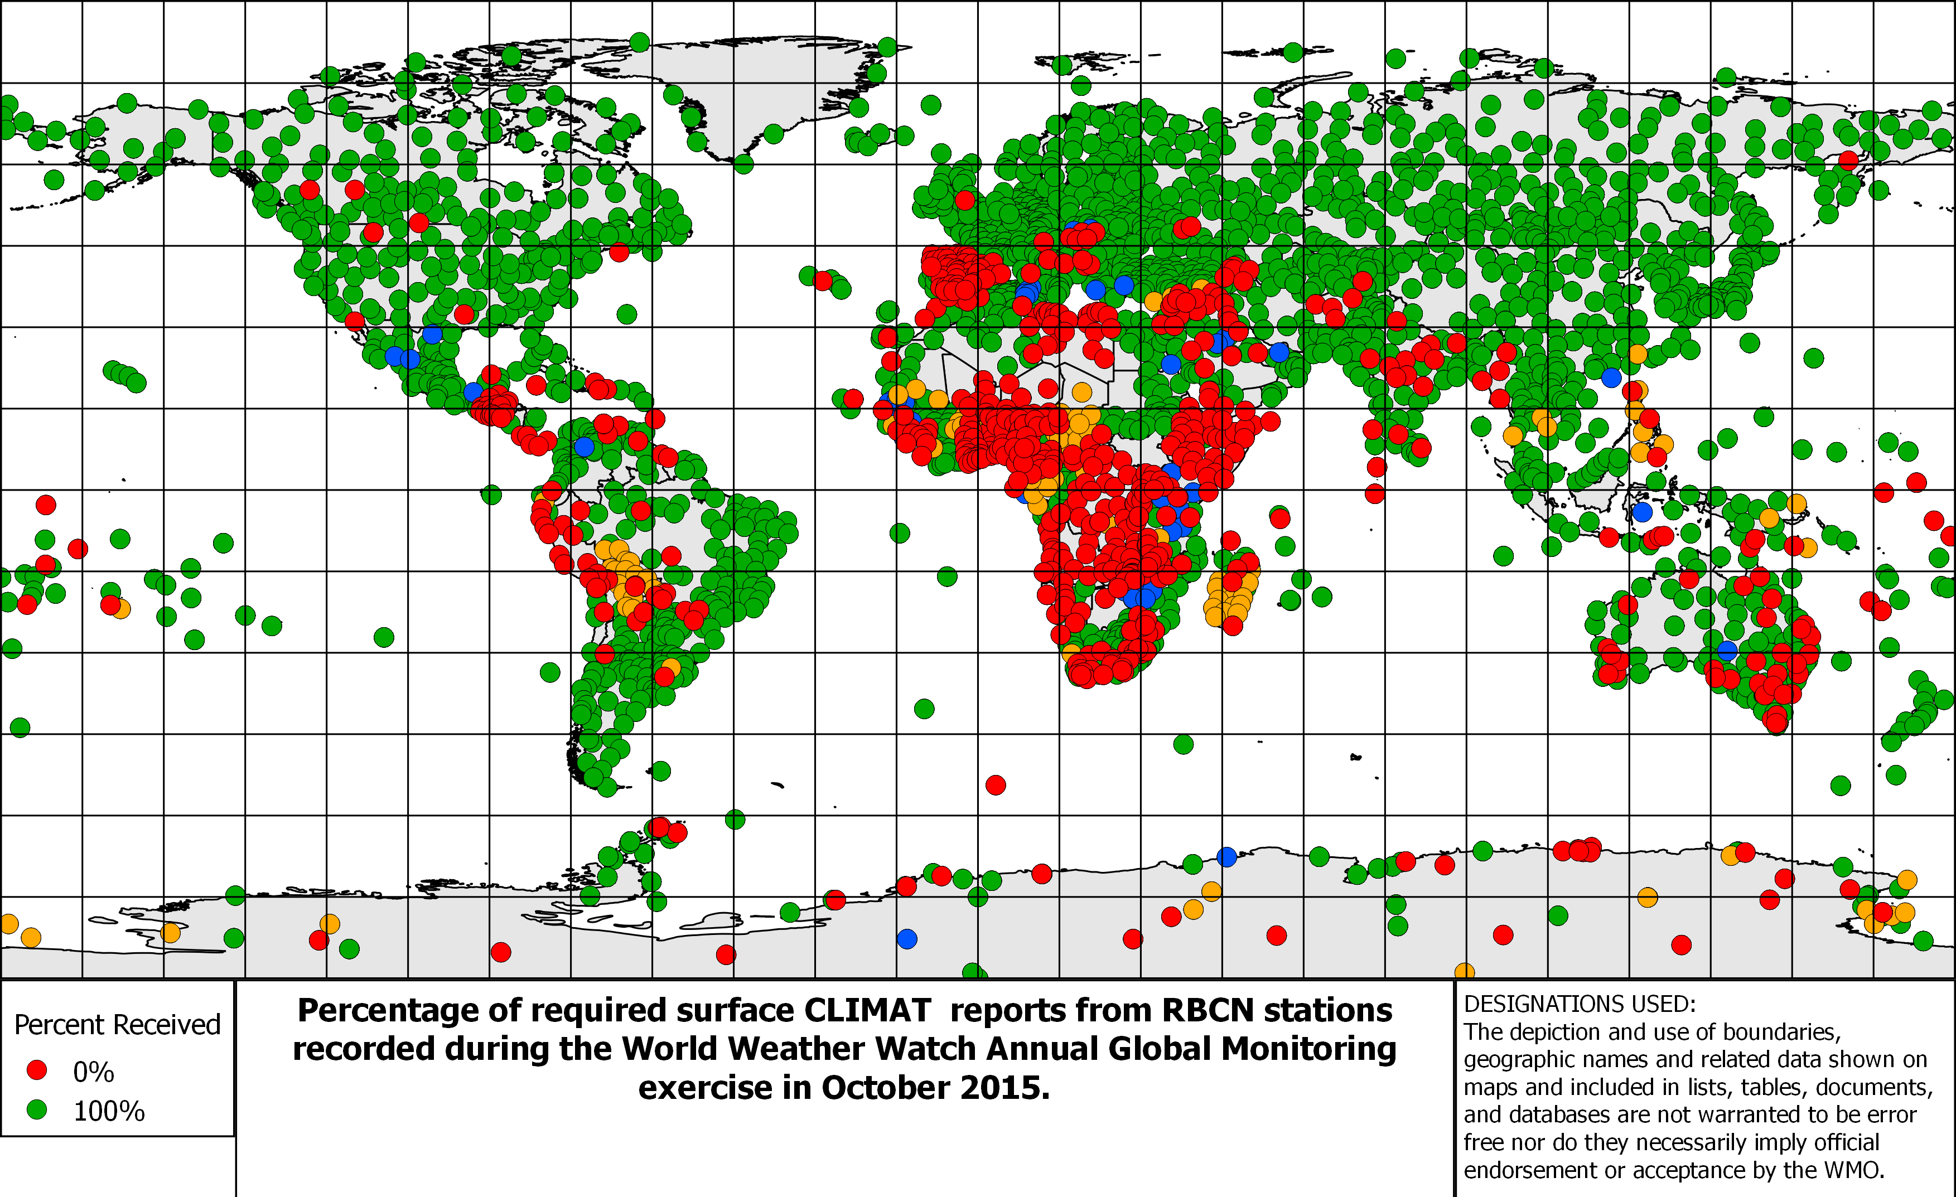
Figure 4. Percentage of required reports received during the October 2015 WWW Annual Global Monitoring period. (c) Surface climate report
_________

* On a PC, in MS Word 2010 go to “View” and tick the “Navigation Pane” checkbox in the “Show” section. In MS Word 2007 or 2003, go to “View” > “Document Map”. On a Mac, go to “View” > “Navigation Pane” and select “Document Map” in the drop-down list on the left.

