GISC Cache Monitoring for improving cache consistency

Introduction
GISC cache monitoring is one of major objectives of WIS Monitoring. It would help to improve cache consistency and to understand data management and distribution among WIS Centres. A new page on WIS Monitoring dashboard developed by JMA visualizes cache information provided by seven GISCs at the previous cache analysis conducted by CMA on 16 Sep 2015 (http://wis.wmo.int/File=1883).
The purpose of this paper is to collect new ideas and thoughts from everyone and propose the future cache monitoring plan, introducing the new monitoring page. The new page is just one of the results of seeking how to monitor GISC cache, and more information could be potentially derived from cache information to be provided by GISCs.
This work corresponds to the action item 15/1-10 e.

Visualization of GISC Cache on JMA dashboard
The followings are URLs of the new monitoring pages developed by JMA.
Page 1: http://www.wis-jma.go.jp/wcd/cache_TTAAii.html
Page 2: http://www.wis-jma.go.jp/wcd/cache_CCCC.html
Page 3: http://www.wis-jma.go.jp/wcd/cache_TTAAii_VolC1.html
Page 4: http://www.wis-jma.go.jp/wcd/cache_CCCC_VolC1.html

Page 1 visualizes TTAAii the bulletins of which GISCs have with a Venn diagram as in the document by CMA (http://wis.wmo.int/File=1883) and a pie chart. The Venn diagram shows what GISCs have commonly. When double-clicking areas on the diagram, the pie chart on the right shows unique number percentage of the corresponding TTAAii which GISC or GISCs have, and the sequence of TTAAii of the area appears at the bottom of the webpage. (Figure 1) The pie chart has a drill down capability to show T1T2 as well as T1. (Figure 2) If wanting to look into TTAAii which only one GISC has, select the one GISC in the bottom “select list” and the sequence of TTAAii appears below. The pie chart also shows that as well. (Figure 3)
Page 2 visualizes CCCC the bulletins of which GISCs have with a Venn diagram and a world map which indicates countries corresponding to selected CCCCs with blue. (Figure 4) The page also has a select list which shows a sequence of CCCC held by only the selected GISC.
Page 3 and Page 4 focus a comparison with Volume C1. (Figure 5)
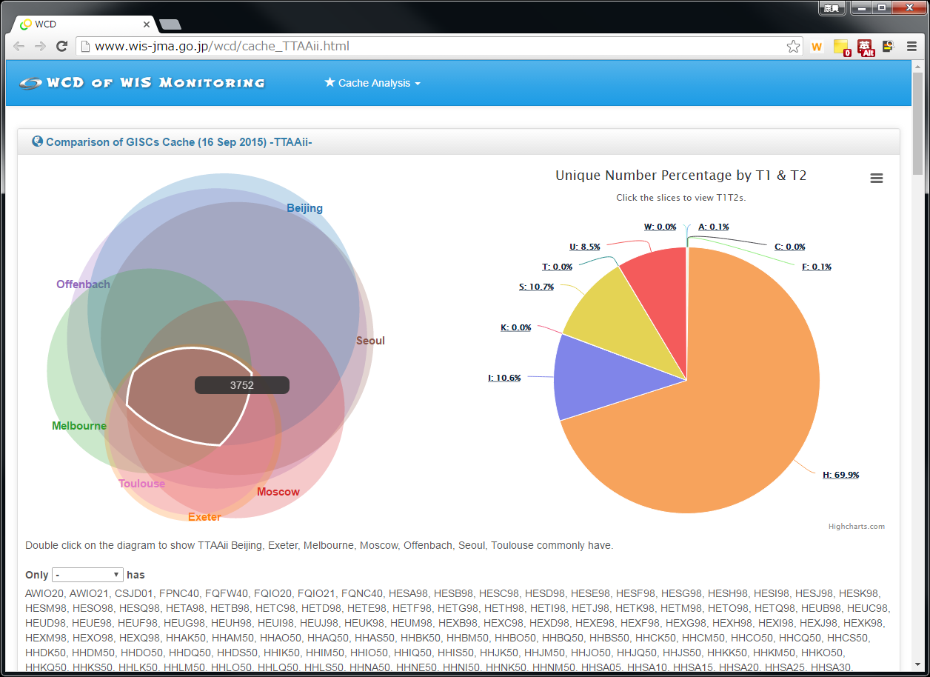
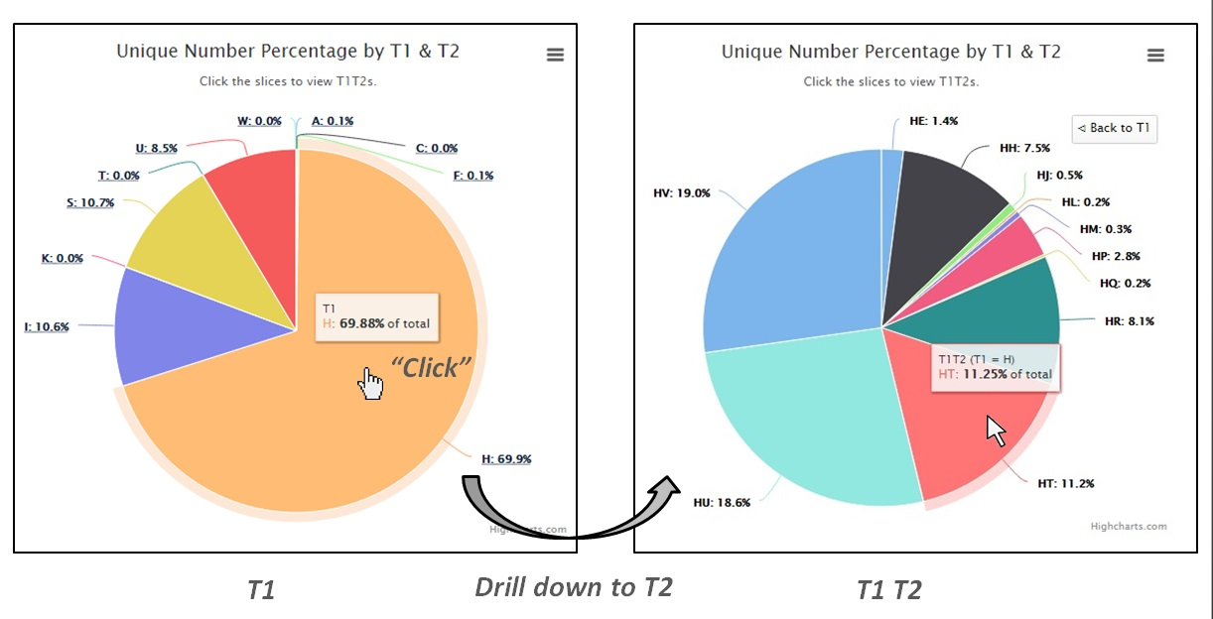
Figure 1: http://www.wis-jma.go.jp/wcd/cache_TTAAii.html
Figure 2: Pie chart with drill down capability (left (before): T1, right (after): T1&T2)
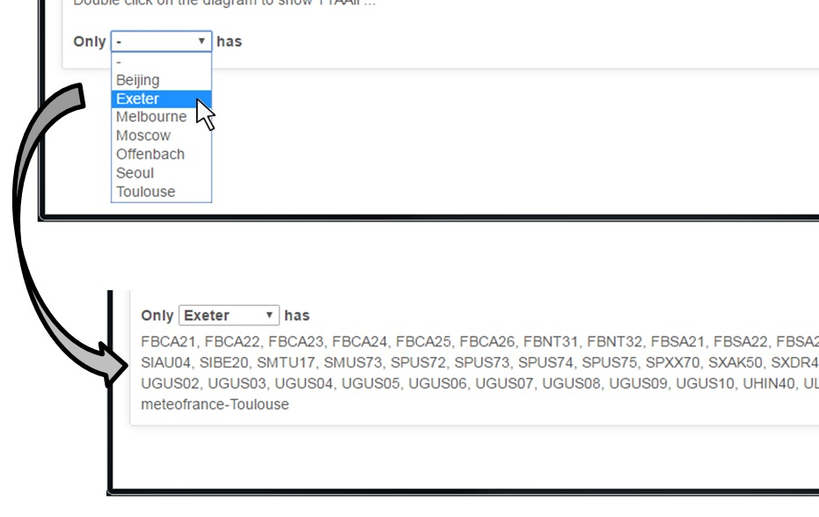
Figure 3: Appearance of TTAAii which only one GISC has
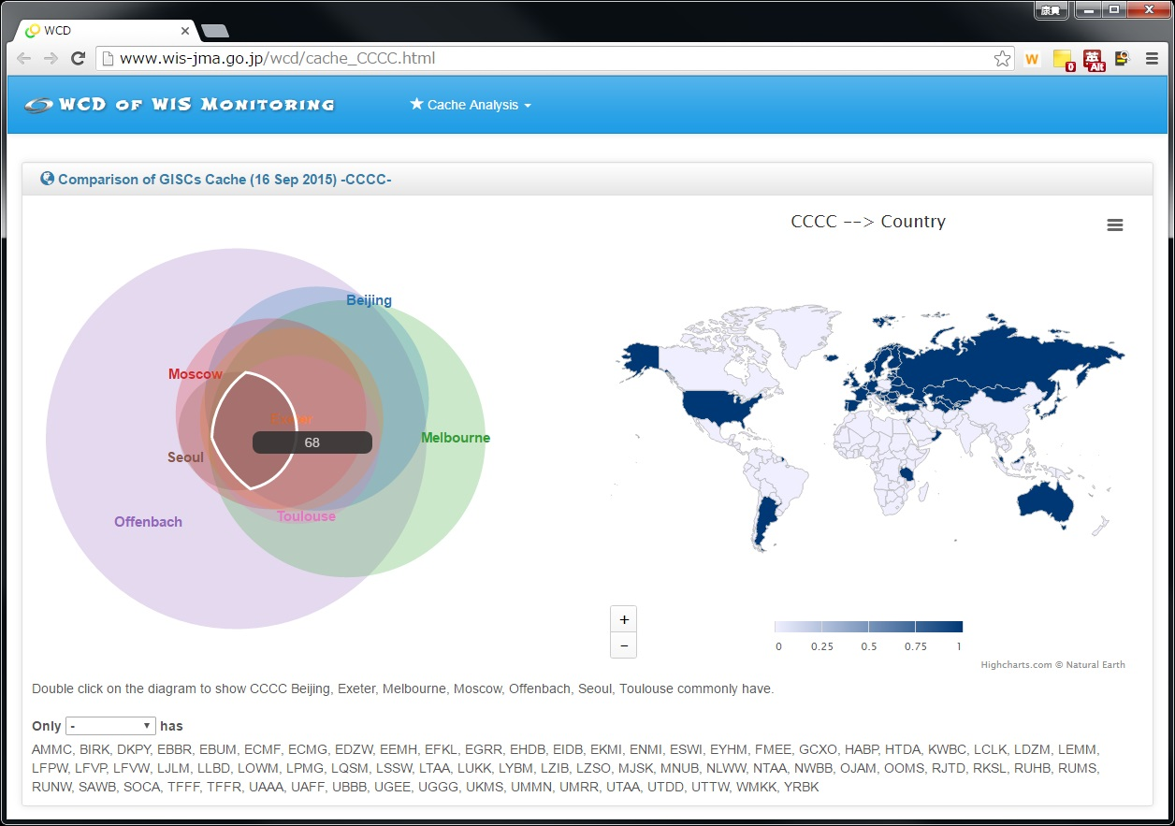
Figure 4: http://www.wis-jma.go.jp/wcd/cache_CCCC.html
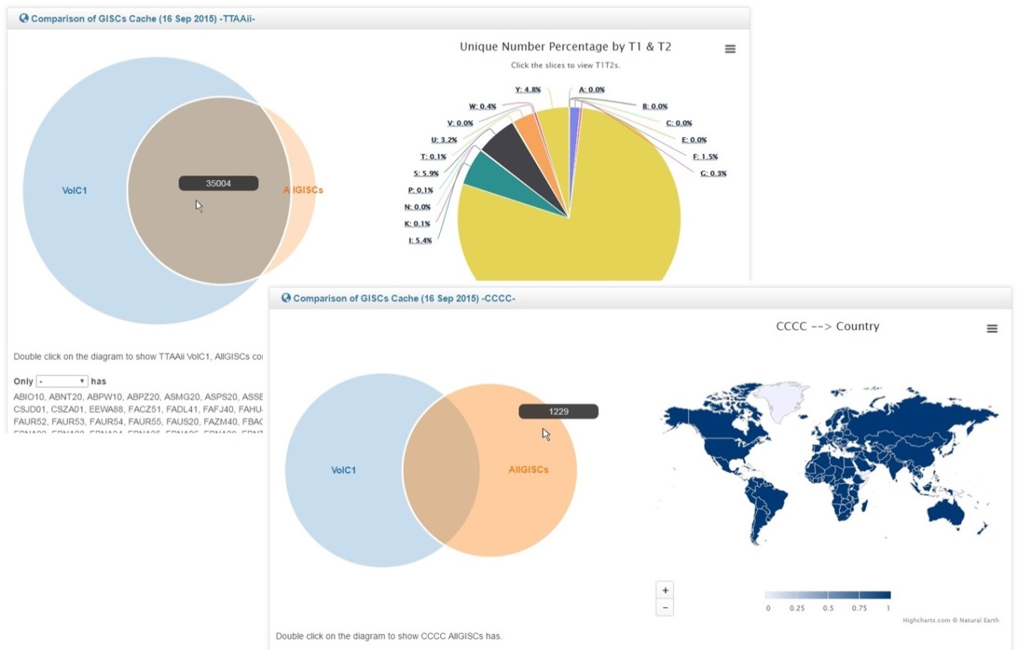
Figure 5: http://www.wis-jma.go.jp/wcd/cache_TTAAii_VolC1.html ,
http://www.wis-jma.go.jp/wcd/cache_CCCC_VolC1.html
Again, these contents are just examples using cache information provided by seven GISCs on 16 September 2015. There would be other ways of showing information, as long as more information can be derived from the cache information. (e.g. another pie chart regarding bulletin size)

Proposal for the future cache monitoring
As described above, cache monitoring provides wide and useful information to improve cache consistency. Therefore I would like to propose that GISCs provide information about cache on a regular basis, as 10 GISCs is currently providing JSON files on the Internet.

How frequently?
Once per day would be enough. This method could be applicable to a time-critical data monitoring, but it should be separated in terms of the frequency. As an interim work, it would be good to conduct “off-line” cache analysis again, taking time enough for GISCs to prepare.

Needed elements of the information provided by GISCs
At the previous cache analysis on 16 September 2015, divided TTAAii and CCCC, the elements were TTAAii, CCCC, the total number of each TTAAii and CCCC, and the total size of each TTAAii and CCCC. However, it would be better to handle “TTAAiiCCCC” as one data without dividing them. Besides, by monitoring cache time, it would be possible to identify approximately where the data has come from. Therefore I would like to propose the following elements.
- Cache Time (required to be formatted)
- TTAAiiCCCC (not unique, not divided)
- Size [MByte]
Since this format resembles “log”, it would be easier for GISCs to provide this. The total number and size of TTAAiiCCCC are not needed, because they can be calculated by dashboard program.
Are there any other necessary elements?

File format of the information provided by GISCs
At the previous cache analysis, GISCs provided Excel file offline. However, CSV file would be convenient for GISCs to provide it automatically. This should be decided based on the major preference among GISCs.

What about data/products without TTAAii?
This should be discussed further.

Regarding working plan for this, first WIS Monitoring team should consider and coordinate this. Then it would be good that voluntary GISCs provide cache information (as GISCs started providing initial JSON files), and that the Monitoring team and GISCs decide what to do next based on the result of the pilot.

References
[1] 24hr cache completeness (CMA) (http://wis.wmo.int/File=1883)

Recommended Text
Mr. Yasutaka Hokase, WIS Monitoring Demonstration work package lead, presented JMA’s new monitoring webpage for GISC cache monitoring using cache information of 16 September 2015 which were provided seven GISCs at the cache analysis conducted by CMA. He highlighted that dashboard can show wide information derived from cache information provided by GISCs, and that such information are necessary to improve cache consistency. He proposed the future cache monitoring that each GISC provides cache information on a regular basis as currently GISCs is providing JSON files and that needed elements are “Cache Time”, “TTAAiiCCCC” and “Size”.
The meeting agreed to ask WIS Monitoring team to consider the proposal for the future cache monitoring and to coordinate this, asking for voluntary GISCs of this pilot.

--------------------

