Review of the current status of implementation of TCP/IP at Météo-France

Telecom protocols

Leased lines
The leased lines with Tunis and Algiers terminated since the end of march.
Tunisia and Algiers are in the process of subscribing an Iron B RMDCN access.
As for now, Internet is used for data exchange between Toulouse and Tunis and Algiers.
A point-to-point link connects New Caledonia (Nouméa) to the BOM (Syndey).

VSAT
A VSAT link is used for data exchange with Dakar, Niamey and Brazzaville.
The VSAT access in Toulouse is located in the Air Navigation Services Direction, next to Météo-France ; the connection to Météo-France uses Wifi.
It is backed up by Internet

RMDCN
Toulouse has a platinum 50Mb/s RMDCN link. The main router is located in Météo-France and the backup router in a military national weather center, connected to Météo-France by optical fiber.
100 GB/day inbound, 80 % ECMWF Dissemination
50 GB/day outbound

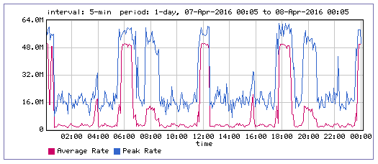
Figure 1 : Inbound bandwidth
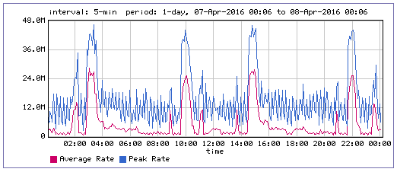
Figure 2 : Outbound bandwidth

Internet
Toulouse has a 1Gb/s Internet secured access. A second 1 Gb/s link is being set up.
Météo-France also has 2 Renater (French NREN) links : one directly connected to Renater, the second one through Remip, Toulouse area regional REN. Those links are currently used for Eumetsat multicast tests.
Internet is used to connect Toulouse to Meteo-France branches in French Polynesia and New Caledonia through IPSEC VPNs, with an ISDN backup.
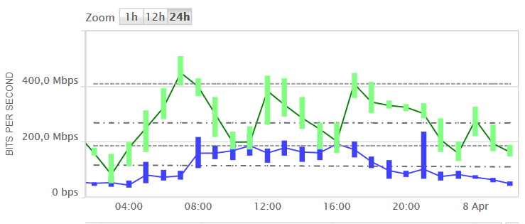
Figure 3 : Inbound (blue) and outbound (green) bandwidth

Data exchange protocols
No WMO tcp-socket is used for GTS data exchanges.
Ftp is the only used protocol.

Architecture evolution
An MSS has been transferred in DMZ. It should be used for more and more external data exchanges.
A second datacenter was built in Toulouse in 2013, interconnected to the main datacenter with a black optical fiber and WDM equipment (currently 40Gb/s + 10Gb/s backup).
This second datacenter could be used as a disaster recovery center.

References

Recommended Text
The 2 leased lines with Tunis and Algiers have been terminated and are in the process to be replaced by RMDCN.
A VSAT link connects Toulouse to Dakar, Niamey and Brazzaville.
The other GTS traffic uses RMDCN and Internet.
--------------------

