Data Policies

Keywords
Metadata, Operational Issue

Abstract
The following paper highlights two different possibilities to encode the “WMO data policy for globally exchanged data” (“WMOEssential”, “WMOAdditional”, “WMOOther” and “NoLimitation”) following WMO Core Profile 1.3 in metadata and it analyses the impact on the users and GISCs. In particular it shows an existing operational problem in some GISC Implementations which potentially can’t handle both encodings.

WMO data policy for globally exchanged data – WMO Core Profile 1.3
Part 2 of the WMO Core Metadata Profile version 1.3 [1] describes on page 61 two possibilities to encode the WMO data policy.
Test method:
Inspect the instance document under test to assess whether one and only one instance of a term from the WMO_DataLicenseCode code list is specified using the following XPath: /gmd:MD_Metadata/gmd:identificationInfo//gmd:resourceConstraints/ ➘gmd:MD_LegalConstaints/gmd:otherConstraints// A normative version of the WMO_DataLicenseCode code list is published by WMO at: http://wis.wmo.int/2012/codelists/WMOCodeLists.xml.
A gmx:Anchor element may be used to specify the location of the code list, e.g. /gmd:MD_Metadata/gmd:identificationInfo//gmd:resourceConstraints/ ➘gmd:MD_LegalConstaints/gmd:otherConstraints/gmx:Anchor/@xlink:href = http://wis.wmo.int/2012/codelists/WMOCodeLists.xml#WMO_DataLicenseCode

The WMO Baseline Metadata published 2012 and most of the metadata for globally exchange data follow example number 1.
Example – WMO Core Metadata Profile version 1.3 Part 1 page 53
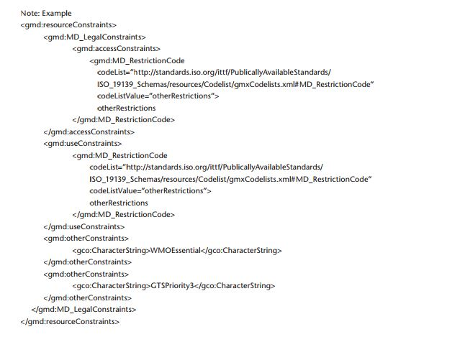
DCPC RTH Rome published recently metadata following example 2 which in my opinion is completely in line with the WMO Core Profile 1.3
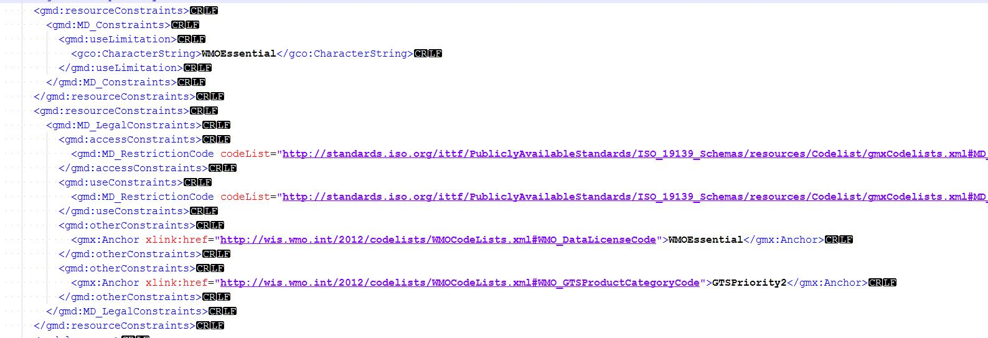
This record uses a <gmx:Anchor> element and a CodeList.
In a next step I searched all GISCs for the bulletin SMIY02 LIIB which metadata uses the encoding style of example 2.
I was able to download the bulletin from 6 portals while in all other cases I wasn’t successfully for various reasons (network connection problem, no metadata, no account, data not available and access denied).
 | Result for SMIY02LIIB (WMOEssential) | Comment
GISC A | -
GISC B | - | Data not in 24h Cache
GISC C | +
GISC D | +
GISC E | - | Metadata Record does not exists
GISC F | +
GISC G | -
GISC H | - | Message: Access denied: You don't have enough credentials to perform this action
GISC I | +
GISC J | - | No Account
GISC K | - | Portal not accessible
GISC L | +
GISC M | +
GISC N | - | Login not possible
GISC O | -

Notes
Since WMO Core Profile 1.3 is endorsed I would like to suggest that each GISC checks its implementation if it can handle metadata following encoding style 2. Furthermore I would like to suggest that the meeting encourages IPET-MDRD to consider this example in the next version of the WMO Core Profile and to allow only one encoding style for crucial information to minimize the implementation work for the GISCs.

References
[1] WMO Core Metadata Profile Version 1.3 Part 2 http://wis.wmo.int/2013/metadata/version_1-3-0/WMO_Core_Metadata_Profile_v1.3_Part_2.pdf
[2] WMO Core Metadata Profile Version 1.3 Part 1 http://wis.wmo.int/2012/metadata/WMO_Core_Metadata_Profile_v1.3_Part_1.pdf

Recommended text for report
The meeting noted the presented report from Germany.

The paper highlighted two different possibilities to encode the “WMO data policy for globally exchanged data” (“WMOEssential”, “WMOAdditional”, “WMOOther” and “NoLimitation”) following WMO Core Profile 1.3 in metadata and it analyses the impact on the users and GISCs. In particular it shows an existing operational problem in some GISC Implementations which potentially can’t handle both encodings. The two methods are 1) to use gmx:Anchor and 2) free text:CharacterString
The meeting urges the GISCs to check if their implementation can cope with both possible encodings of the WMO data policy. Furthermore TT-GISC asks IPET-MDRD to consider this example and to avoid in the next version of WMO Core Profile multiple encoding styles for crucial information to minimize the implementation work for the GISCs.

