Australia Country Report

Review of the current status of implementation of TCP/IP procedures and applications at WIS centers

Internet.
In 2014 the Bureau of Meteorology was required as a whole of government initiative to move to a common Secure Internet Gateway (SIG) for its Internet gateway connectivity. This has been a difficult transition for the organization, as the Bureau has to share in a common gateway with other government departments who do not have the same requirements. Although the Bureau benefited from significant upstream filtering and monitoring it was disadvantaged because of the tuning that was required to allow “unusually long FTP and HTTPS sessions” through this gateway. This causes us significant issues with FTP’s timing out to our meteorological partners and took considerable time to resolve. In part this was caused by multiple upstream firewalls with different settings, and has only partially been solved by tuning the timeout parameters at the remote client end (not the Telco ). The email spam filter setting is also extremely aggressive and a lot of operational email may have not arrived.
In architectural terms the actual gateway is in Canberra and both the Bureaus data centers are in Melbourne making the cost of peering with the gateway very expensive, in addition to this the entire upstream management charge is leveled on the actual bandwidth of the gateway making this cost prohibitive to upgrade the link at the moment (>$1M per year )
As a large amount of model data and observational data is exchanged over this link (outside the GTS) this is will be an issue that needs to be addressed at a political level. It is further complicated as the current use of cloud services is also via this gateway until dedicated links can be installed.

Data From Primary Data Center(SDC) 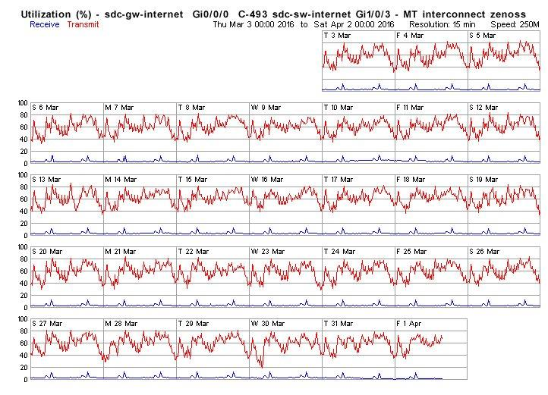

Data From Secondary Data Center
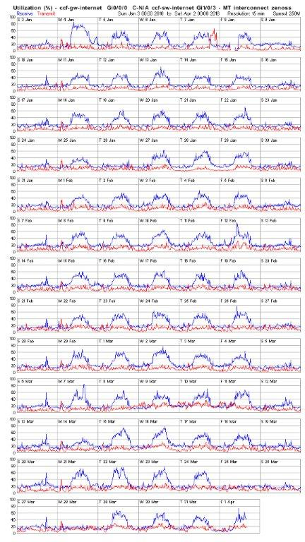

Current utilization of RMDCN circuit.
The RMDCN circuits are also dual homed out of each data center at 4Mbps into the RMDCN cloud. The utilization of these links is not high (care is taken because of the bandwidth not to exchange high volume data over these links,) and the Internet is used instead but presents the current saturation issues.
Whilst the utilization of these links is low the cost is not. The geographic isolation of Australia and the contract that was signed mean that these links cost us $150KAUD per year for 4Mbps. Although the contract is up for a technical review and perhaps a minor upgrade this solution and its associated costs would unlikely be entered into again at these prices. Recently the Bureau went through a process for international links to Japan for Himawari8 connectivity and responses indicated that 100-400mbps would be possible into Europe for the same price we now pay for the 4mbps links.
The RMDCN VPN backup link has remained active but has not been used as the 4mbps link has been reliable and has only rarely dropped back to the second data center link
Main RMDCN link
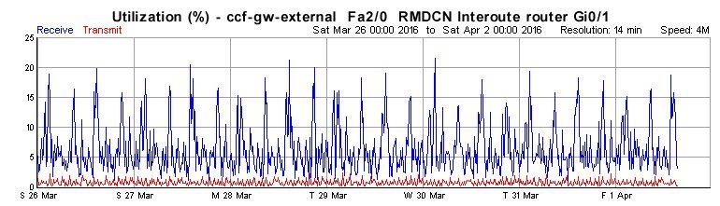
Secondary RMDCN link
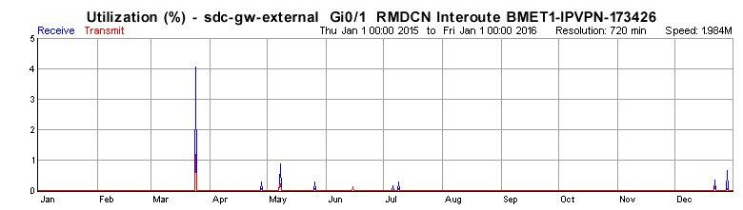

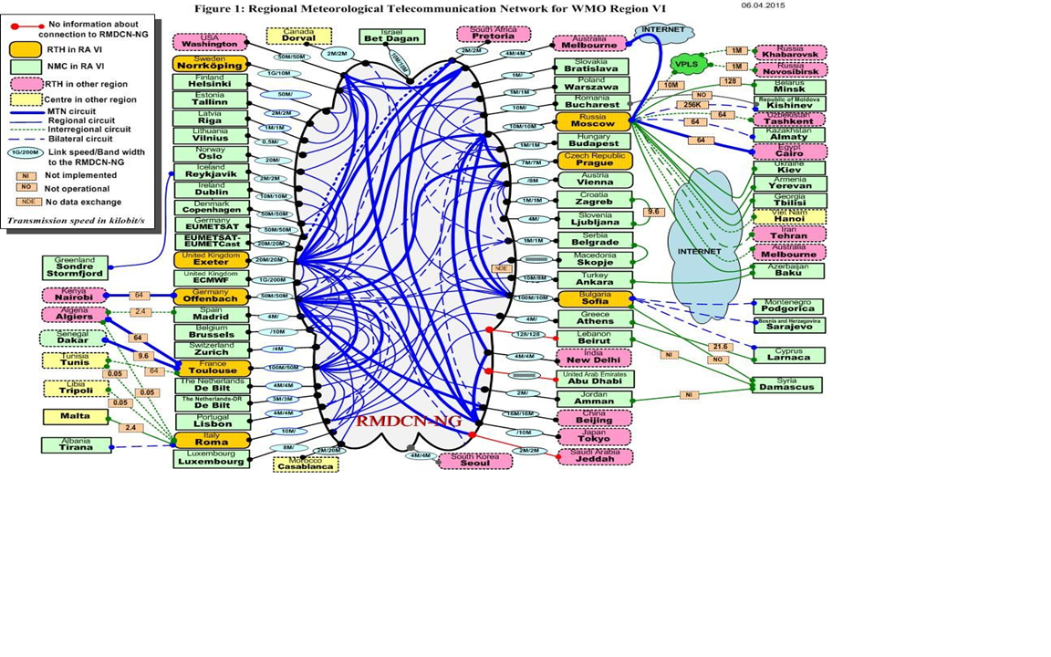

RA5 GTS Links
The RA5 links remain generally unchanged with more Pacific countries using our email (but generally via NZmet) to lodge to the GTS . There exists a Singtel network within RA5 that has links to Indonesia and Singapore. The Singapore link is saturated with most of the high volume data being sent to Singapore . The Nandi and Noumea links are still very expensive and would probably be best utilized via the internet.

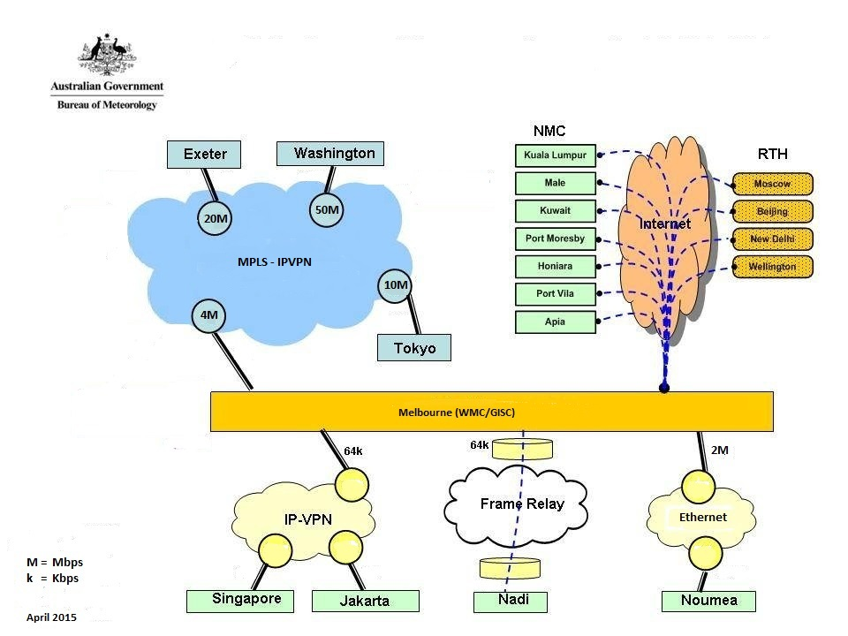
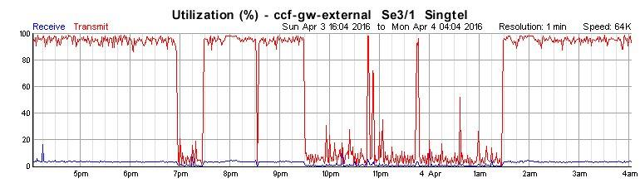

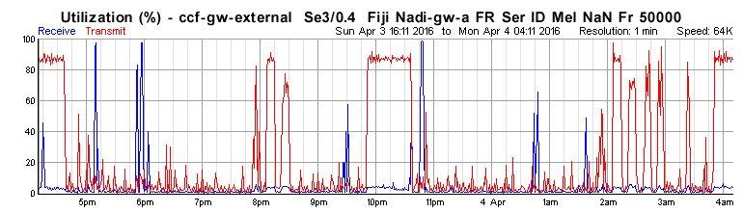
The reason for these saturations are being investigated but probably related to model data now exceeding what is a low bandwidth links. As these links are M2M only they can be pushed hard.

RMDCN/GTS/Internet summary

The RMDCN and GTS links are expensive although reliable. If the Bureau did not have the current Internet restrictions it would be advocating full use of Internet with a VPN mesh connectivity to connect to the European gateways and probably advocate the dropping of the dedicated links . The Bureau will be committed in the future to a dual Internet gateway at high bandwidth. Taking this a step further the Bureau is looking at Cloud services to provide the International peering links – with a dedicated or Internet link to the cloud servers. This will be the subject of a further discussion paper and may negate the need for a complicated VPN mesh in the Internet.

WIS Summary

Overall Status
- Metadata
  - Number of metadata 148,416 (not including draft)
  - Number of drafts 9,799 (draft metadata are placeholder records for ingested data without existing associated metadata)
    - 502 drafts are originated from RA V countries
  - Total number of metadata 158,215 (sum of the above two items). Following graph shows history of the total number for last 30 days.
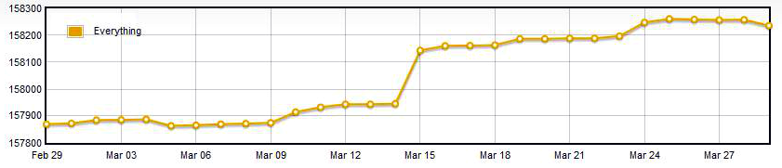
    - Update to existing metadata records do not change the total number and happens almost everyday
  - Synchronisations
    - OAI-PMH protocol
    - Daily sync to 10 GISCs and 1 DCPC
      - GISCs: Beijing, Brasilia, Exeter, Jeddah, Moscow, Offenbach, Seoul, Tehran, Tokyo, Toulouse
      - DCPC: Wellington
- Data/products
  - Total number of data/products 372,328
  - Total volume of data/products is about 1.5 GB
  - Cache size (occupied disk space) is about 3.0 GB
  - Number of data/products that only have draft metadata 276,853 (about 600 MB in volume size)

GISC Monitoring Practices
Automated monitoring is performed three applications
- Daily monitoring for WMO WIS Monitoring Pilot
  - Three JSON files are generated daily
    - monitor.json
    - centres.json
    - events.json
  - The JSON data is aggregated by three WIS Monitoring Common Dashboard websites
- Daily detailed metadata monitoring
  - Used internally to have a closer look to the catalogue
    - Daily metadata traffic
    - Daily Synchronisation results and comparisons to authoritative copies on originating GISCs
    - Daily breakdown report
    - History tracking
- Real-time System performance
  - Used internally to monitor the performance of database, Cache and Data delivery harnesses
    - Memory usage
    - Swap usage
    - Data/products ingestion status
    - Data/products delivery status

GISC Melbourne and RA V Status
- WMO required products
  - Number of metadata 1,112 in set WIS-GISC-MELBOURNE
  - Number of data/products 11,285
- Solar flare forecasts
  - WMO compatible metadata created by IPS
  - Data stored in Cache and available to global exchange
- ACCESS forecast model data
  - WMO compatible metadata records created
  - Data provision is done by implement local data source (both ad-hoc request and subscription are allowed)
  - A subset of the data is made available to Fiji met service for requests and subscriptions

Security Uplift
Media reports in Australia that received world attention relating to the Bureau and security breeches caused a number of follow on consequences in the GTS. The Bureau and the Australian government does not comment on this issue as the media reports specifically mentioned supercomputing – and this is categorized as National Critical Infrastructure so restrictions no apply. In general terms the Bureau was on a 3 year roadmap to use best practice security techniques such as Role based authentication , Network zoning patching and segmentation. The media reports heightened our security profile and necessitated the requirement to accelerate this roadmap meaning that a very intense and tactical security uplift is happening in much reduced timelines.
In GTS terms this will mean that the connection points in the network DMZ will be subject to enhanced monitoring and control, but apart from outages associated with migration little will change in architecture.
Transfers via FTP and the internet will probably be migrated to a cloud based managed file transfer services (MFT) that will support a wider range of secure connectivity methods if they can be utilized by our 3rd party and International partners.
When the media reports hit the public domain internal operations we not affected and Bureau operations were only impeded by the actions other partners took as a reaction. Work is required on te mechanisms and communications channels required to address the actual threat rather than the perceived threat that the media might have. If the default position is to isolate then this must be planned for in backup procedures and guidelines.

Internet of Things
The Bureau is doing considerable work in the Internet of things space, this included the entire technology stack from the remote device to the end user and utilizes the publish subscribe model using MQTT protocols. During this work it has become apparent that some of this may translate to possible future state models for some of the GTS and WIS concepts. A further presentation can be made on this if the group is interested.

-

