Review of the current status of implementation of TCP/IP procedures and applications at GISC Beijing

GISC Beijing’s GTS/WIS connections
GISC Beijing upgraded the RMDCN-NG connection from 8Mbps to 16Mbps.
The Internet connection of GISC Beijing, dedicated for GTS/WIS, upgraded from 350Mbps to 450Mbps.
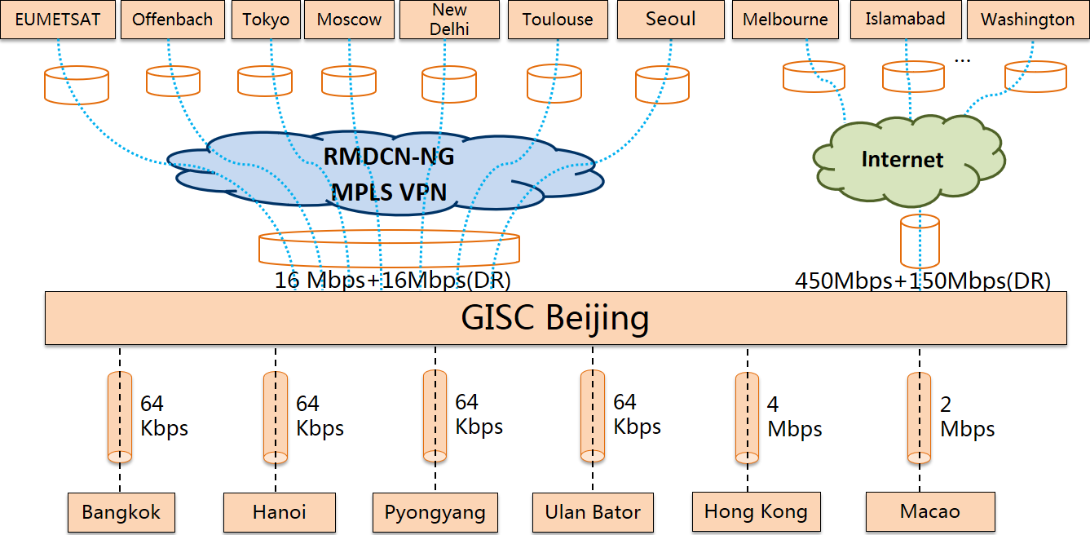
The connection between GISC BEIJING and GISC SEOUL migrated to RMDCN-NG, the FR connection between BEIJING and SEOUL was eliminated in Dec, 2015.

Figure 1. International Telecommunication Network of GISC Beijing

CMACast data Dissemination Service
Daily broadcast data volume of CMACast system to abroad members is about 30GB in 2015.
22 CMACast members abroad, include:
Australia, Bangladesh, DPRK, Indonesia, Iran, Kazakhstan, Kyrgyzstan, Laos, Malaysia, Maldives, Mongolia, Myanmar, Nepal, Pakistan, Philippines, Sri Lanka, Tajikistan (New member), Thailand, Uzbekistan, Viet Nam, Hong Kong(China) and Macau(China)

CMA’s communication DR Center
In 2015, CMA’s communication DR center put into operation. CMA DR center, about 20km south-west from CMA, is in charge of the emergency backup of CMA’s international and internal communication systems. CMA DR center connect CMA with 1GB eth-link. CMA DR center also has 16Mbps RMDCN-NG connection and 150Mbps dedicated Internet connection. In the end of 2014 and in the middle of 2015, two manual switch drills had been completed from the main center to DR.

CMA Cloud Computing Pilot Project
CMA published IT Evolution Action Plan (2015-2016) last year, to promote the application of Cloud Computing Technology. A Cloud Computing pilot project will be launched this year. The goal of the pilot project is to resolve the high resolution NWP data dissemination and acquisition from regional centers to all the other provincial Met services, with public Cloud Computing service. Through the pilot project, the quality of public Cloud Computing services, the requirement of the network connection, the security and the cost of public Cloud Computing services will be evaluated. And recently, CMA Public Meteorological Service Center (CPMSC) will disseminate Local Analysis and Prediction System (LAPS) hourly products to the provincial Met Service via Aliyun (Public Cloud Computing service provided by Ali).

