Review of the current status of implementation of TCP/IP procedures and applications at WIS centers

Current status of implementation of the GTS circuits
Current status of GTS circuits connected with the RTH Tokyo is shown in Table 1 and configuration on connectivity is shown in Figure 1.
- Topics:
  - Establishment of a new link with Toulouse; July 2014
  - Establishment of new link (on RMDCN and NTT-Com) with Disaster Recovery Site in Osaka; January 2015
  - GISC Tokyo has started exchanging data by using HTTPS with Brasilia via internet as pre-operational in October 2015
  - Migration of the link with Seoul from dedicated circuit to the RMDCN link; December 2015
  - Establishment of a new link with Doha; February 2016
- Details are shown here;
  - http://www.jma.go.jp/jma/jma-eng/jma-center/rth/GTS_upgrades.html

Table 1: Implementation status of GTS circuits connected to RTH Tokyo
21st of February 2016
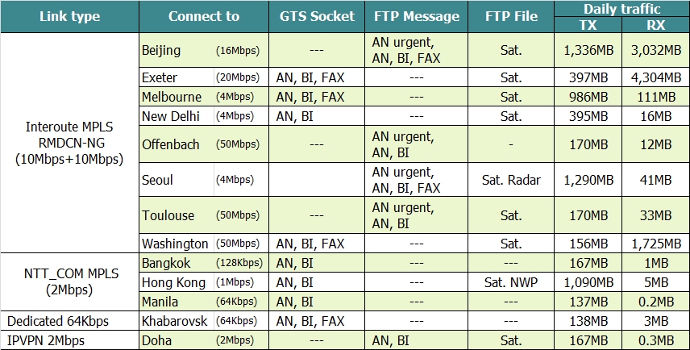

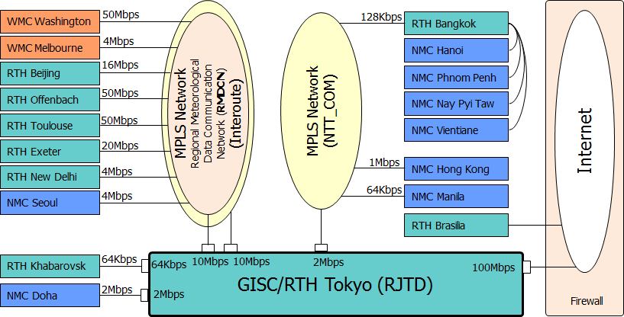
Figure 1: Configuration of the GTS circuits connected to the RTH Tokyo

Implementation status of TCP/IP protocol and applications
TCP/IP protocol is running on all the GTS circuits connected to the RTH Tokyo. HTTPS is used to exchange data with Brasilia. Simple FTP is used to exchange satellite data with Washington, Melbourne, New Delhi, Beijing, Seoul, Hong Kong and Doha. Products of JMA's one week ensemble forecast model are also distributed to Hong Kong by simple FTP. Currently, data and products are exchanged in the following manner.
Table 2: Manner of data exchange on FTP
From |  | To
Washington: | GET by Tokyo | Washington: | PUT by Tokyo with file renaming
Melbourne: | PUT by Melbourne with file renaming | Melbourne: | PUT by Tokyo with file renaming
New Delhi | PUT by New Delhi with file renaming | New Delhi | PUT by Tokyo with file renaming
Exeter: | PUT by Exeter with file renaming | Exeter: | PUT by Tokyo with file renaming
Offenbach: | PUT by Offenbach with file renaming | Offenbach: | PUT by Tokyo with file renaming
Beijing: | PUT by Beijing with file renaming | Beijing: | GET by Beijing
Seoul: | PUT by Seoul with file renaming | Hong Kong: | PUT by Tokyo with file renaming
Hong Kong: | PUT by Hong Kong with file renaming | Seoul: | PUT by Tokyo with file renaming
Doha: | PUT by Doha with file renaming | Doha: | PUT by Tokyo with file renaming

Note) GTS file naming convention is used in these file exchange

WIS
3.1 Status of JMA
  - Global Information System Centre (GISC)
  - 8 Data Collection or Production Centres (DCPCs)
    - RTH
    - RSMC-Typhoon
    - RSMC-Geographical
    - RSMC-ATM
    - Satellite Centre
    - GPC-LRF (Forecast)
    - RCC (Tokyo Climate Centre)
    - WDC-GG (Greenhouse Gases)3.2 GISC Tokyo
Services:
  - Part A - Global Telecommunication System (GTS)
  - Part B - Data Discovery, Access and Retrieval (DAR) Services [Internet]
    - Metadata management
    - Metadata search
    - Web interface for metadata creation and modification
  - GISC cache
    - Warnings, WMO format data
    - Facilitate data subscription
  - Help desk
  - Gateway to data services by DCPC
    - SATAID service – Himawari Satellite imagery & more
    - Global Spectral Model products in 0.5 deg and 0.25 deg
  - GISC Backup

GISC Backup
GISC Tokyo has bilateral agreements on GISC backup with GISC Offenbach, GISC Beijing and GISC Melbourne.
GISC Backup between Beijing and Tokyo is in operational by using GTS and Internet DAR service.
Between GISC Offenbach and Tokyo is in operational by using Internet. The centres of the Area of Responsibilities send data to Offenbach by using FTP_PUT and to Tokyo by using HTTPS file upload function. GISC Tokyo shows their received data on the Internet and currently we are preparing to relay their data through GTS.
GISC Melbourne and Tokyo, GISC Tokyo has two options for the Centre of AoR of Melbourne. Option 1 is to use existing GTS based backup and option 2 is to use Internet based backup.

Disaster Recovery Site (DRS)
JMA’s Disaster Recovery Site (DRS) on west side of Japan (Osaka city, 500km far from Tokyo) has been in operation since March 2015. The DRS has the same architecture of current MSS and access lines of MPLS networks. Some centres finished a connectivity test and started backup operation.
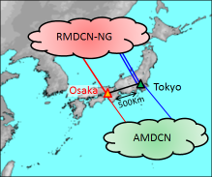
Figure 2 Disaster Recovery Site of JMA

Traffic analysis
5.1 Increasing trend of traffic volume.
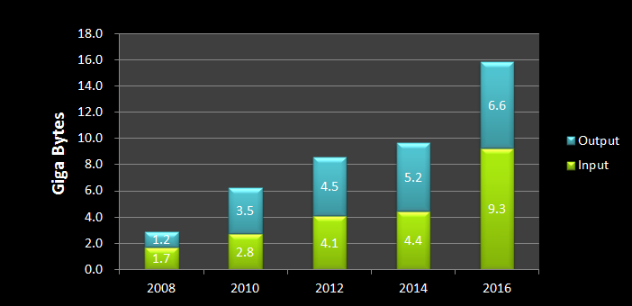
Figure 3 Statistics of traffic volume
5.2 Traffic volume in each channel
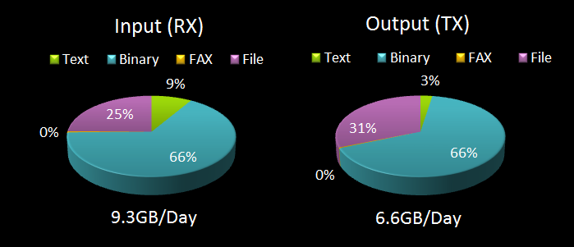
Figure 4 Statistics of traffic volume in each channel (data type)
5.3 Traffic status of each circuit
5.3.1 Washington (50Mbps) – Tokyo (10Mbps)
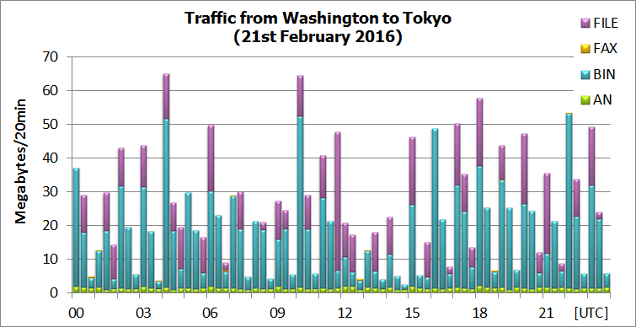
Figure 5 Traffic from Washington to Tokyo
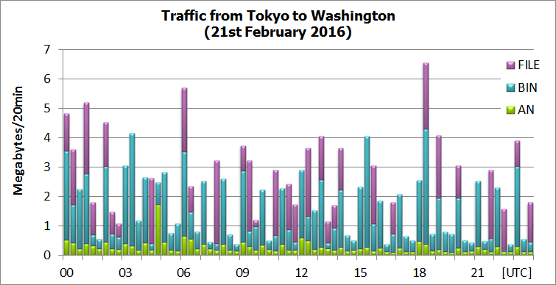
Figure 6 Traffic from Tokyo to Washington

5.3.2 Melbourne (4Mbps) – Tokyo (10Mbps)
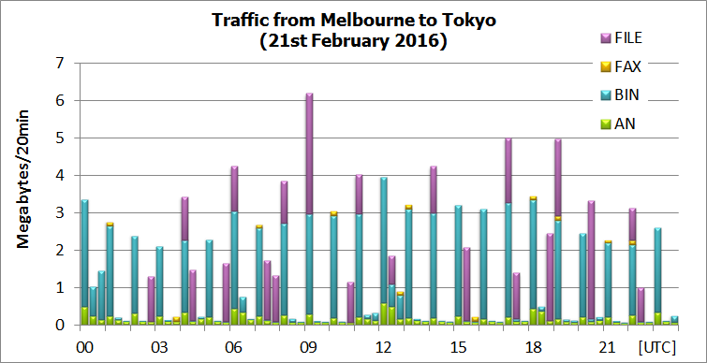
Figure 7 Traffic from Melbourne to Tokyo
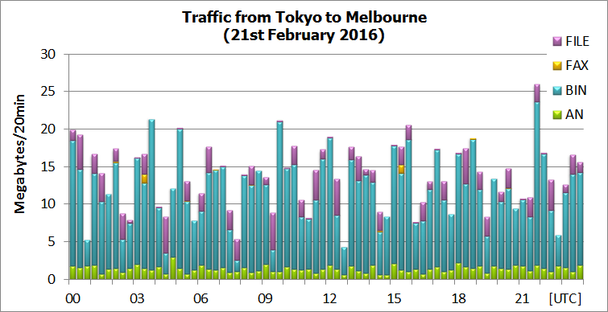
Figure 8 Traffic from Tokyo to Melbourne

5.3.3 Beijing (16Mbps) – Tokyo (10Mbps)
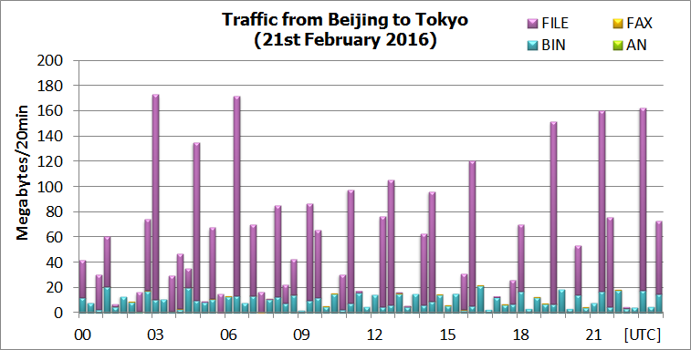
Figure 9 Traffic from Beijing to Tokyo
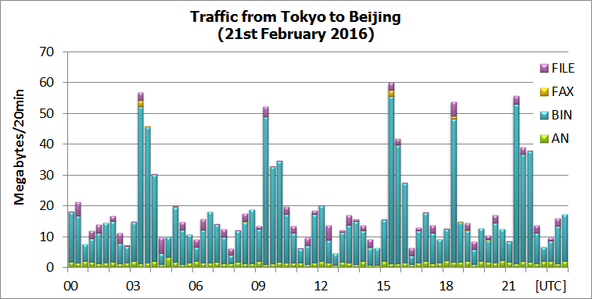
Figure 10 Traffic from Tokyo to Beijing

5.3.4 Exeter (20Mbps) – Tokyo (10Mbps)
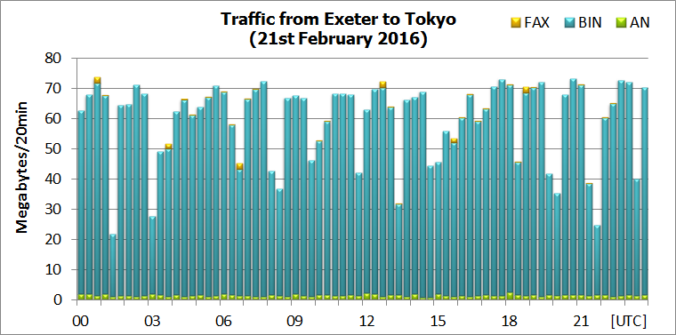
Figure 11 Traffic from Exeter to Tokyo
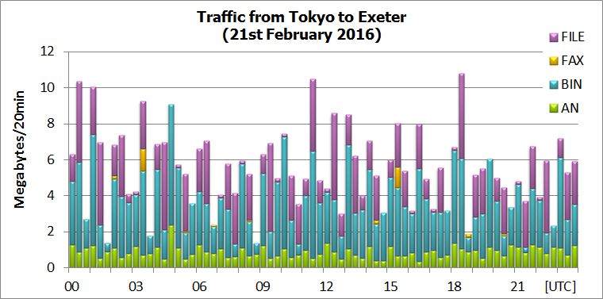
Figure 12 Traffic from Tokyo to Exeter
5.3.5 Offenbach (50Mbps) – Tokyo (10Mbps)
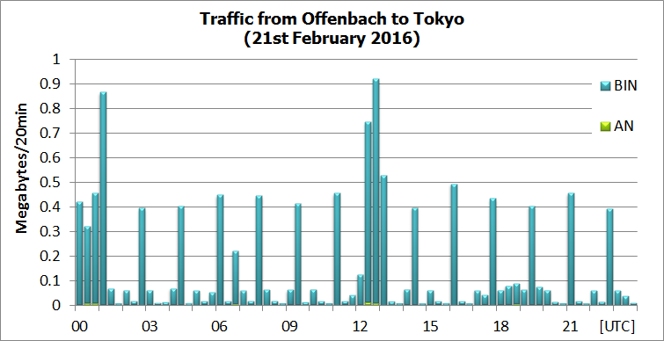
Figure 13 Traffic from Offenbach to Tokyo
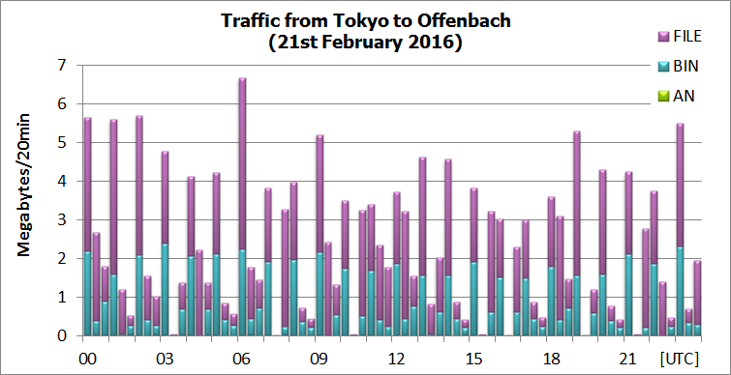
Figure 14 Traffic from Tokyo to Offenbach

5.3.6 New Delhi (4Mbps) – Tokyo (10Mbps)
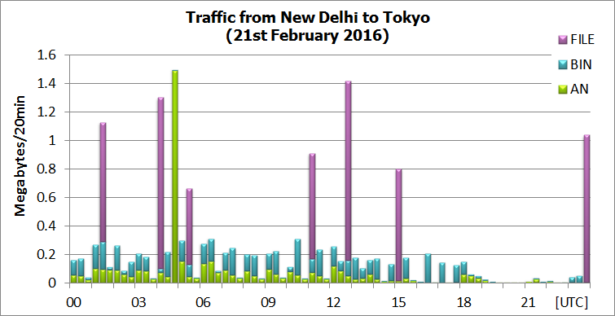
Figure 15 Traffic from New Delhi to Tokyo
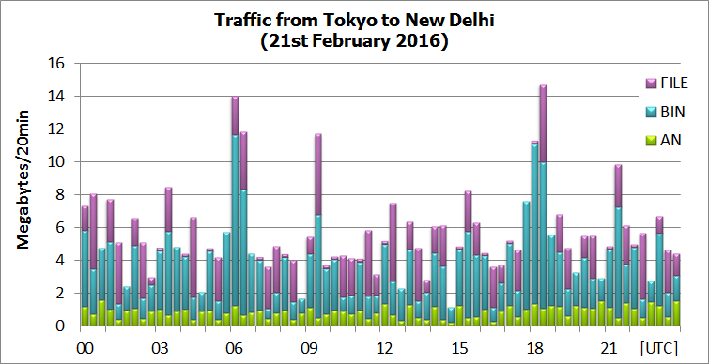
Figure 16 Traffic from Tokyo to New Delhi
5.3.7 Toulouse (50Mbps) – Tokyo (10Mbps)
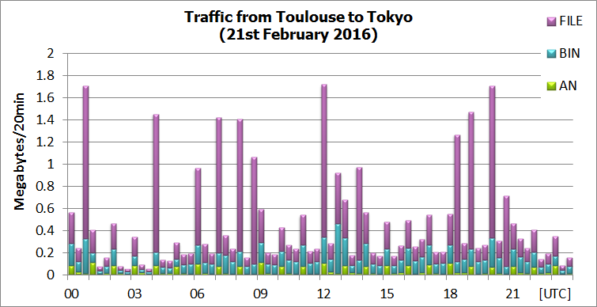
Figure 17 Traffic from Toulouse to Tokyo
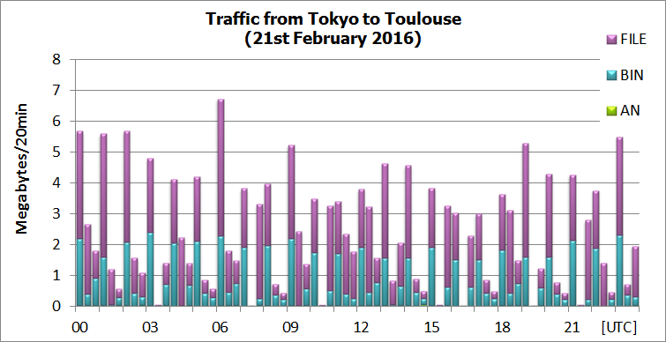
Figure 18 Traffic from Tokyo to Toulouse
5.3.8 Seoul (4Mbps) – Tokyo (10Mbps)
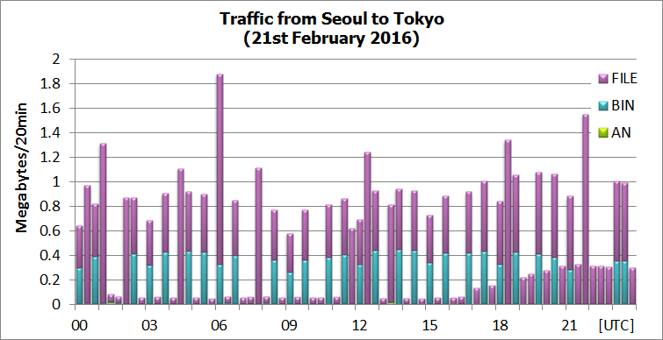
Figure 19 Traffic from Seoul to Tokyo
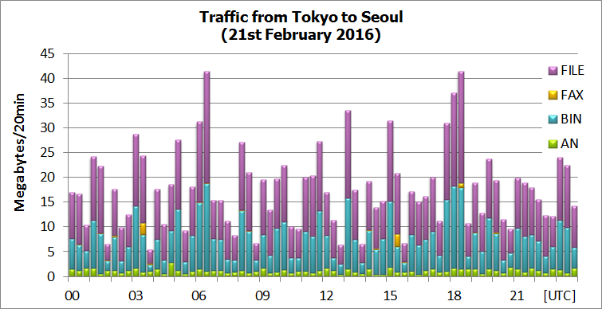
Figure 20 Traffic from Tokyo to Seoul

5.3.9 Bangkok (128Kbps) – Tokyo (2Mbps)
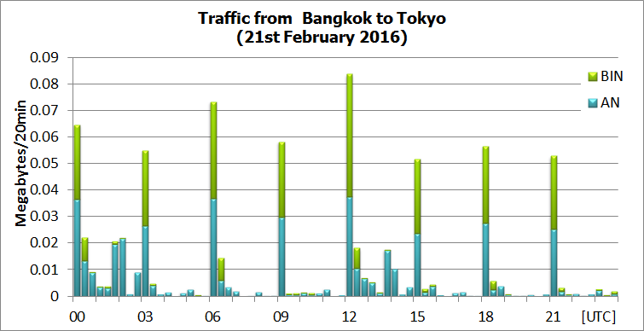
Figure 21 Traffic from Bangkok to Tokyo
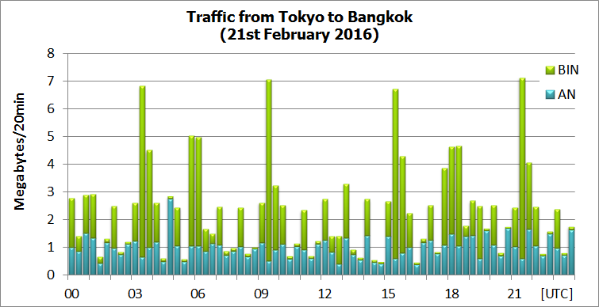
Figure 22 Traffic from Tokyo to Bangkok

5.3.10 Khabarovsk (dedicated 64Kbps) – Tokyo
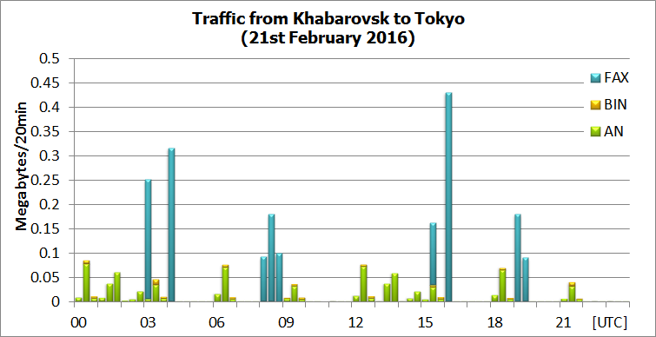
Figure 23 Traffic from Khabarovsk to Tokyo
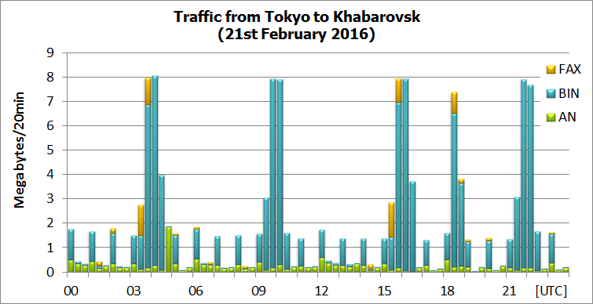
Figure 24 Traffic from Tokyo to Khabarovsk

5.3.11 Hong Kong (1Mbps) – Tokyo (2Mbps)
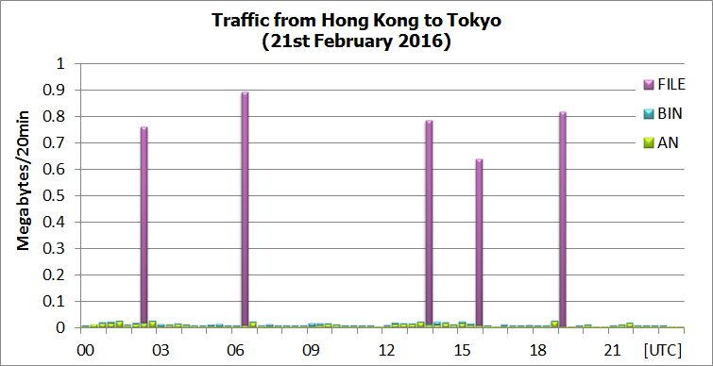
Figure 25 Traffic from Hong Kong to Tokyo
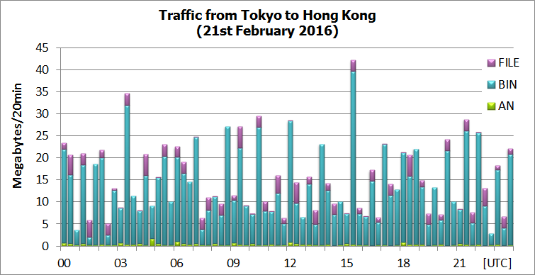
Figure 26 Traffic from Tokyo to Hong Kong

5.3.12 Manila (64Kbps) – Tokyo (2Mbps)
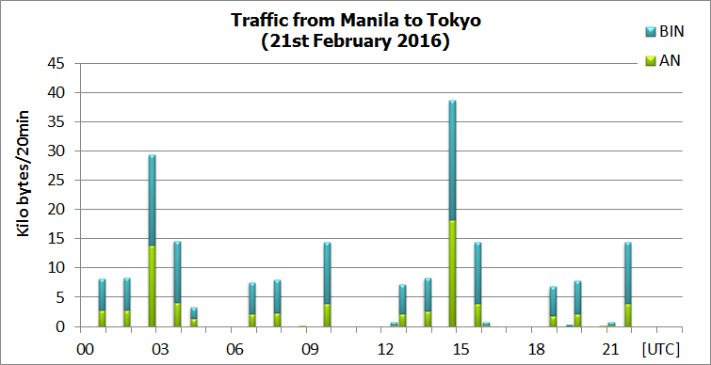
Figure 27 Traffic from Manila to Tokyo
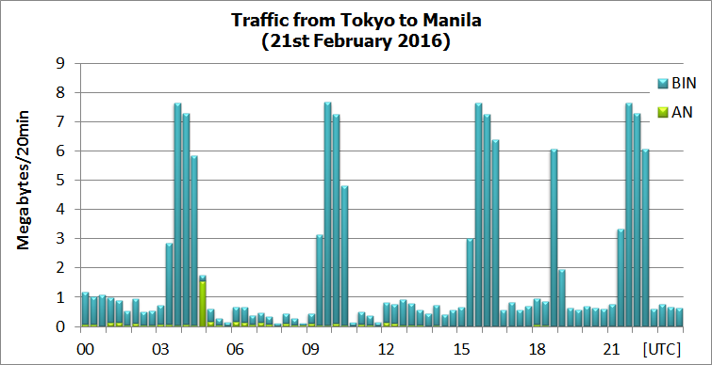
Figure 28 Traffic from Tokyo to Manila

5.3.13 Doha (IPVPN 2Mbps)– Tokyo
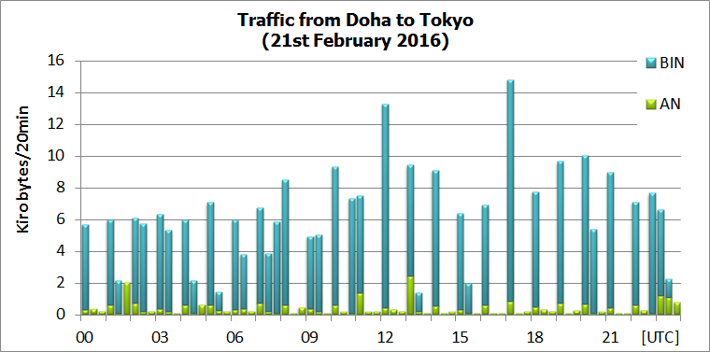
Figure 29 Traffic from Doha to Tokyo
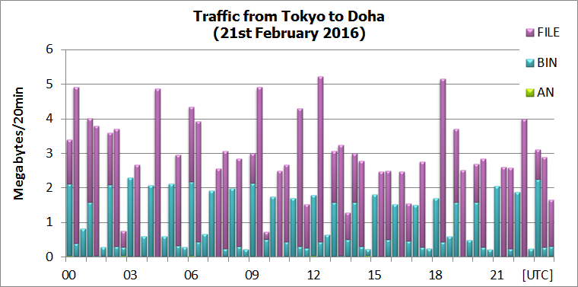
Figure 30 Traffic from Tokyo to Doha

5.4 Traffic status of the Internet for WIS part-B (DAR).
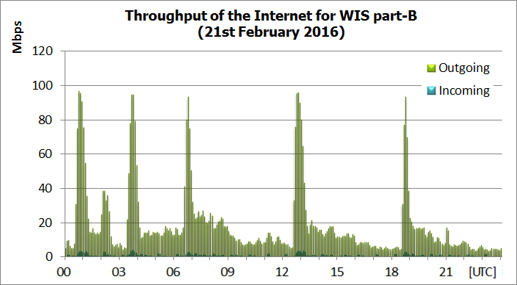
Figure 31 Throughput of the Internet for WIS part-B (Bandwidth 100Mbps)
-------------------

Recommended Text
GISC Tokyo has a high availability connection to RMDCN-NG, NTT-Communications and Internet access.
GISC Tokyo has GISC backup agreements with three GISCs. GISC backups of Offenbach-Tokyo and Beijing-Tokyo are in operational, and GISC backup with Melbourne is being coordinated.
And also GISC Tokyo has established Disaster Recovery Site and this DR site has been in operation since March 2015. This DR site has same architecture of current MSS and access links with RMDCN-NG and NTT-Communications networks. Some centres finished a connectivity test and started backup operation.

