Report on the RMDCN

RMDCN Configuration

Overall Status
- With the successful deployment of the connection to the disaster recovery (DR) site in Germany, the total number of sites connected to the RMDCN is now 54 (47 national sites, ECMWF, EUMETSAT, the Swiss National Supercomputing Centre (CSCS), and DR sites in China, Germany, the Netherlands, and Japan).
- Figure 1 shows the geographical coverage of the sites connected to the RMDCN.

Upgrades
- The NMC connection in Helsinki, Finland was upgraded to 50Mbps in November 2014.
- The NMC connection in Belgrade, Serbia was upgraded to 4Mbps in March 2015 following Serbia becoming a full member of ECMWF.
- The connection to CSCS in Lugano, Switzerland was upgraded to 20Mbps in March 2015.

New Connections
- A 10Mbps service to a disaster recovery site for Japan in Osaka was activated in December 2014.
- A 16Mbps service to a disaster recovery site for China in Beijing was activated in April 2015.
- An IPSec service to the disaster recovery site for Germany in Berlin was activated in March 2016.
- Tunisia has joined the RMDCN community and is finalizing an order for connection.
- Algeria has joined the RMDCN community and is finalizing an order for connection.
- The deployment of the connection in Lebanon has been delayed due to problems with export regulations relating to shipping customer edge equipment from Interoute to Lebanon.

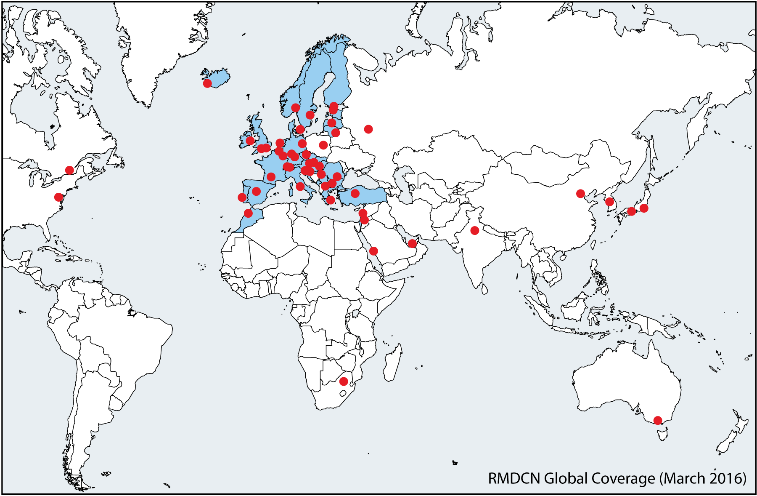
Figure 1 - RMDCN Global Coverage March 2016

Service Performance
- Following the migration of the RMDCN service to Interoute Communications in January 2014 there has now been two years of operational service by Interoute Communications Ltd. During the reporting period there have been several incidents that caused service interruption which had an impact on the Global Service Availability as can be seen in Figure 2.
- Figure 2 illustrates the percentage of availability of the global RMDCN. It shows full operational service without any incidents (Normal Service), operational service with sites having only one circuit available (Degraded Service), operational service using DMVPN (DMVPN Service), service impacted without breach of service level agreement, (Impacted Service (No SLA Breach)) and service impacted with breach of SLA which triggered relevant rebates (Impacted Service(SLA Breach)). It also shows the global availability of the service according to the SLA (According to SLA).
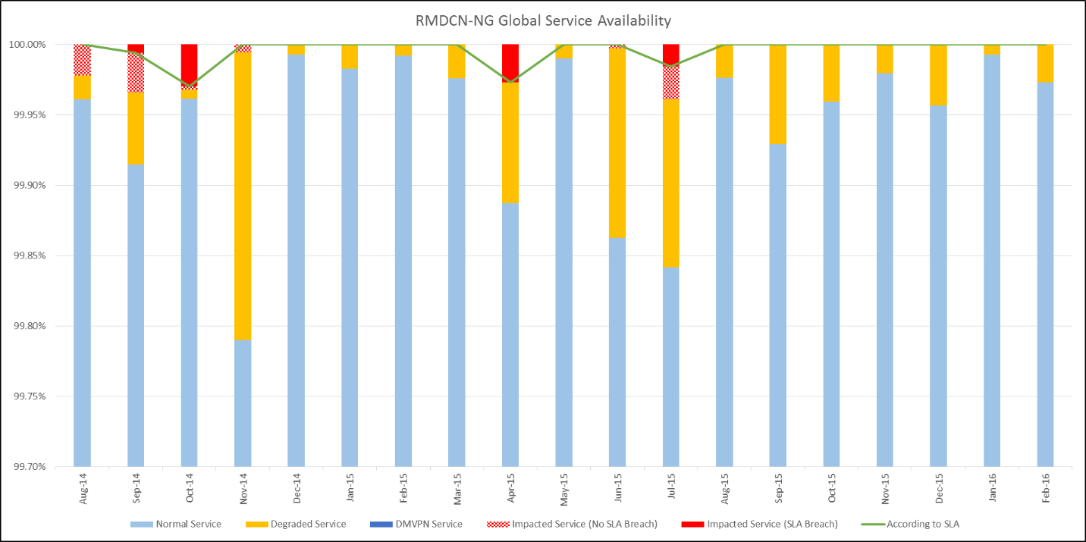
Figure 2 - RMDCN Global Service Availability for the year to March 2016
- Figure 3 shows the sites affected by incidents that breached the availability SLA during the reporting period.
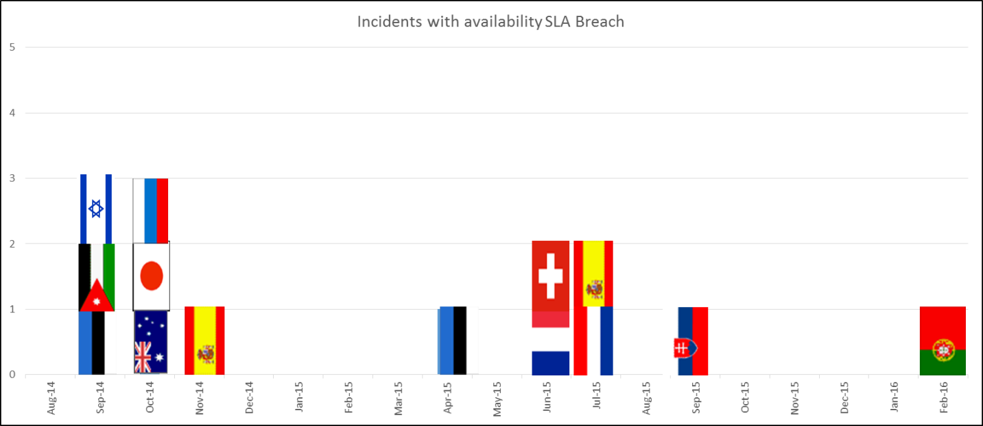
Figure 3 - Incidents results in a breach of availability SLA for the year to March 2016

- Details of the incidents that breached site and/or connection availability were:
  - September 2014
Estonia suffered a total downtime of 1 hour and 45 minutes due to a network outage in the Swedish section of Interoute’s backbone network.
Jordan and Israel had some downtime on one of their connections. The service was not affected and the there was no breach of the site availability SLA, however the circuit availability SLA parameter was breached on these occasions.
  - October 2014
Various sites were affected by a 16 minute downtime due to a problem in the Hong Kong section of Interoute’s network. For Australia and Japan this outage meant a breach of their SLA.
Russia was effected by an outage of 11 hours and 13 minutes due to a problem in the Russian section of Interoute’s network.
  - November 2014
Spain suffered a long downtime (5 days and 9 hours) on the primary connection due to a fibre problem of the access circuit. The operational service was not affected as the backup connection remained active.
  - April 2015
Estonia experienced a 9 hour downtime following configuration problems during a scheduled maintenance session by the local access line provider.
  - June 2015
France had a 26 hour downtime on their secondary connection due to a problem with the network termination box at the Interoute point of presence in France, however this did not affect the overall site availability.
Switzerland had a 27 hour downtime of their primary connection, due to a fibre circuit cut, but this also did not affect the site availability as the backup connection remained active.
  - July 2015
The Netherlands main site and their disaster recovery site experienced 6 hours of down time due to a problem with core switches in the Netherlands segment of Interoute’s core network.
Spain had a problem for 87 hours on their primary connection due to a problem in Interoute’s Madrid point of presence. The site remained available on their backup connection.
  - September 2015
Slovenia experience an outage of 28 hours on their backup circuit due to a modem defect.
  - February 2016
Portugal experienced an outage of 13 hours on their backup circuit due to a fibre break.
- In addition to the service availability, other parameters of the service are also monitored. During the reporting period there were various breaches of Guaranteed Time-To-Repair. Relevant rebates were issued by Interoute for all the incidents which breached the SLA.

Operational DMVPN Pilot
- During the reporting period the DMVPN service was re-implemented to most sites that were already in the DMVPN project during the OBS service. Interoute’s technical implementation of the RMDCN service was different from that of OBS, which resulted in a different setup for the DMVPN deployment and thus a delay in the re-introduction of the DMVPN service to the DMVPN sites. Hence we have not had the full DMVPN service in place to investigate any plans for upgrading the existing pilot project into a fully managed service.
- In addition, the high availability service from Interoute appears to be more robust as there have not been any incidents during the reporting period that triggered the DMVPN service for a backup connection to the RMDCN. However, it is clear that sites affected by site unavailability which do not have the DMPVN service would have benefitted from a DMVPN backup service. The service is still a very good and inexpensive backup solution for emergencies.

Meetings
- Regular RMDCN Operations Committee (ROC) meetings were held in September 2014 hosted by the UK Met Office in Exeter, UK and in September 2015 hosted by EUMETSAT in Darmstadt, Germany.
- During the meetings the following items were presented and discussed: the successful migration project, the first six months of operational service by Interoute Communications Ltd and the performance of the service. In addition, there was a presentation on the management structure for the RMDCN and how the ROC reports to the relevant WMO and ECMWF committees. Presentations were also made on how the RMDCN is featuring in GISC Monitoring and Cache Data Exchange projects within the WMO community.
- The next RMDCN Operations Committee meeting is scheduled to take place on 19-20 September 2016 at ECMWF in the UK.

Technical and Commercial Refresh
- The RMDCN contract with Interoute Communications Ltd is a nine year contract with a break point after six years. At 2 ½ years and 5 ½ years the contract also provides for a technical and commercial refresh of the service with guaranteed minimum reductions in price and/or increases in performance.
- In its role as managing agent of the RMDCN on behalf of the Region VI and WIS Core Network communities, ECMWF has begun discussion and negotiation with Interoute on the terms of the 2 ½ year technical and commercial refresh. A subgroup of ECMWF’s Technical Advisory Committee is being set up to oversee and advise on this process, and the wider RMDCN community will be invited to this group as observer status via the WMO Secretariat.
- Broadly speaking, the refresh is likely take the part of a price/performance review, and the provision of additional technical services to the network. Such services being considered include Cloud Computing, Multicast, and DMVPN.

Recommended Text
During the last 24 months there have been few changes to the RMDCN service. Interoute deployed connections to the disaster recovery sites for Japan (Osaka) in December 2014, China (Beijing) in April 2015, and Germany (Berlin) in March 2016. There were also upgrades of the connection speeds to Finland, Serbia, and CSCS in Switzerland. Tunisia and Algeria have joined the RMDCN community and will soon place an order for connection.
In four months during the reporting period the Global Service Availability fell slightly below 100%. On these occasions sites were impacted with unavailability to the network for some time.
ECMWF is undertaking the contractual 2 ½ year technical and commercial refresh process with the service provider, and a subgroup of the ECMWF Technical Advisory Committee will be open to WMO members connected to the RMDCN as observer status.
The next RMDCN Operations Committee meeting will be held in September 2016 at ECMWF in the UK.
--------------------

