Review of the current status of implementation of TCP/IP at ECMWF

Internet Access
- ECMWF’s Internet connections remain at two 10Gbps circuits in a primary/secondary configuration with 10Gbps of total IP bandwidth available from the service provider.
- Since the ECMWF model upgrade in March 2016 the daily peak utilization has again risen by approximately 1Gbps, to a maximum 7Gbps. As a result ECMWF is now investigating options for an increase of the available IP bandwidth from its service provider.
- The second ECMWF site at University of Reading in the UK, approximately 45 staff, makes use of the same Internet circuits and is rate limited to 3Gbps so as not to impact operations.
- Denial of service attacks on ECMWF’s Internet service provider (Janet/Jisc) resulted in the loss of some Internet services for several hours in December 2015.
- Figure 1 shows the data transfer on the Internet for the week of 14 to 21 March 2016.
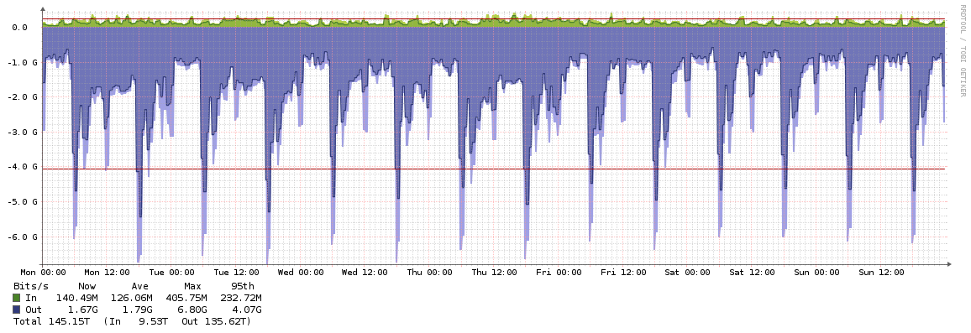
Figure 1 - ECMWF Data Transfer on the Internet 14-21 March 2016

RMDCN Access
- Following the migration to the RMDCN-NG at the beginning of 2014 many user sites upgraded their connection speeds, hence ECMWF in turn upgraded from 200Mbps to 500Mbps.
- ECMWF is operating comfortably within its current RMDCN connection speed, peaking at approximately 130Mbps per day.
- Furthermore, ECMWF and the UK Met Office would like to upgrade their private connection beyond 100Mbps and a project is underway to investigate alternatives to the existing leased line.
- Figure 2 shows the data transfer on the RMDCN for the previous year.
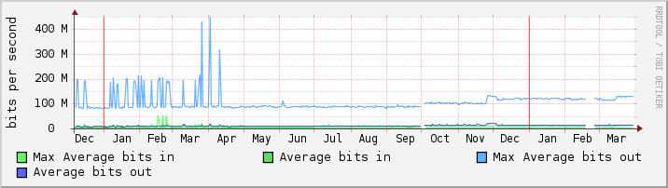
Figure 2 - ECMWF Data Transfer on the RMDCN for the year to March 2016

Acquisition and Dissemination Infrastructure
- ECMWF terrestrial data acquisition and product dissemination systems are now combined:
  - LAN cluster: 6 servers
  - Internet cluster: 19 servers
  - RMDCN cluster: 4 servers
- Data transfer volumes continue to rise, especially since the ECMWF model upgrade in March 2015:
  - Internet: 6.4TB per day
  - RMDCN: 165GB per day
- The number of destinations (hosts) receiving products grows more steadily:
  - Internet: 288 destinations
  - RMDCN: 59 destinations
- The number of data acquisition sources on the Internet is approximately 200.

Technology Updates
- In the past two years several aspects of ECMWF infrastructure have been upgraded to accommodate growth in traffic or development in service requirements:
  - Internet Routers upgraded to accommodate 10Gbps throughput and native Multicast.
  - Firewalls previously Check Point and Fortigate are now Fortigate in LAN, Internet, and RMDCN network zones, capable of 40Gbps on LAN/Internet and 10Gbps on RMDCN.
  - Web/SSH/FTP Proxy deployed based on Sophos anti-malware and malicious web site filtering.
  - SLB/ADC upgraded to F5 with most Internet services being migrated in 2016.

IPv6
- There have been no significant changes to the ECMWF IPv6 infrastructure since the previous ET-CTS status report. ECMWF continues to offer a production IPv6 dissemination and acquisition service on the Internet.
- There has not been any requirement for IPv6 on the RMDCN and indeed this has been excluded from the current technical and commercial refresh discussion.
- There has not been any deployment of IPv6 to the LAN environment at ECMWF. The primary obstacle to this is the integration with other computer systems such as the existing server and desktop environment. There remains no immediate requirement for this solution.

Terrestrial Multicast
- ECMWF participated in the EUMETCast Terrestrial service trials (Internet) in 2015 by hosting a monitoring station for the collection of performance and availability data and statistics. This has recently been decommissioned as the trial came to an end.
- ECMWF has no other active Internet multicast service at present.
- A request for multicast on the RMDCN has been received from EUMETSAT to be included in the RMDCN Technical and Commercial refresh. The service provider, Interoute, will make a technical proposal and also a cost per site for this implementation. As agreed at the RMDCN Operations Committee 2015, this service will be restricted to the EUMETSAT use case and not generally available over the complete RMDCN.

Cloud Computing
- ECMWF has established commercial arrangements with three IaaS cloud providers: Interoute Communications Ltd, CloudSigma Holding AG, and OVH Ltd.
- On Interoute infrastructure ECMWF runs two servers for the monitoring of Internet and RMDCN services respectively, from an external perspective. These servers are integrated into the central Opsview monitoring platform. ECMWF is also supporting the GISC 24Hr Cache Synchronization project using Interoute resources. These projects benefit from the low cost of attaching cloud servers to the RMDCN with this service provider.
- On CloudSigma ECMWF is running a pilot service with FMI to provide access to product data in proximity to FMI computer systems for post processing. CloudSigma in Zurich has a 10Gbps connection to GEANT which allows fast delivery of products to remote ECMWF virtual machine data movers, which are co-located with FMI processing nodes. As this has been successful, the intention is to open the pilot to all ECMWF member states in 2016.
- Within OVH ECMWF is leasing two physical systems located in France and Canada. These are used for testing, and in the case of Canada, as a relay for product dissemination to North American destinations. The dissemination relay project is successful at reducing delays and performance problems, so ECMWF is investigating expansion onto virtual machines in Washington.

Information Security
- ECMWF regularly invites external auditors to assess Information Security practices and implementation status. An audit conducted in 2014 together with an ISO 27001 gap analysis highlighted a lack of Information Security policies and procedures at the Centre.
- ECMWF’s new Information Security governance has been implemented with an Information Security Officer and Information Security Analyst supporting the work of a cross-departmental Information Security Governance Board.
- A Software Security Patch Management Policy has been implemented that establishes controls on operating system level, service pack, hotfix and security patch levels required for all computer systems.
- System-Level and User-Level Password Management policies have been implemented that establish controls on the construction and handling of passwords in different contexts.
- An Information Security Roadmap has been drawn up by the Governance Board to address other critical and major findings of the ISO 27001 gap analysis exercise.

Copernicus Services Offices
- In December 2014 ECMWF signed a delegation agreement with the European Commission to provide the Copernicus Atmosphere Monitoring Service (CAMS) and Copernicus Climate Change Service (C3S). As a result ECMWF established a new Copernicus Services Department and began the recruitment of staff.
- Approximately 45 staff for the Copernicus Services Department are housed away from the existing ECMWF headquarters at office space leased from the University of Reading. These offices have the same ICT environment (desktop, phones, wireless) as the headquarters offices, and are connected to the headquarters site with a dedicated 10Gbps circuit from ECMWF’s Internet Service Provider.
- Having a second site presents ECMWF with many new security and IT management challenges it has not become familiar with over the previous 40 years of operations.

Recommended Text
ECMWF continues to upgrade its TCP/IP environment in line with the requirements of operational services. Several major components of the network and application infrastructure have been upgraded during 2015. Growth in Internet traffic following recent model resolution upgrades will drive the procurement of additional Internet bandwidth. There are new challenges around Information Security, and several projects to investigate the potential use of cloud computing services.
--------------------

