Review of the current status of implementation of TCP/IP procedures and applications at WIS centers

GISC circuits:
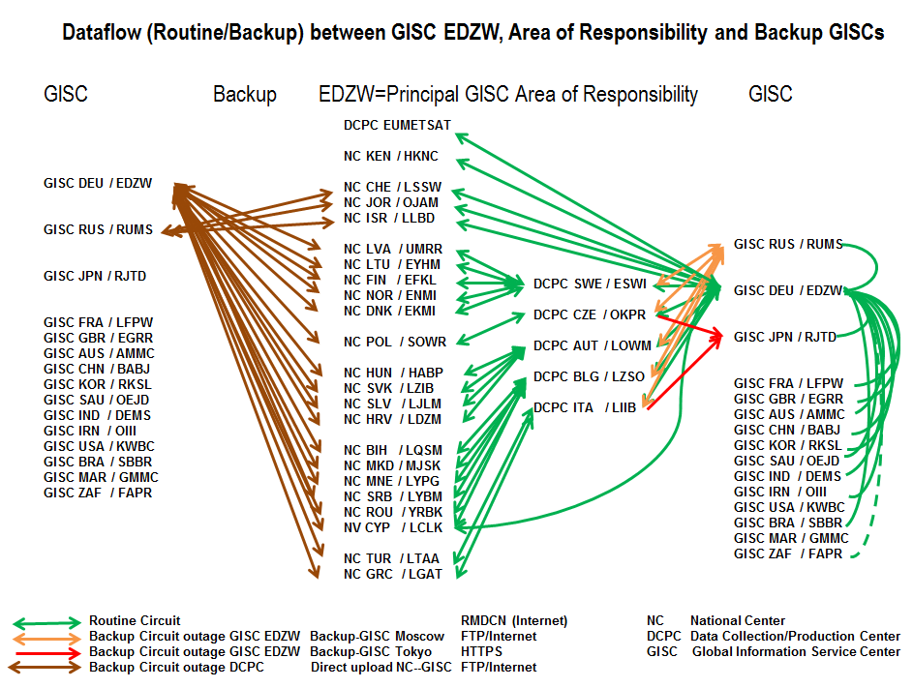

The current connection of GISC Offenbach to the RMDCN is a 50Mbit/s line, and is a Platinum site type.
Dayly Traffic:
Byte char in: 35GB / 92000 files containing 1,5 mio messages
Byte char out: 90GB / 160000 files containing 3 mio messages,
transferred in 72 configured “channels” .

GISC Backup:
The GISC Offenbach Area of Responsibility (AoR) covers 26 countries in RAVI and Nairobi. Backup procedures are running at operational level with GISC Moscow and GISC Tokyo.
NCs connected directly to GISC Offenbach are uploading their data in parallel to Backup GISC Moscow / Tokyo. NCs that are connected via a DCPC/RTH with GISC Offenbach are uploading their data to their DCPC/RTH (which switches these data to GISC Offenbach and to the Backup GISC Moscow / Tokyo) and simultaneously to GISC Offenbach direct.
This dataflow assures that the data of all NCs in the AoR of GISC Offenbach are available in the WIS at either their Principal GISC Offenbach or at the Backup GISC Moscow / Tokyo.
The NCs in the AoR of GISC Offenbach are performing regular (quarterly) download tests from the Backup GISC Moscow. This guarantees that in case of any outage of either GISC Offenbach or their DCPC/RTH, the alternate data access from GISC Moscow / Tokyo can immediately be activated.
These procedures are established in a similar way at GISC Moscow and GISC Tokyo for their AoR with GISC Offenbach as Backup GISC.
Offenbach offers backup via the Internet for all connected WIS partners (ftp). The capacity of the Internet connections in total is 10 Gbit/s, 6,5 Gbit/s in Offenbach (2 ISPs, peering at DE-CIX), and 3,5 Gbit/s at the backup data center.

Recommended Text
WIS center Offenbach has established all circuits in its Area of Responsibility, most of them via the RMDCN. A few of the connections are established using the Internet. The standard data transfer method is now FTP/HTTPs. GISC Offenbach has also established circuits to all operational GISCs, and has invited GISC USA and GISC Morocco to establish the circuits as well.
GISC backup procedures have been set up for both GISC Moscow and GISC Tokyo. All data intended for global exchange are available via a closed user group on an Internet FTP server (EC 65 request).
--------------------

