Establishing a Gateway between GISCs connected to the RMDCN and GISC Tehran

Situation:
Due to a missing license to provide the RMDCN services in Iran, it was not possible for Interoute to connect GISC Tehran to the RMDCN.
The task for ET-CTS therefore was to find an interim solution for the connection of GISC Tehran to the WIS core network (the RMDCN). In an ad-hoc meeting of ET-CTS in October 2014, it was decided to try to connect GISC Tehran using an IPSec tunnel over the Internet from Tehran to a site that has an RMDCN connection, and to relay this traffic then on to the other GISCs on the RMDCN.
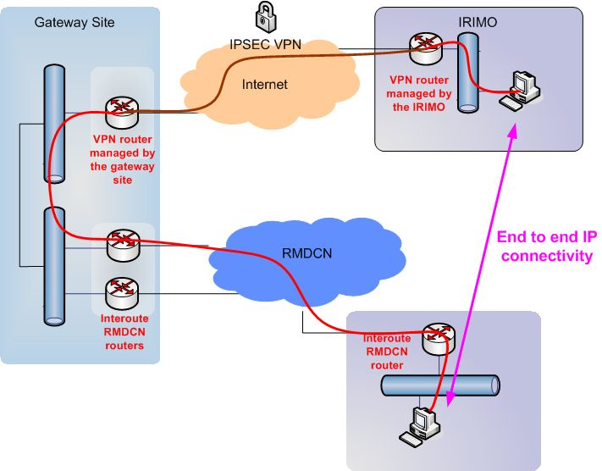

To minimize the impact on the gateway side, it was decided that the connection to the RMDCN should have a capacity of at least 8Mbit/s.
The chair of ET-CTS then asked for WIS sites that would be willing to act as this gateway (in November 2014). The timeline at this point was to deploy this solution for GIS Tehran in QI-2015.

Activities since November 2014:
GISC Offenbach offered to try to set up this solution as a gateway. The current RMDCN access capacity of 50Mbps, and the Internet connection with a capacity of > 5Gbps are seen as sufficient for this data exchange.
The first step was to set up the IPSec tunnel between Offenbach and Tehran for the exchange of data between the two GISCs, and then exchange data for a period of 3 month over the tunnel use to verify the technical solution, and also the robustness and reliability.
The necessary technical discussions on the IPSec parameters with GISC Tehran started early in December 2014, with the aim of implementing the tunnel in January 2015.
Unfortunately, it then took a very long time to finally set up the IPSec tunnel successfully. This was caused by configuration issues, as well as regulatory issues.
The setup of the IPSec tunnel was finally completed in June 2015.
The change request for advertising the routes for GISC Tehran has been realized, the network 185.14.81.0/24 is now being injected by the RMDCN routers at GISC Offenbach.
GISC Toulouse agreed on testing the connection to GISC Tehran via the RMDCN, the connection could be established in early March 2016.

Experiences:
The transfer of a reduced amount of data is working most of the time, but there are sometimes delays / disruptions in the transfer process.
A second “channel” is configured to transfer files of 1,5Mbyte every 15s to test the throughput. This results in wait queues more often, and also in many transfer interruptions.
The maximum throughput seems to be limited to 1,5Mbps sustained. It cannot be influenced from our side, and it probably depends on the other usage of the Internet at GISC Tehran as well.
The response times in failure/problem situations from GISC Tehran are too long, that’s why finding the root cause of this is very difficult. The VPN tunnel itself is stable.
GISC Toulouse is also regularly exchanging data with GISC Tehran over the IPSec tunnel, and there the same problems are seen (data transfer to Tehran is less reliable than receiving data from there).
The graphic below shows a snapshot from March 16, 2016.
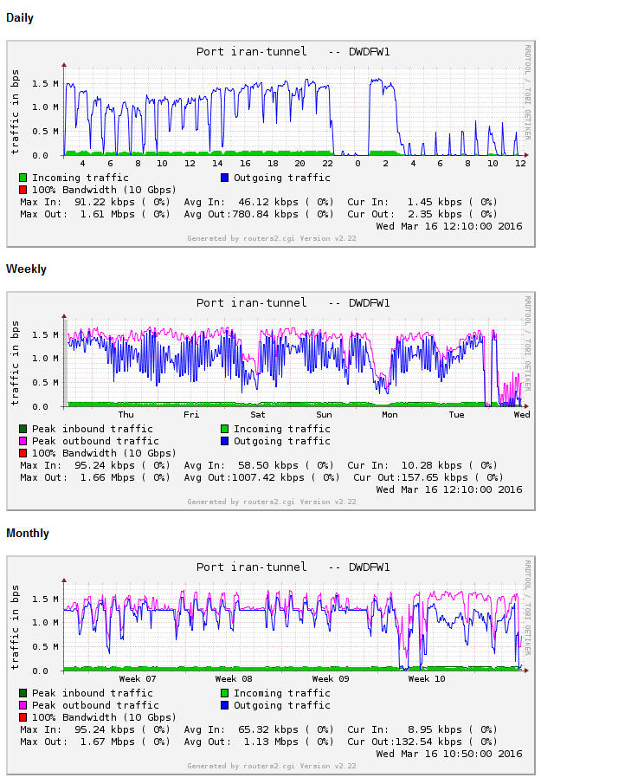
On March 18, we have a situation again, where there are a lot of connection timeouts, and a stable data transfer is not possible.
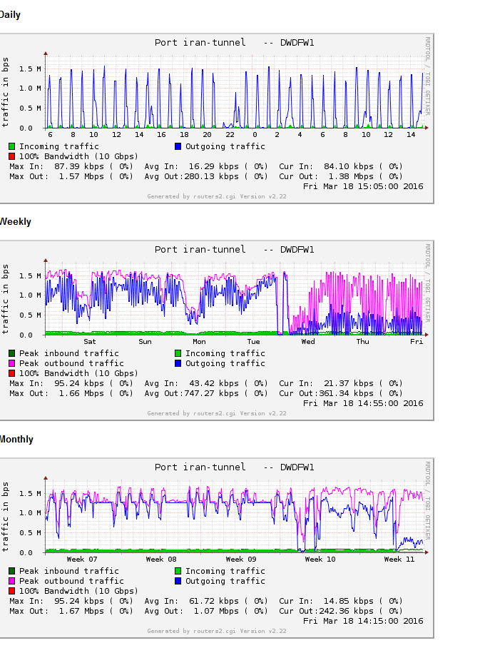

Next steps:
The meeting is invited to discuss this interim solution as an operational connection of GISC Tehran to the core WIS network.
The probability is high that the wait queues for sending traffic to GISC Tehran will grow when more GISCs start to send their data via the IPSec tunnel. Should this be verified by including one more GISC into the test period?
DWD suggests to contact GISC Tehran again on this matter asking them to find a reason for the data transfer timeout, and maybe ask to upgrade their Internet connection (WMO secretariat?). It would maybe also helpful if one or 2 more GISCs would join this test period to verify the assumption above.
If a more stable data transfer can be achieved, DWD would offer to run this setup as an interim solution.
DWD cannot offer a management for this tunnel. GISCs would have to solve problems bilaterally.
However, it might be possible to include the tunnel in the RMDCN monitoring pages (ECMWF?).
A parallel way forward may be to ask Interoute if they can now provide a direct connection, after many of the sanctions against Iran have been lifted.

Recommended Text
The meeting noted that an IPSec tunnel between GISC Tehran and GISC Offenbach had established successfully. While the tunnel itself is stable, the data transfer over it has a lot of timeouts. The meeting thanked DWD for its efforts in supporting IRIMO and for making major step towards connecting all GISCs on the WIS Core Network.
The meeting noted that if the cause for the timeouts can be found and solved, DWD would offer to run this solution as an interim solution to connect GISC Tehran to the WIS core network, but would not be able to offer support in troubleshooting problems between GISCs. The meeting expressed its concern that it will be impossible to move to such an interim solution if IRIMO do not respond promptly to addressing the requests of DWD to IRIMO aiming to resolve the issues associated with maintaining the traffic flow over the tunnel. The meeting asked the secretariat to contact IRIMO to see if this matter can be addressed. If it is, then the next steps would then be:
- Report to OPAG-ISS outlining the technical solution and describing the procedures for the handling of the data exchange.
procedures: GISC Offenbach would need a complete list of all hosts of the GISCs that would participate in the data exchange, and it is necessary for GISC Tehran to have a contact point for 24/7 operations. After configuring the security policy accordingly, and having tested the connection successfully, any further problems should be handled directly between the GISCs.
- OPAG-ISS in consultation with the CBS president and WMO Secretariat will take further steps to initiate the connection to the WIS core network.
The meeting also requested ECMWF and the UK to monitor the situation effecting full implementation of the RMDCN in GISC Tehran with an aim to moving to a more permanent solution. It noted however, that ECMWF is now caught up in the mid cycle review of the RMDCN contract and that distracting the supplier by readdressing the IRIMO connection would be untimely. It decided that given the history of this connection issue, it is better to not restart the application process until more certain of the outcome.

--------------------

