World Meteorological Organization | CBS-MG-16/Doc. 08-1
COMMISSION FOR BASIC SYSTEMS  MANAGEMENT GROUP | Submitted by: | Chair, OPAG/PWS
COMMISSION FOR BASIC SYSTEMS  MANAGEMENT GROUP | Date: | 06.II.2016
Sixteenth Session  Geneva, 15-19 February 2016 | Original Language: | English
Sixteenth Session  Geneva, 15-19 February 2016 | Status: | DRAFT 1

Agenda Item 3.2: cbs structure – opagS AND EXPERT TEAMS

FUTURE DIRECTION OF OPAG/PWS

SUMMARY
This document summarises the discussions held during the meeting of the ICT/PWS in December 2015 (Dublin) concerning the future direction and structure of the OPAG/PWS and brings forward proposals to CBS Management Group for consideration.

DECISIONS/ACTIONS REQUIRED:
CBS Management Group is invited to recommend to the forthcoming Session of the Commission changes to the structure of the OPAG/PWS as described in paragraph 6 below.

BACKGROUND

8-1.1. Management Group notes that OPAG/PWS has a central position within WMO in the promotion and advancement of Service Delivery among NMHSs. The key document – the Service Delivery Implementation Plan – is effectively “owned” by the PWS Programme. There is also, however, a recognition that the concepts of Service Delivery have a broader-based applicability than the traditional areas of responsibility of PWS - for example in the area of Climate Services, as well as services provided through other application areas of meteorology, such as agriculture, aviation and marine. The Service Delivery Progress Model, as defined in the Implementation Plan, is applicable across all of these areas.

8-1.2 The ICT/PWS recognised that a framework is needed which would promote the cascading of best practice in Service Delivery from NMHSs which are advanced in this area to those which would benefit from support and mentoring to improve their delivery of services to users.

8-1.3 The ICT/PWS reflected on proposals that the OPAG/PWS change its name from the “OPAG on Public Weather Services” to the “OPAG on Service Delivery”. It considered that such a change is not appropriate because of the importance of Service Delivery to other areas beyond the remit of the OPAG – and indeed beyond the remit of the Commission for Basic Systems.

8-1.4 In recognition of the importance of Service Delivery, however, and also acknowledging that much of the work of the OPAG since its foundation had, in fact, been focused on aiding NMHSs to improve their Service Delivery, the ICT/PWS wishes to propose to CBS that the name of the OPAG be changed to the “OPAG on Public Weather Services Delivery (OPAG/PWSD)”. The ICT/PWS feels that this formulation accurately reflects both the importance of Service Delivery and the remit of the OPAG within CBS. Management Group is asked to support this proposal.

8-1.5 Management Group notes the outcome of the meeting of the Task Team on Impact-Based Forecasting, held in Geneva in February 2015, and in particular the proposed structure of an “Impact Advisory Group” which would oversee the establishment of a resource group of experts who could facilitate projects in Impact-Based Forecasting and also assist in the establishment and oversight of individual projects. This approach would help in bringing together both development partners and experts to focus on specific challenges. This approach may be useful model for a new structure for OPAG/PWS.

Actions and decisions for consideration by the CBS-MG

8-1.6 Management Group is invited to support the following structure for the OPAG/PWS, to be proposed to the Commission at the forthcoming Session in November 2016:

- That the name of the OPAG on Public Weather Services be changed to the “OPAG on Public Weather Services Delivery (OPAG/PWSD)”. (Annex I shows a diagrammatic representation of the proposed new structure of the OPAG on Public Weather Service Delivery).

- That the structure of the OPAG would henceforth move towards the establishment of Task Teams (TTs) which would be focused on specific, time-bound, objectives.

- That the areas of Communications, Competency Assessment, Service Delivery and Quality Management were fundamental enablers to the work of the OPAG, and that any Task Teams formed to address these areas would report directly to the ICT/PWS(D).

- That the existing Expert Team on Communication, Outreach and Public Education (ET/COPE) would be disbanded and its responsibilities transferred to the ICT, to be devolved to specific Task Teams as may be established to address particular issues.

- That a Task Team be established to work closely with the WMO/ETR Programme to assist in the development of suitable material to support Members in the implementation of the “Competency Framework for PWS Forecasters and Advisors” as approved by Resolution 4 of Cg-17.

- That the existing Expert Team on Meeting User Needs in Reducing the Impact of Hydro-Meteorological Hazards (ET/DPM) be re-named ET/IMPACT. This Expert Team would effectively take over the responsibilities of the “Impact Advisory Group” as referred to in para 5 above.

- That possible focus areas for Task Teams to be established under ET/IMPACT would include specific country or region-based projects, social and economic benefit assessments, and the interface with users.

- That the existing Expert Team on Services and Products Innovation and Improvement (ET/SPII) would be retained to assist Members with the application of technological developments to the effective delivery of public weather services.

- That possible focus areas for Task Teams to be established under ET/SPII would include Big Data, Nowcasting, application of the Common Alerting Protocol (CAP), further development of World Weather Information Service/Severe Weather Information Centre (WWIS/SWIC), GIS-compatibility of meteorological information, and the optimum exploitation of smartphone technology.

- That ET/SPII would also work in close collaboration with the OPAG/DPFS to facilitate the rapid and efficient application of new and emerging science and technology to improved service delivery.

8-1.7 Revised Terms of reference for the OPAG/PWS(D) to reflect the proposed new structure have been drafted and are presented in Annex II below. Management Group is invited to consider these revised ToRs for ratification.

8-1.8 Terms of Reference for the two constituent Expert Teams within the proposed revised structure for the OPAG/PWS(D) are presented in Annex III below. Management Group is invited to consider these ToRs for ratification.

____________

Annex I - DIAGRAMMATIC REPRESENTATION OF THE PROPOSED NEW STRUCTURE OF THE opag ON pUBLIC WEATHER SERVICE DELIVERY

Governance, structure and linkages of the CBS- Public Weather Services and Delivery Implementation/Coordination Team
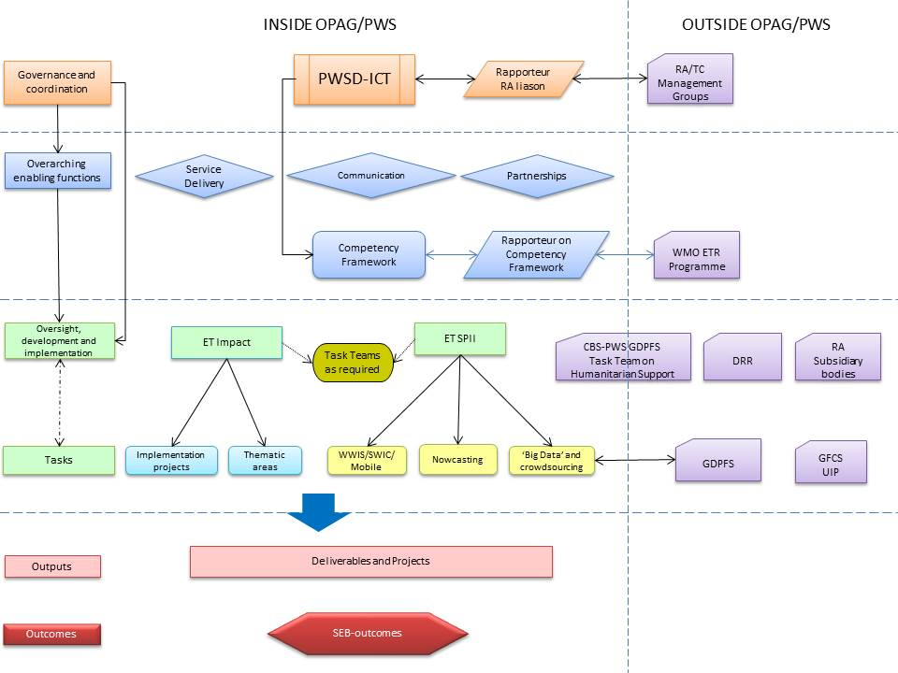

ANNEX II

DRAFT Terms of Reference (TORs) of the ICT/PWS(D)

- The following draft Terms of Reference (TORs) were agreed by the ICT/PWS for presentation to CBS-MG and ultimately to CBS-16 for consideration:

Draft ToRs of the OPAG on Public Weather Service Delivery
- Coordinate the implementation of the decisions of Congress, the Executive Council and the Commission for Basic Systems (CBS) with respect to Public Weather Services;
- Consult and collaborate to ensure coordination of the work of the Open Programme Area Group (OPAG) on PWSD with that of other CBS OPAGs, technical commissions (TCs), EC Working Groups, regional associations (RAs) and WMO Programmes and initiatives;
- Support a strengthening of partnerships between National Meteorological and Hydrological Services (NMHSs), other agencies, and user sectors (e.g., media, health, emergency management) in areas relevant to PWSD;
- Through the constituent teams of the OPAG, promote the implementation of the WMO Strategy for Service Delivery in the context of Public Weather Services, and making full use of emerging technologies;
- Keep under review the work of the PWSD Expert Teams and co-ordinate and guide their work programmes;
- Continue to encourage and provide guidance to Members to assert the authority of NMHSs as the sole providers of official high-impact weather warnings;
- Facilitate the development of guidance and training material to underpin and support those elements of the WMO competency framework relevant to PWS-related activities;
- Support and promote excellence in communication as a key enabler of quality service delivery;
- Collaborate with development partners and other WMO entities to assist NMHSs in the identification and assessment of societal, economic and environmental benefits of hydro-meteorological services; and
- Continue to promote the awareness and use of guidance documents developed through the work of the OPAG, in collaboration with Regional Associations, and by other means.
- Guide the work of the OPAG to assist Members in developing their capacity to deliver improved services though the use of the best science and emerging technologies.

t____________

ANNEX III

DRAFT Terms of Reference (TORs) of CONSTITUENT eXPERT TEAMS of the OPAG/PWSD

Draft ToRs of the Expert Team on Service Provision Innovation and Improvement

- Monitor, evaluate and advise on challenges and opportunities for Public Weather Service Delivery presented by developing science and technology;
- Address the user requirements identified by ET/ IMPACT for data provision, management and visualisation, through collaboration with DPFS and other partners as necessary;
- Take responsibility for, and review PWS guidance on, scientific and technical aspects of Service Delivery improvement, including nowcasting, uncertainty, CAP and mobile/web services.
- Identify experts to advice on technical aspects of Service Delivery improvement as required.
- Provide oversight, quality assurance and coordination of the continuing development of WWIS/SWIC

Draft ToRs of the Expert Team on Impact-Based Forecasting and Risk-Based Warning

- Building on the WMO Guidelines on Multi-hazard Impact-Based Forecast and Warning Services (WMO No. 1150), develop an implementation strategy which describes next actionable steps and evolution.
- Develop and maintain an expert resource to facilitate activities and projects in the area of Impact-Based Forecasting, including representatives from the social sciences.
- Create a network of champions, ambassadors, and change agents within NMHSs, their partners, and users to support and promote Impact-Based Forecasting.
- Actively promote Impact-Based Forecasting by sharing best practices through symposiums, journal papers and communication outlets.
- Provide NMHSs with guidance on how to standardize Impact-Based Forecasting messaging protocols and formats (e.g. colour-coding, language, icons etc.).
- Working with Technical Commissions, Regional Associations, and ET/SPII within the OPAG/PWSD, establish user requirements for service improvements through science and technological innovation.
- Evolve current methodologies for verification and evaluation to incorporate a focus on Socio-Economic Benefits.

Draft ToR for the Coordinator on the Competency Framework

- Facilitate the development of guidance and training material to underpin and support those elements of the WMO competency framework relevant to PWS-related activities.

Draft ToR for the PWSD Rapporteur on Regional Association Liaison

- Consult and collaborate to ensure coordination of the work of the Open Programme Area Group (OPAG) on PWSD with Regional Associations (RAs) and their subsidiary bodies.

_____________

