24h cache completeness

Abstract

This paper will report the basic status of the bulletins in 24h cache based on analysis of the information provided by 7 GISCs.

Background
GISC Beijing, GISC Exeter, GISC Melbourne, GISC Moscow, GISC Offenbach, GISC Seoul and GISC Toulouse provided the information of bulletins which is put into 24h cache from 00:00 to 23:59 on 16 Sep 2015 as below:
1) TTAAII, number of files, size of files
Eg: IEIX01, 16534, 801.15MB
2) CCCC, number of files, size of files
Eg: EUMP, 1014861, 27380.71MB
In order to comprehend the completeness and consistency of 24h cache in GISCs, GISC Beijing analyzed this information and compared the analytical results with the VolC1 and WIS GTS metadata.

Ingredient of data in 24h cache
By Summing the number of files in 7 GISCs’ cache for unique TTAAII and analyzing the ingredient of data identified with T1, we found the main ingredients of bulletins is the data designator T1 is “I”, “S" ,“H” and “U”.

T and TT | File Number | Number Percent | File Size (MB) | Size Percent
A | 214 | 0.01% | 0.47 | 0.00%
B | 236 | 0.01% | 0.09 | 0.00%
C | 147 | 0.00% | 0.50 | 0.00%
E | 1464 | 0.04% | 0.47 | 0.00%
F | 24904 | 0.73% | 20.14 | 0.03%
G | 570 | 0.02% | 0.70 | 0.00%
H | 340000 | 9.92% | 10929.49 | 16.95%
I | 2004309 | 58.48% | 49818.29 | 77.26%
IE | 713563 | 20.82% | 26874.25 | 41.68%
IM | 288 | 0.01% | 39.40 | 0.06%
IN | 799119 | 23.32% | 17699.43 | 27.45%
IO | 20237 | 0.59% | 39.42 | 0.06%
IP | 288 | 0.01% | 37.47 | 0.06%
IR | 5029 | 0.15% | 205.09 | 0.32%
IS | 225600 | 6.58% | 2211.95 | 3.43%
IU | 216408 | 6.31% | 2474.05 | 3.84%
IX | 23777 | 0.69% | 237.23 | 0.37%
J | 16242 | 0.47% | 137.08 | 0.21%
K | 6588 | 0.19% | 14.66 | 0.02%
M | 37 | 0.00% | 0.01 | 0.00%
N | 28 | 0.00% | 0.03 | 0.00%
P | 40069 | 1.17% | 1571.05 | 2.44%
Q | 548 | 0.02% | 109.36 | 0.17%
S | 863402 | 25.19% | 384.28 | 0.60%
T | 11975 | 0.35% | 71.73 | 0.11%
U | 95374 | 2.78% | 44.72 | 0.07%
V | 1186 | 0.03% | 426.58 | 0.66%
W | 6284 | 0.18% | 3.77 | 0.01%
Y | 13749 | 0.40% | 951.55 | 1.48%
Grand Total | 3427326 | 100.00% | 64484.99 | 100.00%
Table 1 Ingredient identified with T1T2 of 24h cache data measured by file number and file size

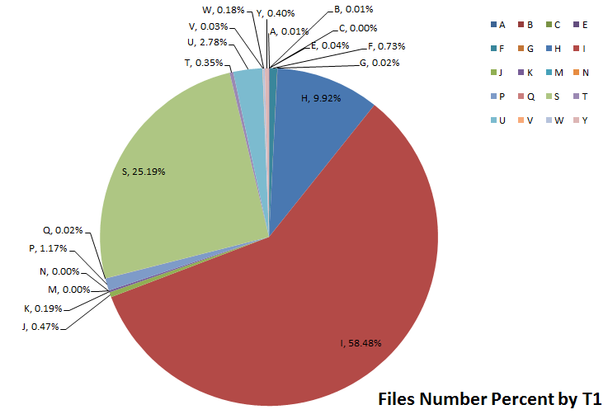
By Summing the number of files in 7 GISCs’ cache for unique CCCC and analyzing the ingredient of data identified with data origin, we found the main ingredients of bulletins is the data originated from EUMP, EUMC , RJTD, EUMS, EGRR, KWBC, EHDB, LFPW, EDZW, AMMC, and KNES etc.
CCCC | File Number | Number Percent
EUMP | 1014861 | 40.23%
EUMC | 285056 | 11.30%
RJTD | 251896 | 9.98%
EUMS | 233312 | 9.25%
EGRR | 162469 | 6.44%
KWBC | 143732 | 5.70%
EHDB | 109372 | 4.34%
LFPW | 91953 | 3.64%
EDZW | 63642 | 2.52%
AMMC | 47682 | 1.89%
KNES | 31212 | 1.24%
EUMG | 28912 | 1.15%
DEMS | 18444 | 0.73%
RKSL | 8789 | 0.35%
KARP | 8227 | 0.33%
EKMI | 7724 | 0.31%
OKPR | 6440 | 0.26%
LSSW | 6026 | 0.24%
HABP | 1749 | 0.07%
ECMG | 1432 | 0.06%
… | … | …
Table 2 Ingredient identified with CCCC of 24h cache data measured by file number

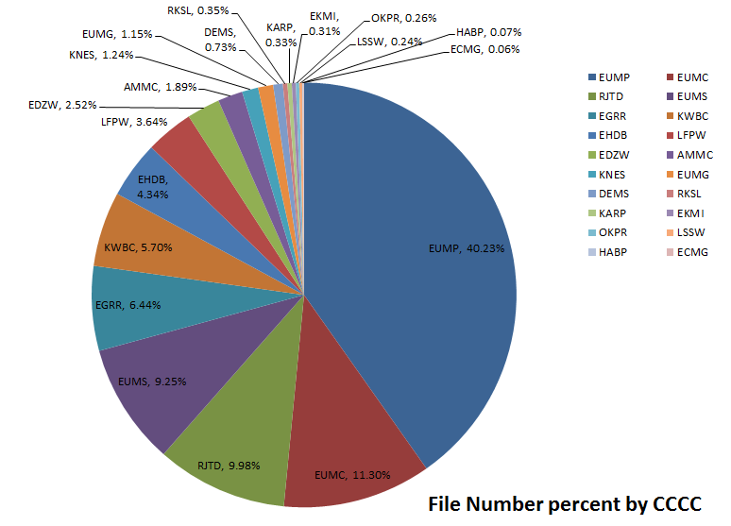

Consistency of 24h cache in GISCs
There are 64,485 MB data in 3,427,326 files in the 7 GISCs’ 24h cache in total.
GISC Name | Sum of Size (MB) | Number of Files
GISC OFFENBACHE | 18465.49 | 847263
GISC BEIJING | 16345.64 | 850164
GISC MOSCOW | 12792.15 | 378671
GISC EXETER | 8053.93 | 592188
GISC TOULOUSE | 6039.74 | 246341
GISC MELBOURNE | 1498.24 | 355228
GISC SEOUL | 1289.80 | 157471
TOTAL | 64484.99 | 3427326
Table 3 Total number and size in the 7 GISCS’ 24h cache
There are clear difference between the 7 GISCs both in file number and file size.
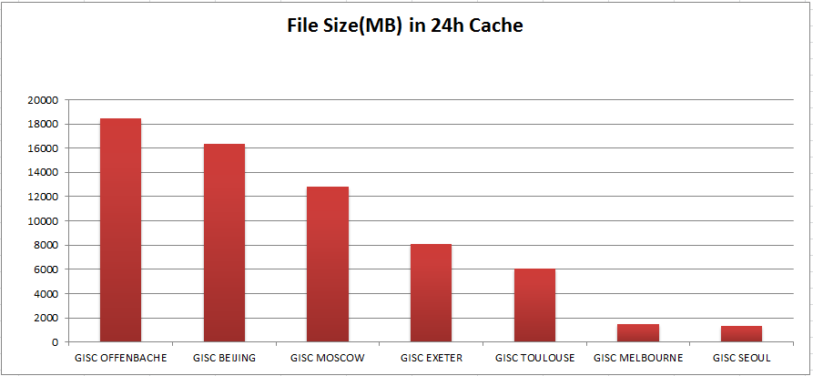
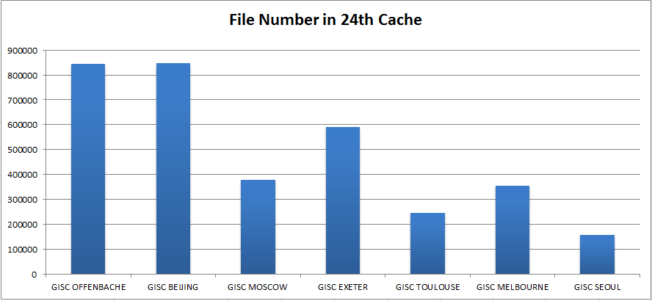

Beijing
There are 850,164 files put into 24h cache in GISC Exeter from 00:00 to 23:59 on 16 Sep 2015. Total size is 16,345MB. Bulletins with data designator T1 is “I” or Bulletins with CCCC is “EUMP”,”EUMC”,“EDZW” are the main ingredient of 24h cache.
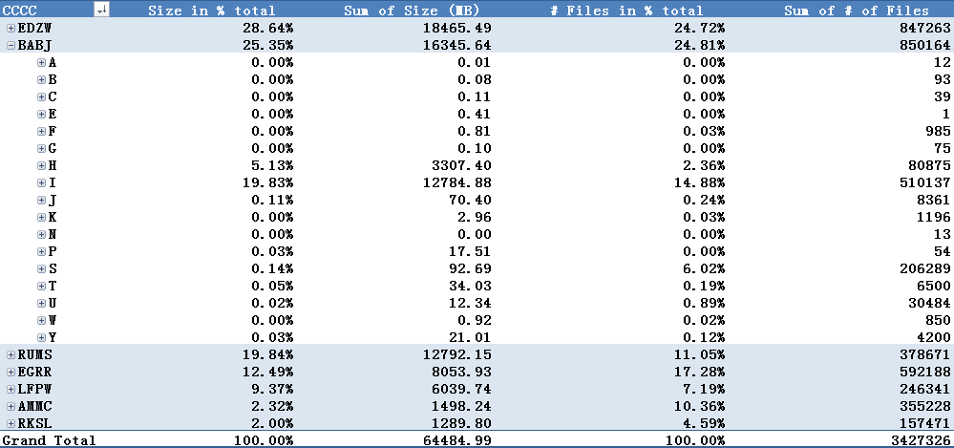
Table 4 Ingredient identified with T1 in GISC Beijing’s 24h cache
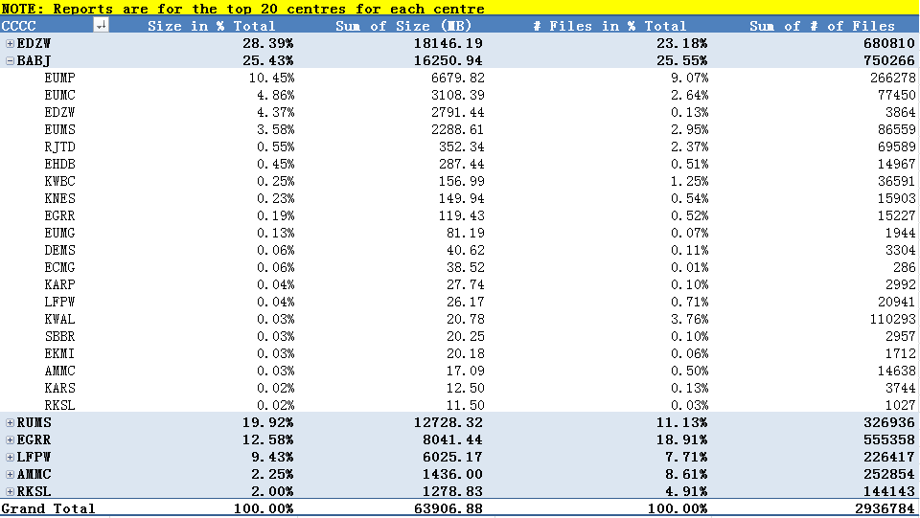
Table 5 Ingredient identified with CCCC in GISC Beijing’s 24h cache

Exeter
There are 592,188 files put into 24h cache in GISC Exeter from 00:00 to 23:59 on 16 Sep 2015. Total size is 8,053MB. Bulletins with data designator T1 is “I” or Bulletins with CCCC is “EUMP”,”EHDB”,“EUMS” are the main ingredient of 24h cache.
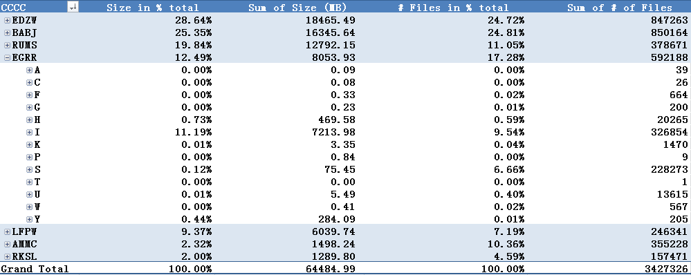
Table 6 Ingredient identified with T1 in GISC Exeter’s 24h cache
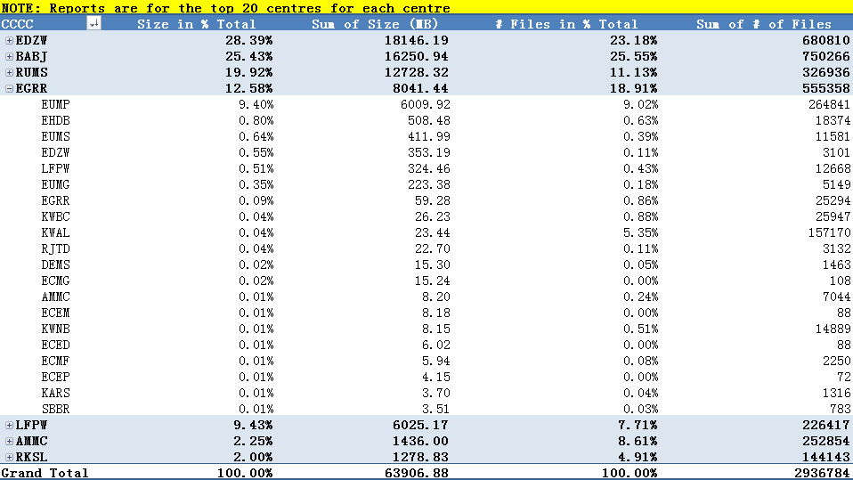
Table 7 Ingredient identified with CCCC in GISC Exeter’s 24h cache

Melbourne
There are 355,228 files put into 24h cache in GISC Melbourne from 00:00 to 23:59 on 16 Sep 2015. Total size is 1,498MB. Bulletins with data designator T1 is “I” or Bulletins with CCCC is “EHDB”,”EUMG”,“EUMS” are the main ingredient of 24h cache.
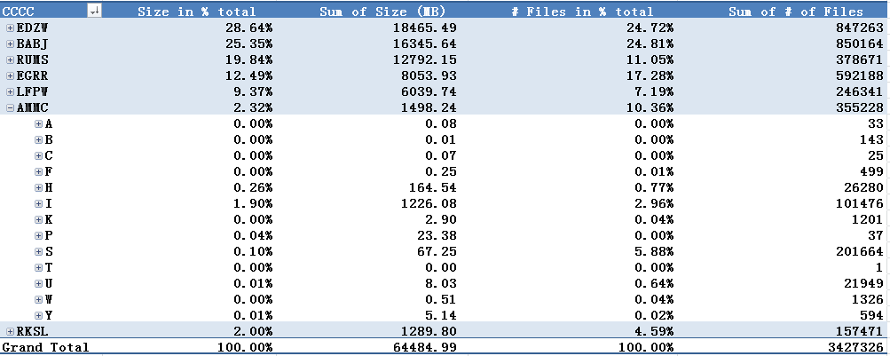
Table 8 Ingredient identified with T1 in GISC Melbourne’s 24h cache
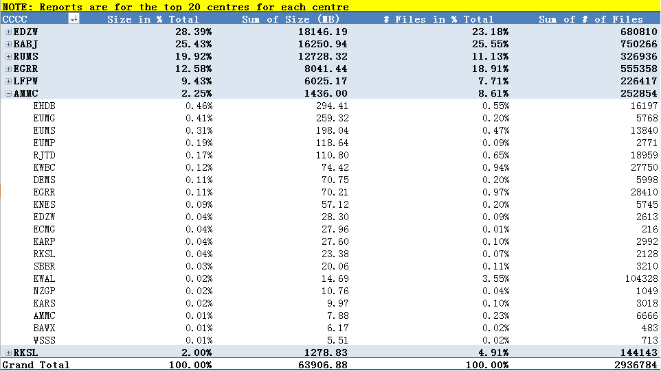
Table 9 Ingredient identified with CCCC in GISC Melbourne’s 24h cache

Moscow
There are 378,671 files put into 24h cache in GISC Moscow from 00:00 to 23:59 on 16 Sep 2015. Total size is 12,792MB. Bulletins with data designator T1 is “I” or Bulletins with CCCC is “EUMP”,”EDZW” and “EUMC”are the main ingredient of 24h cache.
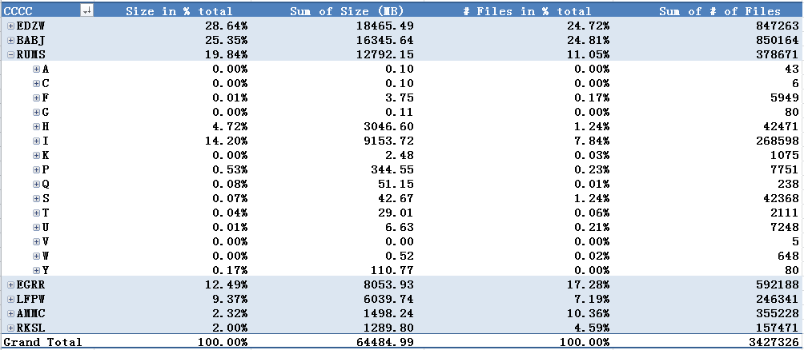
Table 10 Ingredient identified with T1 in GISC Moscow’s 24h cache
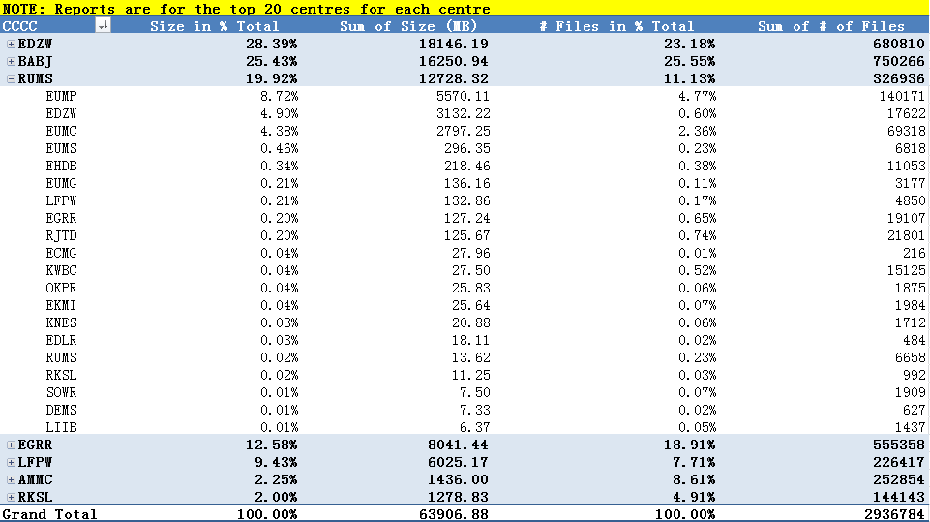
Table 11 Ingredient identified with CCCC in GISC Moscow’s 24h cache

Offenbach
There are 847,263 files put into 24h cache in GISC Offenbach from 00:00 to 23:59 on 16 Sep 2015. Total size is 18,465 MB. Bulletins with data designator T1 is “I” or Bulletins with CCCC is “EUMP”,”EDZW” and “EUMC”are the main ingredient of 24h cache.
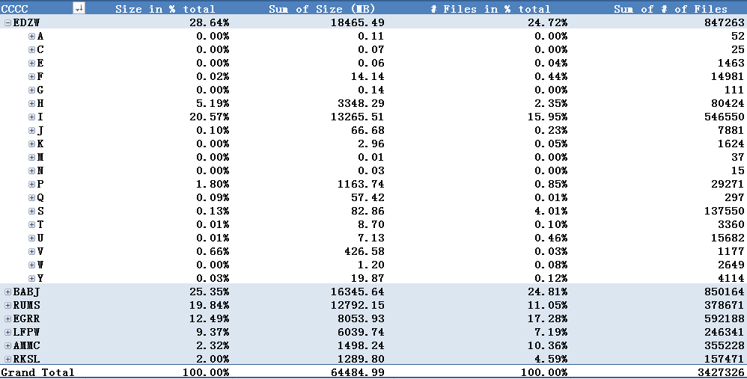
Table 12 Ingredient identified with T1 in GISC Offenbach’s 24h cache
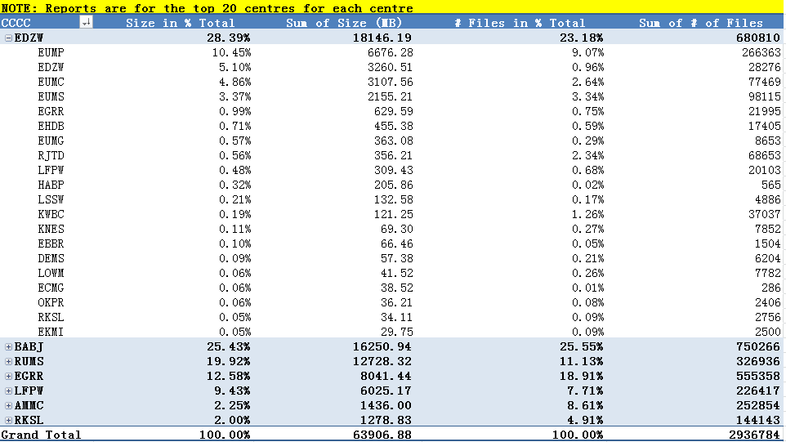
Table 13 Ingredient identified with CCCC in GISC Offenbach’s 24h cache

Seoul
There are 157,471 files put into 24h cache in GISC Seoul from 00:00 to 23:59 on 16 Sep 2015. Total size is 1,289 MB. Bulletins with data designator T1 is “I” or Bulletins with CCCC is “EHDB”,”RJTD” and “LFPW”are the main ingredient of 24h cache.
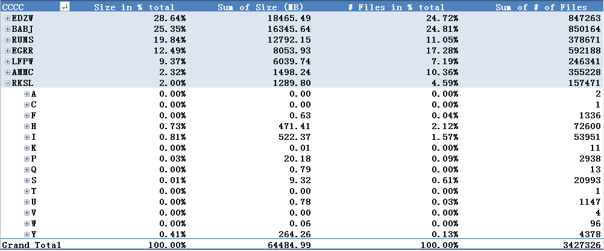
Table 14 Ingredient identified with T1 in GISC Seoul’s 24h cache
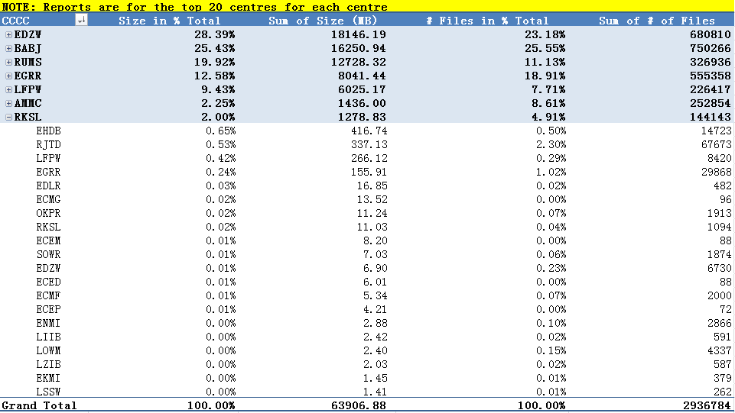
Table 15 Ingredient identified with CCCC in GISC Seoul’s 24h cache Toulouse

Toulouse
There are 246,341 files put into 24h cache in GISC Toulouse from 00:00 to 23:59 on 16 Sep 2015. Total size is 6,039 MB. Bulletins with data designator T1 is “I” or Bulletins with CCCC is “EUMP”,”ECMC” and “EUMS”are the main ingredient of 24h cache.
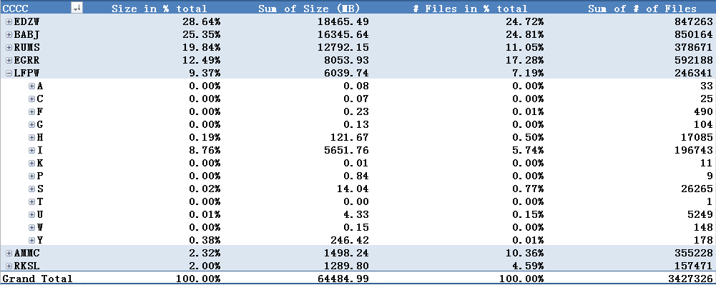
Table 16 Ingredient identified with T1 in GISC Toulouse’s 24h cache
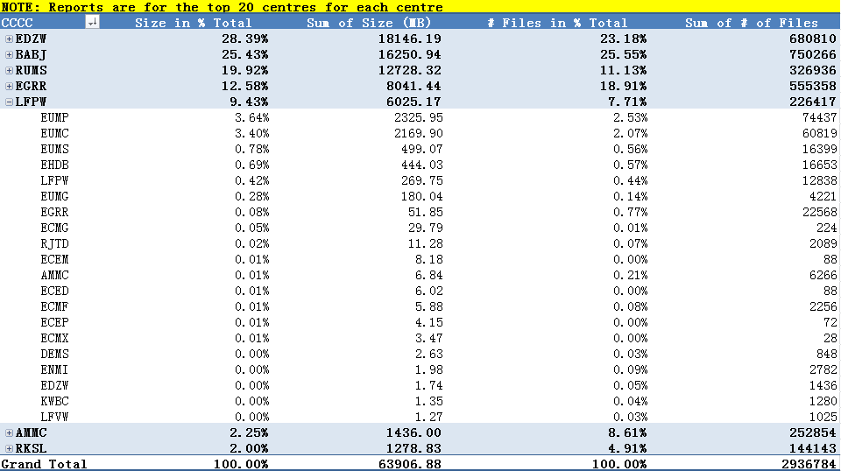
Table 17 Ingredient identified with CCCC in GISC Toulouse’s 24h cache

Completeness of 24h cache

We found it is difficult to measure the completeness of 24h cache. We compared the 24h cache information provided by 7 GISCSs with Volc1 and WIS GTS metadata.

Compare 24h cache with VOLC1
There are 77,789 unique TTAAii and 1,509 CCCC in VolC1. And GISC Caches have 39,551 unique TTAAii and 1,229 CCCC. There are 35,118 unique TTAAii and 413 CCCC are both in VolC1 and 24h Cache.

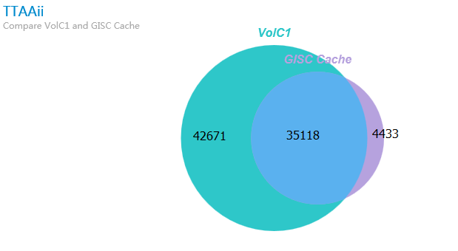
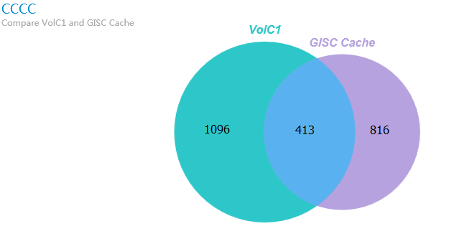

Compare 24h cache with WIS GTS metadata
There are 37,685 unique TTAAii and 210 CCCC in WIS GTS metadata. And GISC Caches have 39,551 unique TTAAii and 1,229 CCCC. There are 31231 unique TTAAii and 172 CCCC are both in WIS GTS metadata and 24h Cache.

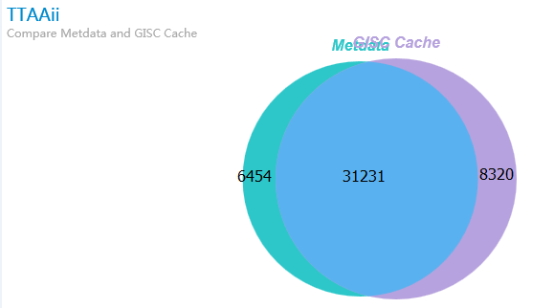
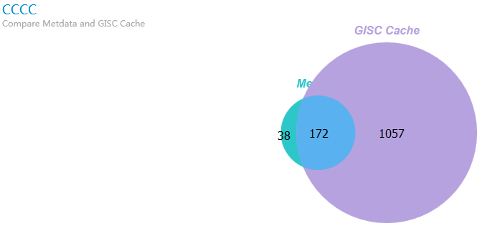
Because the 24h cache used to compare includes only one day’s data, there are some lacks in data cache is reasonable. But there are many lacks in VolC1 and WIS GTS metadata, which should be mark up as soon as possible.

Recommended Text For Report
TT-GISC appreciated CMA’s initiative for providing a cache monitoring. The meeting noted that the ITT-WIS has still to determine the governance process for the implementation of the Global Exchange and cache me flag and that once this governance is resolved, the cache management will be managed by the flag. In the meantime we are able to see the results of the cache management, including the variability across GISCs resulting from this approach.

TT-GISC agreed that future analyses should include all GISCs

The meeting noted the presented report from CMA and realized that the data in GISCs 24h cache is clearly different from VolC1 and WIS GTS metadata, TT-GISC noted that this paper is a starting form for monitoring and agreed to provide this report to the WIS Monitoring Team to take into consideration.

The meeting requested that the GISCs investigate the difference between the bulletins on GTS in their area of responsibility and WIS GTS metadata provided by GISCs as soon as possible.
CMA agreed to upload the raw data sets to assist GISCs in their analysis.

