The use of metadata in the development of long-term climate data sets – the example of the Australian ACORN-SAT data set
Blair Trewin, Australian Bureau of Meteorology
The development of long-term climate data sets requires consideration of any factors which may produce a non-climatic influence on the data, in order to ensure that the data set reflects the behaviour of the background climate, and not the influence of changes in the way the data are observed or in the local environment in which they are reserved. Such changes can include:

- Site moves
- Changes in instruments (including changes in instrument shelters)
- Changes in the local site environment (e.g. urban development, vegetation)
- Changes in observer
- Changes in observation procedures (e.g. change in observation time)

The process of removing such influences from a data set is known as homogenisation. Metadata are of major importance in determining the extent to which changes have occurred, and when.

The Australian ACORN-SAT data set and the Australian metadata environment

The Australian Climate Observations Reference Network – Surface Air Temperature (ACORN-SAT) data set is a data set of daily maximum and minimum temperature data covering the period from 1910 to the present. It consists of 112 stations from around Australia, with 60 of these having data from the full 1910-2014 period.

Only one of the 112 stations was found to be homogeneous throughout its period of record, so it was necessary to carry out homogeneity tests and make adjustments for all of the other stations. The detection of inhomogeneities was carried out using a combination of statistical testing (involving the comparison of the candidate station with data from other stations in the region) and metadata.

There are a number of different sources of metadata in Australia. These include:

- The Bureau of Meteorology’s digital metadata database (SitesDB). This contains a large range of information, including details of site moves, station inspection reports, station photographs and diagrams, and information on instruments and tolerance checks of them. SitesDB has been routinely populated since it was established in 1997, but contains only very limited pre-1997 information.
- Hard-copy station history files. These are established for each station, with separate files being maintained in the Bureau’s head office in Melbourne, and the regional office in the capital of the state/territory where the station is located. (Most of the documents in the head office files have been scanned, but not indexed). These contain extensive site information in more recent years, but information becomes significantly sparser in earlier years. They also contain many documents of limited or no relevance for climate (e.g. financial records relating to observer payments). The completeness of documentation varies; typically instrument changes are well documented (probably because they involve the spending of public money), whereas information on changes in the local site environment, especially outside the immediate instrument enclosure, is often limited or non-existent.
- Bureau observer instructions and procedures. These are not consistently indexed and can be quite difficult to locate in some cases. These can be considered as “general” metadata (as opposed to station-specific metadata) as they document matters which affect much or all of the network simultaneously.
- Instrument books. These are hard-copy ledgers in which details of instruments issued to sites are listed, covering primarily the period from the 1880s to the 1910s/1920s (Queensland and South Australia have particularly comprehensive ones). Their main interest in the context of ACORN-SAT is in documenting the date of Stevenson screen installation, which mostly took place from 1906-1908 in New South Wales and Victoria, and from the late 1880s to the mid-1890s at most sites in other states.
- Other documents describing instruments or observing procedures. These were often published in annual reports or similar publications, but can also be found in other locations, not all of which might be expected. (For example, details of changes to observation procedures resulting from the introduction of daylight saving time (as a temporary wartime measure) in 1917 were found in a Brisbane newspaper).

The clearest evidence of all of a change at a site is a change in station number. It is now standard practice in Australia for a new station number to be issued when there is a significant site change. However, this is only a relatively recent development; until the mid-1990s, a new station number was not normally issued for a site move unless the old and new sites were operating simultaneously, so some quite large site moves occurred with no change in station number.

As with any comparable data set, the detection of potential inhomogeneities is optimised by the use of both statistical methods and metadata. Ideally it would be possible to use metadata for the detection of all inhomogeneities. Having metadata support strengthens the level of confidence in inhomogeneity detection and often (but not always) allows the inhomogeneity to be attributed to a precise date.

Metadata, however, cannot be assumed to be complete (especially in the earlier part of the record), so statistical methods are a very important complement to the metadata. Metadata also often play a second-stage role in providing confirmatory evidence once an inhomogeneity has been detected by statistical methods. One example in the ACORN-SAT data set occurred at Victoria River Downs (Northern Territory), where statistical testing revealed an inhomogeneity of approximately +1°C in maximum during the dry season in about 2007. An examination of annual station photographs on the SitesDB database then revealed that the grass around the observing site was watered up until 2007, but was unwatered (and therefore brown during the dry season) from 2007 onwards.

About 650 inhomogeneities were found in the data of the 112 ACORN-SAT stations. Approximately half of these were identified primarily from metadata, with the remainder being identified through statistical testing.

Relevant metadata is not always easy to distil to a number to be put in a database

Many frameworks for metadata assume, explicitly or implicitly, that relevant metadata can be reduced to a field in a database – for example, site moves can be defined in terms of the station’s coordinates between a given pair of dates.

In practice, important information is often imprecisely defined, or may relate to information which is difficult to quantify in a database field (for example, the nature of surrounding vegetation or buildings). In the Australian case, historical station coordinates often have low precision (typically the nearest minute of latitude/longitude, equating to about 2 kilometres) and are thus of little use in defining site locations.

Perhaps a greater challenge is that often metadata require considerable interpretation to obtain the information required for climate studies. A good example of this is the case of Rutherglen (Appendix A), where statistical testing indicates substantial inhomogeneities in minimum temperature in 1966 and 1974. No single document has been located which states that the Rutherglen site moved, nor is the exact location of the pre-1966 site known, but information in 11 different documents combines to show that the site must have moved at least once (and probably twice) between 1958 and 1975.

Additional issues for international data sets

International data sets, such as the global data sets developed by agencies such as the (former) U.S. National Climatic Data Center, or the UK Meteorological Office/Climatic Research Unit, have numerous additional challenges relating to metadata.

The greatest challenge is that of accessibility of metadata. In most countries (as in Australia), metadata, where it exists at all, is primarily in hard-copy documents and not in digital database, making it difficult or impossible to access from outside the country. Even if accessible, much important information is available only in the local language. Even identifying a station can be difficult – station numbers (either domestic or WMO) are reallocated by some countries, and station names (particularly those originally in non-Latin alphabets) can have multiple spellings – which means the consolidation of duplicate records is an important part of all international data sets.

One useful development in recent years is the ready availability of online geographical information through tools such as Google Earth. As long as the station coordinates are known with sufficient precision, this allows assessments of factors such as whether or not the station is in an urban area, and the nature of the local topography.

Further information

Trewin, B.C. 2012. Techniques used in the development of the ACORN-SAT dataset. CAWCR Technical Report 49, Centre for Australian Weather and Climate Research, Melbourne. Available at http://cawcr.gov.au/publications/technicalreports/CTR_049.pdf.

Appendix 1 (this is a document posted on the Bureau of Meteorology website in September 2014)
Rutherglen – evidence for a site move prior to 1975
The Rutherglen observation site is located at the Victorian Department of Environment and Primary Industries research centre, to the south-east of the town of Rutherglen. The current observation site is located about 700 metres south of the main research centre buildings (Figure 1), on flat ground and just to the east of a dirt road (Figure 2), at an elevation of 175 metres above sea level. Station photos from February 1975 (Figure 3) show the site in, or very close to, its current location.
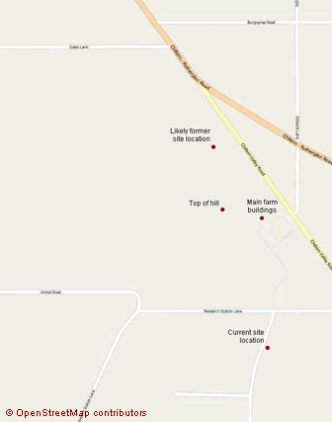
Figure 1. A map of the Rutherglen research centre, showing the location of the current observation site, the suspected location of the site in 1958 and earlier years, and other key features of the property.
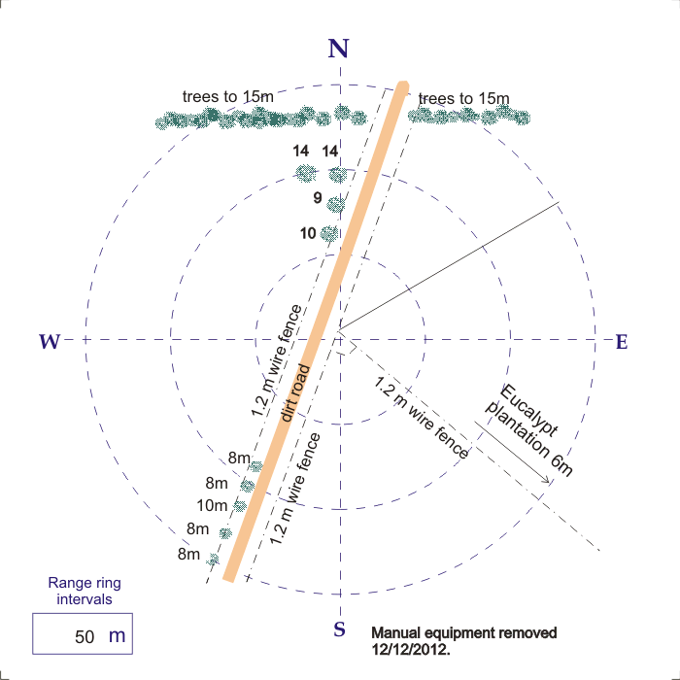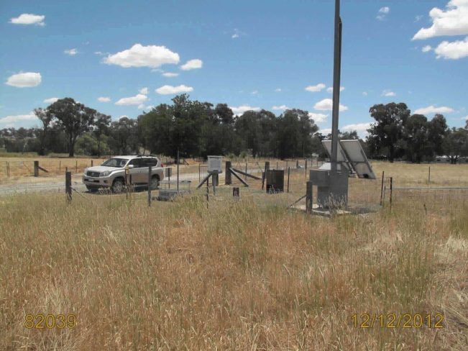

Figure 2. A site diagram (left) and station photograph looking north (right), 12 December 2012.

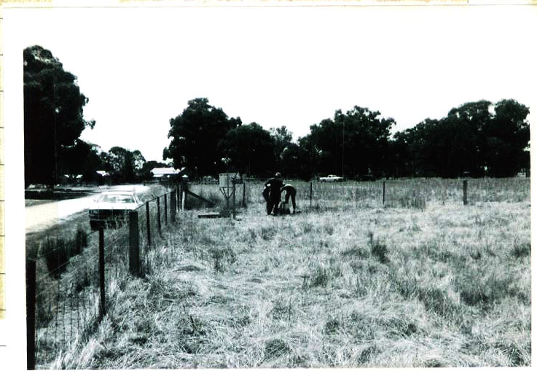

Figure 3. Station photograph at Rutherglen, looking north-northeast, February 1975.

No document has been located which states explicitly that the observation site moved. However, there are a number of documents from 1958 or earlier which make references to the site which are not consistent with its being in its current location, indicating that the site moved on one or more occasions at some point between 1958 and 1975. There are also additional documents which indicate a strong likelihood of a move or other changes.

Inconsistencies between pre-1958 site and current site

A number of documents present information about the pre-1958 site which is inconsistent with the current location. The major relevant items are:

- A 1939 station inspection report (Figure 4) which refers to the site as “Station flat but country falls slightly to north”. This does not match the current site, which is on flat ground for several hundred metres around, with a slope rising steeply approximately 500 metres to the north.
- A 1953 document (Figure 5) which refers to a hill of over 700 feet (213 metres) approximately 300 yards (270 metres) to the south of the site. No hill exists for several kilometres south of the current site. The possibility that the ‘300 yards to south’ is a reference to the station buildings, not the observing site, can be ruled out as the hill on the Rutherglen property – whose height closely matches this description - is to the west, not the south, of the buildings. (The co-ordinates listed are not useful in accurately determining the site location as they are given only to the nearest minute, and would therefore only specify the location to about the nearest kilometre).
- A site sketch from a November 1958 inspection report (Figure 6). This shows a woolshed 18 feet high approximately 150 feet (45 metres) west of the screen, and shows no indication of any road to the west of the screen, neither of which match the current site. (The possibility cannot, however, be ruled out from the available information that the woolshed might have been removed after 1958, or the road might have been built between 1958 and 1975).
- A reference in the November 1958 inspection report (Figure 7) to the site being “1/4 mile from office” (400 metres). This differs considerably from the present site which is 700 metres from the office.

No document has been located which gives a definitive location for the pre-1958 site. However, the site shown on Figure 1 as ‘suspected pre-1958 site’ matches these descriptions in a number of ways, including the slope of the ground, its location with respect to the hill and a currently existing woolshed, and the absence of a nearby road. It is also about 500 metres from the station buildings and thus matches the “1/4 mile” reference more closely than the current site does.

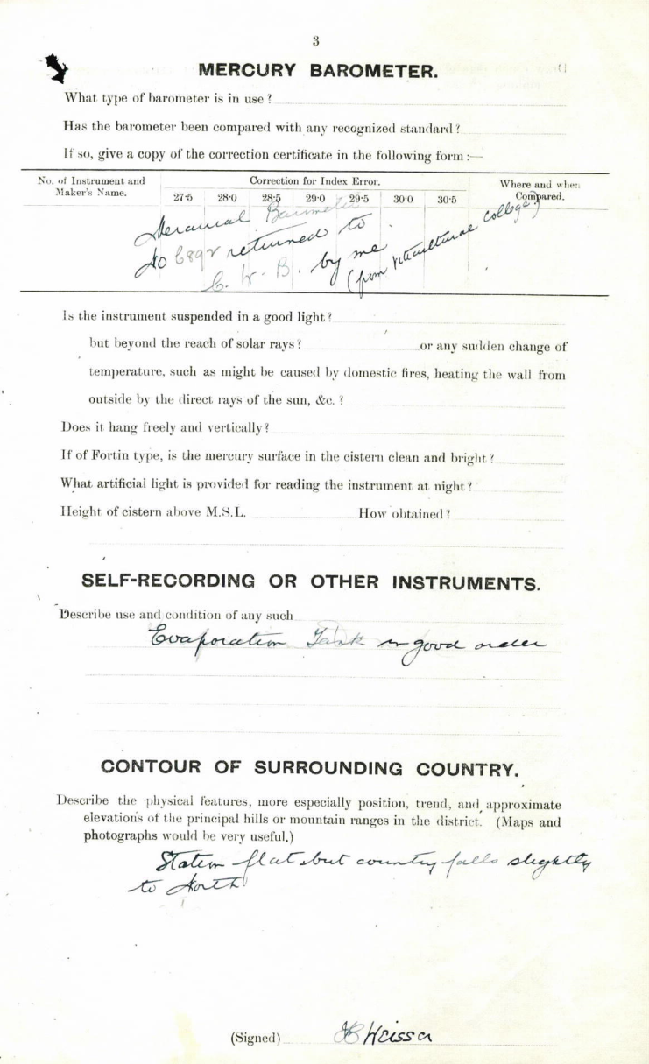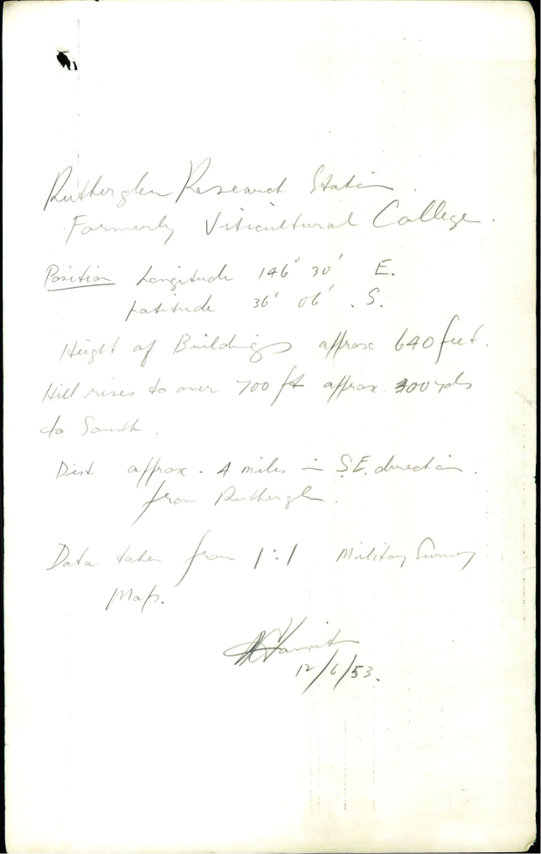

Figure 4 (left). Station inspection report from 1939. Figure 5 (right). Note from 12 June 1953 making reference to site location relative to nearby hills.

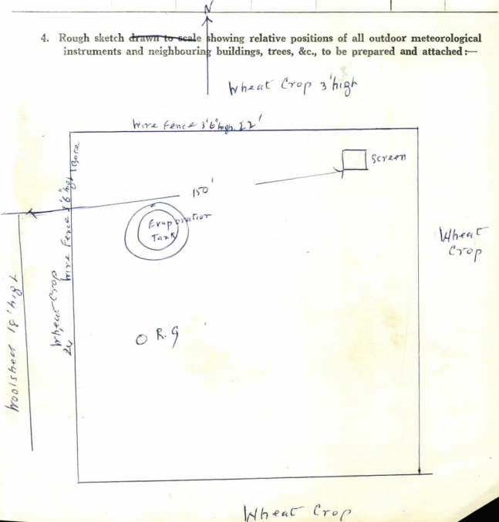

Figure 6. Site sketch from 1958 inspection report.
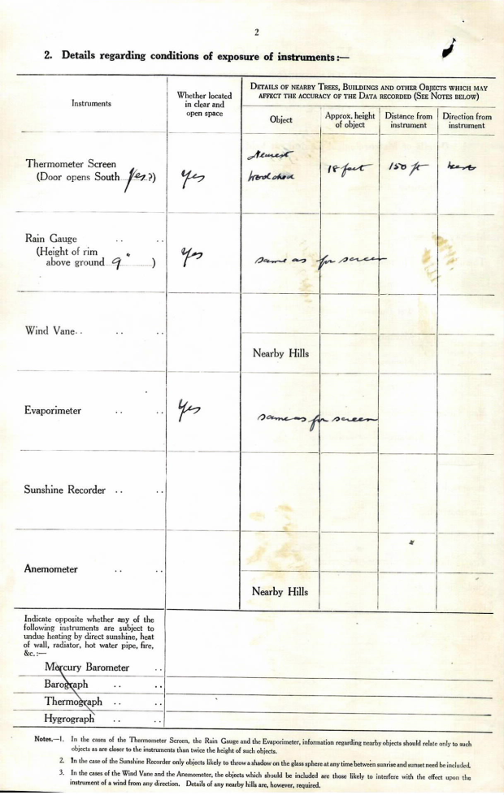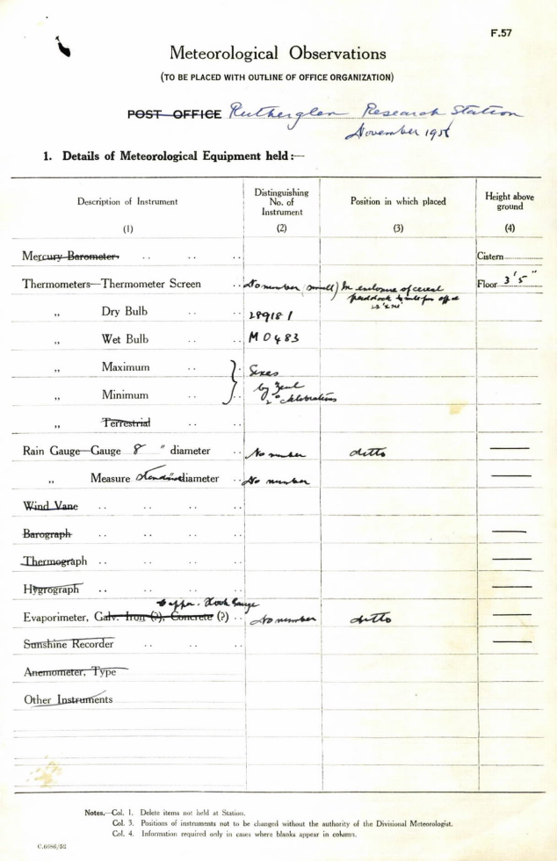
Figure 7. November 1958 site inspection report, containing reference to site being ¼ mile from office (right).
Other documents consistent with one or more site moves

A number of other documents are consistent with one or more site moves having taken place. These include:

- Internal Bureau correspondence (Figure 8) which is a reply to a request for advice from Rutherglen on appropriate station layout. (Note that this letter is dated 26 January 1965, but the fact that it refers to a letter from November 1965, and its position in the file, suggests that this date is incorrect and the correct date is likely to be 26 January 1966). This is indicative that a site move and/or a reconfiguration of the instrument enclosure is likely to have taken place shortly after this date.
- An inspection report dated 27 November 1974 (Figure 9). This refers to the site having new co-ordinates, which is likely to indicate a site move took place shortly before this date (although the possibility exists that it could be a resurvey). The report also states (as do a number of other documents) that the site was to be upgraded with additional instruments, something which would potentially require a new site and/or expanded instrument enclosure.

Note that the 1966 and 1974 dates match the two breakpoints in minimum temperature identified at Rutherglen through a statistical comparison of its data with that of other sites in the region.

Conclusions

- The observation site at Rutherglen that existed in 1958 and earlier years was not in the same location as that which has been operating from 1975 to the present. This conclusion is based on documentation of aspects of the site’s topographic setting which cannot be consistent with the current site, features of the 1958 site (woolshed, absence of road) which do not match the site as it existed in 1975, and a reference to the distance of the 1958 site from the main research station buildings which indicates either a different site to the 1975 site or a substantial distance estimation error by the 1958 inspector.
- While no firm evidence exists as to the exact location of the site in 1958 and earlier years, an approximate location has been identified which is consistent with all documented features of the pre-1958 site. This location is more elevated, and has less flat country in its vicinity, than the post-1975 site and would therefore be expected to have warmer minimum temperatures, which is consistent with the observed data.
- As a logical consequence of (a), the site moved at least once between November 1958 and February 1975. Based on the documentation described above, it is likely that the site moved twice, with the moves taking place in the months following January 1966, and in the months preceding November 1974. (It is possible that the 1966 ‘move’ could instead have been a reconfiguration of the instrument enclosure in situ). No documentation has been located between 1966 and 1974 which gives any direct or indirect indication of the site’s location or configuration during the 1966-1974 period.

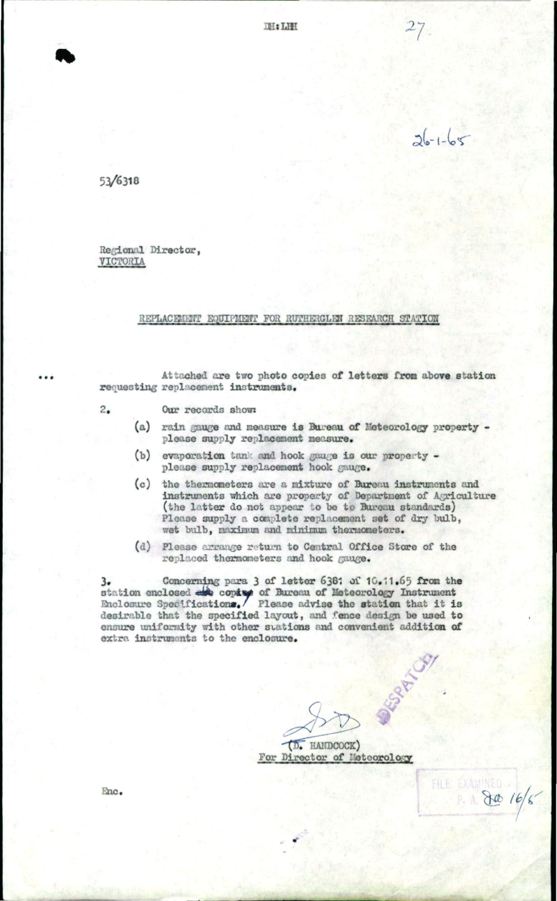

Figure 8. Correspondence from 1965-66 relating to the layout of the Rutherglen site.

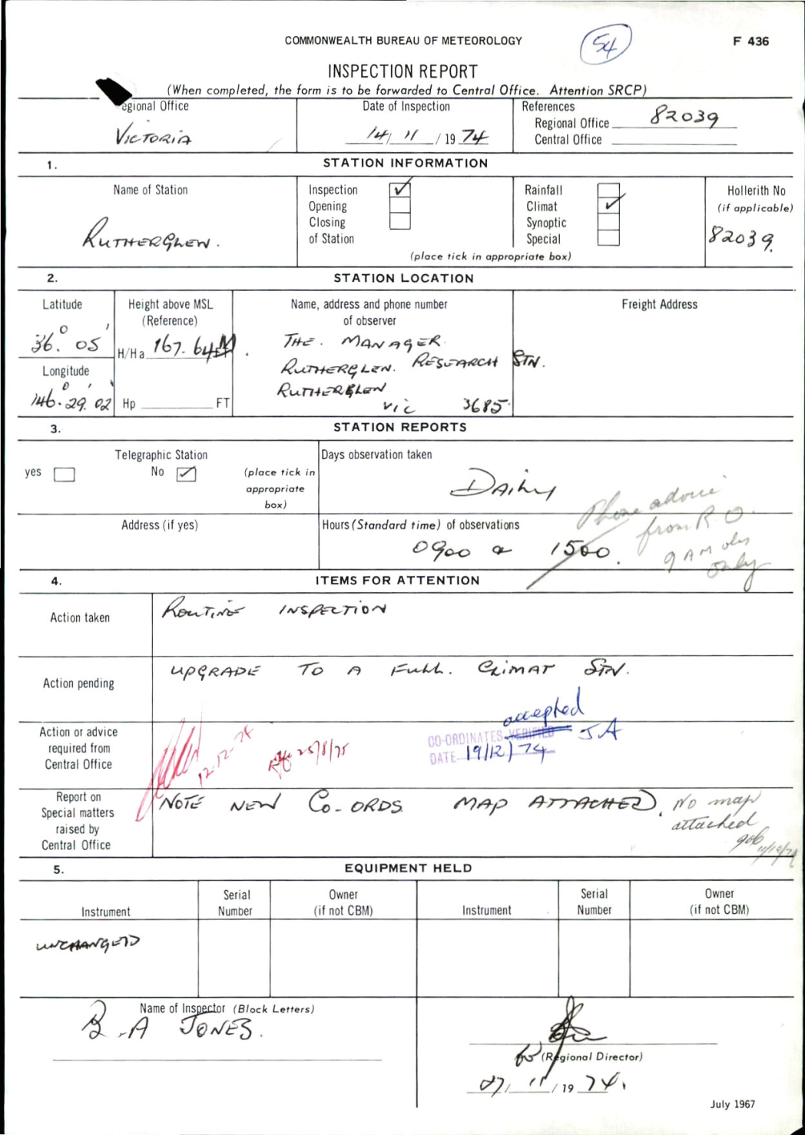

Figure 9. Site inspection report from 27 November 1974, stating that the site has new co-ordinates, and that an upgrade of the station is pending.

