WORLD METEOROLOGICAL ORGANIZATION
REGIONAL ASSOCIATION VI

WORKSHOP ON WIGOS AND AMDAR
Minsk, Belarus, 2-3 October 2018

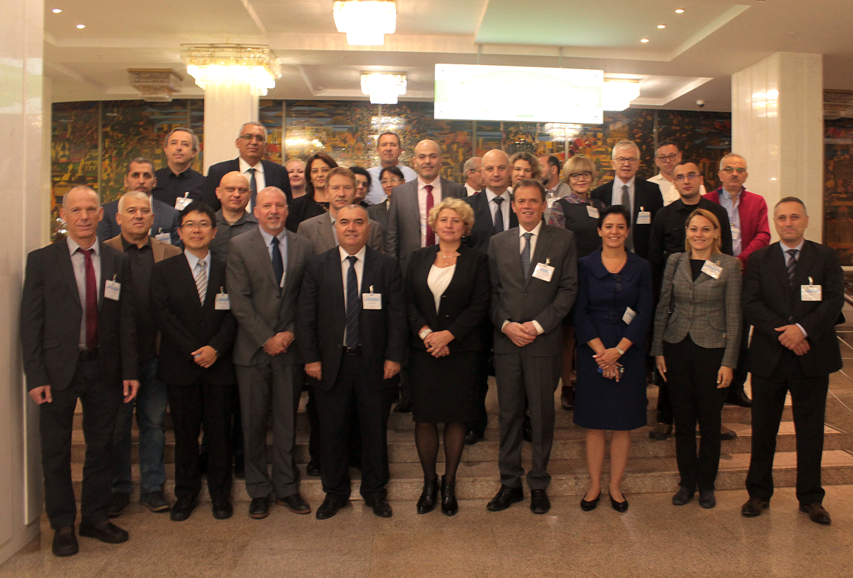
GROUP PHOTO

REPORT

EXECUTIVE SUMMARY

On 2 and 3 October 2018 in Minsk, WMO Secretariat held a Workshop on WIGOS and AMDAR with the view to trigger the implementation of the WIGOS and AMDAR related resolutions and decisions adopted by RA VI at its 17th session, held in February 2018.
The Workshop was addressed to the WIGOS and AMDAR National Focal Points of RA VI Members from Middle East, South Caucasus, Eastern European, South East European sub-regions, Baltic States and to the related National Focal Points of RA II Members from Central Asian sub-region.
IATA representative and the members of the RA VI Task Teams on WIGOS and Aircraft based observations were invited to the Workshop to contribute to the discussions and to follow up, as necessary. Taking this opportunity, the first meetings of both RA VI Task Teams were conducted back to back on 4 October.
19 out of 31 invited Members delegated their National Focal Points to the Workshop.
Albania, Bulgaria, Croatia, Greece, Israel and Slovenia as well as Estonia, Latvia and Lithuania and RA II Members of Central Asia sub-region (Kyrgyzstan, Tajikistan, Turkmenistan, Uzbekistan) did not attend the Workshop.
The Communication and Outreach activities of the Regional WIGOS Implementation Plan will be used to reach out the missing Members.
The conduction of a European WIGOS Conference for Decision Makers was recommended, for which the venue and the date will be determined. The Permanent Representatives of RA VI Members with WMO, the national WIGOS focal points, and the related international organizations should be invited to the conference to make it more efficient and to increase the awareness on WIGOS at both decision-maker and technical levels.

CONCLUSIONS
The automated aircraft-based observing system (AMDAR) is a component of WMO Integrated Global Observing System (WIGOS). It is operated by WMO Member NMHSs with partner national airlines, based on meteorological (WMO) requirements for provision of data.
ABO/AMDAR provides a growing global spatial coverage, a much higher temporal coverage than radiosondes, a better accuracy than satellites and the lowest cost of these systems at very low implementation risk.
WIGOS is 70% through its pre-operational phase; main technical systems are implemented or under implementation; there is powerful diagnostics of WIGOS performance and the compliance of WMO Members with WMO regulatory and guidance material.
There is room for substantial improvement in the data quality, and Regional WIGOS Centers are a key element in supporting Members in the implementation of WIGOS and in improving the overall performance of WIGOS.
RA VI pioneered the Regional WIGOS Centre implementation, but is still looking for a way forward to make this operational.
This will rely on the collaboration and contribution that WMO and its Members receive from the institutions having observing systems, including their partner airlines.
WMO is seeking to work with Members and their respective national institutions to expand WIGOS and AMDAR and improve observations coverage.
Collaboration with partner institutions, such as IATA, will contribute to the expansion of the WIGOS and AMDAR programs across the Region, and will also establish a more equitable cost-recovery mechanism for the participating institutions.
The RA VI Members are expected to contribute to the planning and resourcing of operations, to be coordinated by the RA VI Task Team on Aircraft based observations.
Regional Operational Centres for data processing and quality management need to be established as a component of Regional WIGOS Centres. The operational structure is shown in the chart below.

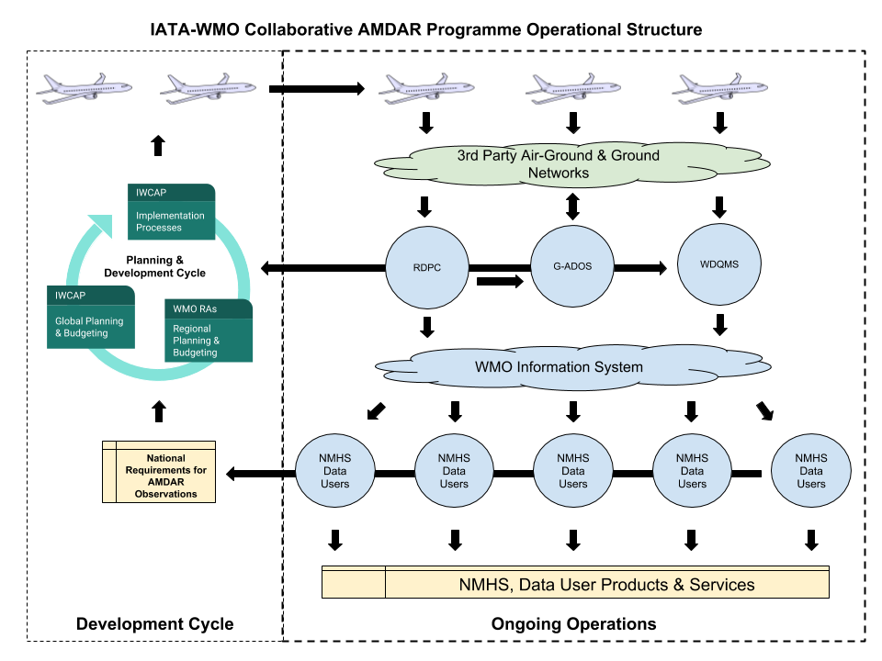

RECOMMENDATIONS
- On the implementation of WIGOS (National WIGOS Implementation):
  - Recommend a continued outreach by the WMO Secretariat to the national governments, both to the Permanent Representatives and to the decision-makers at higher levels. Integration across government agencies and academia is important to the national implementation of WIGOS.
  - Recommend to the WMO Secretariat to make available and publish the WIGOS compliance metrics by country.
  - Recommend to the Members, in case of any need, to ask for assistance from the WIGOS Project Office, the RA VI Task Team on WIGOS and the Regional Office for Europe for the development and implementation of the National WIGOS Implementation Plans.
  - Recommend to the Members of WMO to utilize more effectively the Regional Instrument Centres and the Regional Training Centres.
  - Recommend to the National Focal Points on WIGOS to inform the Permanent Representatives of Members with WMO and related entities on the WIGOS by highlighting the importance and benefits for NMHSs as well as whole country.
  - Recommend to the National WIGOS Focal Points to provide regular feedback via a web based portal to the Task Team on WIGOS and WIGOS Project Office.

- On Regional WIGOS Centres:
  - Recommend to the RA VI Task Team on WIGOS, in collaboration with the WIGOS Project Office, to bring to the attention of the RA VI Members the EC-68 Decision 30 on the responsibilities and functions of the Regional WIGOS Centres;
  - Recommend to the RA VI president to ask the Members of their intention to host a RWC with limited or full functions;

- On the implementation of GBON:
  - Recommend that WMO Members get a broader access to the Numerical Weather Prediction outputs of the Global Processing Centres, such as ECMWF (e.g. the agreement between ECMWF and Ukraine).
  - Recommend that the WMO Secretariat make available to Members the statistics on the NWP usage of observation by country, e.g. via the WDQMS.
  - Recommend to utilize at a national level all available studies from WMCs (e.g. ECMWF) on the impact of GBON observations on the quality of NWP products.

- On OSCAR/Surface:
  - Recommend to the WMO Secretariat in collaboration with Regional Training Centres to provide training courses.
  - Recommend that all Members ensure that their station metadata are kept up to date and quality controlled.

- On the establishment of RBON:
  - Recommend to the Members to consider the support and commitment for the establishment of RBON.

- On the establishment of sub-regional radar networks:
  - Recommend to the Members to participate in the BLACKRAD and SEERAD
  - Recommend to the RA VI president to encourage and identify the intention of the Members to participate in the Radar Networks.

- On the implementation of AMDAR programme:

- The business case with the proposed costs for Member’s participation in the WMO- IATA Collaborative AMDAR Programme (WICAP) should be available to the Permanent Representatives of RA VI Members with WMO.
- The members of the RA VI Task Team on ABO should communicate to the National Focal Points on WICAP, its status and progress.
- The List of National Focal Points on AMDAR must be updated on a continuous basis.
- The National Focal Points on AMDAR should communicate benefit of AMDAR and WICAP participation to the Permanent Representatives of Members with WMO and to the relevant programme managers in their National Meteorological and Hydrological Services.

