WORLD METEOROLOGICAL ORGANIZATION

WMO RA II WORKSHOP ON WIGOS
Abu Dhabi, United Arab Emirates
2 – 3 November 2016

FINAL REPORT

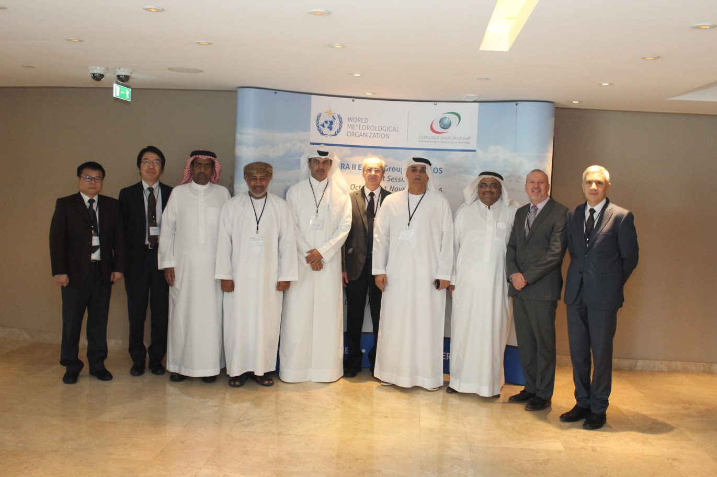

DISCLAIMER

Regulation 42

Recommendations of working groups shall have no status within the Organization until they have been approved by the responsible constituent body. In the case of joint working groups the recommendations must be concurred with by the presidents of the constituent bodies concerned before being submitted to the designated constituent body.

Regulation 43

In the case of a recommendation made by a working group between sessions of the responsible constituent body, either in a session of a working group or by correspondence, the president of the body may, as an exceptional measure, approve the recommendation on behalf of the constituent body when the matter is, in his opinion, urgent, and does not appear to imply new obligations for Members. He may then submit this recommendation for adoption by the Executive Council or to the President of the Organization for action in accordance with Regulation 9(5).

© World Meteorological Organization, 2017

The right of publication in print, electronic and any other form and in any language is reserved by WMO. Short extracts from WMO publications may be reproduced without authorization provided that the complete source is clearly indicated. Editorial correspondence and requests to publish, reproduce or translate this publication (articles) in part or in whole should be addressed to:

Chairperson, Publications Board
World Meteorological Organization (WMO)
7 bis, avenue de la Paix Tel.: +41 (0)22 730 84 03
P.O. Box No. 2300 Fax: +41 (0)22 730 80 40
CH-1211 Geneva 2, Switzerland E-mail: Publications@wmo.int

NOTE:

The designations employed in WMO publications and the presentation of material in this publication do not imply the expression of any opinion whatsoever on the part of the Secretariat of WMO concerning the legal status of any country, territory, city or area or of its authorities, or concerning the delimitation of its frontiers or boundaries.

Opinions expressed in WMO publications are those of the authors and do not necessarily reflect those of WMO. The mention of specific companies or products does not imply that they are endorsed or recommended by WMO in preference to others of a similar nature which are not mentioned or advertised.

This document (or report) is not an official publication of WMO and has not been subjected to its standard editorial procedures. The views expressed herein do not necessarily have the endorsement of the Organization.

____________

CONTENTS
Executive Summary
General Summary
List of Participants (Appendix I)
Workshop Programme (Appendix II)
Recommendations (Appendix III)

____________

Executive Summary
The WMO RA II WIGOS Workshop on strengthening the observing capabilities of West Asia for better climate & weather services was held in Abu Dhabi, the United Arab Emirates, 2 - 3 November 2016. Dr Abdullah Ahmed Al Mandoos, Permanent Representative of the United Arab Emirates with WMO, opened the Workshop.
There were three main purposes of the Workshop: (a) to brief participants about the activities planned for the WIGOS Pre-operational Phase; (b) to advise them on WIGOS implementation at the regional and national levels; and (c) to consider a way forward in the regional planning efforts for WIGOS, specifically for establishing Regional WIGOS Centres in pilot mode in RA II.
The Workshop Programme is reproduced in Appendix II and the presentations are available at the WIGOS web site: http://www.wmo.int/pages/prog/www/WIGOS-WIS/meetings/RA-II_EG-WIGOS_WIGOS-wksp_Abu-Dhabi_Nov2016/RA-II_WIGOS_workshop_Abu-Dhabi_Nov2016.html.
Based on the presentations delivered by the invited speakers and follow-up discussions, the participants formulated their recommendations that are summarized in Appendix III.

_________

General summary

- WORKSHOP OPENING AND KEYNOTE SPEECH
  - The WMO RA II WIGOS Workshop on strengthening the observing capabilities of West Asia for better climate & weather services was held in Abu Dhabi, the United Arab Emirates, 2 - 3 November 2016. Dr Abdullah Ahmed Al Mandoos, Permanent Representative of the United Arab Emirates with WMO, opened the Workshop.
  - He underlined the importance of observations for weather and climate services. He also mentioned that WIGOS is needed to address standardization in observations as well partnerships and data sharing. He welcomed the participants to the Workshop, and extended his wishes for a successful meeting.
  - Dr. I. Zahumensky, WIGOS Project Office, welcomed the participants on behalf of P. Taalas, Secretary-General of WMO, and Dr. L. P. Riishojgaard, WIGOS Project Manager.
  - In his opening speech, he mentioned the specific regional and subregional context of the Workshop.
  - He further listed three main purposes of the Workshop: (a) to brief participants about the activities planned for the WIGOS Pre-operational Phase; (b) to advise them on WIGOS implementation at the regional and national levels; and (c) to consider a way forward in the regional planning efforts for WIGOS, specifically for establishing Regional WIGOS Centres in pilot mode.
  - Finally Dr. Zahumensky extended his gratitude to Dr. Mandoos and his staff at the National Center of Meteorology and Seismology (NCMS) for hosting the meeting and for all their help with the logistics.
  - Dr Ayman Salem Ghulam, PR of Saudi Arabia with WMO, delivered a keynote speech on Status and Prospective of the WIGOS implementation in RA II.
  - The importance of WIGOS at all three levels, global, regional and national, was stressed. In this regard, close and enhanced collaboration with partners will be more and more needed to successfully achieve WIGOS implementation.

- WIGOS PRE-OPERATIONAL PHASE (WPP) 2016-2019
  - The Secretariat delivered the comprehensive presentations on: i) Recommendations from Cg-17 and EC-68; ii) OSCAR/Surface; iii) Concept of the Regional Basic Observing Network (RBON); iv) WIGOS Data Quality Monitoring System; and v) WIGOS regulatory and guidance material.
  - The brief discussion was focused on the collaboration with partners, as well as some aspects of OSCAR/Surface.

- WIGOS in RA II
  - In a brief discussion, some experiences of West Asia Members with WIGOS Implementation were shared amongst the participants. A short presentation on observing capabilities of the NCMS was made.
  - The Secretariat delivered the presentation “Protection of Radio frequencies in West Asia” and on the Jakarta Declaration “Satellite Data Project” and “Radar Data Project”.
  - Dr Chen, the chair of RA II Expert Group on WIGOS (EG-WIGOS) presented the outcomes from the first session of EG-WIGOS (31 Oct-1 Nov 2016, Abu Dhabi, UAE).

- REGIONAL WIGOS CENTRES
  - A detailed presentation on the RWCs concept endorsed by EC-68 was delivered by the Secretariat. There was a very interesting discussion about this subject, including the consideration on how WIS GISC facilities could be used in support of WIGOS and what would be the process of establishing such a RWC in this region, amongst others. The Secretariat promised to provide the participants with related technical guidance.

- SESSION 4: NATIONAL WIGOS IMPLEMENTATION
  - A series of presentations was delivered under this section, namely: “National Observing Strategy and National WIGOS Implementation Plans” by the Secretariat; “Progresses in the implementation of a national integrated observing network” by Dr. Chen;
  - Saudi Arabia delivered a presentation on the integration of meteorological and hydrological observations; the operational centre for radar data processing (as a joint effort with the UAE) was presented as well; the plan is to develop a similar centre for AWS data for the Gulf Countries.
  - The role of NMHS in the implementation of WIGOS, the importance of WIGOS for the NMHSs, the status of the nomination of national WIGOS and OSCAR/Surface focal points and their terms of references, as well as national partnerships opportunities, were discussed.
  - Much of the follow-up discussion was focused on the OSCAR/Surface, and matters related to national focal points, such as competencies, training, workload, etc. A training workshop on OSCAR/Surface was requested to be delivered to the West Asia.
  - Several participants indicated an urgent need for assistance and guidance from the Secretariat on how to start with the implementation of WIGOS at the national level, and how to develop a National WIGOS Implementation Plan (N-WIP); examples of N-WIP were requested. In this regard, Saudi Arabia asked more information about how to organize a national/sub-regional meeting dedicated to national WIGOS planning, possibly also related to establishing a RWC in this sub-region.

- RECOMMENDATIONS
  - In the general discussion, the workshop recommendations were finalized and they are listed in Appendix III.

- CLOSURE OF THE WORKSHOP
  - On behalf of the Permanent Representative of the UAE with WMO, Mr. Mohamed Al Ebri, closed the Workshop. He thanked all the participants for their commitment and contributions throughout the workshop and also thanked the WMO Secretariat for their continued support.
  - The workshop closed on Thursday, 3 November 2016, at 16:00 hours.

_______
Appendix I
List of Participants

Dr. Mohammed Al Marri
Head of Observation
e-mail: mohammed.jabir@caa.gov.qa
Qatar
H.E Dr. Ayman Ghulam
Deputy of the President for Meteorological Affairs, PR of Saudi Arabia
e-mail 1: a.ghulam@pme.gov.sa
e-mail 2: ghulamas@yahoo.com
Saudi Arabia
Mr. Mohamad Babidhan
Assistant Deputy of the president for meteorological Affairs
e-mail 1: mbabidhan@pme.gov.sa
e-mail 2: babidhan@gmail.com
Saudi Arabia
Mr. Said Abdullah Al Harthy
Director Met Technical Services
DGMet / Paka / Oman
e-mail: s.alharthy@met.gov.om
Oman
Mr. Mohamed Al Ebri
Head of Aviation Meteorology
e-mail: malabri@ncms.ae
UAE
Dr Yongqing CHEN
Chair, RA II EG-WIGOS
Igor ZAHUMENSKY
WMO Secretariat, OBS/WIGOS-PO
e-mail: izahumensky@wmo.int
WMO Secretariat
Luis Filipe NUNES
WMO Secretariat, OBS/WIGOS-PO
e-mail: lfnunes@wmo.int
WMO Secretariat
Ryuji Yamada
WMO Secretariat, DRA/RAP
e-mail: ryamada@wmo.int

Appendix II

WIGOS Workshop for West Asia
Strengthening the observing capabilities of West Asia for better climate & weather services
Abu Dhabi, United Arab Emirates (2 – 3 November 2016)
Final Programme

Wednesday, 2 November
08:30 – 09:00 | Registration
Opening (Chair: Dr Abdullah Ahmed Al Mandoos) |  |  | Speaker
09:00 – 09:15 | Welcome remarks, Director-General of the National Centre for Meteorology & Seismology, Permanent Representative of United Arab Emirates |  | Dr Abdullah Ahmed Al Mandoos
09:15 – 09:30 | Statement by the Representative of WMO Secretary-General |  | Dr Igor Zahumensky
09:30 – 10:00 | Keynote speech: Status and Prospective of the WIGOS implementation in RA II |  | Dr Ayman Salem Ghulam
10:00 – 10:30 | Coffee/Tea Break
WIGOS Pre-operational Phase (2016-2019) (Chair: Dr Abdullah Al Mandoos) |  |  | Speaker
10:30 – 10:50 | Recommendations from Cg-17 and EC-68 |  | Dr Igor Zahumensky
10:50 – 11:20 | OSCAR/Surface |  | Mr Luis Filipe Nunes
11:20 – 11:50 | Concept of Regional Basic Observing Network |  | Dr Igor Zahumensky
11:50 – 12:10 | WIGOS Data Quality Monitoring System |  | Mr Luis Filipe Nunes
12:10 – 12:30 | WIGOS Regulatory and Guidance material |  | Dr Igor Zahumensky
12:30 – 14:00 | Lunch Break
WIGOS in RA II (Chair: Mr Abdulla Al-Mannai) |  | Speaker
 | Experiences of West Asia Members with WIGOS Implementation
14:00 – 14:30 | United Arab Emirates | Dr Abdullah A. Al Mandoos
14:30 – 15:30 | Other Members and discussion | Volunteers
15:30 – 15:50 | Coffee/Tea Break
15:50 – 16:10 | Protection of Radio frequencies in West Asia | Mr David Thomas (by videoconference)
16:10 – 16:30 | The Jakarta Declaration: The “Satellite Data Project” and the “Radar Data Project” | Mr Luis Filipe Nunes
10:50 – 11:20 | Outcomes from the RA II EG-WIGOS session | Mr Yongqing Chen
Thursday, 3 November
Regional WIGOS Centres (Chair: Mr Abdulla Al-Mannai) |  | Speaker
09:00 – 09:30 | Concept of Regional WIGOS Centres | Dr Igor Zahumensky
09:30 – 10:40 | Regional WIGOS Centres in West Asia – Discussion | All
10:40 – 11:00 | Coffee/Tea Break
National WIGOS Implementation (Chair: Dr Abdullah A. Al Mandoos) |  | Speaker
11:00 – 11:20 | National Observing Strategy and National WIGOS Implementation Plans | Dr Igor Zahumensky
11:20 – 11:40 | Progresses in the implementation of a national integrated observing network | China
11:40 – 12:00 | Role of NMHS in implementation of WIGOS | Saudi Arabia
12:00 – 12:20 | Importance of WIGOS for the NMHSs | Qatar
12:20 – 12:30 | National WIGOS and OSCAR/Surface Focal Points in West Asia | Dr Igor Zahumensky
12:30 – 14:00 | Lunch Break
14:00 – 14:40 | WIGOS relevant national partnerships opportunities and arrangements - Examples | United Arab Emirates, Volunteers
Recommendations to RA II MG (Chair: Mr Abdulla Al-Mannai) |  | Speaker
14:40 – 15:30 | Recommendations | All
15:30 – 15:50 | Coffee/Tea Break
15:50 – 16:50 | Recommendations | All
Closure (Chair: Dr Abdullah A. Al Mandoos) |  | Speaker
16:50 – 17:00 | Closing remarks | Dr Igor Zahumensky  Dr Abdullah A. Al Mandoos

Appendix III
Recommendations to RA II Management Group
1. To support the urgent delivery of training on OSCAR/Surface for NFPs of West Asia
2. To support the development of the WDQMS and related training in West Asia
3. To support the development of a Regional WIGOS Centre in pilot mode for West Asia
4. To consider the establishment of specific thematic RWCs for sub-regions of RA II, e.g. for Weather Radar data processing, AMDAR data processing
5. To take into account the existing infrastructures of GISCs as a basis for sub-regional RWC – putting WIS and WIGOS working close together
6. To support further promotion and communications on benefits of WIGOS to Members of West Asia
7. To urge Members of West Asia to support the protection of Radio-Frequencies used for observing systems, by taking appropriate actions at national level
8. To urge Members of West Asia to nominate the national WIGOS FPs as well as the OSCAR/Surface NFPs, if not done yet
9. To support the sharing of national documentation on WIGOS, such as National Implementation Plans from the Members of RA II

________

See http://www.wmo.int/pages/prog/www/WIGOS-WIS/meetings/RA-II_EG-WIGOS_WIGOS-wksp_Abu-Dhabi_Nov2016/RA-II_WIGOS_workshop_Abu-Dhabi_Nov2016.html for the presentations and the references

