WORLD METEOROLOGICAL ORGANIZATION
REGIONAL ASSOCIATION I

WMO RA I WORKSHOP ON
AUTOMATIC WEATHER STATION NETWORKS
Strengthening and modernizing observing systems in Africa
Windhoek, Namibia, 19 – 21 November 2018
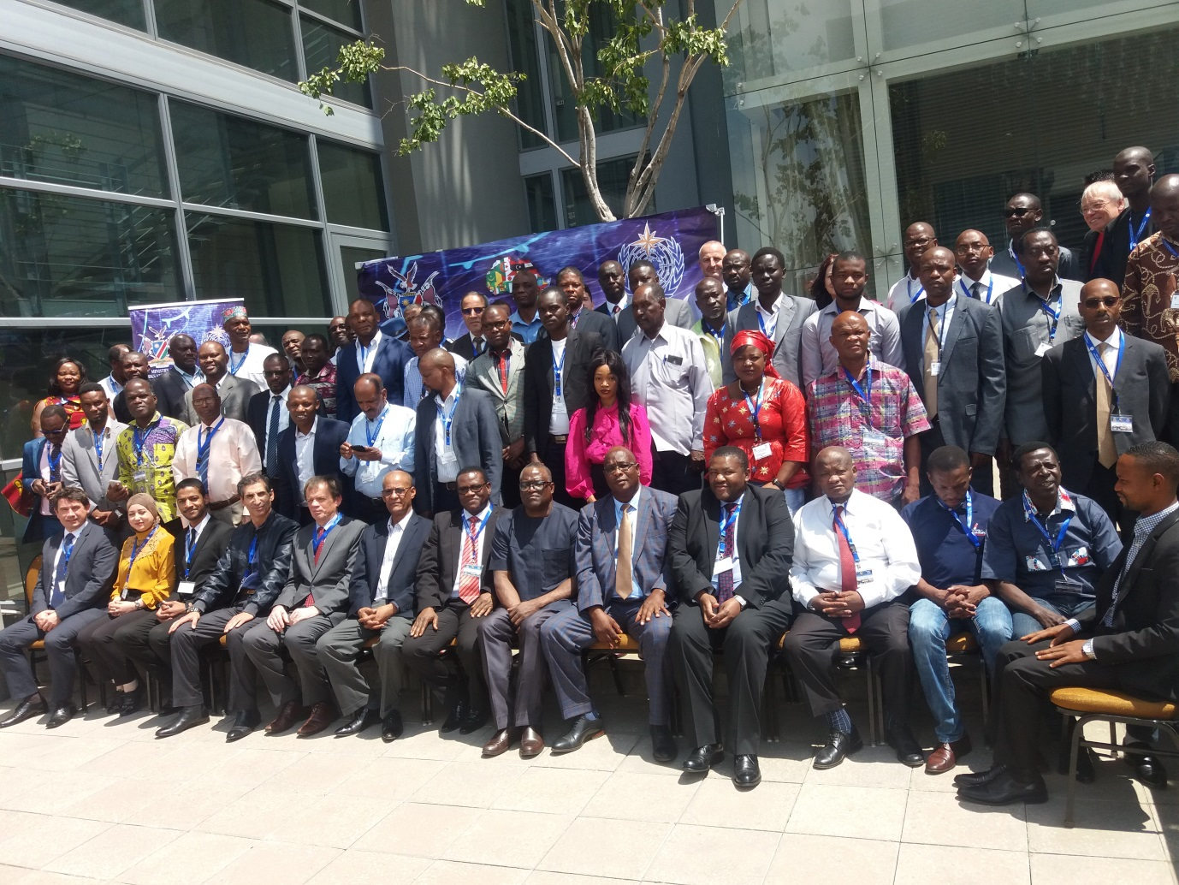

REPORT

SUMMARY
The WMO RA I WIGOS Workshop on Automatic Weather Station (AWS) networks, Strengthening and modernizing observing systems in Africa, was organized in Windhoek, Namibia, from 19 to 21 November 2018. The working languages were English and French; two-way interpretation was provided.
The main workshop theme was “Design, specification, procurement, installation and operation of Automatic Weather Station (AWS) networks in Africa; facing the challenge of introducing new and potentially transformative technologies and integrating their observations into the daily work of NMHSs and their WMO partners”.
The objectives of the Workshop were: 1) To assist Members with the implementation of AWS networks in accordance with WMO Technical Regulations and best practices; 2) To share AWS experiences, lessons learned and best practices; 3) To increase regional awareness of WIGOS tools (OSCAR/Surface and WDQMS) and WIGOS guidance material relevant to AWS networks; 4) To facilitate a dialog between WMO, the NMHSs and donor organizations interesting in strengthening observing systems and/or weather and climate service delivery in Africa; and 5) To provide recommendations to WMO, international development community and Ra I Members.
The Workshop was dedicated to NMHS surface observing system managers and National WIGOS Focal Points of RA I. Representatives from donor organizations such as the World Bank, and of partner organizations operating AWS networks in RA I, e.g. CREWS, HIGHWAY, TAHMO, were also invited. Fiftyfour participants from fifty RA I Members participated in the Workshop. The List of the Participants is provided in Annex 1.
The programme and all presentations are available at: http://www.wmo.int/pages/prog/www/WIGOS-WIS/meetings/RA-I_AWS_Namibia-Nov2018/RA-I_WIGOS-Workshop-Programme.html and also reproduced in Annex II to this Report.
The first day was focused on issues of global relevance. A series of presentations was delivered on the topics such as: Drivers of change, challenges and consequences; WIGOS Framework; Overarching AWS network implementation issues (Keynote Presentation); Specification and procurement of AWS networks; WIGOS technical systems (OSCAR/Surface and WDQMS); WMO technical regulation; The Global Basic Observing Network, a new driver for AWS Network development; Competency Requirements and Training, just to mentioned some of them.
The second day was dedicated to National presentations on automation - status of surface observing network and automation, experiences, lessons learned, issues, challenges, needs; experience with available documentation; expectations from the workshop. Altogether thirty-four participants delivered their presentation.
The third day was focused on regional and global contexts of the development and presentation were provided on Specifics of the Region by the WMO Secretariat, and Capacity development and AWS networks by the World Bank. The final sessions of the meeting were dedicated to discussing the way forward and to developing a set of recommendations from the Workshop to the WMO Secretariat, to AMCOMET, to WMO Regional Association I, and to the international development and climate finance communities. The list of agreed recommendations is provided below.

Recommendations

I. To WMO
- Work with NMHSs where needed to impress upon national governments the importance of their NMHSs and observational data;
- Help coordinate and provide training in AWS-related issues to RA-I Members;
- With development community, e.g. World Bank, UNDP, GEF, GCF, national development agencies, to design better and ultimately more successful projects related to AWS networks;
- Recognizing that data transmission is as important as making the observation itself, engage relevant parts of WIS together with WIGOS to ensure that observations are delivered to users;
- Develop and issue Region-specific guidance on AWS Networks as captured during this Workshop;
- Consider issuing strict directives (e.g. using ICAO as example), requiring countries to comply with obligations specified in the WMO Technical Regulations (WMO-No. 49), Volume I, regarding observing standards, station density, etc. to help ensure adequate investments in NMHSs;
- Promote local initiatives between NMHSs and entities from public and private sectors and academia to stimulate local manufacturing of AWS;
- NMHS personnel to be cognizant of impact of the Minamata Convention on Mercury and the need to adopt alternative technologies instead of mercury-based instruments;
- Support NMHSs in ensuring that AWS generate quality data;

II. To international development community
- Work within the context of national observing strategy and national WIGOS Implementation Plan, where such documents exist;
- In addition to new installation of AWSs (hardware), ensure that adequate attention is paid to capacity development issues such as:
  - Staffing levels,
  - Staff competencies;
- Let project design and success criteria be centred on outcomes such as integration of AWS data in national systems, improvements in volume and quality of observations exchange internationally (as shown in WDQMS monitoring maps);
- Do not assume that missing observational data will be addressed by buying new observational hardware; be aware of the whole life-cycle when developing observing-system related projects, such as requirements analysis, design, system specification, procurement, installation, operation, calibration, maintenance, repair, etc.;

III. To countries (RA-I Members)
- Request to WMO to organize forum(s) with AWS manufacturers/suppliers to address pertinent issues raised by the NMHSs;
- Where necessary and found helpful, work with WMO to impress upon your national government the importance of your services to your national constituencies and of your observational data to both national and international users;
- Develop a national WIGOS Implementation Plan that:
  - Will help you become a better development project partner,
  - Will help you receive, process, integrate and ultimately benefit from AWS data;
- Input and update your station metadata in OSCAR/Surface; this will help your own planning efforts;
- Use the WDQMS to help troubleshoot observing network issues – and let WMO (RWC or Secretariat) know if monitoring results are incorrect;
- Consider taking part in a Regional WIGOS Center pilot project;
- Work with your RA-I neighbours to share experience, provide or receive training, calibration support, etc.;
- Implement competency framework for meteorological observations, installation and maintenance of instrumentation, instrument calibration and management of observing programmes and networks;
- Use Generic AWS Tender Specifications documentation and provide feedback to the Secretariat on its appropriateness and areas for further improvement;
- Strive for implementation and certification of quality management systems, in particular for accreditation of Regional Instrument Centres, as well as of other calibration laboratories when appropriate, according to ISO/IEC 17025;
- Consider acting as host of the next International Conference on AWS, ICAWS-2019.
Annex 1
List of Participants
Country | Name of Participants
Algeria | SALMI Abdelkader
Angola | AMARAL Guedes
Benin | KPO-N-MEY Maurile
Botswana | PHOREGO Morwamang
Burkina Faso | OUEDRAOGO Aime Evariste, AMARA Guedes
Burundi | BARAKIZA Ruben
Cabo Verde | FORTES DA LUZ José Carlos
Cameroon | FODOUE Ahmadou
Central African Republic | GODITE Berthrand
Chad | NGARMADJI Ndingatoloum
Comoros | ABDOUL-OIKIL Said Ridhoine
Congo | SAMBA Francilly Lardin
Côte d'Ivoire | KOUASSI Gboka Alexandre
Democratic Republic of the Congo | Muhanga Mabamba Adelbert
Djibouti | OMAR Hassan Iltireh
Egypt | SOKKAR Shahky Abdelfattah, Abouelfadl
Eswatini | MANYONI Mbongeni Ian
Ethiopia | JEMAL Mohammed Amin
Gabon | ONDO NDONG Gilbert
Gambia | KOMMA Toiiibong
Ghana | BORTEYE Edmund Borteye
Guinea | TOUNKARA Maimadou
Guinea-Bissau | CA Luis
Kenya | NJOROGE Joseph Thuo, Gilberth Mwangi
Lesotho | TSEKOA Maqhanolle David
Liberia | GAR-GLAHN Eugene V.S
Libya | ABULKHIARAT Jalal, AEBEEDAH Rabeea
Madagascar | TSIZAFY Pierce Samuel
Malawi | CHIPETA Symon
Mali | KONE Koumba
Mauritania | GANDEGA Abdoulaye
Morocco | DARARI Youssef
Mozambique | NOSTADO Francisco
Namibia | NWALWA Bernard, REBANG Benjamin
Nigeria | ZAKARIYAU Abdulrasheed Darazo
Rwanda | MUSONI Didace
Sao Tome and Principe | LIMA ONOFRE José Luiz
Senegal | MBENGUE Abdoulaye IBN Ibrahima
Seychelles | MONCHERRY Theron Carl Harry
Sierra Leone | KALLON Ahmed
Somalia | HASSAN Ahmed Mohamed
South Africa | MHLONGO Thabani
South Sudan | GORBE Emmanuel Qurino Nijak
Sudan | AHMED Osman Ahmed Musa
Togo | Benida Koudjoubabalo
Tunisia | CHERIAA Saoussen
Uganda | WAISWA Milton
United Republic of Tanzania | WANIHA Pascal Felix
Zambia | MUTAU MUTAU
Zimbabwe | Dennis Kapaso
Netherlands | Jitze van der Meulen; Keynote speaker
WMO | DRA: E. Afiesimama,  OBS: K. Premec, L.P. Riishojgaard, I. Zahumensky
World Bank | M. Suwa
WMO-Regional Offices | B.E. Gomez, M. Majodina
ACPC | F. Rutabingwa, Ch. Muraya
MASA | B. Sekoli

_______
Annex 2
PROGRAMME
Monday, 19 November 2018
08:00-09:00 | Registration
09:30-10:00 | Opening and organization of the workshop
E. Kambueza, Namibia Meteorological Service; Master of Ceremony
L.P. Riishojgaard, Representative of the Secretary General of WMO
E. Afiesimama, DRA/RAF, WMO Secretariat
Mr Willem Goeiemann, Permanent Secretary, Ministry of Works and Transport, Namibia
Group photo
Session 1: AWS Issues of Global Relevance
10:00-10:30 | Drivers of change, challenges and consequences | B.E. Gomez
10:30-11:00 | COFFEE & TEA BREAK
11:30-12:00 | WIGOS Framework | L.P. Riishojgaard
12:00-12:30 | Overarching AWS network implementation issues (Keynote Presentation) | J. van der Meulen  (Netherlands)
12:30-14:00 | LUNCH BREAK
14:00-14:20 | ICAWS-2017 recommendations | K. Premec
14:20-14:40 | Requirements analysis and network planning | David Muchemi (Kenya)
14:40-15:00 | Specification and procurement of AWS networks | K. Premec
15:00-15:20 | Siting and deployment | Abdoulaye MBENGUE (Senegal)
15:20-15:40 | Operation and maintenance | Pascal Waniha (Tanzania)
15:40-16:00 | COFFEE & TEA BREAK
16:00-16:20 | Data processing and data dissemination | Youssef Darari (Morocco)
16:20-16:40 | Lifecycle Management | Thabani Mhlongo (South Africa)
16:40-17:00 | WIGOS technical systems: OSCAR/Surface and WDQMS | L.P. Riishojgaard
17:00-17:15 | WMO technical regulations and guidance material  AWS related documentation | I. Zahumensky
17:15-17:30 | The Global Basic Observing Network; a new driver for AWS Network development | L.P. Riishojgaard
17:30-17:45 | Competency Requirements | K. Premec

Tuesday, 20 November 2018
Session 2: Regional and National Issues
Session 2: Regional and National Issues
National presentations on automation
on status of surface observing network and automation, experiences, lessons learned, issues, challenges, needs; experience with available documentation; expectations from the workshop
Algeria | Mali
Benin | Mauritania
Botswana | Namibia
Burkina Faso | Nigeria
Burundi | Rwanda
Central African Republic | Sao Tome and Principe
Comoros | Senegal
Côte d'Ivoire | Seychelles
Democratic Republic of the Congo | Sierra Leone
Ethiopia | South Africa
Gambia | South Sudan
Ghana | Togo
Guinea | Tunisia
Guinea-Bissau | Uganda
Lesotho | United Republic of Tanzania
Liberia | Zambia
Madagascar | Zimbabwe

Wednesday, 21 November 2018
Session 3: Technical Regulations and Guidance Material
09:00-09:30 | RA I specifics | AFLDC
09:30-10:00 | Common Themes from National Presentations | L.P. Riishojgaard
10:00-10:30 | Capacity development and AWS networks | M. Suwa  (World Bank)
10:30-11:00 | COFFEE & TEA BREAK
11:00-11:20 | Linking Climate Information to Development Policy | Ch. Muraya (ACPC)
11:20-12:00 | TAHMO (pdf) | Gilbert Mwangi (TAHMO)
12:45-14:00 | LUNCH BREAK
14:00-15:00 | Round-table discussions to share experiences, lessons learned, etc. | J. van der Meulen,  B. Mwalwa
15:00-15:30 | Recommendations | E. Afisiemama  L.P. Riishojgaard
15:30-16:00 | Closure of the workshop | E. Kambueza  E. Afisiemama  L.P. Riishojgaard

