WORLD METEOROLOGICAL ORGANIZATION

Guide to Aircraft-based Observations

COMMISSION FOR BASIC SYSTEMS

Expert Team on Aircraft-based Observing Systems

August 2017

1. AIRCRAFT-BASED OBSERVATIONS

1.1 INTRODUCTION
In the context of this Guide, aircraft-based observations (ABO) are defined as a set of measurements of one or more meteorological variables, along with the required observational metadata, made at a particular time or according to a defined schedule at a location or series of locations in three-dimensional space from an aircraft platform (aircraft meteorological station). Such observations might be made or obtained from commercial passenger, military, private business, remotely piloted or other aircraft, utilizing either existing or purpose-deployed sensors, systems and/or avionics software.
Ideally and whenever possible, ABO should be made to best meet or contribute to meeting meteorological requirements for upper-air data, as defined in section 1.5.1.
The thousands of aircraft flying every day offer an efficient and cost-effective way to gather meteorological information. In the case of the majority of modern aircraft, the aircraft’s sensors, while flying, measure air temperature, wind speed and direction, air pressure and other variables of the atmosphere, as this information is necessary for the aircraft’s navigation systems and to monitor aircraft performance. While these data are used as input to a range of on-board applications supporting flight operation, they are also often automatically transmitted over the aircraft communications system to the airline for performance monitoring by the operator’s technical division. In the case of the aircraft meteorological data relay (AMDAR) observing system, the meteorologically relevant information can be accessed by a specific software package (AMDAR on-board software (AOS)) for the production of ABO.
In some cases where a sensor or an appropriate communication system is unavailable (for example, for the measurement of water vapour and humidity), the installation of equipment from commercial manufacturers, including additional sensors and communications facilities, may be required. However, the WMO AMDAR observing system relies predominantly on the innate aircraft sensors, avionics and communications systems.
Collaboration and cooperation between National Meteorological and Hydrological Services (NMHSs) and meteorological service providers, airlines and the aviation industry for the provision of ABO will result in significant positive benefits to the meteorological community, the air transport industry and aeronautical agencies – see section 1.4.
In addition to ABO provided by the WMO AMDAR observing system, there are several other sources of ABO that Members should endeavour to obtain, maintain and provide, including those made available by commercial airlines acting in accordance with the International Civil Aviation Organization (ICAO) and national air traffic management (ATM) regulations and guidance.
In this Guide, the words “shall” and “should” are intended to have their literal meaning in English and not to imply or indicate regulatory status for WMO Members. In general, the Guide provides recommended practices and procedures only, unless directly referencing provisions from other WMO Technical Regulations as indicated.

1.2 HISTORY AND BACKGROUND
The use of the aircraft platform as a meteorological observing system dates back to the late 1910s when so-called “meteographs” were mounted to the wings of early military biplanes. A meteograph made recordings of air pressure, temperature and humidity. The data were used for tracking layers of air in the higher atmosphere. Once or twice per day pilots flew predefined tracks for 1 hour, up to 6 000 metres in altitude.
Aircraft soundings were discontinued in the early 1940s with the advent of the balloon-borne radiosondes.
The use of modern navigation and communication systems in the 1960s and 1970s sparked renewed interest in the use of aircraft to measure and report meteorological data. Automated weather observations by aircraft were first used to relay wind and temperature data in support of the first Global Atmospheric Research Program Global Weather Experiment (1978–1979). One of the instruments contributing to the Global Weather Experiment dataset was a newly developed automated weather-observing system installed in aircraft. This (prototype) aircraft-to-satellite data-relay (ASDAR) system provided wind and temperature information from different levels of the atmosphere. The information was transmitted through the Geostationary Meteorological Satellite System for transmission on the WMO Global Telecommunication System (GTS).
A consortium of 10 WMO Members funded the industrial development of the next generation ASDAR equipment that was operational in the period 1991–2007. The development phase was supervised by the Consortium for ASDAR Development. For support of the operational phase, the Consortium was transformed into the Operational Consortium for ASDAR Participants, which managed a trust fund for the financial support of ASDAR operations and expansion, and for contracting a technical coordinator.
The advent of flight computers in modern aircraft allowed an alternative approach to ASDAR by exploiting the data from innate systems and instruments on the aircraft. In addition to alleviating the requirement to fit aircraft with expensive, purpose-built hardware, this approach made it possible to retrieve valuable atmospheric information and transmit it in near-real time using the aircraft communications system through the installation of a dedicated software package. This new approach – identified by its acronym AMDAR, as defined previously – is now an operational component within the ABO system in support of the WMO Global Observing System (GOS). Its description and requirements for operation are described in section 2.1.

1.3 DESCRIPTION OF AIRCRAFT-BASED OBSERVATIONS GUIDANCE
Aircraft-based observations are to be made by aircraft operating on national and international air routes. The provision of such observations for both aviation and meteorological purposes and applications is regulated by both WMO and ICAO, and described in Technical Regulations (WMO-No. 49), Volume I – General Meteorological Standards and Recommened Practices, and Volume II – Meteorological Service for International Air Navigation. The material in the present Guide is provided for WMO Members to supplement the regulations provided within the Manual on the Global Observing System (WMO-No. 544), Volume I – Global Aspects, Part III, 2.5 – Aircraft meteorological stations, and within the Guide to the Global Observing System (WMO-No. 488), Part III, 3.4 – Aircraft meteorological stations.
Additionally, the ABO system is a subsystem of the WMO Integrated Global Observing System (WIGOS), of which GOS is a component system, and so Members are required to comply with the Manual on the WMO Integrated Global Observing System (WMO-No. 1160) in the operation of their ABO systems.
For the purpose of this Guide a distinction is made between three categories of ABO:
(a) WMO ABO: Derived from ABO systems operated by WMO Members in collaboration with their national or other partner airlines, within which requirements for ABO are specified by WMO and its Members to meet meteorological needs;
(b) ICAO ABO: Derived from ICAO-regulated aircraft observations, which are made available to WMO and its Members under the provisions of ICAO as set out in Technical Regulations (WMO-No. 49), Volume II – Meteorological Service for International Air Navigation;
(c) Other ABO: Those observations derived from ABO systems operated by other entities. In this case, while Members do not define specifications for the operation of the observing system, they are urged to ensure that the observations are fit for purpose.
These sources of ABO are described in detail in section 1.6.
Section 1 of this Guide provides information on ABO data sources and guidance on how the data should be managed by Members. Section 2 provides information on the systems that produce these data and, in the case of the AMDAR observing system, guidance on its implementation, operation and maintenance.
The WMO AMDAR observing system is currently the chief source of ABO and its description and operational guidance will form the main contribution to the present Guide.

1.4 BENEFITS OF AIRCRAFT-BASED OBSERVATIONS
The great benefit to meteorology of ABO, and AMDAR data in particular, is the fact that the data are derived according to specific meteorological requirements, so that the meteorological parameters measured are reported at a high frequency during take-off and landing of participating aircraft. This means that an aircraft provides a "meteorological snapshot" of the atmosphere on a vertical trajectory at positions crucial for aeronautical operations and at a frequency that provides a suitable vertical resolution of the meteorological variables measured. Vertical profiles derived from ABO should be considered as being very similar in character and application to those derived from meteorological radiosondes. There are three elements of the AMDAR observing system that make it especially valuable for forecasting applications, including aeronautical meteorology:
(a) AMDAR wind and temperature observations have been shown to have data quality (that is, accuracy or uncertainty of measurement) equivalent to that of radiosondes;
(b) The measurement sensors and systems on the aircraft are able to produce this accurate data at a very high rate or frequency of measurement, thus providing very fine detail within the vertical profiles (in particular at the lower altitudes);
(c) Owing to the frequency at which aircraft are landing and taking off from airports, these vertical profiles can be produced on a 1-to-3-hourly basis at many airport locations, with higher profile production (for example, sub-hourly) at larger hub airports.
In addition to the vertical profiles at take-off and landing, the aircraft provide data at selected time intervals during flight at cruise level up to an altitude around 12 000 metres.
These features of the AMDAR observing system have led forecasters to provide testimony that these data are very valuable and useful, providing significant improvement to applications for monitoring and predicting weather systems and phenomena, such as:
– Surface and upper-air forecasts of wind and temperature;
– Thunderstorm genesis, location and severity;
– Wind-shear location and intensity;
– Low cloud formation, location and duration;
– Fog formation, location and duration;
– Turbulence location and intensity;
– Jet-stream location and intensity;
– Precipitation type, amount and rate;
– Conditions leading to aircraft icing.
Modern numerical weather prediction (NWP) systems are able to precisely quantify the benefits of ABO, resulting in the conclusion that in many, if not most cases, these observations are second only to high-volume satellite data in their positive impact on improving NWP forecasting skill and reducing error. AMDAR and other ABO generally provide an improvement in forecasting ability through a reduction in NWP forecast error of 10%–20% over the first 24 hours of the forecast period. Recent studies with the High Resolution Rapid Refresh model in the United States of America have also demonstrated a large positive impact on model error reduction and have concluded that AMDAR data are the most significant contributor to that model’s forecast skill.
A study in 2014 provided information on the cost-effectiveness of the AMDAR observations relative to all other data sources used in global NWP systems. When cost estimates for each observing system were included, the authors concluded that ABO observations have the largest impact per unit cost.
For more detailed information on the benefits and impact of ABO and AMDAR data, the reader is referred to The Benefits of AMDAR Data to Meteorology and Aviation, WIGOS Technical Report 2014-01.

1.5 REQUIREMENTS

1.5.1 Requirements for upper-air data
The requirements of WMO for upper-air observations are maintained and specified under the WMO Rolling Review of Requirements, which is described in detail in the Manual on the WMO Integrated Global Observing System (WMO-No. 1160), 2.2.4 and Appendix 2.3.
The Rolling Review of Requirements defines observational data requirements for WMO application areas, which are based on the statement of guidance documents available for each application area and expressed in terms of space and time resolution, uncertainty, timeliness, and the like, for each of the required observed variables, independent of the observing technology.
The application areas most relevant to ABO and AMDAR are global NWP, high-resolution NWP and aeronautical meteorology. The requirements are defined for the variables atmospheric pressure, air temperature, horizontal wind and specific humidity. ABO data are also useful for most of the other application areas.
More information on the requirements for upper-air observations from the AMDAR observing system is provided in section 2.1.1.

1.5.2 Requirements for aircraft-based observations
In addition to complying with the regulations and guidance as referenced in section 1.3, Members should also endeavour to meet the following requirements and practices:
– Observations should meet WMO requirements for upper-air observational data as referred to in section 1.5.1;
– Agreements should be made with operators of other ABO systems and data owners to ensure that data can be transmitted on the WMO Information System (WIS) in accordance with WMO Resolution 40 (Cg-XII) – WMO policy and practice for the exchange of meteorological and related data and products including guidelines on relationships in commercial meteorological activities;
– Observational data should be managed in accordance with sections 1.7–1.11;
– AMDAR observing systems should be operated in accordance with section 2.1.
It is recommended that ABO consist of at least the following variables, with indication if these are considered as desirable or optional:
– Static air temperature;
– Wind speed;
– Wind direction;
– Pressure altitude;
– Latitude;
– Longitude;
– Time of observation;
– Turbulence: mean, peak and event-based eddy dissipation rate (EDR) – desirable;
– Geometric altitude – desirable;
– Humidity – desirable;
– Icing – desirable;
– Turbulence: derived equivalent vertical gust (DEVG) – optional.
For more details and further requirements on the measurement processes and data processing associated with these and additional optional variables, see AMDAR On-board Software Functional Requirements Specification [AOSFRS], Version 1.1, Instruments and Observing Methods Report No. 115, 3 – AMDAR on-board software requirements (https://library.wmo.int/pmb_ged/iom_115_en.pdf).
For more details on instruments and methods of observation associated with ABO, see Guide to Meteorological Instruments and Methods of Observation (WMO-No. 8), Part II, 3 – Aircraft-based observations.
In addition to meeting requirements for measurement resolution and accuracy of reported variables, ABO should be made to best meet temporal, spatial and timeliness requirements for provision of vertical profiles and horizontal observations of variables, which are taken as the participating aircraft are ascending and descending, and in level flight, respectively.
For more details on requirements for observations in support of WIGOS and the WMO World Weather Watch (WWW) Programme, see the Manual on the WMO Integrated Global Observing System (WMO-No. 1160), 2.5 – Observational metadata.
For more detailed guidance on the provision of ABO in support of requirements for upper-air observations, see the Guide to the Global Observing System (WMO-No. 488), Part III, 3.4.
More specific details regarding the configuration of systems so as to most optimally meet requirements for upper-air data are provided in Chapter 2.

1.6 SOURCES OF AIRCRAFT-BASED OBSERVATIONS
Sources of ABO can be categorized in terms of a range of different aspects and functions, including:
– The system that provides the ABO;
– The entity or organization that is responsible for their regulation or provision;
– How measurements and reports are generated (including whether they are produced automatically/routinely or manually/non-routinely);
– Whether measurements are obtained from on-board sensors installed for the primary functions of the aircraft (innate), or from sensors purposely installed for meteorological observations (additional);
– The communications systems used for air-to-ground relay;
– Whether or not the downlink message always contains meteorological information;
– The format used for air-to-ground downlink;
– The entity responsible for processing the reports on the ground;
– The format used for provision to WIS.
An overview of the various ABO data sources and systems is shown in Table 1.1.

Table 1.1. Sources of aircraft-based observations
System/type | Regulator/  provider | Auto/manual | Sensors | Commun-  ications | Meteo-  rological information | Air–ground format | Responsible for ground reception | Responsible for meteo-  rological processing and WIS provision | Preferred  WIS format
AMDAR | WMO | Auto | Innate to aircraftª | ACARS | Always | AMDAR | NMHS | NMHS | BUFR^{b}
AIREP | ICAO | Auto & manual | Innate & pilot (from cockpit display and subjective) | ACARS | Always | AIREP | ANSP^{c} | Currently NMHS^{d} | BUFR^{e}
PIREP^{f} | FAA | Manual | Innate & pilot (from cockpit display and subjective) | VHF radio/ACARS | Always | PIREP | NCAA | Currently NMHS^{d} | BUFR^{g}
ADS-C | ICAO | Auto | Innate to aircraft | ACARS | Optional | ICAO aircraft report | ANSP | Currently NMHS^{d} | BUFR^{h}
Mode S | ICAO | Auto | Innate to aircraft | L-Band (SSR) | Derived | ICAO aircraft report | ATC/NMHS | NMHS | BUFR
TAMDAR | Other (external) | Auto | Additional | Satellite | Always | TAMDAR | PAC | NMHS | BUFR
AFIRS | Other (external) | Auto | Innate to aircraft and/or additional | Satellite | Optional | AFIRS | FLYHT | NMHS | BUFR
Notes:
ª An additional sensor is required for measurement of humidity.
^{b} AMDAR ABO have historically also been submitted in WMO FM42 format; however, since November 2014, WMO no longer supports character-based formats. See Appendix C for guidance on provision of these data in WIS.
^{c} ANSP responsible for collection and forwarding of AIREP and other aircraft reports to the World Area Forecast Centres (WAFCs) and Meteorological Watch Offices (MWOs) (ICAO).
^{d} The WMO Aircraft-based Observations Programme plans to establish one or more lead centres to undertake these data-processing functions.
^{e} AIREPs have historically also been submitted in WMO FM41 format; however, since November 2014, WMO no longer supports character-based formats.
^{f} A PIREP is a special type of aircraft report developed for use over United States and Canada airspace and is not an ICAO-regulated report.
^{g} PIREPs have historically also been transmitted on GTS in FM41 format; however, since November 2014, WMO no longer supports character-based formats.
^{h} Observations from ADS-C have historically also been submitted in WMO FM41 format; however, since Nov 2014, WMO no longer supports character-based formats.
Acronyms not previously defined:
ACARS: aircraft communications addressing and reporting system; ADS-C: automatic dependent surveillance – contract (ICAO); AFIRS: automated flight information reporting system (FLYHT Aerospace Solutions Ltd.); AIREP: aircraft report (ICAO); ANSP: air navigation service provider; ATC: air traffic control; BUFR: binary universal form for the representation of meteorological data; FAA: Federal Aviation Administration (United States); FLYHT: FLYHT Aerospace Solutions Ltd.; Mode S: mode select; NCAA: National Civil Aviation Authority; PAC: Panasonic Avionics Corporation; PIREP: pilot report; SSR: secondary surveillance radar; TAMDAR: tropospheric airborne meteorological data reporting.

1.6.1 WMO aircraft-based observations
World Meteorological Organization ABO are defined as meteorological observations made from an aircraft platform under cooperation and/or commercial arrangement between aircraft operators or their agents with a WMO Member NMHS, meeting prescribed WMO standards and requirements for reporting and quality, and transmitted by Members on WIS. These observations are to be made in accordance with WMO regulations contained in Technical Regulations (WMO-No. 49), Volume I – General Meteorological Standards and Recommended Practices, including its annexes.

1.6.1.1 Aircraft meteorological data relay aircraft-based observations
The global AMDAR observing system was initiated by WMO and its Members. National and regional AMDAR programmes are operated by WMO Member NMHSs in cooperation and collaboration with their partner commercial airlines.
The AMDAR programme is an integrated component of GOS and WIGOS, and is defined and maintained under the WWW Programme.
A technical description of aircraft-based sensors and the methods for deriving meteorological observations from them can be found within the Guide to Meteorological Instruments and Methods of Observations (WMO-No. 8), Part II, 3 – Aircraft-based observations.
The WMO AMDAR observing system, as depicted in Figure 1.1, collects the following meteorological data from commercial aircraft for global distribution to NMHSs via WIS:
– High-resolution vertical profiles of air temperature, wind speed and direction on aircraft ascent and descent;
– Regular near-real-time reports (for example, every 5–10 minutes) of meteorological variables while the aircraft is en route at cruise level;
– Accurate measurement of coordinates (time, latitude, longitude and pressure altitude);
– If available, measurement of turbulence as EDR and/or DEVG;
– Water vapour or humidity (from suitably equipped aircraft).
See section 2.1 for a detailed description of the AMDAR system and requirements, and guidance relating to ground infrastructure and programme development, operation and maintenance.
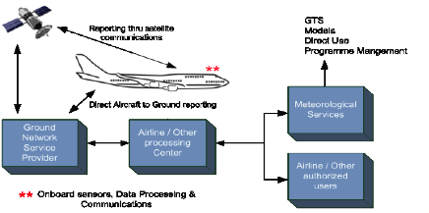
Figure 1.1. Simplified overview of the AMDAR observing system

1.6.1.2 Data reception and processing
Observations from AMDAR should be received and processed by the Member NMHS before reformatting into BUFR for provision to WIS.
In some cases, AMDAR observations may be processed by one Member on behalf of one or more others under bilateral or multilateral arrangements and agreements. In the interests of programme efficiency and capacity development, WMO strongly encourages such collaboration.
To facilitate such efficiencies, Members should ensure that AMDAR observations are provided in a WMO standard (air-to-ground) format, as described in section 2.1.2.3.
Members should undertake prescribed minimum quality control of ABO prior to their provision to WIS, as described in section 1.8 and Appendix A.

1.6.1.3 Provision of observations to the WMO Information System
Members should provide AMDAR observations to WIS in accordance with WMO Resolution 40 (Cg-XII) and in accordance with the referenced provisions and recommended practices in section 1.9 and Appendix C.

1.6.1.4 Maintenance and provision of metadata
Members should maintain a record of AMDAR observational metadata in accordance with the referenced provisions and recommended practices in section 1.10 and Appendix D.

1.6.1.5 Monitoring and quality assessment
Members should undertake routine monitoring and quality assessment of AMDAR observational data in accordance with the referenced provisions and recommended practices in section 1.8 and Appendix B.
Members should ensure that changes to the programme or schedule of reporting of ABO on WIS are planned and notified in advance.

1.6.2 International Civil Aviation Organization aircraft-based observations

1.6.2.1 International Civil Aviation Organization aircraft reports
Several sources of ICAO ABO are available to WMO Members under the regulations of ICAO governing its contracted States. The requirements for the making of aircraft observations and the provision of aircraft reports (also denoted in many places as air-reports) are described and defined by ICAO.,
Note: The detailed descriptions and provisions for ICAO aircraft reports are not provided in full within the present Guide. The reader is referred to the ICAO and/or WMO publications as indicated.
From ICAO (see footnote ICAO, 2011, 7.5.1):
A report consisting of a position report and of meteorological information is called a “routine air-report”. (It may also contain operational information.) Reports containing special aircraft observations are called “special air-reports” and, in most cases, constitute a basis for the issuance of SIGMETs.
Routine aircraft reports are to be made by aircraft with air–ground data link when air–ground data link is used and ADS or SSR Mode S is being applied. Aircraft reports are to be made by such aircraft at 15-minute intervals during their en route phase and every 30 seconds during the climb-out phase for the first 10 minutes of flight.
A brief description of the ADS and SSR systems that can be used to generate aircraft reports of various content is provided in section 2.2.
Routine and special reports from an aircraft are prepared during flight in conformity with requirements for position and operational and/or meteorological reporting, as described in the following text:
From ICAO (see footnote ICAO, 2011, 7.7):
7.7.1 Basic principles: Air traffic services and meteorological authorities must establish appropriate arrangements to ensure that routine and special air-reports reported to [air traffic services] ATS units by aircraft in flight are transmitted without delay to the World Area Forecast Centres (WAFCs) and to the associated [Meteorological Watch Offices] MWO).
7.7.3 Additional exchange of air-reports beyond WAFCs: Air-reports exchanged beyond WAFCs are considered as basic meteorological data and therefore their further dissemination is subject to WMO provisions.
While the ICAO ABO derived from AIREPs are made available as basic data to WMO Members for their use in the provision of their mandated services and applications, the primary purposes of these observations are for the applications of ATS, MWOs and WAFCs.
Regulations and guidance for WMO Members on the reception, provision to WIS and management of ICAO ABO are provided in the Manual on the Global Telecommunication System (WMO-No. 386), Part I, 2.7 – Responsibility for collection (reception) of reports from aircraft. These regulations state that:
2.7.1 Collecting centres designated in the ICAO Regional Air Navigation Plans for the collection of aircraft weather reports shall send all available aircraft weather reports to the [National Meteorological Centre] NMC situated in the respective country or to other meteorological centres designated by agreement between the aeronautical and meteorological authorities concerned.
2.7.2 [Regional Telecommunication Hubs] RTHs shall collect the aircraft weather reports from the NMCs in their respective zones of responsibility.
Provisions for ICAO ABO are regulated at the highest level in Technical Regulations (WMO-No. 49), Volume II – Meteorological Service for International Air Navigation, Part I, Aircraft observations and reports, and Part II, Appendix 4 – Technical specifications related to aircraft observations and reports. They are also published by ICAO in Annex 3 to the Convention on International Civil Aviation (see footnote ICAO, 2007) (hereafter referred to as “ICAO Annex 3”), Appendix 4 – Technical specifications related to aircraft observations and reports. These texts state the requirements in terms of (mandatory) standards and recommended practices.
Details on data processing and delivery can be found in the following ICAO documents:
– Procedures for Air Navigation Services. Air Traffic Management, document 4444, 4.12 – Reporting of operational and meteorological information;
– Manual of Aeronautical Meteorological Practice, document 8896, 7 – Aircraft observations and reports;
– Manual on Coordination between Air Traffic Services, Aeronautical Information Services and Aeronautical Meteorological Services, document 9377, 4.2 – Reports of aircraft observations received in ATS units.
Based on these current provisions, aircraft reports received by WAFCs can be processed and the meteorological information made available to WMO for provision on GTS and used by WMO Members as basic meteorological data. WMO expects in the future to implement more formal procedures in which aircraft reports are forwarded to NMCs Washington and London for processing and dissemination via GTS.
At the current time, meteorological information from aircraft reports can be considered to be supplementary sources of ABO that assist in meeting the requirements of WMO Members for upper-air observations (see section 1.5). However, in most countries, these reports are either not being made or are not being made available to MWOs and WAFCs in accordance with ICAO provisions. Members should therefore liaise with their NCAAs to ensure that aircraft reports are made and that they are then sent to WAFCs so as to be made available to WIS as ABO.
Beyond the provisions that are made in the WMO and ICAO documents cited above for the derivation of ABO from aircraft reports, the additional derivation of ABO from these and other national ATM systems and sources is essentially a matter between WMO Members and their respective NCAAs. In the event that such additional ABO data are able to be made available to NMHSs, they should remain subject to WMO Resolution 40 (Cg-XII) and the requirements for provision of such data to WIS as described in section 1.8.
For example, the derivation of ABO from PIREPs (described in section 1.6.2.2) and high-resolution ADS-broadcast (ADS-B) or Mode S systems (described in section 2.2) are not regulated under ICAO provisions.

1.6.2.2 Other national aviation aircraft reports – pilot reports
A PIREP is a routine or urgent report made by a pilot of hazardous weather conditions encountered by an aircraft in flight. This information is usually relayed by radio to the nearest ground station, but other options (for example, electronic submission) also exist in some regions. The message would then be encoded and relayed to other weather offices and ATS units. At a minimum, the PIREP must contain a header, aircraft location, time, flight level, aircraft type and one other field. The provision of PIREPs by aircraft is regulated in accordance with national requirements and is not subject to regulation by ICAO.
Information on the origins or PIREPs is difficult to find, but the requirements, content and other details should be available from the relevant NCAA. In the United States, the requirements for PIREPs are issued as a directive and documented within the FAA Aeronautical Information Manual, 7-1-20, Pilot weather reports.
If provided by NCAAs for provision on WIS, PIREPs should be subject to quality control and reported as described in Appendix C. It is preferable that such observations are able to be distinguished from other ABO sources, including aircraft reports.

1.6.2.3 Format and content of air reports
The meteorological content of routine aircraft reports transmitted via air-to-ground data link is provided in ICAO document 8896, Table 7-3, as shown in Table 1.2.
Table 1.2. Contents of Table 7-3 from Manual of Aeronautical Meteorological Practice, ICAO document 8896
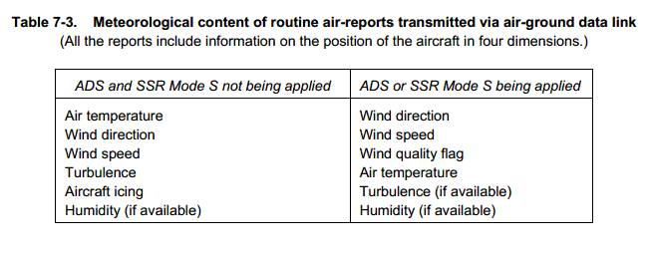
Criteria for reporting
When air–ground data link is used, the wind direction, wind speed, wind-quality flag, air temperature, turbulence and humidity included in aircraft reports should be reported in accordance with the following criteria (from ICAO Annex 3, Appendix 4, 2 – Criteria for reporting):
2.2 Wind direction
The wind direction shall be reported in terms of degrees true, rounded to the nearest whole degree.
2.3 Wind speed
The wind speed shall be reported in kilometres per hour or knots, rounded to the nearest 2 km/h (1 knot). The units used shall be indicated.
2.4 Wind quality flag
The wind quality flag shall be reported as 0 when the roll angle is less than 5 degrees and as 1 when the roll angle is 5 degrees or more.
2.5 Temperature
The temperature shall be reported to the nearest tenth of a degree Celsius.
2.6 Turbulence
The turbulence shall be reported in terms of the cube root of the eddy dissipation rate (EDR). [For further details, see ICAO Annex 3, Appendix 4, 2.6.]
[…]
2.7 Humidity
The humidity shall be reported as the relative humidity, rounded to the nearest whole per cent.
Note: The ranges and resolutions for the meteorological elements included in aircraft reports are detailed in ICAO Annex 3, Appendix 4,Table A4-3.
The AIREP format is described in more detail in Appendix C to the present Guide.

1.6.2.4 Provision of observations to the WMO Information System
Members must provide ABO derived from ICAO aircraft reports (ICAO ABO)to WIS in accordance with the referenced provisions described in sections 1.6.2.1, 1.8 and 1.9. Members should also follow recommended practices described in Appendices A and C.

1.6.2.5 Maintenance and provision of metadata
Members should maintain a record of observational metadata for ICAO ABO in accordance with the referenced provisions and recommended practices described in section 1.10 and Appendix D.

1.6.2.6 Monitoring and quality assessment
Members should undertake routine monitoring and quality assessment of ICAO ABO in accordance with the referenced provisions and recommended practices described in section 1.8 and Appendix B.
For details on systems that generate ICAO aircraft reports, see section 2.2.

1.6.3 Other aircraft-based observations
Aircraft-based observations are also available through commercial manufacturers and system operators. Such systems are distinct from the AMDAR and ICAO-regulated systems in that the collaboration is between the NMHS and a third-party commercial entity rather than between the NMHS and the airline and/or the NCAA.
Such third parties currently include:
– PAC, that under its Weather Solution Program manufactures and deploys the TAMDAR system, a deployable device designed to collect and transmit weather and other data during the flight of an aircraft. TAMDAR has the ability to transmit the atmospheric data over the company’s global aeronautical broadband connectivity service and the Iridium satellite network, in real time;
– FLYHT Aerospace Solutions Ltd., that manufactures AFIRS, which interfaces with the aircraft flight data, and processes, stores and transmits them over the Inmarsat and Iridium global satellite networks.
Both systems provide downlink, voice and text communications and flight-following features as services to the client airline.
Both companies provide a centralized data processing centre (DPC) at which the data is received, processed and routed to the airline and data subscribers.
In the case of TAMDAR, meteorological sensors are deployed as components of the TAMDAR device so that observations of meteorological parameters are made independently from the aircraft. These data are openly shared back with the host airline. With the airline's permission, a host airline's data may also be shared with other participating fleets.
The TAMDAR and AFIRS systems and their operation are briefly described in section 2.3.3.

1.6.3.1 Data policy and agreements with data providers
It is critically important that Members are aware of the methods of measurement and observation that are employed by the third party in operation of the observing system from which the ABO are derived – in particular those aspects that have an impact on reliability and quality of the data source.
It is important to understand that third-party ABO data providers are generally commercial entities that operate their systems and provide services and products in the expectation that they will receive a return on their investment. Such providers may apply data policies that differ from WMO data policy as set out in Resolution 40 (Cg-XII). In some cases, the collection of meteorological data may be considered to be a secondary or tertiary revenue stream for the operator and the primary source may be the service provided to the airline. In any case, the business rationale for provision of meteorological data to the NMHS still holds. This fact should be utilized in negotiating with the two parties, the third-party data provider and the airline, for the provision of ABO. The stronger the business case and the more the NMHS can do to offset the cost of the ABO data through the provision of improved meteorological services to the airline, the greater the likelihood that a lower-cost contract or agreement can be negotiated by the NMHS.

1.6.3.2 Provision of observations to the WMO Information System
Members should ensure that the formation of a contract or agreement with the service provider for the provision of third-party ABO data allows the data to be transmitted to WIS in accordance with WMO Resolution 40 (Cg-XII).
Members should provide third-party data derived from other ABO systems to WIS in accordance with the referenced provisions and recommended practices described in sections 1.8 and 1.9 and Appendices A and C.

1.6.3.3 Maintenance and provision of metadata
Members should maintain a record of observational metadata for other ABO systems in accordance with the referenced provisions and recommended practices described in section 1.10 and Appendix D.

1.6.3.4 Monitoring and quality assessment
Members should undertake routine monitoring and quality assessment of third-party ABO data in accordance with the referenced provisions and recommended practices described in section 1.8 and Appendix B.

1.7 OBSERVATIONAL DATA MANAGEMENT
The entities, functions and practices described in this section, together with the data and quality management practices undertaken by Members and described in sections 1.8 through 1.11 form the overall ABO data-management system. Within the data-management system, the monitoring and improvement of the quality chain is a leading theme; that is, improvement follows from evaluation, research and ongoing development of the data-processing and production chain. For ABO, including aircraft-derived data from ICAO ABO, this chain is a relatively complex system because of the many data-processing operations and autonomous data switches involved. This complex data-management and distribution system can be described as a system of entities that each undertake a number of tasks, activities and practices to support observational data management, starting from initial variable measurement on the aircraft platform through to the delivery of data products to data users.
Figure 1.2 shows the proposed Aircraft-based Observations Global Data Management Framework that was first developed at the WMO AMDAR Panel Workshop on Aircraft Observing System Data Management (Geneva, 5–8 June 2012) and later updated by the second session of the WMO Commission for Basic Systems (CBS) Expert Team on Aircraft-based Observing Systems (Casablanca, Morocco, 7–11 December 2015). While many of the elements of this proposed Framework are not yet in place, including the ABO Data Centre and the framework for metadata management, it provides an inspirational focus for the future to support improved ABO data management.
While Figure 1.2 does not depict the data-management framework for other ABO and ABO systems as described in sections 1.6.3 and 2.3, these data should be managed under a similar data-management framework.
The important entities, functions, roles and practices depicted in Figure 1.2 are described in the following paragraphs.
Aircraft observing platforms
A range of aircraft platforms, as described in section 2, routinely obtain measurements from dedicated sensors, which are processed, controlled and combined with static and dynamic metadata to form observations, which are then dispatched by communications systems to the ground based on a programmed schedule of reporting.
Aviation data-service providers
An aviation data service provider (DSP) is responsible for maintaining the air–ground and ground–ground communications networks in support of the ACARS contract with an airline. Reports of ABO under the ACARS communications contract are delivered to airlines, ATM and ABO DPCs. In some cases, an arrangement between airlines and NMHSs is made for airlines to deliver AMDAR data directly to the ABO DPC.
World Area Forecast Centres
In accordance with ICAO Annex 3, ICAO WAFCs operated by WMO Members provide weather services in support of air navigation requirements and receive ICAO AIREPs for use within their mandated responsibilities. Aircraft reports can then be made available to WIS as described in section 1.6.2. In the future, WMO expects that all aircraft reports might be processed and made available on WIS by one or more designated ABO DPCs, in accordance with ICAO and WMO regulations and guidelines.
Airlines
Airlines of ICAO-contracted States are responsible for meeting the regulations of ICAO for the provision of aircraft reports. Airlines providing ABO in partnership with WMO Members are responsible for the delivery of ABO to DPCs under the terms of agreements put in place between the parties and as described in detail in section 2.1.3.1.2. Airlines should also be responsible for the provision of required aircraft metadata in support of ABO quality management and meteorological applications that require such information.
ABO data-processing centres
Data-processing centres are operated by NMHSs and may undertake ABO DPC responsibilities and functions in support of one or more national ABO programmes. ABO DPCs have responsibility for:
– Reception, processing, quality control and archival of ABO and its transmission on GTS;
– Reception, processing and maintenance of metadata and its relay to the Observing Systems Capability Analysis and Review tool (OSCAR);
– Optimization of ABO data, in particular the management of data optimization systems supporting AMDAR observing systems as described in section 2.1.2.2 and Appendix E;
– In some cases, the provision of data display or visualization functionality in support of ABO programme management.
Third-party ABO data-processing centres
Third-party ABO DPCs are centres that undertake DPC functions on behalf of and in agreement with an NMHS or region. Generally, such centres should not be responsible for provision of ABO to WIS, which should be maintained as a WMO Member responsibility.
ABO National Meteorological Service
An ABO National Meteorological Service is a WMO Member that receives and uses ABO and, in some cases, also makes its national ABO data available on GTS. In the latter case, the ABO National Meteorological Service should also take responsibility for the provision of required partner or national airline metadata.
Observing System Capabilities Analysis and Review tool
The WMO OSCAR is the repository for all ABO metadata. Members will be responsible for ensuring that ABO metadata is obtained from national airlines and provided to OSCAR in accordance with the requirements described in section 1.10 and Appendix D.
ABO data-monitoring centres
These centres are responsible for the monitoring of ABO data and may undertake a global or regional data-monitoring role. The requirements of DPCs are specified in Appendix B. ABO data-monitoring centres will be designated by CBS.
ABO lead centres
A WMO global and regional ABO lead centre is responsible for the monitoring and management of ABO and associated data-quality issues. ABO lead centres will be designated by CBS. The requirements of ABO lead centres are specified in Appendix B.
ABO data centre
The WMO ABO data centre is responsible for the reception, management and maintenance of all ABO data and is expected to provide the following functions:
– Reception and database storage of all ABO transmitted on GTS;
– Maintenance of quality monitoring data and information on ABO data-quality issues;
– Provision of interface to the ABO database and secured provision to WMO Members.

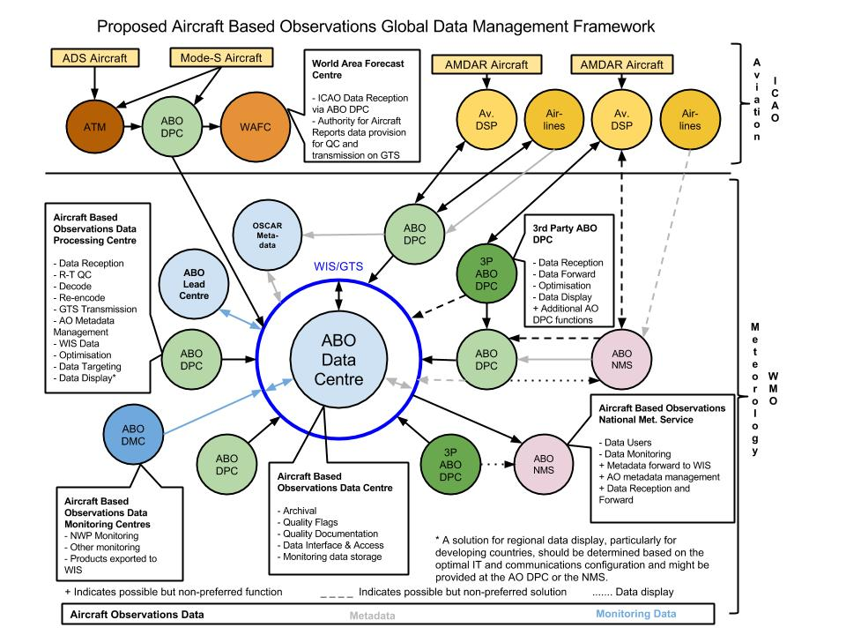
Figure 2. Proposed Aircraft-based Observations Global Data Management Framework

1.8 QUALITY MANAGEMENT
The Manual on WMO Integrated Global Observing System (WMO-No. 116) provides the overarching framework for quality management for all WIGOS component observing systems and subsystems. Members that receive, process and provide ABO to WIS must comply with all the relevant general provisions in the Manual for quality control of their ABO systems and quality management of their observational data.
In particular, Members should ensure that they are compliant with the provisions for quality management within the Manual on WMO Integrated Global Observing System, 2.6 – Quality management, and 3.6 – Quality management; the Manual on the Global Data-processing and Forecasting System (WMO-No. 485), Volume I, Part II, Appendix II.1 – Minimum standards for quality control of data for use in the GDPFS (both real-time and non-real-time); and the Manual on the Global Observing System (WMO-No. 544), Volume I, Part V – Quality control.
Members must adhere to the provisions made in relation to quality management of ABO and systems as made within the Manual on the Global Observing System, Volume I, Part III, 2.5 – Aircraft meteorological stations.

1.8.1 Member quality management system
Members who make available ABO to WIS should ensure that their quality management system incorporates the required procedures, practices and documentation necessary to maintain their ABO data at prescribed quality standards. This should include the recommended quality management practices described in the present Guide.

1.8.2 Aircraft-based observations quality management

1.8.2.1 System quality control
Members that operate AMDAR and other ABO systems in collaboration with partner airlines and aircraft operators should ensure compliance with all practices and guidance that have an impact on observational data quality provided in Chapter 2.

1.8.2.2 Data quality management
A broad and basic depiction of the data flows and quality management processes in place at the national and international levels that have a significant impact on the quality of ABO is provided in Figure 1.3.
Members should ensure that each of the following elements and functions are addressed in establishing a national or regional framework for the management of ABO data quality:
(a) A person (or persons) should be appointed to the role of ABO programme manager; in most cases this person will also serve as the WMO/CBS focal point on ABO (see section 1.12). The ABO programme manager should be responsible for:
(i) Establishing that airline partners meet national and international requirements and standards for ABO provision as outlined within the present Guide;
(ii) Obtaining and acting on feedback on data-quality issues, including those provided by the quality evaluation centre (see (c));
(iii) Obtaining and acting on changed or new requirements that have an impact on the programme;
(iv) Establishing and maintaining a feedback mechanism with ABO data providers on ABO data quality;
(b) A facility should be established for the reception and quality control of ABO (see section 1.8.2.2.1);
(c) A quality evaluation centre should be made responsible for continuously monitoring and analysing the quality of the ABO data. The quality evaluation centre should receive and utilize feedback on ABO data quality from various sources, including national, regional and global data users and the WMO/CBS Lead Centre for aircraft and satellite data monitoring, Washington (see section 1.8.2.2.2);
(d) A mechanism should be established to ensure that the national ABO programme accommodates the ongoing and changing requirements of national and international data users.

1.8.2.2.1 Data quality control practices
Members that receive, process and provide ABO to WIS must as a minimum comply with the requirements for quality control of these data, as defined within the following manuals:
– Manual on the Global Data-processing and Forecasting System (WMO-No. 485), Volume I, Part II, Appendix II-1, Minimum standards for quality control of data for use in the GDPFS (both real-time and non-real-time);
– Manual on the Global Observing System (WMO-No. 544), Volume I, Part V, Quality control.
Members that receive, process and provide ABO to WIS should comply with the observational data-quality control recommended practices within Appendix A.

1.8.2.2.2 Quality monitoring and improvement
Members that receive, process and provide ABO to WIS should develop and implement policy and procedures for quality monitoring and quality assessment of ABO to continuously assure the quality of such observations provided to WIS.
Members that receive, process and provide ABO to WIS should comply with the observational data quality control practices within Appendix B.
The WMO Lead Centre for aircraft and satellite data monitoring, Washington, is responsible for quality monitoring of ABO and the dissemination of monitoring information to WMO Members. It has the role of lead centre for aircraft and satellite data using the data-monitoring processes carried out by the United States National Weather Service, National Centers for Environmental Prediction (NCEP) Central Operations.
Current requirements for the monitoring of aircraft data by monitoring centres (Regional Specialized Meteorological Centres) are defined in the Manual on the Global Data-processing and Forecasting System, Volume I, Part II, Attachment II-9, 5 – Aircraft data.
Members that receive, process and provide ABO to WIS should utilize the quality monitoring information available from the WMO/CBS Lead Centre for aircraft and satellite data monitoring, as described in Appendix B, as an integrated component of their quality monitoring practices.
The national WMO focal point on ABO is responsible for receiving, utilizing and acting upon information from WMO or other Members relating to the quality of their ABO. This will include the timely rectification of related faults and errors and, when required, the removal of such data from provision on GTS until such time as faults are rectified.

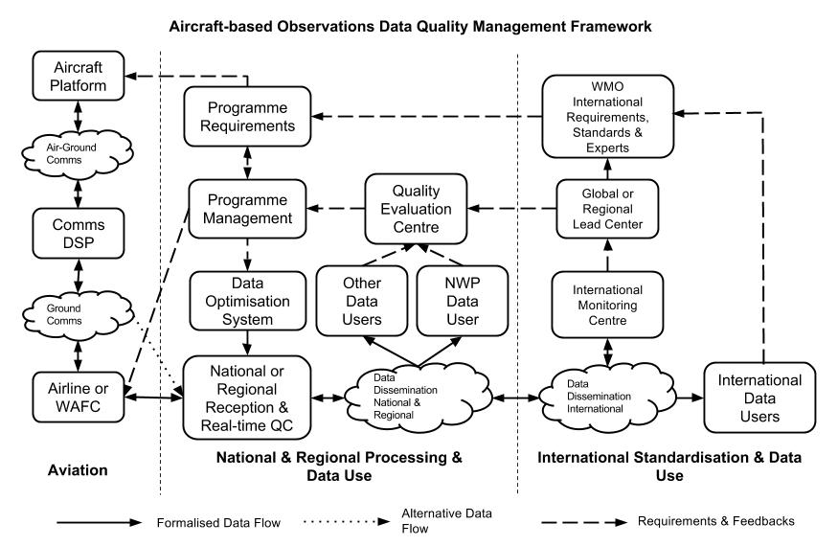
Figure 1.3. Aircraft-based Observations Data Quality Management Framework

1.9 PROVISION OF AIRCRAFT-BASED OBSERVATIONS TO THE WMO INFORMATION SYSTEM
Members must adhere to the provisions made in relation to provision of ABO as made within the Manual on the Global Observing System, Volume I, Part III, 2.5 – Aircraft meteorological stations.
Members that receive, process and provide ABO to WIS from any source, including AMDAR, ICAO aircraft observations and other ABO systems should do so in accordance with WMO Resolution 40 (Cg-XII) and in accordance with the guidance provided in Appendix C.
Members must ensure that each aircraft reporting ABO to WIS is designated with a unique national aircraft identity in accordance with the requirements established in Appendices C and D.
Members should ensure that on receipt of advice of poor quality data from the relevant WMO lead centre or from other WMO Members, they have the capacity to remove such data from further provision on WIS until such time as the data quality is restored.

1.10 OBSERVATIONAL METADATA REQUIREMENTS AND MANAGEMENT
Observational metadata refers to all types of metadata necessary to interpret the (sets of) observational data.
Members that receive and process ABO data from any source should ensure that they maintain a database of metadata related to the following observational aspects and elements of their observational data:
– Models and types of aircraft;
– On-board sensors and their siting and calibration, maintenance issues and calibration (where available and when able to be provided);
– Specific software and algorithms used to process data and generate the reported variables;
– Quality control processes and data-processing and communication practices.
Members should maintain and provide internationally required metadata relating to their ABO data in accordance with both the provisions and recommended practices within:
– Manual on the WMO Integrated Global Observing System (WMO-No. 1160), 2.5 – Observational metadata, and Appendix 2.4 – The WIGOS metadata standard;
– Manual on the Global Observing System (WMO-No. 544), Volume I, Part III, 2.5 – Aircraft meteorological stations;
– Appendix D of the present Guide.

1.11 OPERATIONS, MAINTENANCE, AND MANAGEMENT OF INCIDENT AND CHANGE
Maintenance consists of the routine processes and procedures that ensure that infrastructure and equipment, upon which the quality and reliability of observing system outputs depend, are planned and implemented.
Members must ensure that they operate and manage incidents and changes related to their ABO systems in accordance with the general provisions within:
– Manual on the WMO Integrated Global Observing System (WMO-No. 1160), 2.4 – Operations, and 3.4 – Operations;
– Manual on the Global Observing System(WMO-No. 544), Volume I, Part III, 2.5 – Aircraft meteorological stations;
– Manual on the Global Telecommunication System (WMO-No. 386), Part II, 5 – Procedures for amending WMO publications and methods of notification.
Members who make available ABO to WIS must, in collaboration with their partner airlines, develop and agree on policy and procedures for the detection, notification and rectification of issues and errors associated with the quality and operational performance of airline sensors, systems and infrastructure upon which their ABO systems depend.
Members should ensure that changes to the programme or schedule of reporting ABO on WIS are planned and notified in advance.
The Manual on the Global Telecommunication System, Part II, states that:
5.1 Responsibility for notification of amendments
Information for WMO publications shall be kept current. Notification of amendments shall be sent to the Secretariat at least two months in advance of the effective date of the change.
In practice and for the purpose of fulfilling the above requirement in relation to the operation of their ABO systems, Members should do the following to report changes to ABO programmes:
(a) Provide a written description of the change to be made within a “METNO” as described in the Manual on the Global Telecommunication System;
(b) Provide a written description of the change to be made by email to gos@wmo.int or via the contact form at http://www.wmo.int/pages/prog/www/OSY/form_enOBS.php;
(c) Update nationally and internationally required metadata as described in section 1.10 and Appendix D.

1.12 INTERNATIONAL AND REGIONAL PLANNING AND CAPACITY DEVELOPMENT

1.12.1 WMO Aircraft-based Observations Programme
To coordinate and promote the development of ABO and national (and regional) AMDAR programmes, the WMO Executive Council at its forty-ninth session in 1997 decided to establish a WMO Panel on AMDAR, composed of WMO Members that operated, or intended to operate, national AMDAR programmes. In 1998, the WMO AMDAR Panel took over the responsibilities for the operation of AMDAR, the remaining ASDAR units and the AMDAR Trust Fund.
At its fourteenth session in 2003, WMO Congress agreed with a recommendation made by CBS that AMDAR should become fully integrated into the WWW Programme. At its fifteenth session in 2007, Congress paved the way for the AMDAR observing system to become a recognized, operational component of the WWW Global Observing System.
At its fifteenth annual session in 2012, the WMO AMDAR Panel agreed that all was in place within WMO and its technical commissions to formally hand over full responsibility for the AMDAR observing system and the AMDAR Trust Fund, and for the Panel to cease its activities.
The international Aircraft-based Observations Programme (ABOP – not an officially designated WMO programme), which includes AMDAR, is now supported by an Expert Team on Aircraft-based Observing Systems within CBS and also an Expert Team on Aircraft-Based Observations within the Commission for Instruments and Methods of Observation (CIMO).
The tasks and activities of the two expert teams include the provision of programmatic and technical support for development, enhancement and maintenance of all ABO systems and for management of international standards and practices associated with ABO. Figure 1.4 represents the current governance and programmatic management of ABO within WMO.
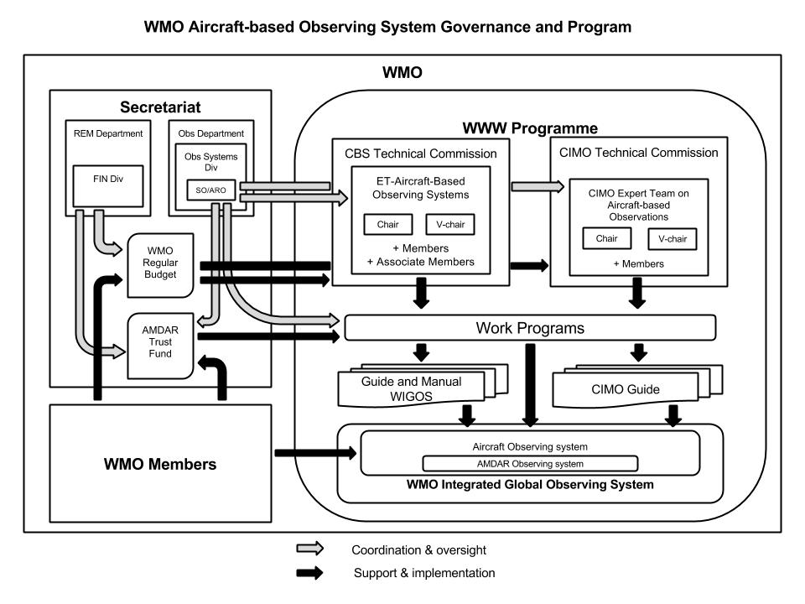
Figure 1.4. ABO system governance and programmatic structure

1.12.2 Projects and development
Under ABOP, WMO technical commissions have instigated a regional approach to ABO development in collaboration with WMO regional associations and its Members. ABOP intends to assist regional associations in developing and maintaining ABOP regional implementation plans (A-RIPs) in each of the six WMO regions. These A-RIPs are based on and in line with the relevant actions of the CBS Implementation Plan for Evolution of Global Observing Systems (EGOS-IP), WIGOS Technical Report No. 2013-04. An important role in this process is assigned to the WMO national focal points for ABO nominated by the Members. The focal points are listed in the WMO Country Profile Database.
While AMDAR is now a mature and stable operational observing system, there are many developments and enhancements underway or planned that are expected to improve the benefits of the system, the use of its observational data products and its operational coverage:
(a) Development of new programmes that will improve global upper-air-data coverage over currently data-sparse areas, including:
– Regions I and III;
– Eastern Europe;
– Western Asia;
– The South-West Pacific;
– Central and South America;
– The Middle East;
(b) Implementation of WVM as a component of the AMDAR observing system;
(c) Implementation of turbulence monitoring and reporting;
(d) Implementation of icing monitoring and reporting;
(e) Wider implementation of ground-based AMDAR data optimization;
(f) Wider integration of AMDAR standards and protocols into the avionics and aircraft manufacturing process;
(g) Implementation of routine data targeting in support of weather systems monitoring and prediction.
WMO Members should provide support for the continued development and enhancement of ABOP through the following actions:
– Continue financial support to the AMDAR Trust Fund in line with the relevant WMO Congress resolutions;
– Contribute staff resources to the membership of relevant WMO technical commission and regional association work teams and groups;
– Endeavour to obtain and provide ABO on WIS;
– Endeavour to develop and maintain operational AMDAR observing systems in line with national, regional and global requirements.

1.12.3 Training and outreach

1.12.3.1 Training requirements
Members should ensure that staff members are adequately trained for competency in the following areas of operational practices relating to ABO and the AMDAR programmes:
– Interaction and negotiation with aviation representatives and contact persons for collaboration on ABO and AMDAR programme participation;
– Specification of technical and functional requirements for AMDAR observing system planning and design;
– IT skills supporting data communications and data-processing systems infrastructure development and maintenance;
– Data monitoring and scientific and meteorological data analysis;
– Systems- and data-quality management.
For further information in relation to capacity development of AMDAR, refer to section 2.1.4.

1.12.3.2 Outreach
It is critical to the maintenance and continued development of the AMDAR observing system that the interests of Members are represented and promoted to the important stakeholders, for example, relevant sections within the NMHS concerned, the air transport industry, aeronautical associations and associated forums.
WMO and ABOP promote ABO and the AMDAR observing system through a range of activities:
– Maintaining the ABO and AMDAR areas of the WMO website (see http://www.wmo.int/pages/prog/www/GOS/ABO/index_en.html);
– Publishing the WMO AMDAR Observing System Newsletter and maintaining the news and events website (see http://www.wmo.int/amdar-news-and-events/);
– Maintaining statistical reports and quality monitoring information on the WMO website (see http://www.wmo.int/pages/prog/www/GOS/ABO/ABO_Data.html);
– Developing and maintaining guidance on the benefits and business case for aviation and airline collaboration on ABO (see http://www.wmo.int/pages/prog/www/GOS/ABO/AMDAR/resources/index_en.html);
– Cooperating actively with airlines and other relevant organizations, and participating in aviation-related bodies, for example, the Airlines Electronic Engineering Committee (AEEC).

1.12.3.3 Publications
The WMO technical commission expert teams on ABO support the revision and production of technical and scientific studies relevant to ABO, observing systems and their related technologies. See Appendix H for a list of important references.

1.12.3.4 Focal points
Members should nominate WMO focal points on ABO who can liaise with WMO technical commissions, WMO lead centres and fellow focal points on matters related to ABO and AMDAR. WMO focal points on ABO are listed in the WMO Country Profile Database.

2. AIRCRAFT-BASED OBSERVING SYSTEMS

2.1 AIRCRAFT METEOROLOGICAL DATA RELAY OBSERVING SYSTEM DEVELOPMENT AND OPERATION
Aircraft meteorological data relay is the WMO meteorological observing system that facilitates the fully automated collection and transmission of meteorological observations from commercial aircraft. AMDAR is an integrated component of GOS of the WWW Programme (http://www.wmo.int/pages/prog/www/index_en.html). The system is operated by WMO Member NMHSs in collaboration and cooperation with partner airlines and has grown rapidly and continuously since the early 1990s.
While the AMDAR programme is currently (mid-2017) served by a worldwide fleet of over 4 000 aircraft contributing around 800 000 high-quality upper-air observations per day, there are still many areas of the world with little or no AMDAR coverage. WMO and CBS urge Members to work towards improving upper-air coverage of GOS by developing new, and expanding existing national and regional AMDAR programmes.
Figure 1.1 provides a general overview of the AMDAR system in which on-board sensors, computers and communications systems collect, process, format and transmit the data to ground stations via satellite and VHF links. The transmission of this data to the ground is accomplished through use of aircraft ACARS. Once transmitted to ground, the data are processed and provided to WIS for global use by NMHSs and other authorized users.
The primary AMDAR dataset includes:
– Time of observation and aircraft position in three-dimensional space;
– Wind speed and direction;
– Ambient temperature;
– Pressure altitude;
– Where available, DEVG turbulence information.
Additional parameters include humidity measurement, requiring the deployment of a WVM sensor, and turbulence, requiring the implementation of the calculation and reporting of a supplementary metric, the EDR.
See section 1.9 for details on reporting AMDAR data on WIS.

2.1.1 Requirements and planning
When considering developing or participating in an AMDAR programme, the NMHS should ensure planning and availability of resources to fulfil the following requirements:
– Members must comply with the provisions within the Manual on the WMO Integrated Global Observing System (WMO-No. 1160), Volume I, Part III, 2.5 – Aircraft meteorological stations;
– Members should ensure that WMO requirements for upper-air data will be met (see section 1.5.1);
– Members should ensure compliance with relevant standards:
• AOSFRS, providing a standard for the meteorological functionality of AMDAR software applications and air–ground data formats;
• The AEEC Data Link Ground System Standard and Interface Specification (DGSS/IS) (ARINC 620-8), providing a specification of the meteorological report versions 1 to 6 uplink and downlink messages supporting AMDAR data delivery under the ACARS protocols;
• Guide to Meteorological Instruments and Methods of Observations (WMO-No. 8), Part II, 3 – Aircraft-based observations;
– Members should comply with WMO Resolution 40 (Cg-XII);
– Members should comply with the requirements for the operation of an AMDAR programme as provided in section 2.1.3;
– Members should comply with requirements for quality management of AMDAR data as provided in section 1.8;
– Members should comply with requirements for data-quality control of AMDAR observations as provided in Appendix A;
– Members should comply with requirements for the provision of AMDAR data to WIS as provided in section 1.9;
– Members should comply with requirements for the management and provision of AMDAR metadata as provided in section 1.10.

When considering and planning for the development and implementation of a national or regional AMDAR programme with one or more partner airlines, it is necessary for NMHSs to address each of the following basic topics and requirements:
– Assessment of national, regional and global requirements for upper-air data, including requirements for measurement of humidity and turbulence;
– Assessment of the capabilities and potential coverage of national airlines;
– Obtaining airline contacts and commencing negotiations with the airline(s);
– Building a business case for airline participation;
– AMDAR programme cost considerations;
– Contracts and agreements between NMHSs and airline(s);
– Design and implementation of the AMDAR system;
– Data display and use.

2.1.1.1 Assessment of requirements for upper-air observations
Before starting to develop an AMDAR programme, the requirements of upper-air data users and applications areas (national, regional and global) should be gathered and consolidated. These requirements should be assessed against the capabilities of the current national composite upper-air observing system and the ability of an AMDAR programme to fill gaps and/or to provide an efficiency dividend. Upper-air observing systems that might be considered in such an analysis are radiosondes, radar wind profilers, other ground-based remote-sensing systems, and polar orbiting and geostationary satellites.
The national aspects of such an analysis can be undertaken only by each NMHS individually in consideration of both the current configuration of the composite upper-air observing system and its likely future evolution.
An obvious consideration is that the AMDAR programme coverage is fully dependent on the flight schedule and coverage of the potential participating airlines. Flight schedules can vary daily, weekly, monthly and seasonally depending on customer demand and other airline-dependent factors.
Given the international operations (that is, regional and long-haul international flights) of many airline operators, it is also important to take into consideration that the AMDAR programme, by its nature, offers the opportunity to collaborate with regional and international NMHS partners to share and optimize the efficiency and coverage that can be provided. It is highly recommended that Members consider the various A-RIPs and WIGOS implementation plans for their respective regional association. This may provide the opportunity to collaborate on a regional basis, including the possibility to share costs and resources associated with the establishment, operation and maintenance of the necessary infrastructure, including AOS development, ground-based data acquisition and processing systems.

2.1.1.2 Requirements for humidity measurement
It is possible to equip aircraft with instrumentation for the provision of high-quality observations of WVM during all phases of flight. This greatly increases the value of the meteorological information collected by an AMDAR programme. The benefits and cost considerations of this equipment are described in detail in The Benefits of AMDAR Data to Meteorology and Aviation, WIGOS Technical Report 2014-01, mentioned in 1.4.
The report Impact and Benefits of AMDAR Temperature, Wind and Moisture Observations in Operational Weather Forecasting, WIGOS Technical Report 2015-01, was commissioned by ABOP. The report provides a comprehensive revision and summary of the impacts of AMDAR ABO of air temperature and wind over the past decade, and a comprehensive analysis and assessment of data quality of WVM derived from the United States Meteorological Data Collection and Reporting System (MDCRS)/AMDAR/WVSS-II programme.
Members should consider requirements for humidity measurement as a component of their AMDAR programme and endeavour to include this observation capability in new and existing AMDAR programmes. While this does require the installation of equipment to the aircraft, that process is well defined and the resulting observations lead to a significantly greater benefit to AMDAR data users.

2.1.1.3 Assessment of national airlines capabilities and coverage
Potential operators of a national or regional AMDAR programme should start with a preliminary assessment of the national airlines’ aircraft fleets and an analysis of the operational routes serviced by the airlines. In the case that a national airline does not exist, other commercial airlines operating within the nation or region may be considered.
The overall aim of the survey and analysis of the national airlines should be to determine what coverage might be obtained by equipping one or more fleets of aircraft types and which combination of airlines and aircraft fleets most efficiently provides the optimal coverage that best meets established requirements for upper-air data.
Detailed information on airline fleets and the flight routes they operate can usually be found on airline websites. If not, it will be necessary to establish direct contacts with the companies (see section 2.1.1.4) to obtain this information.
In particular, the following aspects and questions regarding an airline require consideration:
– Of prime importance is whether the airline and aircraft have ACARS capability, which enables the near-real-time automated reporting functionality required for AMDAR.
– Which types of aircraft does the airline operate and which routes does each aircraft type tend to fly?
– Of these types, which aircraft type fly domestic routes and which fly internationally?
– What is the age of the aircraft? The more modern the aircraft, the more likely they will be able to accommodate an AMDAR software application. Note that it will be necessary to determine exactly which avionics the aircraft have and whether or not they will support an AMDAR software application.
– Which airports does each airline and aircraft fleet service routinely?
– Based on the airline flight schedules, how many vertical profiles per day at each airport are likely to be obtained through equipping the different aircraft types?
– Is the airline well established, stable and likely to continue operation well into the future?
– Does the airline have a strong maintenance division? While this is not crucial and, in fact, many airlines outsource their maintenance operations, it is certainly beneficial to be able to liaise directly with technical staff and engineers within the airline who will understand the engineering aspects of aircraft maintenance and monitoring via avionics systems.
Once the initial analysis of national airlines has been undertaken, it is then necessary to make a firmer determination on whether or not the airlines and aircraft have the required technical capabilities. This can be done by asking the airline to complete a questionnaire, the Airlines AMDAR Compatible Systems Survey, that is available from the WMO AMDAR resources website. Once the survey has been completed it should be returned to the WMO Secretariat for analysis.
The survey should be completed before the airline has agreed to participate in the AMDAR programme and will be necessary to identify the on-board avionics type and capabilities, which will determine the suitability and requirements for AOS (see section 2.1.2.3 and Appendix F).
For a global summary of airlines operating aircraft suitable for AMDAR, highlighting those that have been targeted by WMO to contribute to extending global AMDAR coverage, it is also recommended to consult the WMO report AMDAR Coverage and Targeting for Future Airline Recruitment – In AMDAR-data-sparse regions (January 2013).

2.1.1.4 Obtaining airline contacts and commencing negotiations
Once it has been confirmed that one or more national airlines operate aircraft that might be suitable for contributing to the WMO AMDAR programme and the upper-air data requirements, the NMHS should seek to establish some key contacts within the airline to be able to begin negotiations and present a business case to the airline for its participation in the programme. Table 2.1 provides the various recommended airline personnel that might be strategic contacts to make and maintain so as to assist, provide information and/or negotiate with in relation to the establishment of an AMDAR programme.

Table 2.1. Airline contacts and their roles and associations with the AMDAR programme
Airline contact | Role in the airline | Role in AMDAR programme development and/or operation | Comment
Airline CEO or other senior executive officer | Executive manager and high level decision-maker | – May understand the impact of weather on airline operations  – May be a recipient of the business case for programme participation  – May provide initial, high-level decision on airline involvement in the programme | – Unlikely to be involved in detailed negotiations  – Unlikely to be involved in ongoing aspects of the programme
Chief pilot | Senior representative of pilots to airline executive and is influential in airline decision-making, particularly in relation to those aspects of flight operations and safety | – Will understand the impact of weather on airline operations and efficiency, including fuel usage  – May provide influence on high-level decisions on airline involvement in the programme  – May be a recipient of the business case for programme participation  – May provide a link to flight operation aspects of the programme | – May be involved in the initial negotiations  – Unlikely to be involved in ongoing aspects of the programme
Flight operations manager | Manager of all aspects of aircraft flight operations and is often the contact who liaises with NMHSs for weather services | – Will understand the impact of weather on airline operations and efficiency, including fuel usage  – May provide a link to aircraft maintenance and engineering areas of the airline | – May be involved in the initial negotiations and also the ongoing aspects of the programme  – Often is the first airline contact made by the AMDAR programme manager due to the weather services link
Avionics and maintenance engineering | Responsible for airline aircraft and avionics maintenance | – Will be involved in determining avionics capabilities  – Will be responsible for AMDAR software integration | – Can be a useful first-up contact, but usually defers to other airline managers regarding participation in the programme and its benefit to the airline
Once a suitable group of airline contacts has been established, the NMHS should start negotiations with the airline management to convince them of the benefits of participation in the programme and assist in the development of a business case for airline participation. The ultimate goal is to reach agreement on the various programme parameters, including AMDAR fleet size and configuration, AMDAR software development and integration, implementation and ongoing costs, and other factors associated with the design of the AMDAR system as describe in section 2.1.2.

2.1.1.5 Building a business case for airline participation
Of critical importance in the process of convincing an airline to participate in the AMDAR programme is the development of a business case. The NMHS should clearly establish the business relationship between the provision of the AMDAR data, the expected improvement in weather forecasting skill, and the resulting positive impact on the services to aviation that the NMHS will be able to provide. It should be made clear that this will lead to improved, more efficient and safer flight operations, reduction in airline costs (for example, reduced fuel consumption) and increased airline customer satisfaction based on the airline demonstrating concern and being willing to assist in mitigation of environmental issues (for example, CO₂ emissions and noise production) related to activities in the aviation industry.
For more detailed information on the benefits and impacts of AMDAR that can be used in developing a business case, see The Benefits of AMDAR Data to Meteorology and Aviation, WIGOS Technical Report 2014-01.
Other important considerations for inclusion and explanation in the airline business case are the following:
– It should be emphasized that the AMDAR software module, once installed and operational, will have no adverse impact on safety or the aircraft operation. The AMDAR software is tested and certified to ensure seamless and safe integration into the avionics, such as the aircraft condition monitoring system (ACMS) or its equivalent;
– The AMDAR observations, collected and pre-processed by the AMDAR software, are interleaved with the routine aircraft-to-ground data flow and communications over the ACARS system;
– The airline may argue that the AMDAR data provided to the NMHS improves weather services generally, which benefits all airlines. While this is true, it should be emphasized that there are additional benefits that participating airlines will have over non-participating airlines:
• The performance of on-board sensor(s) providing data to the AMDAR software, which are integral to the operation and performance of the aircraft, are monitored for quality control reasons as a result of the provision of AMDAR data to the NMHS. The NMHS can therefore provide a complimentary service to the airline to inform them if and when a sensor is errant or out of calibration;
• The impact of AMDAR is generally greatest where and near to where the AMDAR observations are made and reported and, therefore, the improvement to weather forecasting skill would be expected to be most pronounced for those routes the participating airline operates and provides data for;
• In the near future, ABOP expects to establish a Global Data Centre for Aircraft-based Observations, which participating airlines would have access to and be able to utilize for flight operations and other applications that might enhance their business;
• The airline can promote its participation in the programme, demonstrating its commitment to improved airline operational performance and service to the nation through a partnership with the NMHS. As a result, it will likely generate greater satisfaction and loyalty from those customers that appreciate the airline’s endeavours to reduce its impact on the environment and support the NMHS in improving forecasting services for the nation.

2.1.1.6 Aircraft meteorological data relay programme cost considerations
The costs for the development and operation of an AMDAR programme are highly dependent on the size and complexity of the programme. They also depend on the relationship established between the NMHS and the airline and the extent to which the airline perceives or quantifies the benefits based on the business case for AMDAR programme participation.
Generally, AMDAR programmes have been and should be established between NMHSs and their partner airlines under the understanding and agreement that the mutual benefits dictate that the NMHS should pay no more than the incremental costs (incurred by the airline) of establishing and operating the programme.
A costing model for comparing the estimated costs associated with operating an AMDAR programme with those of a radiosonde programme has been developed and the results are available in The Benefits of AMDAR Data to Meteorology and Aviation, WIGOS Technical Report 2014-01, Annex 5 – Cost comparison between AMDAR and radiosondes.
In summary, the programme costs are largely dependent on the following factors:
– The communications solutions adopted in cooperation with the airline;
– The contractual arrangements between the particular airline and its DSP;
– The size of the AMDAR fleet and the volume of AMDAR data generated by the fleet;
– The extent to which data optimization methods are deployed and utilized;
– The extent to which the airline perceives and quantifies the benefits of participating in the programme;
– The extent to which the airline itself is willing to contribute (financially) to the programme.

The following costs have to be considered:
– Development and infrastructure costs:
• AOS;
• Software integration and roll-out;
• Communications infrastructure;
• Data processing and quality management development;
• AMDAR data optimization system (ADOS);
– Ongoing operational costs:
• Data communications costs;
• Aircraft system utilization costs;
• Maintenance costs for the AOS and the required ground-based infrastructure and software.

2.1.1.7 Contracts and agreements between National Meteorological and Hydrological Services and airlines
It is very important that an agreement, contract or memorandum of understanding is established between the NMHS and each participating airline for the operation of the national or regional AMDAR programme. Such a document should outline the terms and conditions agreed upon to cover at least the following aspects of the programme operation:
– The time period for operation of the agreement and the programme, including an arrangement for contract or agreement termination;
– The number of aircraft to be equipped with AMDAR software for reporting AMDAR data at an agreed frequency of reporting;
– Costs payable to the airline by the NMHS;
– Requirements for the airline to ensure data supply and quality;
– Requirements for the NMHS to report to the airline any issues or faults associated with AMDAR software performance and data quality;
– The terms and conditions, including liabilities and the rights of the NMHS and third parties (for example, NMHS clients) covering the use of AMDAR data, which would preferably include ownership (that is, jointly with the airline) of the associated meteorological data upon reception. It is critical that this aspect of the agreement at least allows AMDAR data to be distributed to WIS and used by WMO Members according to WMO Resolution 40 (Cg-XII);
– Third-party liabilities associated with operation of the programme and AMDAR data use:
• The NMHS should seek to ensure that the agreement precludes the NMHS from being liable for any damages (including third-party claims) associated with any aspect of the aircraft operation (this must be the airline’s responsibility);
– The agreement should preclude the airline being liable for damages (including third-party claims) associated with any aspect of data use by the NMHS and its data users and clients (this should be the NMHS’s responsibility);
– Ownership and intellectual property rights – the agreement might stipulate that:
• If appropriate and depending on which party contributed resources to its development, the NMHS has ownership of the AOS;
• If the airline claims ownership of the AOS, it should be agreed that this software would be made available for implementation in aircraft of other airlines under a non-exclusive and free licence for use;
• WMO and/or the NMHS have rights over the intellectual property associated with the specification of the AOS.
Important notes:
The arrangement of contracts and agreements can be a complex process and such documents must be consistent and in keeping with both national and international laws and legislation. For this reason, it is highly recommended that Members consult with either their own or hired legal staff to assist in this process and ensure that any agreement or contract developed is compliant with the law and does not unknowingly or otherwise disadvantage any of the parties to the agreement.
In many cases, national laws prevent contracts from containing the waiving of third-party liabilities. In such cases, it is critical to undertake a risk assessment and ensure that each party has developed and implemented appropriate mitigation strategies for any risks associated with the operation of the programme.
If requested, WMO may be able to assist in the process of developing an agreement or contract between an NMHS and an airline for operation of an AMDAR programme.

2.1.2 Design and implementation of the aircraft meteorological data relay system
When commencing a new AMDAR programme, many requirements must be taken into consideration regarding the design, development and the implementation of the system.
In designing and implementing the AMDAR system, the NMHS must consider all components of the AMDAR system shown in Figure 1.1.
The following are the major system elements to be addressed for design, development and implementation:
(a) Regional and international design considerations;
(b) Requirements for measurement of humidity (including sensor installation and maintenance) and turbulence (with associated algorithm software);
(c) Configuration and optimization;
(d) AOS development and implementation;
(e) Air-to-ground communications;
(f) Ground-based communications and data processing infrastructure;
(g) Delivery to data users;
(h) Data-quality management and monitoring.

2.1.2.1 Regional and international design considerations
There are two international aspects of an AMDAR programme design that might be taken into consideration before designing and implementing an AMDAR programme and system. These are:
(a) International AMDAR data sharing and optimization opportunities;
(b) International cooperation on AMDAR system infrastructure.

Many national airlines operate internationally and, therefore, may be capable of producing valuable AMDAR data both within and outside national boundaries. This has implications for two aspects of the AMDAR programme.
First, if a national airline is not yet ready to participate in the AMDAR programme, it might be possible to provide AMDAR data over or within that country generated by another operational national AMDAR programme. Through a bilateral arrangement, the recipient NMHS would cover the incremental costs to the operational AMDAR programme for providing that data.
Second, when it comes to the roll-out of the AMDAR fleet that will be made operational, it is worth considering equipping a combination of domestic, regional and international aircraft fleets that, when combined with suitable configuration or optimization (see below) would allow a more comprehensive national and regional coverage. This would have several advantages including an even greater impact on national, regional and global NWP and the opportunity for collaboration and data-cost sharing with other NMHSs.
The second consideration may lead to significant opportunities for reducing the costs associated with AMDAR system infrastructure. The international aspect of airline operations and communications and the fact that the AMDAR programme relies on using standardized aviation and meteorological communications protocols (that is, ACARS and WMO BUFR), makes it possible for AMDAR data to be received and processed by dedicated regional data acquisition and processing hubs. This offers the opportunity for international and regional collaboration and efficiency dividends in relation to the development of AMDAR programme infrastructure.
Examples of regional cooperation in AMDAR are:
– The European Meteorological Services Network (EUMETNET)-AMDAR programme (E-AMDAR) (15 airlines, supported by 31 member States) providing supplementary global data outside the EUMETNET domain through bilateral agreements and as a contribution to the WWW programme;
– The United States MDCRS programme (seven airlines) providing data outside the United States domestic airspace over central and South America;
– AMDAR data-cost sharing between Australia and New Zealand;
– The South Africa programme providing data outside South African and continental African airspace over the Atlantic and Indian Oceans.
Cooperative arrangements are strongly encouraged by WMO and can be facilitated through supportive actions within WMO regional associations (see section 1.10) and communication between the national WMO ABO focal points.
Under ABOP, A-RIPs have been developed as a component of the WIGOS regional implementation plans.

2.1.2.2 Network configuration and optimization
Before initiating the development of AOS, it is necessary to consider the likely size of the potential national AMDAR fleet and how data production will be configured and controlled. AOS contains software configuration parameters and functions for optimizing reporting based on geographical area, airport identification or time. The default configuration of the software should be discussed with the software developer and specified before the software is developed and released.
When limited to the AOS configurable optimization functionality only, AMDAR systems and programmes can still have high redundant data levels (up to and more than 50% for large programmes). Given the significant communications costs associated with the AMDAR system, the AOS specification and requirements have been developed to enable the software application to respond to "uplink commands", transmitted through the ACARS system.
Some AMDAR programmes have made use of this AMDAR software functionality by developing and implementing ground-based ADOS. Based on flight plans between so-called “airport pairs” (departure and destination locations) these systems are able to determine the potential AMDAR data that might be produced during a set time interval. If data is already available or scheduled to be produced during the period by another AMDAR aircraft, the ADOS will automatically compile and send uplink commands to the aircraft to reconfigure the reporting configuration of the AOS and thus avoid the production of redundant data not required for meteorological service provision. Such ADOS have demonstrated the capability to reduce the communications costs associated with AMDAR systems by 50% or more while not having an adverse impact on useful data coverage.
The E-AMDAR and Australian AMDAR programmes have both implemented ADOS. Commercial service providers (Rockwell Collins/ARINC and the Societé internationale de Télécommunications aéronautiques (SITA)) have also developed optimization systems which can also be used for AMDAR data optimization.
For national AMDAR programmes with fleet sizes of the order of 50 or more aircraft, it is recommended that ADOS be implemented as a component of the system infrastructure.
In addition to reducing costs and data redundancy, ADOS also offer the capability of altering and adjusting data observations output based on short-term requirements. Potential applications include the targeting of additional AMDAR data for severe synoptic or other scale weather system monitoring and prediction, or mitigating coverage loss during airline strikes or system outages that have an impact on data output and network coverage. Furthermore, optimization systems can be used for additional data acquisition from areas or regions where no national or regional AMDAR programme is available, and where national NMHSs have agreed to cover the incremented cost.
Further information and guidance on the requirements for development and utilization of an ADOS can be found in Appendix E.

2.1.2.3 Aircraft meteorological data relay on-board software development and implementation
The role of AOS is to facilitate the functions and the required system interfaces of the on-board AMDAR system. The primary functions of AOS are:
(a) Function as an interface to a variety of innate aircraft avionics equipment;
(b) Perform initial quality checks on the input data;
(c) Perform calculations upon the input data to derive required meteorological variables;
(d) Process, at set intervals, collected data into standard output messages for transmission to ground stations;
(e) Accept and process inputs, allowing users to alter the AOS behaviour by manual or uplink command reconfiguration.

Given that the full functionality of AOS is relatively computationally complex and demanding, the AMDAR system relies on and is usually best employed in modern commercial aircraft, equipped with the necessary avionics, flight data computers and communications systems.
The current AMDAR observing system relies on the communications protocols defined for ACARS, which are specified within the standards of AEEC.
The World Meteorological Organization currently specifies and maintains two meteorological standards for AOS:
(a) AOSFRS, which supersedes the ACARS AMDAR ACMS (AAA) specification series (versions 1 to 3);
(b) The ARINC 620 Meteorological Report, versions 1 through 6 defined within the AEEC 620-8 DGSS/IS, which is maintained by the AEEC Data Link Systems Subcommittee. Within the specification, AMDAR reporting formats and functionality are defined through the definition of the Meteorological Report.
The AOSFRS and ARINC 620 specifications both rely on the basic DGSS/IS ACARS protocols. The specifications or their URL references are provided from the AMDAR resources area.
The NMHS and the Airlines will need to reach agreement on the terms and conditions for any software development that is required to be undertaken and whether there will be a requirement for the involvement of a third-party applications developer. The AOS will generally be required to undergo testing and certification with the avionics manufacturer to ensure that it complies with requirements and does not interfere with or adversely affect existing and standard applications.
Further information and guidance on AOS development can be found in Appendix F.

Flight testing
Once AOS has been developed, it should be tested operationally to ensure its correct functionality and performance, including message format, response to uplink commands, correct software configuration and quality of the AMDAR data produced. Arrangements to conduct flight testing on one or more aircraft over a suitable period of time (for example, 1–2 weeks) should be made with the airline and the AOS developer in advance and, if necessary, include a process to correct any software defects or bugs. Such testing can be undertaken at ground-testing facilities or from the ground during aircraft maintenance, but it is recommended to also examine and analyse the AMDAR data received from a series of operational flights very carefully before the full AOS roll-out occurs and before AMDAR data is provided to WIS. The flight testing process and data analysis should involve a number of checks including (as a minimum):
– Comparing temperature, wind and other meteorological data with co-located radiosonde and/or NWP information;
– Validating spatial and temporal coordinates;
– Ensuring compliance with the (latest) WMO AMDAR BUFR specification FM 94.
Experts from ABOP can assist and provide technical advice in relation to AOS specification, development and testing.

Software roll-out
Once AOS and data quality have been tested, and the AMDAR data acquisition and processing system is operationally implemented, the airline can be requested to install the software across the entire proposed AMDAR fleet. This will usually occur during standard aircraft maintenance checks and processes so as to minimize costs and disruption to airline operations.

2.1.2.4 Air-to-ground communications
The primary system that supports communications for the global aviation industry is ACARS. The aeronautical communications infrastructure that supports air-to-ground communications of ACARS is normally provided by one of the two major aviation DSP companies, ARINC and SITA. Independent communications companies are operating similar aviation services (in Brazil, China, Japan and Thailand, for example) and are linked to the ground-based component of the global services provided by ARINC and SITA. Both ARINC and SITA provide two-way communications based on VHF, HF and satellite systems. Airlines will usually have a contract with one or other of these companies to guarantee global communications services for their own commercial operational purposes.
On-board avionics applications require air-to-ground communications via ACARS utilizing both VHF and satellite communications systems for global coverage. Some AMDAR software applications are, however, configured to use only the VHF communications channel for data delivery. In such cases, this can mean that en route reports, compiled over locations where VHF coverage is not available, will be delayed by several hours on long-haul international flights.
The downlinked AMDAR data are received by the ground reception system of the DSP and routed to the airline. Data can then either be routed by the airline to the NMHS or in some cases, in agreement with the airline, can be routed directly to the NMHS by the DSP in parallel. Both approaches would usually require the establishment of hardware and software systems within the NMHS to which the data is routed using an Internet transfer protocol such as, for example, TCP/IP or FTP. In the latter case, the NMHS will need to negotiate a contract with the DSP for providing the service.
In both cases the data will be received in a type-B ACARS message format. The NMHS will have to develop a ground processing system for receiving, de-coding and quality checking the data before reformatting them into a bulletin for operational use and distribution to WIS.

2.1.2.5 Ground-based reception and processing
It is the responsibility of the NMHS to ensure that the necessary ground-based processing system for AMDAR data is developed, implemented and made operational by the time the airline(s) commence producing data.
The data acquisition and processing system is normally located in the NMHS and is required to:
(a) Receive the data (most usually delivered as a type B ACARS message, for which the format can be obtained from the relevant software specification – see AOSFRS version 1.1 (referenced previously) or ARINC 620 (see 2.1.2.3);
(b) Decode the data;
(c) Conduct rudimentary data-quality checks (range, rates of change, observations consistency, and the like – see Appendix A;
(d) Reformat the data into acceptable messages or bulletins for operational use within the NMHS and for exchange on WIS – see Appendix C.

2.1.2.6 Planning for water vapour measurement in the aircraft-based observations network
The addition of WVM should also be evaluated in the planning of an ABO network, as it enables the network to include observations of all the basic meteorological parameters provided by radiosondes. WVM can be accomplished with the addition of an appropriate water vapour sensor to some or all of the aircraft participating in the ABO programme. This requires a relatively minor modification to the aircraft for sensor installation, which is typically installed by the airline partner’s maintenance team. The sensor must also be certified for use on specific aircraft types by the governing aviation regulatory body for the nation or region (for example, the Civil Aviation Administration of China, the European Aviation Safety Agency, FAA, among others). This process, known as a supplemental type certification is explained on the WMO AMDAR website.
The Water Vapor Sensing System version II is a specialized sensor designed specifically for aviation use in AMDAR. It has undergone extensive performance testing and operational evaluation by WMO Member NMHSs in collaboration with the WMO AMDAR programme. It has been certified for use on multiple aircraft types in the United States and Europe. WVSS-II is currently the only sensor deemed to be capable of meeting operational and performance requirements for use with AMDAR (see AOSFRS version 1.1 (referenced previously), Appendix C.2 – Atmospheric water vapour content). A WMO Instruments and Observing Methods document regarding the performance of WVSS-II has been drafted and is expected to be finalized in 2017.
As at July 2017, there are 150 aircraft equipped with WVSS-II reporting WVM within the AMDAR programme globally. The United States AMDAR and the E-AMDAR programmes operate 141 and 9 equipped aircraft respectively. Both regions are continuing to expand their implementations of WVM with WVSS-II. WVM data is currently used in various NWP models and recent studies have indicated this addition provides a significant benefit to model performance (see James and Benjamin, 2017; Ingleby, 2016).,
While it is recommended to start a WVM programme after standard AMDAR operations have begun, reaching agreement for this addition will take time and it is best to commence discussions on this aspect with the airline early. The following factors should be considered when implementing WVM:
– Whenever possible, consideration should be given to airline partners that operate aircraft types for which a sensor certification (supplemental type certification) is available. This will reduce the need to go through a lengthy certification process, which can take close to a year to complete, depending on many factors.
– The AOS must be adapted to accommodate the addition of the new sensor.
– The ground-based processing centre must accommodate the new data type, including quality controls, data formatting and management of metadata.
– While ideally all aircraft in the ABO network would be equipped to report WVM, realistically only a relatively small percentage of the fleet will typically be equipped. That percentage will be determined by the anticipated operational frequency and location of the aircraft concerned. Consideration must be given to the fact that an airline will always have a small number of their aircraft fleet out of service for maintenance at any one time. Therefore a sufficient number of aircraft must be equipped to ensure WVM data is always available to support NMHS data needs.
– The sensor is typically installed during a scheduled aircraft “heavy maintenance” check. This is a routine aircraft maintenance that typically lasts for one or two months, depending on local practice. Experience shows that installation is easily accomplished during this period without impact on other airline maintenance activities. Since this maintenance is only done on each aircraft approximately every two years, it may take time to get the planned number of aircraft equipped with the sensor.
– While sensor performance has proven to be stable for six years or more, it is recommended that a store of spare sensors of at least 5% of the installed fleet should be maintained. This will allow the most effective maintenance programme and not cause undue impact to the partner airline. Maintenance of the sensor unit has proven to be very infrequently required and, when it is necessary, the unit can be replaced within a matter of hours.

2.1.3 Operations

2.1.3.1 General requirements

2.1.3.1.1 Responsibilities of Members
Members should ensure that their AMDAR system is operated in accordance with the following general requirements:
– Agreements with partner airlines should be in place to ensure that they undertake those responsibilities identified in section 2.1.3.1.2, and so that ABO generated by the programme can be made available to all WMO Members on WIS in accordance with the requirements of WMO Resolution 40 (Cg-XII);
– In consultation with airline partners, the AOS should be configured in accordance with requirements for upper-air data and ABO (see section 1.5);
– If implemented and utilized as a component of the AMDAR system, correct configuration and operation should be ensured of the ground-based optimization systems in consultation with airline partners;
– Processing and management of AMDAR messages and observational data received from partner airlines should proceed in accordance with sections 1.7, 1.8 and 2.1.3.3;
– Partner airlines should be informed when an aircraft is reporting data outside of tolerance ranges for meteorological parameters;
– The reporting of ABO and metadata should be in accordance with national, regional and international requirements and for provision of such data on WIS – see sections 1.9, 1.10, 2.1.3.4 and 2.1.3.5;
– Monitoring of operational systems and AMDAR data should be performed in accordance with sections 1.8, 2.1.3.3 and Appendix B;
– Management of incidents, including the identification and rectification of defects, should be in accordance with section 2.1.3.7;
– Maintenance of the observing system components should be in accordance with sections 1.11 and 2.1.3.9;
– Planning, implementation and documentation of changes in the operational practices and procedures of the observing system should be in accordance with sections 1.11 and 2.1.3.8.

2.1.3.1.2 Responsibilities of partner airlines
Partner airlines have several responsibilities to facilitate and support the planning and operation of an AMDAR programme and these responsibilities should be negotiated in a formal agreement as described in section 2.1.3.1.1. Thus, partner airlines will be expected to:
– Assist in developing AOS as needed – see section 2.1.2.3;
– Develop documentation to support AOS installation and maintenance;
– Assist in flight testing of the software – see section 2.1.2.3.1;
– Implement the software in avionics systems through roll-out on the selected fleet(s) – see section 2.1.2.3.2;
– Arrange air-to-ground communication of AMDAR data to the NMHS – see section 2.1.2.4;
– Facilitate contacts between the NMHS and DSP(s) as needed – see section 2.1.2.4;
– Assist in setting up ground-based data transmission as needed – see section 2.1.2.5;
– Allow the NMHS the use, or ownership of data for Member-mandated purposes in accordance with WMO Resolution 40 (Cg-XII);
– Ensure that updates to avionics systems do not disable or adversely affect AMDAR operation and that the NMHS is informed of such updates in a timely manner;
– Provide required operational metadata – see sections 1.10 and 2.1.3.5;
– Rectify sensor and data-quality issues as soon as possible within operational constraints;
– Inform about planned operational changes, for example, flight schedules and routes, fleet configurations or renewals and other issues that could influence AMDAR data provision;
– Agree on operational programme costs – see section 2.1.1.5.

2.1.3.1.3 Responsibilities of other partners
The NMHS and airlines may have to contract a DSP for the transmission of AMDAR data from the aircraft to the ground and from the airline’s data processing infrastructure to the NMHS. The contract should:
– Guarantee the highest possible reliability of the transmission infrastructure operated by the DSP – see sections 2.1.2.4 and 2.1.2.5;
– Include a feedback mechanism to inform the NMHS and the airline about any planned changes or incidental issues that will disrupt the data transmission;
– Define back-up solutions needed to prevent or minimize the duration of disruption in data provision.

2.1.3.2 Observing practices

2.1.3.2.1 Reporting configuration

Observing frequency
Members should be responsible, in collaboration with partner airlines, for ensuring that AOS is configured optimally so as to best meet requirements for upper-air data and ABO as described in section 1.5.
As described in section 2.1.2.3, the primary standard for AOS is AOSFRS, maintained by WMO. The AOSFRS provides the functional and meteorological requirements for AOS that should also underpin any applications that adhere to the uplink and downlink message formats associated with the AEEC ARINC 620-8 meteorological report.
Depending on the degree of configurability of the AOS that has been implemented (see section 2.1.2), Members should collaborate with partner airlines to ensure that the AOS reporting configuration is established and maintained so as to best meet the default reporting regime defined within AOSFRS as a minimum.
The AOS should be used to configure and determine both the frequency of reporting during the various phases of flight (see Figure 2.1) and also over which geographical areas and locations the observations are to be made and reported.
Figure 2.1. AMDAR flight phases
The reporting frequency during the ascent, en route and descent phases of a flight should be in accordance with AOSFRS as a minimum, either based on air pressure level specification (vertical resolution) or on a time-based specification (temporal resolution) – see Figure 2.2.
Figure 2.2. Specifications for AMDAR observing intervals by flight phase

Reporting location and optimization
Ideally, vertical profiles of AMDAR observations obtained at airports would be equally spaced (both geographically and temporally) and configured or optimized so as to best meet requirements associated with the relevant WMO application areas for which the AMDAR network has been established to address (see section 1.5). For example, the AMDAR network might be configured and optimized so as to endeavour to meet the requirements for the provision of upper-air data for global NWP. However, in practice the ideal data output necessary to meet the precise requirements is very difficult to attain. Airports are located where they are to meet requirements for transport of people and goods. In some areas they are closer to each other, so that observations at all locations would be surplus to requirements, whereas in sparsely populated areas there are longer distances between airports and the requirements for observations are not able to be fully met. Furthermore, an airline participating in an AMDAR programme might not service all airports needed to deliver the required horizontal coverage of vertical profiles.
The geographical production of observations by the AOS can be controlled through two mechanisms ideally available within the AOS application and as defined within AOSFRS. First, geographical boxes can be defined and set either to report or supress observations. Second, a list of airports can be defined and set either to report or suppress vertical profiles. Members should collaborate with airline partners to ensure that these configurations are established and maintained so as to best meet the requirements for horizontal resolution of reporting of both vertical profiles and en route AMDAR observations.

Ground-based data optimization configuration
Once the AOS is configured and activated, the aircraft will make observations and send reports in the same way during each flight. The default AOS configuration settings can be changed but that requires either a manual intervention, usually by the airline, or, if the software has the required functionality, through the sending of configuration-change uplink commands to each aircraft in the fleet. As a result, and depending on the number of aircraft in the AMDAR fleet and their flight schedules, the permanent default configuration may result in the collection of more data than required at certain airports or along certain routes. These redundant data may be up to 50% or more of the total volume of AMDAR data collected and can result in unnecessarily high communications costs for the NMHS. This issue can be alleviated or resolved through the development and employment of a ground-based ADOS. More details on the development and implementation of an optimization system are provided in section 2.1.2.2 and Appendix E.
If Members employ an optimization system, they should:
– Configure or arrange for configuration of the system to ensure that they optimally meet requirements for provision of ABO as described in section 1.5;
– Collaborate and cooperate with regional Members and other AMDAR programmes to endeavour to optimize regional and global coverage of ABO outside and beyond national borders – see sections 1.12 and 2.1.2.2.

2.1.3.3 Quality management
General requirements and provisions for management of the quality of ABO are provided in section 1.8.

Data-quality control

On-board data processing
Quality control processing should be applied to AMDAR observational data variables in accordance with the data validation procedures as specified in AOSFRS.

Ground-based data processing
Members should apply the relevant quality control procedures to AMDAR data after their reception by the DPC.

Data monitoring and quality assessment
Members should develop and implement policy and procedures for quality monitoring and assessment of AMDAR observations made by their AMDAR programme.
The WMO Lead Centre for aircraft and satellite data monitoring, Washington, is responsible for quality monitoring of ABO and the dissemination of monitoring information to WMO Members. It has the role of lead centre for aircraft data using the data monitoring processes carried out by the US National Weather Service, NCEP, Central Operations.
At the current time, ABO data monitoring is limited to the compilation and notification of monthly NWP comparison reports that are available online from NCEP Central Operations, Quality Assessment Project (http://www.nco.ncep.noaa.gov/pmb/qap/).
Members should use the monitoring information and reports provided by the WMO Lead Centre for aircraft and satellite data monitoring as an integrated component of the quality management operations of their AMDAR programme.
Members should consider the development and implementation of additional monitoring procedures for AMDAR observational data, which might include:
– Use of statistics and diagnostic results from their AMDAR quality control procedures (see 1.7.2.1 and Appendix A);
– Use of the monitoring results of other WMO Member monitoring centres;
– Use of AMDAR information available at the Global Data Centre for Aircraft-based Observations;
– Intercomparison of AMDAR observations with NWP fields;
– Intercomparison of AMDAR observations with other sources of upper-air observations, for example radiosonde data;
– Monitoring diagnostics developed and based on other data analysis techniques such as:
• Temporal consistency/gradient checks;
• Spatial consistency/gradient checks;
• Aircraft intercomparison;
• Aircraft apparent velocity checks.

Members should develop procedures for the analysis of available monitoring information and take prompt and appropriate corrective action (see 2.1.3.6) for systemic defects and issues identified that adversely affect the quality of AMDAR observations provided to WIS.
Detailed guidance on quality monitoring and analysis of ABO data is provided in Appendix B.

2.1.3.4 Data management and reporting
Members should develop policy and procedures for the management of their AMDAR observations in accordance with the provisions defined above and in sections 1.7, 1.8 and 1.9.

2.1.3.5 Metadata management and reporting
Members that provide AMDAR observations to WIS must provide their AMDAR metadata in accordance with the provisions in the Manual on the WMO Integrated Global Observing System (WMO-No. 1160), 2.5 – Observational metadata, 3.5 – Observational metadata, and Appendix 2.4 – The WIGOS metadata standard.
Members should manage and report their AMDAR metadata in accordance with the provisions and recommended practices referenced and provided in section 1.10 and Appendix D.

2.1.3.6 Systems operations and management
An operational AMDAR system will have several important communications and data-processing components, which may include one or more of:
– A networked data-reception computer or server that receives AMDAR data from the aviation DSP, airline or other data provider entity;
– A message switching/routing computer or server;
– A data-processing computer system;
– A data-archival or database computer system;
– If optimization/uplinking is implemented, a networked computer or server that compiles and sends AMDAR uplink commands to the aviation DSP or airline.
Members should ensure that they develop and implement a policy, plans and procedures for each of the AMDAR component systems to ensure that their operations are maintained and assured at the highest possible level of availability and to meet both national and international requirements for the continuous and uninterrupted provision of AMDAR observational data.
Members should ensure that systems management policy and procedures includes suitable provisions for such measures as:
– Computer system redundancy;
– System fault and maintenance switchover;
– Message and data buffering, archiving and backup;
– Database mirroring or replication;
– Computer hardware, operating system and applications software maintenance.

2.1.3.7 Incident management
An incident is an unplanned interruption or reduction in the quality of a service or product. Incident management is the undertaking of procedures and actions in response to such incidents and includes as a minimum their reporting, rectification and documentation.
The objectives of incident management procedures are to:
– Recover and return as quickly as possible to normal service production and minimize the negative impact for data users;
– Ensure that the highest possible levels of service quality and availability are maintained.
Examples of incidents that will have a negative effect on the production of AMDAR data are:
– Operational computer system outage or malfunction;
– Malfunction of a sensor of an aircraft, for example, of a temperature probe;
– Industrial actions by airline staff (usually announced some time in advance);
– Unplanned grounding of a number of aircraft for meteorological, environmental, technical or operational reasons;
– Updates of avionics software that disturbs the proper functioning of the on-board AMDAR software.
Members should ensure that suitable policy and procedures for the management of incidents are developed, documented and maintained by staff responsible for the operation of the ABO programme. Such procedures should ensure that incidents adversely affecting the quality or timeliness of AMDAR observations are rectified in a timely manner.
Members should ensure that incidents, particularly those that have an impact on data quality or availability, are documented, recording the nature of the incident, the corrective action taken and the times and dates of occurrence and rectification.
Members should, in collaboration with their partner airlines, develop and agree on policy and procedures for incident management associated with any additional AMDAR-related, airline-operated equipment or sensors, in accordance with the requirements specified by the manufacturer. This will include, for example, provisions for WVSS humidity sensor replacement in the event of quality reduction or operational failure.
It is recommended that Members report such incidents to the relevant WMO lead centre for ABO and to WMO focal points on ABO through the relevant communications channels.

2.1.3.8 Change management
Change management involves the planning, defining and implementing of new or modified procedures and/or technologies, either out of necessity or so as to take advantage of opportunities that lead to improvement or greater efficiency in operations.
In contrast to incident management, change management is a planned and managed process that will influence programme operations for a predictable or known time and might change or even reduce the programme’s capability to produce data as normal. Examples of such changes are:
– An airline stops serving a certain geographical area that is part of the current AMDAR programme;
– An airline retires a certain aircraft type within its fleet;
– An airline commences operation of a different aircraft type;
– The AOS needs to be replaced by an updated version;
– The AMDAR programme changes to using a different data format for provision of data to WIS.
It is recommended that Members should, through the relevant communications channels, report and advise the relevant WMO technical commissions, lead centre for ABO and focal points on future plans for changes to their operational ABO system.

2.1.3.9 Maintenance
Maintenance consists of the routine processes and procedures that ensure that infrastructure and equipment, upon which the quality and reliability of observing system outputs depend, are planned and implemented.
Members must as a minimum maintain their AMDAR observing system in accordance with the provisions in the Manual on the WMO Integrated Global Observing System (WMO-No. 1160), 2.4.7 and 3.4.7, and section 1.11 of the present Guide.
Maintenance of the aircraft, its sensors and avionics hardware and software, is considered to be the responsibility of each cooperating airline. This is also the case for the airline’s ground processing system when the AMDAR data is passed through that system to the NMHS.
Members should, in collaboration with their partner airlines, develop and agree on policy and procedures for the detection, advisement and rectification of issues and errors associated with the quality and operational performance of aircraft sensors, systems and infrastructure upon which their AMDAR observing system depends.
Members should, in collaboration with their partner airlines, develop and agree on policy and procedures for the maintenance and/or calibration of any additional AMDAR-related operational equipment or sensors in accordance with the requirements specified by the manufacturer.

AOS maintenance
Members should plan and budget for maintenance of AOS software and endeavour to comply with AOSFRS.
The NMHS is responsible for the maintenance of its ground-based infrastructure necessary for receiving, processing and distributing the AMDAR data and for monitoring the quality of the data and products.

2.1.4 Capacity development and outreach
The World Meteorological Organization and its Members maintain the work programme of the CBS and CIMO expert teams, which includes activities for training and outreach related to the technical development, implementation and expansion globally of the AMDAR programme and the use and management of AMDAR data. The work programme is supported by the WMO AMDAR Trust Fund. Members should contribute to the AMDAR Trust in line with WMO Resolution 22 (Cg-17) – Global observing system, which urges Members “To continue providing contributions to the AMDAR Trust Fund for the support of technical developments and capacity-building related to AMDAR”.

2.1.4.1 Regional aircraft meteorological data relay workshops
Workshops on AMDAR may be initiated under an agreement between WMO and a hosting WMO Member. Agreement on the hosting of such workshops shall be based on the general terms and conditions for hosting a WMO regional workshop on AMDAR as described in Appendix G. The purpose of workshops is not only to assist Members in the planning and commencement of new AMDAR programmes but also to stimulate wider and collaborative development of AMDAR in the region.
The workshop programme covers presentations made by the WMO Secretariat and invited AMDAR experts, and discussions on the various aspects of planning, implementation and operation of an AMDAR programme. The programme also includes presentations highlighting the benefits of AMDAR data to meteorology and to aviation.
Workshops have previously been held in the following countries:
– Toronto, Canada, September 2002 for Northern America;
– Dakar, November 2002 for the Agence pour la Sécurité de la Navigation aérienne en Afrique et à Madagascar;
– Pretoria, South Africa, October 2003 for the South African Society for Atmospheric Sciences;
– Budapest, December 2004 for Central and Eastern Europe;
– Bucharest, November 2007 for south-east European countries;
– Kuala Lumpur, November 2008 for South-East Asia;
– Mexico City, November 2011 for Latin America;
– Nairobi, June 2015 for Southern, Central and Eastern Africa;
– Casablanca, Morocco, December 2015 for Northern and Western Africa;
– Panama City, August 2016 for Central and South America;
– Abu Dhabi, November 2016 for West Asia;
– Jakarta, May 2017 for the South-West Pacific Region (WMO Region V).

2.1.4.2 Online interactive training course
An online learning module on AMDAR, "Introduction to Aircraft Meteorological Data Relay (AMDAR)" is available to WMO Members through the COMET Program of the University Corporation for Atmospheric Research.
The content is organized into three sections, focused on the meteorological applications of AMDAR, the aviation applications of the data, and additional information about the systems and requirements for AMDAR implementation. Several experts offer interviews describing examples of AMDAR use in numerous meteorological and aviation applications.
The intended audience for the module includes meteorological service managers and providers, observational development groups, the aviation industry, and others interested in benefiting from an ABO system in their region. With its broad scope, the lesson should appeal to anyone interested in learning more about the AMDAR programme, the observations it provides, and how the data are used.
The learning module on AMDAR can be found as part of the COMET’s MetEd freely accessible collection of learning resources for the geoscience community. Among these resources is also the module on volcanic ash describing impacts to aviation, climate, maritime operations and society, and includes training for forecasters.
The COMET learning resources can be accessed at https://www.meted.ucar.edu/training_module.php?id=1114#.WXtXbISGNtT. The user needs to register and set up an account (at no cost).

2.1.4.3 WMO aircraft-based observation and aircraft meteorological data relay websites
The World Meteorological Organization maintains ABO and AMDAR websites providing information on the AMDAR observation system, including data statistics, AMDAR resources and information on the various national and regional AMDAR programmes. The site also provides access to the news, events and email groups.

2.1.4.4 AMDAR Observing System Newsletter
The WMO AMDAR Observing System Newsletter is published twice a year and contains information on the WMO global AMDAR observing system, ABO and the work of ABOP, supported by the relevant expert teams of the WMO technical commissions, CBS and CIMO.

2.2 INTERNATIONAL CIVIL AVIATION ORGANIZATION AIRCRAFT-BASED OBSERVING SYSTEMS
Some of the information in this section is derived from material from the final report of the EUMETNET Aircraft-derived Data Feasibility Study Expert Team on the feasibility to initiate a new EUMETNET activity for aircraft-derived observations (2 October 2015), with the permission of the EUMETNET observations programme.

2.2.1 Automatic dependent surveillance – contract (future air navigation system 1/A)
Automatic dependent surveillance is a specific ATM application that broadcasts or responds to a request to provide aircraft reports that contain position, altitude, vector and other information from the aircraft for use by an ANSP, other aircraft or other ATM entities.
One application of the system is "addressed" or "contract" ADS: ADS-C. The data is transmitted based on an explicit contract between an ANSP and an aircraft. This contract may be a demand contract, a periodic contract, an event contract and/or an emergency contract. ADS-C is most often employed in the provision of ATM over transcontinental or transoceanic areas that see relatively low traffic levels.
The ANSP initiates the request for the required ADS-C report and the ADS-C system (future air navigation system, FANS) automatically responds without any intervention required on the part of the pilot. The generated ADS reports are addressed and sent to the requesting ANSP. For more details see Procedures for Air Navigation Services. Air Traffic Management, ICAO document 4444, 13 – Automatic dependent surveillance: Contract (ADS-C) services.
The ANSP may use an ADS-C report for a variety of purposes. These include:
– Establishing and monitoring of traditional time-based separation minima;
– Establishing and monitoring of distance-based separation standards;
– Flagging waypoints as “overflown”;
– Updating estimates for downstream waypoints;
– Route and level conformance monitoring;
– Updating the display of the ADS-C position symbol and the associated extrapolation;
– Generating (and clearing) alerts;
– Generating (and clearing) ADS-C emergencies;
– Updating meteorological information;
– Updating other information in the flight plan held by the ANSP.
The content of ADS-C aircraft reports is described in ICAO Meteorological Service for International Air Navigation, Appendix 4 – Technical specifications related to aircraft observations and reports, and as outlined and referenced above in section 1.6.2. In routine as well as in special aircraft reports the meteorological information is transmitted in a separate assigned data block. In accordance with ICAO documents 4444 and 8896, the ADS-C reports containing a meteorological information block are relayed without delay to WAFCs for further exchange as basic data on WIS.
The aircraft system sends specific aircraft data in different groups of an ADS-C report. Each group contains different types of data. An ADS-C event report contains only some of the groups, which are fixed. The ADS-C periodic report can contain any of the ADS-C groups, which the air traffic services unit (ATSU) specifies in the contract request. The ADS-C report groups consist of the:
– Basic group;
– Flight identification group;
– Earth reference group;
– Air reference group;
– Airframe identification group;
– Meteorological group;
– Predicted route group;
– Fixed projected intent group;
– Intermediate projected intent group.
For further details on ADS-C see ICAO documents 4444 and 8896, as previously referenced.
For more details on the requirements for provision of meteorological data from ADS-C, see sections 1.6.2, 1.7, 1.8, 1.9, 1.10 and Appendix C.

2.2.2 Automatic dependent surveillance – broadcast
Automatic dependent surveillance – broadcast is a cooperative surveillance technology, regulated by ICAO, in which an aircraft determines its position via satellite navigation and periodically broadcasts it, enabling it to be tracked. The information can be received by ATC ground stations as a replacement for secondary radar. It can also be received by other aircraft to provide situational awareness and allow self-separation.
As it requires no pilot or external input, ADS-B is "automatic". It is "dependent" in that it depends on data from the aircraft's navigation system. ADS-B is always “on” and requires no operator intervention. It continuously broadcasts aircraft position and other data to any aircraft or ground station equipped to receive ADS-B and can therefore replace or supplement radar as the primary surveillance method for controlling aircraft worldwide.
The system has two services: ADS-B out and ADS-B in.
"ADS-B out" periodically broadcasts information about each aircraft, such as identification, current position, altitude and velocity through an on-board transmitter. ADS-B out provides ATC with real-time position information that is, in most cases, more accurate than the information available with current radar-based systems. With more accurate information, ATC will be able to position and separate aircraft with improved precision and timing.
"ADS-B in" is the reception by aircraft of ADS-B data such as direct communication from nearby aircraft. The ground station broadcast data is typically only made available in the presence of an ADS-B-out broadcasting aircraft, limiting the usefulness of purely ADS-B-in devices.
The ADS-B system has three main components:
(a) Ground infrastructure – a receiving subsystem that includes message reception and report assembly functions at the receiving destination; for example, other airplanes, vehicles or ground systems;
(b) Airborne component – a transmitting subsystem that includes message generation and transmission functions at the source, that is, the aircraft;
(c) Operating procedures – the transport protocol; for example, VHF (VHF data link (VDL) mode 2 or 4), 10090 ES, or 978 MHz universal access transceiver (UAT).
The system relies on two avionics components: a high-integrity global positioning system (GPS) navigation source and a data link (ADS-B unit). The format of extended squitter (ES), (see ICAO The Postal History of ICAO, Annex 10 – Aeronautical telecomminications, Volumes III and IV) messages has been codified by ICAO in Protocol Relating to an Amendment to Article 56 of the Convention on International Civil Aviation, document 8971.
The ADS-B ES message (112 bits) includes a 56-bit data field used to carry ADS-B information, as depicted in Figure 2.3:
Figure 2.3. ADS-B ES datagram
At present, only very limited meteorological information (atmospheric thickness) is directly available from ADS-B (ES enhanced surveillance (EHS)), other than information triggered by Mode S meteorological routine air report (MRAR) (see 2.2.3). However, certain ADS-B data contents, when combined with a selection of Mode S parameters, allow the derivation of wind and temperature information as described below.

2.2.3 Secondary surveillance radar Mode S
Mode S is a secondary surveillance radar process that allows selective interrogation of aircraft according to the unique 24-bit address assigned to each aircraft. Recent developments have enhanced the value of Mode S by introducing Mode S EHS. Mode S employs airborne transponders to provide altitude and identification data, with ADS-B adding global navigation data typically obtained from a GPS receiver. The position and identification data supplied by Mode S broadcasts are available to pilots and ATC.
Mode S data updates rapidly, is very accurate and provides pilots and ATC with common air situational awareness for enhanced safety, capacity and efficiency. Further, the system can provide a cost-effective solution for surveillance coverage in non-radar airspace.
Mode S transponder-equipped aircraft must also incorporate an aircraft identification feature to permit flight crew to set the aircraft identification, commonly referred to as “flight ID”, for transmission by the transponder. The aircraft identification transmission must correspond to the aircraft identification specified in item 7 of the ICAO flight plan, or, when no flight plan has been filed, the aircraft registration.
In addition to the downlinking of aircraft identification, which is a prerequisite for Mode S elementary surveillance, other specified downlink parameters may be acquired by the ground system to meet the requirements of Mode S EHS.
The Mode S system requires each interrogator to have an identifier code, which can be carried within the uplink and downlink transmissions (1030/1090 MHz). Responding aircraft transponder identification is achieved by acquiring the unique ICAO 24-bit aircraft address.
Further information on Mode S operation for aviation can be found in the Manual on Mode S Specific Services, ICAO document 9688.

2.2.3.1 Derivation of meteorological data from Mode S and ADS-B
Mode S MRAR
Mode S MRAR data is collected by interrogation of broadcast dependant surveillance register 4.4 by the Mode S EHS ATC radar and contains wind and temperature observations, measured or calculated by the aircraft (see Table 2.2).
Table 2.2. Mode S MRAR data types
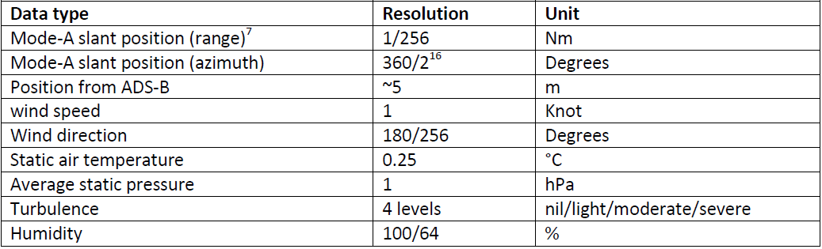
Turbulence and humidity data are not always available. The quality of the EHS MRAR wind and temperature information is comparable to that of AMDAR. The data quality is, however, dependent on the aircraft type, being generally good when transmitted by commercial passenger aircraft, but biased temperatures are sometimes observed when data are transmitted by small business or private aircraft (Strajnar et al., 2015).
ADS-B ES data content
Table 2.3 provides a brief description of the ADS-B message content.
Table 2.3. ADS-B message content
Message type | Downlink format | Data content
ADS-B ES (112 bits) | DF17 | Airborne position  Surface position  ES status  Aircraft type and ID  Airborne velocity
Mode S EHS data does not contain meteorological information generated on board. However, by combining certain parameters from the Mode S EHS downlink aircraft parameters set and from the ADS-B data elements from the downlink format, wind and temperature information can be derived.
From a selection of Mode S EHS downlink aircraft parameters (see Mode S Harmonization of the Transition Arrangements for State Aircraft, EUROCONTROL, for a list of downlink parameters for EHS capability) and ADS-B ES parameters it is possible to derive good-quality wind speed and direction, and moderate-quality air temperature (see Table 2.4) at very high temporal frequency (up to 2-second reports).
Table 2.4. Meteorological parameters derived from Mode S EHS and Mode D ES
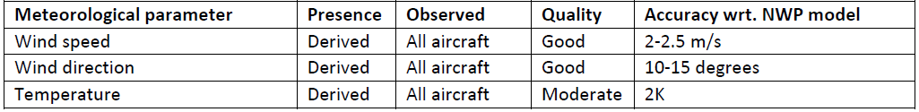
Mode S EHS data transmission requires active interrogation from an ATC radar and can only be performed by an authorized body, for example, the ATC. The response transmission of the aircraft can be received using a local Mode S/ADS-B receiver. The frequency of interrogation is dependent on the application and is generally between 4 and 20 seconds.
If the magnetic heading has been corrected to true north and corrections have been applied for the airspeed, the correct wind vector can be calculated, resulting in good-quality wind-speed and direction information.
Figure 2.4 provides an understanding of how these corrections provide high-quality wind information.
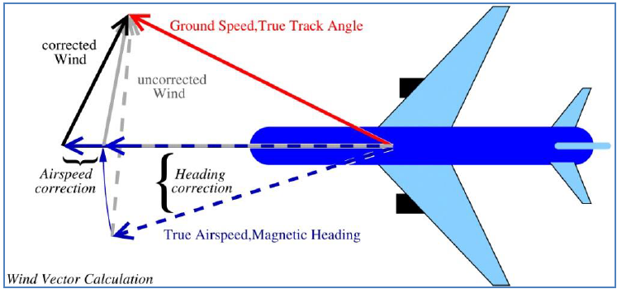
Figure 2.4. Wind vector calculated from aircraft carrying Mode S EHS
Mode S EHS air temperature is derived using the measurements of the downlinked Mach number and airspeed. The airspeed is not an observation provided by the aircraft, but is derived from the measured Mach number (pitot probe) and temperature. The Mach number is the quotient of the airspeed and the speed of sound, and is dependent on the temperature. Comparison between NWP temperatures and Mode S EHS temperatures reveal that a temperature correction will be needed for each aircraft, flight phase and time, resulting in a decrease of the standard deviation. The quality of Mode S EHS temperatures, as provided in Table 2.4, is therefore considered moderate. Due to the dependence on the Mach number, the quality of Mode S EHS temperatures decreases with aircraft speed, which is normally strongly correlated with altitude.
Further information on the derivation of meteorological data from Mode S can be found in the Guide to Meteorological Instruments and Methods of Observation (WMO-No. 8), Part II, 3.4 – Wind speed and direction.
Further information and reference on derived ABO can be found online at the Royal Netherlands Meteorological Institute website, Mode S EHS Research, http://mode-s.knmi.nl/.

2.3 OTHER AIRCRAFT-BASED OBSERVATIONS SYSTEMS
2.3.1 Introduction
As described in section 1.6.3, Members are able to receive ABO from other sources in addition to AMDAR and ICAO. This section describes or provides references for descriptions of the systems currently known to and utilized by WMO Members.
ABO from other systems should be processed and provided to WIS in accordance with the guidance provided within section 1.6.3 and Appendices A and C.
2.3.2 Tropospheric airborne meteorological data reporting
Tropospheric airborne meteorological data reporting is a commercially developed, deployed and operated system that obtains meteorological data derived from the installed and predominantly aircraft-independent sensing and communications probe. The device is marketed by PAC, which provides the data and related services at a contracted cost to the airline concerned. Unlike the WMO AMDAR observing system, emphasis has been placed on equipping primarily regional air carriers, as their flights tend to service more remote and diverse locations, and be of shorter duration. This results in the production of more daily vertical profiles and more data in the boundary layer compared to AMDAR. Although TAMDAR is fully functional and regularly operates above 12 000 metres, the aircraft that typically host the sensor often cruise below 7 600 metres.
TAMDAR collects measurements of RH, pressure, temperature, winds, icing and turbulence, along with the corresponding location, time and geometric altitude from a built-in GPS reference system. These data are relayed via satellite in real time to a ground-based network operations centre, where in-line quality control procedures are performed prior to distribution. The overall humidity and temperature data quality is similar to radiosondes (Gao et al., 2012). The wind observations are derived in a similar fashion to those typical of AMDAR, using aircraft heading and true airspeed, and the ground track vector, which is provided by the internal GPS unit.
The TAMDAR sensor samples on a pressure-based interval during ascent and descent, and a time-based interval during cruise that also varies with altitude from 3 minutes at lower altitudes to 7 minutes at higher altitudes. At present, on ascent and descent the sensor reports every 10 hPa; however, this can be adjusted remotely in real time down to 1 hPa (~9 metres) depending on the rate of ascent and descent. The frequency of turbulence reporting during cruise is aligned with any metric changes above a set threshold, and the TAMDAR report will then be customized, resulting in turbulent flights through the cloud tops generating far more observations than a higher-altitude cruise in clear skies.
Under the NOAA Great Lakes Field Experiment in the 1990s, NOAA collaborated with (at the time) AirDat LLC for the provision of ABO derived from a large fleet of participating aircraft from several airlines operating in the Great Lakes area of the United States and southern Canada. Under this cooperation, TAMDAR data were made available on GTS and several impact assessments were undertaken by NOAA that attest to the quality and utility of TAMDAR data for both NWP and other forecasting applications.
The TAMDAR system is described in more technical detail in Guide to Meteorological Instruments and Methods of Observation (WMO-No. 8), Part II, 3 – Aircraft-based observations.
2.3.3 Automated flight information reporting system
FLYHT Aerospace Solutions Ltd has developed the AFIRS avionics system that provides client airlines with global flight tracking and aircraft performance monitoring with voice and data communications using the Inmarsat and Iridium global satellite network. AFIRS also supports ACARS protocols such as OOOI messaging.
The automated flight information reporting system interfaces to the aircraft flight data computer to obtain high-frequency flight data for processing and dispatch via short-burst downlink messaging over the satellite network. It supports an AMDAR-like functionality that allows meteorological data to be downlinked and delivered to the subscriber in a suitable format, for example, text delimited, which allows for delivery to the user via Internet.
FLYHT has collaborated with at least one NMHS for the provision of good-quality ABO data that has been made available to WIS.
2.3.4 In-service Aircraft for a Global Observing System programme
The In-service Aircraft for a Global Observing System (IAGOS) programme is a European research infrastructure that conducts long-term observations of atmospheric composition, and aerosol and cloud particles on the global scale from commercial aircraft of internationally operating airlines. IAGOS builds on the scientific and technological experience gained within the research projects Measurement of Ozone and Water Vapour on Airbus In-service Aircraft (MOZAIC) and Civil Aircraft for the Regular Investigation of the Atmosphere Based on an Instrument Container (CARIBIC). It provides a database for users in science and policy, including near-real-time data provision for weather prediction, air-quality forecasting and for assimilation in climate models. IAGOS cooperates with several airlines for quasi-continuous measurements. Currently, 5 aircraft are equipped with an IAGOS instrument package, with the number expected to increase to 10 by the end of 2017. Ultimately, the goal of IAGOS is to equip at least 20 long-range aircraft of internationally operating airlines with IAGOS equipment for continuous operational deployment.

The IAGOS aircraft-to-ground communication system and associated WMO BUFR template were developed based on the AMDAR system, which allows the data to be received and processed by standard ABO infrastructure. For further details on the BUFR format see Appendix C.

IAGOS contributes to the IAGOS for the Global Monitoring for Environment and Security Atmospheric Services (IGAS) project, which aims to provide data streams in both near-real time and delayed mode to the Copernicus Atmosphere Monitoring Service. The WMO Global Atmosphere Watch is a partner in IGAS.
2.3.5 Civil Aircraft for the Regular Investigation of the Atmosphere Based on an Instrument Container project
The CARIBIC scientific project is positioned under IAGOS. This ABO system undertakes detailed and extensive measurements during long-distance flights. An airfreight container with automated scientific apparatus is deployed that is connected to an air and particle (aerosol) inlet underneath the aircraft. The container is installed in a passenger Lufthansa Airbus A340-600. It has a system for collecting air samples and has been operational since December 2004. These air samples are analysed in a laboratory. The CARIBIC project is integrated into the IAGOS programme. More information is available at the CARABIC website.

APPENDIX A. GUIDANCE ON QUALITY CONTROL OF AIRCRAFT-BASED OBSERVATIONS

Background
This document provides guidance for the operational quality control of meteorological observations received from an aircraft platform. While generally applicable to most ABO systems, it is expected that the practices for data-quality control will be applied to data derived from Member AMDAR observing systems (see sections 1.6.1 and 2.1) as well as similar data derived from ICAO ABO (see section 1.6.2).
In addition to the data-quality control checks specified in this document, Members should ensure that their quality control systems for ABO meet the more general provisions for quality control of data (see section 1.8).
The data-quality control checks specified in this document are for application in ground-based systems, to be applied to observations received from the ABO system prior to transmission on WIS.
For quality control requirements and checks for application within on-board systems, see section 2.1.3.3.
For provisions for quality monitoring of ABO, see Appendix B.
For general provisions for the management of incident and change, see section 1.11.

Basic data-quality control checks
Members should apply the following basic data-quality control checks on the meteorological variables of their ABO:
(a) Range check;
(b) Static value check;
(c) Temporal variation check.

Range check
The range check tests whether a value lies within a permissible range as specified for each variable within Table A1.

Algorithm
IF v_{i} < {lower value of range} THEN v_{i} is erroneous
IF v_{i} > {upper value of range} THEN v_{i} is erroneous

Variables applied to
The range check should be applied to all variables within Table A1.

Check failure action
– A value outside the range should be flagged as erroneous and not submitted to WIS.
– If the erroneous variable is a temporal or spatial coordinate, then all variables in the observation should be flagged as erroneous, and the observation should not be submitted to WIS.
– If the problem persists over consecutive flights, the aircraft should be excluded from provision to WIS until the airline is notified and the error is rectified.

Static value check
The static value check tests whether values of particular variables are not varying temporally, as they should, from one observation to the next, usually indicating that the variable is not being updated in the on-board data computer.

Algorithm
$$For each valid v_{t }, calculate: ∆v= v_{t}- v_{t+∆t}$$
$$Where v_{t} is the value of v at time t and v_{t+∆t} is the value of v at time t+∆t$$
IF $∆v equals zero over five or more consecutive checks THEN apply check failure action$

Variables applied to
The static value check should be applied to the variables indicated within Table A1.

Check failure action
– Every value in the series of checks that have been failed and every value for the remainder of the flight for which the observations are derived should be flagged as erroneous and not submitted to WIS.
– If subsequent manual checks reveal that the error has ceased to occur, then the non-errant data can be flagged as good quality.
– If the erroneous variable is a temporal or spatial coordinate, then all variables for all observations for which the checks have been failed should be flagged as erroneous, and none of the observations for the remainder of the flight should be submitted to WIS.
– If a problem persists over consecutive flights, then the aircraft should be blacklisted from provision to WIS until the airline is notified and the problem is rectified.

Temporal variation check
The temporal variation check calculates the difference between consecutive values of variables and tests whether the difference exceeds a threshold value, indicating a likely error in one or both values.

Variables applied to
The temporal variation check should be applied to the variables indicated within Table A1.

Algorithm
$$For each valid v_{t}, calculate: ∆v= v_{t}- v_{t+∆t}$$
$$Where v_{t} is the value of v at time t and v_{t+∆t} is the value of v at time t+∆t$$
IF $∆v>T THEN apply check failure action$
Where T is the threshold value from Table A1

Check failure action
– If $v_{t}$ is validated by previous checks, then value $v_{t+∆t}$ should be flagged as erroneous and not submitted to WIS. Otherwise, if $v_{t}$ has not been validated, then both values should be flagged as erroneous and not submitted to WIS.
– If the erroneous variable is a temporal or spatial coordinate, then all variables for all observations for which the checks have been failed should be flagged as erroneous, and none of the observations for the remainder of the flight should be submitted to WIS.
– If a problem persists over consecutive flights, then the aircraft should be blacklisted from provision to WIS until the airline is notified and the problem rectified.

Specific variable and special data-quality checks
Members should apply the following specific and special data-quality control checks to their ABO:

Apparent aircraft velocity check
The apparent aircraft velocity check tests the validity of spatial and temporal coordinates of consecutive observations by calculating an “apparent velocity” at which the aircraft has travelled over the period of time between observations. The apparent aircraft velocity can be approximated by applying a calculation that is a function of the latitude, longitude and time coordinates of the observations.

Algorithm
Calculate the distance (D) in kilometres between the two latitude and longitude coordinates, $\left[{Lat}_{1}, {Lon}_{1}\right] and \left[{Lat}_{2}, {Lon}_{2}\right]$ using the “Haversine formula”:
$D = R * c$
Where:
$R = 6 371$ is an approximation to the average radius of the earth in kilometres
$$c = 2 *atan2(\sqrt{a}, \sqrt{\left(1-a\right)} )$$
$$a = \sin\left(\frac{{dLat}^{r}}{2}\right)*\sin\left(\frac{{dLat}^{r}}{2}\right)+\cos\left({Lat}_{1}^{r}\right)*\cos\left({Lat}_{2}^{r}\right)*\sin\left(\frac{{dLon}^{r}}{2}\right) *\sin\left(\frac{{dLon}^{r}}{2}\right)$$
${dLat}^{r}= rad({Lat}_{2}- {Lat}_{1})$, ${dLon}^{r}= rad({Lon}_{2}- {Lon}_{1})$
${Lat}_{1}^{r}=\text{rad}({\text{Lat}}_{1})$, ${Lat}_{2}^{r}=rad\left({Lat}_{2}\right)$
rad() is a function for the angular conversion of degrees to radians
Calculate: $V_{A}= \frac{D}{∆t}$
Where $∆t$ is the time difference between observations in hours
IF ${\text{V}}_{\text{A}}\text{ > }{\text{V}}^{\text{T}}$ THEN apply check failure action
Where ${\text{V}}^{\text{T}}$ is an appropriate maximum aircraft velocity threshold for the aircraft
Note: It is recommended that the value V^{T} be universally set to 1 250 km/h for Boeing, Airbus and similarly performing aircraft. However, based on sound reasoning or scientific analysis, varying thresholds may be adopted for particular aircraft types and their performance.

Check failure action
– All values corresponding to $\left[{Lat}_{2}, {Lon}_{2}\right]$ and all subsequent observations should be flagged as erroneous and not submitted to WIS.
– If a problem persists over consecutive flights, then the aircraft should be blacklisted from provision to WIS until the airline is notified and the problem is rectified.

Additional data-quality control checks
Members may elect to apply the following additional data-quality control checks on the meteorological variables of their ABO:
(a) Numerical weather model comparison check;
(b) Radiosonde comparison check;
(c) Vertical spatial check;
(d) Horizontal spatial check.
It should be noted that such checks should be applied as part of the data-quality control process only if they do not have significant impact on latency of provision of data to WIS. See section 1.5 on requirements for ABO. In the event that such a check has a severe and adverse impact on data provision latency, consideration should be given to applying such checks in the processes of quality monitoring and quality assessment – see Appendix B.

Numerical weather model comparison check
The numerical weather model comparison check tests whether a value is consistent with the comparative value derived from the output of an NWP model.

Algorithm
IF $\left|\text{v}\text{i }\text{- }{\text{v}}_{\text{i}}^{\text{N}}\right|\text{ > }\text{T}$ THEN v_{i} is erroneous
Where ${\text{v}}_{\text{i}}^{\text{N}}$ is the value interpolated and derived, as necessary, from the NWP model output; T is the threshold value, which may be a function of a number of parameters including the variable being compared, the observation altitude, and the like.
Notes:
– The NWP comparison value should, if possible, be derived from the first guess field of the model output.
– The values of T should be determined in consultation with NWP experts and based on the results of comparison statistical analysis.
– The values of T should be such that loss of valid data is prevented or minimized.

Variables applied to
The numerical weather model comparison check should be applied to meteorological variables.

Check failure action
– An erroneous value should be flagged and not submitted to WIS unless the BUFR encoding process makes provision for the setting of data-quality flags and the value is appropriately flagged.
– If a problem persists over consecutive flights, analysis should be undertaken and, if appropriate, the aircraft should be blacklisted from provision to WIS until the airline is notified and the problem is rectified.

Radiosonde comparison check
The radiosonde comparison check tests whether a value is consistent with the comparative value derived from a co-located radiosonde vertical profile.

Algorithm
IF $\left|\text{v}\text{i }\text{- }{\text{v}}_{\text{i}}^{R}\right| \text{>}\text{ T}$ THEN v_{i} is erroneous
Where ${\text{v}}_{\text{i}}^{\text{R}}$ is the value from the collocated radiosonde profile, interpolated and derived as necessary; T is the threshold value, which may be a function of a number of parameters including the variable being compared, the observation altitude, and the like.
Notes:
– The radiosonde comparison value should be logarithmically interpolated to the altitude of the aircraft observation value.
– The values of T should be determined based on the results of comparison statistical analysis.
– Comparison pairs should be derived with a maximum temporal separation of 60 minutes and a maximum horizontal spatial separation of 60 kilometres within which the aircraft is ascending from or descending to an airport.

Variables applied to
The radiosonde comparison check should be applied to meteorological variables.

Check failure action
– An erroneous value should be flagged and not submitted to WIS unless the BUFR encoding process makes provision for the setting of data-quality flags and the value is appropriately flagged.
– If a problem persists over consecutive flights, then analysis should be undertaken and, if appropriate, the aircraft should be black-listed from provision to WIS until the airline is notified and the problem is rectified.

Table A1. ABO variables and quality control test information
Variable | Unit | Range | Apply static value check (Y/N) | Apply temporal variation check (Y/N) | Temporal variation check threshold
Pressure altitude | Foot (ft)  Metre (m) | -1 000 to 50 000  -330 to 17 000 | Y | Y | 5 000 ft/min
Static air temperature | ºC | -99 to 99 | Y | Y | 20 ºC/min
Wind direction | Degrees from true N | 1 to 360 | Y | Y | 180º/min
Wind speed | Knot (kt)  m/sec | 0 to 800  0 to 400 | Y | Y | 50 kts/min
Latitude | Degree:minute | 90º00’S to 90º00’N | N | Y | 30 mins/min
Longitude | Degree:minute | 180º00’W to 180º00’E | N | Y | 300 mins/min
Time (UTC) | Hour:minute:second | 00:00:00 to 23:59:59 | Y | N | N/A
Turbulence (g) | g-unit | -3 to 6 | Y | N | N/A
Turbulence (DEVG) | m s⁻¹ | 0 to 20 | Y | N | N/A
Turbulence (EDR) | m^{2/3} s⁻¹ | 0 to 1 | Y | N | N/A
Humidity (RH) | % | 0 to 100 | Y | N | N/A
Humidity (dew point) | ºC | -99 to +49 | Y | N | N/A
Humidity (MR) | g/kg | 0 to < 100 | Y | N | N/A

APPENDIX B. GUIDANCE ON QUALITY MONITORING OF AIRCRAFT-BASED OBSERVATIONS

Background
This appendix provides guidance for the operational quality monitoring and quality evaluation of ABO received from an aircraft platform. While likely generally applicable to most ABO systems, it is expected that the practices will be applied to data derived from Member AMDAR observing systems (see sections 1.6.1 and 2.1) and also similar data derived from ICAO ABO (see section 1.6.2).
In general, the quality monitoring system for ABO will be consistent with, and should be regarded as a component of the WIGOS Data Quality Monitoring System (Figure A1 depicts the general framework for the System).
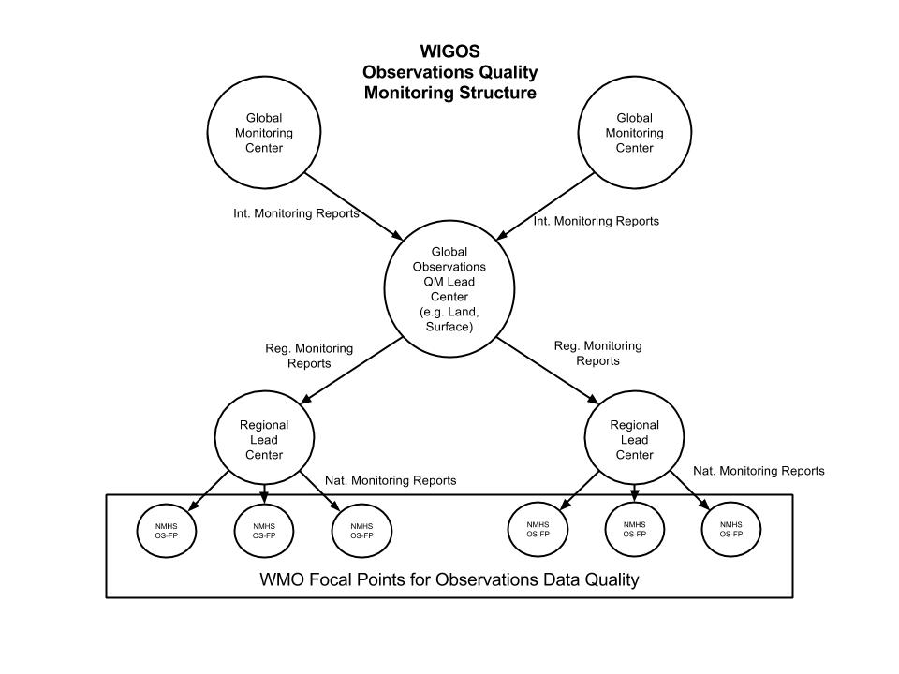
Figure A1. The WIGOS observations quality monitoring structure, supporting the WIGOS Data Quality Monitoring System
For the purposes of the present Guide, “quality monitoring” is defined as practices and procedures, and the production of reports and diagnostics that allow the quality of ABO to be assessed. “Quality evaluation” is defined as the use or application of quality monitoring reports, information, and analysis techniques and tools to analyse and assess the quality of ABO, investigate and isolate systemic issues and make recommendations for improvements to operational practices. These aspects of ABO quality management are depicted in Figure 1.3, section 1.8.2.2. Figure A2 provides a more detailed depiction of the regional and national framework that should be established to support ABO quality evaluation at the programme level.

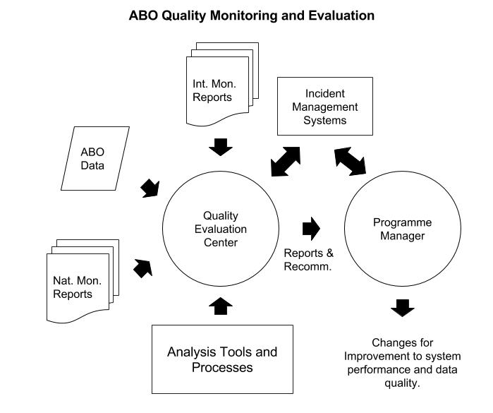
Figure A2. Information, tools and practices supporting the quality evaluation process for ABO

Quality monitoring practices
Data quality monitoring practices should focus on the measurement of the performance of the system against a set of targets, defined for the functional specifications of the ABO or AMDAR system:
(a) Performance figures in terms of quantities, for example, number of observations provided for a specific area and period, stated by the system management and confirming the on-board observing programmes;
(b) Quality indicators of the physical quantities and variables providing a measurement of uncertainties, usually in the form of systematic (average difference with respect to a reference, commonly referred to as bias) and (number or percentage of) incidental (gross) errors;
(c) Quality indicators for metadata, essential for the interpretation and use of the data (timestamp, horizontal and vertical positions, flight phase) and other information necessary for appropriate data management (such as aircraft identification) and usefulness (timeliness);
(d) Results of data-quality control processes, including error and consistency checking of bulletin formatting and the detection and elimination of duplicate observations.

Requirements for WMO global and regional NWP quality monitoring centres
The general description and requirements for WMO-designated global and regional monitoring and evaluation centres are described in section 1.8.2.
The following specifications are applicable for both designated global and regional monitoring centres for ABO but may be used and applied by any NWP monitoring centre:
– The reports produced by NWP monitoring centres should be made available by email to WMO focal points on ABO.
– The reports produced by NWP monitoring centres will be made available to WMO Members and maintained or archived.
– The current requirements for monthly monitoring of ABO by WMO global NWP quality monitoring centres are defined in the Manual on the Global Data-processing and Forecasting System (WMO-No. 485), Volume I, Part II, Attachment II.9 – Procedures and formats for the exchange of monitoring results; the procedures for aircraft data are given in section 5.
– The procedures in the Manual on the Global Data-processing and Forecasting System are considered to be minimal and somewhat limited in terms of serving the modern requirements of ABO programme operators and data users. They provide requirements for monitoring of air temperature and wind only.
The following specifications of requirements are the new procedures recommended for adoption by WMO-designated and other global NWP quality monitoring centres for ABO, and it is expected they will supersede and replace the requirements provided in the Manual on the Global Data-processing and Forecasting System.

Automated monitoring reports

Daily availability monitoring reports of ABO
WMO global NWP quality monitoring centres should undertake monitoring of the availability of ABO and compile and provide a daily report that lists significant changes in the quantity or volume of ABO reported to WIS.
The ABO availability report should:
– Be limited to the provision of information that isolates errors or issues with a low probability of false alarm and according to the criteria following;
– Be made available automatically by email to all focal points for operational ABO programme managers for the previous UTC day as soon after 0000 UTC as possible;
– Isolate those aircraft whose recent availability of observations over the past 3 days varies significantly from their availability of observations over the 7 days preceding the initial 3-day period;
– Be provided in the format described within Attachment B1 to the present appendix.
Criteria for the inclusion of aircraft in the reports are based on the following – an aircraft is suspect if:
– TAd1NA = 0 AND Percentage (TAd3ND, TAd7ND) < 30;
– OR Percentage (TAd3ND, TAd7ND) > 200;
– OR MRd1NA = 0 AND Percentage (MRd3ND, MRd7ND) < 30;
– OR Percentage (MRd3ND, MRd7ND) > 200.
Where: Percentage (x, y) is the value of x expressed as a percentage of y.
Based on Attachment B1, the suggested report content is shown below:
[HEADER]
Report Name:Aircraft-Based Observations Daily Availability Report
Issuing Centre: [Name of Centre]
Report Period of Validity:[hh:mm dd-mm-yyyy to hh:mm dd-mm-yyyy]
Location of Monitoring Site:[Internet address]
ID: Aircraft identity
[Field Header:Field Description]
[etc]
[/HEADER]
[DATA]
ID; SUS_L; TAd3ND; TAd7ND; MRd3ND; MRd7ND
[etc]
[/DATA]

Daily 10-day moving monitoring report of ABO NWP comparison
World Meteorological Organization global NWP quality monitoring centres should undertake monitoring of ABO to provide two daily quality monitoring reports to observing system programme managers by email.
These two quality monitoring reports should consist of:
– A TA and MR daily 10-day moving window NWP comparison;
– A wind daily 10-day moving window NWP comparison.
The quality monitoring reports should:
– Be limited to the provision of information that isolates errors or issues with a low probability of false alarm and according to the criteria following;
– Be made available automatically by email to all focal points for operational ABO programme managers for the previous UTC day as soon after 0000 UTC as possible;
– Provide a 10-day moving window of monitoring statistics for the current and prior 9 days;
– Be provided in the format described within Attachment B1 to the present appendix.
Criteria for the inclusion of aircraft in the reports are provided in Attachment B2 to the present appendix.
Based on Attachment B1, the suggested report content is shown below for the TA and MR daily 10-day moving window NWP comparison:
[HEADER]
Report Name:Aircraft-Based Observations Daily NWP Comparison Check
Issuing Centre: [Name of Centre]
Report Period of Validity:[yyyy-mm-dd hh:mm to yyyy-mm-dd hh:mm]
Comparison Standard:[Model Identity; Model field used for comparison]
Variables:[Air Temperature and Humidity]
Location of Monitoring Site:[Internet address]
ID: Aircraft identity
[Field Header:Field Description]
[etc]
[/HEADER]
[DATA]
ID; SUS_L; TAd1NA; TAd1NC; TAd1NR; TAd1NG; TAd1MB; TAd1SD; TAd1NA; TAd9NC; TAd9NR; TAd9NG; TAd9MB; TAd9SD; MRd1NA; MRd1NC; MRd1NR; MRd1NG; MRd1MB; MRd1SD; MRd1NA; MRd9NC; MRd9NR; MRd9NG; MRd9MB; MRd9SD
[etc]
[/DATA]
Based on Attachment B1, the suggested report content is shown below for the winds daily 10-day moving window NWP comparison:
[HEADER]
Report Name:Aircraft-Based Observations Daily NWP Comparison Check
Issuing Centre: [Name of Centre]
Report Period of Validity:[ yyyy-mm-dd hh:mm to yyyy-mm-dd hh:mm]
Comparison Standard:[Model Identity; Model field used for comparison]
Variables:[Wind speed, wind direction and wind vector difference]
Location of Monitoring Site:[Internet address]
ID: Aircraft identity
[Field Header:Field Description]
[etc]
[/HEADER]
[DATA]
ID; SUS_L; WSd1NA; WSd1NC; WSd1NR; WSd1NG; WSd1MB; WSd1SD; WSd1NA; WSd9NC; WSd9NR; WSd9NG; WSd9MB; WSd9SD; WDd1NA; WDd1NC; WDd1NR; WDd1NG; WDd1MB; WDd1SD; WDd1NA; WDd9NC; WDd9NR; WDd9NG; WDd9MB; WDd9SD; WMd1NA; WMd1NC; WMd1NR; WMd1NG; WMd1WVRMS; WMd9NA; WMd9NC; WMd9NR; WMd9NG; WMd9WVRMS
[etc]
[/DATA]

Monthly monitoring of ABO
World Meteorological Organization global NWP quality monitoring centres should undertake monitoring of ABO to provide two monthly quality monitoring reports to observing system programme managers by email.
These two quality monitoring reports should consist of:
– A TA and MR monthly NWP comparison;
– A winds monthly comparison.
The quality monitoring reports should:
– Contain results for all aircraft providing data to WIS;
– Be made available automatically by email to all focal points for operational ABO programme managers for the previous UTC month as soon after 0000 UTC of the first day of the new month as possible;
– Be sorted so as to provide suspect records first, followed by non-suspect records, grouped by programme;
– Be provided in the format described within Attachment B1 to the present appendix.
Criteria for the designation of aircraft as suspect are provided in Attachment B2.
Based on Attachment B1, the suggested report content is shown below for the TA and MR monthly NWP comparison:
[HEADER]
Report Name:Aircraft-Based Observations Monthly NWP Comparison
Issuing Centre: [Name of Centre]
Report Period of Validity:[ yyyy-mm-dd hh:mm to yyyy-mm-dd hh:mm]
Comparison Standard:[Model Identity; Model field used for comparison]
Variables:[Air Temperature and Humidity]
Location of Monitoring Site:[Internet address]
ID: Aircraft identity
[Field Header:Field Description]
[etc]
[/HEADER]
[DATA]
ID; SUS; SUS_L; TAplNA; TAplNC; TAplNR; TAplNG; TAplMB; TAplSD; TApmNA; TApmNC; TApmNR; TApmNG; TApmMB; TApmSD; TAphNA; TAphNC; TAphNR; TAphNG; TAphMB; TAphSD; MRplNA; MRplNC; MRplNR; MRplNG; MRplMB; MRplSD; MRpmNA; MRpmNC; MRpmNR; MRpmNG; MRpmMB; MRpmSD; MRphNA; MRphNC; MRphNR; MRphNG; MRphMB; MRphSD
[etc]
[/DATA]
Based on Attachment B1, the suggested report content is shown below for the winds monthly NWP comparison:
[HEADER]
Report Name:Aircraft-Based Observations Monthly NWP Comparison
Issuing Centre: [Name of Centre]
Report Period of Validity:[ yyyy-mm-dd hh:mm to yyyy-mm-dd hh:mm]
Comparison Standard:[Model Identity; Model field used for comparison]
Variables:[ Wind speed, wind direction and wind vector difference]
Location of Monitoring Site:[Internet address]
ID: Aircraft identity
[Field Header:Field Description]
[etc]
[/HEADER]
[DATA]
ID; SUS; SUS_L; WSplNA; WSplNC; WSplNR; WSplNG; WSplMB; WSplSD; WSpmNA; WSpmNC; WSpmNR; WSpmNG; WSpmMB; WSpmSD; WSphNA; WSphNC; WSphNR; WSphNG; WSphMB; WSphSD; WDplNA; WDplNC; WDplNR; WDplNG; WDplMB; WDplSD; WDpmNA; WDpmNC; WDpmNR; WDpmNG; WDpmMB; WDpmSD; WDphNA; WDphNC; WDphNR; WDphNG; WDphMB; WDphSD; WMplNA; WMplNC; WMplNR; WMplNG; WMplWVRMS; WMpmNA; WMpmNC; WMpmNR; WMpmNG; WMpmWVRMS; WMphNA; WMphNC; WMphNR; WMphNG; WMphWVRMS
[etc]
[/DATA]

Requirements for World Meteorological Organization lead centres on aircraft-based observations
World Meteorological Organization lead centres on ABO should provide the following functions and services to assist WMO Members in the quality management of their ABO systems:
(a) Receive, process, archive and analyse monitoring reports from designated WMO global and regional monitoring centres for ABO;
(b) Ensure WMO focal points on ABO receive monitoring reports and act upon issues arising from them;
(c) Develop, implement and maintain an incident management system to record and manage faults or issues raised through the monitoring and quality evaluation processes;
(d) Provide technical advice to assist Members in rectifying quality issues associated with their ABO systems;
(e) Establish and maintain an online facility that provides the suite of quality monitoring information and tools as described in Attachment B3 to the present appendix;
(f) Compile an annual report to the CBS Open Programme Area Group on Integrated Observing Systems on the performance of the ABO and ABO quality monitoring systems, highlighting any important issues.

Requirements for quality monitoring and quality evaluation by Members

Quality evaluation information, tools and practices
The quality evaluation process for ABO can be described in terms of the structure and the related processes and practices that are depicted within Figure A2.
The quality evaluation centre should be staffed by a suitable number of scientific officers that have:
– A detailed understanding of the ABO system and its operation;
– Scientific knowledge of meteorological science and skills in scientific data analysis;
– Skills and knowledge in quality management, systems incident management and report writing.
The quality evaluation centre should have access to information and data that support the quality evaluation processes. These include as a minimum:
– Convenient access to the relevant available automated and other global, regional and national monitoring reports;
– Access to the ABO data generated by the ABO system in a form that allows flexible and rapid rendering of the data for analysis, comparison, plotting, and the like. A relational database storage of historical data (at least 2 years) is ideal;
– Access to data analysis applications and tools, for example and as a minimum, a spreadsheet application with mathematical, mapping and graphical tools.
The quality evaluation centre should utilize the incident management system of WMO for the registering and maintenance of errors and issues identified in the quality evaluation process.
The quality evaluation centre should utilize the results of quality evaluation practices and results to identify systemic issues that might be addressed through the improvement of the ABO system operation through modification or changes to processes and procedures.
Results of quality evaluation analyses and resulting changes to the observing system should be notified, recorded and documented in line with national, regional and WMO quality management requirements and practices.
As a minimum, routine quality monitoring and quality evaluation practices and procedures undertaken by Member quality managers and quality evaluation centres should consist of the following:
– The production and use of outputs and reports of national programme data-quality control processes (see Appendix A);
– The reception and use of quality monitoring reports provided by WMO-designated lead centres and monitoring centres;
– The reception and use of reports provided by other global or regional monitoring centres;
– The routine production and scrutiny of national quality monitoring reports;
– Routine analysis of all available quality monitoring outputs and reports;
– Initiation and completion of relevant incident management procedures for identified data-quality errors and issues, including as a minimum:
• Blacklisting of errant aircraft from reporting to WIS;
• Documentation and update of relevant metadata for recording of issues and errors;
• Notification to data users and application areas;
• Compliance with national, regional and global incident management systems operation and maintenance;
– Initiation and completion of relevant system and practice improvements required to rectify systemic errors or issues associated with or causing data-quality issues.

ATTACHMENT B1. RECOMMENDED FORMAT FOR AIRCRAFT-BASED OBSERVATIONS QUALITY MONITORING REPORTS
It is proposed that ABO quality monitoring reports should conform to the following specification, providing a format that is both machine and human readable.
Aircraft-based quality monitoring reports should have the following features and properties:
– The reporting files should be provided as a text file with two distinct information blocks of semicolon-separated values (SSV);
– The reporting files should consist of a header block and a data block;
– The header block should consist of at least one line of SSV information between the header block markers: [HEADER][/HEADER];
– Each SSV in the report header should consist of a header value name and a header value separated by a colon: Header Value Name:header value. For example: Report Name: Daily Global Aircraft Observations QM Report;
– Each line of the header should end with a carriage return and line feed;
– The data block should consist of at least two lines of SSV information between the data block markers: [DATA][/DATA];
– The first line of the data block should be a line of SSV information that contains the field headers of the data submitted within the data block;
– Each line of the data block should provide a SSV for each of the fields corresponding to the field headers provided in the header block;
– Each line of the data block should end with a carriage return and line feed:
[HEADER]
Header Value Name:header value;Header Value Name:header value;…
Header Value Name:header value;Header Value Name:header value;…
…
[/HEADER]
[DATA]
Field Header 1; Field Header 2; Field Header 3;…
Field 1 value;Field 2 value;Field3 value;…
Field 1 value;Field 2 value;Field3 value;…
…
[/DATA]
Reported monitoring parameter field headers are listed below and will take the form VcX, where:
V is the variable indicator (e.g., TA = air temperature)
c is the category indicator (e.g., pl = low pressure category)
X is the statistic indicator (e.g., NA = number of available values)
For example, TAplNA = number of air temperature values available in the low pressure category.
The tables below provide the various elements that can be specified to be included in the quality monitoring reports and the notation to be used to identify them. Table A2 provides the list of non-statistical field headers, Table A3 the list of statistical parameters, Table A4 the field header category indicaters and Table A5 the list of field header statistical indicators.

Non-statistical field headers | Description
ID | Aircraft identity (e.g. AU0001)
SUS | Suspect flag: Y = aircraft is flagged as suspect; N or no value = aircraft is not suspect
SUS_L | List (space delimited) of one or more field headers for which the aircraft has breached the criteria for being suspect. Empty if not SUS. E.g., a value of “TAplNG TApmNG” would indicate that the aircraft was deemed suspect based on the number of gross errors for the LOW and MED pressure level categories for air temperature.
Table A2. List of non-statistical field headers

Table A3. Field headers for statistical parameters
Field header variable indicator | Description
TA | Air temperature
WS | Wind speed
WD | Wind direction
WM | Wind vector difference magnitude
WU | Wind u component
WV | Wind v component
RH | Relative humidity
MR | Water mixing ratio
RT | Report time
LA | Latitude
LO | Longitude
AS | Aircraft apparent speed

Table A4. Field header category indicators
Field header category indicator | Description
Pl | In the low (altitude) pressure category
Pm | In the mid (altitude) pressure category
Ph | In the high (altitude) pressure category
d1 | Calculated over 1 day
d3 | Calculated over 3 days
d7 | Calculated over 7 days (prior to the d3 category)
d9 | Calculated over 9 days (prior to the d1 category)
Ru | Range upper
Rl | Range lower

Table A5. Field header statistical indicators
Field header statistic indicator | Description
NA | Number of values available
NC | Number of values compared
NR | Number of values rejected
NG | Number of values with gross errors against criteria
ND | Daily average number of values available
SD | Standard deviation of differences
MD | Mean of differences (bias)
RMS | Root mean square of differences
WMRMS | RMS of the magnitude of the wind vector difference
NZ | Number of zero values
Notes:
1. Wind vector RMS (WVRMS) is defined as the “root mean square of magnitude of the wind vector differences”. It is defined as:
2. RMS (∆w) = √<|∆w|²> = √<(∆u²+∆v²)>
3. Where ∆w stands for the wind vector difference, |∆w| for the wind vector difference magnitude, ∆u and ∆v for the wind vector difference Cartesian components.
4. <a> represents averaging over a, that is (∑a)/N. The wind vector difference ∆w is a two-dimensional vector, the wind vector difference magnitude |∆w| is a scalar.
5. WVRMS differs from another parameter used to check the wind vector called the “average value of the wind vector difference magnitude”, but usually called “mean wind vector difference”, and which is defined
by <|∆w|> = <√(∆u²+∆v²)>.
6. Note that for wind vector analyses, <∆w>, <∆u> and <∆v> will always be 0.

ATTACHMENT B2. CRITERIA FOR THE SELECTION OF AIRCRAFT HAVING SUSPECT OBSERVATIONS

Variable | Unit | Report | % gross error | Minimum  NC |  |  | Gross error difference |  |  | Mean difference |  |  | RMS
Pressure levels |  |  | ALL | LOW | MID | HIGH | LOW | MID | HIGH | LOW | MID | HIGH | LOW | MID | HIGH
Air temperature | °C | Monthly | 2 | 20 | 50 | 50 | 15.0 | 10.0 | 10.0 | 3.0 | 2.0 | 2.0 | 4.0 | 3.0 | 3.0
 |  | Daily | 2 | 20 | 50 | 50 | 15.0 | 10.0 | 10.0 | 3.0 | 2.0 | 2.0 | 4.0 | 3.0 | 3.0
 |  | 9-day | 2 | 20 | 50 | 50 | 15.0 | 10.0 | 10.0 | 3.0 | 2.0 | 2.0 | 4.0 | 3.0 | 3.0
Wind speed | m/s | Monthly | 2 | 20 | 50 | 50 | 30.0 | 30.0 | 40.0 | 3.0 | 2.5 | 2.5 | 10.0 | 8.0 | 10.0
 |  | Daily | 2 | 20 | 50 | 50 | 30.0 | 30.0 | 40.0 | 3.0 | 2.5 | 2.5 | 10.0 | 8.0 | 10.0
 |  | 9-day | 2 | 20 | 50 | 50 | 30.0 | 30.0 | 40.0 | 3.0 | 2.5 | 2.5 | 10.0 | 8.0 | 10.0
Wind direction | Degrees | Monthly | 2 | 20 | 50 | 50 | 90.0 | 90.0 | 90.0 | 10.0 | 10.0 | 10.0 | 50.0 | 50.0 | 50.0
 |  | Daily | 2 | 20 | 50 | 50 | 90.0 | 90.0 | 90.0 | 10.0 | 10.0 | 10.0 | 50.0 | 50.0 | 50.0
 |  | 9-day | 2 | 20 | 50 | 50 | 90.0 | 90.0 | 90.0 | 10.0 | 10.0 | 10.0 | 50.0 | 50.0 | 50.0
Wind vector | m/s | Monthly | 2 | 20 | 50 | 50 | 30.0 | 30.0 | 40.0 | 10.0 | 8.0 | 10.0 | - | - | -
 |  | Daily | 2 | 20 | 50 | 50 | 30.0 | 30.0 | 40.0 | 10.0 | 8.0 | 10.0 | - | - | -
 |  | 9-day | 2 | 20 | 50 | 50 | 30.0 | 30.0 | 40.0 | 10.0 | 8.0 | 10.0 | - | - | -
Humidity | % humidity | Monthly | 10 | 20 | 50 | 50 | 25.0 | 30.0 | 35.0 | 5.0 | 5.0 | 10.0 | - | - | -
 |  | Daily | 10 | 20 | 50 | 50 | 25.0 | 30.0 | 35.0 | 5.0 | 5.0 | 10.0 | - | - | -
 |  | 9-day | 10 | 20 | 50 | 50 | 25.0 | 30.0 | 35.0 | 5.0 | 5.0 | 10.0 | - | - | -
Notes:
1. The pressure level categories are:
Low: surface to 701 hPa
Mid: 700 to 301 hPa
High: 300 hPa and above
2. The wind vector difference (wind RMS) is determined as: $\left\|\vec{∆V}\right\|=\sqrt{{\left(u_{O}-u_{B}\right)}^{2}{+\left(v_{O}-v_{B}\right)}^{2}} ;$ O = observed, B = background.
3. The basis for the proposed suspect values of humidity stems from a review of sample monthly statistics from the United States aircraft WVSS-II programme.

ATTACHMENT B3. WORLD METEOROLOGICAL ORGANIZATION LEAD CENTRES ON AIRCRAFT-BASED OBSERVATIONS ONLINE FACILITIES REQUIREMENTS
World Meteorological Organization global or regional lead centres on ABO should establish the following facilities to support quality monitoring and evaluation functions of Members:
(a) Establishment and maintenance of a database of ABO data and NWP comparison statistics received from monitoring centres (at least 7 months of high-resolution data and at least 2 years of daily resolution data from multiple monitoring centres) to support the server-side derivation and delivery of tabular and graphical information and diagnostics for the following parameters:
(i) Air Temperature (with NWP comparisons);
(ii) Wind speed (with NWP comparisons);
(iii) Wind direction (with NWP comparisons);
(iv) Wind vector difference magnitude (with NWP comparisons);
(v) Humidity (with NWP comparisons);
(vi) Turbulence;
(vii) Icing;
(viii) Pressure altitude;
(ix) Observation time;
(x) Latitude;
(xi) Longitude;
(b) The database should also support the flagging of data and the display of data based on the following quality checks carried out by the system in accordance with Appendix A:
(i) Numerical weather model comparison check;
(ii) Range check;
(iii) Static value check;
(iv) Temporal variation check;
(v) Apparent aircraft velocity check;
(c) Provision of the following graphical diagnostics for the above parameters:
(i) For an individual aircraft, time-series graphs of ABO values and differences (high and low temporal resolution) with the following configurable features:
a. Time averaging (day, number of days, weeks, months, years);
b. Overlay of up to 50 aircraft;
(d) Provision (online viewing and downloading) of the following tabulated data for the above parameters:
(i) For individual or a selectable set of aircraft, provide statistical reports constructed and generated based on the set of parameters ((a) above), related flags and statistical formulations of parameter values as below:
a. Values;
b. Mean;
c. Standard deviation;
d. RMS;
e. Count.

APPENDIX C. GUIDANCE ON ENCODING OF AIRCRAFT-BASED OBSERVATIONAL DATA FOR TRANSMISSION ON THE WMO INFORMATION SYSTEM

Introduction
The ABO system, of which AMDAR is a component, is comprised of a set of processes and practices, starting from measurement by aircraft sensors through to the delivery of encoded data to users. On the aircraft, aircraft data computers obtain, process and format data from on-board sensors. These observational data are downlinked together with metadata from the aircraft to the ground station.
Once they are received on the ground, the data are usually relayed to the NMHS, most often via the participating airline or an aviation authority, and other authorized users, as shown in Figure 1.1 (section 1.6.1). Data received at NMHSs are decoded and undergo basic quality control checks before being reformatted for distribution to users both internal to the NMHS and to external users in other NMHSs via WMO GTS. AMDAR data formats as used for AOS are described in AOSFRS. Other ABO data formats are described in section 1.6 of the present Guide.
This appendix describes the detailed procedures for recompiling ABO data into encoded data and associated metadata for international distribution on WMO GTS.
A general description of GTS messages and the process for assembling them is also provided below.
More general requirements for provision of ABO on GTS are provided in section 1.9.

Aircraft-based observations data requirements
The data and observational metadata listed below are required to compile ABO within a report for automatic relay to a ground processing centre and data-distribution network. The data are derived from the aircraft sensor and navigation data acquisition system and further processed on board as required and as appropriate. As a minimum, the following observed variables and metadata should be provided, if available, for each observation:
Observation metadata
Aircraft-specific identification:
– Aircraft identifier (WMO aircraft registration number).
Positional information (related to a single-level observation):
– Latitude;
– Longitude;
– Pressure altitude (flight level).
Timestamps (related to a single-level observation):
– Day and time of observation.
Other metadata:
– Phase of flight (ascent, en route, descent);
– Observation number (optional).
Observed variables:
– Air temperature (static air temperature);
– Humidity (MR);
– Wind vector, expressed as wind direction and speed;
– Maximum wind speed during level flight;
– Turbulence (EDR or DEVG);
– Icing.

Introduction to message reporting
The WMO Information System is the framework covering the coordinated global infrastructure responsible for the telecommunications and data-management functions. The architecture enables exchange of observational data in near-real time between centres around the world. Coded messages (also known as bulletins) are used to exchange observational data , including ABO. These messages are disseminated over WMO GTS, linking regional and national telecommunication hubs located at meteorological centres. The encoded messages are transmitted using agreed code forms defined by WMO CBS.
Two types of WMO code forms are currently in practice. The first consists of binary values in a table-driven code format and the other is based on alphanumerical characters. Codes with observations that are encoded in the binary format are called BUFR (FM 94–XIV). The alphanumeric codes, or so-called “traditional alphanumerical codes” (TAC), historically were developed for communications over the telex network. A modern alternative, the “character form for the representation and exchange of data” (CREX) is a human-readable version of a table-driven code format. CREX is intended to be used as an interim solution for those Members who are not yet able to fully transition to use of BUFR.
In November 2014, CBS decided that the use of BUFR code should become mandatory for the distribution of observations, and Members should use BUFR when exchanging new data types.
Because of the reduced relevance of the alphanumeric codes (TAC and CREX) today, only limited details are given here. A detailed description of TAC (for example, code format FM42 (AMDAR)) and CREX can be consulted in the Manual on Codes (WMO-No. 306), Volume I.1, and the WMO codes website (http://www.wmo.int/pages/prog/www/WMOCodes.html).
Apart from the recommended WMO code forms, ICAO entities generate and deliver ABO over GTS. In compliance with ICAO regulations, it is recommended that the two WAFCs in Washington and London authorize the transmission of ICAO-derived ABO bulletins on GTS (for more information see sections 1.6.2, 1.7, 1.8 and 1.9). It is expected that NCAAs will comply with ICAO provisions to ensure that ICAO air reports are sent to one or other of the WAFCs for this purpose.
More details on the responsibilities related to data distribution over GTS can be found in the Manual on the Global Telecommunication System (WMO-No. 386).
Meteorological bulletins
A meteorological bulletin containing aircraft observations may consist of a series of observations from a single aircraft or a collective of observations from several aircraft. All observations within the bulletin must be encoded using the same format. It is common practice to collect observations for a certain time interval, usually no more than 60 minutes, before dissemination in a bulletin. It is also desirable to batch data from similar geographic regions into the same bulletin. This allows communication centres to direct data to appropriate users without the need to sort or filter individual observations.
Format used for meteorological messages
A meteorological message consists of one single meteorological bulletin and is formatted as shown in Figure A3.
Start-of-text identifier and starting line
Meteorological  bulletin | HEADER
 | CODE: TEXT or BINARY BLOCK
End-of-text identifier
Figure A3. Meteorological message format
As shown in Figure A3, the observational information is contained in the text or binary block. This block (that is, the contents of the bulletin) is preceded by a start-of-text line and a heading and followed by an end-of-message identification. The bulletin itself consists of a header and a text/binary block. In practice, the combination of start-of-text line, header and end-of-text identifier as shown in the figure are regarded as the “envelope” of the message. Information on this envelope relates to the origin of the message. It is common practice, but not always the case, that the message is generated by the same centre as the text/binary block.
Description of the bulletin header
The WMO bulleting header format is fully described in the WMO Manual on the Global Telecommunication System (WMO-No. 386), Part II, Attachment II.5 – Data designators T₁T₂A₁A₂ii in abbreviated headings. Parts of that attachment are reproduced here.
The general format of a WMO bulletin header is as follows:
T₁T₂A₁A₂ii CCCC YYGGgg (BBB)
Where:
T₁T₂ are the data type and/or form designators:
– For upper-air observational data in binary (BUFR) T₁= I and T₂ = U;
– For upper-air observational data in TAC encoding upper-air data T₁ = U and T₂ = D for FM42 (AMDAR) or T₂ = A for FM41 (CODAR);
(Note that both FM41 (CODAR) and FM42 (AMDAR) are obsolete.)
A₁A₂ are geographical and data type designators. For binary encoded data (that is, with T₁T₂ = IU):
– A₁ = A for single level observations (both automatic and manual observed, that is, both AMDAR and AIREP);
Or:
– A₁ = O for profiles of AMDAR related aircraft observations in ascending or descending flight phase;
– A₂ indicates the geographical region appropriate for the observations.
Note: A distinction between AMDAR and AIREP can only be made using the data category/subcategory values in section 1 of the BUFR message itself, as documented in the Manual on Codes (WMO-No. 306), Volume I.2, Common Code Table C–13: Data subcategories of categories defined by entries in BUFR Table A; see also the Manual on the Global Telecommunication System (WMO-No. 386), Part II, Attachment II.5, Table C6. The appropriate geographical region indicator A₂ is defined in Table C3 – Geographical area designator A1 (when T1 = D, G, H, O, P, Q, T, X or Y) and geographical area designator A2 (when T1 = I or J), of this Attachment II.5, and presented in Figure A4 and Table A6:

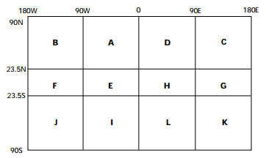
Figure A4. Geographical area designators for A2 when T1 = I or J

Table A6. Geographical area designators; table reproduced from the Manual on the Global Telecommunication System, Part II, Attachment II.5, Table C3
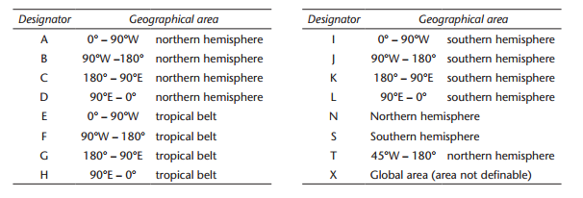
Notes:
1. If the BUFR bulletin contains data from several aircraft flying in different sectors of the globe, X should be coded ‘X’.
2. The tropical belt is defined to be within 23.5°N and 23.5°S.
3. A1A2 (for TAC) or A2 (for BUFR) indicate geographical region appropriate for the first observation in the bulletin.
For upper-air alphanumeric encoded data (that is, with T₁T₂ = UA or UD, used for AIREP and FM42, respectively), A₁A₂ indicates the geographical region appropriate for the observations. Details are published in the Manual on the Global Telecommunication System, Attachment II.5, Table C1 – Geographical designators A₁A₂ for use in abbreviated headings T1T2A1A2ii CCCC YYGGgg for bulletins containing meteorological information, excluding ships’ weather reports and oceanographic data (with preference for Part II – Area designators, prevailing over Part I – National designators) (see Figure A5).
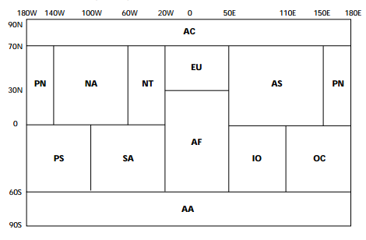
Figure A5. Geographical area designators for A₁A₂ for AIREP and FM42 formats
For further details on the older geographical and/or data-type designators used for TAC-encoded bulletins, see the Aircraft Meteorological Data Relay (AMDAR) Reference Manual (WMO-No. 958) (2003).
ii Shall be a number with two digits (starting with “01”). When an originator or compiler of bulletins issues two or more bulletins with the same T₁T₂A₁A₂ and CCCC, the ii shall be used to differentiate the bulletins and will be unique to each bulletin.
Note: ii has no significance for BUFR-encoded AMDAR bulletins (that is, with T₁T₂ = IU). For AIREP bulletins encoded in TAC (that is, with T₁T₂ = UA), the rule detailed in Table A7 should be followed.
Table A7. Extract from the Manual on the Global Telecommunication System, Attachment II.5, Table D3 – Level designator ii (when T1T2 = FA or UA)
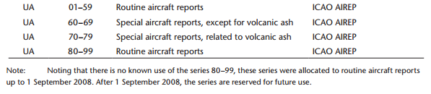
CCCC International four-letter location indicator of the station or centre originating or compiling the bulletin, as agreed internationally and published in Weather Reporting (WMO-No. 9), Volume C1 – Catalogue of Meteorological Bulletins, Annex I.
Notes:
– Once a bulletin has been originated or compiled, the CCCC may not be changed. However, if the contents of a bulletin are changed or recompiled afterwards by another centre for any reason, the CCCC should be changed to indicate the centre or station making the change.
– Originating/generating centres are also reported within each BUFR bulletin (in section 1, descriptor 0 01 035; see Manual on Codes (WMO-No. 306), Volume I.2, Part C, Common Code Table C-11).

YYGGgg International date-time group, where:
YY: Day of the month;
GGgg: The time of compilation in UTC (hour and minute).
Note: Only day (of month), hour and minute are given. Year, month, or seconds are not provided.
BBB (Without brackets if reported) - because an abbreviated heading defined by T₁T₂A₁A₂ii CCCC YYGGgg shall be used only once, for any addition, correction or amendment, it shall be mandatory to add an appropriate BBB indicator. The BBB indicator shall have the following forms: RRx for additional or subsequent issuance of bulletins; CCx for corrections to previously relayed bulletins; AAx for amendments to previously relayed bulletins; where x is an alphabetic character of A through X, as described in the Manual on the Global Telecommunication System (WMO-No. 386), Attachment II-12 – Instructions for the use of the indicator BBB.

Description of the bulletin codes
The relevant contents of a bulletin are within the code block. As explained above, this is an encoded block composed of purely binary information, usually called BUFR. In the past this block was in the ASCII-compatible format TAC. Some bulletin originating centres, such as centres associated with ICAO-related ABO observations, still produce these types of TAC-based bulletins, but as already stated this practice is obsolete and expected to be phased out.
For a description of the obsolete TAC code blocks, see Manual on Codes (WMO-No. 306), Vol I.1, Part A – Alphanumeric Codes.

Description of the BUFR code (FM 94)
A BUFR message is a continuous binary data stream. It is organized into six sections. Section 0 is 64 bits, fixed length and is used to indicate the type and length of the total message. Sections 2–4 are variable in length and contain data descriptors and data. Section 5 is 32 bits, fixed content to indicate the end of the BUFR message. The content of each section is best shown in tabular form. This mimics the BUFR encoding process. The contents of each section are organized into 8 bit bytes, called “octets”. A constraint placed on all sections is that they must contain an even number of complete octets. Detailed information on these table-driven code forms can be found in the Manual on Codes (WMO-No. 306), Volume I.2, and the most current versions are available from http://www.wmo.int/pages/prog/www/WMOCodes.html (see Table A8).
Table A8. Basic structure of a BUFR bulletin code
Section number | Name |  | BUFR table (see Manual on Codes (WMO-No. 306), Volume I.2 | Remarks
0 | Indicator section |  |  | Starting with “BUFR”; length of message, BUFR edition number
1 | Identification section | Table A – Data category |  | Length of section, identification of the message. For AMDAR, use code figure 4, “Single level upper-air data (other than satellite)”
2 | Optional section |  |  | Length of section and additional items for local use by automatic DPCs. Not required for AMDAR
3 | Data description section | Table B – Classification of elements  Table C – Data description operators  Table D – List of common sequences |  | Length of section, number of data subsets, data category flag, data compression flag and a collection of descriptors which define the form and content of individual data elements
4 | Data section | Table B – Classification of elements  Table C – Data description operators  Table D – List of common sequences |  | Length of section and binary data
5 | End section |  |  | Ending with “7777”
Within the BUFR bulletin, the most relevant sections are section 1 (identification section, containing metadata of the bulletin itself), and sections 3 and 4 (data description and data section, respectively). Typically, section 3 presents the list of descriptors and common sequences for the datasets, reported in section 4.
Descriptors
Variables, code tables and other elements are represented by so-called descriptors. Schematically, a BUFR descriptor can be visualized as follows:
F | X | Y
2 BITS | 6 BITS | 8 BITS
F denotes the type of descriptor. With 2 bits, there are 4 possible values for F: 0, 1, 2 and 3. The four values have the following meanings:
F = 0: Element descriptor, and refers to Table B entries;
F = 1: Replication operator;
F = 2: Operator descriptor, and refers to Table C entries;
F = 3: Sequence descriptor, and refers to Table D entries.
The meanings of and uses for X and Y depend on the value of F. Clearly, for variables and code tables, the most relevant are the values for F = 0 or 3. For these values, the descriptor refers to BUFR Tables B or D. X (6 bits) indicates the class or category of descriptor within the table. In the case that F = 0, reference is made to single variables or predefined table values. For instance, F X Y = 0 12 101 stands for “temperature/air temperature” (class 12, “temperature”, is represented with X = 12). In the case that F = 3 (sequence descriptor, used for templates), category 11 (“single level report sequences (conventional data)”) is used to represent AMDAR data, so X = 11. For instance, F X Y = 3 11 010 stands for the “BUFR template for AMDAR, version 7”.
Tables
As indicated in Table A8, references are made to four tables, which are the base of this table-driven code format:
– Table A: Data category – providing a quick check for the type of data represented in the message;
– Table B: Classification of elements (F = 0). Table B is the heart of the data description language for BUFR. First, each individual parameter, or element, defined for use in BUFR is assigned an element name and a descriptor value (values for the F, X, and Y parts of the descriptor as described above). As noted above, the value of F for all descriptors in Table B is 0 (zero). The X part of the descriptor is determined by organizing all the possible parameters into a set of classes based on their nature (for example, X = 11 for temperature parameters, X = 12 for wind parameters, or X = 13 for hydrographic and hydrological elements including moisture parameters). The Y part of the descriptor is the entry within a class X of the parameter (for example, Y = 101 in F X Y = 0 12 101 for “temperature/air temperature”);
– Table C: Data description operators (F = 2). These are used when there is a need to redefine Table B attributes temporarily, such as the need to change data width, scale or reference value of a Table B entry. Table C is also used to add associated fields such as quality control information, indicate characters as data items, and signify data width of local descriptors;
– Table D: List of common sequences (F = 3). A group of data items always transmitted can be defined in what is called a common sequence descriptor, so that the individual element descriptors will not need to be repeated each time in the data description section. It is only the common sequence descriptor that will be listed in the data description section. For AMDAR BUFR bulletins, F X = 3 11 – “single level report sequences (conventional data)”.
Table A9 shows an example of a common sequence.
Table A9. A typical example of a common sequence
TABLE REFERENCES |  |  |  | TABLE REFERENCES
F | X | Y |  | F | X | Y
3 | 01 | 011 | Year, month, day | 0  0  0 | 04  04  04 | 001  002  003 | Year  Month  Day

Value representation
Descriptors referring to numerical values and defined in Table B are integers based on four such characteristics: unit, scale, reference value and data width (in bits).
– Units: In most cases, the basic (SI) units for the element. However, numeric, character, code table, or flag table are also possible;
– Scale: The power of 10 by which the element has been multiplied prior to encoding;
– Reference value: A number to be subtracted from the element, after scaling (if any), and prior to encoding;
– Data width (bits): The number of bits the element requires for representation in section 4.
Table A10 presents two typical examples, used for encoding AMDAR data.
Table A10. Examples of coding of AMDAR data
TABLE REFERENCE | ELEMENT NAME | BUFR
F X Y |  | UNIT | SCALE | REFERENCE VALUE | DATA WIDTH (Bits)
0 12 101 | Temperature/air temperature | K | 2 | 0 | 16
0 11 101 | Aircraft ground speed u-component | m s^{–1} | 1 | –4096 | 13
Note: Where a code table or flag table is appropriate, “code table” or “flag table” respectively is entered in the UNITS column of Table B.
To encode values into BUFR, the data (with units as specified in the unit column) must be multiplied by 10 to the power indicated in the scale column. Then subtract the reference value to give the coded value found in section 4 of the BUFR message. For example, an aircraft ground speed u-component is –200 m s⁻¹. The descriptor is 0 11 101 and the encoded value is –200 x 10¹ – (–4096) = 2096. Or, if the air temperature is –70.32 °C (202.83 K), for descriptor 0 12 101 the encoded value is 203.5 x 10² – (0) = 20 350 (a data width of 16 bits implies a maximum value of 2¹⁶ - 1 = 65 535).
Note:
– Missing values shall be set to fields of all ones (for example, each octet shall be set to 11111111 binary). This shall apply to code tables as well as data elements; flag tables shall be augmented to contain a missing indicator bit where this is deemed to be necessary.
– “Unit” is the basic unit before scaling.

Lists of common sequences (templates)
Although each data centre may define its own set of variables to be disseminated over GTS, it is recommended to follow a standard approach based on predefined lists of variables. Such a list or table containing a predefined set of variables and other parameters is called a list of common sequences, or "template". For all type of observing systems, standard templates are developed and endorsed to be implemented. For each type of observing system, a category is defined. AOB belong to "single level upper-air data (other than satellite)" using the templates in category 11, "single level report sequences (conventional data)". The overview of all lists of common sequences (templates) is maintained in BUFR Table D of the Manual on Codes (WMO-No. 306), Volume I.2 - International Codes, Part B (for BUFR) and C (for CREX). There are 11 templates for BUFR-encoded AOB and 9 templates for CREX-encoded AOB (note that CREX will become obsolete in the near future when all bulletins will report BUFR only).

Recommended BUFR templates
Although 11 BUFR templates have been defined for ABO, it is recommended that the following templates should be adopted as the international standard for exchange of ABO on WIS:
– 3 11 010 "WIGOS BUFR template for AMDAR, version 7";
– 3 11 011 "IAGOS template for a single observation, version 2".
Template 3 11 010 is the recommended standard template for all types of ABO.
Template 3 11 011 is developed in addition to the standard template to provide observations and derived data related to aerosol and chemical components to support the ongoing research of the chemical composition of the atmosphere.
All other templates in the series 3 11 XXX should be regarded as obsolete.
For the further development of the WIGOS framework these standard templates were developed to deliver all types of possible observations (or derived data) performed on board aircraft, including ICAO aircraft reports.
The standard WIGOS BUFR template for AMDAR version 7 (3 11 010) is explained in detail in Attachment C1 to the present appendix. For completeness, a brief description of the special template "IAGOS template for a single observation, version 2" (3 11 011) is presented in Attachment C2. The associated code and flag tables are given in Attachment C3.

Encoding of other ABO data sources
Other sources of ABO that are described within section 1.6.3 should be disseminated over GTS using the same BUFR format as described within Attachment C1. Attachment C1 contains a table with columns indicating which descriptors should be used (that is, are mandatory) or refer to variables defined by the other data sources.
These data are typically sourced from commercially operated observing systems, such as the TAMDAR and AFIRS systems (see section 1.6.3). These may be available on GTS, depending on the arrangements between the contracting NMHS and the vendor for the purchase and provision of the data.

Other (obsolete) BUFR templates
While the WIGOS BUFR template for AMDAR version 7 is recommended for adoption as the standard BUFR template for all ABO, other templates either remain in use transitionally or were used in the past. A reference to these superseded BUFR templates is provided in Attachment C4 to the present appendix.

Description of obsolete TAC codes (FM41, FM42, AIREP)
While it is expected that all ABO reports will eventually be disseminated in BUFR only, a number of bulletins are still generated and transmitted on GTS in the alphanumeric format. Code tables used in the past for reporting ABO are FM-41 (CODAR) and FM-42 (AMDAR). Details on both formats can be found in the Manual on Codes (WMO-No. 306), Volume I.1, Part A – Alphanumeric codes.
Based on a mutual agreement with ICAO and in line with Technical Regulations (WMO-No. 49), Volume II, ABO or derived meteorological data are provided from ICAO-associated centres (WAFCs). Such observations can be generated on board manually (for example, by pilots) or automatically. Derived data is generated on ground after dedicated processing of specific measurements, reported by aircraft. Although the recommended format is the standard BUFR template, the AIREP observations reported by the aircraft are provided in an alphanumerical format. The ICAO AIREP format is in fact an enhancement of the obsolete FM41 (CODAR) format. For a detailed description of the encoding of ICAO AIREPs and ABO derived from them, see Attachment C5.

ATTACHMENT C1. BUFR TEMPLATE FOR AMDAR, VERSION 7 (TABLE REFERENCE 3 11 010)
 |  |  |  | Mandatory  [8] (see section 1.5.1) | Element name | Sequence descriptor  (BUFR Table D/B) | Related descriptor  (BUFR Table B) | Resoltution and unit/table/  numeric | AOSFRS, version1.1, Appendix A | FM42 symbol  [9] | AIREP symbol  [10] | Notes
 |  |  |  |  |  | F X Y | F X Y
Metadata |  |  |  | M | Aircraft registration number or other identification | 0 01 008 | 0 01 008 | * | Table 18, AMDAR aircraft identifier | I_{A}. . . I_{A} | I_{A}. . . I_{A} | [1]; * Max 8 characters, preferable “AANNNN”; to be implemented for AIREPS
 |  |  |  |  | Observation sequence number | 0 01 023 | 0 01 023 | Numeric | N/A |  |  | [2]
 |  |  |  |  | Aircraft flight number | 0 01 006 | 0 01 006 | * | Not documented |  |  | [1]; * 8 characters, ICAO code
 |  |  |  |  | Aircraft tail number | 0 01 110 | 0 01 110 | * | Not documented |  |  | * 6 characters
 |  |  |  |  | Origination airport | 0 01 111 | 0 01 111 | * | Table 18, departure Airport |  |  | * 3 characters, International Air Transport Association code
 |  |  |  |  | Destination airport | 0 01 112 | 0 01 112 | * | Table 18, arrival airport |  |  | * 3 characters, International Air Transport Association code
 |  |  |  |  | Add associated field | 2 04 002 | 2 04 002 | Descriptor operator | N/A |  |  | [3]; Y = 2, so 2 bits extra for indicator of quality (see next field)
 |  |  |  |  | Associated field significance | 0 31 021 | 0 31 021 | Code table |  |  |  | [3], [4]; two bits quality information. Possible values: 7 and 8 (see [4]), but 8 is recommended
 |  |  |  | M | Year | 3 01 011 | 0 04 001 | Numeric | (Not provided) |  |  | Year (UTC, 4 digits format)
 |  |  |  | M | Month |  | 0 04 002 | Numeric | (Not provided) |  |  | Month (UTC, 2 digits format)
 |  |  |  | M | Day |  | 0 04 003 | Numeric | Table 6, value = 1 to 31; Table 19 | YY | YY | Day (UTC, 2 digits format)
 |  |  |  | M | Hour | 3 01 013 | 0 04 004 | Numeric | Table 6, based on HHMMSS format, 000000 to 235959 (0 refers to start of day); Table 19 for ACARS | GG | GG | Hour (UTC, 2 digits format)
 |  |  |  | M | Minute |  | 0 04 005 | Numeric | Table 6, based on HHMMSS format, 000000 to 235959 (0 refers to start of day); Table 19 for ACARS | gg | gg | Minute (UTC, 2 digits format)
 |  |  |  |  | Second |  | 0 04 006 | Numeric | Table 6, based on HHMMSS format, 000000 to 235959 (0 refers to start of day); Table 19 for ACARS |  |  | Second (UTC, 2 digits format)
 |  |  |  | M | Latitude (high accuracy) | 3 01 021 | 0 05 001 | 10⁻⁵ ° | Table 6; Table 19 for ACARS; latitude in seconds | L_{a}L_{a}L_{a}L_{a}A | L_{a}L_{a}L_{a}L_{a}A | Expressed in degrees, WGS84, south is negative
 |  |  |  | M | Longitude (high accuracy) |  | 0 06 001 | 10⁻⁵ ° | Table 6; Table 19 for ACARS; longitude in seconds | L_{o}L_{o}L_{o}L_{o}L_{o}B | L_{o}L_{o}L_{o}L_{o}L_{o}B | Expressed in degrees, WGS84,west is negative
 |  |  |  | M | Flight level (pressure altitude) | 0 07 010 | 0 07 010 | 1 m | Table 6; Table 19 for ACARS | S_{h}h_{I}h_{I}h_{I} | S_{h}h_{I}h_{I}h_{I} | [11]; pressure altitude is with reference to 1 013.25 hPa, not mean sea level (like altitude)
 |  |  |  | [M] | Global navigation satellite system altitude | 0 10 053 | 0 10 053 | 1 m | Table7; Table 20 for ACARS |  |  | [12]; WGS84 as reference system. Correction for GEOID96 to be considered
 |  |  |  | M | Detailed phase of flight | 0 08 009 | 0 08 009 | Code table | Table 6, 3.3.1; Table 19 for ACARS | i_{p}i_{p}i_{p} | i_{p}i_{p}i_{p}
Wind |  |  |  | M | Wind direction | 0 11 001 | 0 11 001 | 1° | Table 6; Table 19 for ACARS | ddd | ddd | In degree true north (so, not magnetic north)
 |  |  |  | M | Wind speed | 0 11 002 | 0 11 002 | 0.1 m s⁻¹ | Table 6; Table 19 for ACARS | fff | fff | In m/s, so not kt
Aircraft speed |  |  |  |  | Aircraft roll angle quality | 0 02 064 | 0 02 064 | Code table | Tables 4 and 6, 3.2.4.4; Table 19 for ACARS
 |  |  |  |  | Aircraft true airspeed | 0 11 100 | 0 11 100 | 0.1 m s⁻¹ | Table 7; Table 20 for ACARS
 |  |  |  |  | Aircraft ground speed u-component | 0 11 101 | 0 11 101 | 0.1 m s⁻¹ | Table 7; Table 20 for ACARS
 |  |  |  |  | Aircraft ground speed v-component | 0 11 102 | 0 11 102 | 0.1 m s⁻¹ | Not documented |  |  | May be derived from wind speed and direction
 |  |  |  |  | Aircraft ground speed w-component | 0 11 103 | 0 11 103 | 0.1 m s⁻¹ | Not documented |  |  | May be derived from wind speed and direction
 |  |  |  |  | Aircraft true heading | 0 11 104 | 0 11 104 | 1 ° | Table 7; Table 20 for ACARS |  |  | In degree true north (so, not magnetic north)
Temperature |  |  |  |  | Temperature/air temperature | 0 12 101 | 0 12 101 | 0.01 K | Table 6; Table 19 for ACARS | SST_{A}T_{A}T_{A} | SST_{A}T_{A}T_{A} | Static air temperature; high resolution (0.01 K), chosen for correct conversion from kelvin temperature to Celsius temperature
Humidity |  |  |  |  | Aircraft humidity sensors | 0 02 170 | 0 02 170 | Code table | Table 25 and Appendix C.2 |  |  | See list in code table 0 02 170
 |  |  |  |  | Change data width | 2 01 144 | 2 01 144 | Descriptor operator |  |  |  | [3], [7]; Y = 144, so add (144-128) = 16 bits to the default width (14) to become 30
 |  |  |  |  | Change scale | 2 02 133 | 2 02 133 | Descriptor operator |  |  |  | [3], [7]; Y = 133, so add (133 - 128) = 5 to the default scale (5) to become 10
 |  |  |  | [M] | Mixing ratio | 0 13 002 | 0 13 002 | 10⁻¹⁰ kg/kg | Appendix C.2 |  |  | MR with enhanced resolution [7]
 |  |  |  |  | Change scale | 2 02 000 | 2 02 000 | Descriptor operator |  |  |  | Reset scale to default (5)
 |  |  |  |  | Change data width | 2 01 000 | 2 01 000 | Descriptor operator |  |  |  | Reset data width to default (14 bits)
 |  |  |  |  | Change data width | 2 01 135 | 2 01 135 | Descriptor operator |  |  |  | [3], [7]; Y = 135, so add (135-128) = 7 bits to the default width (7) to become 14
 |  |  |  |  | Change scale | 2 02 130 | 2 02 130 | Descriptor operator |  |  |  | [3].[7]; Y = 130, so add (130 - 128) = 2 to the default scale (0) to become 2
 |  |  |  | [M] | Relative humidity | 0 13 003 | 0 13 003 | 0.01 % | Appendix C.2 | UUU | UUU | Relative humidity with enhanced resolution
 |  |  |  |  | Change scale (to default) | 2 02 000 | 2 02 000 | Descriptor operator |  |  |  | Reset scale to default (0)
 |  |  |  |  | Change data width (to default) | 2 01 000 | 2 01 000 | Descriptor operator |  |  |  | Reset data width to default (7)
 |  |  |  |  | Delayed replication of 1 descriptor | 1 01 000 | 1 01 000 | Replication descriptor |  |  |  | [5]; Y=0, so delayed
 |  |  |  |  | Short delayed descriptor replication factor | 0 31 000 | 0 31 000 | (Related to replication descriptor) |  |  |  | [6]; (1 bit)
 |  |  |  |  | Dewpoint temperature | 0 12 103 | 0 12 103 | 0.1 K | Not documented | SST_{d}T_{d}T_{d}
 |  |  |  |  | Moisture quality | 0 33 026 | 0 33 026 | Code table | Table 26 in Appendix C.2 |  |  | See code table
icing |  |  |  |  | Delayed replication of 1 descriptor | 1 01 000 | 1 01 000 | Replication descriptor |  |  |  | [5]; Y = 0, so delayed
 |  |  |  |  | Short delayed descriptor replication factor | 0 31 000 | 0 31 000 | (Related to replication descriptor) |  |  |  | [6]; (1 bit)
 |  |  |  | [M] | Airframe icing present | 0 20 042 | 0 20 042 | Code table | Table7; Table 20 for ACARS |  |  | Present or not present
Liquid water |  |  |  |  | Delayed replication of 3 descriptors | 1 03 000 | 1 03 000 | Replication descriptor |  |  |  | [5]; Y = 0 so delayed
 |  |  |  |  | Short delayed descriptor replication factor | 0 31 000 | 0 31 000 | (Related to replication descriptor) |  |  |  | [6]; (1 bit)
 |  |  |  |  | Peak liquid water content | 0 20 043 | 0 20 043 | 10⁻⁴ kg m⁻³ | Not documented
 |  |  |  |  | Average liquid water content | 0 20 044 | 0 20 044 | 10⁻⁴ kg m⁻³ | Not documented
 |  |  |  |  | Supercooled large droplet (SLD) conditions | 0 20 045 | 0 20 045 | Code table | Not documented |  |  | Present or not present
 |  |  |  |  | Delayed replication of 1 descriptor | 1 01 000 | 1 01 000 | Replication descriptor |  |  |  | [5]; Y = 0 so delayed.
 |  |  |  |  | Short delayed descriptor replication factor | 0 31 000 | 0 31 000 | (Related to replication descriptor) |  |  |  | [6]; (1 bit)
 |  |  |  |  | ACARS interpolated values indicator | 0 33 025 | 0 33 025 | Code table | Not documented
Turbulence |  |  |  |  | Delayed replication of 3 descriptors | 1 03 000 | 1 03 000 | Replication descriptor |  |  |  | [5]; Y = 0 so delayed.
 |  |  |  |  | Delayed descriptor replication factor | 0 31 001 | 0 31 001 | (Related to replication descriptor) |  |  |  | [6]; (8 bit)
 |  |  |  | [M] | Mean turbulence intensity (EDR) | 0 11 075 | 0 11 075 | 0.01 m^{2/3} s^{–1} | See 3.3.5 and Appendix C.1.2
 |  |  |  |  | Peak turbulence intensity (EDR) | 0 11 076 | 0 11 076 | 0.01 m^{2/3} s^{–1} | See 3.3.5 and Appendix C.1.2
 |  |  |  |  | Extended time of occurrence of peak eddy dissipation rate | 0 11 039 | 0 11 039 | Code table | See 3.3.5 and Appendix C.1.2
 |  |  |  |  | Delayed replication of 2 descriptors | 1 02 000 | 1 02 000 | Replication descriptor |  |  |  | [5]; Y= 0 so delayed
 |  |  |  |  | Short delayed descriptor replication factor | 0 31 000 | 0 31 000 | (Related to replication descriptor) |  |  |  | [6]; (1 bit)
 |  |  |  | [M] | Turbulence index | 0 11 037 | 0 11 037 | Code table | Table7; Table 20 for ACARS; see 3.3.5 and Appendix C.1.2 | TBB_{A} |  | Equivalent to EDR
 |  |  |  |  | Reporting interval or averaging time for eddy dissipation rate | 0 11 077 | 0 11 077 | 1 s | See 3.3.5 and Appendix C.1.2
 |  |  |  |  | Delayed replication of 3 descriptors | 1 03 000 | 1 03 000 | Replication descriptor |  |  |  | [5]; Y = 0 so delayed.
 |  |  |  |  | Short delayed descriptor replication factor | 0 31 000 | 0 31 000 | (Related to replication descriptor) |  |  |  | [6]; (1 bit)
 |  |  |  |  | Vertical gust velocity | 0 11 034 | 0 11 034 | 0.1 m s⁻¹ | Appendix C.1.1 | VGf_{g}f_{g}f_{g}
 |  |  |  |  | Vertical gust acceleration | 0 11 035 | 0 11 035 | 0.01 m s⁻² | Appendix C.1.1
 |  |  |  |  | Maximum derived equivalent vertical gust speed | 0 11 036 | 0 11 036 | 0.1 m s⁻¹ | Appendix C.1.1
 |  |  |  |  | Add associated field (cancel) | 2 04 000 | 2 04 000 | Descriptor operator |  |  |  | Cancel associated field
 |  |  |  |  | Delayed replication of 19 descriptors | 1 19 000 | 1 19 000 | Replication descriptor |  |  |  | [5]; Y = 0 so delayed.
 |  |  |  |  | Delayed descriptor replication factor | 0 31 001 | 0 31 001 | (Related to replication descriptor) |  |  |  | [6]; (1 bit)
 |  |  |  |  | Year | 3 01 011 | 0 04 001 | Numeric | Table 6; Appendix C.1.1
 |  |  |  |  | Month |  | 0 04 002 | Numeric | Table 6; Appendix C.1.1
 |  |  |  |  | Day |  | 0 04 003 | Numeric | Table 6; Appendix C.1.1
 |  |  |  |  | Hour | 3 01 013 | 0 04 004 | Numeric | Table 6; Appendix C.1.1
 |  |  |  |  | Minute |  | 0 04 005 | Numeric | Table 6; Appendix C.1.1
 |  |  |  |  | Second |  | 0 04 006 | Numeric | Table 6; Appendix C.1.1
 |  |  |  |  | Latitude (high accuracy) | 3 01 021 | 0 05 001 | 10⁻⁵ ° | Table 6
 |  |  |  |  | Longitude (high accuracy) |  | 0 06 001 | 10⁻⁵ ° | Table 6
 |  |  |  |  | Height | 0 07 007 | 0 07 007 | 1 m | (Not documented) recommendation: use pressure altitude |  |  | Instead of height, pressure altitude (flight level should be reported); for height, no reference pane is defined
 |  |  |  |  | EDR algorithm version | 0 11 105 | 0 11 105 | Numeric | See 3.3.5 |  |  | Data width = 6 bits, so value = 0..63
 |  |  |  |  | Add associated field | 2 04 007 | 2 04 007 | Descriptor operator |  |  |  | [3]; Y = 7, so 7 bits
 |  |  |  |  | Associated field significance | 0 31 021 | 0 31 021 | Code table |  |  |  | [3], [4]; code figure to be 7, percentage confidence
 |  |  |  |  | Peak turbulence intensity (EDR) | 0 11 076 | 0 11 076 | 0.01 m^{2/3} s^{–1} | See 3.3.5 and Appendix C.1.2
 |  |  |  |  | Mean turbulence intensity (EDR) | 0 11 075 | 0 11 075 | 0.01 m^{2/3} s^{–1} | See 3.3.5 and Appendix C.1.2
 |  |  |  |  | Add associated field (cancel) | 2 04 000 | 2 04 000 | Descriptor operator |  |  |  | Cancel associated field
 |  |  |  |  | Running minimum confidence | 0 11 106 | 0 11 106 | Numeric | (Not documented) |  |  | Scale = 1, data width = 4 bits, so value = 0, 10, 20, … 150
 |  |  |  |  | Maximum number bad inputs | 0 11 107 | 0 11 107 | Numeric | (Not documented) |  |  | Scale = 0, data width = 5 bits, so value = 0 .. 31
 |  |  |  |  | Peak location | 0 11 108 | 0 11 108 | Numeric | (Not documented) |  |  | Scale = 1, data width = 4 bits, so value = 0, 10, 20, .. 150
 |  |  |  |  | Number of good EDR | 0 11 109 | 0 11 109 | Numeric | (Not documented) |  |  | Scale = 0, data width = 4 bits, so value = 0 … 15
 |  |  |  |  | Temperature/air temperature | 0 12 101 | 0 12 101 | 0.01 K | Table 6; Table 19 for ACARS
 |  |  |  |  | Wind direction | 0 11 001 | 0 11 001 | 1° | Table 6; Table 19 for ACARS
 |  |  |  |  | Change data width | 2 01 130 | 2 01 130 | Descriptor operator |  |  |  | [7];Y = 130, so add (130-128) = 2 bits to the default width (8) to become 10
 |  |  |  |  | Wind speed | 0 11 084 | 0 11 084 | 1 kt | Table 6; Table 19 for ACARS |  |  | Data width = 10, scale = 0, so value = 0 … 1023
 |  |  |  |  | Change data width (to default) | 2 01 000 | 2 01 000 | Descriptor operator |  |  |  | Reset data width to default (8)

Notes:
1. Care should be taken to use an appropriate identifier. Such an identifier should be a unique identifier related to one single and unique aircraft only (such as the aircraft tail number, and which should not be encoded here but is provided, if available, via 0 01 110). The wording “aircraft identifier” was first used in TAC code FM42, indicated by I_{A}...I_{A}. For further details, see the Aircraft Meteorological Data Relay (AMDAR) Reference Manual (WMO-No. 958) (2003). This identifier should not be confused with “aircraft flight number”, which is represented by descriptor 0 01 006 and should only ever be used to encode an aviation or airline assigned flight number, if it is available. The recommended and preferred format to be used for AMDAR is XXnnnn, where XX is a fixed character string representing the country in which the aircraft is registered or representing the national or regional AMDAR programme, and nnnn is a unique number assigned to the aircraft within the fleet of the programme. For example, for aircraft identity EU0001, EU represents the E-AMDAR programme and 0001 is a number that uniquely identifies a particular aircraft within the E-AMDAR fleet. Members shall ensure that the XX identity is unique to the programme by obtaining approval for use of the designator from WMO.
2. The sequence number is a simple observation count to be included in the downlinked message. It should be reset at 0000 UTC each day and is especially useful for quality control, data management and archiving purposes.
3. Data description operators (with F = 2) are used when there is a need to redefine Table B attributes temporarily, such as the need to change data width, scale or reference value of a Table B entry. The following three data description operators are used in sequence number 3 11 010:
Table  reference | Operand | Operator name | Operation definition
F X
2 01 | YYY | Change data width | Add (YYY–128) bits to the data width given for each data element in Table B, other than CCITT IA5 (character) data, code or flag tables
2 02 | YYY | Change scale | Add YYY–128 to the scale for each data element in Table B, other than CCITT IA5 (character) data, code or flag tables
2 04 | YYY | Add associated field | Precede each data element with YYY bits of information. This operation associates a data field (e.g. quality control information) of YYY bits with each data element

Notes:
1. The operations specified by operator descriptors 2 01, 2 02, 2 03, 2 04, 2 07 and 2 08 remain defined until cancelled or until the end of the data subset.
2. If change scale is used, then it may be necessary for the originator of the message to supply an appropriately rescaled reference value and data width.
3. Cancellation of the use of the redefined value shall be effected by the inclusion of the appropriate operand with YYY set to 000. The value shall then revert to the original Table B value.
4. Nesting of operator descriptors must guarantee unambiguous interpretation. In particular, operators defined within a set of replicated descriptors must be cancelled or completed within that set, and the 2 07 operator may neither be nested within any of the 2 01, 2 02, and 2 03 operators, nor vice versa.
5. Nesting of the operator descriptor 2 04 is defined such that:
(a) Each new definition adds to the currently defined associated field. The order of the included associated information shall correspond with the order in which the associated fields have been defined;
(b) Each cancellation (2 04 000) cancels only the most recently defined addition to the associated field.
6. When the descriptor 2 04 YYY is to be used, it shall precede the first of the data descriptors to which it applies.
7. The data description operator 2 04 YYY, other than 2 04 000, shall be followed immediately by the descriptor 0 31 021 to indicate the meaning of the associated field.
8. In the data stream, the 6 bits described by 0 31 021 (code table) shall precede the YYY bits.
4. The result of the associated field significance (0 32 021) follows the preceding add associated filed (2 04 002) value for YYY. In case of code figure values 7 and 8 we have:
Code figure
7 | Percentage confidence |  |  | (Value)
8 | 2-bit indicator of quality |  |  | 0 = Not suspected
 |  |  |  | 1 = Suspected
 |  |  |  | 2 = Reserved
 |  |  |  | 3 = Information not required
5. The replication operation. If F = 1, the descriptor shall be called a “replication descriptor”. For this case, X shall indicate the number of descriptors to be repeated, and Y the total number of occurrences (replications) of the repeated subsequence. A value of Y = 0 associated with the replication descriptor shall indicate delayed replication. In this case, the replication data description operator shall be completed by the next element descriptor, which shall define a data item indicating the number of replications. This descriptor may also indicate (by its value of Y) that the following datum is to be replicated together with the following descriptor.
6. The “delayed descriptor and data repetition factor” is intended for run-length encoding (for example, scanning an image). It specifies a count N that applies to both descriptor and data, that is, the value of the single element defined by the following descriptor is repeated N times (at intervals already specified). A special application of replication consists in specifying a replication factor of either 0 or 1 for a subsequence.
Important feature: For a value of zero, the sub-sequence is replicated “zero” time – that is, not at all. This makes it possible, when appropriate, to shut down whole sections of a template, thereby shortening the data section! So if, for example, 0 31 00 = 0, a sub-sequence may be replicated zero times, with the result that, although the sub-sequence exists in the template, it is skipped when the sequence is encoded into the data section. This is in particular of relevance for the two sections on turbulence at the end of the template.
7. Change data width and change scale (see note 3). In Table B scale and data width are defined. For example, MR and RH are defined as follows:
Table reference  F X Y | Element name | Unit | Scale | Reference  (value) | Data width  (bits)
0 13 002 | MR | kg kg^{–1} | 5 | 0 | 14
0 13 003 | RH | % | 0 | 0 | 7
For MR, a scale = 5 together with a data width of 14 bits and a reference value of 0 implies a range from 0 to (2¹⁴ – 1) × 10⁻⁵ , that is, {0, 0.00001, .. 0.16383} kg kg^{–1} and with a resolution of 1 x 10⁻⁵ kg kg^{–1}. Because the descriptors are presented as integers, a variable such as MR covering a large number of decades cannot be reporting for its full range and required resolution. As a result, the scale and data width should be enhanced. Using a scale of 10 and a data width of 30, the range becomes 0 to 2³⁰ x 10⁻¹⁰, or {0, 10⁻¹⁰, .. 0.10737} kg kg^{–1} with a resolution of 1 x 10⁻¹⁰ kg kg^{–1}.
8. M if mandatory; [M] mandatory if available. Note that a large number of descriptors are preceded by FXY = 0 31 000 (short delayed descriptor replication factor), which implies that reporting is optional (Y = 0 means no report, if the preceding FXY = 1 X 000 (delayed replication of X descriptors) is set to 0 – see note 6).
9. Selected descriptor for transition from FM42.
10. Selected descriptor for transition from AIREP; see explanation of symbols used in Attachment C5 under "ICAO aircraft reports".
11. Flight level is equal to pressure altitude by definition. Its value is derived from the measured static pressure using the unique relationship as defined by the International Standard Atmosphere, described by the International Organization for Standardization Standard Atmosphere (ISO 2533:1975), based on a standard reference pane of 1 013.25 hPa (see footnote 43 of the present appendix). As a result, the observed static pressure can be derived directly from the reported pressure altitude (see AOSFRS version 1.1 (referenced previously) for details).
12. Correct use of datum reference system is recommended. If WGS84 is used with its primary earth ellipsoid only, to obtain the altitude with a local reference pane according to the GEOID96 model further correction is required (GEOID96 is referenced to mean sea level; see the Guide to Meteorological Instruments and Methods of Observation (WMO-No. 8), 1.3.3.2).

ATTACHMENT C2. IN-SERVICE AIRCRAFT FOR A GLOBAL OBSERVING SYSTEM TEMPLATE FOR A SINGLE OBSERVATION, VERSION 2
(Based on the Manual on Codes (WMO-No. 306), Volume I.2, Table reference 3 11 011)
 |  | Element name | Mandatory  (M = mandatory; [M] = mandatory if available) | Descriptor  (BUFR Table B) | Related sequence descriptor  (BUFR Table D) | Notes
 |  |  |  | F X Y | F X Y
 |  | Observation sequence number |  | 0 01 023
 |  | (IAGOS template for a single observation), version 2
 |  | Observation sequence number |  | 0 01 023
 |  | Phase of aircraft flight |  | 0 08 004
 |  | Year, month, day |  | 3 01 011
 |  | Hour, minute, second |  | 3 01 013
 |  | Latitude (coarse accuracy) |  | 0 05 002
 |  | Longitude (coarse accuracy) |  | 0 06 002
 |  | Pressure |  | 0 07 004
 |  | Wind direction |  | 0 11 001
 |  | Wind speed |  | 0 11 002
 |  | Temperature/air temperature |  | 0 12 101
 |  | Delayed replication of 6 descriptors |  | 1 06 000
 |  | Delayed descriptor replication factor |  | 0 31 001
 |  | Atmospheric chemical or physical constituent type |  | 0 08 046
 |  | Change data width |  | 2 01 139 |  | 20 bits long
 |  | Change scale |  | 2 02 126 |  | Scale: 7
 |  | Concentration of pollutant (mol mol^{–1}) |  | 0 15 026
 |  | Change scale |  | 2 02 000 |  | Cancel
 |  | Change data width |  | 2 01 000 |  | Cancel
 |  | Delayed replication of 6 descriptors |  | 1 06 000
 |  | Delayed descriptor replication factor |  | 0 31 001
 |  | Atmospheric chemical or physical constituent type |  | 0 08 046
 |  | Change data width |  | 2 01 138 |  | 19 bits long
 |  | Change scale |  | 2 02 130 |  | Scale: 11
 |  | Concentration of pollutant (mol mol^{–1}) |  | 0 15 026
 |  | Change scale |  | 2 02 000 |  | Cancel
 |  | Change data width |  | 2 01 000 |  | Cancel
 |  | Log₁₀ of number density of aerosol particles with diameter greater than 5 nm |  | 0 15 052
 |  | Log₁₀ of number density of aerosol particles with diameter greater than 14 nm |  | 0 15 053
 |  | Log₁₀ of number density of aerosol particles with diameter between 0.25 and 2.5 µm |  | 0 15 054
 |  | Non-volatile aerosol ratio |  | 0 15 055
 |  | Pressure |  | 0 07 004
 |  | Pressure |  | 0 07 004
 |  | Log₁₀ of integrated cloud particle density |  | 0 13 099
 |  | Log₁₀ of integrated cloud particle area |  | 0 13 100
 |  | Log₁₀ of integrated cloud particle volume |  | 0 13 101

ATTACHMENT C3. REFERRED CODE TABLES
(Extracted from the Manual on Codes (WMO-No. 306), Volume I.2)
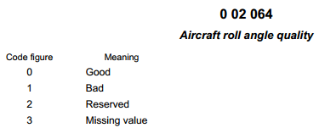

Note: Bad is currently defined as a roll angle > 5 degrees from vertical.

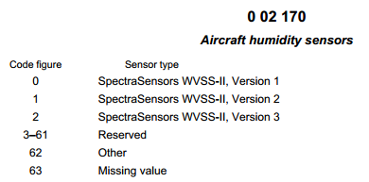

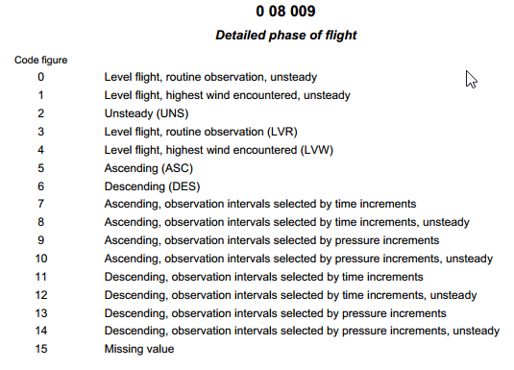
Note: Unsteady in case roll angle > 5 degrees and will take precedence over all other codes.

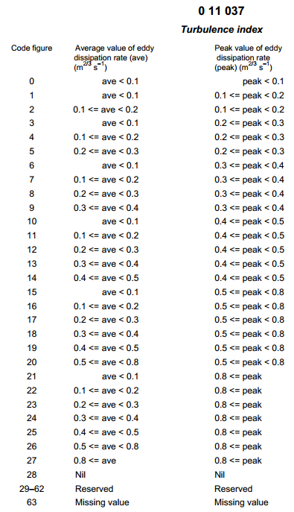
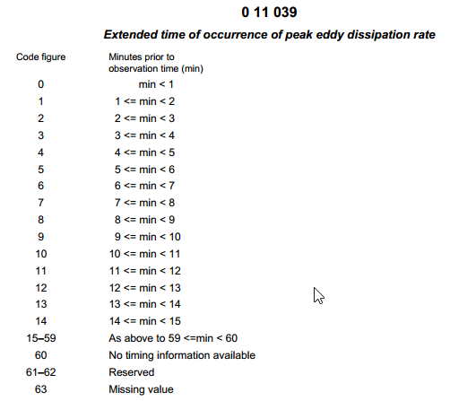

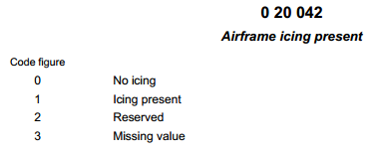

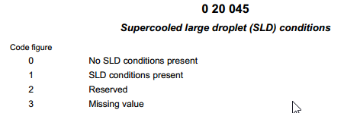

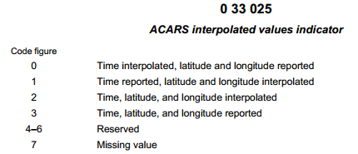

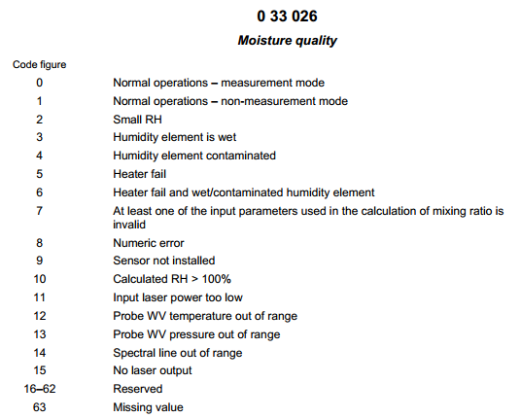

ATTACHMENT C4. OTHER BUFR TEMPLATES STILL IN USE OR USED IN THE PAST
All these templates follow the common sequences, as published in the Manual on Codes (WMO-No. 306), Volume I 2, BUFR Table D, with F XX = 3 11:
Category 11 – Single level report sequences (conventional data)
3 11 001: Aircraft reports for ASDAR, using common sequence (template): 3 01 051 (flight number, navigational system, date/time, location, phase of flight) and standard descriptors.
3 11 002: ACARS reports, using four common sequences (templates) only: 3 01 065 (ACARS identification), 3 01 066 (ACARS location), 3 11 003 (ACARS standard reported variables) and 3 11 004 (ACARS supplementary reported variables).
3 11 003 ACARS standard reported variables (used by 3 11 002), with standard descriptors only.
3 11 004 ACARS supplementary reported variables (used by 3 11 002) with standard descriptors only.
3 11 005 Standard AMDAR reports, using common sequences (template): 3 01 021 (latitude/longitude indicated – high accuracy), 3 01 011 (year, month, day), 3 01 013 (hour, minute, second) and standard descriptors.
3 11 006 AMDAR data or aircraft data for one level without latitude/longitude indicated, with standard descriptors only.
3 11 007 Aircraft data for one level with latitude/longitude indicated, using common sequence (template): 3 01 021 (latitude/longitude indicated – high accuracy) and standard descriptors.
3 11 008 Aircraft ascent/descent profile without latitude/longitude indicated for each level, using common sequences (template): 3 01 021 (latitude/longitude – high accuracy), 3 01 011 (year, month, day), 3 01 013 (hour, minute, second), 3 11 006 (AMDAR data or aircraft data for one level without latitude/longitude) and standard descriptors. This template is designed for reporting profiles based on 3 11 006, AMDAR data or aircraft data for one level without latitude/longitude indicated.
3 11 009 Aircraft ascent/descent profile with latitude/longitude indicated for each level, using common sequences (template): 3 01 021 (latitude/longitude – high accuracy), 3 01 011 (year, month, day), 3 01 013 (hour, minute, second), 3 11 006 (AMDAR data or aircraft data for one level without latitude/longitude) and standard descriptors. This template is designed for reporting profiles based on 3 11 007, aircraft data for one level with latitude/longitude indicated.

ATTACHMENT C5. ENCODING OF AIRCRAFT-BASED OBSERVATIONS AND DERIVED DATA FROM INTERNATIONAL CIVIL AVIATION ORGANIZATION AIRCRAFT REPORTS

Automatic dependent surveillance reports
Automatic dependent surveillance reports are generated automatically. ADS are a component of communication, navigation and surveillance (CNS)/ATM systems of ICAO. ADS are a service for use by ATS in which aircraft automatically provide, via a data link, data derived from on-board navigation and position-fixing systems. As a minimum, the data include aircraft identification, time and position and additional data may be provided as appropriate. The additional data may include a meteorological information data block. Data transmitted by digital data link are required to be forwarded to the WAFCs and Regional Area Forecast Centres (as appropriate) without delay in the form that they are received.
Only the ADS-C sub-type contains meteorological data covering the following elements:
 | ADS element
 | Message type designator
 | Aircraft-address
Data block 1 | Position | Latitude
 |  | Longitude
 |  | Level
 | Date time group | Year, month, day
Timehours,
Timeminutes,
Timeseconds
Data block 2 | Wind-speed
 | Wind-direction
 | Wind-quality-flag
 | Air temperature
 | Turbulence (if available) | Time-of-occurrence, index
 | Humidity (if available)
Note: Aircraft icing is not reported if ADS or SSR Mode S is being applied.
ADS-B itself does not provide observational data. ADS reports are currently and generally formatted as AIREPs for dissemination over GTS. Details on the quality of these reports can be found in de Haan et al (2013).
Aircraft-derived data, such as those derived from SSR Mode S, provide single-level upper-air observations of wind and temperature based on the complex process of publically broadcast messages by SSR receivers, as explained in de Haan et al (2013) and in section 2.2.3.1.
Observational data are also received within communications made by pilots and encoded manually as, for example, AIREPs or PIREPs, as defined by ICAO and NCAA.

International Civil Aviation Organization aircraft reports
AIREP is an alphanumerical code designed originally for encoding manual (pilot) aircraft observations according to ICAO aviation meteorological requirements. In fact, this code is comparable to the WMO code format FM41, CODAR, and to a certain extent to WMO code format FM42, AMDAR, both being obsolete (phased out).
In practice, there is no well-defined format of the AIREP code and national rules are implemented, resulting in dissemination of AIREP bulletins that are not encoded according to any standard (such as exist for BUFR or other WMO code formats). The AIREP code format is not regulated by WMO and not published in the Manual on Codes (WMO-No. 306). However, some documentation on AIREP encoding is available in ICAO Manual of Aeronautical Meteorological Practice, Document 8896 AN/893, 7 – Aircraft observations and reports. Reference to this document can be found in ICAO Air Traffic Management, Document 4444, 4.12. Although the detailed instructions on how to encode AIREP in ICAO Document 8896, are referred to in 7.9 as “Detailed instructions concerning the content of special air-reports received by voice communications by MWOs”, that is, special AIREPs (ARS), they can also be used for routine AIREPs (ARP). Note that this instruction also refers to ICAO Document 4444, Appendix 1 – Instructions for air reporting by voice communications (on acronyms to be used to report special phenomena).
AIREP code format
CCCC | ICAO identifier of transmitting unit
AIREP | Type ARP or ARS. Will precede all AIREP text. See following table for ARS conditions.
Aircraft number | Reported as a 7-character group. The identifier will be a combination of numbers and letters.
Latitude | Four figures indicating the latitude of the aircraft to the nearest minute followed by the letter N (north) or S (south).
Longitude | Five figures indicating the longitude of the aircraft to the nearest minute followed by the letter E (east) or W (west).
UTC time | Four figures depicting time to the nearest minute. For AIREP corrections, add one minute to the actual time.
Flight level | A 4-character group (the letter F followed by three figures), representing the aircraft altitude in hundreds of feet (e.g., F370).
Air temperature | Two figures indicating the temperature in whole degrees Celsius preceded by PS (plus) or MS (minus).
Spot wind | A wind group. The first three figures indicate true wind direction in degrees. The last two figures indicate wind speed to the nearest knot. In the following code: DDD = true wind direction at current position; SS = wind speed at current position. If the wind is above 99 knots, use three figures.
Turbulence | Severe turbulence is reported as TURB SEV and moderate turbulence as TURB MOD – when turbulence in cloud is experienced, INC is added. TURB SEV is reported immediately on occurrence and this requires an ARS, otherwise TURB MOD is reported only if it occurs within the last 10 minutes prior to reaching the position.
Icing | Severe aircraft icing is reported as ICE SEV. Moderate aircraft icing is reported as ICE MOD. ICE SEV is reported immediately on occurrence and this requires an ARS, otherwise ICE MOD is reported only if it occurs within the last 10 minutes prior to reaching the position.
Supplementary information | Cloud bases and/or tops are reported as BASE and/or TOP followed by the respective height indication F (number) or (number) M or (number) FT. Thunderstorm tops may be reported by TS TOP followed by the flight level. Other abbreviations include: present weather – RA (rain), SN (snow), FZRA (freezing rain), FC (funnel cloud), TS (thunderstorm), FRONT (front); clouds – SCT (scattered), BKN (broken), CNS (continuous), CB (cumulonimbus).  To correct an AIREP, add 1 minute to the initial time and add a remark (e.g., COR 1814) when the correction is transmitted as the last entry.

Meteorological ARS:
Thunderstorms (see note) | Severe icing
Tropical storm | Severe or extreme turbulence
Squall line | Mountain wave turbulence
Hail | Widespread sandstorm
Widespread duststorm/sandstorm | Volcanic eruption or ash cloud

Note: The requirement for thunderstorms refers to the occurrence of an area of widespread activity, thunderstorms along a line with little or no space between individual storms, or thunderstorms embedded in cloud layers or concealed by haze. It does not refer to isolated or scattered thunderstorms not embedded in clouds or concealed in haze.

Supplementary information that can be reported includes turbulence, towering thunderstorms, and the like.
AIREPs are compiled automatically or manually and can be transmitted as an ARP or an ARS.
The following is an example of an ARS message as recorded on the ground by the MWO concerned (taken from ICAO Document 8896):
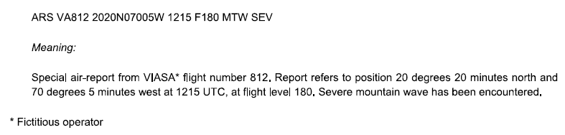
To stimulate uniform use of the AIREP format and to reduce ambiguity due to misinterpreting these reports it is recommended to follow the following standard format:
SECTION 1 AIREP YYGG
SECTION 2 RRR I_{A}...I_{A} L_{a}L_{a}L_{a}L_{a}A L_{o}L_{o}L_{o}L_{o}L_{o}B GGgg S_{h}h_{I}h_{I}h_{I} i_{p}i_{p}i_{p} SST_{A}T_{A}T_{A} ddd/fff SYMBOLS=
Explanation:
YYGG: Day YY and hour GG in UTC related to the bulletin.
RRR: ARP for routine air-reports, ARS for special air-reports. Use of ARS is mandatory, use of ARP is recommended.
I_{A} ... I_{A}: Aircraft identification: aircraft identification consists of either the operator’s designator and aircraft registration, or flight number, reported as one unit without any spaces or hyphens. However, it is recommended to provide an identifier, unique for the aircraft (such as the aircraft registration number).
L_{a}L_{a}L_{a}L_{a}A: Position (latitude, in degrees and minutes): latitude position is given in degrees and minutes (4 figures for latitude L_{a}, followed without a space by A = N or S, that is, direction of latitude, N = north, S = south.
L_{o}L_{o}L_{o}L_{o}L_{o}B: Position (longitude, in degrees and minutes): longitude position is given in degrees and minutes (5 figures for longitude L_{o}, followed without a space by B= E or W; that is, direction of longitude, E = east, W = west).
Note: ICAO Document 8896 (7.9.3 – Position) suggests not to use a space between L_{a}L_{a}L_{a}L_{a}A and L_{o}L_{o}L_{o}L_{o}L_{o}B. However, it is common practice to use spaces to avoid misinterpretation.
GGgg: Time of observation: the time of aircraft, at the position indicated, is shown in hours (GG) and minutes (gg) UTC.
S_{h}h_{I}h_{I}h_{I}: Flight level or altitude: the flight level is shown by sign S_{h} (F for positive flight levels, A for negative flight levels) followed by the actual level h_{I}h_{I}h_{I}; the altitude is shown by an S_{h} followed by h_{I}h_{I}h_{I} and M or FT, as appropriate.
i_{p}i_{p}i_{p}: Phase of flight: flight level S_{h}h_{I}h_{I}h_{I} is followed by ascent (ASC) (level) or descent (DES) (level) when ascending or descending, respectively, to a new level; otherwise omitted.
SST_{A}T_{A}: Sign of the temperature and air temperature in whole degrees Celsius: if air temperature is zero or positive, SS shall be encoded as the letters PS; if air temperature is negative, SS shall be encoded as the letters MS. Air temperature T_{A}T_{A}, in whole degrees Celsius, at the level given by S_{h}h_{I}h_{I}h_{I}.
Note: It is common practice to use a three digit T_{A}T_{A}T_{A}, providing air temperature, in tenths of degrees Celsius.
ddd/fff: Wind direction and wind speed separated by a slash: wind direction ddd to be the true direction, in whole degrees, from which wind is blowing. Wind speed fff, in knots, is indicated for the level given by S_{h}h_{I}h_{I}h_{I}. Units, separated with a space from fff, may be added (KT for knots, MPS for m/s).
SYMBOLS Phenomenon prompting an ARS:
- Severe turbulence as TURB SEV
- Moderate turbulence as TURB MOD
- Severe icing as ICE SEV
- Moderate icing as ICE MOD
- Severe mountain wave as MTW SEV
- Thunderstorm without hail as TS
- Thunderstorm with hail as TSGR
- Heavy dust storm or sandstorm as HVY SS
- Volcanic ash cloud as VA CLD
- Pre-eruption volcanic activity or a volcanic eruption as VA.
General:
– In a bulletin of AIREP reports, the contents of section 1 (the code name AIREP and the group YYGG) shall be included only as the first line of the bulletin.
– An AIREP report shall include section 2 containing at least the aircraft identifier, its geographical location and the day and time of observation, as well as the observed temperature and wind.
– Data fields shall be encoded using the solidus (/) when the data-collection platform cannot acquire correct data, or in the event of parity errors.
– Section 1 and section 2 data shall be reported on single lines without line breaks. Section 2 data to be ended with an “=” sign.
Example
AIREP 1521
ARP UAL137 1712N 14249E 2153 F380 MS470 100/024=

AIREP 1521 Air report for day 15, at 21 H UTC.
ARP Routine air report
UAL137 Flight number
1712N Latitude 17 deg 12 min north
14249E Longitude 142 deg 49 min east
2153 Time 21:53 UTC
F380 Flight level 380 (38 000 ft)
MS47 Air temperature -47.0 °C
100/024 Wind direction 100° true, wind speed 12 m/s (24 knots).

APPENDIX D. GUIDANCE ON AIRCRAFT-BASED OBSERVATIONS METADATA MAINTENANCE AND PROVISION

Background
Obtention, maintenance and international provision of ABO metadata supports the following primary functions in the operation of ABO observing systems:
– Ongoing and historical documentation by Members of the platforms (aircraft), systems (for example, AMDAR and ADS-C) and sensors (for example, total air temperature probes) that contribute to observing system observations;
– Definition of the capabilities of the observing system in terms of various fundamental aspects, which include uncertainty, spatial and temporal resolution or coverage, latency and reporting frequency;
– Provision of additional information about the observing system, including:
• The variables observed;
• The purpose of the observation and the networks and applications for which they are intended to contribute;
• The environment in which the observations are made and their representativeness;
• The methods of observation employed;
• The way in which the measurements are sampled and processed;
• Data ownership and policy;
• Contact details of operators, authorities, data owners, and the like.
ABO metadata consists of three basic types:
(1) Metadata about aircraft platforms and associated observational practices to be obtained, maintained and retained by Members;
(2) Metadata about aircraft platforms and observational practices to be provided to and maintained by WMO;
(3) Metadata about ABO that should be maintained and provided with observational data.
Metadata type 1 would consist of all data within type 2 plus the additional national metadata that is not required to be exchanged.
Metadata type 2 consists of those metadata required to be exchanged by WMO Members to fulfil the requirements and provisions relating to WIGOS.
Metadata type 3 can be described as the additional data that provides further information about required observational variables. For example, the roll angle flag can be considered metadata for the AMDAR wind direction and speed variables, as it provides information about the quality of the wind measurement.
The present appendix is chiefly concerned with the first two types of metadata.

Requirements for metadata
The regulations for maintenance and provision of metadata for WIGOS observing systems are defined within the Manual on WMO Integrated Global Observing System (WMO-No. 1160), 2.5 – Observational metadata.
The requirements for ABO metadata are based upon the WIGOS Metadata Standard, which is defined in the WIGOS Metadata Standard (WMO-No. 1192), edition 2017.

WMO Integrated Global Observing System metadata profile
The WIGOS Metadata Standard provides a framework to define and ensure the availability of all required metadata to ensure maximum usefulness of WIGOS observations in support of all WIGOS observing system data users and WMO application areas.
The WIGOS Metadata Standard, published in July 2017, contains information regarding the primary categories that have been approved to provide a framework for the specification of a metadata profile for ABO.
The WIGOS Metadata Standard makes provision for the following primary categories of metadata:
– Observed variable;
– Purpose of observation;
– Station/platform;
– Environment;
– Instruments and methods of observation;
– Sampling;
– Data processing and reporting;
– Data quality;
– Ownership and data policy;
– Contact;
– A full set of metadata elements that will map to the ABO metadata elements: the current mapping from the WIGOS Metadata Standard to the ABO metadata is provided in the first column of the table within Attachment D1.

Requirements for ABO metadata
The requirements for and applications of ABO metadata envisaged initially were identified under the WIGOS Pilot Project for AMDAR and subsequently updated by the Expert Team on Aircraft-based Observing Systems based on the outcomes of the WMO AMDAR Panel Workshop on Aircraft Observing System Data Management (June 2012). The ABO metadataset, as provided in Attachment D1, has been further refined and approved by the Expert Team in consultation with the WMO OSCAR Project Team.
Members operating ABO systems that report observational data to WIS will be expected to provide metadata within several categories and/or levels:
(a) Metadata in support of ABO data discovery – this will generally be in support of the operation of WIS and is not relevant to the present Guide;
(b) Metadata in support of ABO data:
(i) Metadata to be maintained at the national level: this is the superset of all ABO metadata, encompassing national, regional and global metadata. Note that not all national ABO metadata required is specifically identified in the present Guide. Members must identify all national metadata that is required to meet the provisions for ABO observing system operation as described within the Guide to the Global Observing System (WMO-No. 488) and section 2 of the present Guide;
(ii) Metadata to be provided at the regional level: to be provided to a regional operator such as the E-AMDAR programme. The requirements for regional ABO metadata are not specified within the present Guide;
(iii) Metadata to be provided at the global level: to be provided, as described in the following section, via the interface to the surface component of OSCAR (OSCAR/Surface).
The ABO metadata elements required to be maintained by ABO system operators are specified within the table in Attachment D1. The notes below the table provide a description of the columns and their content.
Attachment D2 provides an alternative structural depiction of the ABO metadata elements.

Metadata requirements for ABO systems capabilities in the Observing Systems Capability Analysis and Review tool
OSCAR is a web-based resource being developed through consultancy under coordination by WMO and its technical commissions. The system is being developed to store all internationally required metadata for WIGOS and also to define and allow analysis of the capabilities of the WIGOS component observing systems that support the various WMO application areas.
Within OSCAR, the capabilities of observing systems that provide ABO are defined in terms of two observing types;
– Atmospheric vertical profilers – observations made during ASC and DES phases of flight to or from airports;
– High-speed mobile platforms – observations made during the en route or cruise (ENR) phase of flight.
Atmospheric vertical profilers will be modelled in OSCAR as observations of vertical profiles of a given variable or set of variables, made with a “virtual instrument”. For ABO, the virtual instrument will be provided by a fleet of aircraft that, by virtue of their operational and reporting schedule, make a programme of vertical profiles at one or more airports.
High-speed mobile platforms will be modelled as “virtual stations” in three-dimensional space, located at the centre of regular grid cells (for example, 1° x 1°) and at one of 13 flight levels. Such stations can also provide observations using virtual instruments, each with its own schedule of observation. For ABO, the programme of observations made by virtual instruments will be, at least initially, based on the aggregated data output derived from the ABO programme, on a system-by-system basis.
OSCAR requires metadata relating to each ABO system that will provide a means for determining the capabilities of each ABO system in terms of the various user requirements for WMO application areas defined and specified within the OSCAR user requirements database. These requirements include spatial and temporal coverage and resolution, and data latency and uncertainty. This means that, in addition to the metadata describing the aircraft platforms and the sensors that provide measurements of atmospheric variables, there will also be a requirement for the provision of programmatic metadata that describes where and when aircraft make observations. It is expected that OSCAR will eventually differentiate between the “programmatic capability” and the “actual coverage” provided by the observations.
However, in the first stage of OSCAR development, the capability of horizontal coverage (ENR phase of flight) will be provided based on a statistical compilation or “snapshot” of observational ABO data, while the capabilities of vertical profiles (ASC and DES phases of flight) will be depicted based on the programmatic information for airport locations serviced by “aircraft fleets”, as defined and provided by national programme managers.
Therefore, in addition to the metadata fields defined within the ABO metadata template and the WIGOS Metadata Standard, OSCAR will provide “key link fields” that will associate aircraft with one or more aircraft fleets and that will provide a programme of vertical profiles for an associated set of “fleet airports”.
An aircraft fleet will be a set of aircraft of the same system type (for example, AMDAR or ADS-C) with common programmatic and OSCAR capability attributes. The aircraft fleet metadata will hold common observing systems capabilities; for example, vertical resolution (in both the lower and upper troposphere), the uncertainty of the observed variables and latency of observations.
Metadata relating to fleet airports will also define a set of airports serviced by the aircraft fleet that will provide a specific cycle of vertical profiles at each airport; for example, the number of profiles per hour/day/week with any diurnal resolution variance.
This structure, along with the associated and required metadata, is depicted within the ABO metadata profile map in Attachment D2.

Responsibilities for provision and maintenance of metadata
In order for ABO metadata for operational ABO systems to be obtained and maintained, and the required internationally exchanged metadata and information provided to the OSCAR system, Members will be required to ensure that roles and procedures are developed and assigned to appropriate staff to fulfil the following functions:
– Member Permanent Representative to WMO:
• Nominate and provide contact details of a WMO national focal point on ABO (NFP-ABO);
• Designate the role of ABO programme manager;
– WMO NFP-ABO:
• Receive and act upon information and advice relating to ABO metadata management and provision;
• Liaise with the ABO programme manager to ensure that requirements for ABO metadata are understood and met;
• Oversee the development of the procedures of their organization for timely provision of internationally exchanged ABO metadata to WMO via OSCAR;
– Member ABO programme manager:
• Establish roles and procedures for the collection, maintenance and provision to WMO of required ABO metadata – see Attachment D1;
• Liaise with partner system operators, airlines, DSPs, avionics vendors and other relevant third parties to ensure that required ABO metadata are able to be made available to the ABO programme and establish the procedures for enabling this exchange.

Provision and association of WMO Integrated Global Observing System station identifiers with aircraft platforms
Members are responsible for the designation of at least one unique WIGOS station identifier (WSI) for all aircraft stations/platforms in accordance with the regulations established within the Manual on the WMO Integrated Global Observing System (WMO-No. 1160), 2.4 – Operations, and Attachment 2.1 – WIGOS station identifiers. Further elaboration on the use of WSI is provided in the Guide to the WMO Integrated Global Observing System (WMO-No. 1165; in preparation), Chapter 2.
A WSI consists of the following four components:
WIGOS identifier series (number) | Issuer of identifier (number) | Issue number (number) | Local identifier (characters)
In designating WSIs for aircraft platforms, ABO focal points must comply with the regulations stipulated in the Manual on the WMO Integrated Global Observing System and should seek to comply with the fundamentals that are established in the Guide to the WMO Integrated Global Observing System, and in particular that:
– WMO observing stations and platforms shall be uniquely identified by a WSI;
– All observing stations must be associated with at least one WSI;
– A station may have more than one WSI, but it is desirable to have as few as possible.
The following additional guidance, specifically related to the provision of WSIs for aircraft platforms, should also be complied with:
– The country in which the aircraft platform is registered should have primary responsibility for the management of the WSI(s) associated with that aircraft and for all the associated metadata.
– Members wishing to provide ABO on GTS for aircraft platforms that are not registered within their country should endeavour to collaborate with the appropriate country of registration in the provision and maintenance of ABO metadata.
– Members should seek to minimize the number of WSIs associated with unique and distinct aircraft platforms that provide ABO on GTS.
– It should be noted that AIREPs generally do not uniquely identify the aircraft that provides the report but usually provide an airline identifier with a flight number. Such flight identifiers must not be used to create a WSI as they will fail to satisfy the regulation that WSIs must be associated with one platform only. Data from such aircraft can still be encoded and transmitted on WIS but should not provide a WSI or aircraft identifier with the data unless it can be obtained from some other source which definitively, uniquely identifies the aircraft.
– The assignment of WSIs for aircraft platforms should be undertaken based on the flow chart provided in Attachment D3.
– Generally:
• A WSI (the first one) with issuer of identifier of the country in which the aircraft is registered should be adopted as the primary WSI for the aircraft platform;
• The primary WSI should be based on the local identifier for the AMDAR observing system if it exists and if a primary WSI has not already been issued;
• A secondary WSI for a system, if required, should be issued using the issuer of identifier for the system.
– Theoretically, a distinct aircraft platform should require only a single WSI issued with the country issuer of identifier of the country in which the aircraft is registered. However, in practice, additional WSIs are permitted (and should be issued) in the cases that:
• Data are being or have been previously transmitted on GTS using a different local identifier using the same or a different ABO system;
• Data are to be transmitted on GTS by a country other than the country in which the aircraft is registered, and this country is not successful in having the system registered against the primary WSI of the registration country.
– A distinct aircraft/system configuration should not be assigned more than one WSI.
– If an ABO programme wishes to submit ABO for an aircraft that is not registered within a country associated with that programme, then the following possibilities can be considered:
• The ABO programme NFP should advise the NFP for the ABO programme in which the aircraft is registered and request the NFP-ABO to add the system to the existing metadata record for the aircraft platform in OSCAR/Surface, and/or make the requesting ABO programme NFP a system operator contact so that they can modify the aircraft metadata record for the particular system providing ABO from the aircraft;
• In the case that the aircraft is not yet registered in OSCAR/Surface, the ABO programme should request the NFP-ABO for the programme in which the aircraft is registered to either create the ABO station and WSI or else make the NFP-ABO of the inquiring programme a system operator contact so that they can create the aircraft metadata record and the WSI;
• In the event that neither of these first two points are possible, the NFP-ABO of the country can create the metadata record for the aircraft under their own ABO programme and a WSI can be issued with the issuer of identifier for the system(s) to be registered. In this case, the metadata should identify any known associated systems together with their WSIs.
– At the current time the following system-based issuer of identifier numbers are available:
System | Issuer of identifier | Status
AMDAR | 20005 | Designated within Guide to WIGOS
AIREP | 20011 | WIS approvedª
ADS-C | 20012 | WIS approved
TAMDAR | 20013 | WIS approved
AFIRS | 20014 | WIS approved
IAGOS | 20015 | WIS approved
Note: https://wiswiki.wmo.int/tiki-index.php?page=WIGOS-Identifiers.

Local identifier designation for aircraft platform WMO Integrated Global Observing System station identifiers
In the past, WMO has specified that AMDAR aircraft station identifiers should have the format AANNNN, where:
– AA should consist of two characters that uniquely identify the AMDAR programme with which the aircraft is associated; for example, AU for an aircraft in the Australia AMDAR programme;
– NNNN is a number that uniquely identifies the aircraft within the programme.
With the use of WSIs, Members are required to establish their own system of local identifiers that will ensure that, when coupled with the issuer of identifier, the WSI will uniquely identify each and every station. Given that 16 characters are available for the provision of a local identifier, there is scope to establish a system of characters and numbers that will allow visual recognition of station and system type, although this is neither required nor encouraged. A simple numbering beginning at 0 or 1 and then enumerated, irrespective of the station or system type is sufficient.
For ABO systems, a requirement is that current and historical stations are provided with a WSI based on the example above. This means that, for each existing or historical aircraft platform for which ABO data have been transmitted on GTS, a WSI must be created of the form: 0-N1-N2-national_identifier, where national_identifier is the unique national identifier that was previously used (for example, EU0246).
For new ABO aircraft, Members may wish to continue to use the AANNNN format for ABO WSI local identifiers, or they can transition to a new system through the use of WSIs.

Examples and specific cases for WMO Integrated Global Observing System station identifiers for aircraft platforms
Example 1
The example in Table A11 is taken from the Guide to the WMO Integrated Global Observing System and contains an example of a WSI for an E-AMDAR aircraft issued with the issuer of identifier number for the AMDAR observing system: 0-20005-0-EU0246.
In the case of a regional AMDAR programme such as this, it may be most appropriate to use the AMDAR system issuer of identifier, rather than using individual country numbers. This is a matter for the ABO programme NFP.
However, if the aircraft was registered in a country with issuer of identifier number 9999, then the WSI could alternatively be designated as: 0-9999-0-EU0246.
Table A11. Example of a WSI for an E-AMDAR aircraft
Issuer of identifier | Category of station identifier | Method of allocating issue number | Method of allocating local identifier
20005 | AMDAR aircraft identifier | 0 – aircraft most recently issued the identifier on 1 July 2016  Any other number: To distinguish between different aircraft that used the same aircraft identifier at different times | Aircraft identifier  Example: Aircraft EU0246 would be represented by 0-20005-0-EU0246

Responsibility and procedures for maintenance of metadata within OSCAR
As with all OSCAR metadata, Members will be responsible for the routine and timely maintenance of the internationally exchanged component of ABO metadata through manual and/or machine interface to the OSCAR system.
Detailed instructions for and guidance on OSCAR metadata maintenance procedures are provided in the Guide to the WMO Integrated Global Observing System. This Guide will contain the OSCAR User Manual, which will include instructions on how to perform manual inputs to the OSCAR system.
Automated input will involve a “machine-to-machine” exchange, most likely using XML data format.
To allow for the transfer of ABO metadata (not in XML) to OSCAR/Surface, a metadata conversion tool will need to be developed, that is, MSExcel→XML, csv→XML, and the like. This conversion tool will be the responsibility of the programme focal point.
Members and ABO focal points of operational ABO programmes should ensure that they make and implement plans for adherence to the above requirements and responsibilities immediately, and should ensure compliance with the requirements for the operation of OSCAR and maintenance of OSCAR metadata upon WMO provision of the relevant regulations and guidance, and notification of completion of the operational implementation of the OSCAR system.

ATTACHMENT D1. AIRCRAFT-BASED OBSERVATIONS METADATA PROFILE
WIGOS MDS category.  element | ABO metadata element | Parent metadata element | Historical record required | Description | Examples | AMDAR | AIREP | ADS-C | TAMDAR | AFIRS | IAGOS
Mandatory / optional / not applicable (M / M* / O / NA)
M* = Mandatory allowing “unknown”, “not given”
9-01 | WMO ABO programme (name) |  | N | Name of the programme – usually the WMO Member country/territory having jurisdiction over the ABO observing system and the observations. For a regional collaboration, the ABO programme operator or the ABO system operator field can be used to provide the regional collaborative body – e.g. EUMETNET | Canada | M | M | M | M | M | M
10-01 | WMO ABO national focal point contact | ABO programme | N | WMO ABO national focal point contact details: name, email, address, phone number  The NFP-ABO is delegated by the Permanent Representative to WMO of the Member country/territory. In addition to providing metadata they can create new operator contacts with authority to enter ABO metadata |  | M | M | M | M | M | M
2-02 | ABO programme operator | ABO programme | N | The name of the observations programme operator – usually this will be the name of the Member country/territory NMHS but could be the name of a regional programme operator, for example, E-AMDAR | Australian Bureau of Meteorology | M | M | M | M | M | M
10-01 | ABO programme contact | ABO programme | N | Set of ABO programme manager contact details: name, email, address, phone number |  | M | M | M | M | M | M
3-04 | ABO system (name) | ABO programme | N | Provides the ABO system name  Systems:  AMDAR  AIREP  ADS-C  TAMDAR  AFIRS  IAGOS | Canada/AMDAR | M | M | M | M | M | M
9-01 | ABO system operator | ABO system | N | The name of the ABO observing system operator – usually this will be the name of the Member country/territory NMHS but it may also be a regional or commercial entity or another country NMHS | E-AMDAR, Bureau of Meteorology | M | M | M | M | M | M
10-01 | ABO system operator contact | ABO system | N | Contact details for ABO system operator contact: name, email, address, phone number |  | M | M | M | M | M | M
3-05 | ABO system fleet (name) | ABO system | Y | Will identify a fleet based on a set of aircraft within a particular ABO system type. An aircraft can have more than one ABO system – for example, an aircraft can report under both the AMDAR programme and also provide AIREPs. However a particular aircraft should be associated with only one ABO system fleet within a particular ABO system | Japan/AMDAR/Air Nippon B737  USA/ADS-C/International | M | M | M | M | M | M
3-02 | Data origination centre | ABO system fleet | Y | Identity of centre issuing the ABO report to WIS | EGRR | M* | M* | M* | M* | M* | M*
10-01 | Data origination centre contact | ABO system fleet | Y | Set of data origination centre contact details: name, email, address, phone number |  | M* | M* | M* | M* | M* | M*
9-01 | Operating authority | ABO system fleet | Y | Name of organization or country responsible for ownership of the majority of the component sensors deployed – usually the airline | United Airways,  PAC | O | O | O | O | O | O
10-01 | Operating authority contact | ABO system fleet | Y | Set of data origination centre contact details: name, email, address, phone number |  | O | O | O | O | O | O
1-01 | Measured variables | ABO system fleet | Y | Provides a key link to the set of measured variable metadata for the system fleet |  | N/A | N/A | N/A | N/A | N/A | N/A
1-02 | Variable name | Measured variable | Y | Name of the measured variable | Air temperature | M | M | M | M | M | M
5-04 | Reporting status | Measured variable | Y | Provides the current status of reporting of the measurement within the downlink messages. | Reported (on GTS) | M | M | M | M | M | M
8-03 | Quality status | Measured variable | Y | Provides the current quality status of the measurement. | Good | M | M | M | M | M | M
1-02 | Measured units | Measured variable | Y | The units in which the measurement is measured on board the aircraft | g/kg | M | M | M | M | M | M
7-11 | Reported units | Measured variable | Y | The units in which the measurement is reported to WIS. | % humidity | M | M | M | M | M | M
7-12 | Reported resolution | Measured variable | Y | The resolution to which the measurement is reported to the WIS. | 5 g/kg | M | M | M | M | M | M
6-05 | Measurement resolution | Measured variable | Y | The resolution to which the measurement is measured on board the aircraft | 1% | M | M | M | M | M | M
6-02 | Smoothing | Measured variable | Y | Has the measurement been smoothed as part of the on-board measurement process? | Y | M* | M* | M* | M* | M* | M*
6-02 | Algorithm | Measured variable | Y | The name, version and/or description of the algorithm used to process the measurement on board the aircraft |  | M* | O | O | O | O | O
6-03 | Sampling method upper | Measured variable | Y | Indication of method used to sample the measurement in the upper troposphere. Should indicate whether the sampling regime is based on pressure or time | Pressure | M* | NA | NA | O | O | O
6-03 | Sampling method lower | Measured variable | Y | Indication of method used to sample the measurement in the lower troposphere. Should indicate whether the sampling regime is based on pressure or time | Time | M* | NA | NA | O | O | O
6-03 | Sampling method en route | Measured variable | Y | Indication of method used to sample the measurement while en route. Should indicate whether the sampling regime is based on pressure or time | Event-based | M* | NA | NA | O | O | O
6-04 | Sampling frequency ascent upper | Measured variable | Y | Frequency or reporting conditional upon sampling method upper. Used to determine the vertical resolution of the measurement | 10 hPa | M* | NA | NA | O | O | O
6-04 | Sampling frequency ascent lower | Measured variable | Y | Frequency or reporting conditional upon sampling method lower. Used to determine the vertical resolution of the measurement | 1 min. | M* | NA | NA | O | O | O
6-04 | Sampling frequency descent upper | Measured variable | Y | Frequency or reporting conditional upon sampling method upper. Used to determine the vertical resolution of the measurement | 50 hPa | M* | NA | NA | O | O | O
6-04 | Sampling frequency descent lower | Measured variable | Y | Frequency or reporting conditional upon sampling method lower. Used to determine the vertical resolution of the measurement | 1 min. | M* | NA | NA | O | O | O
6-04 | Sampling frequency en route | Measured variable | Y | Frequency or reporting conditional upon sampling method en route. Used to determine the horizontal resolution of the measurement | 7 min. | M* | NA | NA | O | O | O
6-04 | Ascent second phase level | Measured variable | Y | Estimation of the second phase level for transition between ascent flight phases | 1 000 m | M* | NA | NA | O | O | O
6-04 | En route level | Measured variable | Y | Estimation of the en route or cruise level of the fleet | 10 500 m | M* | NA | NA | O | O | O
6-04 | Top of descent | Measured variable | Y | Estimation of the top of descent altitude. | 6 000 m | M* | NA | NA | O | O | O
8-01 | Uncertainty | Measured variable | Y | Uncertainty of the measurement in reported units | 1.0 °C | M* | M* | M* | M* | M* | M*
8-02 | Uncertainty determination method | Measured variable | Y | Method used to determine the uncertainty | Comparison with national standard | M* | M* | M* | M* | M* | M*
7-13 | Data latency | Measured variable | Y | Estimate of the data latency of the measured variable, which will generally be consistent across the observations set. Should be estimated based on average availability of 90% of the set of vertical profile data (ascent and descent) | 15 min. | M* | M* | M* | M* | M* | M*
7-05 | ABO system software | ABO system fleet | Y | Provides a key link to the set of system software metadata for the system fleet |  | M* | NA | NA | O | O | O
7-05 | System software specification | ABO system software | Y | The name of the software specification upon which the software is based | AOSFRS 1.1 | M* | NA | NA | O | O | O
7-05 | System software version | ABO system software | Y | The ABO software version as provided by the developer/manufacturer | Honeywell AOSFRS 1.0 | M* | NA | NA | O | O | O
7-05 | Avionics manufacturer | ABO system software | Y | The avionics manufacturer and name of the avionics system on which the ABO system software is deployed | Honeywell ACMS | M* | NA | NA | O | O | O
7-05 | Avionics serial number | ABO system software | Y | The avionics serial number of the avionics system on which the ABO system software is deployed |  | M* | NA | NA | O | O | O
7-05 | Avionics software number | ABO system software | Y | The avionics software number of the avionics system on which the ABO system software is deployed |  | M* | NA | NA | O | O | O
3-08 | Communications system | ABO system software | Y | The avionics communications system unit utilized by the ABO system software for downlink messaging | Honeywell ATSU | M* | NA | NA | O | O | O
3-08 | Communications serial number | ABO system software | Y | The serial number of the avionics communications system unit utilized by the ABO system software for downlink messaging |  | M* | NA | NA | O | O | O
3-08 | Communications software number | ABO system software | Y | The software number of the avionics communications system unit utilized by the ABO system software for downlink messaging |  | M* | NA | NA | O | O | O
7-05 | Uplink configurable | ABO system software | Y | Binary flag to indicate whether or not the ABO system software supports uplink configurability | Y | M* | NA | NA | O | O | O
7-05 | Number airport configurable | ABO system software | Y | Number of airport locations configurable in the ABO system software | 10 | M* | NA | NA | O | O | O
7-05 | Number boxes configurable | ABO system software | Y | Number of geographical boxes configurable in the ABO system software. | 5 | M* | NA | NA | O | O | O
3-06 | ABO system aircraft identifier | ABO system fleet | N | WIGOS station identity for aircraft – see related guidance in the present Guide, Appendix D | EU1234 | M | M | M | M | M | M
9-01 | Airline name | ABO system aircraft identifier | N | Name of the airline to which the aircraft belongs | Jetstar | M | M* | M* | M* | M* | M*
3-02 | Airline country | ABO system aircraft identifier | Y | The country in which the airline (and aircraft) are registered | Canada | M | M* | M* | M* | M* | M*
9-01 | Parent airline | ABO system aircraft identifier | N | Name of the parent airline | Qantas | O | O | O | O | O | O
10-01 | Airline contact | ABO system aircraft identifier | N |  |  | O | O | O | O | O | O
5-09 | Sensor type | ABO system aircraft identifier | Y | Provides a key link to the sets of measured variable metadata for the aircraft | Total air temperature probe | O | O | O | O | O | O
1-01 | Measurement variable | ABO system aircraft identifier | Y | The variable measured by the sensor | Air temperature | O | O | O | O | O | O
1-02 | Measurement units | ABO system aircraft identifier | Y | The unit of measurement of the sensor | °C | O | O | O | O | O | O
5-09 | Part number | ABO system aircraft identifier | Y | The part number of the sensor |  | O | O | O | O | O | O
5-09 | Serial number | ABO system aircraft identifier | Y | The serial number of the sensor |  | O | O | O | O | O | O
5-09 | Manufacturer | ABO system aircraft identifier | Y | The name of the manufacturer of the sensor | Rosemount | O | O | O | O | O | O
9-01 | Aircraft owner | ABO system aircraft identifier | N | Name of the organization or entity that has ownership of the aircraft platform. May be different from the airline name | United Airways,  British Airways | O | O | O | O | O | O
3-02 | Country registered | ABO system aircraft identifier | Y | Name of the country in which the aircraft is registered | China | M | M* | M* | M | M | M
3-06 | Aircraft registration | ABO system aircraft identifier | N | The aircraft registration call sign | VH-ABC | M* | M* | M* | M* | M* | M*
3-05 | Aircraft manufacturer | ABO system aircraft identifier | N | The name of the manufacturer of the aircraft | Boeing | M* | O | O | M* | M* | M*
3-05 | Model serial number | ABO system aircraft identifier | N | Unique airframe model serial number provided by the manufacturer | nnnn | M* | O | O | M* | M* | M*
3-04 | Type | ABO system aircraft identifier | N | Aircraft type | 747 | M* | O | O | M* | M* | M*
3-04 | Series | ABO system aircraft identifier | N | Aircraft type series | 400 | M* | O | O | M* | M* | M*
3-04 | Model | ABO system aircraft identifier | N | Aircraft type model | 436 | O | O | O | O | O | O
3-04 | Engine | ABO system aircraft identifier | N | Aircraft engine serial number. | 4 x RR RB211-524G2-19 | O | O | O | O | O | O
5-02 | Navigation system | ABO system aircraft identifier | N | Navigation system type. | GNSS | O | O | O | O | O | O
3-04 | Structure | ABO system aircraft identifier | N | Aircraft structure type | Fixed-wing landplane | O | O | O | O | O | O
3-04 | European Aviation Safety Agency category | ABO system aircraft identifier | N | Aircraft European Aviation Safety Agency category | CS-25 large aeroplane | O | O | O | O | O | O
3-03 | Airports | ABO system fleet | Y | Provides a key link to the set of airport metadata for the fleet |  | M | NA | NA | M | M | M
6-08 | Profile time unit | Airports | Y | Unit of time to which the number of profiles pertains | Daily | M | NA | NA | M | M | M
6-08 | Hour of day | Airports | Y | If profile time unit is hourly, then optionally provide stratification of profiles over each UTC hour of the day |  | M | NA | NA | M | M | M
6-03 | Number profiles | Airports | Y | Number of profiles per profile time unit (or at hour of day) | 2 | M | NA | NA | M | M | M
3-03 | En route airport pairs | ABO system fleet | Y | Provides a key link to the set of en route airport pairs metadata for the fleet |  | O | NA | NA | O | O | O
6-03 | Number en route legs | En route airport pairs | Y | Number of flights or legs between the en route airport pairs | 10 | O | NA | NA | O | O | O
6-08 | En route time unit | En route airport pairs | Y | Unit of time to which the number en route legs pertains | Daily | O | NA | NA | O | O | O
6-08 | Hour of day | En route airport pairs | Y | If en route time unit is hourly, then optionally provide stratification of profiles over each UTC hour of the day | 0, 1, …23 | O | NA | NA | O | O | O
6-01 | Uplink controlled | ABO system fleet | Y | Binary flag to indicate whether or not the fleet is uplink controlled by a ground based optimization system | Y | M | NA | NA | O | O | O
3-09 | Activity status | ABO system fleet | Y | Provides an indication of the fleet’s reporting status | Reporting | M | M | M | M | M | M
Notes:
1. Column “WIGOS MDS category.element” provides the mapping to the WIGOS Metadata Standard.
2. Column “ABO metadata element” provides the metadata element which the “Description” column describes.
3. Column “Parent metadata element” provides the ABO metadata element that is the parent element of the ABO metadata element.
4. Column “Historical record required” provides an indication as to whether the Member and/or OSCAR system should maintain and provide a historical record of changes in the ABO metadata element.
5. Column “Description” provides a description of the ABO metadata element.
6. Column “Examples” provides an example of the content of the ABO metadata element.
7. Columns “AMDAR” through “IAGOS” indicate which metadata fields are deemed to be mandatory (M), optional (O) or not required to be submitted (NA) for each ABO observing system.

ATTACHMENT D2. AIRCRAFT-BASED OBSERVATIONS METADATA PROFILE MAP
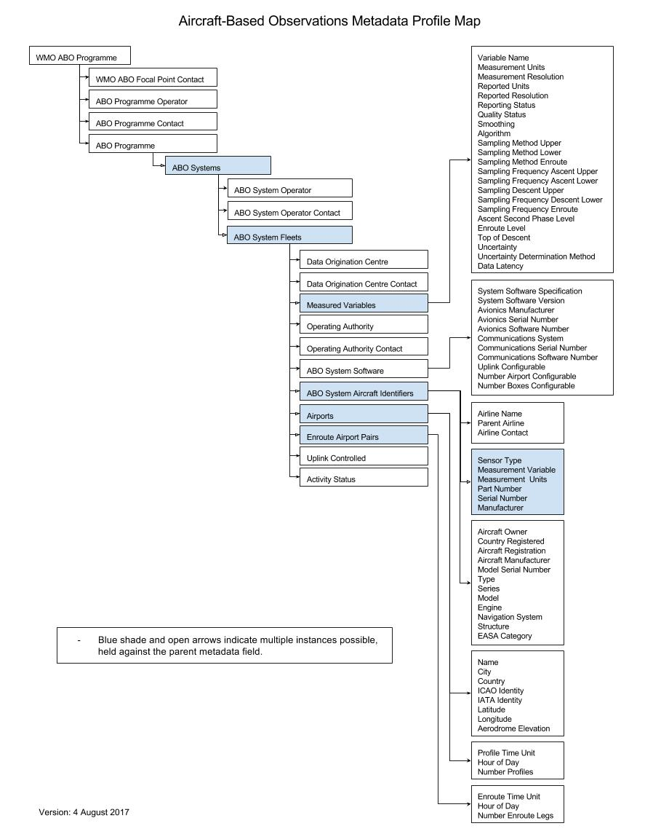

ATTACHMENT D3. FLOW CHART FOR AIRCRAFT-BASED OBSERVATIONS WIGOS STATION IDENTIFIER DESIGNATION

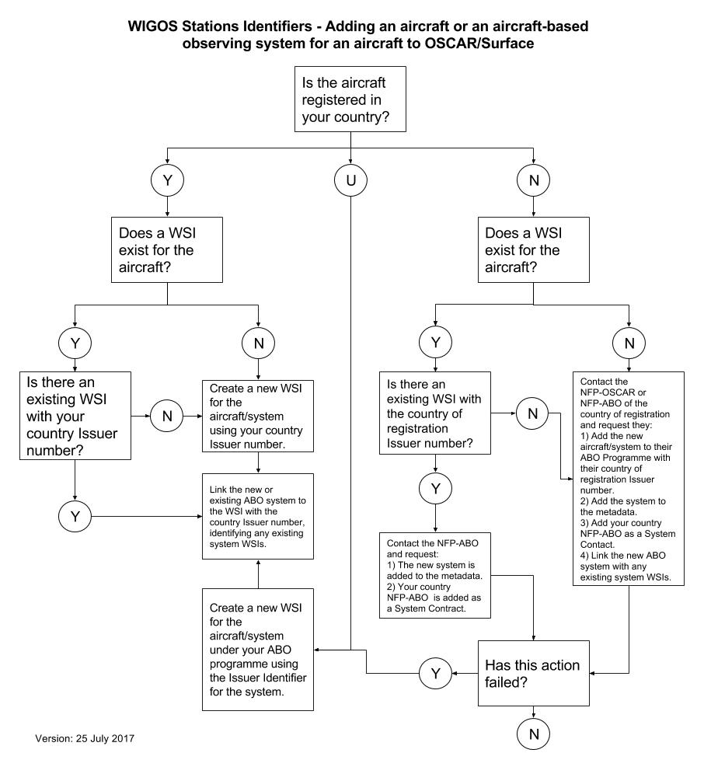

APPENDIX E. GUIDANCE ON AIRCRAFT METEOROLOGICAL DATA RELAY OBSERVING SYSTEM DATA OPTIMIZATION

Background

The aircraft meteorological data relay observing system
Aircraft meteorological data relay predominantly uses the on-board aircraft sensors to measure meteorological information. The resulting data are then transmitted to the ground via VHF or satellite link using the aircraft’s own communications system – ACARS. When the airline receives the data, it sends it on to the respective NMHS where it is processed, checked for quality, distributed on WMO GTS and then incorporated into meteorological applications, including NWP models and forecasts for aviation.
The WMO global AMDAR system, as depicted in Figure A6, now produces over 700 000 high-quality observations per day of air temperature, wind speed and direction, together with the required positional and temporal information and with an increasing number of humidity and turbulence measurements being made.

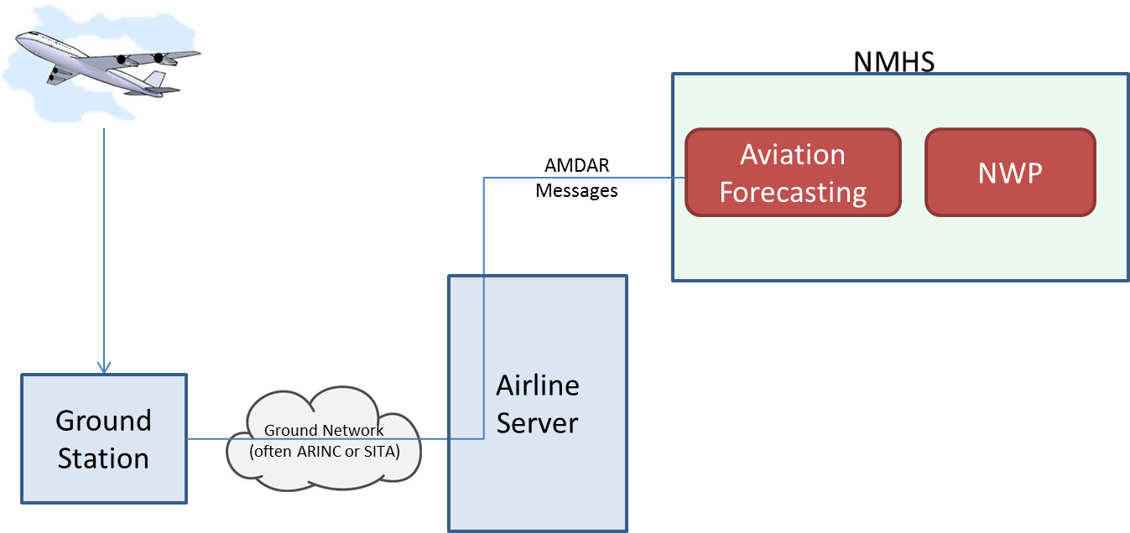
Figure A6. Diagram of a typical non-optimized AMDAR observation system
While the cost per observation is generally lower than for other upper-air measurement systems, for example, the balloon-borne radiosonde measurement system, most AMDAR programmes involve a cost for each observation received by the NMHS. A large component of this cost is associated with the air-to-ground communications that, particularly over remote land and ocean areas, can be significant in a larger programme with a fleet of many aircraft. It becomes a more significant issue still when satellite communications are required to be used (in preference to or in the absence of VHF communications).

Requirements for data

Redundant data
Redundant data are any observations that are surplus to requirements of data users and their applications. Meteorological requirements for upper-air observational data are defined by WMO under its Rolling Review of Requirements process. WMO Members should ensure that they are aware of both national and international requirements of data users for the provision of upper-air data before determining the best methods and configurations for optimization of ABO and AMDAR systems.
Importantly, some data users may actually specify a requirement for what might initially be considered “redundant” data. For example, NWP systems may be advantaged by the provision of one or more additional observations of particular variables at the same point in space and time so as to obtain or allocate a higher degree of certainty to such observations. Consideration of such requirements should also be made.

Data coverage
Data coverage refers to the spatial and temporal distribution of aircraft observations.
For an AMDAR programme producing redundant data, there are two key aspects of data coverage that are required to be specified and controlled:
(a) The temporal and spatial separation of vertical profiles (of meteorological parameters) made on aircraft ascent and descent;
(b) The temporal and spatial separation of isolated reports made during level flight.
The principal aim of an effective ADOS is to enable delivery of output data at sufficient spatial resolution and temporal frequency to satisfy user requirements, without delivering greater volumes than required (redundant data).
One of the challenges is that such requirements may vary with location, local weather situation and season.
Whereas data supply will depend on:
(a) Passenger demand, which affects the number of aircraft that fly to a particular destination and the types of aircraft used;
(b) Airline priorities and agreements made with NMHS for provision of data;
(c) Airport capacity and regulations (for example curfews).
Figure A7 shows modelling based on data from the Australian Bureau of Meteorology. While actual figures for each AMDAR programme will vary, the relationship between AMDAR fleet size and the trends in vertical profile production and redundancy are likely to be similar. The following points are made in relation to this model:
(a) The percentage of redundant profiles increases linearly with the number of non-optimized aircraft (blue line). Based on this and with a fleet of 50 aircraft, approximately one third of the profiles produced are redundant.
(b) The number of redundant profiles (and hence their cost) increases nonlinearly with the number of non-optimized aircraft (red line). Therefore, a greater percentage of a larger number of profiles are redundant. In this particular example, the number of redundant profiles increases as the square of the number of aircraft.
(c) Based on this model and the requirements specified, 50 aircraft would produce approximately 66 000 redundant profiles a year. Assuming a cost of US$ 2 per profile, this leads to an unnecessary and potentially avoidable cost of US$ 132 000 per year in redundant data.
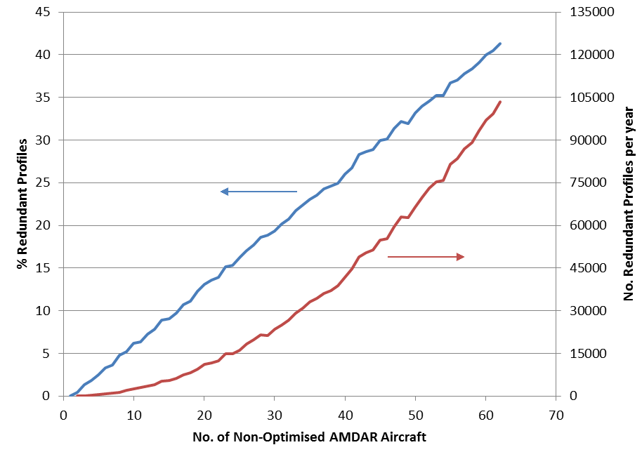
Figure A7. Increase in redundant data with number of aircraft

Optimization methods/strategies

Aircraft meteorological data relay software capabilities
The AOSFRS specifies possible functionality of the AOS that would allow for varying degrees of data optimization, depending on the level of compliance implemented. This includes:
(a) Initiation of AOS configurations to manage:
(i) Production of vertical profile data at a list of airports:
a. With airport-specific profile frequencies;
b. With airport-specific sampling frequencies;
(ii) Production of AMDAR data during the en route phases with aircraft-specific sampling frequencies;
(iii) Production of AMDAR data within geographical boxes;
(iv) Production of AMDAR data within time windows;
(b) Ability to adjust stored configurations both manually and remotely;
(c) Ability to receive and process requests to remotely make changes to the AMDAR reporting configuration, to be effective either permanently or for the current or next flight only.
While use of the stored/default configurations for each aircraft can provide a degree of control over data output and programme optimization, in isolation the aircraft will be unable to respond dynamically to the reporting of observations by other aircraft, which will be variable and changing, being subject to airline operational schedules. For this reason, the ability to make changes to an aircraft configuration, both remotely and automatically, in response to a command request, is required.
Remote changes typically require a formatted command message to be sent to the aircraft using the standard ACARS (data) link. This command is often referred to as an “uplink”.

Aircraft meteorological data relay optimization systems
While it is feasible for some degree of data optimization to be achieved by a person issuing uplink commands in response to changing conditions, the best solution comes from using a ground-based and automated (optimization) system. This allows 24/7 response to changing meteorological requirements for data and aircraft operations and data availability.
The following section outlines the steps such optimization software should ideally implement. The perfect system would be one that has the flexibility to manage all the AMDAR-equipped aircraft available to an NMHS. This allows the best response to changes in weather conditions and demand.
However, it is recognized that in practice, perhaps due to issues of compatibility between the systems used by different airlines, or due to their preferences, an AMDAR optimization system may well have to rely on individual airline-by-airline optimization.

Optimization system processes
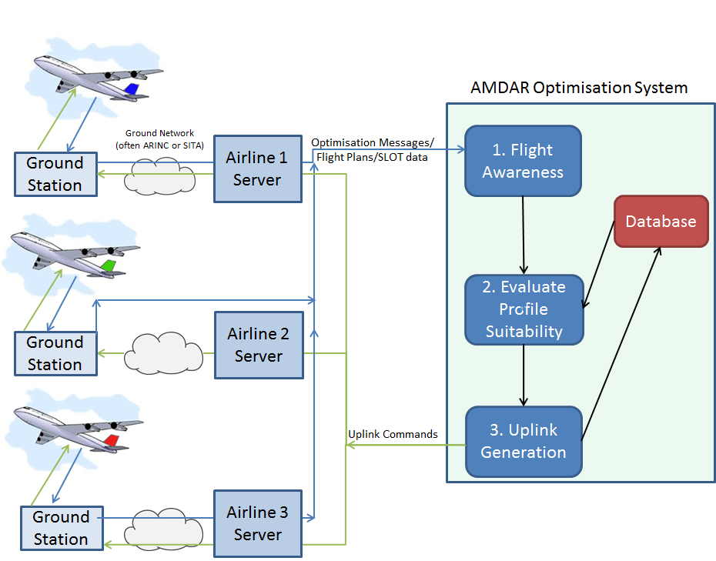
Figure A8. Diagram of a full AMDAR optimization system
A full AMDAR optimization system is depicted in Figure A8. It consists of three main components:
(a) Flight awareness: Before take-off (generally when the aircraft leaves the gate) it sends an optimization message to the AMDAR optimization system. This contains sufficient information for the system to identify the aircraft and the route (origin/destination) involved. Alternatively, the aircraft can be identified from flight plans.
(b) Evaluate profile suitability: Before the aircraft takes off, the optimization system decides what data, if any, is required from this flight.
(c) Uplink generation: Sends the appropriate uplink command to switch on/off data collection during the different flight phases. Even if no data is required from this flight, an uplink command may still be required to override the settings from the previous flight by this aircraft.
These components are described in more detail in Figure A9.

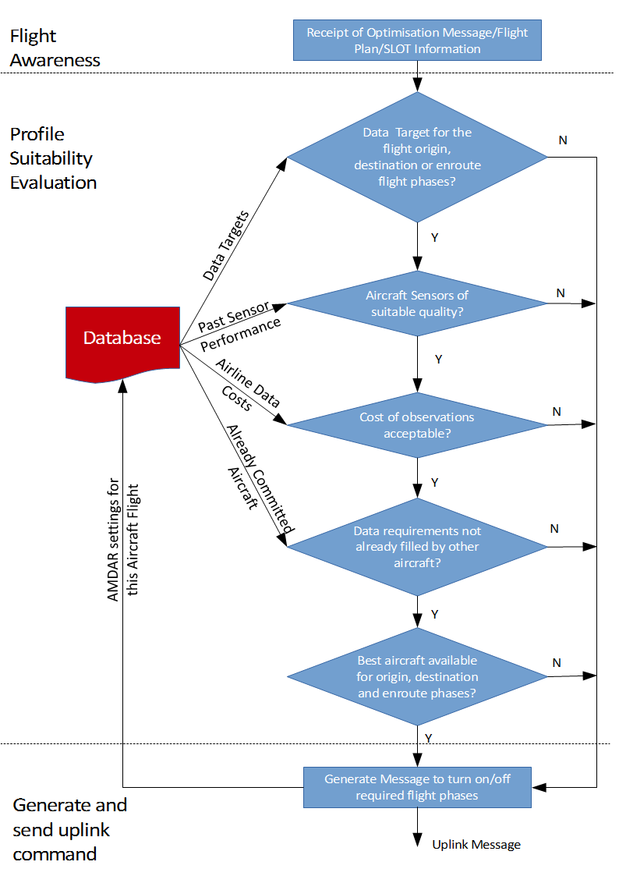
Figure A9. Decision steps for AMDAR optimization processing
Step 1: Flight awareness
The first stage of any optimization is the system “becoming aware” of an AMDAR aircraft flight. This can be the result of the receipt of an optimization message. Alternatively, flight plans can be reviewed to extract the required information.
Whatever the format, the message contains (at a minimum):
– Aircraft identity – either providing or able to be linked to the aircraft call sign (or tail number);
– Flight origin;
– Flight destination;
– Time of departure;
– Time of arrival at destination.
Step 2: Profile suitability evaluation
Once the optimization system is aware of a flight, it must decide if that aircraft meets the requirements or if there is a better flight available. In any case the optimization system must decide which flight phases (if any) shall be configured to report AMDAR data.
The decision to activate or deactivate the AOS for data collection will depend on one or more of the following factors:
– Data requirements:
• From the flight-awareness phase, the flight origin and destination are known. Thus it can be determined where and (an estimate of) when profiles (on aircraft ascent and descent) and the series of en route reports (made between the departure and destination airports) will be generated.
• This potential data availability is then compared to a maintained set or database of rules or targets for AMDAR data collection for a list of airports, areas and routes, which are based on the requirements for upper-air data. Rules may also be dependent on:
o Time of day;
o Season;
o Local weather conditions;
o A preference for ascent profile data over descent;
o A special area or airport configuration;
o A preference for short- or long-haul flights;
o A preference for en route reporting.
– Aircraft reporting and configuration status:
• From the flight-awareness phase the identity of the aircraft is known. This can be used to interrogate an internal NMHS database to determine the status of the aircraft based on available metadata. Factors to be considered include:
o Data quality of reported parameters, such as whether the aircraft has been excluded from reporting based on previous data-quality checks; for example, by comparison to computer-model or radiosonde data;
o The preference of one aircraft over another for the provision of critical parameters; for example, the reporting of humidity or turbulence.
– Aircraft/airline observation cost:
• From the flight-awareness phase the identity of the aircraft is known and can be used to obtain from the database the aircraft- or airline-based cost of the data;
• This can be compared with the costs of any alternative flights for the same time and departure or destination airport and the en route segment.
– Flights already committed by aircraft not configurable by uplink:
• There may already be aircraft committed to providing some or all of the data required for the particular time and flight phases, as offered by the uplink-capable aircraft; while these cannot be changed by the optimization system, they might be taken into consideration if the system is “aware” of their operations;
• An optimization system can be made aware of these flights and their output data from their OOOI/optimization messages, or deduced from received observations if these messages and data are provided to and processed by the optimization system.
– Uplink-capable AMDAR aircraft already committed:
• Many airlines charge a cost for uplink messages. The comparative cost of uplink versus downlink/observation messages determines whether changing an aircraft configuration in flight provides any benefit.
No data may be required from a flight because the AMDAR quota for the origin and destination airports and the route are already filled by flights nearby in time and/or space.
An optimization system may wait to see if a “better” aircraft becomes available (for example, one with a humidity sensor). While changing an aircraft’s configuration during flight is usually possible, the decision on whether an ascent profile is collected needs to be made before the aircraft takes off.
Step 3: Generate and send uplink command
Once the optimization system has decided which flight phases (if any) to activate, the system should generate the necessary uplink message(s) and send it or them automatically.
An uplink message may still be required to turn off flight phases that are activated from previous flights or by default.
Uplink message security
Airlines understandably have security concerns about allowing third parties to directly uplink to their aircraft. As an alternative, the optimization system may send uplink commands to an airline server, where they undergo further checks before being sent to the aircraft. These checks are ideally automated (to save time and allow continuous, unattended operation), but may require additional interfaces to be developed on the airline server.
Airline server checks include:
– Message formatting is correct – parameters are within allowed ranges and there has been no corruption during transmission;
– Message type and content is allowed – only certain types and formats of uplink messages are authorized to be sent by the optimization system; this stops a hacked optimization system having unlimited access to the aircraft;
– Message volumes are within acceptable limits; this stops a malfunctioning (or hacked) optimization system overloading the aircraft uplink.
Optimization system formats
Flight awareness messages
Several formats are currently in use including:
– “Out” message;
– EUMETNET ADOS (E-ADOS) OPS or SLOT format;
– AOSFRS optimization message.

Uplink Messages
Currently a number of different formats for this message are in use. The key difference between the formats is whether the message is:
– Passed unchanged through the airline servers to aircraft (Australian Bureau of Meteorology ADOS, AOFSRS);
– In a format that an airline’s server translates into the appropriate (airline-specific) format (E-ADOS).
A summary of the functional requirements for an AMDAR data optimization system is provided within Table A12. Descriptions of several existing national and regional data optimization systems are given in Attachment E1.

Table A12. ADOS functionality requirements
Component | Functionality | Importance
System user interface | Allow modification of targets for data coverage | Essential
System user interface | Allow NMHS direct access via a graphical user interface | Recommended
System user interface | Allow temporary adjustment of coverage targets for a set period, followed by reversion to a default | Optional
System user interface | Allow maintenance of fleet metadata | Essential
System user interface | Allow configuration for:  - Airports  - Aircraft  - Geographic areas | Essential
System user interface | Allow configuration for routes/airport pairs | Recommended
Database | Store target number of profiles for an airport (e.g., profiles per hour) | Essential
Database | Store target data coverage for routes (i.e., airport pair), e.g., route legs per hour | Recommended
Optimizer | Awareness of future flights with enough lead time to make decisions as to best aircraft configurations to meet targets | Essential
Optimizer | Algorithm to decide which phases of flight (if any) to enable | Essential
Optimizer | Optimization incorporates preferential selection of aircraft based on measurement capabilities | Recommended
Optimizer | Optimization incorporates preferential selection of aircraft based on observations cost | Optional
Optimizer | Optimization incorporates preferential selection of aircraft based on measurement quality status | Recommended
Optimizer | Optimization incorporates preferential selection of aircraft based on estimated time of flight phase | Optional
Optimizer | Reception and analysis of response and non-response to uplink commands | Optional
Optimizer | Reception and analysis of AMDAR data to assess response and non-response to configuration | Optional
Optimizer | Optimization incorporates awareness of AMDAR-equipped aircraft which cannot have their configurations changed by uplink | Optional
Database | Ability to store current aircraft configurations for reference when assessing future flights | Essential
Communications | Ability to send (re)configuration messages to aircraft (possibly via airline server) | Essential
Database | Store data-quality status information for aircraft to assist configuration decisions | Recommended
Database | Store aircraft additional sensor (e.g., water vapour, icing) to assist configuration decisions | Recommended
Database | Store airline/aircraft data cost to assist configuration decisions | Optional

ATTACHMENT E1. AIRCRAFT METEOROLOGICAL DATA RELAY OPTIMIZATION IMPLEMENTATIONS

1. Australian Bureau of Meteorology
The Australian Bureau of Meteorology runs a fully automated ADOS. The screenshot in the figure below following shows the available options for each aircraft, including:
– Sensor quality information for temperature, wind, DEVG (turbulence) and water vapour;
– Aircraft specific rules for:
• Airport;
• Latitude/longitude reporting boxes;
• Reporting times.

This system uses OOOI messages as its flight awareness message and generates an uplink command that is passed unchanged to the aircraft after being checked by the airline’s servers.
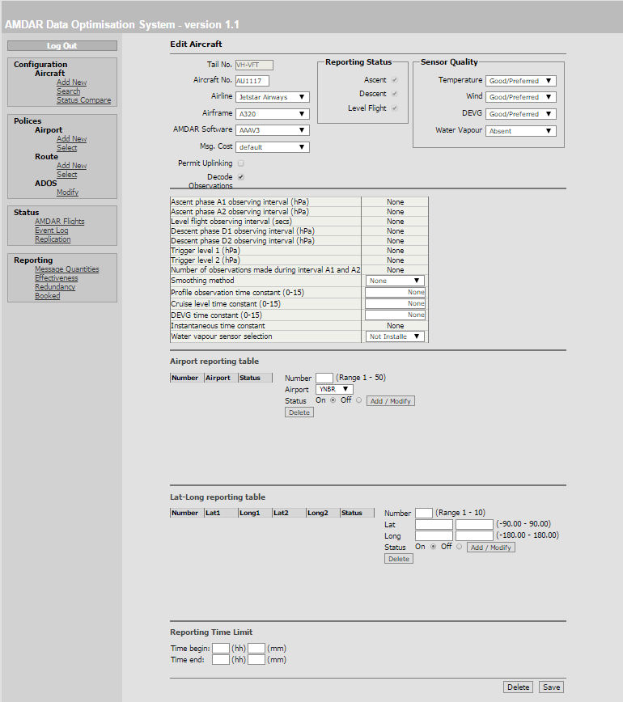
Australian Bureau of Meteorology ADOS system screen shot

2. E-AMDAR
Currently (August 2017), the E-AMDAR programme has a range of optimization options. These include:
– E-ADOS:
• Fully automated and flexible AMDAR optimization;
• Graphical interface allows real configuration;
• Optimization configurations for airports, aircraft, routes and geographic regions in general or for time periods;
• For flight awareness E-ADOS accepts several message formats, including International Air Transport Association (ASM and OOOI) messages;
• Standard format flight awareness and uplink command messages are generated, which each airline then translates or adapts to its own system; alternatively, an uplink command is generated that is passed unchanged to the aircraft after checking by the airline’s servers;
• Supports uplink message formats according to ARINC 620 and AAA V3 specification;
• Airlines:
o Lufthansa;
o Lufthansa Cityline;
o Lufthansa Cargo;
o Germanwings;
o Eurowings Europe;
o Eurowings Germany;
o Thomas Cook Group (Thomas Cook Airlines, Thomas Cook Airlines Scandinavia);
o Finnair;
o Austrian Airlines;
o KLM (B737NG fleet);
o Air France;
o Scandinavian Airlines;
– British Airways flight selection system:
• Optimization rules for each participating airport;
• Aircraft:
o British Airways B747 and B767 fleets;
o British Airways B777 optimized using the flight deck communication function – uses airport elevations to trigger ASC and DES at calculated barometric altitudes;
– ARINC OpCenter:
• Optimization on airport/route pairs;
• Airline:
o EasyJet.

APPENDIX F. GUIDANCE ON AIRCRAFT METEOROLOGICAL DATA RELAY ON-BOARD SOFTWARE DEVELOPMENT

1. INTRODUCTION
This appendix provides brief and general guidance to WMO Members and their partner airlines on the requirements and processes to develop and implement AOS on commercial aircraft fleets. Such development enables on-board atmospheric measurements to be accessible in near-real time for use by NMHSs in NWP and other meteorological forecasting applications for both aviation and the general public. The appendix consists of:
- An overview of the various aircraft and avionics (aviation electronics) platforms and AMDAR applications solutions;
- A simple road map for the process of AOS development and implementation.
General descriptions and information about the AMDAR observing system and its functionality can be found at http://www.wmo.int/pages/prog/www/GOS/ABO/AMDAR/. Specific and detailed requirements for AMDAR on-board functionality are provided by AOSFRS version 1.1 (referenced previously).
Guidance on the wider requirements for implementation and operation of an AMDAR programme is available in Requirements for the Implementation and Operation of an AMDAR Programme, WIGOS Technical Report No. 2014-02 (https://library.wmo.int/pmb_ged/wigos-tr_2014-02_en.pdf).

2. BACKGROUND
Until the middle of the twentieth century, information and data relating to various aspects of aircraft flight operation, performance and navigation were available within the cockpit only as a visual analogue or coarsely digitized displays and gauges. Gradually, the avionics evolved into digitized systems, either receiving digital input or converting the analogue input after reception.
In modern aircraft, the raw measurements of static and total pressure and air temperature are sampled and transmitted to the aircraft data computer where they are corrected, quality controlled and then sent or made available to other avionics units within the aircraft, for example, the flight management system (FMS), via digital connections.
All the flight mechanical and navigation signals as well as all other system data (for example, engine status) are processed digitally. The real-time flight data are of interest to the cockpit crew for a range of purposes associated with flight operation and aircraft performance, and some elements are also of interest to ATM. Whereas the communication of this information during the flight was once done via voice radio, nowadays large volumes of data can be automatically transmitted to ground via ground-based or satellite-borne networks of transceiver stations, or else downloaded on arrival for use by the airline for post-flight analysis.
3. AUTOMATIC AIRCRAFT DATA-PROCESSING AND COMMUNICATIONS SYSTEMS
The first international deployment of an automatic aircraft communications system is the ARINC system solution ACARS. The corresponding equipment on board an aircraft may be called the management unit (MU) or, in the case of newer versions with more functionality, the communications management unit (CMU). Since the late 1990s, Airbus aircraft are equipped with the ATSU system. In addition to the conventional ACARS data and message processing, this system also handles the routing of ATC information.
These avionics units function both as data-acquisition systems and as routers for the processed data.
On some aircraft types (for example, UPS aircraft Boeing B757) the data sampling and processing is carried out by a system called the digital flight data acquisition unit, which sends these data to a separate ACARS unit. Another kind of data acquisition unit is the ACMS. These units are modular in design and transfer their output data to the system component that provides the ACARS downlink communications function.
There are a range of vendors of these avionics systems that include the most common and widespread in deployment, including Teledyne, Rockwell-Collins and Honeywell.
In most cases, the unit’s sampling behaviour is programmable in compliance with special ARINC standards. Key standards include:
– ARINC 618 – air/ground character-oriented protocol specification – which governs the format of user-defined ACARS messages (that is, air to ground);
– ARINC 620 – DGSS/IS - which describes the requirements of the use for sampling activity, frequency and configurability;
– ARINC 429 – digital information transfer system – which describes the data bus used on most commercial aircraft.
Using such functionality, purpose-built applications can be developed for avionics systems to enable the controlled recording and sending of data in real time or based on various triggers, such as time or the value of particular parameters and variables. External and ground-based control of these applications is also possible through the use of uplink commands sent via the communication provider to the on-board ACARS unit or the corresponding data-acquisition unit. In this way, the applications can be reconfigured before or during flight for specified sampling and reporting behaviour during different flight phases.
In the case of AOS, it is the aircraft’s sampled data of the ambient atmosphere that is of interest for meteorological purposes.
4. SPECIAL AMENDMENT OF THE AIRCRAFT COMMUNICATIONS ADDRESSING AND REPORTING SYSTEM FOR METEOROLOGICAL USE
4.1 AIRCRAFT METEOROLOGICAL DATA RELAY ON-BOARD SOFTWARE
In the following description, AOS is referred to as the “AOS module”. It consists of the following components and functionality:
– Accept input data from a variety of aircraft innate avionics equipment;
– Perform high-level quality checks on the input data;
– Perform calculations upon the input data to derive required meteorological parameters (flags and, optionally, turbulence statistics);
– At set intervals, process collected data into standard output messages for transmission to ground stations;
– Accept inputs, allowing users to alter AOS behaviour.
The World Meteorological Organization and its expert teams have historically developed and maintained several standards for AOS functionality and corresponding uplink and downlink formats:
(a) AOSFRS, issued by WMO, an approach for overarching the standards for the aircraft communications systems (http://www.wmo.int/pages/prog/www/GOS/ABO/AMDAR/resources/index_en.html): This specification provides the primary WMO meteorological-based specification for AOS. AOSFRS defines the recommended formats for AMDAR data uplink and downlink for ACARS applications of AOS. This specification will be consistent with and provide the functional requirements for the ARINC 620-8 meteorological report version 6. AOSFRS is published and will be maintained as a CIMO Instruments and Observing Methods technical report.
(b) ARINC 620, issued by AEEC, for applications on ACARS units such as MU or CMU (programmed by Honeywell): This document contains the specifications of the AOS meteorological report (from version 1 through to version 6). Data link formats and flags are also defined. A copy of the latest specification can be purchased from the ARINC Store (http://store.aviation-ia.com/cf/store/).
(c) AAA, once written for applications on Teledyne units. These software applications have been developed by AirDatec and implemented for the fleets of Qantas and Jetstar Airbus, Boeing, South African Airways Airbus and British Airways. The AAA specification series is now superseded by AOSFRS.
The standards provide the specification of requirements for functionality and message formats for the AOS module’s implementation by an avionics applications developer. It is recommended that only the most recent versions of these standards are used as a basis for new and future AOS application solutions using ACARS and alternative or succeeding systems. In particular, AOSFRS provides the full and detailed specification of required functionality for AOS, with version 1.1 being compatible and consistent with version 6 of the meteorological report formats as specified within the ARINC 620-8.
The feasibility of AMDAR implementation, the level of functionality and also the options able to be implemented (humidity, turbulence, event-controlled transmissions, optional parameters for quality control) will heavily depend on the performance and architecture of the avionics.
The figure following provides a schematic and simplified overview of those parts of the avionics infrastructure playing a role in the AOS operation.
The left-hand side of the figure shows the existing avionics system components that continuously generate the input for the AOS, such as:
(a) The air-data computer for the aerodynamic parameters;
(b) The navigation system delivering flight mechanic data and the position.
These data are transmitted to the FMS. Many of the real-time flight operational processes are run in the FMS, for example, the wind calculation.
The parameters listed in the output column of the FMS box in the figure are transmitted to the data acquisition unit running the AOS. On some aircraft types this is the same unit that hosts the data-link functions for ACARS (for example, MU, CMU and ATSU). On other aircraft the AOS may be run on separate data acquisition units, for example, the digital flight data acquisition unit or ACMS.
The parameters FMS 1 to 7 are the conventional set of AMDAR data to be processed by the AOS.
The humidity values are transmitted directly into the AOS unit via an extra ARINC 429 interface driven by the humidity sensor system.
The parameters FMS 8 and 9 are requested by the latest ARINC 620 or AOSFRS versions. These parameters are useful input to nowcasting and NWP respectively.
The parameters FMS 10 to 16 are parameters that are required if the AOS also incorporates the turbulence statistics process.
The parameters FMS 17 to 19 are temporarily of interest for quality control purposes. The activation depends on corresponding uplink commands sent on demand to the aircraft.
Depending on the avionics architecture or the firmware’s dimensioning, the AOS unit can process uplink commands from ACARS.
This unit sends the AMDAR data to ACARS for downlink transmission. It is possible that, in addition to the regular reports, the downlink will also send supplementary reports triggered by intervening turbulence events.

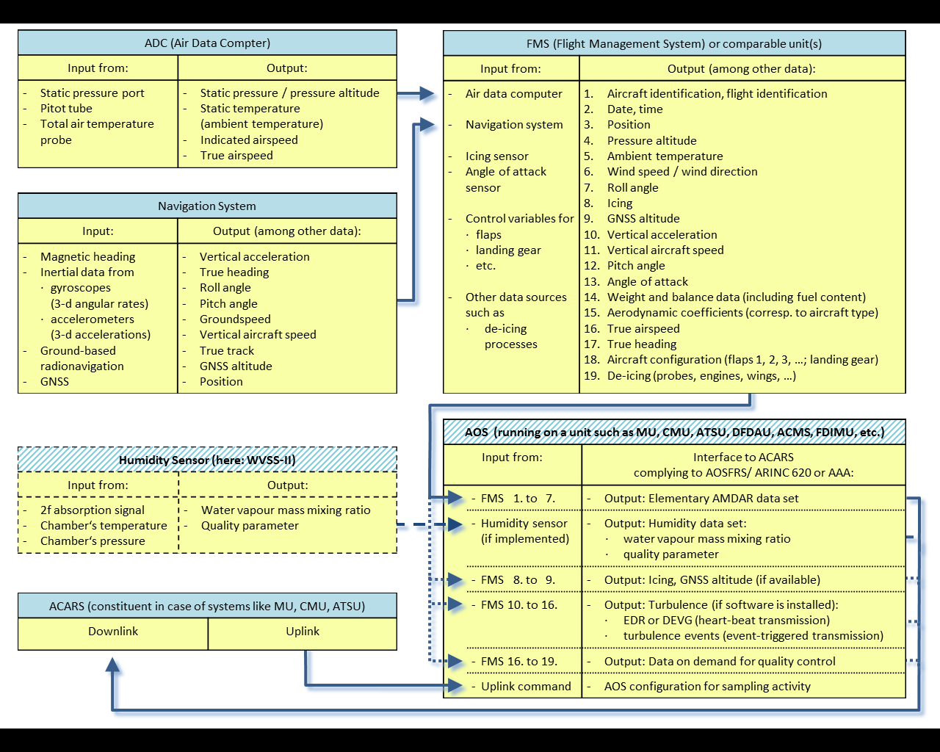 | Schematic view of aircraft information flow  Schematic overview of the information flow on an aircraft from the relevant sensors to the system component where the AOS is running and where the transfer to the downlink process of ACARS takes place.  The table blocks with the hatched title bar describe the parts that do not belong to the standard aircraft equipment.  The dashed and dotted arrows mark the handling of parameters beyond the basic AMDAR dataset. Provision of humidity data depends on the existence of humidity instrumentation and on the implementation of an AOS complying with the latest AOSFRS or ARINC 620 standards.

4.2 DEVELOPMENT AND IMPLEMENTATION OF AIRCRAFT METEOROLOGICAL DATA RELAY ON-BOARD SOFTWARE

4.2.1 Availability of existing AOS modules
In some cases, it may be that an AOS application is already available as an ARINC 620-compliant module (enabling provision of AMDAR reporting via the ARINC 620 meteorological report) within the existing avionics system and the applications suite delivered by the avionics vendor of the prospective airline AMDAR fleet.
Alternatively, it may also be possible that such an application is available but not yet installed within the particular avionics system in question. This has been true of several AMDAR programmes taking advantage of Honeywell systems. Unfortunately however, at the current time this seems to be rare and in most cases a special AOS application development will be necessary, especially in the case that compliance with the latest AOS standards is required.
In addition, an AOS module for the prospective AMDAR airline fleet and its particular avionics configuration may have already been developed and implemented in another AMDAR programme. In which case, it may also be possible to arrange for that AOS to be provided or purchased through negotiation with either the relevant airline or avionics vendor.
However, care should be taken to ascertain if the existing AOS module provides the required functionality for the new or prospective AMDAR programme. Additionally, it is often the case that an AOS module that functions correctly on one airline fleet may not do the same on another, even if the avionics systems are the same, due to differences in configuration and other factors. Therefore, ground-based and in-flight testing of all AOS modules, whether new or ported from another development, should be undertaken and it should be understood that there may be a requirement for some reprogramming and/or reconfiguration of the AOS module by a developer.

4.2.2 Development of AOS modules
The development of AOS applications for the relevant avionics equipment of an airline can be done in one of several possible ways:
– The corresponding avionics vendor;
– By a suitably qualified and certified third-party contractor;
– By a specialized department of the airline itself.
In most cases, the airline will make the decision about which of these possible solutions for AOS development is appropriate and/or permissible. The cost of AOS implementation is outlined in Requirements for the Implementation and Operation of an AMDAR Programme, WIGOS Technical Report No. 2014-02. Depending on the circumstances ranging from readily installable routines to the necessity of a completely new software development, the costs might range anywhere between $ 10 000 and $ 100 000.

4.2.3 Process to achieve AOS implementation
The organizational project framework for the software implementation is given in Requirements for the Implementation and Operation of an AMDAR Programme, WIGOS Technical Report No. 2014-02, 5.3 – AMDAR onboard software development and implementation.
However, the required meteorological functionalities are to be programmed in compliance with or at least following the latest releases of AOSFRS and/or ARINC 620.

4.2.4 Decision concerning the commercial structure of the AMDAR programme
Decisions are required in conjunction with the contract partners concerning the topology of the AMDAR programme and related systems. The NMHS or the regional AMDAR programme must decide whether the individual airlines or the network provider will be the contract partner. As a consequence, the path of the downlinked meteorological data to the principal data-processing system either goes through the airline’s communication centre or directly via the network provider.
In both cases, the cooperation of the partner airlines is required.
Two factors have to be cleared with the airline either directly or by the contracted network provider:
(a) The possibility of an AOS implementation (possibly including humidity and turbulence);
(b) The legal framework of the AMDAR data use (the owner of the data being the airline).

4.2.5 The AOS design or preparation
The airline is responsible and has the authority to address requirements for configuration of the avionics system and ACARS functionality and will decide if the communication system may be modified. Some airlines are able to perform software modifications or configurations themselves, but in most cases the avionics vendor or another system integration partner will be required to configure and install software on the avionics units of the aircraft that host the data acquisition and ACARS components. Final success will likely depend on several elements:
(a) Performance of the AOS host avionics unit;
(b) The possibility to port already available or existing AOS to the host unit;
(c) Resource and finance requirements to support software certification that might be necessary if the AOS interacts with system components that are relevant to aircraft security or air traffic services communication.
It should be noted that, apart from the application for monitoring turbulence, all AMDAR parameters and their processing for reporting via the AOS are independent of the aircraft type. The ability to report these parameters depends only on their availability via interfaces to the AOS host unit.
However, for the monitoring of turbulence by the AOS, there is a requirement to configure and tune the turbulence application for some coefficients that will have dependency on the aircraft type. This means a requirement for some software configuration for each aircraft type in the AMDAR fleet.
Depending on the various factors associated with the feasibility, viability and price of the programme implementation, including technical capability and compatibility of the AOS hosting units, the NMHS or regional AMDAR programme will need to work with the airline to make a decision on whether or not to proceed with the development.

4.2.6 Testing of the AOS
The elementary precondition for this test is the correct operation of the ground systems doing both:
– The separation of the meteorological data from the downlinked ACARS reports;
– The meteorological data transmission to the NMHS or regional programme.
The AOS prototype implementation has to be tested during the normal flight operation over several months. The data analysis has to take into consideration data plausibility, outliers and deviations of the meteorological parameters from the first-guess background of models.
The turbulence measurement part of the AOS needs test flights for each different type of aircraft. The sampled data need to be analysed offline by specialists who derive the correct coefficients to be applied for the aerodynamically different aircraft.

4.2.7 Final implementation of the AOS
In the case of AOS without turbulence, part the implementation consists of identical software installations on the appropriate family of hosting units of the fleet. In the case where the AOS also covers turbulence, part the installations need different modules depending on the aircraft type.
However, the realization of AMDAR software implementations always depends on the cooperation of the partner airline. They need to see the advantages of the outcomes for improved weather forecasts as well as the improved quality control possible for the on-board instruments.

4.3 GROUND COMPONENT OF AIRCRAFT METEOROLOGICAL DATA RELAY SOFTWARE
While not strictly part of the AOS, any development needs to consider the ground software systems that have the job of converting AMDAR data and controlling the AOS activity. Currently there is no international standard for this, with many different implementations in use around the world.
Two main considerations are:
– Conversion/decoding of downlinked data;
– Optimization of AMDAR data collection.

4.3.1 Converter for downlinked data
The meteorological data sent to the ground have to be picked out of the ACARS downlink data stream and sent to the corresponding NMHS or the data-management centre of the regional AMDAR programme. This diverting job can either been done by:
– The contracted airline as being the proper receiver of the data;
– (By agreement with the airline directly) the broadcasting network service provider such as ARINC or SITA;
– By the receiving NMHS.
In any of these scenarios it is necessary to implement or at least configure software systems for that data-diverting job.

4.3.2 Ground-based optimization and AOS control
Ideally the AOS should be controllable via ACARS uplinks, as this can provide a significant operating cost reduction by limiting redundant data. For example, within a region like central Europe there are a large number of AMDAR-configured aircraft. Over the frequented air traffic hubs the problem of costly redundancies from too many ascent and descent profiles has to be considered. Via an optimizing tool controlled by a ground based system, reporting can be activated or deactivated to optimally meet meteorological requirements for the production of profiles and possibly en route data in both time and space.
The AOS features to be uplink configurable should be:
– Data production and reporting during selected flight phases;
– Modification of configurable software settings and parameters affecting the reporting regime;
– Addition or removal of optionally reported flight operations parameters for quality control purposes.
The detailed requirements for the uplinks are given by ARINC 620 and AOSFRS. An overview of the systems already in existence for optimization and AOS control has been provided in Appendix E.

APPENDIX G. GENERAL TERMS AND CONDITIONS FOR HOSTING A WMO REGIONAL WORKSHOP ON AIRCRAFT METEOROLOGICAL DATA RELAY

(a) The workshop will usually be held in the location and country of a WMO Member that has a strong interest and commitment to the development of an AMDAR programme and where such development will advance the global AMDAR programme. The workshop will usually be of a duration of 1–2 days.
(b) One or more national airlines from the host country must be represented at the workshop.
(c) There should be at least three or four other regional Members represented at the workshop and, for most of those, national airline representatives should also be in attendance.
(d) The host will be responsible for:
(i) Providing a suitable conference venue with audiovisual equipment for the workshop;
(ii) Organization of all associated local logistical requirements, including information for participants on local arrangements, identification of suitable hotels and any requirements for interpretation and language translation;
(iii) Invitation of other regional stakeholders, except those under (e)(iii);
(iv) Unless otherwise agreed with WMO, the costs associated with the above items.
(e) WMO will be responsible for:
(i) The workshop programme and agenda, in consultation with the host and regional Members;
(ii) The provision of presenters, teaching experts and educational material;
(iii) Invitation of Members of the region/subregion;
(iv) Unless otherwise agreed, the costs associated with the above items, including travel of experts.
(f) Regional participating Members will be responsible for:
(i) The costs associated with the attendance of their respective experts at the workshop;
(ii) Invitation and any agreed or required costs of national airline representatives to attend the workshop.
(g) WMO must be advised of the request to host a workshop by official correspondence from the host Permanent Representative to WMO, preferably six months before the expected date of the workshop.
(h) A letter of agreement between WMO and the workshop host with the agreed terms and conditions for hosting the workshop will be provided by WMO and will be required to be signed by the candidate host.

Note that, in the case of some regions and areas, particularly in the case of developing and least developed countries, the costs associated with the hosting of the workshop (that is, the costs detailed in (d), above) might also be borne by WMO

APPENDIX H. LIST OF AIRCRAFT-BASED OBSERVATIONS AND AIRCRAFT METEOROLOGICAL DATA RELAY TECHNICAL AND SCIENTIFIC PUBLICATIONS AND REFERENCES

WMO Manuals
– Manual on the WMO Integrated Global Observing System (WMO-No. 1160)
– Manual on the WMO Information System (WMO-No. 1060)
– Manual on the Global Observing System (WMO-No. 544), Volume I – Global Aspects; Volume II – Regional Aspects
– Aircraft Meteorological Data Relay (AMDAR) Reference Manual (WMO-No. 958)
– Manual on the Global Telecommunication System (WMO-No. 386)
– Manual on the Global Data-processing and Forecasting System (WMO-No. 485), Volume I – Global Aspects; Volume II – Regional Aspects

WMO Guides
– Guide to the WMO Integrated Global Observing System (WMO-No. 1165; in preparation)
– Guide to the Global Observing System (WMO-No. 488)
– Guide to Meteorological Instruments and Methods of Observation (WMO-No. 8)

Standards
– AMDAR On-board Software Functional Requirements Specification, Version 1.1, WMO CIMO, Instruments and Observing Methods Report No. 115
– ARINC Specification 620-8 Data Link Ground System Standard and Interface Specification (DGSS/IS) (meteorological report), https://store.aviation-ia.com/cf/store/catalog_detail.cfm?item_id=2388
Technical reports
– The Benefits of AMDAR Data to Meteorology and Aviation, WIGOS Technical Report No. 2014-01
– Requirements for the Implementation and Operation of an AMDAR Programme, WIGOS Technical Report No. 2014-02
– Impact and Benefits of AMDAR Temperature, Wind and Moisture Observations in Operational Weather Forecasting, WIGOS Technical Report No. 2015-01
– Currently Developing and Future Communications and Technology Impact on AMDAR, WMO CIMO, Instruments and Observing Methods Report No. 123
– AMDAR Benefits to the Air Transport Industry, WIGOS Technical Report No. 2016-01
– AMDAR Coverage and Targeting for Future Airline Recruitment (in AMDAR data-sparse regions) (2013), https://www.wmo.int/pages/prog/www/GOS/ABO/AMDAR/resources/AMDAR_Coverage_Recruitment_Study.html

Publications

AMDAR data-impact studies
Andersson, E., C. Cardinali, B. Truscott and T. Hovberg, 2005: High-frequency AMDAR data – a European aircraft data collection trial and impact assessment. European Centre for Medium-range Weather Forecasts, Technical Memorandum 457.
Cardinali, C., L. Isaksen and E. Andersson, 2003: Use and impact of automated aircraft data in a global 4DVAR data assimilation system. Monthly Weather Review, 131:1865–1877.
Baker, R., R. Curtis, D. Helms, A. Homans and B. Ford, 2011: Studies of the effectiveness of the water vapor sensing system, WVSS-II, in supporting airline operations and improved air traffic capacity. Presented at the Second Aviation, Range and Aerospace Meteorology Special Symposium on Weather – Air Traffic Management Integration, Seattle, WA, 22–27 January. American Meteorological Society.
Eyre, J. and R. Reid, 2014: Cost-benefit studies of observing systems. Forecasting Research Technical Report No. 593. Exeter, United Kingdom, Met Office.
Moninger, W.R., R.D. Mamrosh and P.M. Pauley, 2003: Automated meteorological reports from commercial aircraft. Bulletin of the American Meteorological Society, 84:203–2016.
Petersen, R.A., 2004: Impact of AMDAR data on numerical prediction models. In: Proceedings of the Third WMO Workshop on the Impact of various Observing Systems on Numerical Weather Prediction (WMO/TD-No. 1228). Geneva.
Petersen, R.A., 2016: On the impact and future benefits of AMDAR observations in operational forecasts – Part 1: A Review of the impact of automated aircraft wind and temperature reports. Bulletin of the American Meteorological Society, 97:585–602.
Petersen, R.A., L. Cronce, R. Mamrosh, R. Baker, and P. Pauley, 2016: On the impact and future benefits of AMDAR observations in operational forecasting – Part II: Water vapour observations. Bulletin of the American Meteorological Society, 97:2117–2133.

Scientific publications on AMDAR
Drüe, C., W. Frei, A. Hoff and Th. Hauf, 2008: Aircraft type-specific errors in AMDAR weather reports from commercial aircraft. Quarterly Journal of the Royal Meteorological Society, 134(630):229–239.
Fleming, J.R., 1996: The use of commercial aircraft as platforms for environmental measurements. Bulletin of the American Meteorological Society, 77:2229–2242.
Freming, R.J., D.R. Gallant, W. Feltz, J.G. Meitin, W.R. Moninger, S.F. Williams and R.T. Baker, 2002: Water Vapor Profiles from Commercial Aircraft. University Corporation for Atmospheric Research/NOAA Report No. NA17GP1376.
Helms D., A. Hoff, H.G.J. Smit, S. Taylor, S. Carlberg and M. Berechree, 2010: Advancements in the AMDAR humidity sensing. Presented at the WMO Technical Conference on Meteorological and Environmental Instruments and Methods of Observation, Helsinki, 30 August–1 September, session 2.
Hoff, A., 2009: WVSS-II Assessment at the DWD. Deutscher Wetterdienst/German Meteorological Service Climate Chamber of the Meteorological Observatory Lindenberg. Offenbach.
Isaksen, L., D. Vasiljevic, R. Dee and S Healy, 2012: Bias correction of aircraft data implemented in November 2011. European Centre for Medium-range Weather Forecasts Newsletter, Spring:6.
Petersen R.A. and L. Cronce, 2014: Automated meteorological reports from commercial aircraft: improving weather forecasts and aviation safety and efficiency. In: Proceedings of the Eighteenth Air Transport Research Society World Conference, Bordeaux, France, 17–20 July, Volume 1:1331–1355.
Sparkman, J.K., J. Giraytys and G.J. Smidt, 1981: ASDAR: A[n] FGGE real-time data collection system. Bulletin of the American Meteorological Society, 62:394–400.
Vance, A.K., S.J. Abel, R.J. Cotton and A.M. Woolley, 2014: Performance of WVSS-II hygrometers on the FAAM research aircraft. Atmospheric Measurement Techniques, 7:8643–8667.
Vance, A.K., A. Woolley, R. Cotton, K. Turnbull, S. Abel and C. Harlow, 2011: Final Report on the WVSS-II Sensors Fitted to the FAAM BAe 146. Exeter, Met Office.

General AMDAR references
Grooters, A.T.F, 2008: Aircraft observations. WMO Bulletin, 57(1).
Stickland J.J. and A.T.F. Grooters, 2005: Observations from the global AMDAR programme. Presented at the WMO Technical Conference on Meteorological and Environmental Instruments and Methods of Observation, Bucharest, 4–7 May, session 2.

Eyre, J. and R. Reid, 2014: Cost-benefit studies for observing systems, Forecasting Research Technical Report No. 593, Exeter, United Kingdom of Great Britain and Northern Ireland, Met Office.
http://www.wmo.int/pages/prog/www/GOS/ABO/data/ABO_Benefits.html.
http://www.wmo.int/pages/prog/www/OSY/GOS-RRR.html.
Vertical resolution of around 100 metres in the lower troposphere (to 700 hPa) and temporal resolution of up to approximately one profile per hour depending on fleet size and configuration for reporting and AMDAR fleet traffic at individual airports.
A vertical profile consists of single-level observations at regular intervals during the ascent and descent phases, grouped together to generate atmospheric profiles.
Specific requirements may deviate from these observation frequencies (NWP or budgetary limitations may require 15-minute intervals).
The Water Vapor Sensing System version II (WVSS-II) (SpectraSensors Inc., United States) is a specialized sensor designed for use in aviation that has undergone extensive testing and operational evaluation by WMO Member NMHSs and is currently the only sensor deemed to be capable of meeting operational and performance requirements for use with AMDAR (see AOSFRS version 1.1 (referenced previously), Appendix C2 – Atmospheric water vapour content).
ICAO, 2011: Manual of Aeronautical Meteorological Practice, Document 8896 AN/893, Montréal, 7 – Aircarft observations and reports.
ICAO, 2007: Meteorological Service for International Air Navigation, Annex 3 to the Convention on International Civil Aviation, Montréal, 5 – Aircraft observations and reports.
https://www.skybrary.aero/index.php/Pilot_Report_(PIREP).
http://www.srh.noaa.gov/msd/sram/directives/10-804.pdf.
https://www.faa.gov/air_traffic/publications/media/aim_basic_4-03-14.pdf.
https://www.wmo.int/cpdb/.
https://library.wmo.int/pmb_ged/iom_114.pdf.
https://store.aviation-ia.com/cf/store/catalog_detail.cfm?item_id=2388.
http://www.wmo.int/pages/prog/www/GOS/ABO/AMDAR/resources/index_en.html.
http://www.wmo.int/pages/prog/www/GOS/ABO/AMDAR/resources/AMDAR_Coverage_Recruitment_Study.html.
Business case templates are available at http://www.wmo.int/pages/prog/www/GOS/ABO/AMDAR/resources/AMDAR_Business_Case_Resources.html.
http://www.eumetnet.eu/.
http://www.wmo.int/pages/prog/www/GOS/ABO/AMDAR/resources/index_en.html.
Although a new operational system has recently been developed based on the low earth orbiting satellite system IRIDIUM and may also be an optional consideration.
James, E.P. and S.G. Benjamin, 2017: Observation system experiments with the hourly updating rapid refress model using GSI hybrid ensemble–variational data assimilation. Monthly Weather Review, 145:2897–2918.
Ingleby, B., 2016: Extra aircraft data including humidity: ECMWF evaluation of quality and impact. Presented at the ninty-sixth American Meteorological Society Annual Meeting, New Orleans, 9–14 January.
Message switching is a network switching technique in which data is routed in its entirety from the source node to the destination node.
http://www.wmo.int/pages/prog/www/GOS/ABO/index_en.html.
http://www.wmo.int/pages/prog/www/GOS/ABO/AMDAR/index_en.html.
https://sites.google.com/a/wmo.int/amdar-projects-and-collaboration/email-groups/newsletters-and-news.
http://mode-s.knmi.nl/documents/EUMETNET_ADD_Report_FINAL_v1.0_03102015.pdf.
https://en.wikipedia.org/wiki/Automatic_Dependent_Surveillance-Broadcast_-_Relationship_to_Addressed_ADS.
http://www.skybrary.aero/index.php/Transponder.
See also de Haan, S., 2014: Availability and Quality of Mode-S MRAR (BDS4.4) in the MUAC Area: A First Study, Royal Netherlands Meteorological Institute Internal Report IR 2014-01, http://mode-s.knmi.nl/documents/IR-2014-01.pdf.
https://www.eurocontrol.int/sites/default/files/publication/files/mode-s-harmonisation-of-the-transition-arrangements-for-state-ed-1.0-20050114.pdf.
http://www.airdat.com/tamdar/tamdar.php.
Gao, F., X. Zhang, N.A. Jacobs, X. Huang, X. Zhang and P.P. Childs, 2012: Estimation of TAMDAR observational error and assimilation experiments, Weather Forecasting, 27:856–877.
http://flyht.com/products/.
http://www.iagos.org/.
http://www.igas-project.org/index.php/ProjectInfo/ProjectInformation.
http://www.wmo.int/pages/prog/arep/gaw/gaw_home_en.html.
http://www.caribic-atmospheric.com/.
http://www.wmo.int/pages/prog/www/DPS/Monitoring-home/mon-procedures.htm.
AOSFRS version 1.1 (referenced previously).
See note 1 to the table in Attachment C1.
Pressure altitude is a measure of height relative to the standard datum pane of 1 013.25 hPa (see Manual on Codes (WMO-No. 306), Vol I.1, Part A – Alphanumeric codes). In fact, pressure altitude is the indicated height with an altimeter setting of 1 013.25 hPa according to the International Standard Atmosphere (as defined in ISO 2533:1975). The International Standard Atmosphere assumes a linear decrease in temperature with height of 6.5 °C per kilometre up to 11 kilometres, and a mean sea-level temperature and pressure of 15 °C and 1 013.25 hPa, respectively. From 11 to 20 kilometres the temperature is assumed constant at -56.5 °C. Because the variable flight level equals pressure altitude, altitude may also be reported as flight level. Note that for observations below the level of 1 013.25 hPa, pressure altitude or flight level shall be reported as negative values.
BUFR template or common sequences [3 11 008] and [3 11 009] (aircraft ascent/descent profile) may be used for reporting AMDAR profiles. However, it is recommended to report sets of single-level observations according to BUFR template [3 11 010] (BUFR template for AMDAR, version 7).
TAC code formats FM41 and FM42 are considered obsolete from 11 November 2014 and thus, when this transition is complete, it should be expected that all ABO bulletins use only the BUFR code format with T₁T₂ = IU.
ICAO, 2014: Manual on Coordination between Air Traffic Services, Aeronautical Information Services and Aeronautical Meteorological Services. Standard: ICAO 9377, 2.2.
de Haan, S., L.J. Bailey and J.E. Konnen, 2013: Quality assessment of automatic dependent surveillance contract (ADS-C) wind and temperature observation from commercial aircraft. Atmospheric Measurement Techniques, 6:199–206.
de Haan, S., M. de Haij and J. Sondij, 2013: The use of a commercial ADS-B receiver to derive upper-air wind and temperature observations from Mode-S EHS information in the Netherlands. Technical Report TR-336. Koninklijk Nederlands Meteorologisch Instituut.
http://www.wmo.int/pages/prog/www/OSY/Meetings/AMDAR-DM-Workshop-2012/DocPlan.html.
http://www.wmo.int/amdar.
The WMO AMDAR Observing System: Benefits to airlines and aviation, http://www.wmo.int/pages/prog/www/GOS/ABO/AMDAR/documents/JN14991_amdar_foldout_080914_en.pdf.
http://www.wmo.int/pages/prog/www/OSY/GOS-RRR.html.
“Out” of the gate, “off” the ground, “on” the ground, “into” the gate, collectively known as OOOI messages, are transmitted automatically by aircraft systems to the ground station. These are used by the airline industry to track the status of aircraft.
E-ADOS general task description, v1.8, 29 October 2014, Deutscher Wetterdienst.
AOSFRS latest version is available at the WMO AMDAR Observing System Resources site: http://www.wmo.int/pages/prog/www/GOS/ABO/AMDAR/resources/index_en.html#amdar_stds.
See also http://www.wmo.int/pages/prog/www/GOS/ABO/AMDAR/resources/ABO_Papers_References.html.

