|  |  |
| --- | --- |
| **World Meteorological Organization**  **Inter-Commission Coordination Group On WIGOS/Task Team on WIGOS Metadata**  **Sixth Session** Zurich, Switzerland, 27-29 November 2017 | **TT-WMD-6/Doc.4.6** |
| Submitted by: Tony Boston  19.11.2017  **Version 2** |

# 

# WMO Hydrological OBSERVING SYSTEM (WHOS) and OSCAR/Surface

(Submitted by Tony Boston)

|  |
| --- |
| **Feedback from hydrological community on WHOS implementation and sharing of hydrological metadata with OSCAR/Surface** |

**Action proposed**

1. Test automated machine-to-machine provision of WIGOS metadata from WHOS to OSCAR/Surface.
2. Consider if any changes are required to WIGOS Metadata Standard to incorporate hydrological metadata suggested by the Arctic-HYCOS project or the hydrological community.

**References:**

1. WMO Hydrological Observing System (WHOS). CHy-15 pre-session. <http://www.whycos.org/wordpress/?page_id=896>
2. Chy-15 Doc 4.1(3) Data Operations and Exchange. <http://meetings.wmo.int/CHy-15/_layouts/15/WopiFrame.aspx?sourcedoc=/CHy-15/English/2.%20PROVISIONAL%20REPORT%20(Approved%20documents)/CHy-15-d04-1(3)-DATA-OPERATIONS-MANAGEMENT-AND-EXCHANGE-approved_en.docx&action=default>
3. WMO Hydrological Observing System (WHOS). <http://www.wmo.int/pages/prog/hwrp/chy/whos/index.php>
4. First Session of CHy Advisory Working Group - AWG 1. <http://www.wmo.int/pages/prog/hwrp/chy/chy15/awg-1.php>
5. Arctic-HYCOS project. <http://www.whycos.org/whycos/projects/under-implementation/arctic-hycos>
6. jOAI Overview. <https://uc.dls.ucar.edu/joai/>

____________

**4.6.1 Overview**

4.6.1.1 Easy access to near real-time and historical hydrological data from around the world has been a goal of the hydrological and water resources community for more than two decades. In early 2013, in response to questions raised by the Inter-Commission Group on the WMO Integrated Global Observing System (ICG-WIGOS) regarding the availability of hydrological observations, the president of the Commission for Hydrology (CHy) proposed the development of a WMO Hydrological Observing System (WHOS) as the hydrological component of WIGOS1.

4.6.1.2 At the Commission for Hydrology (CHy) 15th session meeting in December 2016, in resolution 4.1(3)/1, CHy approved **“**the further implementation of WHOS Phase I as well as the initial concept of WHOS Phase II, …, and requested the AWG, with the support of the WMO Secretariat, develop an initial implementation plan, covering issues such as governance, architecture, relationships with the WIGOS and WIS centres, provision of metadata into OSCAR and a clear definition of the roles of CHy, the Secretariat, the global data centres, and the NMHSs, to be presented to EC-70 in 2018 for its endorsement”.2

4.6.1.3 Chy-15 also requested that the CHy Advisory Working Group (AWG) “engage with the Commission for Basic Systems to ensure that Phase 2 of the WHOS is fully aligned with the WIS 2.0 Strategy”.2

**4.6.2 WHOS IMPLEMENTATIOn**

4.6.2.1 WHOS was conceived as the hydrological input to WIGOS to be implemented in two phases, a short-term capability to access the hydrological data of NMHSs that are already freely and openly available online, launched as a demonstration in July 20153, and a longer-term capability that is WIGOS and WIS compliant and makes use of a hydrological information system enabling data registration, data discovery, and data access.

4.6.2.2 In resolution 8/1, CHy-15 approved the work programme and structure of the Commission of Hydrology for the 2017-20 period. The Measurement, Monitoring and Infosystems focus area of the AWG has been tasked with further development of WHOS.

4.6.2.3 In February-March 2017 the CHy AWG held its first session meeting4 at which its workplans were further developed and refined. WHOS developments, through the Measurement, Monitoring and Infosystems focus area, will include “implementation of WHOS phase II, offering standardized web services, data hosting, archival, data rescue and dissemination, and relevant training, based upon data policies and adopted standards, and provision of support to the HydroHub functions related to WHOS”.4

4.6.2.4 WHOS milestones from the AWG workplan include:

1. Establish user requirements [data providers and data consumers] (September 2017)
2. Definition of WHOS architecture (December 2017)
3. Implementation Plan Development, draft Plan presented to EC-70 (June 2018)
4. Develop new Statement Of Guidance (SOG) and requirements (Q1 2018)

4.6.2.5 Beyond these milestones, next steps in WHOS implementation will include piloting software at NMHSs around the globe, as well as training and communications programs for WMO members regarding WHOS.

4.6.2.6 User requirements and a systems architecture for WHOS [milestones a) and b) above] are almost complete. WHOS can be deﬁned as a collection of components which work together to store, index, access and distribute hydrological information. The system contains servers, catalogs and applications which communicate with one another through a set of web services. Web services are the set of protocols and speciﬁed functions that exchange hydrological metadata and data through the web using a common standardized language. In particular, WHOS is built around seven fundamental components: (1) data, (2) format, (3) service, (4) mediator, (5) broker, (6) ontology and (7) client.

4.6.2.7 WHOS components enable the implementation of service providers and service consumers. Although service consumers directly connect to service providers to request and receive data, the WHOS components also enable service registries to facilitate the discovery of different service providers; this can be done using various keywords, metadata and ﬁlters. As service providers introduce their services within WHOS, services are registered at the service registry. Service consumers can then search the registry to ﬁnd available services of interest.

4.6.2.8 The individual components of WHOS each serve an important role in the data discovery and fetching process. Data providers are the principal locations for storing large volumes of hydrological data, speciﬁcally time series. Within the provider itself, data and metadata are managed in a database and then exposed through its principal GISC as well as through a suite of web services so that remote users can access the data through the web.

4.6.2.9 Standard formats for hydrological data sharing developed by the WMO/OGC Hydrology Domain Working Group have been approved by OGC and adopted by WMO. These include WaterML2 Parts 1 and 2 which were adopted at Chy-152 and CBS-16. WHOS will make use of these standards in the exchange of hydrological data.

4.6.2.10 WHOS will support exchange of hydrological data at local, national, regional and global levels. It will be able to support federated services at all or any of these levels, for example a within country federation of states or provinces sharing hydrological data to provide a national view, or a regional association of countries sharing data for a transboundary hydrological basin. Ultimately it is envisaged that WHOS will provide a global federated system for hydrological data sharing as shown in Figure 1.

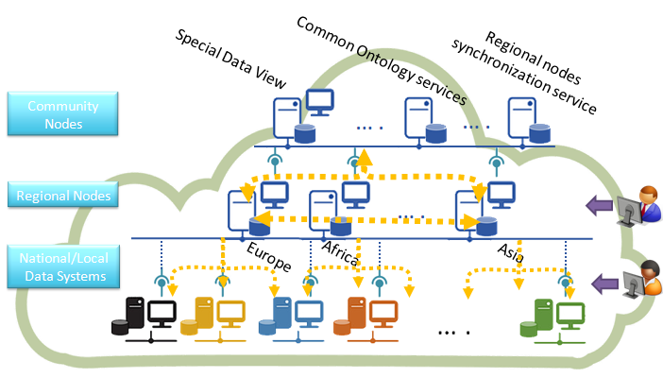

**Figure 1 – Federation of global hydrological data**

**4.6.3 WHOS and OSCAR/SURFACE**

4.6.3.1 At the 17th session of the CBS Management Group in February-March 2017, CBS support for “CHy Advisory Working Group (AWG) in the planning and implementation of WHOS, especially links to WIGOS, WIS and OSCAR”4 was requested.

4.6.3.2 Support for the WIGOS metadata profile is being implemented within WHOS and testing of the provision of metadata from installations of WHOS to OSCAR/Surface needs to be carried out.

4.6.3.3 WHOS will use of the Open Archives Initiative Protocol for Metadata Harvesting (OAI-PMH) interface to provide access to its metadata which can be encoded as Dublin Core, ISO 19139 (XML encoding of ISO 19115) or in the WIGOS metadata standard. Several WHOS implementations are ready to be tested with provision of metadata to OSCAR/Surface via OAI-PMH or other machine-to-machine interfaces. Figure 2 shows a WHOS OAI-PMH service being harvested using the jOAI client6.

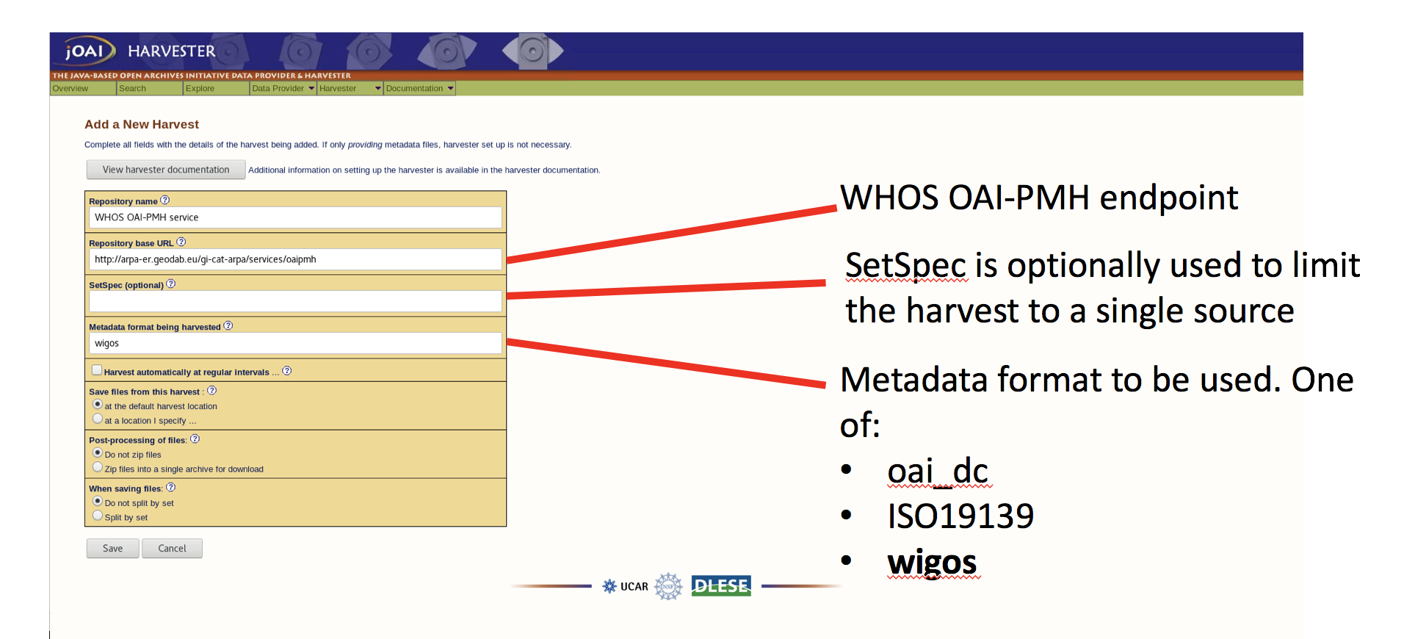

**Figure 2 – jOAI Harvester configuration**

4.6.3.4 The Arctic-HYCOS 4th Project Steering Committee meeting held in October 2017 discussed priority hydrological metadata for WIGOS OSCAR/Surface. The Arctic-HYCOS project5 is finalizing a list of attributes which could be taken into account for hydrological purposes – this document will be provided to TT-WMD in the near future.

# __________