World Meteorological Organization  Inter-Commission Coordination Group On WIGOS/Task Team on WIGOS Metadata  Sixth Session  Zurich, Switzerland, 27-29 November 2017 | TT-WMD-6/Doc.7.2
Submitted by:
Jörg Klausen
23.11.2017
Version 1

fUNCTIONALITIES OF THE oscar/surface MACHINE-TO-mACHINE iNTERFACE

(Submitted by Jörg Klausen)

Requirements and current status of implementation of the API (application programming interface) of OSCAR/Surface

Action proposed

- Review WMD XML schema and communicate issues to OSCAR/Surface project team
- Test automated machine-to-machine provision of WIGOS metadata to OSCAR/Surface.

References:
- Release candidates of WMD UML model and XML schema, including supporting documentation
http://schemas.wmo.int/wmdr/1.0RC6
- Test release of OSCAR/Surface API REST endpoint for upload of WMD records
https://oscardevt.meteoswiss.ch/surface/index.html#/m2m

____________

7.2.1 Overview
7.2.1.1 OSCAR/Surface is a web-based client-server application built following a service-oriented architecture (SOA) model. This means that all actions that can be performed using the graphical user interface (GUI) are translated into http requests that are self-contained. These requests use a REST API and are machine-accessible.
7.2.1.2 A specific REST API endpoint is being developed to allow upload and interpretation of full and partial WIGOS metadata records encoded as XML files to the database supporting OSCAR/Surface. A first test interface has been made available in October 2017.
7.2.1.3 The API provided by OSCAR/Surface will allow machines to execute queries to obtain WIGOS metadata, including full WMD records.

7.2.2 WIGOS metadata uml Model and XML Schema
7.2.2.1 The UML model is developed and maintained using Enterprise Architect 13. Tagged versions of the model are published to http://schemas.wmo.int/wmdr. Figure 1 shows the current version 1.0RC6 of the model. The UML model is expressed as a GML 3.3 XML schema for practical use.
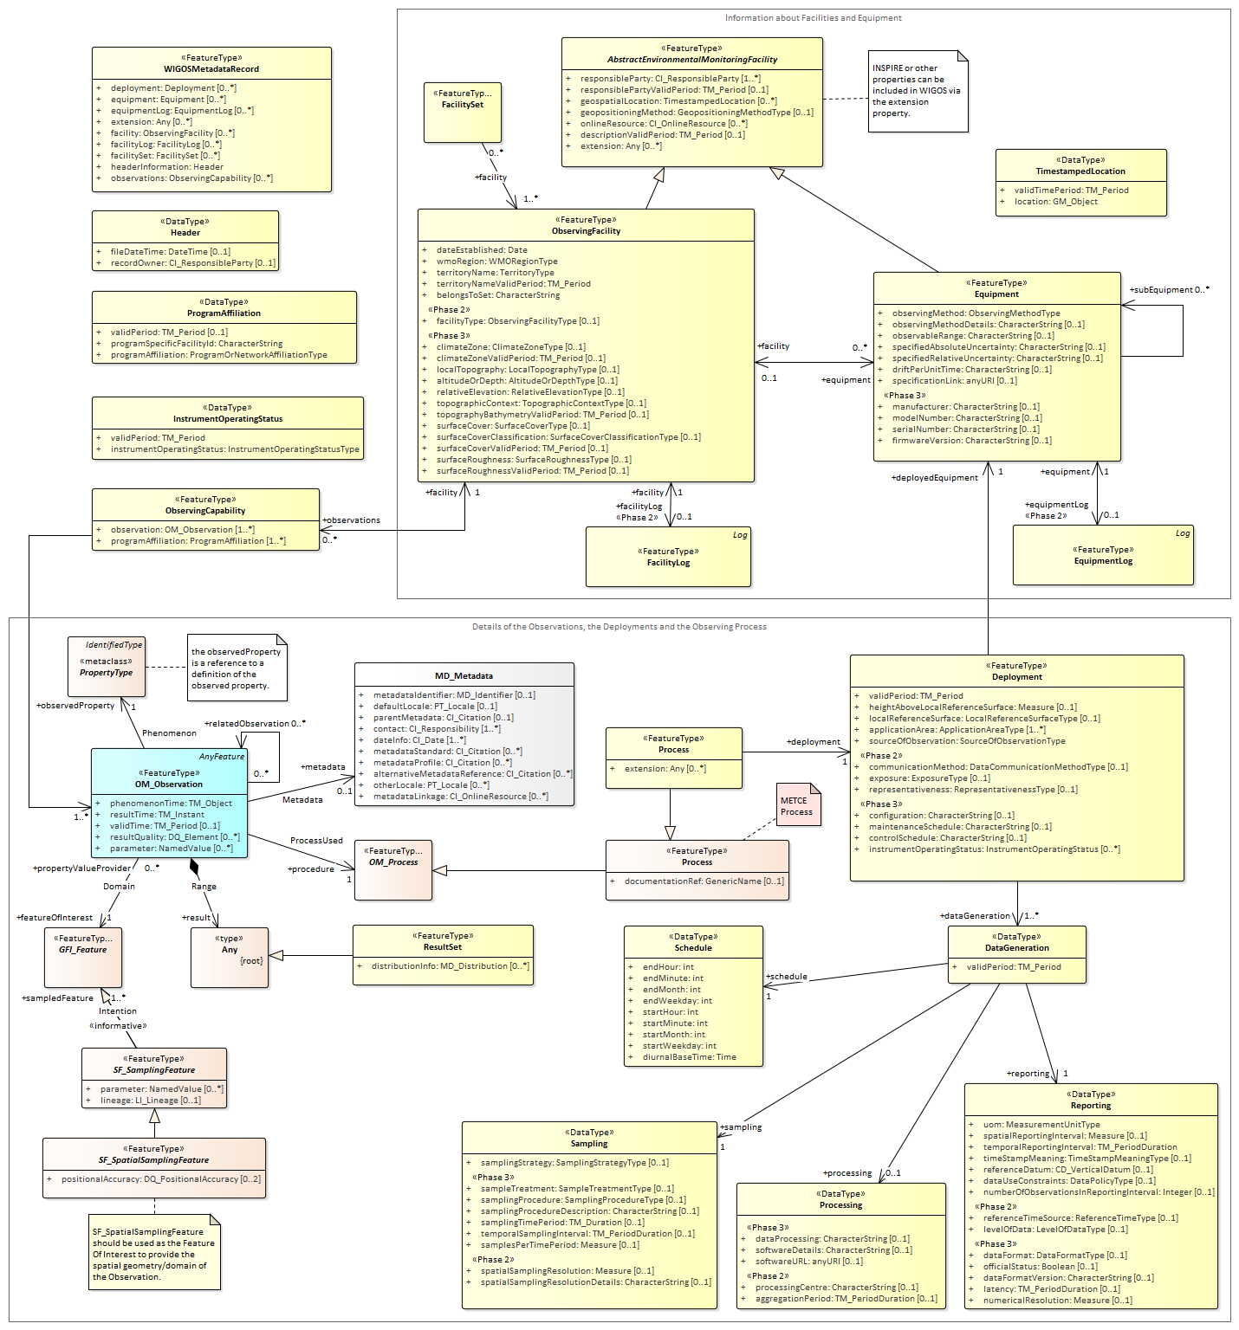
Figure 1 – UML model for WIGOS metadata representation
(source: http://schemas.wmo.int/wmdr/1.0RC6)

7.2.3 requirements for machine-to-machine interface
7.2.3.1 Business processes to be supported include
_.1.1 The applications OSCAR/Surface and GAWSIS are able to accept and generate WMDR XML records (files) via an API.
_.1.2 The applications OSCAR/Surface and GAWSIS are able to process parameterized queries and to return metadata information contained in the database that can be consumed by other systems via an API.
_.1.3 External systems providing WMDR XML for update of metadata information are able to authenticate themselves and be authorized based on their role in the application.
7.2.3.2 Functional Requirements
ID | Description | Weighting*
R1 | The system must allow upload of full or partial WMD XML records (files). The API will determine if the update involved is creating a station or updating an existing one.  Note: The WMDR schema allows several stations to be documented in one file (cf. R7). | M
R2 | The system must be able to validate and parse the WMD XML, i.e., to map objects generated from XML to GAWSIS/OSCAR classes (~45 classes) and compare element-by-element to insert/update the database | M
R3 | The system must be able to log parsing and logic errors for clients in order to convert system exceptions to human understandble error messages | M
R4 | The system could provide a messaging-based queue for asynchronous XML parsing (allows parallel, throttled processing of requests) | C1
R6 | The API must provide endpoints for queries returning information held in OSCAR | M
R7 | The API should support batch changes to the metadata | C2
*Weighting: M=must haves, C=can haves with prioritization 1-3, in which 1=high priority

7.2.4 status of machine-to-machine interface for WMD upload
7.2.4.1 A first test interface has been made available in October 2017 (Figure 2). The interface is meant to be used by NMHSs and other selected partners willing to upload XML examples of various complexity. For the OSCAR/Surface development team, such tests are indispensable in developing the business logic (parser and DB transactions) needed to correctly safe metadata elements delivered in the XML file.
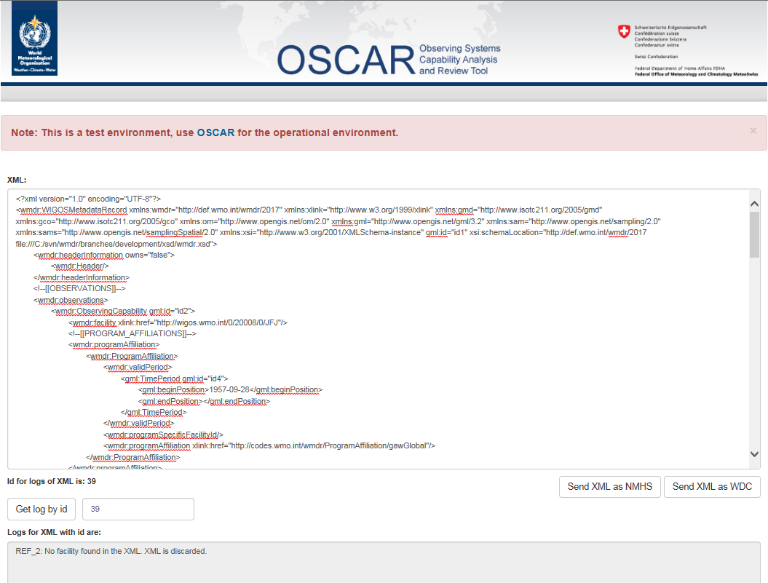
Figure 2 – Screenshot of initial web interface for test uploads of WMD encoded in XML
[In the example, observations were documented without proper reference to the facility concerned. Such XML file may be well-formed and even valid, but the parser will reject it.]
7.2.4.2 The Web Application Description Language (WADL) of the application can be found under following URL:
https://[Environment_URL]/surface/rest/api?_wadl
e.g. https://oscardevt.meteoswiss.ch/surface/rest/api?_wadl

The endpoints that are relevant for treatment of WIGOS metadata are under <resource path="/wmd">.
- <resource path="/upload/nmhs">
  - Upload XML as a National Meteorological Hydrological Service (NMHS).
- <resource path="/upload/wdcs">
  - Upload XML as World Data Centres (WDCs).
- <resource path="/get-log/{xmlId}">
  - Retrieve parsing logs after XML ID returned by /nmhs and /wdcs endpoints.
At this stage, these endpoints work without authentication. In the production system, the same security architecture as used elsewhere in the application will be used.
7.2.4.3 The current timeline for further development and deployment of this interface is as follows:
- Service release 1.3.1 (patch): beginning of Dec 2017
- Testing by selected users, identification of issues: Dec 2017-Feb 2018
- Updates of UML model and XML schema to 1.0: Jan 2018-Mar 2018
- Release 1.4.0: mid May 2018 (depends on outcome of testing activities)

__________

