World Meteorological Organization  Inter-Commission Coordination Group On WIGOS/Task Team on WIGOS Metadata  Sixth Session  Zurich, Switzerland, 27-29 November 2017 | TT-WMD-6/Doc.7.1
Submitted by:
Secretariat
22.11.2017
Version 3

OSCAR/SURFACE
Operational status and change requests tables

/ 7.1

(Submitted by Jörg Klausen)

Summary and purpose of document

OSCAR/Surface has been operationalized on 2 May 2016 and has been available since then at https://oscar.wmo.int/surface. OSCAR/Surface contains observational metadata of the GOS, the GAW (and affiliated programs), JCOMMOPS and the WMO Radar DB. OSCAR/Surface has replaced the former Pub 9 Vol A, but a flat file of similar format is being generated daily for the time being. At present, data updates are only possible online through the GUI of the application. Therefore, not all information is up-to-date.

Action proposed

TT-WMD-6 is requested to take note of the document.

References:
- OSCAR google analytics
- MeteoSwiss ticketing system

____________
7.1.1 Introduction
The Observing Systems Capability Analysis and Review (OSCAR) platform is the authoritative repository of WIGOS metadata and an implementation of the WMDS. OSCAR/Surface, operated by MeteoSwiss on behalf of WMO, addresses all surface-based observations from land, air and oceans. OSCAR/Surface contains an instrument catalogue (not fully populated at present) to describe how observations are obtained, and supports the CIMO siting classification. Importantly, OSCAR/Surface replaces WMO Publication 9, Volume A as the operational source of information on surface and radio-sounding stations. The OSCAR/Surface component is a modern, web-based client-server application with extended information search, filtering and mapping capabilities including a fully developed management console to add and edit observational metadata. In addition, an application programming interface API REST endpoint prototype has been developed to allow machine-to-machine metadata exchange for bulk updates. This API endpoint utilizes the version 1.0RC6 ISO/OGC-compliant XML schema for the WMDS (available at http://schemas.wmo.int/wmdr/1.0RC6).
7.1.2 Operational STATUS

The OSCAR/Surface application is a web-based reference implementation of the WIGOS Metadata Standard as approved by WMO Cg-17. It consists of a public part and a management console only accessible after login. Depending on the role, logged-in users are able to change and expand the information on record for different platforms/stations (observing facilities).

OSCAR/Surface is supported by the MeteoSwiss operational services unit. A ticketing system has been established that allows users to provide “feedback” and to also ask for “support”. Other statistics can be derived by analyzing the audit trail of the application.
7.1.2.1 Tickets

A total of around 228 tickets (61% “support”, 39% “feedback”) have been opened so far. Issues addressed range from registration and login problems to inquiries about application functionalities and difficulties in updating or correcting station metadata. Currently 35 tickets are still open: 13 are in progress and 22 are pending (i.e., awaiting user response). Resolution time depends heavily on the type of issue with a median of 22 days so far. It was only of 6 days in 2016 and this increase can be partly explained by the increase of users and thus the increase of requests. Simple requests that can be managed by the MeteoSwiss team are usually resolved within a week. More complex inquiries i.e. requiring changes in the OSCAR database can be closed on average within three weeks.

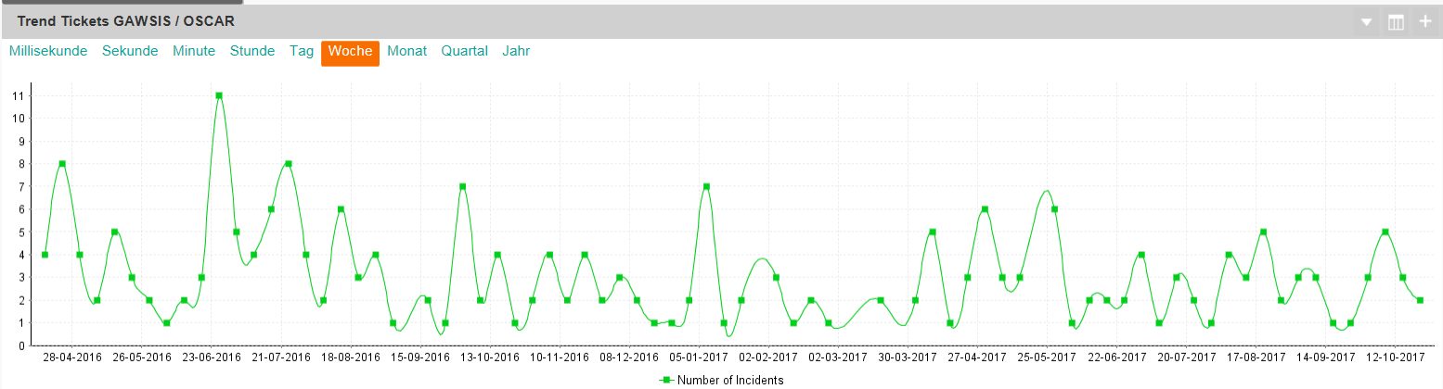
Figure 1a – Number of submitted tickets per week from start of operations
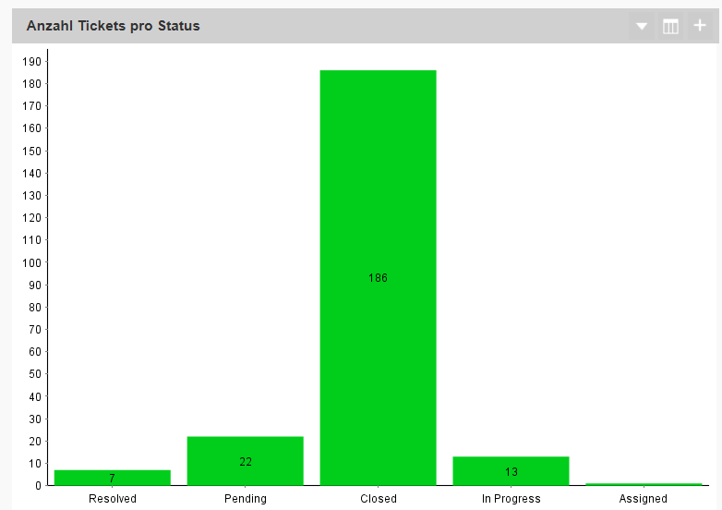
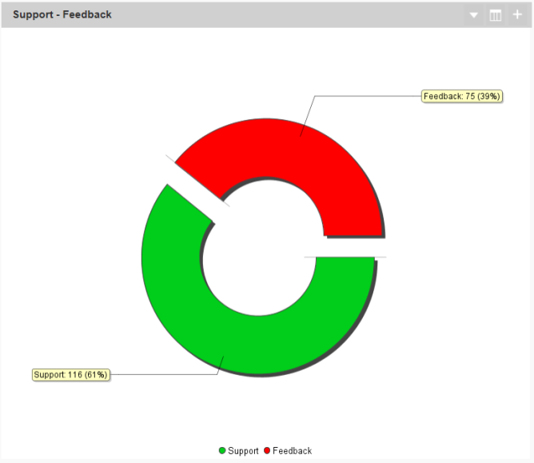
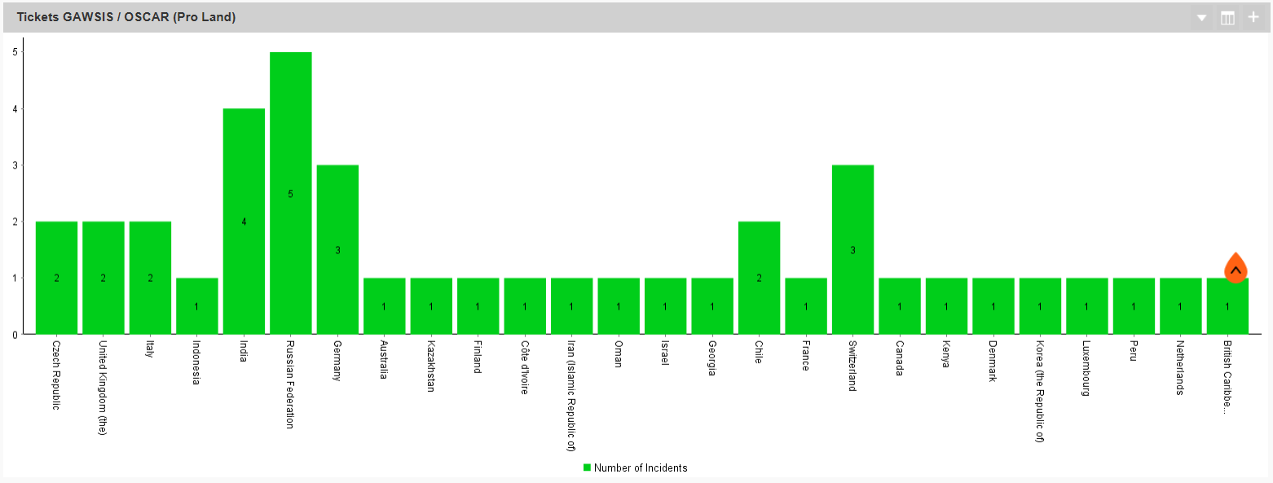
Figure 1b – GAWSIS-OSACR tickets statistics.
7.1.2.2 Usage of applications
a) Number of unique users that logged in and registered/edited a station or registered/edited a contact (incl. admins):
- 2016-2017: 124
b) Number of stations that have been created/edited at least once (excluding SQL updates, incl. updates by admins):
- 2016: 744
- 2017: 1079
The Annex 1 contains additional statistics on the usage of the application.

7.1.2.3 Geographical distribution and number of sessions

Figure 2 shows the global distribution of access to the application. While the distribution appears heavily skewed, it is comforting to note that the application has already reached global use. Some new countries start to use the application this year. Only very few countries remain from where no traffic has been recorded up to now.

As of 1 November 2017, a total of ca. 22’698 sessions have been opened by 7’924 users. The number of sessions has triple compare to last year (7’727 sessions). The number of users of the application has increased of around 63 % in comparison to 2016. Figure 3 provides these figures and the daily evolution since May 2016
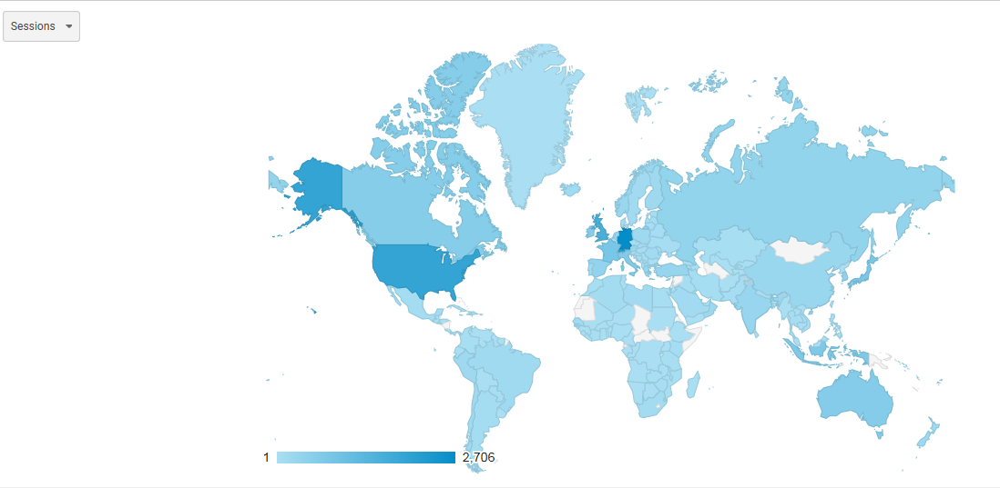
Figure 2. Global distribution of sessions of OSCAR/Surface according to Google Analytics (as per 02.11.2017)

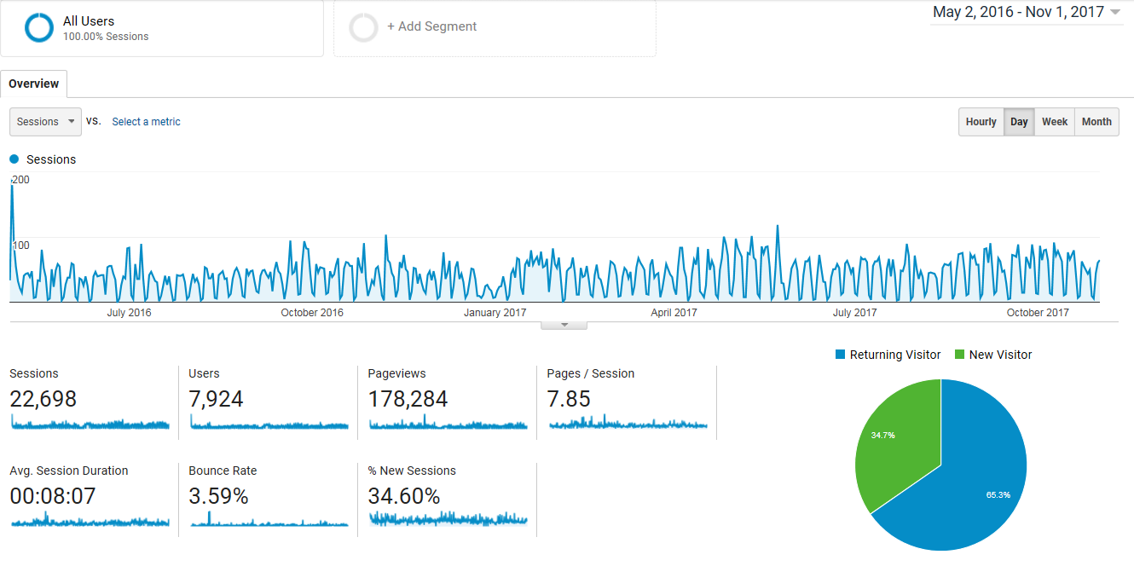
Figure 3. Statistics overview of the application use

    - Actual performance of stations from WDQMS
Goal: The actual performance of stations available in the WDQMS should be provided to OSCAR/Surface, so that it can be compared to the status of the instrument documented in the application OSCAR/Surface*.
Needs: The exact requirements needed to communicate the real status of an observation (i.e. observed variable with a specific instrument) in OSCAR/Surface must be defined and listed.
*Used instrument status in OSCAR/Surface DB:
- Operational. The instrument is declared operational and subject to routine maintenance
- Testing. The instrument is deployed for testing purposes and the information provided may not be reliable
- Not in service / inactive. The instrument is deployed but presently not in service

_______________

Annex 1

