World Meteorological Organization  Inter-Commission Coordination Group On WIGOS/Task Team on WIGOS Metadata  Sixth Session  Zurich, Switzerland, 27-29 November 2017 | TT-WMD-6/Doc. 4.7
Submitted by:
the Secretariat
24.Nov.2017
Version 1

AMDAR / AGENDA ITEM 4.7

(Submitted by the Secretariat)

Summary and purpose of document

This document provides information on the development of the metadata framework for aircraft-based observations and the AMDAR observing system within the WIGOS Metadata Standards and describes its implementation in OSCAR/Surface.

Action proposed

The meeting is invited to consider the information in the document, discuss its content and consider the recommendations made and relevant follow up actions.

References:
- Annex 1 – WMO No. 1200, Guide to Aircraft-based Observations, Appendix D, Guidance on Aircraft-based Observations Metadata Maintenance and Provision

____________

1.1 Background
1.1.1 Over the past two years, the CBS Expert Team on Aircraft-Based Observing Systems (ET-ABO) has been developing the Guide to Aircraft-based Observations as a formal WMO WIGOS guide that has now been approved for publication by the 69th Session of the Executive Council (EC-69) based on recommendation by CBS (CBS-16). The guide, WMO No. 1200 is expected to be published either later in 2017 or early 2018.
1.1.2 As a significant component of the work of the sub-group of ET-ABO responsible for the guide, this includes Appendix D, Guidance on Aircraft-based Observations Metadata Maintenance and Provision, which is included in this document as Annex 1.
1.1.3 Over 2016 and 2017, the WIGOS Project Office and the OSCAR/Surface development team have been working together with the Observing Systems Division and ET-ABO to apply the ABO metadata framework for the development of an interface for the provision and management of ABO metadata with OSCAR/Surface. This interface along with the machine-to-machine interface, is expected to become operational in 2018.
1.2 aircraft-based obserations metadata and development of the aircraft-based observings system metadata interface in oscar
1.2.1 Attachment D1 of Appendix D (Annex 1), provides the full specification of ABO metadata elements, including their description and mapping to the MDS. Attachment D2 provides a hierarchical depiction of the metadata profile for ABO, which has been used as a basis for the development of the ABO metadata interface in OSCAR/Surface. The body of Attachment D1 describes the ABO metadata profile in detail and how the various elements are used to define the Aircraft-Based Observing System (ABOS) within OSCAR/Surface. The ABOS incorporates all aircraft-based observing system types which provide ABO data on the GTS, including AMDAR, AIREP, ADS-C, TAMDAR and IAGOS.
1.2.2 Given that the ABO OSCAR/Surface interface will not be operational until after the publication of WMO No. 1200, it is envisaged that there will later be a requirement to develop additional, more detailed guidance to support the processes and procedures for the provision of ABO metadata by Members to OSCAR/Surface, including both the use of the OSCAR/Surface interface and its machine-to-machine interface.
1.2.3 Some important aspects of the guidance on ABO metadata within WMO No. 1200 are the following:
- The guidance and the interface have been developed so as to support the expression of ABO metadata through means of 3 OSCAR station types, namely: aircraft, airports and fleets. These stations each have related metadata elements which together define the reporting of ABO as mobile platforms that produce both vertical profiles and en-route observations and will allow the ABOS OSCAR observing system capabilities to be determined based on defined algorithms.
- The specification for the utilisation and derivation of WIGOS Station Identifiers (SIs) allows for multiple SIs to be associated with individual aircraft platforms that have multiple ABO systems. However, the specification seeks to minimise the production of ABOS SIs in the future through the concept of a Primary WIGOS SI, that is usually associated with the country in which the aircraft is registered. This process is described in Appendix D and represented by the flow diagram shown in Attachment D3.
1.3 Recommendations
The following recommendations are made:
- The task team might consider the proposed use of WIGOS IDs for ABO and whether there are wider implications for standardisation of this aspect across OSCAR/Surface; and
- The task team might consider and provide feedback to ET-ABO on requirements for guidance on the use of OSCAR/Surface and whether these should be consolidated in one area of the Guide to WIGOS or whether ET-ABO should develop such guidance within WMO No. 1200.

__________

Annex 1

APPENDIX D. GUIDANCE ON AIRCRAFT-BASED OBSERVATIONS METADATA MAINTENANCE AND PROVISION

Background
Obtention, maintenance and international provision of ABO metadata supports the following primary functions in the operation of ABO observing systems:
– Ongoing and historical documentation by Members of the platforms (aircraft), systems (for example, AMDAR and ADS-C) and sensors (for example, total air temperature probes) that contribute to observing system observations;
– Definition of the capabilities of the observing system in terms of various fundamental aspects, which include uncertainty, spatial and temporal resolution or coverage, latency and reporting frequency;
– Provision of additional information about the observing system, including:
• The variables observed;
• The purpose of the observation and the networks and applications for which they are intended to contribute;
• The environment in which the observations are made and their representativeness;
• The methods of observation employed;
• The way in which the measurements are sampled and processed;
• Data ownership and policy;
• Contact details of operators, authorities, data owners, and the like.
ABO metadata consists of three basic types:
(1) Metadata about aircraft platforms and associated observational practices to be obtained, maintained and retained by Members;
(2) Metadata about aircraft platforms and observational practices to be provided to and maintained by WMO;
(3) Metadata about ABO that should be maintained and provided with observational data.
Metadata type 1 would consist of all data within type 2 plus the additional national metadata that is not required to be exchanged.
Metadata type 2 consists of those metadata required to be exchanged by WMO Members to fulfil the requirements and provisions relating to WIGOS.
Metadata type 3 can be described as the additional data that provides further information about required observational variables. For example, the roll angle flag can be considered metadata for the AMDAR wind direction and speed variables, as it provides information about the quality of the wind measurement.
The present appendix is chiefly concerned with the first two types of metadata.

Requirements for metadata
The regulations for maintenance and provision of metadata for WIGOS observing systems are defined within the Manual on WMO Integrated Global Observing System (WMO-No. 1160), 2.5 – Observational metadata.
The requirements for ABO metadata are based upon the WIGOS Metadata Standard, which is defined in the WIGOS Metadata Standard (WMO-No. 1192), edition 2017.

WMO Integrated Global Observing System metadata profile
The WIGOS Metadata Standard provides a framework to define and ensure the availability of all required metadata to ensure maximum usefulness of WIGOS observations in support of all WIGOS observing system data users and WMO application areas.
The WIGOS Metadata Standard, published in July 2017, contains information regarding the primary categories that have been approved to provide a framework for the specification of a metadata profile for ABO.
The WIGOS Metadata Standard makes provision for the following primary categories of metadata:
– Observed variable;
– Purpose of observation;
– Station/platform;
– Environment;
– Instruments and methods of observation;
– Sampling;
– Data processing and reporting;
– Data quality;
– Ownership and data policy;
– Contact;
– A full set of metadata elements that will map to the ABO metadata elements: the current mapping from the WIGOS Metadata Standard to the ABO metadata is provided in the first column of the table within Attachment D1.

Requirements for ABO metadata
The requirements for and applications of ABO metadata envisaged initially were identified under the WIGOS Pilot Project for AMDAR and subsequently updated by the Expert Team on Aircraft-based Observing Systems based on the outcomes of the WMO AMDAR Panel Workshop on Aircraft Observing System Data Management (June 2012). The ABO metadataset, as provided in Attachment D1, has been further refined and approved by the Expert Team in consultation with the WMO OSCAR Project Team.
Members operating ABO systems that report observational data to WIS will be expected to provide metadata within several categories and/or levels:
(a) Metadata in support of ABO data discovery – this will generally be in support of the operation of WIS and is not relevant to the present Guide;
(b) Metadata in support of ABO data:
(i) Metadata to be maintained at the national level: this is the superset of all ABO metadata, encompassing national, regional and global metadata. Note that not all national ABO metadata required is specifically identified in the present Guide. Members must identify all national metadata that is required to meet the provisions for ABO observing system operation as described within the Guide to the Global Observing System (WMO-No. 488) and section 2 of the present Guide;
(ii) Metadata to be provided at the regional level: to be provided to a regional operator such as the E-AMDAR programme. The requirements for regional ABO metadata are not specified within the present Guide;
(iii) Metadata to be provided at the global level: to be provided, as described in the following section, via the interface to the surface component of OSCAR (OSCAR/Surface).
The ABO metadata elements required to be maintained by ABO system operators are specified within the table in Attachment D1. The notes below the table provide a description of the columns and their content.
Attachment D2 provides an alternative structural depiction of the ABO metadata elements.

Metadata requirements for ABO systems capabilities in the Observing Systems Capability Analysis and Review tool
OSCAR is a web-based resource being developed through consultancy under coordination by WMO and its technical commissions. The system is being developed to store all internationally required metadata for WIGOS and also to define and allow analysis of the capabilities of the WIGOS component observing systems that support the various WMO application areas.
Within OSCAR, the capabilities of observing systems that provide ABO are defined in terms of two observing types;
– Atmospheric vertical profilers – observations made during ASC and DES phases of flight to or from airports;
– High-speed mobile platforms – observations made during the en route or cruise (ENR) phase of flight.
Atmospheric vertical profilers will be modelled in OSCAR as observations of vertical profiles of a given variable or set of variables, made with a “virtual instrument”. For ABO, the virtual instrument will be provided by a fleet of aircraft that, by virtue of their operational and reporting schedule, make a programme of vertical profiles at one or more airports.
High-speed mobile platforms will be modelled as “virtual stations” in three-dimensional space, located at the centre of regular grid cells (for example, 1° x 1°) and at one of 13 flight levels. Such stations can also provide observations using virtual instruments, each with its own schedule of observation. For ABO, the programme of observations made by virtual instruments will be, at least initially, based on the aggregated data output derived from the ABO programme, on a system-by-system basis.
OSCAR requires metadata relating to each ABO system that will provide a means for determining the capabilities of each ABO system in terms of the various user requirements for WMO application areas defined and specified within the OSCAR user requirements database. These requirements include spatial and temporal coverage and resolution, and data latency and uncertainty. This means that, in addition to the metadata describing the aircraft platforms and the sensors that provide measurements of atmospheric variables, there will also be a requirement for the provision of programmatic metadata that describes where and when aircraft make observations. It is expected that OSCAR will eventually differentiate between the “programmatic capability” and the “actual coverage” provided by the observations.
However, in the first stage of OSCAR development, the capability of horizontal coverage (ENR phase of flight) will be provided based on a statistical compilation or “snapshot” of observational ABO data, while the capabilities of vertical profiles (ASC and DES phases of flight) will be depicted based on the programmatic information for airport locations serviced by “aircraft fleets”, as defined and provided by national programme managers.
Therefore, in addition to the metadata fields defined within the ABO metadata template and the WIGOS Metadata Standard, OSCAR will provide “key link fields” that will associate aircraft with one or more aircraft fleets and that will provide a programme of vertical profiles for an associated set of “fleet airports”.
An aircraft fleet will be a set of aircraft of the same system type (for example, AMDAR or ADS-C) with common programmatic and OSCAR capability attributes. The aircraft fleet metadata will hold common observing systems capabilities; for example, vertical resolution (in both the lower and upper troposphere), the uncertainty of the observed variables and latency of observations.
Metadata relating to fleet airports will also define a set of airports serviced by the aircraft fleet that will provide a specific cycle of vertical profiles at each airport; for example, the number of profiles per hour/day/week with any diurnal resolution variance.
This structure, along with the associated and required metadata, is depicted within the ABO metadata profile map in Attachment D2.

Responsibilities for provision and maintenance of metadata
In order for ABO metadata for operational ABO systems to be obtained and maintained, and the required internationally exchanged metadata and information provided to the OSCAR system, Members will be required to ensure that roles and procedures are developed and assigned to appropriate staff to fulfil the following functions:
– Member Permanent Representative to WMO:
• Nominate and provide contact details of a WMO national focal point on ABO (NFP-ABO);
• Designate the role of ABO programme manager;
– WMO NFP-ABO:
• Receive and act upon information and advice relating to ABO metadata management and provision;
• Liaise with the ABO programme manager to ensure that requirements for ABO metadata are understood and met;
• Oversee the development of the procedures of their organization for timely provision of internationally exchanged ABO metadata to WMO via OSCAR;
– Member ABO programme manager:
• Establish roles and procedures for the collection, maintenance and provision to WMO of required ABO metadata – see Attachment D1;
• Liaise with partner system operators, airlines, DSPs, avionics vendors and other relevant third parties to ensure that required ABO metadata are able to be made available to the ABO programme and establish the procedures for enabling this exchange.

Provision and association of WMO Integrated Global Observing System station identifiers with aircraft platforms
Members are responsible for the designation of at least one unique WIGOS station identifier (WSI) for all aircraft stations/platforms in accordance with the regulations established within the Manual on the WMO Integrated Global Observing System (WMO-No. 1160), 2.4 – Operations, and Attachment 2.1 – WIGOS station identifiers. Further elaboration on the use of WSI is provided in the Guide to the WMO Integrated Global Observing System (WMO-No. 1165; in preparation), Chapter 2.
A WSI consists of the following four components:
WIGOS identifier series (number) | Issuer of identifier (number) | Issue number (number) | Local identifier (characters)
In designating WSIs for aircraft platforms, ABO focal points must comply with the regulations stipulated in the Manual on the WMO Integrated Global Observing System and should seek to comply with the fundamentals that are established in the Guide to the WMO Integrated Global Observing System, and in particular that:
– WMO observing stations and platforms shall be uniquely identified by a WSI;
– All observing stations must be associated with at least one WSI;
– A station may have more than one WSI, but it is desirable to have as few as possible.
The following additional guidance, specifically related to the provision of WSIs for aircraft platforms, should also be complied with:
– The country in which the aircraft platform is registered should have primary responsibility for the management of the WSI(s) associated with that aircraft and for all the associated metadata.
– Members wishing to provide ABO on GTS for aircraft platforms that are not registered within their country should endeavour to collaborate with the appropriate country of registration in the provision and maintenance of ABO metadata.
– Members should seek to minimize the number of WSIs associated with unique and distinct aircraft platforms that provide ABO on GTS.
– It should be noted that AIREPs generally do not uniquely identify the aircraft that provides the report but usually provide an airline identifier with a flight number. Such flight identifiers must not be used to create a WSI as they will fail to satisfy the regulation that WSIs must be associated with one platform only. Data from such aircraft can still be encoded and transmitted on WIS but should not provide a WSI or aircraft identifier with the data unless it can be obtained from some other source which definitively, uniquely identifies the aircraft.
– The assignment of WSIs for aircraft platforms should be undertaken based on the flow chart provided in Attachment D3.
– Generally:
• A WSI (the first one) with issuer of identifier of the country in which the aircraft is registered should be adopted as the primary WSI for the aircraft platform;
• The primary WSI should be based on the local identifier for the AMDAR observing system if it exists and if a primary WSI has not already been issued;
• A secondary WSI for a system, if required, should be issued using the issuer of identifier for the system.
– Theoretically, a distinct aircraft platform should require only a single WSI issued with the country issuer of identifier of the country in which the aircraft is registered. However, in practice, additional WSIs are permitted (and should be issued) in the cases that:
• Data are being or have been previously transmitted on GTS using a different local identifier using the same or a different ABO system;
• Data are to be transmitted on GTS by a country other than the country in which the aircraft is registered, and this country is not successful in having the system registered against the primary WSI of the registration country.
– A distinct aircraft/system configuration should not be assigned more than one WSI.
– If an ABO programme wishes to submit ABO for an aircraft that is not registered within a country associated with that programme, then the following possibilities can be considered:
• The ABO programme NFP should advise the NFP for the ABO programme in which the aircraft is registered and request the NFP-ABO to add the system to the existing metadata record for the aircraft platform in OSCAR/Surface, and/or make the requesting ABO programme NFP a system operator contact so that they can modify the aircraft metadata record for the particular system providing ABO from the aircraft;
• In the case that the aircraft is not yet registered in OSCAR/Surface, the ABO programme should request the NFP-ABO for the programme in which the aircraft is registered to either create the ABO station and WSI or else make the NFP-ABO of the inquiring programme a system operator contact so that they can create the aircraft metadata record and the WSI;
• In the event that neither of these first two points are possible, the NFP-ABO of the country can create the metadata record for the aircraft under their own ABO programme and a WSI can be issued with the issuer of identifier for the system(s) to be registered. In this case, the metadata should identify any known associated systems together with their WSIs.
– At the current time the following system-based issuer of identifier numbers are available:
System | Issuer of identifier | Status
AMDAR | 20005 | Designated within Guide to WIGOS
AIREP | 20011 | WIS approvedª
ADS-C | 20012 | WIS approved
TAMDAR | 20013 | WIS approved
AFIRS | 20014 | WIS approved
IAGOS | 20015 | WIS approved
Note: https://wiswiki.wmo.int/tiki-index.php?page=WIGOS-Identifiers.

Local identifier designation for aircraft platform WMO Integrated Global Observing System station identifiers
In the past, WMO has specified that AMDAR aircraft station identifiers should have the format AANNNN, where:
– AA should consist of two characters that uniquely identify the AMDAR programme with which the aircraft is associated; for example, AU for an aircraft in the Australia AMDAR programme;
– NNNN is a number that uniquely identifies the aircraft within the programme.
With the use of WSIs, Members are required to establish their own system of local identifiers that will ensure that, when coupled with the issuer of identifier, the WSI will uniquely identify each and every station. Given that 16 characters are available for the provision of a local identifier, there is scope to establish a system of characters and numbers that will allow visual recognition of station and system type, although this is neither required nor encouraged. A simple numbering beginning at 0 or 1 and then enumerated, irrespective of the station or system type is sufficient.
For ABO systems, a requirement is that current and historical stations are provided with a WSI based on the example above. This means that, for each existing or historical aircraft platform for which ABO data have been transmitted on GTS, a WSI must be created of the form: 0-N1-N2-national_identifier, where national_identifier is the unique national identifier that was previously used (for example, EU0246).
For new ABO aircraft, Members may wish to continue to use the AANNNN format for ABO WSI local identifiers, or they can transition to a new system through the use of WSIs.

Examples and specific cases for WMO Integrated Global Observing System station identifiers for aircraft platforms
Example 1
The example in Table A11 is taken from the Guide to the WMO Integrated Global Observing System and contains an example of a WSI for an E-AMDAR aircraft issued with the issuer of identifier number for the AMDAR observing system: 0-20005-0-EU0246.
In the case of a regional AMDAR programme such as this, it may be most appropriate to use the AMDAR system issuer of identifier, rather than using individual country numbers. This is a matter for the ABO programme NFP.
However, if the aircraft was registered in a country with issuer of identifier number 9999, then the WSI could alternatively be designated as: 0-9999-0-EU0246.
Table A11. Example of a WSI for an E-AMDAR aircraft
Issuer of identifier | Category of station identifier | Method of allocating issue number | Method of allocating local identifier
20005 | AMDAR aircraft identifier | 0 – aircraft most recently issued the identifier on 1 July 2016  Any other number: To distinguish between different aircraft that used the same aircraft identifier at different times | Aircraft identifier  Example: Aircraft EU0246 would be represented by 0-20005-0-EU0246

Responsibility and procedures for maintenance of metadata within OSCAR
As with all OSCAR metadata, Members will be responsible for the routine and timely maintenance of the internationally exchanged component of ABO metadata through manual and/or machine interface to the OSCAR system.
Detailed instructions for and guidance on OSCAR metadata maintenance procedures are provided in the Guide to the WMO Integrated Global Observing System. This Guide will contain the OSCAR User Manual, which will include instructions on how to perform manual inputs to the OSCAR system.
Automated input will involve a “machine-to-machine” exchange, most likely using XML data format.
To allow for the transfer of ABO metadata (not in XML) to OSCAR/Surface, a metadata conversion tool will need to be developed, that is, MSExcel→XML, csv→XML, and the like. This conversion tool will be the responsibility of the programme focal point.
Members and ABO focal points of operational ABO programmes should ensure that they make and implement plans for adherence to the above requirements and responsibilities immediately, and should ensure compliance with the requirements for the operation of OSCAR and maintenance of OSCAR metadata upon WMO provision of the relevant regulations and guidance, and notification of completion of the operational implementation of the OSCAR system.

ATTACHMENT D1. AIRCRAFT-BASED OBSERVATIONS METADATA PROFILE
WIGOS MDS category.  element | ABO metadata element | Parent metadata element | Historical record required | Description | Examples | AMDAR | AIREP | ADS-C | TAMDAR | AFIRS | IAGOS
Mandatory / optional / not applicable (M / M* / O / NA)
M* = Mandatory allowing “unknown”, “not given”
9-01 | WMO ABO programme (name) |  | N | Name of the programme – usually the WMO Member country/territory having jurisdiction over the ABO observing system and the observations. For a regional collaboration, the ABO programme operator or the ABO system operator field can be used to provide the regional collaborative body – e.g. EUMETNET | Canada | M | M | M | M | M | M
10-01 | WMO ABO national focal point contact | ABO programme | N | WMO ABO national focal point contact details: name, email, address, phone number  The NFP-ABO is delegated by the Permanent Representative to WMO of the Member country/territory. In addition to providing metadata they can create new operator contacts with authority to enter ABO metadata |  | M | M | M | M | M | M
2-02 | ABO programme operator | ABO programme | N | The name of the observations programme operator – usually this will be the name of the Member country/territory NMHS but could be the name of a regional programme operator, for example, E-AMDAR | Australian Bureau of Meteorology | M | M | M | M | M | M
10-01 | ABO programme contact | ABO programme | N | Set of ABO programme manager contact details: name, email, address, phone number |  | M | M | M | M | M | M
9-01 | ABO system (name) | ABO programme | N | Provides the ABO system name  Systems:  AMDAR  AIREP  ADS-C  TAMDAR  AFIRS  IAGOS | Canada/AMDAR | M | M | M | M | M | M
10-01 | ABO system operator | ABO system | N | The name of the ABO observing system operator – usually this will be the name of the Member country/territory NMHS but it may also be a regional or commercial entity or another country NMHS | E-AMDAR, Bureau of Meteorology | M | M | M | M | M | M
3.05 | ABO system operator contact | ABO system | N | Contact details for ABO system operator contact: name, email, address, phone number |  | M | M | M | M | M | M
3-02 | ABO system fleet (name) | ABO system | Y | Will identify a fleet based on a set of aircraft within a particular ABO system type. An aircraft can have more than one ABO system – for example, an aircraft can report under both the AMDAR programme and also provide AIREPs. However a particular aircraft should be associated with only one ABO system fleet within a particular ABO system | Japan/AMDAR/Air Nippon B737  USA/ADS-C/International | M | M | M | M | M | M
10-01 | Data origination centre | ABO system fleet | Y | Identity of centre issuing the ABO report to WIS | EGRR | M* | M* | M* | M* | M* | M*
9-01 | Data origination centre contact | ABO system fleet | Y | Set of data origination centre contact details: name, email, address, phone number |  | M* | M* | M* | M* | M* | M*
10-01 | Operating authority | ABO system fleet | Y | Name of organization or country responsible for ownership of the majority of the component sensors deployed – usually the airline | United Airways,  PAC | O | O | O | O | O | O
1-01 | Operating authority contact | ABO system fleet | Y | Set of data origination centre contact details: name, email, address, phone number |  | O | O | O | O | O | O
1-02 | Measured variables | ABO system fleet | Y | Provides a key link to the set of measured variable metadata for the system fleet |  | N/A | N/A | N/A | N/A | N/A | N/A
5-04 | Variable name | Measured variable | Y | Name of the measured variable | Air temperature | M | M | M | M | M | M
8-03 | Reporting status | Measured variable | Y | Provides the current status of reporting of the measurement within the downlink messages. | Reported (on GTS) | M | M | M | M | M | M
1-02 | Quality status | Measured variable | Y | Provides the current quality status of the measurement. | Good | M | M | M | M | M | M
7-11 | Measured units | Measured variable | Y | The units in which the measurement is measured on board the aircraft | g/kg | M | M | M | M | M | M
7-12 | Reported units | Measured variable | Y | The units in which the measurement is reported to WIS. | % humidity | M | M | M | M | M | M
6-05 | Reported resolution | Measured variable | Y | The resolution to which the measurement is reported to the WIS. | 5 g/kg | M | M | M | M | M | M
6-02 | Measurement resolution | Measured variable | Y | The resolution to which the measurement is measured on board the aircraft | 1% | M | M | M | M | M | M
6-02 | Smoothing | Measured variable | Y | Has the measurement been smoothed as part of the on-board measurement process? | Y | M* | M* | M* | M* | M* | M*
6-03 | Algorithm | Measured variable | Y | The name, version and/or description of the algorithm used to process the measurement on board the aircraft |  | M* | O | O | O | O | O
6-03 | Sampling method upper | Measured variable | Y | Indication of method used to sample the measurement in the upper troposphere. Should indicate whether the sampling regime is based on pressure or time | Pressure | M* | NA | NA | O | O | O
6-03 | Sampling method lower | Measured variable | Y | Indication of method used to sample the measurement in the lower troposphere. Should indicate whether the sampling regime is based on pressure or time | Time | M* | NA | NA | O | O | O
6-04 | Sampling method en route | Measured variable | Y | Indication of method used to sample the measurement while en route. Should indicate whether the sampling regime is based on pressure or time | Event-based | M* | NA | NA | O | O | O
6-04 | Sampling frequency ascent upper | Measured variable | Y | Frequency or reporting conditional upon sampling method upper. Used to determine the vertical resolution of the measurement | 10 hPa | M* | NA | NA | O | O | O
6-04 | Sampling frequency ascent lower | Measured variable | Y | Frequency or reporting conditional upon sampling method lower. Used to determine the vertical resolution of the measurement | 1 min. | M* | NA | NA | O | O | O
6-04 | Sampling frequency descent upper | Measured variable | Y | Frequency or reporting conditional upon sampling method upper. Used to determine the vertical resolution of the measurement | 50 hPa | M* | NA | NA | O | O | O
6-04 | Sampling frequency descent lower | Measured variable | Y | Frequency or reporting conditional upon sampling method lower. Used to determine the vertical resolution of the measurement | 1 min. | M* | NA | NA | O | O | O
6-04 | Sampling frequency en route | Measured variable | Y | Frequency or reporting conditional upon sampling method en route. Used to determine the horizontal resolution of the measurement | 7 min. | M* | NA | NA | O | O | O
6-04 | Ascent second phase level | Measured variable | Y | Estimation of the second phase level for transition between ascent flight phases | 1 000 m | M* | NA | NA | O | O | O
6-04 | En route level | Measured variable | Y | Estimation of the en route or cruise level of the fleet | 10 500 m | M* | NA | NA | O | O | O
8-01 | Top of descent | Measured variable | Y | Estimation of the top of descent altitude. | 6 000 m | M* | NA | NA | O | O | O
8-02 | Uncertainty | Measured variable | Y | Uncertainty of the measurement in reported units | 1.0 °C | M* | M* | M* | M* | M* | M*
7-13 | Uncertainty determination method | Measured variable | Y | Method used to determine the uncertainty | Comparison with national standard | M* | M* | M* | M* | M* | M*
7-05 | Data latency | Measured variable | Y | Estimate of the data latency of the measured variable, which will generally be consistent across the observations set. Should be estimated based on average availability of 90% of the set of vertical profile data (ascent and descent) | 15 min. | M* | M* | M* | M* | M* | M*
7-05 | ABO system software | ABO system fleet | Y | Provides a key link to the set of system software metadata for the system fleet |  | M* | NA | NA | O | O | O
7-05 | System software specification | ABO system software | Y | The name of the software specification upon which the software is based | AOSFRS 1.1 | M* | NA | NA | O | O | O
7-05 | System software version | ABO system software | Y | The ABO software version as provided by the developer/manufacturer | Honeywell AOSFRS 1.0 | M* | NA | NA | O | O | O
7-05 | Avionics manufacturer | ABO system software | Y | The avionics manufacturer and name of the avionics system on which the ABO system software is deployed | Honeywell ACMS | M* | NA | NA | O | O | O
7-05 | Avionics serial number | ABO system software | Y | The avionics serial number of the avionics system on which the ABO system software is deployed |  | M* | NA | NA | O | O | O
3-08 | Avionics software number | ABO system software | Y | The avionics software number of the avionics system on which the ABO system software is deployed |  | M* | NA | NA | O | O | O
3-08 | Communications system | ABO system software | Y | The avionics communications system unit utilized by the ABO system software for downlink messaging | Honeywell ATSU | M* | NA | NA | O | O | O
3-08 | Communications serial number | ABO system software | Y | The serial number of the avionics communications system unit utilized by the ABO system software for downlink messaging |  | M* | NA | NA | O | O | O
7-05 | Communications software number | ABO system software | Y | The software number of the avionics communications system unit utilized by the ABO system software for downlink messaging |  | M* | NA | NA | O | O | O
7-05 | Uplink configurable | ABO system software | Y | Binary flag to indicate whether or not the ABO system software supports uplink configurability | Y | M* | NA | NA | O | O | O
7-05 | Number airport configurable | ABO system software | Y | Number of airport locations configurable in the ABO system software | 10 | M* | NA | NA | O | O | O
3-06 | Number boxes configurable | ABO system software | Y | Number of geographical boxes configurable in the ABO system software. | 5 | M* | NA | NA | O | O | O
9-01 | ABO system aircraft identifier | ABO system fleet | N | WIGOS station identity for aircraft – see related guidance in the present Guide, Appendix D | EU1234 | M | M | M | M | M | M
3-02 | Airline name | ABO system aircraft identifier | N | Name of the airline to which the aircraft belongs | Jetstar | M | M* | M* | M* | M* | M*
9-01 | Airline country | ABO system aircraft identifier | Y | The country in which the airline (and aircraft) are registered | Canada | M | M* | M* | M* | M* | M*
10-01 | Parent airline | ABO system aircraft identifier | N | Name of the parent airline | Qantas | O | O | O | O | O | O
5 | Airline contact | ABO system aircraft identifier | N |  |  | O | O | O | O | O | O
1-02 | Sensor type | ABO system aircraft identifier | Y | Provides a key link to the sets of measured variable metadata for the aircraft | Total air temperature probe | O | O | O | O | O | O
5-09 | Measurement variable | ABO system aircraft identifier | Y | The variable measured by the sensor | Air temperature | O | O | O | O | O | O
5-09 | Measurement units | ABO system aircraft identifier | Y | The unit of measurement of the sensor | °C | O | O | O | O | O | O
5-09 | Part number | ABO system aircraft identifier | Y | The part number of the sensor |  | O | O | O | O | O | O
9-01 | Serial number | ABO system aircraft identifier | Y | The serial number of the sensor |  | O | O | O | O | O | O
3-02 | Manufacturer | ABO system aircraft identifier | Y | The name of the manufacturer of the sensor | Rosemount | O | O | O | O | O | O
3-06 | Aircraft owner | ABO system aircraft identifier | N | Name of the organization or entity that has ownership of the aircraft platform. May be different from the airline name | United Airways,  British Airways | O | O | O | O | O | O
3-05 | Country registered | ABO system aircraft identifier | Y | Name of the country in which the aircraft is registered | China | M | M* | M* | M | M | M
3-05 | Aircraft registration | ABO system aircraft identifier | N | The aircraft registration call sign | VH-ABC | M* | M* | M* | M* | M* | M*
3-04 | Aircraft manufacturer | ABO system aircraft identifier | N | The name of the manufacturer of the aircraft | Boeing | M* | O | O | M* | M* | M*
3-04 | Model serial number | ABO system aircraft identifier | N | Unique airframe model serial number provided by the manufacturer | nnnn | M* | O | O | M* | M* | M*
3-04 | Type | ABO system aircraft identifier | N | Aircraft type | 747 | M* | O | O | M* | M* | M*
3-04 | Series | ABO system aircraft identifier | N | Aircraft type series | 400 | M* | O | O | M* | M* | M*
5-02 | Model | ABO system aircraft identifier | N | Aircraft type model | 436 | O | O | O | O | O | O
3-04 | Engine | ABO system aircraft identifier | N | Aircraft engine serial number. | 4 x RR RB211-524G2-19 | O | O | O | O | O | O
3-04 | Navigation system | ABO system aircraft identifier | N | Navigation system type. | GNSS | O | O | O | O | O | O
3-03 | Structure | ABO system aircraft identifier | N | Aircraft structure type | Fixed-wing landplane | O | O | O | O | O | O
6-08 | European Aviation Safety Agency category | ABO system aircraft identifier | N | Aircraft European Aviation Safety Agency category | CS-25 large aeroplane | O | O | O | O | O | O
6-08 | Airports | ABO system fleet | Y | Provides a key link to the set of airport metadata for the fleet |  | M | NA | NA | M | M | M
6-03 | Profile time unit | Airports | Y | Unit of time to which the number of profiles pertains | Daily | M | NA | NA | M | M | M
3-03 | Hour of day | Airports | Y | If profile time unit is hourly, then optionally provide stratification of profiles over each UTC hour of the day |  | M | NA | NA | M | M | M
6-03 | Number profiles | Airports | Y | Number of profiles per profile time unit (or at hour of day) | 2 | M | NA | NA | M | M | M
6-08 | En route airport pairs | ABO system fleet | Y | Provides a key link to the set of en route airport pairs metadata for the fleet |  | O | NA | NA | O | O | O
6-08 | Number en route legs | En route airport pairs | Y | Number of flights or legs between the en route airport pairs | 10 | O | NA | NA | O | O | O
6-01 | En route time unit | En route airport pairs | Y | Unit of time to which the number en route legs pertains | Daily | O | NA | NA | O | O | O
3-09 | Hour of day | En route airport pairs | Y | If en route time unit is hourly, then optionally provide stratification of profiles over each UTC hour of the day | 0, 1, …23 | O | NA | NA | O | O | O
9-01 | Uplink controlled | ABO system fleet | Y | Binary flag to indicate whether or not the fleet is uplink controlled by a ground based optimization system | Y | M | NA | NA | O | O | O
10-01 | Activity status | ABO system fleet | Y | Provides an indication of the fleet’s reporting status | Reporting | M | M | M | M | M | M
Notes:
1. Column “WIGOS MDS category.element” provides the mapping to the WIGOS Metadata Standard.
2. Column “ABO metadata element” provides the metadata element which the “Description” column describes.
3. Column “Parent metadata element” provides the ABO metadata element that is the parent element of the ABO metadata element.
4. Column “Historical record required” provides an indication as to whether the Member and/or OSCAR system should maintain and provide a historical record of changes in the ABO metadata element.
5. Column “Description” provides a description of the ABO metadata element.
6. Column “Examples” provides an example of the content of the ABO metadata element.
7. Columns “AMDAR” through “IAGOS” indicate which metadata fields are deemed to be mandatory (M), optional (O) or not required to be submitted (NA) for each ABO observing system.

ATTACHMENT D2. AIRCRAFT-BASED OBSERVATIONS METADATA PROFILE MAP
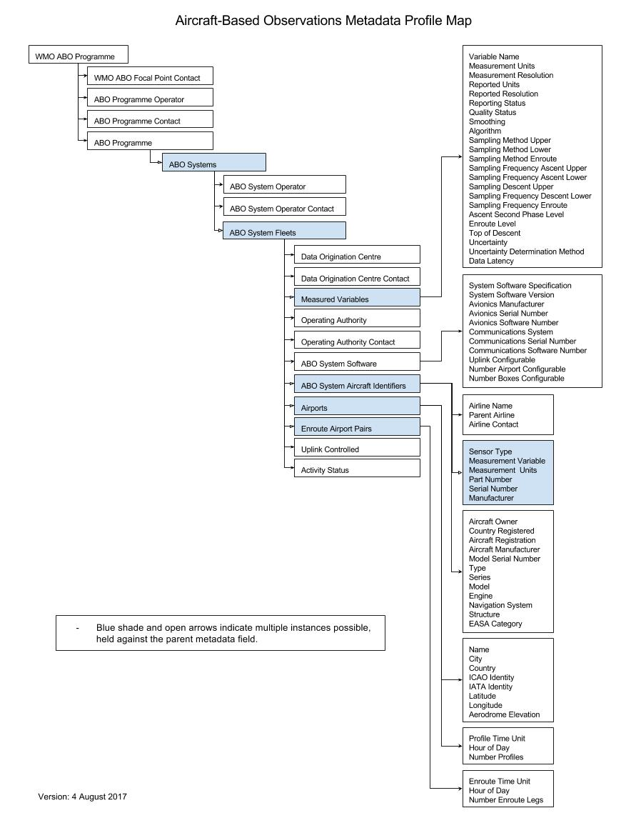

ATTACHMENT D3. FLOW CHART FOR AIRCRAFT-BASED OBSERVATIONS WIGOS STATION IDENTIFIER DESIGNATION

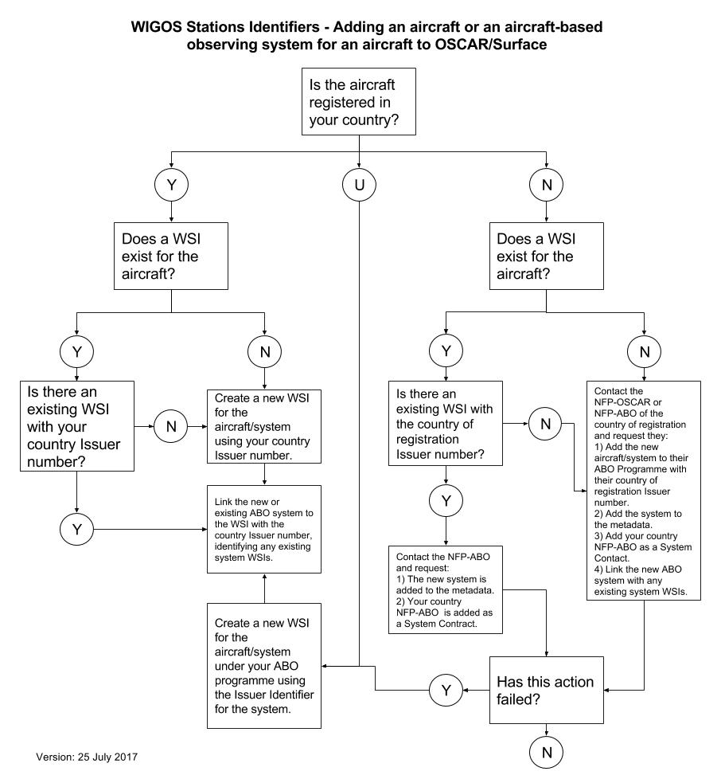

http://www.wmo.int/pages/prog/www/OSY/Meetings/AMDAR-DM-Workshop-2012/DocPlan.html.

