World Meteorological Organization  Inter-Commission Coordination Group On WIGOS/Task Team on WIGOS Metadata  Sixth Session  Zurich, Switzerland, 27-29 November 2017 | TT-WMD-6/Doc.4.5
Submitted by:
Secretariat
23.11.2017
Version 2

Global Cryosphere Watch (GCW) and OSCAR/SURFACE

(Submitted by WMO Secretariat)

Feedback from GCW regarding the development and implementation of metadata for cryosphere variables

Action proposed

- Advance the definition of metadata semantics for cryosphere variables, in cooperation with other stakeholder communities
- Recommend changes to the WIGOS Metadata Standard to incorporate the cryosphere metadata recommended by the cryosphere community.
- Decision on identifying variables measuring the same parameter for different domains.

References:

____________

1.1 GCW Data Portal Overview
1.1.1 The GCW Data Portal is the planned interface with all the data centres and stations, contributing to GCW, which is a heterogeneous community of large and small organizations (NMHSs, Universities, independent research institutions), with varying degrees of interoperability for metadata.
Currently there are protocols and structures for metadata, however the semantics and terminology are highly diverse, impacting the ability to achieve interoperability.
GCW has established guidelines for interoperability with data centres. It recommends the use of OAI-PMH . The search model for the GCW Portal is currently built around parameter descriptions using the GCMD Science Keywords.
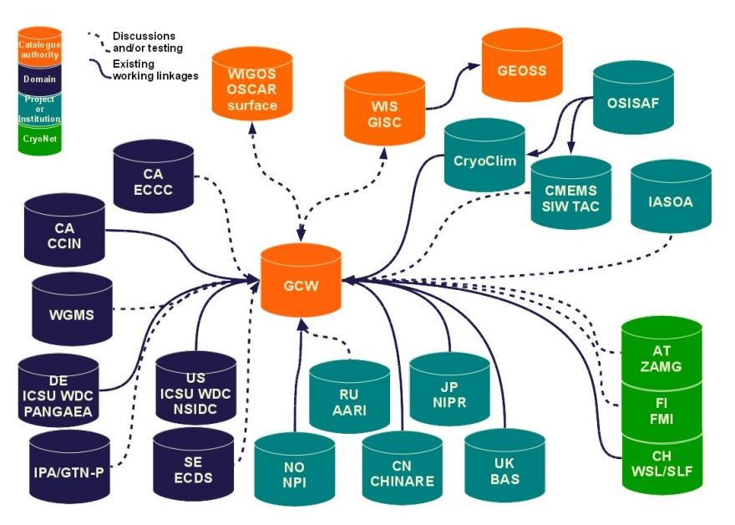
Figure 1 GCW Data Portal interoperability map (2017)

1.2 GCW in-situ Observing REQUIREMENTS
1.2.2 The Global Cryosphere Watch has developed a list of variables, by component of the cryosphere, which are recommended and desired to be observed at CryoNet surface stations (the high quality, standardised observing network of GCW). The list was approved at the GCW Steering Group meeting in Jan 2017. http://globalcryospherewatch.org/cryonet/variables/recommended_variables.html
There are 10 different cryosphere components (snow, glacier and ice caps, ice sheets, ice shelves, icebergs, permafrost, seasonally frozen ground, sea ice, lake ice, river ice). Components and measured combined, there are 52 recommended cryosphere variables and 66 desired cryosphere variables, which cover all observing applications envisioned as supported by GCW, at this time.
Additionally, the CryoNet observing programme has 4 required meteorological variables (air temperature, air humidity, wind speed, wind direction), 3 recommended meteorological variables (air pressure, incoming shortwave radiation, reflected shortwave radiation), and 3 desired meteorological variables (incoming long wave radiation, outgoing longwave radiation, and precipitation).
These variables have been compiled from input received from a wide range of cryosphere scientists and practitioners and reflect applications, not all, yet, formally documented in the RRR process of WMO, which are managed, in most cases, by other than NMHSs, or for operational purposes. Hence the metadata associated with these observations needs to be endorsed and applied by the broader community, not familiar with the WMO processes. GCW is working closely with these.
1.2.3 A comparison of the list of recommended variables, noted above, with the OSCAR catalogue of variables, and IGOS, 2007, Integrated Global Observing Strategy Cryosphere Theme Report - For the Monitoring of our Environment from Space and from Earth. Geneva: World Meteorological Organization. WMO/TD-No. 1405. 100 pp. was completed as an outcome of the IPET-OSDE, second session, 11-14 April 2016.
a) overall, it shows that there are discrepancies between the OSCAR listed variable and the GCW recommended/desired variables.
b) these discrepancies vary from nuances in naming to variables being present on one list, but not the other, in which case a reconciliation is needed.

1.3 GCW and WIGOS/OSCAR Surface
1.3.1 Resolution 43 (Cg-17) decided:
- to mainstream and implement GCW in WMO Programmes as a cross-cutting activity;
- that implementation activities will be undertaken during the seventeenth financial period as one of the major efforts of the Organization with the goal that GCW should become operational;
1.3.2 Some variables included in the GCW recommended observing programme refer to the same measurand for different domains, e.g. temperature, which is included as:
- snow surface temperature,
- snow temperature,
- ground temperature (permafrost or seasonally frozen ground),
- rock glacier spring temperature (permafrost),
- surface temperature (surface-air temperature) for sea ice;
- ice surface temperature (lake ice or river ice)
- air temperature,
- temperature profiles:
  - snow profiles,
  - ice/firn temperature profile (point) for glaciers, ice caps, or ice sheets;
  - sea ice temperature profile (vertical),
  - ice temperature profile (vertical) for river or lake ice.

As a result, the number of different variables to be tracked is smaller provided that the physical domain for which the measurement is taken is well characterised with appropriate metadata (domain, instrumentation, location, method, etc…).
Alternatively, metadata for compounded variables could be developed, to account for the above listed variables (discussion on decision 3).
1.3.3. Given the large number of new variables for the WIGOS Metadata catalogue, and the need to support communities of practice which have not traditionally been supported before, this will be prioritised for action to address discrepancies in 2018.
GCW will work with WIGOS TT, IPET-OSDE, and the cryosphere scientific and operational communities, to ensure that there is a general agreement on terminology and semantics.
This is an area of great interest, well beyond the WMO communities, and includes the Arctic Data Committee (SAON), GEO, EU Arctic Cluster of projects, Scientific Committee of Antarctic Research, World Glacier Monitoring Services, etc… They are recognizing WMO’s experience in establishing regulatory frameworks for data exchange.
1.3.5 The exchange of cryosphere data requires the standardization of terminology (name, definition), observing practices and methodologies (development of GCW best practices guides), and support from the diverse communities of practitioners (science).
To support this effort, GCW is working with the international community to address the requirement for consistency in terminology and semantics for the naming of variables, their definitions, and for documenting the observing methods.
A contract has been issued to review and streamline definitions and gain acceptance of naming of variables.
The Best practices Guide, under development, will provide the information needed for the measurement methods, configuration, etc.
1.3.4 At its 5th session, in Jan 2018, the GCW Steering Group will identify the areas of focus to demonstrate the operationalization of GCW by 2020. One primary area is the ability to exchange data in real time from the stations included in the GCW observing network.
Priority will be given to the meteorological variables, selected snow variables, and others to be determined. As a result metadata for the selected variables need to be established and endorsed by the community of users.
1.3.6 An analysis of the existing cryosphere variables in the WIGOS Manual and their status, for snow observations, is provided in Annex 1.
1.3.7 Annex 2 provides examples of entries in the OSCAR table (version 20.09.2017) which require further clarification in relation to the GCW recommended observing programmes. This work will be conducted in conjunction with WIGOS and IPET-OSDE.

Annex 1 Recommended Measurements for CryoNet Stations and how they compare with WMO Code Registry, WIGOS and OSCAR

Variable (source: GCW recommended variable list) | Included in the WMO Code Registry (y/n) | WMO Identifier | Included in OSCAR | Is it defined (No, W, O) | Definition: agreement with GCW Glossary definitions? | Comments
Snow on the ground | No | n/a | n/a | No | Not defined in GCW Glossary | GCW experts to clarify the term Snow on the Ground
Snow depth | Yes | 629 | Yes | Yes, W,O | 6 def’s in GCW glossary plus 1 called “depth of snow” (AMS). WIGOS/OSCAR definitions are in agreement. | Note distance from “ground” is specified in most definitions in GCW glossary, while WMO codes includes both ground and ice.
Snow Water Equivalent | Yes | 631 | Yes | Yes, W,O | Somewhat; GCW glossary has 5 related definitions, but agreement is needed (IPCC def looks clearest). | WIGOS/OSCAR definition is comprehensive but reference to density may need clarification?
Solid Precipitation | No | n/a | No | No | n/a | One definition in GCW glossary; likely a measurement of two parameters: amount and type of precip.
Snow profiles (density, grain shape & size, hardness, liquid water content, salinity, temperature) | No | n/a | No | No | n/a | Recommend to change from “profiles” to “profile”. It may erquire the definition of several measured/observed variables to include all elements listed in paranthesis. One definition in GCW glossary.

Annex 2. WIGOS/OSCAR variables and their agreement with CryoNet list and/or GCW Glossary

Variable (primary source is the WIGOS/OSCAR table) | Included in the WMO Code Registry (y/n) | WMO Identifier | Included in OSCAR | Is it defined (No, W, O) | Definition: agreement with GCW Glossary definitions? | Comments
Ice | No | 10017 | Yes | No | 10 different definitions of ice in GCW Glossary. | WIGOS/OSCAR table refers to “clouds” as the medium. The 10017 code doesn’t seem to exist in the online WMO codes list.
Snow/Ice/Glacier | No | 10077 | Yes | No | Not in GCW glossary. | WIGOS/OSCAR table – refers to “sea-water” as medium. The 10077 code doesn’t seem to exist in the online WMO codes list.
Ice | No | 10078 | Yes | No | 10 different definitions of ice in GCW Glossary. | WIGOS/OSCAR table – refers to “sea-water” as medium.
Snow/Ice/Glacier | Yes | 10094 | Yes | No | Not in GCW glossary. | WIGOS/OSCAR table refers to “ice-water(?)” as species. WMO Codes Notation is “lakeSnowIceGlacier”.  Unclear of what this refers to.
Ice | Yes | 10095 | Yes | No | 10 different definitions of ice in GCW Glossary. | WIGOS/OSCAR table refers to “ice-water(?)” as species. WMO Codes Notation: “ice” (same as identifier #10104). Not sure why “ice” has two identifier numbers.
Snow/Ice/Glacier | Yes | 10102 | Yes | No | Not in GCW glossary. | WMO Codes Notation is “landSurfaceSnowIceGlacier”.
Glacier | Yes | 10103 | Yes | No | 14 different definitions of “glacier” in GCW glossary.
Ice | Yes | 10104 | Yes | No | 10 different definitions of ice in GCW Glossary. | WMO Codes Notation is “ice” (same as identifier #10095). Not sure why “ice” has two identifier numbers.
Snow | Yes | 10105 | Yes | No | 14 different definitions of “snow” in GCW glossary.
Snow/Ice/Glacier | Yes | 10109 | Yes | No | Not in GCW glossary. | WMO Codes Notation is “riverSnowIceGlacier”
Ice | Yes | 10110 | Yes | No | 4 different definitions of “river ice" | WIGOS/OSCAR table refers to “river” as medium. WMO Codes Notation is “riverIce”

