Regional Training Center (RTC) Turkey Alanya Facilities

1. The City
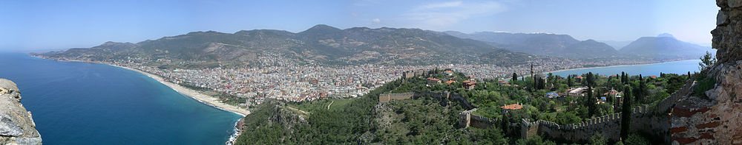
Alanya is a beach resort city and a component district of Antalya Province on the southern coast of Turkey. The city is surrounded by high mountains, wide green meadows, plateaus and innumerable rivers. This little town of the Mediterranean Coast possesses the typical climate of this region with 300 days of sunshine and temperatures rarely going below 10 degrees in the winter.
2. The Facility
It’s built on an area of 4600 square meters. Replacement on establishment with laying out the garden is designed for living healthy and roomy.
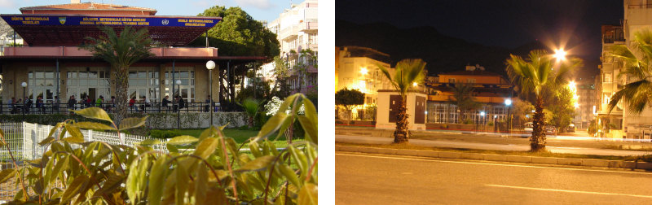

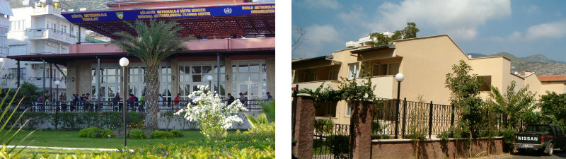
Address of the Facilities (in Turkish): Atatürk cad. Meteoroloji Sokak No:3 Saray Mahallesi / Merkez / Alanya
Computer Lab
Computer laboratory is capable of 20 person and we have 20 PC. All computers that have PIV processor and able to active all kinds of office applications. Windows XP or Linux is used on computers.

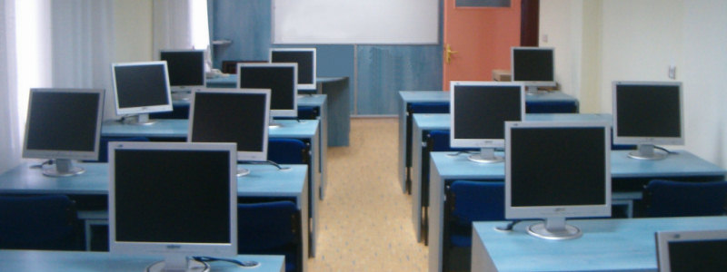

Meeting Room
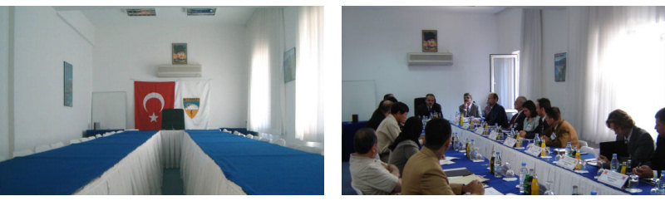

Guest House Room
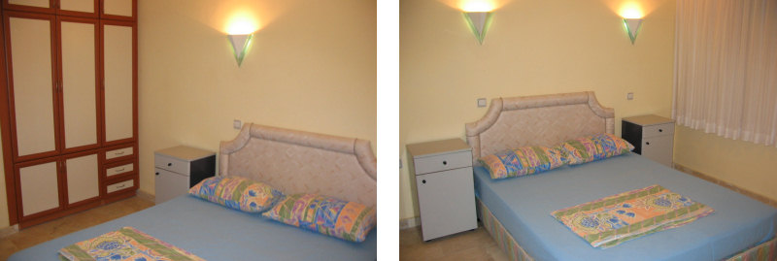
3. How to reach?
There are two international airports close to Alanya. These are Antalya and Gazipaşa Airports.
1) From Antalya Airport: The main gateway is the Antalya airport (AYT). It is appr. 125 km western from Alanya. It takes 2 hours by taxi and taxi prices are app. 70-80 euros.

See also http://www.antalyaairportshuttle.com/alanya.html for shuttle services.

2) From Gazipaşa Airport: The newly opened airport. It’s appr. 45 km eastern from Alanya city center. It takes 20 - 30 minutes by and the price is app. 30 euro per car / one way.

See also: http://www.gzpairport.com/en-EN/Transportation/Pages/Taxi.aspx .

For the entrance conditions and visa requirements please visit the following web page:

http://www.mfa.gov.tr/visa-information-for-foreigners.en.mfa

4. Relevant Information
Debit/Credit Cards: All bancomats(cash dispensers) are compatible with VISA and Mastercard. Also credits cards can be used for shopping.
Mobile Phone: There are three network operators(Turkcell, Vodafone, Avea) in Turkey. You can buy prepaid sim cards to make phone calls or else roaming will be the second option to use your mobile phone. www.turkcell.com.tr , www.vodafone.com.tr , www.avea.com.tr
Currencies: Turkish lira is the official money of Turkey. Other currency types are not used in shops or daily life but you can exchange via exchange offices, banks, airports and etc.
1 USD= 2,7 TL; 1 EUR= 3 TL
For currency rates please visit following page: http://www.tcmb.gov.tr/wps/wcm/connect/tcmb+tr/tcmb+tr/main+page+site+area/bugun
Electricity: All plugs are 220v AC and Europe style (CEE7)
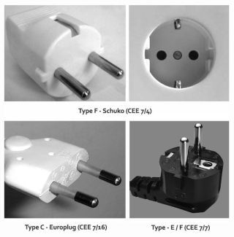
For any further information please contact the Turkish State Meteorological Service or the WMO Secretariat at the following addresses:

Turkish State Meteorological Service
Mr. Ercan Büyükbaş
E-mail: ebuyukbas@mgm.gov.tr; ercanbuyukbas@gmail.com

Mr. Hacı Murat Pulla (Manager of International Affairs Division)
E-mail: hmpulla@mgm.gov.tr

WMO Secretariat:
Dr. Steve Foreman – email: sforeman@wmo.int, Tel.: +41(0)22 730 81 71,
Mr. Luis Nunes – email: lfnunes@wmo.int, Tel.: +41(0)22 730 81 38,
Ms. Anu Baidya – email: abaidya@wmo.int, Tel.: +41(0)22 730 84 36
7bis, avenue de la Paix, Case postale No. 2300, CH-1211 Geneva 2, Switzerland
Fax: +41(0)22 730 80 21

