World Meteorological Organization |  | ICG-WIGOS/TT-WMD-2/Doc.4.6
INTER-COMMISSION COORDINATION GROUP ON WIGOS (ICG-WIGOS)  TASK TEAM ON WIGOS METADATA (TT-WMD)  SECOND SESSION |  | Submitted by: | Bruce Bannerman, Bureau of Meteorology, Australia
 |  | Date: | 05.V.2014
GENEVA, SWITZERLAND  12 – 15 MAY 2014 |  | Original Language: |  | English
GENEVA, SWITZERLAND  12 – 15 MAY 2014 |  | Agenda Item: |  | 4.6

agenda item 4.6
4. WORK OF OTHER BODIES RELEVANT TO THE WORK OF TT-WMD

4.6 Commission for Climatology (CCl) Expert Team on Climate Data Management Systems (ET-CDMS)
(Submitted by Bruce Bannerman, Australian Bureau of Meteorology)

Summary and purpose of document

This document provides some comments and suggestions on the WIGOS Core Metadata Standard (v.0.0.20) from the perspective of the CCl ET-CDMS regarding Observational Metadata

Action proposed

The session is invited to consider the comments and suggestions contained in this document.

____________

References
[1] Bannerman and Stuber. 2014, WMO Climate Data Management System Specifications version 1.2: to be published May 2014 by World Meteorological Organisation, Geneva, Switzerland. Manuscript may be accessed at: https://dl.dropboxusercontent.com/u/35369774/et-cdms/doc-latest-files/cdms-specifications-v3.30.doc
[2] Bannerman B. 2012, Stations Metadata and WMO Core Profile, A Way Forward: ET-CDMS: The World Meteorological Organisation: Geneva, Switzerland: as viewed February 2014: http://www.wmo.int/pages/prog/wcp/wcdmp/documents/etcdms-metadata-discussionpaper.pdf
[3] Bannerman B. 2014, Is a climate observations application schema a viable goal?: IPET-MDRD: The World Meteorological Organisation: Geneva, Switzerland: as viewed April 2014: http://www.wmo.int/pages/prog/www/WIS/wiswiki/tiki-download_file.php?fileId=905

Review of Draft WIGOS Metadata Standard
(version 0.0.20)

Introduction
- It is pleasing to see how far the TT-WMD work on the draft WIGOS Metadata Standard has progressed. There is some very good work within the document.
- Parallel with the TT-WMD effort on this document, has been the development of the WMO Climate Data Management System Specification (CDMS Spec). This document is expected to be published in May 2014 to provide official guidance to NMHS seeking to implement CDMS. It is viewed as a living document that will require future refinement.
- The CDMS Spec, Bannerman and Stuber (2014) defines what is meant by the term Climate Metadata. This definition includes:
    - Observations Metadata (also known as WIGOS Metadata), pp 51-57.
In summary, Observations Metadata is ‘time series data about how, when and where meteorological observations were made and the conditions that they were made under’;
    - Discovery Metadata (as per ISO 19115), pp 58-59.
In summary, Discovery Metadata is ‘intended to facilitate the discovery and assessment of a dataset to determine if it is fit for re-use for a purpose that may be at odds with the reason that it was originally created’; and
    - Data Provenance Metadata (based on W3C PROV), pp 60-62.
In summary, Data Provenance Metadata is ‘information relevant to climate data that facilitates end users, including data managers, scientists and the general public, developing trust in the integrity of the climate data’.
- The CDMS Spec Definition of Observations Metadata, as well as the draft WIGOS Metadata Standard are in essence addressing the same issue.
  - The CDMS Spec is at a quite high level, providing references to appropriate WMO and other references as appropriate. It can be thought of as a high level definition of requirements.
  - The draft WIGOS Metadata standard is at a much more detailed level and has a wider focus, beginning to address remote sensing platform requirements e.g. satellite imagery, LIDAR etc. This is work that was scheduled for a later revision of the CDMS Spec.
- The main difference between the two views of Observations Metadata is the climate requirement to understand the full history of what has happened that could potentially affect the integrity of observations data. Observations Metadata is seen as being critical for a range of climate data management and analysis uses, including:
  - Routine quality control activities; and
  - The preparation of high quality climate datasets that are used for global and regional climate analysis. See Bannerman and Stuber (2014), CDMS Component 6.1.3.1 Data Homogenisation, p 90 and related references for an overview of this type of analysis.
- Therefore, rather than having observations metadata relating to a single observation, the climate requirement is for a consistent time series record of WIGOS Observations Metadata that analysts can interrogate as required to understand issues that may have affected observations over the life of a station / platform / sensor. These issues may relate to a number of factors including:
  - Issues relating to a single station, platform or sensor;
  - Issues relating to a consistent network of stations / sensors;
  - Issues relating to work practices used by a specific maintenance practice etc.
- The CDMS Spec work on Observations Metadata and the draft WIGOS Metadata Standard are complementary and currently sufficiently mature to allow the work to be merged to minimise duplication of effort.
- The draft WIGOS Metadata Standard is more advanced in providing a proscriptive definition that will be required to underpin currently planned IPET-MDRD efforts to establish relevant authoritative definitions of WIGOS Observations Metadata within the WMO Registry (see CDMS Spec, component 8.1.2.2, p102) together with establishing an application schema based on Observations and Measurements to underpin METCE; a future Climate Observations Application Schema; as well as potentially application schema other domains (see CDMS Spec, component 4.2.2, pp 49-51). These application schemas are expected to be required to underpin future NMHS interoperable Internet based services.
- Therefore it is proposed that the CDMS Spec Observations Metadata work is merged into the WIGOS Metadata Standard, perhaps creating a WIGOS Observations Metadata Standard to retain the lineage of both pieces of work, and to avoid unnecessary confusion amongst relevant communities.

Related Activities
- There are several related activities that are closely aligned to work that is being undertaken by the Task Team on WIGOS Metadata. These are outlined below.

WMO CDMS Specification

ET-CDMS
- Within the Commission for Climatology (CCl) OPACE Structure, OPACE-1.1 Expert Team – Climate Data Management Systems has an active interest in a successful outcome of work related to Observations Metadata.

IPET-MDRD
- Within the Commission for Basic Systems (CBS) the Inter-Program Expert Team – Metadata and Data Representation Development has an interest in a timely completion of the definition of WIGOS Observations Metadata to facilitate several pieces of work:
  - Publish authoritative definitions of WIGOS Observations Metadata in a machine readable format via the WMO Registry to support and facilitate future automated services;
  - Extend the METCE logical data model to support WIGOS Observations Metadata;
  - Facilitate an extension to METCE that will allow combined Observations data and WIGOS Observations Metadata to be modelled as an application Schema to facilitate future interoperable services.

IPET-MDRD-TT-? (Name TBA)
- IPET-MDRD-1 has recommended that a new task team be established to develop a data model to support CDMS and WIGOS Metadata. It is expected that this data model will be complementary to METCE.
- The Terms of Reference for this Task Team are due by the end of August 2014.
- It is anticipated that the Task Team would also draw on members from ET-CDMS, TT-WMD and JCOMM DCMG ET-DMP.

Initial Analysis
The style of diagrams presented within this document is deliberate in order to retain a relationship back to the CDMS Specification for future readers of this document who may not be familiar with UML.
There has been insufficient work done to date to establish detailed enough definitions of many aspects of Climate Data and Climate Metadata to support immediate implementation within a database, or data schema.
Therefore the pictorial representations presented in this document should be treated as concepts representing the type of data that will need to be modelled. It is expected that work on WIGOS Observations Metadata and COAS will help facilitate a more detailed definition of what is actually required, and that can be effectively implemented within IT systems (see Bannerman and Stuber (2014), Component 4.2.3.2, pp50-51, and Bannerman (2014)).

Summary of CDMS Spec Observations Metadata Components
- The WMO CDMS Specification, Bannerman and Stuber (2014) defines what is considered to be within the scope of Climate Data at Section 4, Time Series Climate Data, pp 44-70. This is summarised in the high level diagram below. Climate Metadata, including Observations Metadata components may be found at the top of the diagram. Further details may be found in the text of the CDMS Specification.
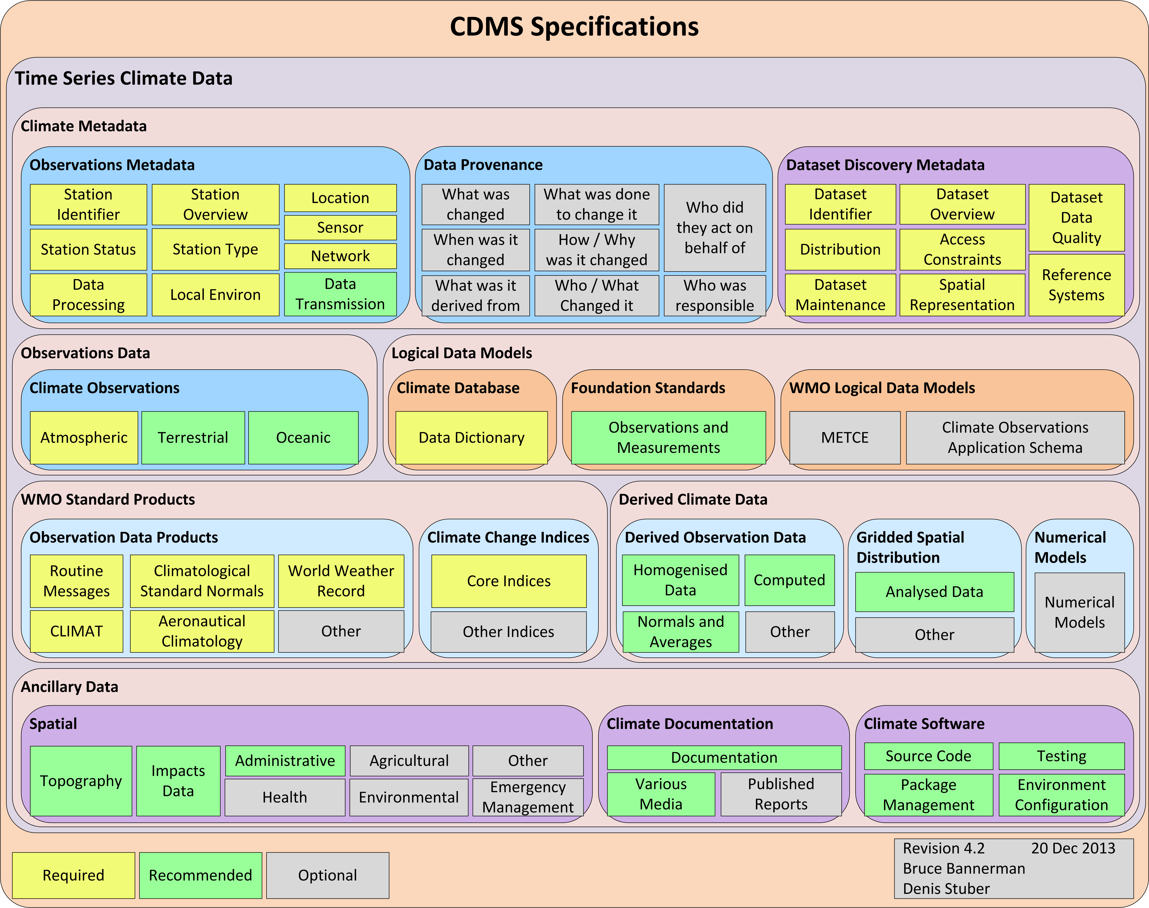

- The text describing Observations Metadata components from the CDMS Spec, Bannerman and Stuber (2014), component 4.3.1, pp 51-58, were summarised and presented diagrammatically for the IPET-MDRD-1 meeting (however for the purposes of the meeting, Data Transmission aspects were omitted). This diagram is included below. It also includes related components required for a future Observations Application Schema.
- As can be seen, there is considerable overlap with the content presented in the draft WIGOS Metadata Standard document.
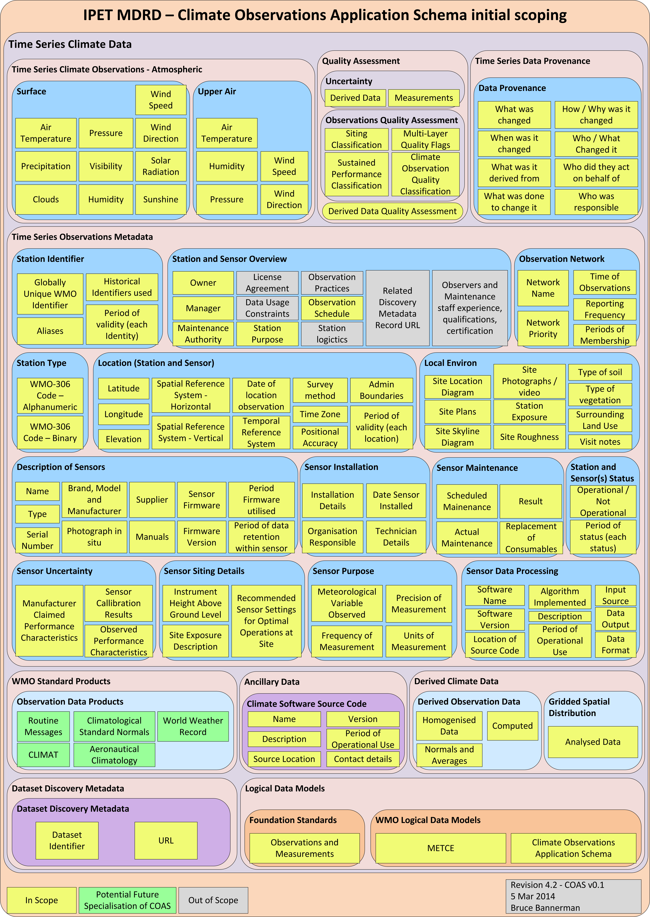

Suggestions for Draft WIGOS MEtadata Standard document

(version 0.0.20)
- The Task Team WIGOS Metadata Standard is to be congratulated on the work that has been done to date. Of particular note is the approach taken to define terms and detail and provide examples in tables. This is good work.
- Due to time constraints and conflicting work priorities, it has not been possible to undertake an in-depth review of the version 0.0.20 in the time available prior to the TT-WMD meeting in early May 2014. The following brief points were noted however:
  - Relationship between WIGOS Metadata and WIS Metadata
    - V0.0.20, of the WIGOS Metadata Standard, p10 makes reference to an overlap in the relationship between the WIGOS Metadata Standard and the WMO Core Profile of ISO 19115 (WCMP) (also known as Discovery Metadata).
    - For TT-WMD reference, Bannerman (2012) explored the relationship between Observations Metadata and Discovery Metadata and concluded that they are actually two different types of data. A collection of Observation Metadata records would be expected to have an appropriate WCMP Discovery Metadata Record, however the information that is typically contained within this type of record is different to that typically required by staff who need to analyse data that describes the context around how an observation was made.
    - Bannerman (2012) further argued that Observations Metadata would be better portrayed via a data model based on ISO 19156 Observations and Measurements (O&M). Since this work the Open Geospatial Consortium (OGC) have released the SensorML 2.0 standard that is based on O&M. SensorML and related SensorWeb standards also has relevance for WIGOS Metadata.
    - Bannerman and Stuber (2014) pursued this analysis further and concluded that there are actually three distinct, but complementary types of metadata required, i.e. Observations Metadata; Discovery Metadata; and Data Provenance Metadata.
  - Authoritative Definitions
    - For WIGOS Discovery Metadata to successfully underpin future WMO related services, it is considered that a WIGOS Metadata Standard will need to provide an Authoritative Definition that can be used within the WMO Register for systems to use to reference and qualify their data.
    - There may be some more work required to provide unambiguous definitions for some of the WIGOS Metadata terms as described in version 0.0.20. For example the modelling of Horizontal, Vertical and Temporal coordinates need to be constrained by relevant reference systems to ensure appropriate use and re-use of data.
    - This additional work could perhaps be better undertaken within a detailed data modelling exercise that is undertaken in conjunction with the proposed IPET-MDRD Task Team work.
    - This approach has advantages in that the WIGOS Metadata Standard document be developed iteratively with the IPET-MDRD TT to ensure that what is defined can be effectively implemented both within a METCE based data model and also an IT System?

CONCLUSION
- It is pleasing to see how far the TT-WMD work on the draft WIGOS Metadata Standard has progressed. There is some very good work within the document.
- There is complementary Observations Metadata work that is being undertaken by ET-CDMS and also planned by IPET-MDRD. This work needs to be coordinated to ensure that there is minimal duplication of effort and that all interested parties are engaged constructively.
- As a first step, it is recommended that the CDMS Specification work on Observations Metadata be merged into the WIGOS Metadata Standard to create the WIGOS Observations Metadata Standard.
- For consideration and discussion.

Recommendation

The ET-CDMS Climate Data Management System Specification has explored the requirements for Observations Metadata. This work is complementary to that being undertaken by TT-WMD in defining WIGOS Metadata.

It is recommended that the CDMS Specification work on Observations Metadata be merged into the WIGOS Metadata Standard to create the WIGOS Observations Metadata Standard.
It is further recommended that TT-WMD and ET-CDMS work closely together with the proposed IPET-MDRD Task Team to ensure that the WIGOS Observations Metadata data model is developed in a manner that is consistent with the directions that are being taken with METCE and the WMO Registry.

--------------------

