World Meteorological Organization |  | ICG-WIGOS/TT-WMD-1/Doc.6.1
INTER-COMMISSION COORDINATION GROUP ON WIGOS (ICG-WIGOS)  TASK TEAM ON WIGOS MATADATA (TT-WMD)  FIRST SESSION |  | Submitted by: |  | WMO Secretariat
 |  | Date: |  | 8.III.2013
GENEVA, SWITZERLAND  11 – 15 MARCH 2013 |  | Original Language: | English
GENEVA, SWITZERLAND  11 – 15 MARCH 2013 |  | Agenda Item: | 6

REQUIREMENTS FOR OBSERVATIONAL METADATA
6.1 CAS Presentation

(Submitted by Jörg Klausen, Representing CAS)

Summary and purpose of document

This document provides information on the requirements for WIGOS Metadata from the perspective of CAS / GAW.

Action proposed

The session will be informed on the requirements for WIGOS Metadata from the perspective of CAS / GAW.

References:
1. TT-WMD-1_Doc.6.5 (Karl Monnik)

____________

6.2 CAS / GAW Presentation

Introduction
The mission of the Global Atmosphere Watch [WMO, 2011], taking into account the Integrated Global Atmospheric Chemistry Observations (IGACO) strategy, is to
- Reduce environmental risks to society and meet the requirements of environmental
- conventions.
- Strengthen capabilities to predict climate, weather and air quality.
- Contribute to scientific assessments in support of environmental policy.
Through
- Maintaining and applying global, long-term observations of the chemical composition and selected physical characteristics of the atmosphere.
- Emphasizing quality assurance and quality control.
- Delivering integrated products and services of relevance to users.

The main long-term objectives of GAW address the WMO Strategic Plan 2008-2011 and are
adapted from the IGACO Strategy [IGACO, 2004]:
- Detection of long-term man-made trends in the concentration of greenhouse gases and aerosols related to climate change above natural variability and the corollary impacts of climate change on atmospheric composition.
- Better environmental assessments related to climate, air quality, ozone depletion and the long-range transport of pollution between regions. Better quantification of pollution sources and their atmospheric pathways to sensitive downwind receptors.
- Reliable global concentration fields of the selected chemical variables and aerosols at various altitudes for the study of outstanding problems in atmospheric chemistry.
- Better predictions of UV intensities at the Earth's surface both in populated and remote regions.
- Direct observation of plumes from major events such as forest fires, dust storms and volcanic eruptions; and
- Improved regional forecasts of both weather and air quality, and forecasts in regions where these are unobtainable at the moment.

Observations covered by GAW comprise of the following topical areas
- Ozone (both surface, free tropospheric and stratospheric)
- Greenhouse gases
- Reactive gases
- Atmospheric wet deposition
- UV radiation
- Aerosols
- Ancillary variables, including solar radiation, radioactivity, and meteorology

GAW has broadened its scope to address environmental risk reduction; improved prediction of climate, weather and air quality; as well as contributions to scientific assessments [WMO, 2007]. For example, a renewed awareness of the effects of volcanic eruptions primarily on air traffic safety has underlined the usefulness of GAW. In future, GAW will expand further to include a focus on megacities, building on the GURME (GAW Urban Research Meteorology and Environment) component.

The observation components of the GAW observing system comprise of ground-based (stationary) platforms (cf. Figure 1), ship-based platforms, airborne platforms as well as satellites. Traditionally, and still to date, the ground-based stations are the back-bone of the observing system.

Figure 1 - Location of stations in GAW as of May 2011. Closed or inactive stations for which data are available at a GAW World Data Centre or an affiliated data centre are denoted with open symbols

Specific challenges of GAW that bear also on the data management and metadata requirements are rooted in the diversity and the comparatively strong research orientation of atmospheric monitoring networks contributing to the Program. These networks are not only managed by NMHSs but rely strongly on the contribution of other government agencies as well as academia. The challenges have to do with global network design and implementation on the one hand, and integrated application of observations in 4D space on the other hand. Specific requirements include
- Increased coordination among regions and within each type of network
- Extension of the Program in under-sampled regions
- A focus on quality-control
- Further harmonization and operationalization of data management;
while the integration of observations requires some of the above plus
- Enhanced interaction of the data generation and assimilation/modeling communities
- Development of re-analysis products for combining different types of measurements

The end-to-end approach of GAW and applications of GAW data are shown in Figure 2. GAW data are being collected for the purposes of advancing our understanding of atmospheric processes as well as to document the composition and selected physical properties of the atmosphere in space and time. Several components of GAW have matured to the point of service-oriented operations, but in all of the topical areas of GAW listed above, there is a strong research component that drives instrument and method development.

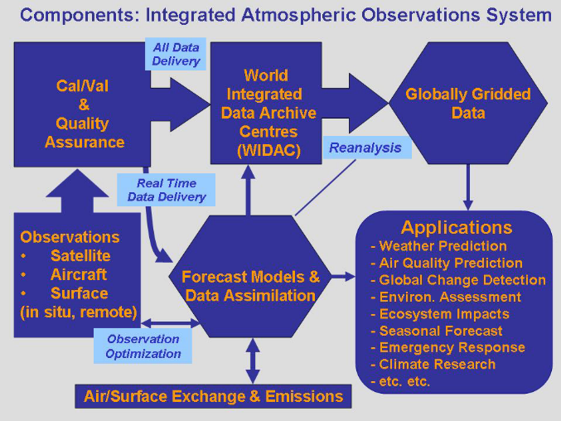
Figure 2. Framework of a global integrated atmospheric observations system [IGACO, 2004].

Quality Assurance and Data Management
GAW observations span several orders of magnitude both in terms of horizontal spatial scales (O{10¹ km} to O{10³ km}) as well as temporal scales (minutes to weeks).

The strategy to assure homogeneity and data quality is to standardize as much as possible data quality objectives and measurement methods and procedures, and to use GAW World Data Centres with a topical orientation (e.g., ozone and UV, greenhouse and reactive gases, aerosols, radiation, atmospheric wet deposition, satellite data) to prescribe a certain level of homogeneity on data formats and metadata requirements. The GAW data management strategy includes as elements
- To improve open access to data and comprehensive metadata including calibration histories of ground-based, aircraft and satellite observations for the primary GAW variables.
- To strive to harmonize GAW data management activities with the WMO Information System (WIS) whenever possible.
- To develop and promote support of data archiving and analysis centres that address the needs of an integrated global atmospheric chemistry observational system.
- To ensure that data collected and archived by WMO/GAW WDCs are of known quality, adequate for their intended use and documented comprehensively.
- To deliver those variables pertinent to air quality and forecasting in near-real-time, using WMO GTS/WIS as it evolves into an open, decentralized and node-oriented structure (with an initial priority on ozone and selected aerosol variables.)

Metadata Requirements of GAW
The metadata requirements of GAW are a reflection and natural consequence of the complexity of the program, both in terms of instrumentation as well as governance and ownership.

The Expert Team on World Data Centres (ET-WDC, cf. http://sites.google.com/site/wmoetwdc) is making significant efforts to serve the need of the users of GAW data to discover useful data and make adequate use of these data. The former is more the realm of WIS, while the latter is the focus of WIGOS. It is important to realize, however, that for the user, the distinction between ‘discovery’ and ‘interpretation’ metadata is not particularly relevant, while for the producers of metadata, the ‘discovery metadata’ are merely a subset of the ‘interpretation metadata’.

In a situation of dynamic development of the metadata standards within and around WMO, the ET-WDC has taken the approach of developing a ‘GAW Metadata Profile’ that
- serves the interoperability of the GAW WDCs,
- strives to satisfy the requirements of WIS,
- is extensible to satisfy future WIGOS requirements.

It is important to realize that the GAW Metadata Profile is ‘work in progress’.

GAW Metadata Profile for WIS
The GAW Metadata Profile builds on the ‘WMO Core Metadata Profile’ (cf. Figure 3). The present version (http://gaw.empa.ch/et-wdc/docs/2012/doc_5.1_Template_Metadata_ET-WDC_2012.xltx) should be compliant with WMO Core ver 1.2 (http://www.wmo.int/pages/prog/www/WIS/wiswiki/tiki-download_wiki_attachment.php?attId=456&page=ipetmdiPackage&download=y). It has been implemented for the GAW Station Information System (GAWSIS), and XML representations of GAWSIS metadata describing individual data series are available for download (http://gaw.empa.ch/gawsis/xml). In general, the GAW Metadata Profile should also be compliant with WMO Core metadata profile ver 1.3 (http://wis.wmo.int/2013/metadata/version_1-3-0/WMO_Core_Metadata_Profile_v1.3_Specification_Part_1_v1.0FINAL.pdf). However, as the documentation of ver 1.3 is more specific in defining the requirements, several issues have been identified recently with the current XML implementation in GAWSIS. These are presently being addressed.

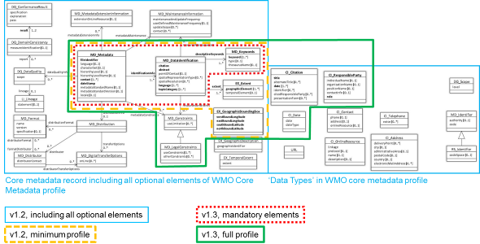

Figure 3. UML diagrams and scope of WMO Core ver 1.2 and 1.3

Interestingly, the current WMO Core Metadata Profile does not specify where and how the name of the observed variable is to be stated. This is clearly a requirement.

GAW Metadata Profile for WIGOS
The elements specified in the CIMO Guide (WMO No. 8) and listed in Doc-6.5 paragraphs 23 and 24 of this session are fully in line with the requirements of CAS / GAW.

Elements that are essential to GAW on top of what the CIMO Guide requires and that are not sufficiently well captured in the present GAW Metadata Profile are
- traceability information (this is related to calibration information)
- constraints on ‘meaningful’ application of the data (this may be related to ‘network purpose’)
- specification of central laboratories if applicable
- specification of sampling procedures and sample treatment
- specification of characteristics of the vicinity of an observing platform that potentially influence the measurement result (soil cover, horizon, local sources, …)
- version of data being described
- data policy and use constraints (partly covered already)

Conclusions
Standardization of metadata is useful and the development of a comprehensive set of metadata elements is clearly supported. Meanwhile, it will be important to acknowledge that the maturity of the various observing networks contributing to GAW varies a great deal. Thus, while the support of a WIGOS metadata standard in guiding the operations and in defining ‘best practices’ is very welcome, the enforcement of such a standard on an individual basis might very well harm the further development of the program. GAW is a voluntary WMO program, and the implementation of standards in GAW involves a process of convincing the partners of their usefulness.

References
IGACO, 2004. Integrated Global Atmospheric Chemistry Observations, GAW Report No. 159
WMO, 2007. GSP, GAW Report No. 172
WMO, 2011. GSP Addendum, GAW Report No. 197
_______

