WIGOS Data Quality Monitoring System (WDQMS)

Guidance on

Quality Monitoring, Evaluation and

Incident Management Procedures

For Regional WIGOS Centres (RWC)

Version 3
Last change: 05/12/2016

Version | Date | Change | Author
1 | 01/07/2016 | First draft | Tanja Kleinert
2 | 20/10/2016 |  | Tanja Kleinert, Stefan Klink
3 | 31/10/2016 | WMO Secretariat feedback | Tanja Kleinert, Luis Nunes
4 | 08/12/2016 |  | Tanja Kleinert

CONTENT

1. Functions of a WIGOS Data Quality Monitoring System for surface-based system of GOS 3
2. WDQMS Quality Monitoring Practices 4
2.1 WDQMS Quality Monitoring Main Categories 5
2.2 WDQMS Performance Targets 5
2.3 Requirements on Web-tools and Automated Daily Quality Monitoring Reports 6
3. Data quality monitoring and evaluation 7
3.1 Resources 7
3.2 Daily Quality Monitoring and Evaluation tasks 7
4. Incident Management Procedure 9
4.1 Responsibilities 9
4.2 Steps of the Incident Management Procedure 10
4.3 ISSUE IDENTIFICATION (A) 10
4.4 ISSUE RAISED AS INCIDENT (PROCESS INITIATION) (B) 11
4.5 RECEIPT CONFIRMATION (C) 11
4.6 ACTION PROPOSAL (D) 12
4.7 INCIDENT STATUS (E) 12
4.8 CONFIRMATION OF SUCCESSFUL INCIDENT RECTIFICATION (F) 12
4.9 Incident Escalation Procedures 13
5. Quality Monitoring Reports 13
Annex 1: WDQMS Performance Targets 14
Annex 2: WDQMS Priority Levels 16
Annex 3: High level description of potential causes of incidents and corresponding actions to be taken on NMHS/operator side 18
Annex 4: List of Acronyms 19

Functions of a WIGOS Data Quality Monitoring System for surface-based system of GOS

According to the outcome of the Second WIGOS Workshop on Quality Monitoring and Incident Management (Geneva, Switzerland, 15-17 December 2015) the WIGOS Data Quality Monitoring System (WDQMS) should consist of three basic functional components:

- the WIGOS Quality Monitoring (QM) Function,
- the WIGOS Evaluation (Ev) Function and
- the WIGOS Incident Management (IM) Function.

These functions have inputs, undertake processing tasks and generate outputs and are further described below.

WIGOS Quality Monitoring Function:

For the practical implementation of WDQMS to the Global Observing System (GOS) in the near term, the monitoring function is essentially undertaken by Global NWP Centres. Quality monitoring reports, as a by-product of data assimilation systems should be generated and made available by the Global NWP Centres for further use in the quality monitoring and evaluation process.

WIGOS Evaluation Function:

This function ensures that a more universally model can be applied to the WDQMS. It takes the Quality Monitoring outputs from all the contributing centres, extracts the relevant information from OSCAR/Surface metadata database, and generates routine daily performance reports based on at least two performance indicators: comparison with the status of WIGOS described in OSCAR; trends in network performance over a suitable period (for GOS elements monthly rolling averages are proposed). Additionally the Evaluation Function will take Quality Monitoring Reports, that include issues identified with the base observational data, OSCAR status information, Quality Monitoring Contributing Centre features and other contextual information (such as geo-political, environmental, expectation of typical performance & exceptional circumstance) to determine if the observational issues raised justify the issue being formally raised as an incident with the observational data provider, usually but not exclusively a NMHS. It is envisaged there is a semi-automated Global Centre providing routine reports and making available regional and thematic specific information to Regional Centres or WIGOS Component or sub-component Centres (Regional WIGOS Centres - RWC) in future.

WIGOS Incident Management Function:

If the issues considered by the Evaluation Function merit being raised as incidents, this will be undertaken by the Incident Management Function. Key to the success of the Incident Management Function will be the clear communication of the incident with the supplier, but also the users of the data to ensure they take suitable precautions with the source.

The process of the WDQMS is described in the diagram below.

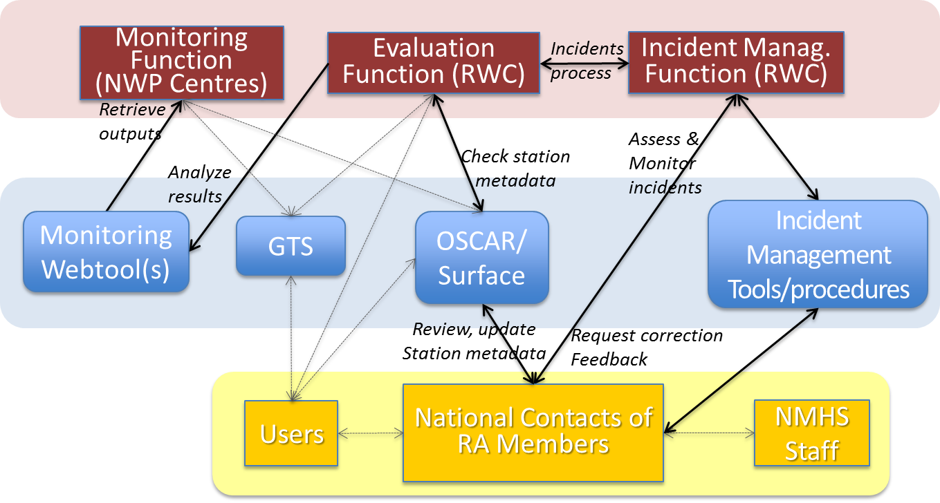
Figure 1: Process of the WDQMS

WDQMS Quality Monitoring Practices

Data quality monitoring practices should focus initially on the assessment of the performance of the Global Observing System (GOS) against a set of targets, defined for its functional specifications:

- Performance figures in terms of quantities, for example, number of observations provided on a daily basis, compared to the required and expected number of observations according to the schedule outlined in OSCAR/Surface metadata database.
- Performance figures in terms of timeliness or latency indicating the delay of data during data transmission between the observation time and the reception of the data by the users (in NMHSs database).
- Quality indicators of the physical quantities and variables, providing a measurement of uncertainties, usually in the form of systematic (bias) and statistical (root mean square) and (number or percentage of) incidental gross errors.
- Quality indicators for metadata, essential for the interpretation and use of the data (timestamp, station positions, station elevation) and other information, necessary for appropriate data management and usage.
- Results of data quality control processes, including error and consistency checking of meteorological bulletin formatting in Traditional Alphanumerical Code (TAC) or Table Driven Code Form (TDCF/BUFR) and the detection and elimination of discrepancies in TAC and BUFR bulletins.

WDQMS Quality Monitoring Main Categories
To run the GOS effectively and to ensure the system is delivered to the required standard of common user needs, three main categories have been identified to be most important to measure the performance of the system against a set of targets:

- Data availability: total number of meteorological bulletins (TAC/BUFR) received during a defined period (e.g. 24 hours) compared to the required number of bulletins as determined by the observing schedule according to OSCAR/Surface;
- Timeliness: delay between observation time and reception time at users´ database;
- Uncertainty: Sum of trueness (sometimes called accuracy) and precision: mainly derived from “Observation minus Background” (O-B) NWP results from Global NWP Centres for particular parameters such as air pressure, air temperature, wind and relative humidity observations.

Further issues and incidents might be identified during the quality monitoring and evaluation process which should result in the initiation of the Incident Management Procedure in the same way as for the three main categories. Further issues might be:

- Discrepancies in station metadata (station position, station or barometer height) between OSCAR/Surface and BUFR reports;
- Suspicious values of particular variables (consistency check);
- Discrepancies in total number of TAC and BUFR bulletins, etc;
- Encoding issues mainly in BUFR data (due to wrong use of descriptors, missing descriptors, incorrect TAC to BUFR conversions, etc).

WDQMS Performance Targets
To identify stations which are underperforming, targets for the three main categories described above have to be agreed, to which the station performances have to be compared to. Whenever a station shows non-compliance to one of these three categories an Incident Management Procedure has to be initiated as described in chapter 4.

The WDQMS Performance Targets take into account:

- WMO guidance, especially from CBS Open Programme Area Group on Integrated Observing Systems - Inter Programme Expert Team on Observing System Design and Evolution (CBS OPAG IOS IPET-OSDE);
- WMO requirements for Global and High Resolution NWP, Nowcasting and Climate application areas as indicated in the OSCAR/Requirements database;
- OSCAR/Surface, World Meteorological Organization's official repository of metadata on surface-based WIGOS observations that are required for international exchange;
- National and other Requirements;
- Constraints of Members, in particular NWP centres’ data assimilation cut-off times;

All targets regarding data availability refer to the percentage of observations received from the different observing system networks in relation to the number of observations expected according to the observation schedules being defined in OSCAR/Surface.

All targets regarding timeliness (latency) refer to the time delay between the nominal observation time and the data reception time at the NMHSes. Targets relate to percentage of data actually received, not expected.

All precision targets are stated as root mean square (RMS) errors. It is expected that any accuracy errors (biases) of measurement systems form a small part of the overall error.

Targets within the document mainly use Threshold requirements but also several Breakthrough requirements as descriptors. The general definition of these terms is:

- Threshold – the minimum level to which routine observations must be made to have an impact on regional NWP performance;
- Breakthrough – the level to which routine observations must be made in order to make significant improvements to regional NWP performance.

The WDQMS Performance Targets for surface land stations and territorial radiosonde stations are described in Annex 1.

Requirements on Web-tools and Automated Daily Quality Monitoring Reports
Global NWP Centres should produce and make available automated data availability and quality monitoring reports on a daily basis. This might be provided on a 3- or 6-hourly basis or on a daily accumulated/ averaged basis. These reports should be made available and maintained on the Internet in appropriate Web-tools (e.g. the WIGOS Quality Monitoring Web-tool: http://128.65.196.37/wdqms/ or the WMO Quality Monitoring Portal operated by EUMETNET: https://eucos.dwd.de/ravi ) to display the data availability, timeliness of the data as well as accuracy and precision of observations (derived from observation minus first guess/ background fields (O-B results) from surface land stations and territorial radiosonde stations over a period of time. The RWC should use these Web-tools to fulfil their task of a daily quality monitoring and evaluation and to be in a position to identify issues and raise an incident if an issue seems to be ongoing. To further assist the RWC in their daily quality monitoring the Web-tool should compile and provide daily summaries on the basis of the files produced by Global NWP Centres that lists the quantity or volume of land based observations reported on the GTS compared to the required (and thus expected) number of reports according to OSCAR/Surface, the average daily timeliness of the data and daily averaged O-B results from the different Global NWP Centres. The Web-tool should allow the filtering per country and to display only those stations which exceed targets on data availability, timeliness or uncertainty (trueness and precision).

The RWC has to be in a position to access the entries in OSCAR/Surface metadata database which is accessible via https://oscar.wmo.int/Surface. During the quality monitoring and evaluation process it often will turn out that amendments in the entries of OSCAR/Surface metadata database will be needed. Furthermore a detailed background and understanding of the defined observing schedule of the monitored stations is essential to operate an effective WDQMS.

Data quality monitoring and evaluation

Resources

Staff Competences
To be in a position to effectively run the quality evaluation process the RWC should be staffed by a suitable number of technical/scientific officers that have:
- A detailed understanding of the surface-based system of the GOS and its operation (to be expanded in future to other WIGOS observing components, although the functions might be split amongst multiple RWCs).
- Sound knowledge of meteorological observations and skills in data analysis.
- Skills and knowledge in quality management, incident management and report writing.
Technical resources
The RWC should have access to information, data and tools that supports the quality evaluation processes. These include as a minimum:
- Access to OSCAR/Surface and GTS data
- Convenient access to the relevant available automated monitoring statistics and other global, regional and national monitoring reports which might be of use for the quality evaluation process;
- Access to the quality monitoring results and statistics in a form that allows flexible and rapid rendering of the data for analysis, comparison, plotting, etc.
- Access to data analysis applications and tools.
Duties
The RWC should utilise the incident management system of the WDQMS for the registering and follow-up of errors and issues identified in the quality evaluation process.

The RWC should utilise the results of quality evaluation practices to identify systemic issues that might be addressed to improve the performance of the stations through modification or changes to processes and procedures.

Results of quality evaluation analyses and resulting changes to the observing system should be notified, recorded and documented in line with national, regional and WMO quality management requirements and practices.

The RWC should utilise a list of national focal points (NFPs), e.g. RBSN NFPs for each WMO Member to get in touch with the relevant persons in case of an incident as fast as possible. The NFPs should ideally be in charge of GTS data ingestion or the observations area.

Daily Quality Monitoring and Evaluation tasks
The RWC should evaluate the performance of RBSN synoptic surface land stations and territorial radiosonde stations of countries of the corresponding Regional Association or sub-region on a daily workday´s basis. The RWC should evaluate yesterday´s performance in the morning hours by following the guidance below:

- Check the available Web-tools and quality monitoring reports by comparing yesterday´s performance against the performance of the previous days to identify stations which show any non-compliance concerning data availability, timeliness and uncertainty (trueness and precision) regarding the WDQMS Performance Targets (see Annex 1).
- A non-compliance might be:
  - The station didn´t report any data yesterday (category: data availability).
  - The total number of reports is significantly lower than the expected number of observations as defined in the observing schedule in OSCAR/Surface (category: data availability).
  - The data arrived with a significant delay which might lead to a situation where data can’t be used in near-real time applications (e.g. nowcasting tools) (category: timeliness).
  - The daily averaged trueness/precision statistics derived from O-B results from Global NWP Centres exceed the WMO requirements concerning (a) particular variable(s) (category: uncertainty (trueness and precision).
- In the case of any non-compliance of a particular station a ticket should be raised according to the procedure described in 4.3. In case several stations of a country show the same non-compliance one ticket might be raised for a group of stations.
- Especially in the case of non-compliance according to 2a. ‘The station didn´t report any data yesterday’ the RWC should check in the Web-tools whether the station started reporting again later the day.
- If an issue has been reported to the RWC by a user (e.g. Global NWP Centres, countries of the RA, etc.) the RWC shall check the performance of this station and follow the same quality evaluation procedure.
- Besides checking yesterday´s station performances the RWC should furthermore check the status of issues identified in the previous days. Thus, the RWC should check stations with identified issues whether the performance improved again, e.g. did the station start reporting again, did the station report as many reports as required according to OSCAR/Surface observing schedule again, did the data start arriving without delays again or did the uncertainty (trueness/precision) of observations improve again and therefore remained below the agreed targets on a daily average.
  - In case an issue endured for 5 (or more) days for surface land stations or radiosonde stations an incident process according to the Incident Management Procedure as described under 4 should be initiated by defining a unique incident ticket number and by informing the national contact of the concerned country (see 4.4).
  - In case an issue ‘disappeared’ within these 5 days because the performance of the station improved again, no formal incident process has to be initiated and the issue will be closed again (see 4.4). In this case the issue reporter should be informed about the improved performance and the closure of the issue.
- The RWC should also monitor the status of raised incident reports on a daily basis. The RWC should supervise that the country to which an incident has been reported
  - confirmed the reception of a new IM ticket,
  - provided an appropriate action proposal containing details on the cause of the incident, proposed actions and a timeline to solve the incident,
  - provided weekly updates even ‘no change’ reports and
  - reported on incident rectification.
- The RWC should close an IM ticket after the national contact of the concerned country had reported incident rectification, the RWC had checked the improvement in performance of the station in question and had confirmed the successful rectification of the incident. Issue reporters should be informed by the RWC about the successful incident rectification and the closure of the report.
- In cases of suspicions that an issue or incident was caused by incorrect input to OSCAR/Surface the RWC should ask the national contacts of the country operating the station to investigate and if needed update the entries in OSCAR/Surface accordingly.

Incident Management Procedure

The Incident Management Procedure to report about issues, follow-up on actions and to correct incidents is illustrated below:
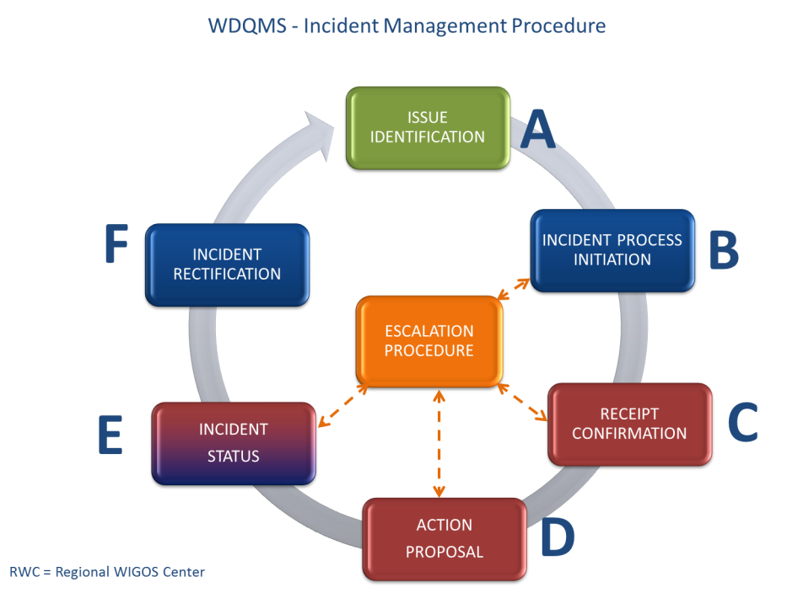

Figure 2: Incident Management Procedure

Responsibilities
The Incident Management Procedure relies on clear identification of roles and responsibilities. These are defined below for each of the 6 incident process steps illustrated in the diagram.

It is essential to have clearly defined contacts for each country of the Regional Association or sub-region, which are responsible for ensuring that corrective action is taken once requested by the RWC. It would be beneficial to have generic email addresses available for each country which are accessible by all national contact points to ensure that several persons can be informed about any incident at once.

Steps of the Incident Management Procedure
To ensure the efficient operation of an Incident Management System, the RWC should utilize a standard ticket template for raising, tracking and resolving of an operational incident. The IM ticket should record the following information:

A | The name of the person and the organization who raised the issue, including contact details (email address), plus time and date when the issues is being raised
 | Station details in particular WMO ID and network type, stations name and country
 | A full description of the issue, including the dates of the issue firstly being identified, characteristics of the issue, category of incident type (examples: availability of data, quality of data).
B | A unique reference number for the incident/ ticket
 | Date of incident creation (process initiation)
 | Priority level assigned to incident (low, medium, high, very high)
 | Description of the evaluation results
C | Ticket receipt confirmation from concerned national contact including date/time, name of recipient and potential comments
D | Action proposal by NFP and to be completed by national contact, containing date/time, name of NFP and details of proposed action including timeline to solve the incident and additional comments
E | A record of the activities undertaken to resolve the incident, by whom and when – essentially a work log of the tasks undertaken during the lifetime of the ticket.
F | Closure of the incident ticket including date/time and name of the RWC person closing the ticket

The IM tickets and correspondence between the RWC and the countries of the Regional Association shall be uploaded and maintained on an appropriate web-site or ticket system tool which can be easily accessed by all organizations being involved. The RWC should create and keep updated an Incidents Ticket Summary, preferably by means of automatic procedures. The Ticket Summary shall aid communication during all stages of the Incident Management Procedure, to ensure that all of the necessary information is supplied to monitor and document the status of the raised incident.

ISSUE IDENTIFICATION (A)
Generally the RWC will be responsible for monitoring network performances on a daily basis and identifying issues, although participating organizations, such as NMHSs and Global NWP Centres, are encouraged to report non-compliances to the RWC if they become aware of an issue.

In any case a NMHS or a Global NWP Centre identifies an issue on data availability or timeliness of a particular station / several stations or on uncertainty (trueness and/or precision) by showing high O-B results, which leads to under-performance compared to the WDQMS Performance Targets (Annex 1). The RWC should be informed about the issue. Once an issue has been reported to the RWC or has been identified by the RWC the issue will be documented by creating a new IM ticket.
All tickets should have a ticket number which should consist of five parts
[ccc-WMO ID-nnnnn–i-yyyymmdd]:

- ccc: the 3 characters country code, e.g. KEN;
- WMO ID (or WIGOS Identifier in future)
- nnnnn: a sequential number (for every single new ticket opened), e.g. 01204;
- i: a figure indicating if the issue has been raised as incident (using “1”) or not (“0”);
- yyyymmdd: the four digits of the year, month and day when the ticket was created;
Example: KEN-63740-01204-1-20161031

The RWC shall insert the following information in part A of the IM ticket:

- Date and time when ticket was created
- The name of the person and of the organization who raised the issue, including contact details (email address);
- Station details in particular WMO ID and network type, station name and WMO Member country;
- A full description of the issue, including the dates of the issue firstly being identified, characteristics of the issue, category of incident type (availability, timeliness or quality of data), instrumentation identified as source of the issue and, if possible, application areas impacted by the issue.
- The issue should be added to the Ticket Summary by setting “i” in the incident ticket number to ’0’ at this stage. The RWC shall set the ticket status to open.
The RWC should monitor each issue at surface land stations and territorial radiosonde stations over 5 working days before raising the issue into an incident and initiating the incident management process (Part B of the IM ticket).

ISSUE RAISED AS INCIDENT (PROCESS INITIATION) (B)
The RWC will be responsible for initiating the incident management process. Once an issue (Part A) has been deemed serious enough to be raised as an incident, e.g. if the identified issue lasted longer than 5 working days, an ‘incident ticket number’ as well as the notification to the NFP of the concerning country is required. This will involve the following tasks and additions to the ticket in Part B:

- Assigning a unique incident ticket number for the issue which shall be raised as incident (which will be used in all future correspondence);
- Add date and time of incident raising (process initiation) to the IM ticket;
- Add details of the evaluation results to document why the RWC raised an incident (e.g. reported data outage of a particular station was monitored via the Web-tools and the outage was still ongoing);
- Priority level assigned to incident (low, medium, high, very high, see details in Annex 2);
- Bringing the problem to the attention of the country in question, making the ticket available to them via the NFP and requesting the relevant NFP to take corrective action as rapidly as possible;
- Add the new incident ticket number (‘Incident ID’) to the Ticket Summary and update the date, status and Part of IMS accordingly.

In case the identified issue has been monitored over the defined periods and the issue has been resolved (disappeared) without further action taken by the RWC this shall be highlighted by adding ‘No incident process required’ to the ticket. The issue ticket shall either be closed in Part F or the performance of the station will be monitored over the next 2 days before deciding once again to finally close the issue or to raise an incident.

RECEIPT CONFIRMATION (C)
As soon as the NFP of the concerned country received the incident ticket with the unique incident number from the RWC, actions shall be taken to investigate the cause of the incident and to find a solution to solve the incident. Annex 3 provides a description of a set of potential causes. To make the RWC aware that the concerned country took over the task to follow up the incident, a receipt confirmation (Part C) including date/time, name of recipient and potential comments shall be added to the IM ticket by the NFP. The Part C of the incident ticket should be updated by the NFP and the RWC should be informed about the update immediately after reception. The RWC will update the date, ticket status and part of IMS in the Ticket Summary of the country in question accordingly. Once a confirmation is received at RWC the ticket status should be set as “in progress”.

ACTION PROPOSAL (D)
As soon as the NFP of the concerned country identified the cause of the incident and found a solution to solve the incident, the NFP should make the RWC aware of the proposed actions by adding the following information to the incident ticket in part D:

- Date/time, name of NFP and details of proposed action including timeline to solve the incident and additional comments being relevant.

Annex 3 provides a description of a set of potential causes and the corresponding actions to be taken on operator side. The incident ticket should be updated by the NFP and the RWC should be informed about the update as soon as possible. The RWC will then update the date, ticket status and part of IMS in the Ticket Summary of the country in question, accordingly, and preferably by automatic means.

INCIDENT STATUS (E)
The NFP will provide the corresponding RWC with brief, regular updates on the status of the incident (Part E):

- To inform the RWC of any significant action that has been taken that should be recorded (e.g. ‘IM ticket passed on to another department’ or ‘cause of problem identified’)
- Routinely on a weekly basis (including ‘no change’ reports)
- In the moment when the incident has been rectified.

The NFPs should document the updates in the incident ticket by adding the following information in part E of the ticket:

- Activities undertaken to resolve the incident, by whom and when – essentially a work log of the actions undertaken during the lifetime of the ticket by adding date/time, organization and name of who is taking actions, as well as the resulting status after each action.

The IM ticket should be updated once a week. The RWC will update the date, ticket status and part of IMS in the Ticket Summary of the country in question accordingly.

CONFIRMATION OF SUCCESSFUL INCIDENT RECTIFICATION (F)
In case the incident has been rectified by the concerned country and the RWC has been informed (Part E), the RWC will check whether the incident ticket can be closed or has to be kept open due to still ongoing non-compliance and under-performance compared to the WDQMS Performance Targets. In case of still ongoing non-compliance the RWC will ask the NFP to take further actions, to be recorded in Part E. If the RWC decides that the incident ticket can be closed, the RWC will add a closing date and time to the IM ticket (Part F), inform the NFP point as well as the issue reporter and archive the ticket as ‘resolved incident’ in the Ticket Summary (update the date and Part of IMS, set ticket status to closed).

Incident Escalation Procedures
In the unlikely event of non-response to the RWC incident reporting by a national contact of the concerned country, incident escalation procedures will rule whom to contact at higher levels – in most severe cases asking the WIGOS NFP and the CPDB (WMO Country Profile Database) NFP if needed to approach the PR of the corresponding country asking for support.

Quality Performance Reports

The RWC should provide monthly quality performance reports to NFPs of the corresponding Regional Association or sub-region by email and should also make them available online.

These Quality Performance Reports should describe the station and network monthly performances compared to the WDQMS Performance Targets as described in Annex 1 and should contain:

- The total number of observations per station received in the month compared to the total number required, according to the observing schedule outlined in OSCAR/Surface. Furthermore the overall network performance shall be provided on a monthly basis.
- The monthly average timeliness (delay between observation time and reception time at a NWP centre’s database) per station as well as the number of reports which have been received with a significant delay according to the targets. Furthermore the overall network performance shall be provided on a monthly basis.
- Monthly arithmetic averages of daily pressure, temperature, wind and relative humidity root mean square of differences from O-B NWP comparison results and the monthly percentages of gross errors compared to the total number of all single observations for each variable and station. Furthermore the overall network performance shall be provided on a monthly basis.
- It would be beneficial to sort the station performances by listing stations with suspect records first, followed by stations with non-suspect records, grouped by country and network.

Annex 1: WDQMS Performance Targets

Surface Synoptic Land Stations
Observation cycles are defined as in OSCAR/Surface. In general automatic surface synoptic land stations are expected to carry out hourly observations. Manned surface synoptic stations are expected to carry out three hourly observations. Following WIGOS Implementation Plan for the Evolution of Global Observing Systems (EGOS-IP) which promotes the global exchange of even sub-hourly data in support of relevant application areas WMO Members are encouraged to provide data at highest available temporal resolution.

Performance Target Table 1: Surface Synoptic Land Stations
Parameter | Target |  |  | Comment
Data availability:  Percentage of observations received from Network | 95% |  |  | Percentage of monthly data availability from the surface land station network according to the schedule as outlined in OSCAR/Surface (number of obs received per month compared to number of obs expected per month)
Timeliness: Percentage received by  HH+100  HH+50 | 95%  90% |  |  | Percentage of data received by target times (HH+100 or HH+50) to be calculated on a monthly basis.  Targets relate to percentage of data actually received, not expected.  Threshold requirement  Breakthrough requirement
Parameter | Target  Trueness | Target  Precision | Threshold for gross errors | Comment
Pressure (hPa) | 0.5 hPa | 1.5 hPa | 10 hPa  < x% of all single obs. | Trueness: On average (several days) the daily calculated bias of pressure observations (P BIAS) should not exceed the target for trueness.  Precision: On average (several days) the daily calculated root mean square error of pressure (P RMSE) should not exceed the target for precision.  Gross errors: the number of gross errors during one month should not exceed x% of all single obs. of that particular station  Threshold requirement
Temperature (K) | 0.5 K | Not specified at the moment: NWP 2m temperature forecasts are not yet reliable to serve as reference. | 10 K  < x% of all single obs. | Trueness: On average (several days) the daily calculated bias of temperature observations (T BIAS) should not exceed the target for trueness.  Precision: On average (several days) the daily calculated root mean square error of temperature (T RMSE) should not exceed the target for precision.  Gross errors: the number of gross errors during one month should not exceed x% of all single obs. of that particular station  Threshold requirement

Parameter (cont.) | Target  Trueness | Target  Precision | Threshold for gross errors | Comment
Wind Vector (m/s) | 3.0 m/s | 5.0 m/s | 15 m/s  < x% of all single obs. | Trueness: On average (several days) the daily calculated mean vector of wind observations (WIND MVD) should not exceed the target for trueness.  Precision: On average (several days) the daily calculated root mean square error of wind vector differences (RMSVD) should not exceed the target for precision.  Gross errors: the number of gross errors during one month should not exceed x% of all single obs. of that particular station  Threshold requirement
Relative Humidity (%) | 10 % |  |  | Trueness: On average (several days) the daily calculated bias of relative humidity observations (RH BIAS) should not exceed the target for trueness.  Precision: On average (several days) the daily calculated root mean square error of relative humidity (RH RMSE) should not exceed the target for precision.  Gross errors: the number of gross errors during one month should not exceed x% of all single obs. of that particular station  Threshold requirement

Annex 1: WDQMS Performance Targets

Territorial Radiosonde Stations
Observation cycle as defined in OSCAR/Surface (Observing Systems Capability Analysis and Review Tool).
The provision of time and coordinates in BUFR data as well as the provision of high resolution BUFR data of all radiosonde stations is recommended (2 sec).

Performance Target Table 2: Territorial Radiosonde Stations
Parameter | Target |  |  | Comment
Data availability: Percentage of observations received from Network | 95% |  |  | Percentage of monthly data availability of the territorial radiosonde network according to the schedule as outlined in OSCAR/Surface (number of soundings received per month compared to number of soundings expected per month)
Timliness: Percentage data received by  HH+100 - the entire sounding (BUFR) or TEMP parts CD (TAC)  HH+50 - up to 100 hPa (BUFR) or TEMP parts AB (TAC) | 95%  90% |  |  | Percentage of data received by target times (HH+100 or HH+50) to be calculated on a monthly basis.  Targets relate to percentage of data actually received, not expected.  Threshold requirements
Geopotential height:  Percentage achieving  100hPa  50hPa | 97%  95% |  |  | Targets relate to percentage of data actually received, not expected.  Threshold requirements
Parameter | Target  Trueness | Target  Precision | Threshold for gross errors | Comment
Temperature (K) | 0.5 K | 1.5 K | 10 K  < x% of all single obs. | Trueness: On average (several days) the daily calculated bias of temperature observations (T BIAS) should not exceed the target for trueness.  Precision: On average (several days) the daily calculated root mean square error of temperature (T RMSE) over all levels  Gross errors: the number of gross errors during one month should not exceed x% of all single obs. of that particular station  Threshold requirement
Wind Vector (m/s) | 3.0 m/s | 5.0 m/s | 15 m/s  < x% of all single obs. | Trueness: On average (several days) the daily calculated mean vector of wind observations (WIND MVD) should not exceed the target for trueness.  Precision: On average (several days) the daily calculated root mean square errors of wind vector differences (RMSVD) over all levels  Gross errors: the number of gross errors during one month should not exceed x% of all single obs. of that particular station  Threshold requirement

Parameter | Target  Trueness | Target  Precision | Threshold for gross errors | Comment
Relative Humidity (%) | 10 % |  |  | Trueness: On average (several days) the daily calculated bias of relative humidity observations (RH BIAS) should not exceed the target for trueness.  Precision: On average (several days) the daily calculated root mean square error of relative humidity (RH RMSE) over all levels. In range surface to tropopause.  Gross errors: the number of gross errors during one month should not exceed x% of all single obs. of that particular station  Threshold requirement
O-B 100 hPa Geopotential Height Difference (metres) | 65 m |  |  | Equates to 1 hPa error at 100 hPa

Annex 2: WDQMS Priority Levels

Priority levels for surface land stations:

Category | Description | Level of priority
Data availability  (issues/incidents might be identified in TAC and/or BUFR data) | One station showed data outages occasionally | low
 | Several/all stations of one NMHS/country showed data outages occasionally since 5 days | medium
 | One station didn´t provide any data since 5 days | high
 | Several/all stations of one NMHS/country didn´t provide any data since 5 days | very high
Timeliness  (SYNOP data should be available for users within 50 min. after nominal observation time) | Data of one station seemed to arrive delayed (later than 100 min) occasionally since 5 days | low
 | Data of several/all stations of one NMHS/country seemed to arrive delayed (later than 100 min) occasionally since 5 days | medium
 | All data of one station seemed to arrive delayed (later than 100 min) since 5 days | high
 | All data of several/all stations of one NMHS/country seemed to arrive delayed (later than 100 min) since 5 days | very high
Uncertainty  (Issues/ incidents might be identified for several parameters, e.g. pressure, temperature, wind, humidity) | Daily averages of Observation minus Background (O-B) results from NWP of one station exceeded the target occasionally since 5 days (regarding trueness, precision or number of gross errors) | low
 | Daily averages of O-B results of several/all stations of one NMHS/country exceeded the target occasionally since 5 days (regarding trueness, precision or number of gross errors) | medium
 | All daily averages of O-B results of one station exceeded the target since 5 days (regarding trueness, precision or number of gross errors) | high
 | All daily averages of O-B results of several/all stations of one NMHS/country exceeded the target since 5 days (regarding trueness, precision or number of gross errors) | very high
Quality  (Issues/incidents might be identified concerning suspicious values in the reports, e.g. negative temperatures or snow during summer season, etc.) | One station showed suspicious values in reports occasionally in the last 5 days | low
 | Several/all stations of one NMHS/country showed suspicious values in reports occasionally in the last 5 days | medium
 | All data of one station showed suspicious values in reports over several days (in the last 5 days) | high
 | All data of several/all stations of one NMHS/country showed suspicious values in reports over several days (in the last 5 days) | very high

Annex 2: WDQMS Priority Levels

Priority levels for territorial radiosonde stations:

Category | Description | Level of priority
Data availability  (issues/incidents might be identified in TAC and/or BUFR data) | One station showed data outages occasionally in the last 5 days | low
 | Several/all stations of one NMHS/country showed data outages occasionally in the last 5 days | medium
 | One station didn´t provide any data since 5 days | high
 | Several/all stations of one NMHS/country didn´t provide any data since 5 days | very high
Timeliness  (Data of an entire sounding should be available to users within 100 min. after nominal observation time) | Data of the entire sounding of one station seemed to arrive delayed (later than 100 min) occasionally in the last 5 days | low
 | Data of the entire soundings of several/all stations of one NMHS/country seemed to arrive delayed (later than 100 min) occasionally in the last 5 days | medium
 | All data of the entire sounding of one station seemed to arrive delayed (later than 100 min) in the last 5 days | high
 | All data of the entire soundings of several/all stations of one NMHS/country seemed to arrive delayed (later than 100 min) in the last 5 days | very high
Uncertainty  (Issues/incidents might be identified for several parameters, e.g. pressure, temperature, wind, humidity) | Daily averages of Observation minus Background (O-B) results from NWP of one station exceeded the target occasionally since 5 days (regarding trueness, precision or number of gross errors) | low
 | Daily averages O-B results of several/all stations of one NMHS/country exceeded the target occasionally since 5 days (regarding trueness, precision or number of gross errors) | medium
 | All daily averages of O-B results of one station exceeded the target since 5 days (regarding trueness, precision or number of gross errors) | high
 | All daily averages of O-B results of several/all stations of one NMHS/country exceeded the target since 5 days (regarding trueness, precision or number of gross errors) | very high
Quality  (Issues/incidents might be identified concerning suspicious values in the reports, e.g. negative temperatures or snow during summer season, etc.) | One station showed suspicious values in the soundings occasionally in the last 5 days | low
 | Several/all stations of one NMHS/country showed suspicious values in soundings occasionally in the last 5 days | medium
 | All data of one station showed suspicious values in soundings since 5 days | high
 | All data of several/all stations of one NMHS/country showed suspicious values in soundings since 5 days | very high

Annex 3: High level description of potential causes of incidents and corresponding actions to be taken on NMHS/operator side

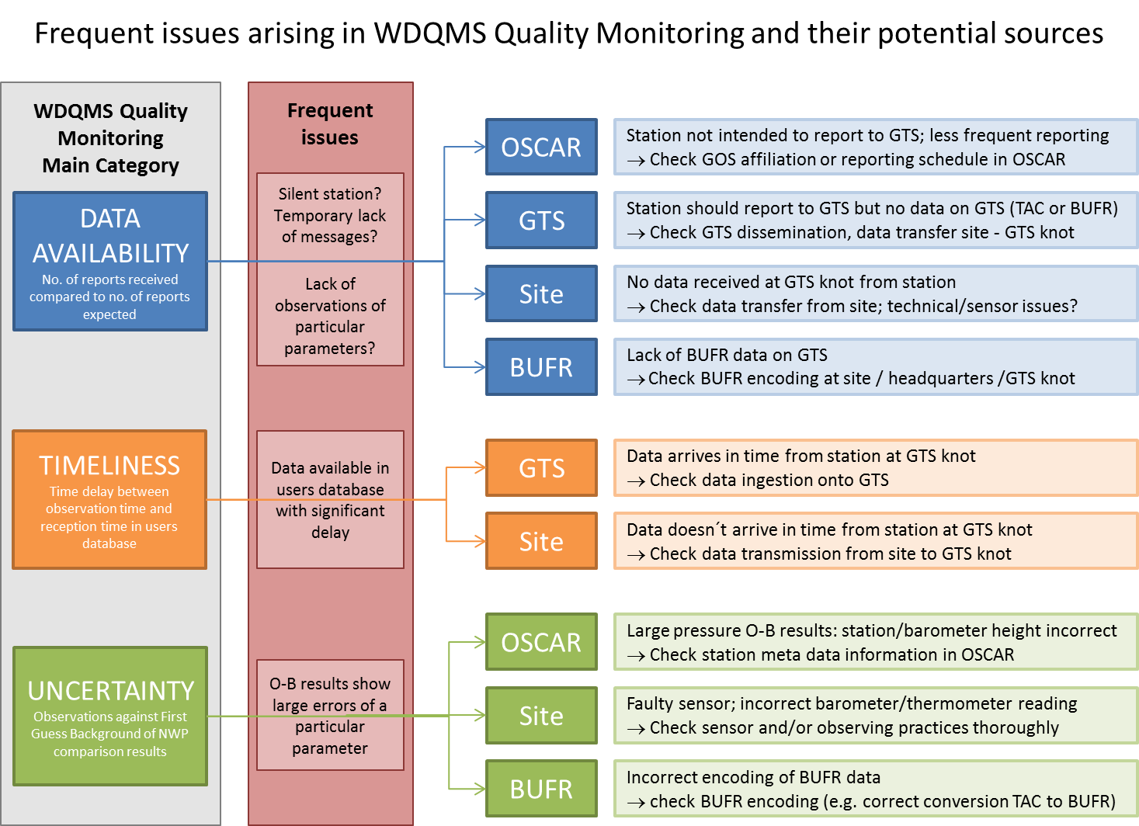

Annex 4: List of Acronyms

CPDB WMO Country Profile Database
ECMWF The European Centre for Medium-Range Weather Forecasts
IM Incident Management
GCOS Global Climate Observing System
GOS Global Observing System
NFP National Focal Point
NMHS National Meteorological and Hydrological Service
NWP National Weather Prediction
O-B Observation minus background
OSCAR Observing Systems Capability Analysis and Review Tool
QMP Quality Monitoring Portal
RA Regional Association
RBSN Regional Basic Synoptic Network
RWC Regional WIGOS Center
RMSE Root mean square errors
WDQMS WIGOS Data Quality Monitoring System
WMO World Meteorological Organization

