World Meteorological Organization  Inter-Commission Coordination Group on WIGOS  Eighth Session  Geneva, Switzerland, 24-26 January 2019 | ICG-WIGOS-8/Doc. 10.6
Submitted by:
Secretariat
18.12.2018
DRAFT 1.1

10. COLLABORATION AND ENGAGEMENT WITH CROSS-CUTTING WMO PRIORITIES; WIGOS MAIN OBSERVING COMPONENTS

10.6 Global Cryosphere Watch (GCW)

Summary and purpose of document

The document provides a brief summary on the progress of GCW, on items relevant to its observing component, which is a component of WIGOS.

Action proposed

The session will be invited to review the progress of GCW and to provide support and guidance, on specific GCW item, of high priority and relevant to the preoperational phase of GCW, 2020-2023: (1) the allocation of WIGOS IDs, (2) registration of GCW stations in OSCAR, (3) further development of WIGOS Metadata Standard, (4) GBON, (5) partnerships and data exchange, (6) regional implementation, (7) WDQMS, (8) WIGOS Vision

References:
GCW Steering Group meeting, session #6 (Reduced), 26-28 November, 2018, Davos, Switzerland.

____________

ICG-WIGOS:
Information and Discussion Document on Global Cryosphere Watch (GCW)

- GCW Preoperational phase
This summary focuses on issues relevant to GCW within the context of the WIGOS framework.
The actions presented here are required to enable GCW to become operational by 2024, and where the engagement within the WIGOS framework has an enabling function.

Recommendation 17 (EC-70), on the Preoperational phase of the Global Cryosphere Watch, “Recommends to Congress the draft Resolution on the Pre-Operational Phase of the Global Cryosphere Watch as provided in the Annex to the Recommendation.”
The annex to this Recommendation includes the draft Resolution for Congress 18 (Cg-18), which states that “THE WORLD METEOROLOGICAL CONGRESS, Decides that the development of GCW will continue during its pre-operational phase in the eighteenth financial period, with the aim proving to Members the benefits of a fully operational, end-to-end GCW, as a cross cutting activity, from 2024 onward;

During the preoperational phase, GCW will focus on key priorities, to enhance the value proposition for Members, in the context of the Earth System approach.
- relevant to WIGOS: Operationalise the GCW Surface Observing Network, by finalising and publishing GCW-relevant regulatory and guidance material, register stations in OSCAR, achive interoperability at data level with all stations, and further enhancing the GCW Surface Observing Network:
- Linked to WIGOS activities: Support Members in developing national frameworks for cryosphere end-to-end monitoring and service partnership:
- Establish the GCW Data Portal as a Data Collection or Production Centre (DCPC) in the WMO Information System (WIS);
  - Pilot the development of an Integrated Global Cryosphere Information System: to provide integrated access to authoritative cryosphere data, information, and products.
- Develop and publishing value added cryosphere products, and contribute to the WMO Annual Statement on Climate. Focusing on user needs e.g. water resources and energy production, safety (transportation), understanding natural hazards and risks, etc.;

These priorities, are being further refined by the GCW Steering Group, for submission to Congress, taking into account the strategic priorities of WMO.

- Establishing GCW Surface Observing Network

Resolution 29 (EC-70) approved the GCW Surface Observing Network (GCW SON), consisting of a core component, called CryoNet, contributing stations, and affiliated cryosphere networks, such as GTN-P for permafrost and RBSN/RBON which measure cryosphere variables.

The GCW Surface Network (fig 1) includes currently, 153 stations, of which 105 are CryoNet stations.
A number of these stations are organized as GCW Clusters (10, currently), which are groupings of approved stations, within a defined geographical area and goals (scientific, operational).

GCW SON is an illustrative example of the principles of WIGOS. The 153 stations are operated by 41 institutions in 29 countries (30% of countries where cryosphere is present). Of these, 15 are NMHSs, 9 are Universities, and 17 other institutions.
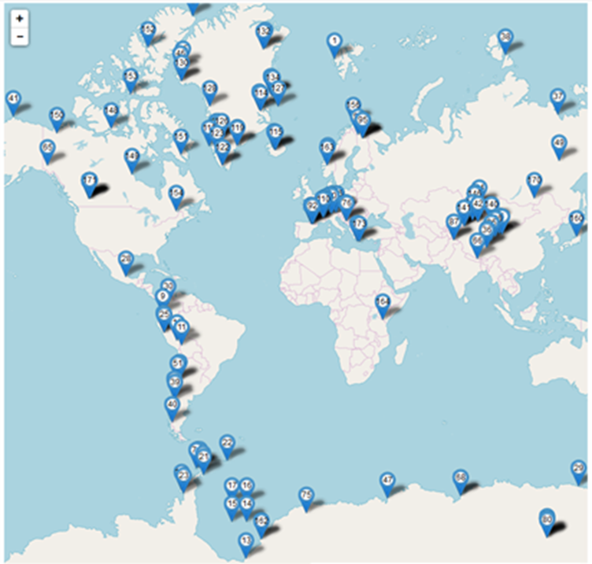
Figure 1: GCW Surface Observing Network (Resolution 29, EC-70)
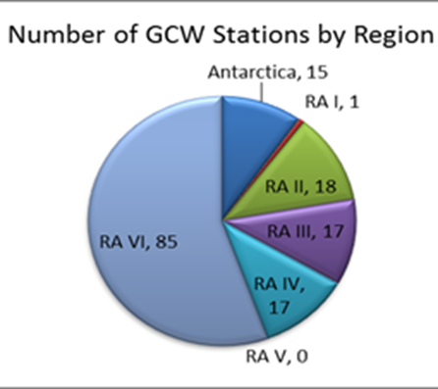
Figure 2: GCW approved stations, by Regional Association

2.1 Next steps: actions to facilitate the operationalization of GCW, by 2024.

Overall, there is a need for a stronger engagement of GCW within the WIGOS framework, as an action of both entities, WIGOS and GCW.

Following EC-70, and as decided by GCW Steering Group in Jan 2018, the expansion of the network has been paused (although the interest in joining GCW network is increasing rapidly), until several elements are addressed, which are critical for the network to be, truly, operational. These are:
- Registration of stations in OSCAR Surface;
- Achieving interoperability at data level (real time and archived data)

3. Registration of GCW stations in OSCAR

3.1 WIGOS IDs

Currently, only 20% of approved GCW stations, have WIGOS IDs.

As most stations in GCW SON are operated by institutions other than NMHSs, the station operators have limited access to the OSCAR National Focal Points, and obtaining WIGOS IDs has proven to be difficult.

- Furthermore, of the GCW stations which already have WIGOS IDs, very few have registered their existing snow observations in OSCAR Surface. This is likely due to the fact that Members have not updated their stations recently, e.g. since the approval by EC-69 of Resolution 15, on the international exchange of snow data.

- GCW Project Office has initiated formal letters to Members reminding them to register their cryosphere observations and stations in OSCAR. GCW requests WIGOS to promote with Members regular updates of station configurations.

The allocation of WIGOS IDs is the major stumbling block to registering GCW stations in OSCAR, and to configuring data access via the GCW Data Portal.

GCW has noted the updated procedure on the allocation of WIGOS IDs, approved by Decision 15 (EC-70), giving the Secretary General of WMO a role in this sense. Within this framework, GCW Steering Group is making the following recommendation to ICG-WIGOS:

RECOMMENDATION to ICG WIGOS:
GCW requests that the procedure is further amended for GCW stations, such that WMO Secretariat, the GCW Project Office , is assigned to issue WIGOS ID for GCW stations, in addition to the already designated entities. This will allow a consistent approach, and addressing the current gaps.

A specific procedure will be developed, to address this amendment, and communicated to all parties, via the WIGOS Manual and Guide, to support this decision.

3.1.1 The procedural aspects of the registration of GCW stations:

Recent engagements with the WIGOS Project Office, including the participation in the GCW Steering Group meeting, in Davos, have led to some practical solutions for pushing the GCW station metadata into OSCAR, directly.

The GCW Project Office is working with the WIGOS Project Office to develop a template to enable the registration of GCW stations, using the station metadata, already available.

GCW Steering Group welcomes the collaboration regarding the registration of GCW stations, and urges WMO to ensure that this function is sustained, during the GCW preoperational phase, and in the future.

3.2 Inclusion of cryosphere variables in OSCAR Surface

The registration of GCW stations in OSCAR requires that the OSCAR Surface database include the cryosphere variables observed at the approved GCW stations (currently, close to 80 variables, in total, and only 12 have been reconfirmed or added).

The work to further develop WIGOS Metadata Standard on cryosphere observations will continue in 2019-2020, and is the primary responsibility of GCW.

3.2.1 WIGOS Metadata Standard (relevant to item 4.3(5) of the ICG-WIGOS meeting agenda)

GCW worked very well in 2018 with the WIGOS Metadata Task Team (TT-WMD). It provided contributions to the WIGOS Metadata Standard (WMO-No. 1192) regarding variables for snow and glacier observations.

In 2019-2020, the goal is to include all cryosphere variables observed (for Table 1-01), and the associated methods of measurement (for Table 5-02).
To date, 10 observed cryosphere variables have been proposed by GCW for inclusion in the WIGOS metadata standard, out of the 80 cryosphere variables observed at GCW stations.

GCW recognizes that it needs to accelerate its contribution to the WIGOS Metadata Standard, to ensure that OSCAR Surface includes the cryosphere variables expected to be reported from GCW stations; the work on WIGOS metadata is a priority for GCW.

GCW would like to acknowledge the excellent working arrangements with TT-WMD.

4. WIGOS Regulatory and Guidance Material (relevant to item 4.2 on the ICG WIGOS meeting agenda)

GCW regulatory framework has been included in the WMO Technical Regulations, draft Volume I of WMO-No 49, and the draft Manual on WIGOS, WMO-No. 1160, and includes the attributes of GCW surface observing network, as prepared for submission to Congress.

GCW would like to thank the WIGOS Project Office for the sustained collaboration in achieving this important milestone.

Note: Initially, GCW had stations and sites, but the term “site” has caused confusion. Hence, that the term “site” becomes “cluster” in the current version of TR-49 and has been already, implemented in OSCAR.

  - GCW Best Practices for the measurement of cryosphere variables

The GCW Best Practices guides for the measurement of cryosphere variables are building upon existing guidelines, including those published by WMO.

In 2018, GCW published jointly with CIMO, the first draft of Chapters 1, General, and 2, Measurement of Snow, as a new volume of the CIMO Guide, WMO No. 8, on the “Measurement of Cryosphere Variables” . This received the approval of the 17th CIMO session.

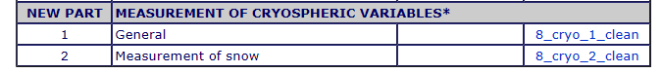

There has been exemplary collaboration between GCW and CIMO, and the GCW Steering Group is grateful to CIMO for it.

The need to merge scientific practices with operational ones and to supplement existing WMO practices is recognized:
- The Sea Ice chapter is developed in collaboration with the JCOMM Expert team on Sea Ice (ETSI), International Ice Charting Working Group (IICWG), the Polar Satellite Task Group (PSTG), and WCRP/CliC. Its publication is planned for 2020.

- Preparation of the Glacier Best Practices chapter is being led by the Icelandic Meteorological Office (IMO), and will continue in 2019 to engage additional experts from NMHSs, academia and institutes as needed. The goal for publication: 2020.

- Discussion on the preparation of the Permafrost Best Practices has been initiated with SLF (alpine expertise) and GTN-P, with a goal for publication in 2021.
These chapters will be added to the new volume of the CIMO Guide, WMO No. 8, on the “Measurement of Cryosphere Variables”

- GCW Interoperability at data level, through the GCW Data Portal

GCW Steering Group and WMO are grateful to:
- the Norwegian Meteorological Institute for their outstanding and ongoing commitment and support to the development of, and for hosting the GCW Data Portal.

- WSL/SLF (Swiss Federal Institute for Forest, Snow and Landscape Research (SLF) for their active contribution to establishing interoperability of GCW Data Portal with GCW stations.

When fully implemented, the GCW Data Portal will facilitate the access to cryosphere data, information and analyses from a distributed and heterogeneous network of providers, with very diverse data management capabilities. It is connected to WIS and can handle BUFR code.

The model pursued is that of data as a service. Interoperability with data centres and archives is a core attribute.

There is very strong interaction with the science community, both data centres and co-ordination bodies. ICSU’s World Data System is an important connection. It is noted that the GCW portal is the basis for the YOPP, Arctic-PRCC portals and national activities.

A priority of the GCW preoperational phase is that the Data Portal becomes a Data Collection or Processing Centre.

An operational GCW is not possible without the interoperability at data level!!
The allocation of WIGOS IDs is critical to implementing the interoperability at data level.

The interoperability at data level is being pursued as a priority of 2019, with the significant engagement of SLF. They are developing an operational application which would access data in the native format of any station/data centre and make it available in NetCDF.

A demonstration is planned at Cg-18, together with Arctic HYCOS.

- WIGOS Data Quality Monitoring System (WDQMS) – relevant to item 4.4 on the ICG WIGOS agenda.

GCW welcomes the WDQMS framework.

GCW Steering Group discussed that the GCW Data Portal could be a reasonable mechanism to act as the GCW WDQMS, however, its development and sustainability depends on the level of commitment from members, in this case Norway.

This topic will need to be addressed during the GCW preoperational phase.

Support from WIGOS is requested, for prompting the WDQMS model regarding the monitoring of cryosphere data, and for ensuring support from Members, for implementing it.
.

- GCW Regional activities in the context of WIGOS – relevant to items 4.1 and 5 on the ICG WIGOS agenda

One of the GCW preoperational phase priorities is “Supporting Members in developing national frameworks for cryosphere end-to-end monitoring and service partnership “.

At the recent GCW Steering Group meeting (Davos, 26-28 Nov, 2018), the group identified as a priority during the pre-operational phase, the need for increasing the focus on regional activities, supporting the integration of existing cryosphere monitoring projects, primarily in developing countries, and addressing major observation gaps, as requested by RA II-16, RA VI-17 (Caucasus region), and RA III-17.

GCW is requesting that WIGOS involves GCW, through the GCW Project Office, in the preparation of Regional Workshops, to provide mechanisms to address GCW related goals, within the framework of WIGOS.

- International Exchange of Data

Resolution 15 (EC-69) decided that Members shall exchange internationally snow depth and snow cover data, including reporting of zero snow depth values (from the previous report as M, missing, when there was no snow on ground), using a dedicated BUFR Table.

ECMWF has reported significant improvements in snow depth data availability since EC-69, although a few countries have not yet converted to BUFR, and may not have the means to fully implement this Resolution.

GCW is requesting support from WIGOS/WIS on this issue.

A new BUFR table on snow water equivalent (SWE) has been approved in Nov 2018, and is available for use by Members. Communication with Members, in this sense, is being prepared.

Issue:
The recent GCW Steering Group identified the challenge regarding the exchange of data in real time, using BUFR or other formats, when the data originates from networks which are not operated by NMHSs.

GCW is seeking from WIGOS guidance on a systematic approach to distributing data on GTS, when data originates from third party institutions, as this is an integral part of the implementation of partnerships.

(e.g. In the western USA, SNOTEL data are available, but in SHEF format, not in BUFR, SWE data from hydrological services, or Hydro Power companies).
Currently, for the case of USA, NOAA has agreed to develop a converter from SHEF to BUFR, and transmit the data on GTS (progress under way).

The Data Portal is a reasonable entry point to GTS, however governance aspects need to be clarified. I.e. who could upload third party data on GTS; could this be done via the GCW Data Portal (in Norway) for any other Member?

- WIGOS Vision – relevant to item 6.0 on the ICG WIGOS agenda.

GCW has coordinated input on observations of the cryosphere , in-situ and remote, including from space, for the WIGOS 2040 Vision. Dr Petra Heil from the Australian Antarctic Division, is the GCW point of contact.

Additional input on ice sheets is being prepared through the GCW Project Office.

A trivia point: there are over 200 references to cryosphere, snow and ice, in the current version of the vision.

- GBON it relates to item 7 on the ICG WIGOS agenda

GCW has discussed the GBON concept, and it recommends that snow observations are included in the core concept, as a need exists in the numerical weather prediction community for real-time snow information, specifically, the geographic distribution, mass, and density of the snowpack
.
________

