WORLD METEOROLOGICAL ORGANIZATION

COMMISSION FOR BASIC SYSTEMS

EXPERT TEAM ON INTEGRATED DATA MANAGEMENT

SECOND MEETING

FINAL REPORT



SHINFIELD PARK, READING, 13 - 16 MAY 2002
DISCLAIMER

Regulation 42
Recommendations of working groups shall have no status within the Organization until they have been approved by the responsible constituent body. In the case of joint working groups the recommendations must be concurred with by the presidents of the constituent bodies concerned before being submitted to the designated constituent body.

Regulation 43
In the case of a recommendation made by a working group between sessions of the responsible constituent body, either in a session of a working group or by correspondence, the president of the body may, as an exceptional measure, approve the recommendation on behalf of the constituent body when the matter is, in his opinion, urgent, and does not appear to imply new obligations for Members. He may then submit this recommendation for adoption by the Executive Council or to the President of the Organization for action in accordance with Regulation 9(5).

CONTENTS

 | Pages
Agenda | ii
Executive summary | iii
General summary of the work of the session | 1
Annexes | 11
List of participants | 47
Glossary | 49
References | 51

AGENDA

- ORGANIZATION OF THE MEETING
1.1 Opening remarks
1.2 Adoption of the agenda
1.3 Working arrangements
- REVIEW WMO CORE METADATA PROFILE DEVELOPED AT THE FIRST MEETING
- DEFINE EXTENSIONS NEEDED FOR ISO CODE LISTS
- FINALISE XML SCHEMA, REPRESENTATION AND EXAMPLES FOR THE WMO CORE METADATA PROFILE
- FINALISE LIST OF KEYWORDS TO DESCRIBE WMO DATASETS
- DEVELOP RECOMMENDATIONS ON COMPREHENSIVE WMO METADATA STANDARDS
- DISCUSS REQUIRED MODIFICATIONS TO THE GUIDE ON WWW DATA MANAGEMENT
- FUTURE WORK PROGRAMME
- CLOSURE OF THE MEETING

Executive Summary
The second meeting of the CBS Expert Team on Integrated Data Management was held 13 to 16 May 2002 at the Met Office Training College in Shinfield Park, Reading, UK.
The team finalized the proposal for a "WMO Core Metadata" profile within the context of the ISO Standard for Geographic Metadata (ISO 19115). This core provides a general definition for directory searches and exchange that should be applicable to a wide variety of WMO datasets. It does not specify how these metadata should be archived or presented to users and does not specify any particular implementation.
The core elements define a minimum set of information required to exchange data for WMO purposes and are not exhaustive. To fully meet the requirements of all WMO Programmes for metadata, application of far more comprehensive standards would be required. The team felt that development of a comprehensive WMO metadata standard would be a difficult, lengthy and expensive undertaking and the potential benefits of a such a standard would be very limited and would not justify the large commitment of resources that would be required. It suggested that each WMO Programme use the WMO Core Metadata as a starting point to develop more detailed metadata standards in response to its own requirements. These more-detailed programme-specific standards should, to the extent possible, be based on the ISO standard with any necessary extensions. Reliance on the ISO standard as a common starting point would reduce the effort required by the Programmes and would greatly enhance the compatibility between the various Programme-specific standards and with the WMO Core Metadata standard.
At its first meeting the team noted that all of the WMO core items could be accommodated within the draft ISO standard but that some WMO extensions to the ISO code lists might be required. Upon further examination the team determined that a few minor extensions were needed in order for the ISO code lists to meet WMO requirements and the proposed extensions are described in report.
There are many possible ways of representing WMO metadata and the team recommended that XML be adopted as the common language (or format) for exchange. To ensure interoperability, the experts developed a framework, as an XML Schema, for mapping the proposed metadata standard into XML.
The team also developed a number of examples to illustrate some implementations of the standard. The examples are provided in structured text format as well as XML.
The team carefully reviewed the existing WMO Guide on WWW Data Management and discussed the requirements for its revision as well as the effort that would be required to bring it up to date. It determined that some sections of the Guide are seriously out of date and in major need of revision. The team felt that the Guide was probably not worth the effort required to bring it up to date and keep it up to date as an entire package. Instead, the experts recommended that the Guide be considered primarily as an on-line document with updates applied chapter by chapter as requirements and advances in technology dictate. Furthermore, the chapters concerned with the most rapidly changing fields, such as computer graphics should be removed or replaced with references to existing on-line authorities on these topics.

- ORGANIZATION OF THE MEETING (agenda item 1)
  - Opening remarks
    - The second meeting of the CBS Expert Team on Integrated Data Management was held 13 to 16 May 2002 at the Met Office Training College in Shinfield Park, Reading, UK. Since Mr S. Foreman(UK), chair of the expert team was not able to attend the meeting, Mr Gil Ross(UK) chaired the meeting. He also opened the meeting and welcomed the participants to the Training College and the Reading area.
  - Adoption of the agenda
    - The experts adopted the agenda as reproduced at the beginning of this report.
- REVIEW WMO CORE METADATA PROFILE DEVELOPED AT THE FIRST MEETING
  - Recalling discussions from their first meeting, the expert team, noted that metadata means different things to different people . In general, it is the descriptive data necessary to allow us to find, process and use data, information and products. While metadata generally can describe products, services and software as well as data at different stages of manipulation, it can also be a specification. Metadata can be extensive and all-inclusive, or it can be specific to a more limited function.
  - WMO Programmes and Members currently maintain a tremendous volume and variety of metadata. However little of this is in a standardized form which could be used to find data, so called discovery-level metadata.
  - The team has been tasked to provide a metadata framework which at the highest level is applicable to all WMO tasks, but which can be extended to specific areas and to new ventures in an acceptable and standardized form. This would not be a metadata repository of the all-inclusive form, but the basis of a description which can be extended by users to cover their own unique applications. Thus, the team concentrated on a "core" set of metadata that could fulfil the requirements for discovery-level metadata while allowing for expansion and extension to meet more specific requirements.
  - At its first meeting the team agreed that ISO Geographic Metadata Standard (ISO 19115) provided the best framework for development of such as standard. It specifies a process where a community can adopt parts of the standard that it feels are relevant (including the “Core Elements”) and also extend the elements, keywords and code table instances to suit that community. The team agreed that there should be a Community Core Profile which could be adopted by all of WMO, with the potential for further extensions under ISO 19115 Annex C where necessary. With this process in mind the team developed a "WMO Core Metadata" profile, which is described in the report of the first meeting.
  - The team noted that the WMO Core Metadata provides a general definition for directory searches and exchange that should be applicable to a wide variety of WMO datasets. It does not specify how these metadata should be archived or presented to users and does not specify any particular implementation.
  - The core elements listed define a minimum set of information required to exchange data for WMO purposes and are not exhaustive. To fully meet the requirements of all WMO Programmes for metadata, application of far more comprehensive standards would be required, as noted in section 6 below.
  - The team reviewed the WMO Core Metadata profile and suggested a few minor modifications. Most-importantly, the team improved the presentation of the WMO Core Metadata profile to make it easier to understand. The latest version of the WMO Core Metadata profile is provided in the annex to this paragraph.
- EXTENSIONS NEEDED FOR ISO CODE LISTS
  - At its first meeting the team noted that all of the WMO core items could be accommodated within the draft ISO standard but that some WMO extensions to the ISO code lists might be required. Upon further examination the team determined that a few extensions were indeed needed in order for the ISO code lists to meet WMO requirements. The proposed extensions are described in the annex to this paragraph.
- XML SCHEMA, REPRESENTATION AND EXAMPLES FOR THE WMO CORE METADATA PROFILE
  - XML is rapidly becoming a standard for exchanging information between applications, as well as for providing information on which the formatting of data for display in a browser may be defined. Industry standards are being defined to allow the exchange of information between applications using the XML standard, with the expectation that many business transactions will use XML as their standard means of data exchange.
  - There are many possible ways of representing WMO metadata in XML. To ensure interoperability the experts developed a framework, as an XML Schema, for mapping the proposed metadata standard into XML. The team developed a proposed XML schema and accompanying code list for the WMO Core Metadata as given in the annex to this paragraph.
  - It should be noted that, although the team recommends that XML be used as the language (or format) for exchange of the WMO Core Metadata, the standard itself is quite general and does NOT depend upon XML for its implementation.
  - The team also developed a number of examples to illustrate some implementations of the standard, which are given in the annex to this paragraph. Examples are provided in structured text format as well as XML.
UNIDART
  - The expert team, considering how the WMO Core Metadata standard could be implemented, was pleased to note a presentation of the EUMETNET Programme UNIDART (Uniform Data Request Interface). The main goal of the UNIDART project is the development of a web-based information system that allows uniform and integrated access to heterogeneous and distributed data sources, storing meteorological data and products. The UNIDART system could be seen as a broker that provides a request/reply facility to its users. The figure below shows the principal architecture of the system. Further information about the project can be found at http://www.dwd.de/UNIDART.
  - In order to connect users to data providers, the data providers must agree to a standard format for the exchange of answers to the user requests. The UNIDART project will consider the WMO Core Metadata profile that has been developed by the team as a candidate for such an standard exchange format.
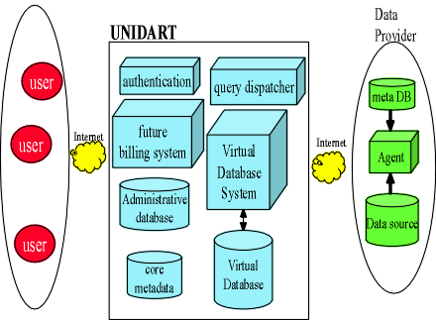

  - The expert team agreed that the UNIDART project provides a good opportunity for a trial implementation of the WMO Core Metadata, which could provide valuable feedback to its further refinement. The experts hoped that the project team of UNIDART would keep the ET informed concerning the progress of the project and its experiences while implementing and using the standard.
Report of the ETDR&C
  - The ET considered the recent report from Charles Sanders, Australia, to the meeting of the Expert Team on Data Representation and Codes (Prague 22-25 April 2002), and the recommendations and observations made by the ETDR&C in their report. The Team concurred with the ETDR&C recommendations, and wished to make some additional observations and suggestions.
  - The team observed that although the set of XML protocols and standards were still evolving, a considerable amount of utility and functionality had already developed. There were many tools and toolkits on the market to support XML technologies supplied both from Open Source and proprietary software vendors.
  - There were a large number of applied XML languages for specific purposes and the paper by Mr Sanders listed a number of meteorological variants. WMO throughout its history has developed protocols, codes and procedures for the interchange of meteorological data. These protocols, codes and procedures are metadata and their development and maintenance are primary functions of WMO. The team strongly agreed with the ETDR&C that WMO must not allow control of meteorological metadata standards to become fragmented or to become the subject of rival formats and conventions, or in the worst case, perhaps to become the subject of commercial patents.
  - The team emphatically supported the arguments of the ETDR&C that internationalisation of the codes should remain a commitment of WMO. There are mechanisms in XML which can be used to permit multiple language versions (even with multiple character sets) of XML tags. The ET observed that while for documents, the internationalization of the tags is a minor part of the task, for data representation, the tags give identification of the element content and the ability to transform the language is very important.
XML "Vocabularies"
  - Much is made of XML being "human-readable". In practice humans do not read XML, computers do. XML is intended to be processed by applications which render the content of the XML elements in human-readable form. After all, humans do not normally read HTML tags in documents, the tags are suppressed and only control how the content is displayed. For XML markup of data, as described above, the identification of the element content is crucial.
  - The utility of XML is to group, describe, identify and structure, or "markup", parts of documents and data. XML Schemas describe shared vocabularies and allow computers to carry out rules that people have defined in the schema. XML Schemas are one mechanism to describe markup tags and the allowable syntax and data types in an XML document - the rules. Where we talk about an XML vocabulary, we mean a specific set of tags and structures defined by an XML Schema.
  - The approach to XML vocabularies that the team has taken is that there should be a cascade, a hierarchy of vocabularies, of which the discovery vocabulary and code tables are at the top. Other discovery vocabularies, which are extensions of the discovery metadata will incorporate or "inherit" the Core Schema terms. Product vocabularies which include the metadata will also refer to the Core schema as well as the schemas developed for the product. The XML schema for the WMO Core Community Profile discovery metadata already works this way, in that the vocabulary references the code-list vocabulary.
  - In principle, discovery metadata should be completed as far as is possible. Optional items should be included whenever they are relevant. For those items which are fairly static, (e.g. organization address), there is a mechanism in XML which allows an XML document to contain a pointer to another XML document, and this second document could include the basic organization particulars.
Uses of meteorological XML data
  - The Team agreed with the ETDR&C that fully XML coded observations are unlikely to replace WMO codes for international exchange. Instead, they will be used to generate a variety of products that make use of different vocabularies for markup of XML documents to control how these data are processed and displayed.
  - XML is not used alone. Currently most browsers will only display an XML file as raw text, or will try to interpret the tags as HTML and will display nothing - because XML cannot be directly interpreted as HTML. However there are languages such as XSLT (eXtensible Stylesheet Language Transform) which with a minimum of instructions will transform the XML document into, for example an HTML or XHTML file which can be displayed. However many current browsers can be configured with a plug-in to use a default style for an XML document to display it. In future these plug-ins are likely to be incorporated into the next release of the browsers, and the user will not need to do any specific set-up task.
  - The applications which interpret XML and carry out the defined processing are not particularly difficult to create. Once created (in XSLT, or Java, say) they are intended to be immediately portable and useable on most other machines. This means that WMO members will be able to reuse code for XML in a very straightforward way.
- KEYWORDS TO DESCRIBE WMO DATASETS
  - To facilitate searches for datasets that will meet a given requirement, the proposed WMO Community Core Metadata Profile provides for keywords that describe the dataset. A standard list of keywords could help to achieve the maximum benefit from this provision and could also contribute to development of multi-lingual capabilities. A draft list of WMO keywords was developed via correspondence. The team reviewed this list and added a number of additional keywords. A copy of the list developed at the meeting is provided in the annex to this paragraph. Please note that since keywords are routinely added to this list, the most recent version is available via the Internet at http://www.wmo.ch/web/www/metadata/WMO-keywords.html .
  - Although a standard list of commonly used keywords could facilitate searches, particularly searches extending across datasets described in multiple languages, the group agreed that uncontrolled or open keywords should also be allowed. This would allow data providers to use keywords that may be unique to their own requirements or language without unnecessarily expanding the list of standard WMO keywords.
  - Thus two types of keywords will be allowed:
- standard WMO keywords, which will be listed on the WMO server in English, French, Spanish and Russian and will be included in the WMO Core Metadata XML Schema
- Other keywords, which can be defined by any dataset originator for their own use.
- RECOMMENDATIONS ON COMPREHENSIVE WMO METADATA STANDARDS
  - The various Programmes of WMO have a wide range of requirements for documentation of their datasets. Thus, it would be extremely difficult to develop a comprehensive standard for metadata that would meet the needs of all Programmes.
  - The team agreed that development of a comprehensive WMO metadata standard would be a difficult, lengthy and expensive undertaking and the potential benefits of a such a standard would be very limited and would not justify the large commitment of resources that would be required. The team recommended an alternative approach.
  - The ET has developed the WMO Community Core Metadata Profile, a subset of the larger and much more comprehensive ISO Metadata standard. It suggested that each WMO Programme use the WMO Core Metadata as a starting point for extension into more detailed metadata standards in response to its own requirements. These more-detailed standards should, to the extent possible, be based on the ISO standard with any necessary extensions. Reliance on the ISO standard as a common starting point would reduce the effort required by the Programmes and would greatly enhance the compatibility between the various Programme-specific standards and with the WMO Core Metadata standard. Furthermore, the team recommended that all WMO Programmes consider using XML as a format for exchanging their metadata.
  - The team suggested that consideration be given to translating the WMO BUFR, CREX and GRIB code tables into XML. The UK Met Office was largely successful in demonstrating how to represent the BUFR code tables in XML(see Meteorological Data and XML by Gorman, Kelly, Ryan and Sanders. 2002). It was also suggested that it would be useful to develop a method, perhaps through the use of XML, to link WMO station numbers with station metadata.
- REQUIRED MODIFICATIONS TO THE GUIDE ON WWW DATA MANAGEMENT
  - CBS requested that the team advise on reorganization of the Guide on WWW Data Management and coordinate the development of the WMO Guide on Data Management, including preparation of the sections relating to the WMO metadata standards. The team carefully reviewed the existing Guide and discussed the requirements for its revision as well as the effort that would be required to bring it up to date.
  - The ET determined that some sections of the Guide are seriously out of date and in major need of revision. The document was written in the years preceding 1993, and over the past decade, the wider world of Information Technology has taken enormous strides and off-the-shelf solutions now dominate all but the most specialized of WMO processes. While some sections are still relevant, many are obsolete. With so much out of date material, the Guide cannot be updated as it stands. Instead it would require a wholesale redesign.
  - The experts discussed the target audience for the Guide, how and where it would be used and how it could be kept up to date while dealing with a field as dynamic as information technology. They noted that new documents have recently been written on some topics of particular interest and relevance to WMO, such as binary representation forms and the use of the Internet and that these have been published as separate documents, outside of the Guide. The team agreed that this is probably the preferred approach to keeping the material in the Guide relevant and up to date. If such material were to be included within a revised Guide, some sections would be in danger of becoming obsolete before the revised Guide were even completed.
  - Although the Guide contains some sections that deal with the rapidly changing field of information technology, it also contains material of use as general background information or as an introduction to basic data management concepts. Such basic information does not go out of date quickly.
  - The team noted the set of requirements that were defined in the Guide and was impressed that they were well written and quite forward looking. In fact, many of the stated requirements remain worthy goals, more than 10 years after they were written.
  - With these considerations in mind the team felt that the Guide was probably not worth the effort required to bring it up to date and keep it up to date as an entire printed package. Some sections could remain relevant for many years, while others become obsolete so quickly that a printed copy is of little use. Instead, the experts recommended that the Guide be considered primarily as an on-line document with updates applied chapter by chapter as requirements and advances in technology dictate. Furthermore, the chapters concerned with the most rapidly changing fields, such as computer graphics should be removed or replaced with references to existing on-line authorities on these topics.
- FUTURE WORK PROGRAMME
  - Having addressed all of the tasks assigned to it by CBS, the only outstanding work is the preparation of a document describing the WMO Core Metadata Standard for the consideration of the Commission at its extraordinary session in December 2002. The team felt that the description defined at the meeting is at a level of detail appropriate for consideration by the Commission. Thus, the preparation of the formal document should be a simple and straightforward task.
- CLOSURE OF THE MEETING
  - The meeting closed on Thursday 16 May 2002.
Annex to Paragraph 2.7
WMO Core Metadata

Notes: The following table provides an overview of the WMO Community Core Metadata Profile suitable for use by decision makers and users - NOT implementers. To implement this standard the ISO DIS 19115 document, which describes the complete ISO standard, must be consulted.
This standard provides a general definition for directory searches and exchange that should be applicable to a wide variety of WMO datasets. It does not specify how these metadata should be archived or presented to users. It also does not specify any particular implementation and could be implemented as a database, a flat file, or any other suitable mechanism. However, XML is recommended as the standard for exchange. The comprehensive and technical details required for implementation of this standard in XML are provided in the WMO Core Metadata XML Schema, which is given in the annex to paragraph 4.2 below. In the XML Schema, Class names (such as MD_Metadata) are reserved for data types. These data type names do not appear in the XML instance. Instead the classes are referenced by the name of an object (e.g. metadata) which is an instance of the class (MD_Metadata).
Of the core elements listed, those in bold are required, with all others being optional.
It must be remembered that this list defines a minimum set of information to describe data for WMO exchange and is not exhaustive. To fully meet the requirements of WMO Programmes for metadata, application of far more comprehensive standards would be required. The development of these comprehensive standards should be pursued by the individual programmes.
Generic Name | ISO Field/Class Name and Reference Lines | Definition
Metadata ID  Metadata language  Metadata char. set  Metadata contact  Metadata date  Metadata name  Metadata Version  Data Reference System  Data information  Data distribution  Information  Data Lineage or Quality | MD_Metadata (1)  fileIdentifier (2)  language (3)  characterSet (4)  contact (8)  CI_ResponsibleParty (see 374 below)  dateStamp (9)  metadataStandardName (10)  metadataStandardVersion (11)  referenceSystemInfo (13)  MD_ReferenceSystem (186)  ReferenceSystemIdentifier (187)  ReferenceAuthority (206)  CI_ResponsibleParty (374) (see below)  ReferenceDescription (207)  IdentificationInfo(15)  MD_DataIndentification (see  36 below)  distributionInfo(17)  MD_Distribution (see 270  below)  dataQualityInfo(18)  LI_Lineage (see 82 below) | Unique identifier for this metadata item  Language of this metadata item  Character set of this metadata item (Default of ISO 10646-1)  Party responsible for this metadata item  Date that this metadata item was created  Name of the metadata standard (including profile name) used  Version (profile) of the metadata standard used  Description of the data temporal and spatial reference system  Information about the reference systems used (temporal, coordinate and geographic)  Name of reference system  Person or party responsible for maintenance of the reference system  Description of the Reference System  Basic information about the data  Information about the data distribution and availability  Information about the data lineage or quality
Title  Reference Date  Identifier  Abstract  Dataset Contact  Update frequency  Access Rights or Restrictions  Spatial Resolution  Language  Character set  Topic Category  Keywords | MD_DataIdentification (36)  Citation (24)  title (360)  referenceDate (362)  CI_Date (see 393 below)  identifier (365)  identifierType (366)  abstract (25)  pointOfContact (29)  CI_ResponsibleParty (see 374 below)  resourceMaintenance(30)  maintenanceAnd UpdateFrequency(143)  maintenanceNote(148)  resourceConstraints (35)  MD_Constraints (67) (see below)  spatialResolution (38)  spatialRepresentationType (37)  language(39)  characterSet (40)  topicCategory (41)  descriptiveKeywords (33) | Basic information required to uniquely identify a dataset  Name of the dataset  Reference date for the dataset  Unique identifier for dataset  Form of the unique identifier (if standardized)  Brief narrative summary of the contents of the dataset  Identification of, and means of communication with, person(s) and organizations(s) associated with the dataset  Frequency with which changes are made to the dataset after the intial dataset is created  Information regarding specific requirements for maintaining the dataset  Restrictions on the access and use of the resource or metadata  Spatial density of the data in the dataset (e.g. grid spacing)  Method used to spatially represent data in the dataset [Code list: B.5.26]  Language(s) used in the dataset, if applicable  Character set used in the dataset, if applicable  Discipline covered by this dataset [ISO code list B.5.27] - Note this field is of limited use for WMO purposes but is a required field within the ISO standard and is included to ensure conformity.  List of predefined and other keywords used to describe the dataset
Date or period | CI_Date (393)  date or period (394)  dateType (395) | Reference date or period for the dataset  Type of date [code list: creation, publication or revision date]
Responsible Party  Organization  Org. role  Individual name  Position  Phone number  Fax number  Address  E-mail address  Web Site | CI_ResponsibleParty (374)  organisationName (376)  role(379)  individualName (375)  positionName (377)  contactInfo (378)  CI_Contact (387)  phone (388)  voice (408)  facsimile (409)  address(389)  deliveryPoint (381)  city (382)  postalCode (384)  country (385)  electronicMailAddress (386)  onLineAddress (390) | Name of the responsible organization  Function performed by the responsible party [code list: resourceProvider, custodian, owner, user, distributer, originator, etc¨]  Name of the responsible person  Position of the responsible person  NOTE: Either a phone number or address is required  Telephone by which individuals can speak to the responsible party  Telephone number of a fax machine for the responsible party  Address line for the location  City of the location  Postal code  Country  Electronic mail address of the responsible party  URL of organization
Vertical Extent  Geographic Extent  Geographic name  Bounding box  Bounding polygon  Temporal Extent | EX_Extent (334)  Description (335)  Ex_VerticalExtent (354)  minimumValue (355)  maximumValue (356)  unitOfMeasure (357)  verticalDatum (358)  EX_GeographicExtent (339)  EX_GeographicDescription (348)  geographicIdentifier (349)  EX_GeographicBoundingBox  westBoundLongitude (344)  eastBoundLongitude (345)  southBoundLatitude (346)  northBoundLatitude (347)  EX_BoundingPolygon (341)  polygon (342)  EX_TemporalExtent (350)  Extent (351)  beginDateTime (new)  endDateTime (new)  dataFrequency (new) | Information about spatial, vertical, and temporal extent of the dataset  Spatial and temporal extent for the dataset (in text)  Vertical domain of the dataset  Lowest vertical extent contained in the dataset  Highest vertical extent contained in the dataset  Vertical units used for vertical extent information (E.g.: metres, feet, hectopascals)  Information about the origin from which the maximum and minimum elevation values are measured (see ISO 1911)  Note: At least either a description, bounding box or bounding polygon is required  Description of the geographic area using identifiers (names)  Identifier used to represent a geographic area or location  NOTE This is only an approximate reference so specifying the co-ordinate system is unnecessary  Western-most limit of the dataset, longitude in decimal degrees (positive east)  Eastern-most limit of the dataset, longitude in decimal degrees (positive east)  Southern-most limit of the dataset, latitude in decimal degrees (positive north)  Northern-most, limit of the dataset, latitude in decimal degrees (positive north)  Sets of points defining a bounding polygon  NOTE: Each of the 3 fields below is required if applicable  Beginning date of the data in the dataset  Ending date of data in the dataset  Observing frequency of the data in the dataset [code: WMO_DataFrequencyCode
Access Rights or Restrictions | MD_Constraints (67)  useLimitation (68)  MD_LegalConstraints (69)  accessConstraints (70)  useConstraints (71)  otherConstraints (72)  MD_SecurityConstraints (73)  classification (74)  userNote (75)  classificationSystem (76)  handlingDescription (78) | Restrictions on the access and use of the dataset or metadata (Could specify WMO Additional Data as free text  Restrictions and legal prerequisites for accessing and using the dataset  Any special restrictions or limitations on obtaining the dataset  Any special restrictions or limitations or warnings on using the dataset  Other restrictions and legal prerequisites for accessing and using the dataset  Handling restrictions imposed on the dataset for security reasons  Name of the handling restrictions on the dataset  Explanation of the application of the legal constraints or other restrictions and legal prerequisites for obtaining and using the dataset  Name of the classification system  Additional information about the restrictions on handling the dataset
Format name  Format version  On-line source  Off-line media | MD_Distribution (270)  distributionFormat (271)  name (285)  version (286)  TransferOptions (273)  OnLine (277)  linkage (397)  WMO_Source (new)  Offline (278)  mediumName (292) | Information about the distributor of and options for obtaining the dataset  Provides a description of the format of the data to be distributed  Name of the data transfer format(s)  Version of the format (date, number, etc.)  NOTE: At least either on-line source or off-line media is required  Information about online sources from which the dataset can be obtained  Location (address) for on-line access using a Uniform Resource Locator  WMO centre identifier  Information about offline media on which the dataset can be obtained  Name of the medium on which the dataset can be received [code list: ISO B.5.20]
Processing Level | LI_Lineage (82)  statement(83)  processStep(84)  source(85) | Information about the level of processing applied to the dataset  Information about the events or source data used in constructing the dataset  Information about an event in the creation process for the dataset  Information about the source data used in creating the dataset
Reference System | MD_ReferenceSystem (186)  referenceSystemIdentifier (187)  authority (206)  CI_ResponsibleParty (374) (see above)  code(207) | Information about the reference systems used (temporal, coordinate and geographic)  Name of reference system  Person or party responsible for maintenance of the reference system namespace  Alphanumeric value identifying an instance in the namespace

Annex to paragraph 3.1

Extensions to ISO Code Lists

B.5.26 MD_SpatialRepresentationTypeCode <<CodeList>>
 | Name | Domain code | Definition
 | MD_SpatialRepresentationTypeCode | SpatRepTypCd | method used to represent geographic information in the dataset
 | vector | 001 | vector data is used to represent geographic data
 | grid | 002 | grid data is used to represent geographic data
 | textTable | 003 | textual or tabular data is used to represent geographic data
 | tin | 004 | triangulated irregular network
 | stereoModel | 005 | three-dimensional view formed by the intersecting homologous rays of an overlapping pair of images
 | video | 006 | scene from a video recording
Additional entries
 | irregularPoints | 007 | Irregularly-spaced points, such as meteorological stations

NEW:
WMO_DataFrequencyCode <<CodeList>>
 | Name | Domain code | Definition
 | WMO_DataFrequencyCode | DataFreqCd | Temporal sampling frequency of the data within the dataset
 | Continuous | 001 | More than once per minute
 | 1minute | 002
 | 5minute | 003
 | 10minute | 004
 | 15minute | 005
 | 30minute | 006
 | Hourly | 007
 | 3hourly | 008
 | 6hourly | 009
 | 8hourly | 010
 | 12hourly | 011
 | Daily | 012
 | Weekly | 013
 | 10day | 014
 | Fortnightly | 015
 | Monthly | 016
 | 3monthly | 017
 | 6monthly | 018
 | Annual | 019
 | decade | 020 | Decade or longer

Annex to Paragraph 4.2
XML Schema Schematic

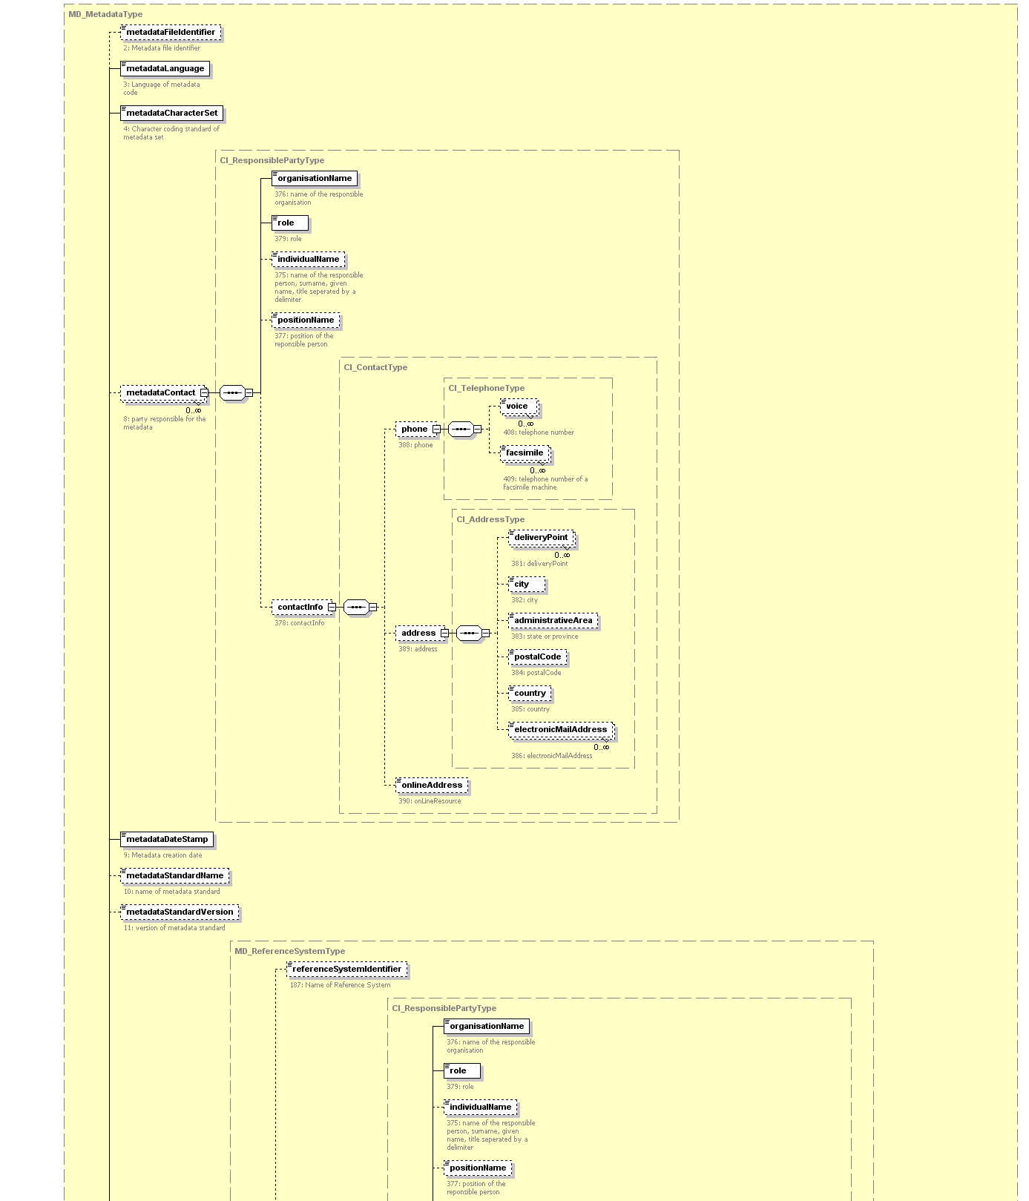

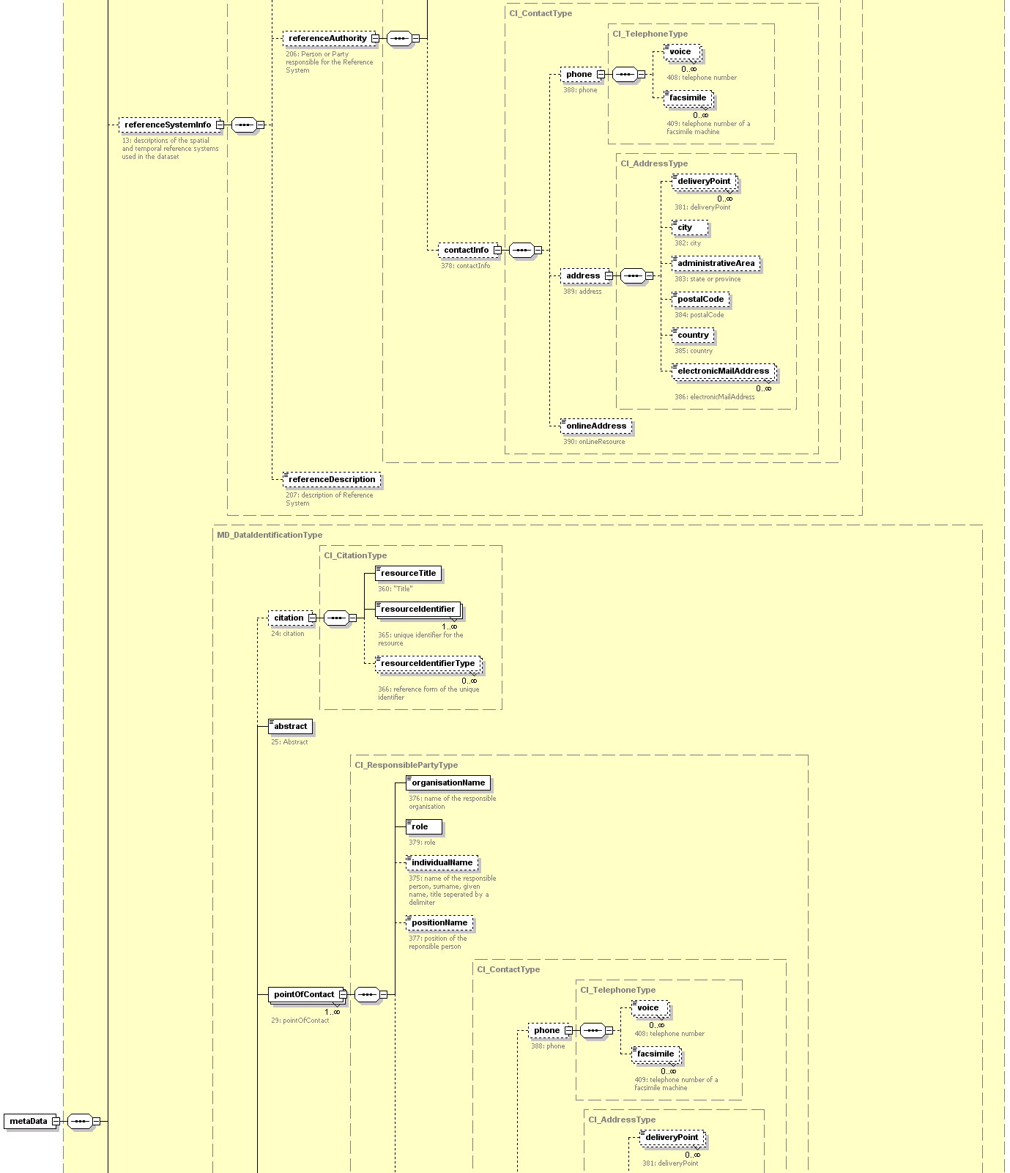

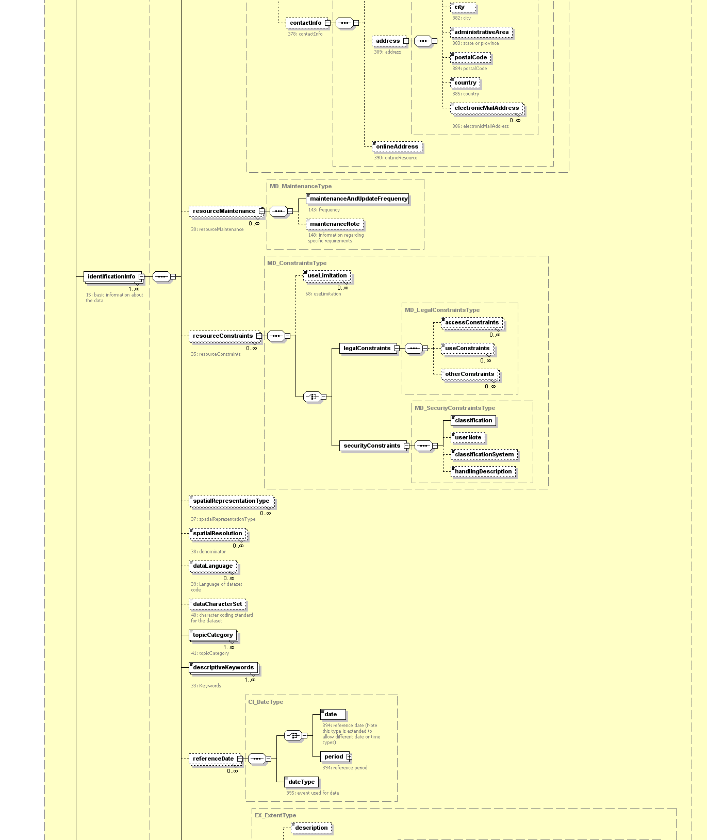

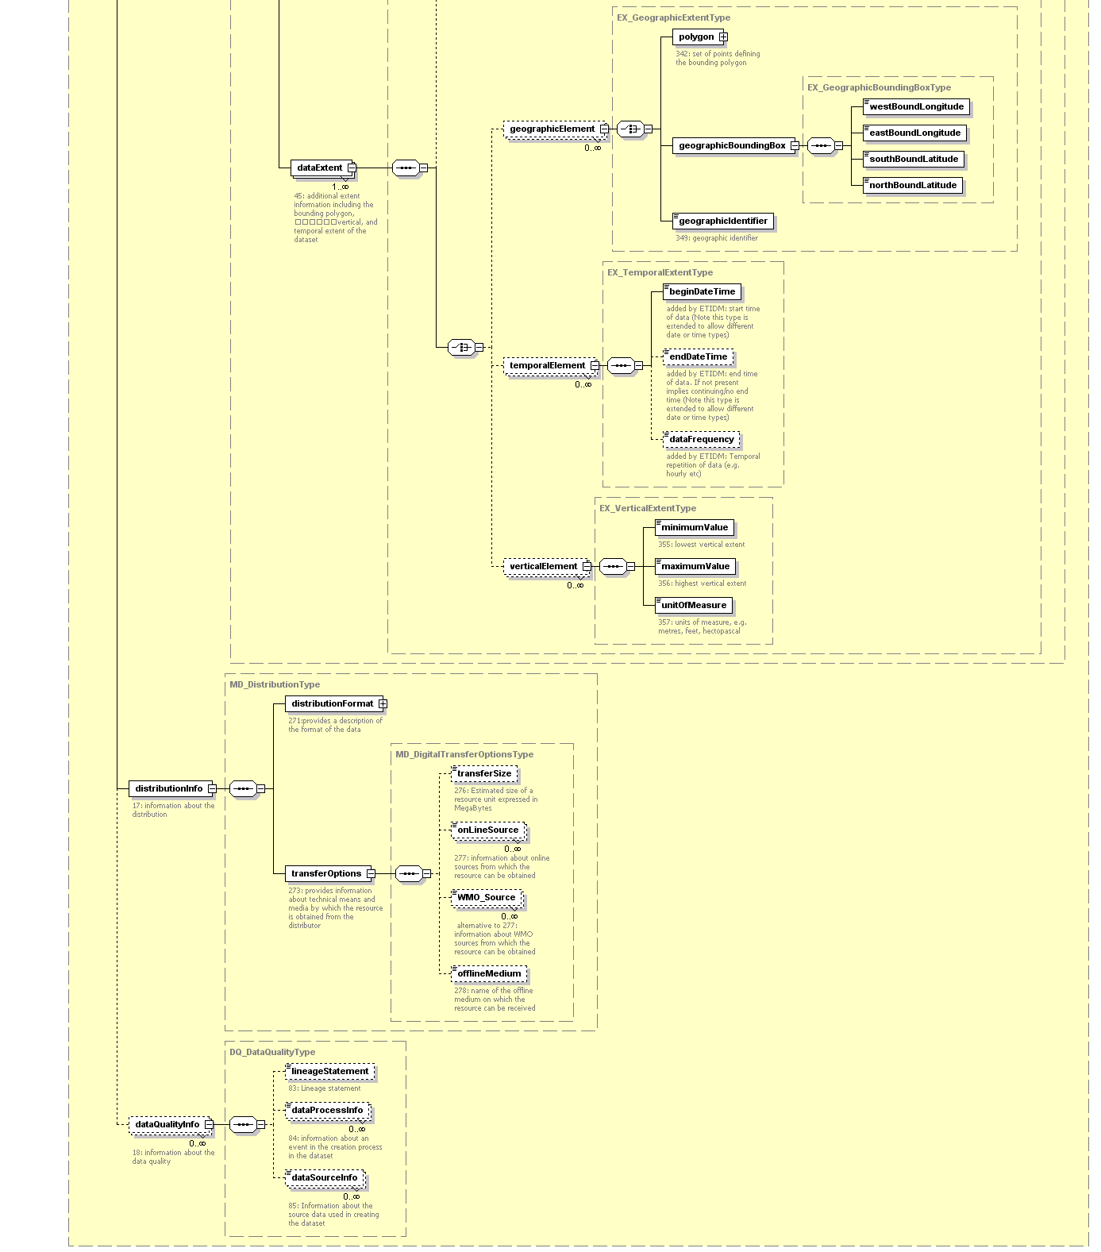
Annex to Paragraph 4.2 (Continued)
XML Schema

Latest version of WMO Metadata XML Schema is available at http://www.wmo.ch/web/www/metadata/WMO-metadata-XML.html

<?xml version="1.0" encoding="UTF-8"?>
<!-- edited with XML Spy v4.1 U (http://www.xmlspy.com) by Gil Ross Met Office UK -->
<xs:schema targetNamespace="http://www.wmo.ch/www/metadata" xmlns:xs="http://www.w3.org/2001/XMLSchema" xmlns="http://www.wmo.ch/www/metadata" elementFormDefault="qualified" attributeFormDefault="unqualified">
<xs:annotation>
<xs:documentation> Schema for the WMO Community Core Metadata Profile. Based on XML Schema and ISO 19115
Version 0.1 Defined by Expert Team on Integrated Data Management 13-16 May 2002 Shinfield England.
</xs:documentation>
</xs:annotation>
<!-- Include code lists -->
<xs:include schemaLocation="http://www.wmo.ch/ww/metadata/WMO19115_CodeLists_v0_1.xsd"/>
<xs:element name="metaData" type="MD_MetadataType"/>
<xs:complexType name="MD_MetadataType">
<xs:annotation>
<xs:documentation>Lines 2-22</xs:documentation>
</xs:annotation>
<xs:sequence>
<xs:element name="metadataFileIdentifier" type="xs:string" minOccurs="0">
<xs:annotation>
<xs:documentation>2: Metadata file identifier</xs:documentation>
</xs:annotation>
</xs:element>
<xs:element name="metadataLanguage" type="xs:language" default="en">
<xs:annotation>
<xs:documentation>3: Language of metadata code</xs:documentation>
</xs:annotation>
</xs:element>
<xs:element name="metadataCharacterSet" type="MD_CharacterSetCodeType">
<xs:annotation>
<xs:documentation>4: Character coding standard of metadata set</xs:documentation>
</xs:annotation>
</xs:element>
<xs:element name="metadataContact" type="CI_ResponsiblePartyType" minOccurs="0" maxOccurs="unbounded">
<xs:annotation>
<xs:documentation>8: party responsible for the metadata</xs:documentation>
</xs:annotation>
</xs:element>
<xs:element name="metadataDateStamp" type="xs:date">
<xs:annotation>
<xs:documentation>9: Metadata creation date</xs:documentation>
</xs:annotation>
</xs:element>
<xs:element name="metadataStandardName" type="xs:string" minOccurs="0">
<xs:annotation>
<xs:documentation>10: name of metadata standard</xs:documentation>
</xs:annotation>
</xs:element>
<xs:element name="metadataStandardVersion" type="xs:string" minOccurs="0">
<xs:annotation>
<xs:documentation>11: version of metadata standard</xs:documentation>
</xs:annotation>
</xs:element>
<xs:element name="referenceSystemInfo" type="MD_ReferenceSystemType" minOccurs="0">
<xs:annotation>
<xs:documentation>13: descriptions of the spatial and temporal reference systems used in the dataset</xs:documentation>
</xs:annotation>
</xs:element>
<xs:element name="identificationInfo" type="MD_DataIdentificationType" maxOccurs="unbounded">
<xs:annotation>
<xs:documentation>15: basic information about the data</xs:documentation>
</xs:annotation>
</xs:element>
<xs:element name="distributionInfo" type="MD_DistributionType">
<xs:annotation>
<xs:documentation>17: information about the distribution</xs:documentation>
</xs:annotation>
</xs:element>
<xs:element name="dataQualityInfo" type="DQ_DataQualityType" minOccurs="0" maxOccurs="unbounded">
<xs:annotation>
<xs:documentation>18: information about the data quality</xs:documentation>
</xs:annotation>
</xs:element>
</xs:sequence>
</xs:complexType>
<xs:complexType name="MD_DataIdentificationType">
<xs:annotation>
<xs:documentation>MD_Identification Lines 24-35 and Lines 37-46</xs:documentation>
</xs:annotation>
<xs:sequence>
<xs:element name="citation" type="CI_CitationType" minOccurs="0">
<xs:annotation>
<xs:documentation>24: citation</xs:documentation>
</xs:annotation>
</xs:element>
<xs:element name="abstract" type="xs:string">
<xs:annotation>
<xs:documentation>25: Abstract</xs:documentation>
</xs:annotation>
</xs:element>
<xs:element name="pointOfContact" type="CI_ResponsiblePartyType" maxOccurs="unbounded">
<xs:annotation>
<xs:documentation>29: pointOfContact</xs:documentation>
</xs:annotation>
</xs:element>
<xs:element name="resourceMaintenance" type="MD_MaintenanceType" minOccurs="0" maxOccurs="unbounded">
<xs:annotation>
<xs:documentation>30: resourceMaintenance</xs:documentation>
</xs:annotation>
</xs:element>
<xs:element name="resourceConstraints" type="MD_ConstraintsType" minOccurs="0" maxOccurs="unbounded">
<xs:annotation>
<xs:documentation>35: resourceConstraints</xs:documentation>
</xs:annotation>
</xs:element>
<xs:element name="spatialRepresentationType" type="MD_SpatialRepresentationTypeCode" minOccurs="0" maxOccurs="unbounded">
<xs:annotation>
<xs:documentation>37: spatialRepresentationType</xs:documentation>
</xs:annotation>
</xs:element>
<xs:element name="spatialResolution" type="xs:positiveInteger" minOccurs="0" maxOccurs="unbounded">
<xs:annotation>
<xs:documentation>38: denominator</xs:documentation>
</xs:annotation>
</xs:element>
<xs:element name="dataLanguage" type="xs:language" minOccurs="0" maxOccurs="unbounded">
<xs:annotation>
<xs:documentation>39: Language of dataset code</xs:documentation>
</xs:annotation>
</xs:element>
<xs:element name="dataCharacterSet" type="MD_CharacterSetCodeType" minOccurs="0">
<xs:annotation>
<xs:documentation>40: character coding standard for the dataset</xs:documentation>
</xs:annotation>
</xs:element>
<xs:element name="topicCategory" type="MD_TopicCategoryCodeType" maxOccurs="unbounded">
<xs:annotation>
<xs:documentation>41: topicCategory</xs:documentation>
</xs:annotation>
</xs:element>
<xs:element name="descriptiveKeywords" type="WMO_KeywordsOrFreeKeywordsType" maxOccurs="unbounded">
<xs:annotation>
<xs:documentation>33: Keywords</xs:documentation>
</xs:annotation>
</xs:element>
<xs:element name="referenceDate" type="CI_DateType" minOccurs="0" maxOccurs="unbounded">
<xs:annotation>
<xs:documentation/>
</xs:annotation>
</xs:element>
<xs:element name="dataExtent" type="EX_ExtentType" maxOccurs="unbounded">
<xs:annotation>
<xs:documentation>45: additional extent information including the bounding polygon,
vertical, and temporal extent of the dataset</xs:documentation>
</xs:annotation>
</xs:element>
<!-- <xs:element name="validityDate" type="CI_DateType" minOccurs="0"/> -->
</xs:sequence>
</xs:complexType>
<xs:complexType name="CI_CitationType">
<xs:annotation>
<xs:documentation>CI_Citation Lines 360-373 </xs:documentation>
</xs:annotation>
<xs:sequence>
<xs:element name="resourceTitle" type="xs:string">
<xs:annotation>
<xs:documentation>360: "Title"</xs:documentation>
</xs:annotation>
</xs:element>
<xs:element name="resourceIdentifier" type="xs:string" maxOccurs="unbounded">
<xs:annotation>
<xs:documentation>365: unique identifier for the resource</xs:documentation>
</xs:annotation>
</xs:element>
<xs:element name="resourceIdentifierType" type="xs:string" minOccurs="0" maxOccurs="unbounded">
<xs:annotation>
<xs:documentation>366: reference form of the unique identifier</xs:documentation>
</xs:annotation>
</xs:element>
</xs:sequence>
</xs:complexType>
<xs:complexType name="CI_ResponsiblePartyType">
<xs:annotation>
<xs:documentation>CI_ResponsibleParty Lines 375-379 </xs:documentation>
</xs:annotation>
<xs:sequence>
<xs:element name="organisationName" type="xs:string">
<xs:annotation>
<xs:documentation>376: name of the responsible organisation</xs:documentation>
</xs:annotation>
</xs:element>
<xs:element name="role" type="CI_RoleCodeType">
<xs:annotation>
<xs:documentation>379: role</xs:documentation>
</xs:annotation>
</xs:element>
<xs:element name="individualName" type="xs:string" minOccurs="0">
<xs:annotation>
<xs:documentation>375: name of the responsible person, surname, given name, title seperated by a delimiter</xs:documentation>
</xs:annotation>
</xs:element>
<xs:element name="positionName" type="xs:string" minOccurs="0">
<xs:annotation>
<xs:documentation>377: position of the reponsible person</xs:documentation>
</xs:annotation>
</xs:element>
<xs:element name="contactInfo" type="CI_ContactType" minOccurs="0">
<xs:annotation>
<xs:documentation>378: contactInfo</xs:documentation>
</xs:annotation>
</xs:element>
</xs:sequence>
</xs:complexType>
<xs:complexType name="CI_ContactType">
<xs:annotation>
<xs:documentation>CI_Contact DataType (B.3.2.2)</xs:documentation>
</xs:annotation>
<xs:sequence>
<xs:element name="phone" type="CI_TelephoneType" minOccurs="0">
<xs:annotation>
<xs:documentation>388: phone</xs:documentation>
</xs:annotation>
</xs:element>
<xs:element name="address" type="CI_AddressType" minOccurs="0">
<xs:annotation>
<xs:documentation>389: address</xs:documentation>
</xs:annotation>
</xs:element>
<xs:element name="onlineAddress" type="xs:anyURI" minOccurs="0">
<xs:annotation>
<xs:documentation>390: onLineResource</xs:documentation>
</xs:annotation>
</xs:element>
</xs:sequence>
</xs:complexType>
<xs:complexType name="CI_TelephoneType">
<xs:annotation>
<xs:documentation>CI_Telephone Lines 408-409</xs:documentation>
</xs:annotation>
<xs:sequence>
<xs:element name="voice" type="xs:string" minOccurs="0" maxOccurs="unbounded">
<xs:annotation>
<xs:documentation>408: telephone number</xs:documentation>
</xs:annotation>
</xs:element>
<xs:element name="facsimile" type="xs:string" minOccurs="0" maxOccurs="unbounded">
<xs:annotation>
<xs:documentation>409: telephone number of a facsimile machine</xs:documentation>
</xs:annotation>
</xs:element>
</xs:sequence>
</xs:complexType>
<xs:complexType name="CI_AddressType">
<xs:annotation>
<xs:documentation>CI_Address Lines 381-386</xs:documentation>
</xs:annotation>
<xs:sequence>
<xs:element name="deliveryPoint" type="xs:string" minOccurs="0" maxOccurs="unbounded">
<xs:annotation>
<xs:documentation>381: deliveryPoint</xs:documentation>
</xs:annotation>
</xs:element>
<xs:element name="city" type="xs:string" minOccurs="0">
<xs:annotation>
<xs:documentation>382: city</xs:documentation>
</xs:annotation>
</xs:element>
<xs:element name="administrativeArea" type="xs:string" minOccurs="0">
<xs:annotation>
<xs:documentation>383: state or province</xs:documentation>
</xs:annotation>
</xs:element>
<xs:element name="postalCode" type="xs:string" minOccurs="0">
<xs:annotation>
<xs:documentation>384: postalCode</xs:documentation>
</xs:annotation>
</xs:element>
<xs:element name="country" type="xs:string" minOccurs="0">
<xs:annotation>
<xs:documentation>385: country</xs:documentation>
</xs:annotation>
</xs:element>
<xs:element name="electronicMailAddress" type="xs:string" minOccurs="0" maxOccurs="unbounded">
<xs:annotation>
<xs:documentation>386: electronicMailAddress</xs:documentation>
</xs:annotation>
</xs:element>
</xs:sequence>
</xs:complexType>
<xs:complexType name="CI_DateType">
<xs:annotation>
<xs:documentation>CI_Date Lines 394-395: reference date and event</xs:documentation>
</xs:annotation>
<xs:sequence>
<xs:choice>
<xs:element name="date" type="dateAndTimeTypes">
<xs:annotation>
<xs:documentation>394: reference date (Note this type is extended to allow different date or time types)</xs:documentation>
</xs:annotation>
</xs:element>
<xs:element name="period" type="EX_TemporalExtentType">
<xs:annotation>
<xs:documentation>394: reference period</xs:documentation>
</xs:annotation>
</xs:element>
</xs:choice>
<xs:element name="dateType" type="CI_DateTypeCodeType">
<xs:annotation>
<xs:documentation>395: event used for date</xs:documentation>
</xs:annotation>
</xs:element>
</xs:sequence>
</xs:complexType>
<xs:complexType name="MD_ConstraintsType">
<xs:annotation>
<xs:documentation>MD_Constraints Lines 68-77: restrictions on the access and use of data</xs:documentation>
</xs:annotation>
<xs:sequence>
<xs:element name="useLimitation" type="xs:string" minOccurs="0" maxOccurs="unbounded">
<xs:annotation>
<xs:documentation>68: useLimitation</xs:documentation>
</xs:annotation>
</xs:element>
<xs:choice>
<xs:element name="legalConstraints" type="MD_LegalConstraintsType"/>
<xs:element name="securityConstraints" type="MD_SecuriyConstraintsType"/>
</xs:choice>
</xs:sequence>
</xs:complexType>
<xs:complexType name="MD_LegalConstraintsType">
<xs:annotation>
<xs:documentation>MD_LegalConstraints Lines 70-72: restrictions and legal prerequisites</xs:documentation>
</xs:annotation>
<xs:sequence>
<xs:element name="accessConstraints" type="MD_RestrictionCodeType" minOccurs="0" maxOccurs="unbounded"/>
<xs:element name="useConstraints" type="MD_RestrictionCodeType" minOccurs="0" maxOccurs="unbounded"/>
<xs:element name="otherConstraints" type="xs:string" minOccurs="0" maxOccurs="unbounded"/>
</xs:sequence>
</xs:complexType>
<xs:complexType name="MD_SecuriyConstraintsType">
<xs:annotation>
<xs:documentation>MD_SecurityConstraints</xs:documentation>
</xs:annotation>
<xs:sequence>
<xs:element name="classification" type="MD_ClassificationCodeType"/>
<xs:element name="userNote" type="xs:string" minOccurs="0"/>
<xs:element name="classificationSystem" type="xs:string" minOccurs="0"/>
<xs:element name="handlingDescription" type="xs:string" minOccurs="0"/>
</xs:sequence>
</xs:complexType>
<xs:complexType name="MD_ReferenceSystemType">
<xs:annotation>
<xs:documentation>MD_ReferenceSystemType Lines 187-188 expanding as classes information about the reference system</xs:documentation>
</xs:annotation>
<xs:sequence>
<xs:element name="referenceSystemIdentifier" type="xs:string" minOccurs="0">
<xs:annotation>
<xs:documentation>187: Name of Reference System</xs:documentation>
</xs:annotation>
</xs:element>
<xs:element name="referenceAuthority" type="CI_ResponsiblePartyType" minOccurs="0">
<xs:annotation>
<xs:documentation>206: Person or Party responsible for the Reference System</xs:documentation>
</xs:annotation>
</xs:element>
<xs:element name="referenceDescription" type="xs:string" minOccurs="0">
<xs:annotation>
<xs:documentation>207: description of Reference System</xs:documentation>
</xs:annotation>
</xs:element>
</xs:sequence>
</xs:complexType>
<xs:complexType name="MD_MaintenanceType">
<xs:annotation>
<xs:documentation>MD_Maintenance Lines 143-148: scope and frequency of updating</xs:documentation>
</xs:annotation>
<xs:sequence>
<xs:element name="maintenanceAndUpdateFrequency" type="MD_MaintenanceFrequencyCodeType">
<xs:annotation>
<xs:documentation>143: frequency</xs:documentation>
</xs:annotation>
</xs:element>
<xs:element name="maintenanceNote" type="xs:string" minOccurs="0">
<xs:annotation>
<xs:documentation>148: information regarding specific requirements</xs:documentation>
</xs:annotation>
</xs:element>
</xs:sequence>
</xs:complexType>
<xs:complexType name="EX_ExtentType">
<xs:annotation>
<xs:documentation>EX_Extent Lines 335-338</xs:documentation>
</xs:annotation>
<xs:sequence>
<xs:element name="description" type="xs:string" minOccurs="0"/>
<xs:choice>
<xs:element name="geographicElement" type="EX_GeographicExtentType" minOccurs="0" maxOccurs="unbounded"/>
<xs:element name="temporalElement" type="EX_TemporalExtentType" minOccurs="0" maxOccurs="unbounded"/>
<xs:element name="verticalElement" type="EX_VerticalExtentType" minOccurs="0" maxOccurs="unbounded"/>
</xs:choice>
</xs:sequence>
</xs:complexType>
<xs:complexType name="EX_GeographicExtentType">
<xs:annotation>
<xs:documentation>EX_GeographicExtent Lines 340-349: geographic area of the dataset</xs:documentation>
</xs:annotation>
<xs:choice>
<xs:element name="polygon" type="PolygonType">
<xs:annotation>
<xs:documentation>342: set of points defining the bounding polygon</xs:documentation>
</xs:annotation>
</xs:element>
<xs:element name="geographicBoundingBox" type="EX_GeographicBoundingBoxType"/>
<xs:element name="geographicIdentifier" type="xs:string">
<xs:annotation>
<xs:documentation>349: geographic identifier</xs:documentation>
</xs:annotation>
</xs:element>
</xs:choice>
</xs:complexType>
<xs:complexType name="EX_GeographicBoundingBoxType">
<xs:annotation>
<xs:documentation>EX_GeographicBoundingBox Lines 344-347</xs:documentation>
</xs:annotation>
<xs:sequence>
<xs:element name="westBoundLongitude" type="LongitudeType"/>
<xs:element name="eastBoundLongitude" type="LongitudeType"/>
<xs:element name="southBoundLatitude" type="LatitudeType"/>
<xs:element name="northBoundLatitude" type="LatitudeType"/>
</xs:sequence>
</xs:complexType>
<xs:complexType name="EX_TemporalExtentType">
<xs:annotation>
<xs:documentation>EX_TemporalExtent: time period covered by the dataset</xs:documentation>
</xs:annotation>
<xs:sequence>
<xs:element name="beginDateTime" type="dateAndTimeTypes">
<xs:annotation>
<xs:documentation>added by ETIDM: start time of data (Note this type is extended to allow different date or time types)</xs:documentation>
</xs:annotation>
</xs:element>
<xs:element name="endDateTime" type="dateAndTimeTypes" minOccurs="0">
<xs:annotation>
<xs:documentation>added by ETIDM: end time of data. If not present implies continuing/no end time (Note this type is extended to allow different date or time types)</xs:documentation>
</xs:annotation>
</xs:element>
<xs:element name="dataFrequency" type="frequencyCodeType" minOccurs="0">
<xs:annotation>
<xs:documentation>added by ETIDM: Temporal repetition of data (e.g. hourly etc)</xs:documentation>
</xs:annotation>
</xs:element>
</xs:sequence>
</xs:complexType>
<xs:complexType name="EX_VerticalExtentType">
<xs:annotation>
<xs:documentation>EX_VerticalExtent Lines 355-358</xs:documentation>
</xs:annotation>
<xs:sequence>
<xs:element name="minimumValue" type="xs:float">
<xs:annotation>
<xs:documentation>355: lowest vertical extent</xs:documentation>
</xs:annotation>
</xs:element>
<xs:element name="maximumValue" type="xs:float">
<xs:annotation>
<xs:documentation>356: highest vertical extent</xs:documentation>
</xs:annotation>
</xs:element>
<xs:element name="unitOfMeasure" type="xs:string">
<xs:annotation>
<xs:documentation>357: units of measure, e.g. metres, feet, hectopascal</xs:documentation>
</xs:annotation>
</xs:element>
</xs:sequence>
</xs:complexType>
<xs:complexType name="PolygonType">
<xs:annotation>
<xs:documentation>set of points to define a polygon</xs:documentation>
</xs:annotation>
<xs:sequence>
<xs:element name="point" type="PointType" maxOccurs="unbounded">
<xs:annotation>
<xs:documentation>point</xs:documentation>
</xs:annotation>
</xs:element>
</xs:sequence>
</xs:complexType>
<xs:complexType name="PointType">
<xs:annotation>
<xs:documentation>Latitude and longitude value</xs:documentation>
</xs:annotation>
<xs:sequence>
<xs:element name="latitude" type="LatitudeType"/>
<xs:element name="longitude" type="LongitudeType"/>
</xs:sequence>
</xs:complexType>
<xs:complexType name="DQ_DataQualityType">
<xs:annotation>
<xs:documentation>DQ_DataQuality Lines 79-81</xs:documentation>
</xs:annotation>
<xs:sequence>
<xs:element name="lineageStatement" type="xs:string" minOccurs="0">
<xs:annotation>
<xs:documentation>83: Lineage statement</xs:documentation>
</xs:annotation>
</xs:element>
<xs:element name="dataProcessInfo" type="xs:string" minOccurs="0" maxOccurs="unbounded">
<xs:annotation>
<xs:documentation>84: information about an event in the creation process in the dataset</xs:documentation>
</xs:annotation>
</xs:element>
<xs:element name="dataSourceInfo" type="xs:string" minOccurs="0" maxOccurs="unbounded">
<xs:annotation>
<xs:documentation>85: Information about the source data used in creating the dataset</xs:documentation>
</xs:annotation>
</xs:element>
</xs:sequence>
</xs:complexType>
<xs:complexType name="MD_DistributionType">
<xs:annotation>
<xs:documentation>MD_Distribution Lines 271-273</xs:documentation>
</xs:annotation>
<xs:sequence>
<xs:element name="distributionFormat" type="MD_FormatType">
<xs:annotation>
<xs:documentation>271:provides a description of the format of the data</xs:documentation>
</xs:annotation>
</xs:element>
<xs:element name="transferOptions" type="MD_DigitalTransferOptionsType">
<xs:annotation>
<xs:documentation>273: provides information about technical means and media by which the resource is obtained from the distributor</xs:documentation>
</xs:annotation>
</xs:element>
</xs:sequence>
</xs:complexType>
<xs:complexType name="MD_FormatType">
<xs:annotation>
<xs:documentation>284 Specifies representation of data objects Lines 285-290</xs:documentation>
</xs:annotation>
<xs:sequence>
<xs:element name="formatName" type="xs:string">
<xs:annotation>
<xs:documentation>285: name of the data transfer format(s)</xs:documentation>
</xs:annotation>
</xs:element>
<xs:element name="formatVersion" type="xs:string" minOccurs="0">
<xs:annotation>
<xs:documentation>286: version of the format(s)</xs:documentation>
</xs:annotation>
</xs:element>
</xs:sequence>
</xs:complexType>
<xs:complexType name="MD_DigitalTransferOptionsType">
<xs:annotation>
<xs:documentation>274 Technical means and media by which a resource is obtained from the distributor Lines 275-278</xs:documentation>
</xs:annotation>
<xs:sequence>
<xs:element name="transferSize" type="xs:float" minOccurs="0">
<xs:annotation>
<xs:documentation>276: Estimated size of a resource unit expressed in MegaBytes</xs:documentation>
</xs:annotation>
</xs:element>
<xs:element name="onLineSource" type="xs:anyURI" minOccurs="0" maxOccurs="unbounded">
<xs:annotation>
<xs:documentation>277: information about online sources from which the resource can be obtained</xs:documentation>
</xs:annotation>
</xs:element>
<xs:element name="WMO_Source" type="xs:string" minOccurs="0" maxOccurs="unbounded">
<xs:annotation>
<xs:documentation> alternative to 277: information about WMO sources from which the resource can be obtained</xs:documentation>
</xs:annotation>
</xs:element>
<xs:element name="offlineMedium" type="MD_MediumNameCodeType" minOccurs="0">
<xs:annotation>
<xs:documentation>278: name of the offline medium on which the resource can be received</xs:documentation>
</xs:annotation>
</xs:element>
</xs:sequence>
</xs:complexType>
<xs:simpleType name="forecastLeadTimeType">
<xs:annotation>
<xs:documentation>Type to allow forecast lead time T+nnn.dd</xs:documentation>
</xs:annotation>
<xs:restriction base="xs:string">
<xs:pattern value="T\+[0-9]+|T\+[0-9]+\.[0-9]*"/>
</xs:restriction>
</xs:simpleType>
<xs:simpleType name="dateAndTimeTypes">
<xs:annotation>
<xs:documentation>Type to allow xs:date or xs:time or xs:dateTime or forecastLeadTimeType</xs:documentation>
</xs:annotation>
<xs:union memberTypes="xs:date xs:time xs:dateTime forecastLeadTimeType"/>
</xs:simpleType>
<xs:simpleType name="WMO_KeywordListType">
<xs:annotation>
<xs:documentation>List of WMO keywords </xs:documentation>
</xs:annotation>
<xs:list itemType="WMO_KeywordType"/>
</xs:simpleType>
<xs:simpleType name="numberListType">
<xs:list itemType="xs:decimal"/>
</xs:simpleType>
<xs:simpleType name="freeKeywordsListType">
<xs:list itemType="xs:string"/>
</xs:simpleType>
<xs:simpleType name="WMO_KeywordsOrFreeKeywordsType">
<xs:annotation>
<xs:documentation>List of WMO keywords including numers (decimals and free string lists)</xs:documentation>
</xs:annotation>
<xs:union memberTypes="WMO_KeywordListType numberListType freeKeywordsListType"/>
</xs:simpleType>
<xs:simpleType name="LongitudeType">
<xs:annotation>
<xs:documentation>Type of a longitude value</xs:documentation>
</xs:annotation>
<xs:restriction base="xs:float">
<xs:minInclusive value="-180.0"/>
<xs:maxInclusive value="180.0"/>
</xs:restriction>
</xs:simpleType>
<xs:simpleType name="LatitudeType">
<xs:annotation>
<xs:documentation>Type of a latitude value</xs:documentation>
</xs:annotation>
<xs:restriction base="xs:float">
<xs:minInclusive value="-90.0"/>
<xs:maxInclusive value="90.0"/>
</xs:restriction>
</xs:simpleType>
</xs:schema>
Annex to Paragraph 4.2 (continued)
XML Code List

Latest version of XML Schema code list is available at
http://www.wmo.ch/web/www/metadata/WMO-metadata-XML.html

Annex to Paragraph 4.4
Examples
Example 1: Climatological data
Structured Text  (extra line spacing to match XML entries) | XML  (indentation for readability only and has no significance in XML)  (white space within enumerations IS important)
MD_Metadata:  language: en  characterSet: utf8  contact:  CI_ResponsibleParty:  organisationName: Agriculture and Agri-Food Canada  role: originator  individualName: Henry Hayhoe  positionName: Research Scientist  contactInfo:  CI_Contact:  phone:  voice: 1-(613)-759-1524  facsimile: 1-(613)-759-1924  address:  deliveryPoint: Eastern Cereal and Oilseed Research Centre  city: Ottawa  administrativeArea: ON  postalCode: K1A 0C6  country: Canada  electronicMailAddress: hayhoeh@em.agr.ca  dateStamp: 20020521  MD_DataIdentification:  citation:  title: Ottawa CDA climate data  identifier: 6105976  identifierType: station number  abstract: Climatological observations from Agriculture and Agri-Food Canada's Central Experimental Farm located in Ottawa 4 km southwest of the Parliament Buildings. Daily observations have been recorded since November 1, 1889. Data are updated monthly and made available online. They are forwarded to the Meteorological Service of Canadian for quality control and archiving in the national climate archive.  PointOfContact:  CI_ResponsibleParty:  OrganisationName: Agriculture and Agri-Food Canada  role: originator  individualName: : Douglas Balchin  positionName: Station Manager  contactInfo:  CI_Contact:  phone:  voice: 1-(613)-759-1531  facsimile: 1-(613)-759-1924  address:  deliveryPoint: Eastern Cereal and Oilseed Research Centre  city: Ottawa  administrativeArea: ON  postalCode: K1A 0C6  country: Canada  electronicMailAddress: balchind@em.agr.ca  ResourceMaintenance:  maintenanceAndUpdateFrequency: monthly  MD_Constraints:  useLimitation: Data have undergone preliminary quality checks and are not for official use  MD_LegalConstraints:  useConstraints: intellectualPropertyRights  spatialResolution:  spatialRepresentationType: irregularPoints  dataLanguage: en  dataCharacterSet: utf8  topicCategory: climatologyMeteorologyAtmosphere  descriptiveKeywords: daily maximum air temperature, daily minimum air temperature, daily soil temperature, rainfall, snowfall, dew point, sunshine, wind, snow depth on ground, rainfall rate  thesaurusName: WMO  CI_Date:  Date: 20020521  dateType: publication date  dataExtent  EX_VerticalExtent:  minimumValue: 79  maximumValue: 79  unitOfMeasure: metres  EX_GeographicExtent:  EX_GeographicBoundingBox:  westBoundLongitude: 75.72  eastBoundLongitude: 75.72  northBoundLatitude: 45.38  southBoundLatitude: 45.38  EX_TemporalExtent:  beginDateTime: 19980101T0000  dataFrequency: Daily  MD_Distribution:  distributionFormat:  name: Free text  TransferOptions:  OnlineSource: ftp:/SIS.AGR.CA/pub/CLBRR/WEATHER/  LI_Lineage:  Statement: Data are collected from a single climatological station | <?xml version="1.0" encoding="UTF-8"?>  <metaData xmlns="http://www.wmo.ch/www/metadata" xmlns:xsi="http://www.w3.org/2001/XMLSchema-instance" xsi:schemaLocation="http://www.wmo.ch/www/metadata  http://www.wmo.ch/www/metadata/WMO19115_metadata_v0_1.xsd">  <metadataLanguage>en</metadataLanguage>  <metadataCharacterSet>utf8</metadataCharacterSet>  <metadataContact>  <organisationName>Agriculture and Agri-Food Canada</organisationName>  <role>originator</role>  <individualName>Henry Hayhoe</individualName>  <positionName>Research Scientist</positionName>  <contactInfo>  <phone>  <voice>1-(613)-759-1524</voice>  <facsimile>1-(613)-759-1924</facsimile>  </phone>  <address>  <deliveryPoint>Eastern Cereal and Oilseed Research Centre</deliveryPoint>  <city>Ottawa</city>  <administrativeArea>ON</administrativeArea>  <postalCode>K1A 0C6</postalCode>  <country>Canada</country>  <electronicMailAddress>hayhoeh@em.agr.ca</electronicMailAddress>  </address>  </contactInfo>  </metadataContact>  <metadataDateStamp>2002-05-21</metadataDateStamp>  <identificationInfo>  <citation>  <resourceTitle>Ottawa CDA climate data</resourceTitle>  <resourceIdentifier>6105976</resourceIdentifier>  <resourceIdentifierType>station number </resourceIdentifierType>  </citation>  <abstract>Climatological observations from Agriculture and Agri-Food Canada's Central Experimental Farm located in Ottawa 4 km southwest of the Parliament Buildings. Daily observations have been recorded since November 1, 1889. Data are updated monthly and made available online. They are forwarded to the Meteorological Service of Canadian for quality control and archiving in the national climate archive.</abstract>  <pointOfContact>  <organisationName>Agriculture and Agri-Food Canada</organisationName>  <role>originator</role>  <individualName>Douglas Balchin</individualName>  <positionName>Station Manager</positionName>  <contactInfo>  <phone>  <voice>1-(613)-759-1531</voice>  <facsimile>1-(613)-759-1924</facsimile>  </phone>  <address>  <deliveryPoint>Eastern Cereal and Oilseed Research Centre</deliveryPoint>  <city>Ottawa</city>  <administrativeArea>ON</administrativeArea>  <postalCode>K1A 0C6</postalCode>  <country>Canada</country>  <electronicMailAddress>balchind@em.agr.ca</electronicMailAddress>  </address>  </contactInfo>  </pointOfContact>  <resourceMaintenance>  <maintenanceAndUpdateFrequency>monthly</maintenanceAndUpdateFrequency>  </resourceMaintenance>  <resourceConstraints>  <useLimitation>Data have undergone preliminary quality checks and are not for official use</useLimitation>  <legalConstraints>  <useConstraints>intellectualPropertyRights</useConstraints>  </legalConstraints>  </resourceConstraints>  <spatialRepresentationType>irregularPoints</spatialRepresentationType>  <dataLanguage>en</dataLanguage>  <dataCharacterSet>utf8</dataCharacterSet>  <topicCategory>climatologyMeteorologyAtmosphere</topicCategory>  <descriptiveKeywords>daily maximum air temperature, daily minimum air temperature, daily soil temperature, rainfall, snowfall, dew point, sunshine, wind, snow depth on ground, rainfall rate</descriptiveKeywords>  < thesaurusName>WMO</thesaurusName>  <referenceDate>  <date>2002-05-21</date>  <dateType>publicationDate</dateType>  </referenceDate>  <dataExtent>  <verticalElement>  <minimumValue>79</minimumValue>  <maximumValue>79</maximumValue>  <unitOfMeasure>metres</unitOfMeasure>  </verticalElement>  </dataExtent>  <dataExtent>  <geographicElement>  <geographicBoundingBox>  <westBoundLongitude>75.72</westBoundLongitude>  <eastBoundLongitude>75.72</eastBoundLongitude>  <southBoundLatitude>45.38</southBoundLatitude>  <northBoundLatitude>45.38</northBoundLatitude>  </geographicBoundingBox>  </geographicElement>  </dataExtent>  <dataExtent>  <temporalElement>  <beginDateTime>1998-01-01T00:00:00</beginDateTime>  <dataFrequency>daily</dataFrequency>  </temporalElement>  </dataExtent>  </identificationInfo>  <distributionInfo>  <distributionFormat>  <formatName>Free text</formatName>  </distributionFormat>  <transferOptions>  <onLineSource>ftp:/SIS.AGR.CA/pub/CLBRR/WEATHER/</onLineSource>  </transferOptions>  </distributionInfo>  <dataQualityInfo>  <lineageStatement>Data are collected from a single climatological station</lineageStatement>  </dataQualityInfo>  </metaData>

Example 2: GRIB gridded data
Structured Text  (extra line spacing to match XML entries) | XML  (indentation for readability only and has no significance in XML)  (white space within enumerations IS important)
MD_Metadata:  language: en  characterSet: utf8  contact:  CI_ResponsibleParty:  organisationName: Met Office  role: originator resourceProvider  positionName: Customer Call Centre  contactInfo:  CI_Contact:  phone:  voice: 0845 300 0300  voice: +44 (0)1344 855680  facsimile: 0845 300 1300  facsimile: +44 (0)1344 855681  address:  deliveryPoint: London Road  city: Bracknell  administrativeArea: Berkshire  postalCode: RG12 2SZ  country: United Kingdom  electronicMailAddress:  enquiries@metoffice.com  onlineAddress: http://www.metoffice.com  dateStamp: 2002-05-21  metadataStandardName: WMO19115_metadata_v0_1  metadataStandardVersion: 0.1  MD_ReferenceSystem:  ReferenceSystemIdentifier: Plat Caree  Description: Global regularly spaced latitude longitude  Grid  MD_DataIdentification:  citation:  title: Complete Met Office Global Model forecast composed of GRIB bulletins  identifier: TBA  abstract: Full set of GRIB bulletins prepared for a single Met Office Global model forecast  PointOfContact:  CI_ResponsibleParty:  OrganisationName: Met Office  role: resourceProvider  positionName: Customer Call Centre  contactInfo:  CI_Contact:  phone:  voice: 0845 300 0300  voice: +44 (0)1344 855680  facsimile: 0845 300 1300  facsimile: +44 (0)1344 855681  address:  deliveryPoint: London Road  city: Bracknell  administrativeArea: Berkshire  postalCode: RG12 2SZ  country: United Kingdom  electronicMailAddress:  enquiries@metoffice.com  resourceMaintenance:  maintenanceAndUpdateFrequency: 12-hourly  maintenanceNote: disseminated at 4 hours past the  reference date/time  MD_Constraints:  useLimitation: This is provided under aegis of WMO, or alternatively under written contract  MD_LegalConstraints:  useConstraints: intellectualPropertyRights  spatialRepresentationType: grid  topicCategory: climatologyMeteorologyAtmosphere  descriptiveKeywords: NWP Model Analysis Forecast GRIB Bulletin Pressure Height Wind Maximum Speed Direction Temperature Relative Humidity Precipitation Amount Rate Cloud Liquid Ice Tropopause  CI_Date:  Date 2002-05-01T00:00:00  dateType: referenceDate  dataExtent  description: Global Grid 2.5 degree latitude and 2.5 degree longitude steps, 6 sectors, one sector per GRIB  geographicElement  geographicBoundingBox  westBoundLongitude: -180  eastBoundLongitude: 180  southBoundLatitude: -90  northBoundLatitude: 90  Description: Validity Time Range  temporalElement:  beginDateTime: T+00  endDateTime: T+120  dataFrequency: 6-hourly  description: Vertical Range also includes surface measures such as rainfall accumulations  verticalElement:  minimumValue: 100  maximumValue: 1000  unitOfMeasure: hectoPascals  MD_Distribution:  distributionFormat:  name: WMO GRIB FM92  version: version 1 GRIB  TransferOptions:  transferSize: 21  OnlineSource: http://www.metoffice.com  WMO_Source: WMO GTS on reference date  OfflineMedium: digitalLinearTape  LI_Lineage:  statement: This is the unmodifed output from the Met  Office Global Model on the declared date  ProcessStep: The NWP Output has been interpolated to  the GRIB grid and compressed using GRIB  methods  Source: The output is from an internally consistent  Numerical Weather Predicton model initiated from  the analysis at the reference date | <?xml version="1.0" encoding="UTF-8"?>  <!-- XML file generated by XML Spy v4.1 U (http://www.xmlspy.com)  Gil Ross Met Office UK-->  <metaData xmlns="http://www.wmo.ch/www/metadata" xmlns:xsi="http://www.w3.org/2001/XMLSchema-instance" xsi:schemaLocation="http://www.wmo.ch/www/metadata  http://www.wmo.ch/www/metadata/WMO19115_metadata_v0_1.xsd">  <metadataLanguage>en</metadataLanguage>  <metadataCharacterSet>utf8</metadataCharacterSet>  <metadataContact>  <organisationName>Met Office</organisationName>  <role>resourceProvider</role>  <positionName>Customer Call Centre</positionName>  <contactInfo>  <phone>  <voice>0845 300 0300</voice>  <voice>+44 (0)1344 855680 </voice>  <facsimile>0845 300 1300</facsimile>  <facsimile>+44 (0)1344 855681</facsimile>  </phone>  <address>  <deliveryPoint> London Road</deliveryPoint>  <city>Bracknell</city>  <administrativeArea>Berkshire</administrativeArea>  <postalCode>RG12 2SZ</postalCode>  <country>United Kingdom</country>  <electronicMailAddress>enquiries@metoffice.com  </electronicMailAddress>  </address>  <onlineAddress> http://www.metoffice.com</onlineAddress>  </contactInfo>  </metadataContact>  <metadataDateStamp>2002-05-21</metadataDateStamp>  <metadataStandardName>WMO19115_metadata_v0_1</metadataStandardName>  <metadataStandardVersion>0.1</metadataStandardVersion>  <referenceSystemInfo>  <referenceSystemIdentifier>Plat Caree</referenceSystemIdentifier>  <referenceDescription>Global regularly spaced latitude longitude grid</referenceDescription>  </referenceSystemInfo>  <identificationInfo>  <citation>  <resourceTitle>Complete Met Office Global Model forecast composed of GRIB bulletins</resourceTitle>  <resourceIdentifier>TBA</resourceIdentifier>  </citation>  <abstract>Full set of GRIB bulletins prepared for a single Met Office Global model forecast</abstract>  <pointOfContact>  <organisationName>Met Office</organisationName>  <role>resourceProvider</role>  <positionName>Customer Call Centre</positionName>  <contactInfo>  <phone>  <voice>0845 300 0300 </voice>  <voice>+44 (0)1344 855680</voice>  <facsimile>0845 300 1300</facsimile>  <facsimile>+44 (0)1344 855681</facsimile>  </phone>  <address>  <deliveryPoint> London Road</deliveryPoint>  <city>Bracknell</city>  <administrativeArea>Berkshire</administrativeArea>  <postalCode>RG12 2SZ</postalCode>  <country>United Kingdom</country>  <electronicMailAddress>enquiries@metoffice.com</electronicMailAddress>  </address>  </contactInfo>  </pointOfContact>  <resourceMaintenance>  <maintenanceAndUpdateFrequency>12-hourly</maintenanceAndUpdateFrequency>  <maintenanceNote>disseminated at 4 hours past the reference date/time</maintenanceNote>  </resourceMaintenance>  <resourceConstraints>  <useLimitation>This is provided under aegis of WMO, or alternatively under written contract</useLimitation>  <legalConstraints>  <useConstraints>intellectualPropertyRights </useConstraints>  </legalConstraints>  </resourceConstraints>  <spatialRepresentationType>grid</spatialRepresentationType>  <topicCategory>climatologyMeteorologyAtmosphere </topicCategory>  <descriptiveKeywords>NWP Model Analysis Forecast GRIB Bulletin Pressure Height Wind Maximum Speed Direction Temperature Relative Humidity Precipitation Amount Rate Cloud Liquid Ice Tropopause </descriptiveKeywords>  <referenceDate>  <date>2002-05-01T00:00:00</date>  <dateType>referenceDate</dateType>  </referenceDate>  <dataExtent>  <description>Global Grid 2.5 degree latitude and 2.5 degree longitude steps, in 6 sectors, one sector per GRIB </description>  <geographicElement>  <geographicBoundingBox>  <westBoundLongitude>-180 </westBoundLongitude>  <eastBoundLongitude>180</eastBoundLongitude>  <southBoundLatitude>-90</southBoundLatitude>  <northBoundLatitude>90</northBoundLatitude>  </geographicBoundingBox>  </geographicElement>  </dataExtent>  <dataExtent>  <description>Validity Time Range</description>  <temporalElement>  <beginDateTime>T+00</beginDateTime>  <endDateTime>T+120</endDateTime>  <dataFrequency>6-hourly</dataFrequency>  </temporalElement>  </dataExtent>  <dataExtent>  <description>Vertical Range also includes surface measures such as rainfall accumulations</description>  <verticalElement>  <minimumValue>100</minimumValue>  <maximumValue>1000</maximumValue>  <unitOfMeasure>hectoPascals</unitOfMeasure>  </verticalElement>  </dataExtent>  </identificationInfo>  <distributionInfo>  <distributionFormat>  <formatName>WMO GRIB FM92</formatName>  <formatVersion>version 1 GRIB</formatVersion>  </distributionFormat>  <transferOptions>  <transferSize>21</transferSize>  <onLineSource>http://www.metoffice.com</onLineSource>  <WMO_Source>WMO GTS on reference date </WMO_Source>  <offlineMedium>digitalLinearTape</offlineMedium>  </transferOptions>  </distributionInfo>  <dataQualityInfo>  <lineageStatement>This is the unmodifed output from the Met Office Global Model on the declared date</lineageStatement>  <dataProcessInfo>The NWP Output has been interpolated to the GRIB grid and compressed using GRIB methods</dataProcessInfo>  <dataSourceInfo>The output is from an internally consistent Numerical Weather Predicton model initiated from the analysis at the reference date</dataSourceInfo>  </dataQualityInfo>  </metaData>
Example 3: Ocean Gridded Data
Structured Text | XML  (indentation for readability only and has no significance in XML)
 | <?xml version="1.0" encoding="UTF-8"?>
MD_Metadata: | <metaData>
language: en  characterSet: UTF-8 | <metadataLanguage>en</metadataLanguage>  <metadataCharacterSet>utf8</metadataCharacterSet>
contact:  CI_ResponsibleParty:  organisationName: Hydrometeorological Research  Center of Russia  role: originator  individualName: Alexander Zelenko  positionName: Head of Laboratory  contactInfo:  CI_Contact:  phone:  voice: 7-095-255-2227  facsimile: 7-095-252-1824  address:  deliveryPoint: Hydrometcenter of Russia  city: Moscow  postalCode: 123242  country: Russian Federation  electronicMailAddress: zelenko@mecom.ru | <metadataContact>  <organisationName>Hydrometeorological Research Center of Russia  </organisationName>  <role>originator</role>  <individua lName>Alexander Zelenko</individualName>  <positionName>Head of Laboratory</positionName>  <contactInfo>  <phone>  <voice>7-095-255-2227</voice>  <facsimile>7-095-252-1824</facsimile>  </phone>  <address>  <deliveryPoint>Hydrometcenter of Russia</deliveryPoint>  <city>Moscow</city>  <postalCode>123242</postalCode>  <country>Russian Federation</country>  <electronicMailAddress>zelenko@mecom.ru  </electronicMailAddress>  </address>  </contactInfo>  </metadataContact>
dateStamp: 2002-05-16 | <metadataDateStamp>2002-05-16</metadataDateStamp>
metadataStandardName: WMO19115 Metadata | <metadataStandardName>WMO19115 Metadata  </metadataStandardName>
metadataStandardVersion: 0.1 | <metadataStandardVersion>0.1</metadataStandardVersion>
MD_DataIdentification  Citation  title: Monthly Sea Surface Temperature Analysis  identifier: MONTH_ASST_HMC  abstract: Monthly sea surface temperature (SST) analysis is based on the in-situ observations, incoming through the GTS (SHIP, BATHY, TESAC, BUOY) | <identificationInfo>  <citation>  <resourceTitle>Monthly Sea Surface Temperature Analysis  </resourceTitle >  <resourceIdentifier>MONTH_ASST_HMC</resourceIdentifier>  </citation>  <abstract>Monthly sea surface temperature (SST) analysis is based on the in-situ observations, incoming through the GTS (code forms SHIP, BATHY, TESAC, BUOY) </abstract>
pointOfContact:  CI_ResponsibleParty:  organisationName: Hydrometeorological Research  Center of Russia  role: principalInvestigator  individualName: Alexander Zelenko  positionName: Head of Laboratory  contactInfo:  CI_Contact:  phone:  voice: 7-095-255-2227  facsimile: 7-095-252-1824  address:  deliveryPoint: Hydrometcenter of Russia  city: Moscow  postalCode: 123242  country: Russian Federation  electronicMailAddress: zelenko@mecom.ru | <pointOfContact>  <organisationName>Hydrometeorological Research Center of Russia  </organisationName>  <role>principalInvestigator</role>  <individualName>Alexander Zelenko</individualName>  <positionName>Head of Laboratory</positionName>  <contactInfo>  <phone>  <voice>7-095-255-2227</voice>  <facsimile>7-095-252-1824</facsimile>  </phone>  <address>  <deliveryPoint>Hydrometcenter of Russia</deliveryPoint>  <city>Moscow</city>  <postalCode>123242</postalCode>  <country>Russian Federation</country>  <electronicMailAddress>zelenko@mecom.ru  </electronicMailAddress>  </address>  </contactInfo>  </pointOfContact>
resourceMaintenance:  maintenanceAndUpdateFrequency: monthly  maintenanceNote: SST analysis is computed at the first day of each month | <resourceMaintenance>  <maintenanceAndUpdateFrequency>monthly  </maintenanceAndUpdateFrequency>  <maintenanceNote> SST analysis is computed at the first day of each month</maintenanceNote>  </resourceMaintenance>
spatialRepresentationType: grid (lat-lon) | <spatialRepresentationType>grid (lat-lon)</spatialRepresentationType>
spatialResolution: 2x2 degree | <spatialResolution>2x2 degree</spatialResolution>
topicCategory: climatologyMeteorologyAtmosphere | <topicCategory>climatologyMeteorologyAtmosphere </topicCategory>
keywords: Sea Surface Temperature Gridded Analysis Monthly Anomalies | <descriptiveKeywords> Sea Surface Temperature Gridded Analysis Monthly Anomalies</descriptiveKeywords>
dataExtent:  description: World ocean grid 2 degree latitude and 2 degree longitude steps  geographicElement:  geographicBoundingBox:  westBoundLongitude: -180  eastBoundLongitude: 180  southBoundLatitude: -40  northBoundLatitude: 60 | <dataExtent>  <description>World ocean grid 2 degree latitude and 2 degree longitude steps</description>  <geographicElement>  <geographicBoundingBox>  <westBoundLongitude>-180 </westBoundLongitude>  <eastBoundLongitude>180</eastBoundLongitude>  <southBoundLatitude>-40</southBoundLatitude>  <northBoundLatitude>60</northBoundLatitude>  </geographicBoundingBox>  </geographicElement>  </dataExtent>
dataExtent:  description: SST analyses fields available from 1984  temporalElement:  beginDateTime: 1984-01-15  dataFrequency: monthly | <dataExtent>  <description>SST analyses fields available from 1984</description>  <temporalElement>  <beginDateTime>1984-01-15</beginDateTime>  <dataFrequency>monthly</dataFrequency>  </temporalElement>  </dataExtent>  </identificationInfo>
MD_Distribution:  distributionFormat:  name: GIF, PNG, ASCII  transferOptions:  onlineSource: http://hmc.hydromet.ru  offlineMedium: hardcopy | <distributionInfo>  <distributionFormat>  <formatName>GIF, PNG, ASCII</formatName>  </distributionFormat>  <transferOptions>  <onLineSource>http://hmc.hydromet.ru</onLineSource>  <offlineMedium>hardcopy</offlineMedium>  </transferOptions>  </distributionInfo>
LI_Lineage:  processStep: SST fields are smothed after analysis procedures  source: Analysis schema is initiated from in-situ data, receiving through GTS | <dataQualityInfo>  <dataProcessInfo>SST fields are smothed after analysis procedures</dataProcessInfo>  <dataSourceInfo>Analysis schema is initiated from in-situ data, receiving through GTS</dataSourceInfo>  </dataQualityInfo>  </metaData>

Annex to Paragraph 5.1
Keywords for Describing WMO Datasets

(any number) | Barometer | Cooling | Dry
Absolute | Biometeorology | Cores | Duration
Accumulated | Boundary | Cover | Dust
Aerosol | Brightness | CREX | Dynamics
Aerosols | BUFR | Crop | Earth
Agriculture | Bulb | Cyclone | Electricity
Agrometeorological | Ceiling | Daily | Element
Air | Change | Data | Elevation
Albedo | Chemistry | Day | Energy
Altitude | Circulation | Days | Equivalent
Amount | Cirrocumulus | Degree | Erosion
Analyses | Cirrostratus | Depth | Evaporation
Analysis | Cirrus | Derived | Evapotranspiration
Annual | Climate | Dew | Events
Anomaly | Climatology | Diffusion | Extent
Anomalies | Cloud | Direction | Extremes
Applied | Clouds | Dissolved | Flux
Atmospheric | Component | Divergence | Fog
Aviation | Condensation | Droplet | Forecast
Balance | Conductivity | Drought | Forestry

Freeze | Hour | Low | Monthly
Frost | Hourly | Marine | Mountain
Gale | Humidity | Maximum | Nuclei
General | Hurricane | Mean | Normals
Geopotential | Hydrological | Measurement | NWP
Glacial | Hydrology | Median | Observation
Global | Hydrometeorology | Meteorological | Ocean
GPS | Ice | Micro | Oceanography
GRIB | Imagery | Micrometeorology | Ordinary
Grid | Index | Military | Oxygen
Gridded | Instruments | Minimum | Ozone
Ground | Land | Missing | Paleoclimatology
Growing | Laser | Mist | Parameterization
Gust | Layer | Mixed | Period
Hail | Layers | Mixing | pH
Hair | Level | Mode | Phenomena
Heating | Lifted | Model | Physics
Heavy | Lightning | Modification | Point
Height | Liquid | Moisture | Polar
High | Long | Monsoon | Pollution

Potential | Relative | Spectral | Tide
Precipitable | Remote | Speed | Topography
Precipitation | Rings | Spout | Tornado
Present | Salinity | Stability | Total
Pressure | Sand | Standard | Track
Properties | Satellite | Static | Transport
Quality | Scale | Storms | Tree
Quantity | Sea | Stratopause | Tropopause
Radar | Sedimentation | Stratosphere | Troposphere
Radiance | Sensing | Stratospheric | Tropospheric
Radiation | Short | Sunshine | Turbidity
Radiative | Size | Surface | Turbulence
Radiological | Sky | Swell | Type
Rain | Snow | SYNOP | Typhoon
Rainfall | Snowfall | System | Upper
Rate | Soil | Temperature | Urban
Ratio | Soils | Tendency | Use
Record | Solar | Thickness | Vapour
Reflectance | Soundings | Thunder | Variable
Reflectivity | Space | Tidal | Velocity

Visibility
Volume
Virtual
Vorticity
Warm
Water
Wave
Waves
Weather
Wet
Wind
Year
Yield

LIST OF PARTICIPANTS

Steve Foreman, Chair | Met Office  London Road  Bracknell, Berkshire RG12 2SZ  United Kingdom  Tel: (+44 1344) 854680  Fax: (+44 1344) 856099  E-mail: sjforeman@meto.gov.uk
Wang Guofu | China Meteorological Administration  46 Zhongguancun Nandajie  Haidian District  Beijing 100081  China  Tel: (+86 10) 6840 7485  Fax: (+86 10) 6217 5930  E-mail: Wanggf@cma.gov.cn
Henry Hayhoe  representing CAgM | Agriculture and Agri-Food Canada  Research Branch  Eastern Cereal and Oilseed Research Centre  Ottawa, Ontario K1A 0C6  Canada  Tel: (+1 613) 7591524  Fax: (+1 613) 7591924  Email: hayhoeh@em.agr.ca
Gil Ross | Met Office  London Road  Bracknell, Berkshire  RG12 2SZ  United Kingdom  Tel: (+44)(0) 1344 856 973  Fax: (+44)(0) 1344 856 119  E-mail: gil.ross@metoffice.com
Jürgen Seib | Deutscher Wetterdienst  Kaiserleistr. 42  63067 Offenbach  Germany  Tel: (+49 69) 80622243  Fax: (+49 69) 80622801  E-mail: juergen.seib@dwd.de
Dr. Alexander A. Zelenko | Hydrometeorological Research Center of the Russian Federation  9-13 Bolshoi Predtechensky pereulok  Moscow 123242  Russian Federation  Tel: (+7 095) 255 2227  Fax: (+7 095) 255 1582  E-mail: zelenko@mecom.ru
WMO Secretariat
David McGuirk | World Meteorological Organization  7 bis Avenue de la Paix  Case postale No. 2300  CH-1211 Geneva 2  Switzerland  Tel: (+41 22) 730 8241  Fax: (+41 22) 730 8021  E-mail: mcguirk_d@gateway.wmo.ch

Glossary

CBS | Commission for Basic Systems
ET | Expert Team
ETDR&C | Expert Team on Data Representation and Codes
HTML | Hypertext Markup Language the lingua franca for publishing hypertext on the World Wide Web. It is a non-proprietary format based upon SGML. However it was never precisely defined, and this allowed many software suppliers to add functionality at whim. This forced browsers to have to recognise these different add-ons, giving rise to inter-operability problems and eventual stalemate.
HTTP | Hypertext Transport Protocol HTTP is a data access protocol currently run over TCP and is the basis of the World-Wide Web
ISO | International Standards Organisation.  There are very many standards which impinge on meteorology and there are 35 metadata standards of which ISO/DIS 19115 is the Geographic standard.
Java | A language of the C++ family developed by Sun as an open language for software to run across multiple platforms.
Markup | Historically, the word markup has been used to describe annotation or other marks within a text intended to instruct a compositor or typist how a particular passage should be printed or laid out. Examples include wavy underlining to indicate boldface, special symbols for passages to be omitted or printed in a particular font and so forth. As the formatting and printing of texts was automated, the term was extended to cover all sorts of special markup codes inserted into electronic texts to govern formatting, printing, or other processing
Metadata | Metadata or "data about data" describe the content, quality, condition, location and other characteristics of data. The term is normally understood to mean structured data about digital (and non-digital) resources that can be used to help support a range of operations and functions. These might include, for example, resource description and discovery, the management of information resources (including rights management) and their long-term preservation.
OML | Weather Observation Definition Format US Navy SYNOP/METAR etc definition format for distribution to USN Ships.
OS | Operating system The interface between programs and the hardware.
SGML | Standard Generalised Markup Language is an international standard for the description of marked-up electronic text. It is a meta-language, that is, a means of formally describing a language, in this case, a markup language.
SVG | Scalar Vector Graphics SVG is a language for describing two-dimensional graphics in XML. SVG allows for three types of graphic objects: vector graphic shapes, images and text. Graphical objects can be grouped, styled, transformed and incorporated into previously rendered objects. SVG drawings can be dynamic and interactive.
URI | Uniform Resource Identifier. The generic set of all names/addresses that are short strings that refer to resources.
URL | Uniform Resource Locator. An informal term (no longer used in technical specifications) associated with popular URI schemes: http, ftp, mailto, etc.
W3C | World Wide Web Consortium The standards organisation developing XML and much of the rest of the alphabet soup.
WMO | World Meteorological Organization
WWW | World Weather Watch
XInclude | XInclude is a processing model and syntax for general-purpose inclusion. Inclusion allows merging a number of XML information sets into a single composite Infoset. It is the way to break XML documents into modules.
XML | EXtensible Markup Language a standard format for structured documents and data on the Web. Structured data includes things like spreadsheets, address books, configuration parameters, financial transactions, and technical drawings. "document" is now taken to be a generalised name for data and documents. It is a derivation and simplification of SGML. XML looks a bit like HTML, but it is not a replacement for HTML. XML is verbose by design, and is intended to be read by an application, not a human in further processing and manipulating the document.
XMLSchema | XMLSchema Define the vocabulary and syntax of an XML document. It is a replacement for the DTD, and it has considerably greater flexibility of definition, datatypes than DTD. Since it is also written in XML it can be processed like any other XML document.
XSLT | eXtensible Stylesheet Language Transformation is a language for transforming XML documents into other XML documents. It is designed for use as part of XSL, which is a stylesheet language for XML. In addition to XSLT, XSL includes an XML vocabulary for specifying formatting. XSL specifies the styling of an XML document by using XSLT to describe how the document is transformed into another XML document that uses the formatting vocabulary.

References

- Geographic Information Draft European Prestandards (http://forum.afnor.fr/afnor/WORK/AFNOR/GPN2/Z13C/index.htm)
- The Spatial Data Infrastructure Cookbook (http://www.gsdi.org/pubs/cookbook/cookbook0515.pdf)
- Problems in Ocean Data Management: Seeking Solutions (http://www.bom.gov.au/OOPC/NVODS_WS/)
- Weather Observation Definition Format (OMF) (http://zowie.metnet.navy.mil/~spawar/JMV-TNG/XML/OMF.html)
- Dublin Core Metadata Initiative: (http://dublincore.org/about/ and http://www.ukoln.ac.uk/metadata/dcdot/)
- US Department of Defense Meteorology and Oceanography Data Administration (https://www.cnmoc.navy.mil/da/jmcdm.htm)
- ISO 639, Code for the representation of names of languages
- ISO 3166, Codes for the representation of names of countries and their subdivisions
- ISO 8879, Information processing Text and office systems Standard Generalized Markup Language (SGML)
- ISO/IEC 10646-1, Information technology Universal Multiple-Octet Coded Character Set (UCS) Part 1: Architecture and Basic Multilingual Plane
- ISO/IEC 11179 (all parts), Information technology ¯ Specification and standardization of data elements
- ISO/TS 19103: 1) , Geographic information Conceptual schema language
- ISO 19106: 1) , Geographic information Profiles
- ISO 19107: 1) , Geographic information Spatial schema
- ISO 19108: 1) , Geographic information Temporal schema
- ISO 19109: 1) , Geographic information Rules for application schema
- ISO 19111: 1) , Geographic information Spatial referencing by coordinates
- ISO 19112: 1) , Geographic information Spatial referencing by geographic identifiers
- ISO 19115: 1) , Geographic information Metadata
- To be published.

