 | World Meteorological Organization  Organisation météorologique mondiale  Temps ● Climat ● Eau  Weather ● Climate ● Water

WIGOS standardization framework for data
and associated metadata

Table of Contents

Summary 2
WMO Standard and recommended practices and procedures for the representation of data for interchange 3
WMO Standard and recommended practices and procedures for the representation of metadata 4
Development of a WMO conceptual model of data and metadata representation and a CBS policy on data representation systems 4
Former ET-ADRS 4
IPET-MDI 5
ET-ODR 5
Cooperation between WMO and ISO 6
Cooperation between WMO and OGC 7
Application of the ISO 19100 series of geographic information standards to the development of a WMO conceptual model of data representation 8
Generalities on the ISO 19100 series of geographic information standards 8
Conceptual modelling – Domain Reference model in the ISO 19100 series 8
Architectural reference model in the ISO 19100 series 11
Application schema supporting data interchange 12
Facilitating the conversion between Data Representation Systems (DRS) 13
Facilitating the transformation of data products instances of different models 14
Annex 1 - Migration matrix 15
Annex 2 - Application of the ISO 19100 series to the development of a pilot project for the presentation of OPMET data in XML 17
Annex 3 - Facilitating the transformation of datasets instances of different models 18
Annex 4 – Extracts from ISO/DIS 19156 standard (observations and measurements) 19
Annex 5 – Terminology, including extracts from the TC 211 multilingual glossary 28
References 30
WMO Acronyms 30

Copyright
Since this information reproduces parts of the ISO 191xxx series of standards, Copyright for these parts remains with ISO.

Table of the versions
The proposals for amendments should be sent to pkerherve@wmo.int

 | Date | Author
Version 1 | February 2010 | WMO Secretariat - P. Kerhervé

Summary

- The standardisation of the representation of the weather, water and climate data and metadata is essential to ensure an orderly and efficient share and use of the information from the provider to the user. As mentioned in the WMO Technical Regulations (WMO - No. 49), coded information exchanged for international purposes shall be in the appropriate international code forms, specified in Annex II to the WMO Technical Regulations (Manual on Codes).

- The Manual on Codes contains the WMO international codes for representing weather, water and climate data and other related geophysical data for their interchange between WMO Members. The code forms described in the Manual on Codes include Traditional alphanumerical Codes (TAC) and Table Driven Code Forms (TDCF). TAC are being migrated to TDCF. TDCF can be easily expanded to satisfy all observational requirements.

- A three-level modelling (meta-model, model and data level) methodology based on BUFR/CREX tables was developed to create models for WMO data product specifications. Such modelling facilitates the implementation of the database applications at centres for the production, exportation, importation and storage of WMO data products, including the representation of WMO data products for interchange in different data representation systems, in particular in XML.

- Metadata, which are generally defined as data about data, are specifically defined within the WIS as:
- Metadata required for the Discovery, Access and Retrieval (DAR) facility of the WIS;
- WMO Operational catalogues required for the use of the data, such as DAR catalogues (sets of WMO core profile metadata descriptions), Volumes A and C1 of WMO Publication No. 9.

- The ISO 19100 series of geographic information standards establishes a structured set of standards for information concerning objects or phenomena that are directly or indirectly associated with a location relative to the Earth. This standard specifies methods, tools and services for management of geographic information, including the definition, acquisition, analysis, access, presentation, and transfer of such data between different users, systems and locations.

- CBS endorsed a WMO core profile of the ISO 19115 Metadata standard for the presentation of metadata required for the Discovery, Access and Retrieval (DAR) facility of the WIS. The WMO operational catalogues have to be considered as ISO “data sets”. The ISO 19100 series of geographic information standards provide methods for the development of schemas of data sets, but provide detailed standard schemas only for DAR metadata “data sets”.

- In addition to the data representation systems described in the Manual on Codes, data representation systems such as NetCDF, HDF or XML-derived systems are used by the environment community to present data products related to weather, climate and water. CBS agreed that the application of the ISO 19100 series of geographic information standards to the development of a WMO conceptual model of data representation should be considered as a fundamental element of a CBS policy on data representation systems. The CBS policy should lead to :
  - The development of a WMO core profile of the ISO 19100 series for data and metadata;
  - A standard approach for data representation, facilitating the interoperability and data interchange between applications based on different data representations systems.

- The development of the WMO conceptual model of data and metadata representation is based on international standards developed by ISO or the Open Geospatial Consortium (OGC), in particular the ISO 19100 series of geographic information standards and the OGC Sensor Web Enablement (SWE) standards, including the Observations & Measurements (O&M) standard. This development benefits from the cooperation with ISO and OGC.

WMO Standard and recommended practices and procedures for the representation of data for interchange

- The code forms described in the Manual on Codes (Ref. 1) include:
- Traditional alphanumerical Codes (TAC);
- Table Driven Code Forms (TDCF): BUFR, CREX and GRIB.

- The development of the TAC has been quasi stopped; during the last years, the amendments to the Manual on Codes were limited to changes to aeronautical codes (e.g. METAR, TAF) required by ICAO.

- The table driven codes BUFR (Binary Universal Form for the Representation of meteorological data, CREX (Character form for the Representation and Exchange of data) and GRIB (GRIdded Binary) offer great advantages in comparison with the TAC. The main features of these codes are self-description, flexibility and expandability, which render these data representation forms easy to maintain. BUFR and GRIB allow condensation (packing); CREX permits simple readability. BUFR and CREX are universal permitting the representation of any type of observations. BUFR and CREX can be easily expanded to satisfy all observational requirements. GRIB was designed for the representation of gridded data.

- CBS-XIV agreed to the migration from TAC to TDCF for the presentation of observational data as given in Annex 1. CBS-XIV emphasized that the WMO Integrated Global Observing System (WIGOS) demonstration and pilot projects should address the generation and exchange of data in TDCF where appropriate. It requested that these projects be reviewed in this respect, and integrate specific migration activities or Migration Implementation Project (MIP).

- CBS tasked the OPAG-ISS Inter-Programme Expert Team on Data Representation and Codes (IPET- DRC) to:
- Maintain WMO data representations and further develop table-driven codes in particular BUFR, CREX, and GRIB edition 2, by defining descriptors, common sequences and data templates, including the data representation of regional practices, so they meet the requirements of all Members and other concerned international organizations, such as ICAO, most efficiently;
- Adapt and update the alphanumeric code regulations for table-driven code forms; coordinate with the OPAG on IOS to ensure their observation representation requirements are met;
- Invite, coordinate and assist Members to validate modified or new formats, and provide Members with guidance on data representation of national practices;
- Monitor and coordinate the progress of migration to TDCF;
- Update the content of the Manual on Codes (WMO-No. 306) and associated reference and guidance materials as required and publish in suitable electronic formats;
- Publish the Code Tables in appropriate processable electronic formats;
- In collaboration with IPET-MDI, review and clarify the WMO data representations, to ensure efficient and effective implementations, interoperability and consistency with the WMO Metadata Core Profile and with the WMO data model that it is starting to be developed.

- The procedures for amending the Manual on Codes include the following :
- Fast track procedure;
- Procedure for the adoption of amendments between CBS sessions;
- Procedure for the adoption of amendments during CBS sessions.
The three procedures are detailed in the introduction to Volumes I.1 and I.2 of the Manual on Codes (Ref. 2). Amendments to the Manual on Codes must be proposed in writing to the WMO Secretariat. The proposal shall specify the needs, purposes and requirements and include information on a contact point for technical matters.

- CBS-XIV agreed that the NMHSs running automated processing systems such as encoders, decoders and translators require the code tables in an electronic format suitable for these systems and that all these users currently had to translate these tables. The electronic format of presentation of the code tables should also facilitate the management of the changes to the Manual. As requested by CBS-XIV, the Secretariat is developing a data base application to make available the code tables in an appropriate electronic format, and to adapt the form of presentation of the Manual on Codes in this respect.

WMO Standard and recommended practices and procedures for the representation of metadata

- The initial version 1.0 of the WMO core profile of the ISO Metadata standard included extensions of the ISO 19115 standard, i.e. additional elements and extensions to the code lists, which may lead to difficulties, for example when using existing software applications to create or interpret the metadata. Draft version 1.1 of the WMO core profile of the ISO Metadata standard had therefore been developed, in which the additional elements were deleted and the extensions of code lists were reviewed. CBS-XIV endorsed the version 1.1 of the WMO core profile of the ISO Metadata standard (Ref. 3).

- The operational catalogues, such as Discovery, Access and Retrieval (DAR) catalogues (sets of WMO core profile metadata descriptions), Volumes A and C1 of WMO Publication No. 9, have to be considered as ISO “data sets”. The ISO 19100 standards provide methods for the development of schemas of data sets but provide standard schemas only for metadata data sets. The ISO 19100 standards recommend the development of Feature Data Dictionaries and Feature Catalogues with a view to harmonizing the definition of features between catalogues. CBS-XIV agreed that it will take time to develop these Feature Data Dictionaries and Feature Catalogues and that their contents must be defined within the respective WMO Programmes responsible for the data to be described. CBS-XIV recommended that the development of catalogues, such as the catalogue of variables measured by a standard observing station, or the catalogue of instruments used for variables measured by standard observing stations should not wait for the development of these Feature Data Dictionaries and Feature Catalogues.

Development of a WMO conceptual model of data and metadata representation and a CBS policy on data representation systems

Former ET-ADRS
- The extraordinary session of CBS (Seoul, Republic of Korea, November 2006) agreed to study the implications of using data forms, such as XML or NetCDF, for meteorological data, especially in operational meteorological real time exchanges, and to assess the development efforts and resources that would be required. The former Expert Team on the Assessment of Data Representation System (ET-ADRS) was tasked to assess advantages and disadvantages, including implications (need for defining standardization, data processing development and integration, costs and benefits: flexibility, compression, feasibility of implementation, etc.), of different data representation systems (e.g. BUFR, CREX, XML, NetCDF, HDF) for use in real time operational international exchanges between NMHSs and in transmission of information to users outside the NMHSs. The ET-ADRS should aim at developing a proposal for a CBS policy on data representation systems.

- CBS-XIV noted with satisfaction that the former Expert Team on the Assessment of Data Representation System (ET-ADRS) assessed advantages and disadvantages of different Data Representation Systems (DRSs). The preliminary analysis of the team indicated that GRIB and BUFR are the most suitable DRSs for the real-time operational exchange of information between NMHSs, whereas the other DRSs offer some advantages for the distribution of information to the end users such as aeronautical users.

- CBS-XIV agreed that the CBS policy on Data Representation Systems (DRS) should be driven by users’ requirements. It stressed the importance of the interoperability between the different DRS that were utilized. CBS-XIV agreed that the application of the ISO 19100 series of geographic information standards to the development of a WMO conceptual model of data representation should be considered as a fundamental element of a CBS policy on data representation systems.

IPET-MDI
- CBS-XIV tasked the Inter-Programme Expert Team on Metadata and Data Interoperability (IPET- MDI) to:
- Develop a WMO core profile of the ISO 19100 series of standards for metadata and data, encompassing the WMO Metadata core profile of the ISO metadata standard, including relevant ISO 19100 feature catalogues, application schema(ta) and data product specification(s);
- Further develop procedures and guidance for the interoperability of metadata and data, including BUFR, CREX, GRIB, XML, NetCDF and HDF, and liaise with the NetCDF and the Climate and Forecast (CF) communities in this respect, in particular develop and maintain a WMO conceptual data model to facilitate the interoperability of metadata and data;
- Develop a WMO inter-programme metadata and data representation policy, including governance;
- Coordinate extensions to the WMO core profile needed to satisfy the requirements of all WMO Programmes;
- Develop guidance for the implementation and use of the data representation systems, metadata and the WMO core profile, including training aspects;
- Propose extensions to the ISO 19100 series of standards required for the WMO core profile and liaise with ISO and OGC as required.

ET-ODR
- The CAeM-CBS Expert Team on OPMET Data Representation (ET-ODR) was tasked to specifically address the requirements of aeronautical meteorology, including ICAO, for Data Representation systems..

- Noting the activities undertaken by Eurocontrol and US FAA for the presentation of OPMET data in XML, the former Expert Team on Assessment of Data Representation Systems (ET-ADRS) recommended the development of a pilot project for the presentation of OPMET data in XML, possibly based on the applications of ISO 19131 – data product specification – and ISO 19118 – encoding rules - as given in Annex 2. The application of the conceptual modelling defined in the ISO 19100 series facilitates the conversion between Data Representation Systems (DRS) and the transformation of data products instances of different models (see paragraphs 51 to 54). The pilot project aims at gaining practical experience in the application of such a standard approach. The CAeM/CBS Expert Team on OPMET Data Representation (ET-ODR) coordinates the development and implementation of the pilot project.

- CBS-XIV noted the development of a pilot project for the presentation of OPMET data in XML and requested the OPAG-ISS to pursue the development of the project in collaboration with CAeM and ICAO

- TDCF tables and regulations provide a data model and a data representation system. The Secretariat prepared a document (Ref. 4) presenting a methodology for creating models for data product specifications based on BUFR/CREX tables. This document also presents the application of this methodology to:
- The development of a three-level modelling of the WMO data products based on BUFR/CREX tables;
- The implementation of database applications for the production, exportation, importation and storage of the WMO data products; the three-level modelling (meta-model, model and data level) is independent from the implementation of the database applications used at centres for the production, exportation, importation and storage of the data products. The application of the meta-model makes it possible to generate automatically the models for all types of data products from a database application; the models facilitate the implementation of the database applications at centres for the production, exportation, importation and storage of data products since the same type of applications or algorithms, based on these three levels, can be used to produce and receive the data products;
- The implementation of the WMO data products as datasets and their representation for data interchange in different Data Representation Systems (DRSs), in particular in XML.

- Examples of application of this three-methodology modelling methodology are given in the document (Ref. 4) for the presentation of:
- OPMET data product (METAR, SPECI, TAF);
- Synoptic reports from fixed land stations suitable for SYNOP data;
- P, T, U and wind vertical profiles suitable for TEMP, TEMP SHIP and TEMP MOBIL observation data;
- Synoptic reports from sea stations suitable for SHIP data;
- Reports of monthly values from a land station suitable for CLIMAT data.

- A test of the transmission on the ICAO aeronautical fixed service (AFTN) of a METAR instance of the three-level Modelling of WMO data products based on BUFR/CREX tables (Ref. 4) presented in XML was carried out in July 2009. The XML-encoded METAR was sent from Brussels to Hong Kong (China) via London, Singapore and Bangkok. Several problems/constraints in the exchange of the XML-encoded METAR on the AFTN were observed, such as differences in the interpretation of IA-5 character-set encodings across AFTN resulting in minor (non-critical) changes to XML-encoded message and the constraint of the limitation of the length of messages to 1800 characters. The second session of the ET-ODR (Paris, November 2009) concluded that XML can be accepted for encoding & exchange OPMET data within the aviation community.

- The second session of the ET-ODR (Paris, November 2009) (Ref. 5) agreed to make the team dormant until candidate data-encodings from common data models developed by the IPET-MDI are ready to test – whereupon the AFTN XML data-transfer pilot will be repeated by ET-ODR.

Cooperation between WMO and ISO

- WMO was granted the Class A liaison status for participating in the Technical Committee (TC) 211 (Ref. 6) responsible for the ISO 19100 series of geographic information standards.

- New Workings arrangement between WMO and ISO were signed in 2008. Subject to their respective rules and procedures, and within the limits of their responsibility and available resources, WMO and ISO will share with each other relevant information regarding their respective work programmes and facilitate active participation and substantive contribution to each other’s relevant meetings, appropriate workshops, seminars, working party or expert group meetings addressing standards issues associated with meteorological, climatological, hydrological, marine and related environmental data, products and services. This cooperation includes and encourages the active participation of WMO as a liaison organization in relevant ISO technical committees, including TC 211, as well as reciprocal participation by ISO in relevant WMO meetings. It more specifically addresses cooperation arrangements between ISO and WMO in the development of standards and their subsequent publication. Standards development and standards adoption modalities apply to existing WMO publication proposed for approval 'as is' by ISO, and to joint development of a standard by WMO and an ISO technical committee.

Cooperation between WMO and OGC

- CBS-XIV agreed that WMO and CBS would benefit from closer cooperation with the Open Geospatial Consortium (OGC) (Ref. 8), that sets standards for web access to geospatial information, by:
- Having access to technical experts with resources to conduct technical demonstrations on six-monthly timescales;
- Giving a wider visibility of the specific needs of WMO, contributing to ERs 6,7 and 8;
- Influencing future international standards and profiles, and revisions of current ones, of direct impact on WMO Members.

- A Memorandum of Understanding (MoU) (Ref. 9) between WMO and OGC was signed in November 2009. Through this MoU:
- OGC will provide WMO with a Not for Profit Associate Membership in the OGC. Membership privileges will be limited to WMO Secretariat staff and up to 8 designated members of WMO. WMO will consider granting a consultative status to OGC as an International Non-governmental Organization.
- The OGC and WMO will support the cooperative development of conventions for using ISO 19100 series of geographic information standards in the respective meteorology, hydrology, climatology, and oceanography communities, in accordance with ISO/OGC Standards and Best Practices and WMO directives to its Members.
- The OGC and WMO will cooperatively develop and publish joint outreach materials designed to promote the mission and standards of both organizations, to include best practice papers on usage of ISO 19100 series of geographic information standard, OGC Web Map Service (WMS), Web Feature Service (WFS), Web Coverage Service (WCS), Catalogue Service for the Web (CSW), Geography Mark-up Language (GML), Sensor Web Enablement (SWE) technology and standards, and others as appropriate.

- The OGC's Sensor Web Enablement (SWE) standards (Ref. 10) aim at making all types of sensors discoverable, accessible and useable via the Web. SWE include the following OGC standards:
- Observations & Measurements (O&M) - The general models and XML encodings for observations and measurements; the ISO 19156 standard (observations and measurements) is being developed from this OGC O&M standard. Extracts from ISO/DIS 19156 standard (observations and measurements) are reproduced in Annex 4 – Extracts from ISO/DIS 19156 standard (observations and measurements).
- Sensor Model Language (SensorML) - standard models and XML Schema for describing the processes within sensor and observation processing systems.
- Transducer Markup Language (TML) - Conceptual model and XML encoding for supporting real-time streaming observations and tasking commands from and to sensor systems.
- Sensor Observation Service (SOS) - Open interface for a web service to obtain observations and sensor and platform descriptions from one or more sensors.
- Sensor Planning Service (SPS) - An open interface for a web service by which a client can 1) determine the feasibility of collecting data from one or more sensors or models and 2) submit collection requests.

- The experts mentioned in the WMO/OGC MoU include a WIGOS expert from CIMO tasked to develop awareness of SWE and related standards within WMO WIGOS community and CIMO in liaison with the meteorology/hydrology OGC Domain Working Groups (DWGs) (Ref. 11).

Application of the ISO 19100 series of geographic information standards to the development of a WMO conceptual model of data representation

Generalities on the ISO 19100 series of geographic information standards
- The ISO 19100 series of geographic information standards establishes a structured set of standards for information concerning objects or phenomena that are directly or indirectly associated with a location relative to the Earth (ISO 19101). This standard specifies methods, tools and services for management of geographic information, including the definition, acquisition, analysis, access, presentation, and transfer of such data between different users, systems and locations.

- The ISO 19100 series are developed by the ISO Technical Committee 211 (See Ref. 6). Summaries of the standards are available in the TC 211 standard guide (see Ref. 7)

- A goal of the ISO 19100 series standardization effort is to facilitate the interoperability of geographic information systems, i.e. the ability to:

- Find information and processing tools, when they are needed, independent of physical location;

- Access, understand and use the information and tools, no matter what platform supports them, whether local or remote.

- The ISO geographic information series of standards is flexible allowing a large number of options that may be tailored to suit any application. An ISO geographic information profile is a subset of one or several of the ISO 19100 standards. ISO 19106 describes the procedures for the development of profiles.

Conceptual modelling – Domain Reference model in the ISO 19100 series
- Conceptual modelling is critically important to the definition of the ISO 19100 series. The approach to conceptual modelling in the ISO 19100 series is based on the principles described in the Conceptual Schema Modelling Facilities (CSMF). The ISO CSMF includes four model levels: Meta-meta model, Meta model, Application model and data. The Unified Modelling Language (UML) is the basis for the conceptual schema language (ISO 19103) used within the ISO 19100 series.

- A fundamental concept of geographic data is the feature, being defined as an abstraction of real world phenomena (see Figure 1). The General feature model (GFM) (ISO 19109) is a meta-model for developing conceptual models of feature types, feature attributes, feature associations and feature operations. It serves as a meta-model for feature catalogues (ISO 19110) (see Figure 2) containing the definition and descriptions of the feature types, feature attributes, and feature associations occurring in one or more sets of geographic data, together with any feature operations that may be applied.

- ISO 19126 specifies a schema for geographic feature concept dictionaries managed as registers. A feature concept dictionary provides basic definitions and related information about a set of concepts that may be used to describe geographic features and shared across multiple application areas. Elements from a feature concept dictionary may be re-used in one or more feature catalogues. A feature catalogue is often associated with a particular application schema, product specification, and data set. ISO 19126 does not specify schemas for feature catalogues or for the management of feature catalogues as registers. However, because feature catalogue are often derived from feature concept dictionaries, ISO 19126 does specify a schema for a hierarchical register of feature concept dictionaries and feature catalogues. Feature concept dictionaries and feature catalogues maintained as registers may serve as sources of reference for similar registers established by other geographic information communities as part of a system of cross-referencing. Cross-referencing between respective items in registers of items of geographic information may be difficult in cases where the structure of registers differs between information communities. ISO 19126 may serve as a guide for different information communities to develop compatible registers that can support a system of geographic information cross-referencing.

Figure 1 – The process from universe of discourse to geographic data

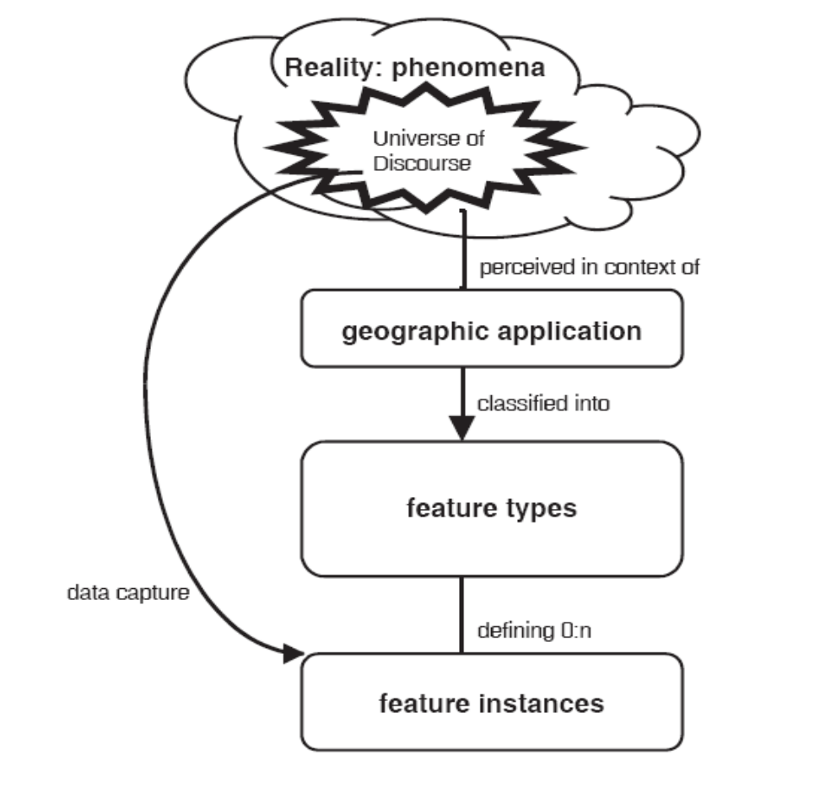
Figure 2 - From reality to geographic data

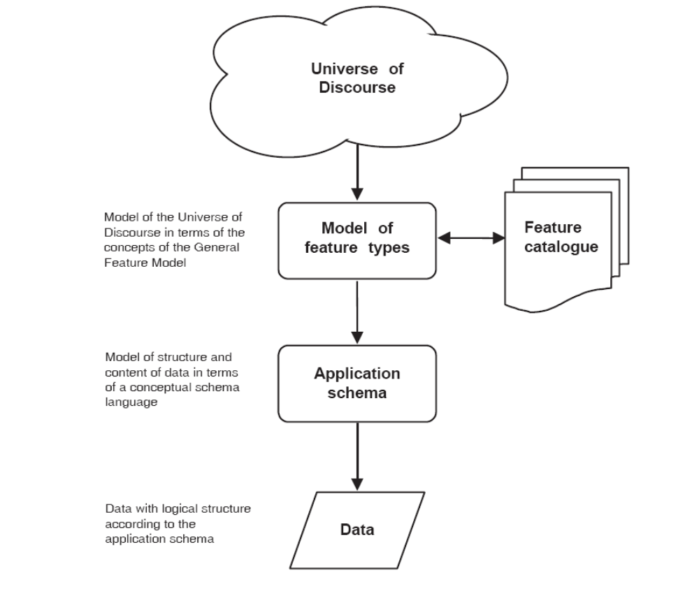

- The application schema (ISO 19109) provides the formal description of the data structure and content of the dataset. The information model may be broken down into independent parts that can be integrated by a defined interface. The application schema is one part; other standardized schemas (e.g. ISO 19107, 19108, 19111, 19112 for spatial and temporal schemas) are other parts.

- Metadata are defined as data about data. At the application model level, ISO 19115 provides a structure for describing the data, and defines the metadata element definitions (or types of metadata elements) for the metadata in a metadata dataset. A metadata dataset, in turn, describes the administration, organization, and content of a dataset at the data level. The metadata dataset provides necessary information in order to facilitate the data discovery, retrieval ant reuse. Figure 3 shows the relationship between features, metadata and data within the ISO CSMF. ISO 19139 provides a rule-based encoding for carrying out ISO 19115. ISO 19139 defines Extensible Mark-up Language (XML) schemas, which provide a common specification for describing, validating and exchanging metadata.

Figure 3 - Relationship between features, metadata and data within the ISO CSMF

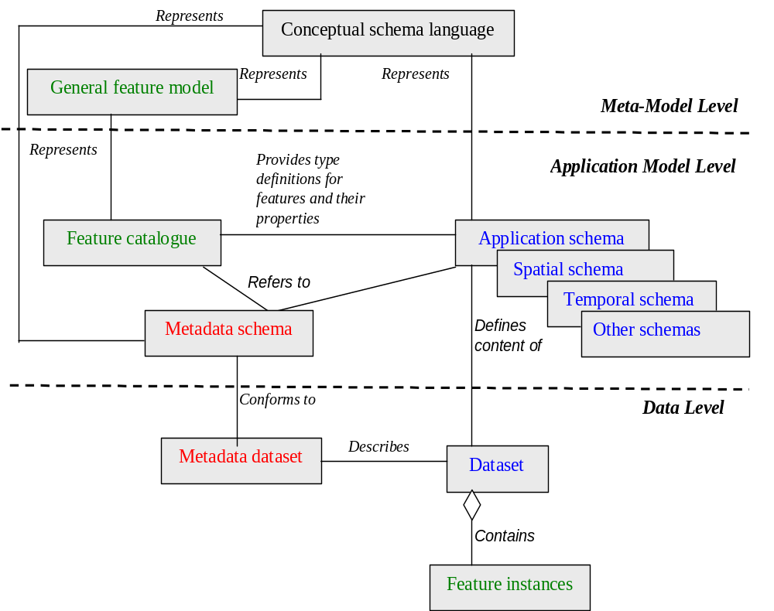

- A data product specification (ISO 19131) (see Figure 4) is a detailed description of a dataset or data set series together with additional information that will enable it to be created, supplied to and used by another party. The data product specification defines how the dataset should be. The metadata, associated to the product dataset, should reflect how the product dataset actually is.

Architectural reference model in the ISO 19100 series
- The Architectural reference model (ISO 19101) describes the general types of services that will be provided by computer systems to manipulate geographic information and enumerates the service interfaces across which those services must interoperate (ISO 19116, 19117, 19118, 19119). This model also provides a method of identifying specific requirements for standardization of geographic information that is processed by these services. As an example for communication services, encoding rules (ISO 19118) allow geographic information defined in an application schema to be coded into a system independent data structure suitable for transport or storage. The encoding rule based on XML specifies the types of data to be coded and the syntax, structure and coding schemes used in the resulting data structure.
Figure 4 - Relationship of data product specification to data and metadata

Data product specification

Specifies
Data product
Dataset
Metadata
Described as
Implemented as
Application schema
Feature catalogue
Metadata schema
Spatial schema
Temporal schema
Other schemas

Application schema supporting data interchange
- The rules for application schema (ISO 19109) does not standardize application schemas, but aim at creating application schemas in a consistent manner (including the consistent definition of features) to facilitate the acquiring, processing, analysing, accessing, presenting and transferring of geographic data between different users, systems and locations. The rules are, in the case of data transfer or interchange, used by suppliers and users of geographic data to:

- Build a transfer application schema for data interchange;

- Interpret the semantics of the transferred dataset with respect to user's local data and content and structure of data;

- Determine the necessary transformations between the two datasets.

- The rules in ISO 19109 assist the users of applications with similar data requirements in creating a common application schema for the interface between their systems and data The mapping from one application schema to another application schema may be difficult and even impossible if the two schemas are too divergent. The mapping is facilitated if the application schema used within a system is designed considering also the requirements for the data interchange.

- Figure 5 shows the case of data interchange between information systems in a data transfer model. The user and the supplier must agree on a creating an application schema for the data being exchanged in accordance with ISO 19109. This application schema shall be developed using the applications schemas from the user and the supplier. One mapping will be made from the supplier’s application schema to this application schema for the exchanged data, and second mapping will be made from this application schema to the user’s application schema. The supplier must be able to transform the application data according to supplier’s application schema into a transfer dataset defined according to its application schema for the exchanged data. The user must be able to transform the transfer data defined according to its application schema to the application data defined according to the user’s application schema.

- The conceptual schemata and related application schemata of the data representation systems BUFR, CREX, XML, NetCDF or HDF are not presented in accordance with the ISO 19100 series; however, as for example in the BUFR tables, these schemata include a collection of implicit feature types and instances, and data product specifications, which could be used to model the universe of discourse for the WMO Programmes and to develop a WMO core profile of the ISO 19100 series for data and metadata, including the relevant ISO 19100 feature catalogues, application schema(ta) and/or data product specification(s).

Figure 5 - Data interchange by transfer

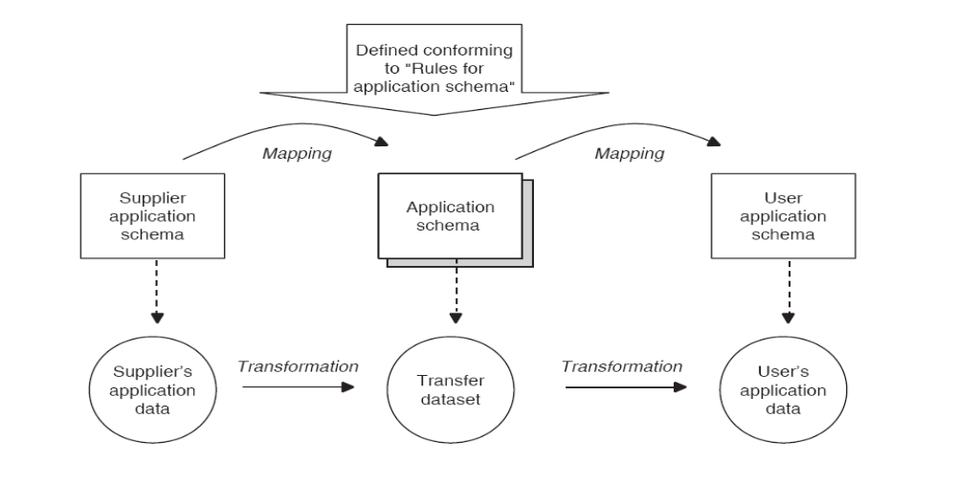

Facilitating the conversion between Data Representation Systems (DRS)
- The conceptual modelling defined in the ISO 19100 series provides a framework for the implementation of decoders and encoders by decoding a data product presented in a DRS into a reference dataset format, e.g. a dataset format derived directly from the model, and by encoding the reference dataset into data products presented in any other DRS (see Annex 2). The reference dataset is defined by the implementer of the database application. In the case of the three-level Modelling of WMO data products based on BUFR/CREX tables (see paragraph 25), the tree of the tables derived directly from the model in accordance with the model documentation is a possible example of reference dataset format in a database application. The encoding rules used to present the data products for their interchange in a DRS and the decoding rules used to import a data product received are defined by the model documentation and the reference documentation specific to the DRS.

- When considering a requirement to ensure the conversion between n DRS in a database application, n decoders and n encoders as defined in the above paragraph should be developed for the database application. This number (2n) of decoders or encoders in the model approach is to be compared to the number of the converters (permutations P(n,2)) needed in a systematic conversion between pairs of DRS.

Facilitating the transformation of data products instances of different models
- In different domains, different approaches may be used to represent the universe of discourse, leading to different models for the same set of data products. The transformation of data products instances of a model into data products instances of another model is facilitated by mapping the models. For example, in the case of the information included in a METAR, aeronautical users may define a model B embedded in a more general model defined for aeronautical purposes and this model may be different from the WMO model A defined for weather, climate and water data products. The data product instance of the model A made available to the aeronautical user should be transformed in a data product instance of the model A. This transformation can be facilitated by mapping the feature catalogues and the application schemas of the models A and B (see Annex 3).

- When data products instances of several models (e.g. METAR, TAF) have to transformed, the mapping between models, and then the transformations of the data products, will be further facilitated when the models are instances of a meta-model. In the case of the three-level Modelling of WMO data products based on BUFR/CREX tables (see paragraph 25), the basic reference documentation of each model includes a table instance of the meta-model of the table of the tables of the tree, and a table instance of the meta-model of the tables of the tree; the standardisation of the form of presentation of these tables facilitates the importation and the use of these tables in the processes required for the transformation of data products.

Annex 1 - Migration matrix

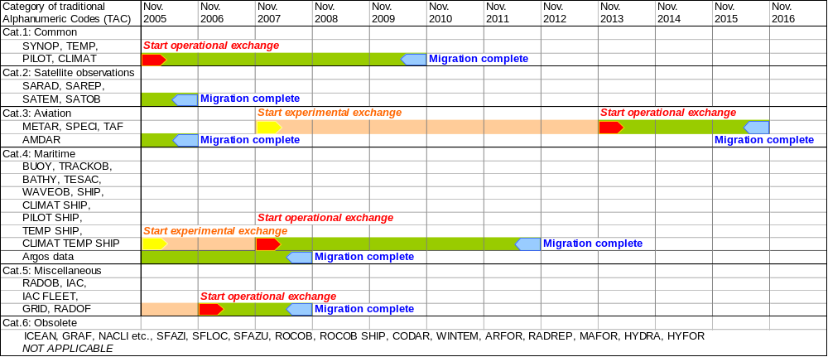
NOTES:
(1) Aviation Codes require ICAO coordination and approval, except for AMDAR.
(2) SAREP and RADOB require coordination by the ESCAP/WMO Typhoon Committee.
(3) For category 5, codes need to be reviewed in order to decide whether or not they should be migrated to BUFR/CREX.
(4) Codes in category 6 are not to be migrated.
(5) All dates above are meant as "not later than". However, Members and Organizations are encouraged to start experimental exchange, and, if all relevant conditions (see below) are satisfied, to start operational exchange as soon as possible.

- Start of experimental exchange means: data will be made available in BUFR (CREX) but not operationally, i.e. in addition to the current alphanumeric codes, which are still operational.
- Start of operational exchange means: data will be made available in BUFR (CREX) whereby some (but not all) Members rely on them operationally. Still the current alphanumeric codes will be distributed (parallel distribution).
- Migration complete means: at this date the BUFR (CREX) exchange becomes the standard WMO practice. Parallel distribution is terminated. For archiving purposes and at places where BUFR (CREX) exchange still causes problems the alphanumeric codes may be used on a local basis only.

Relevant conditions to be satisfied before experimental exchange may start:
- Corresponding BUFR/CREX-tables and templates are available;
- Training of concerned testing parties has been completed;
- Required software of testing parties (encoding, decoding, viewing) is implemented;

Relevant conditions to be satisfied before operational exchange may start:
- Corresponding BUFR/CREX-tables and templates are fully validated;
- Training of all concerned parties has been completed;
- All required software (encoding, decoding, viewing) is operational.

Annex 2 - Application of the ISO 19100 series to the development of a pilot project for the presentation of OPMET data in XML

specifies
Encoding rules for DRS No. 2

Data product specification (ISO 19131)

Data product
Dataset
Metadata
Described byas
Implemented as
Application schema
WMO Feature catalogue
Metadata schema
Spatial schema
Temporal schema
Other schemas
Dataset encoded in DRS No.2
Encoding rules for DRS No. 1 (ISO 19118)
Dataset encoded in DRS No.1
Model level
Data level
Dataset encoded in DRS No.2
Dataset encoded in DRS No.1
Decoding rules for DRS No. 1 (ISO 19118)
Decoding rules for DRS No. 2

Annex 3 - Facilitating the transformation of datasets instances of different models
Mapping
Transforming
Models A
Models B

Application schema A
Feature catalogue A
Metadata schema A
Spatial schema A
Temporal schema A
Other schemas A

Application schema B
Feature catalogue B
Metadata schema B
Spatial schema
Temporal schema B
Other schemas B
Data products instances of Models A
Model level
Data level
Data products instances of Models B
Meta-Model level
Meta-Model A
Meta-Model B

Annex 4 – Extracts from ISO/DIS 19156 standard (observations and measurements)
Copyright
Since this information reproduces parts of the ISO 191xxx series of standards, Copyright remains with ISO.

Observation schema

    - OM_Observation

General

The class OM_Observation (Figure 6) is an instance of the «metaclass» GF_FeatureType (ISO 19109:2005), which therefore represents a feature type. OM_Observation shall support five attributes and six associations, and shall be subject to four constraints.

Figure 6 — The basic Observation type
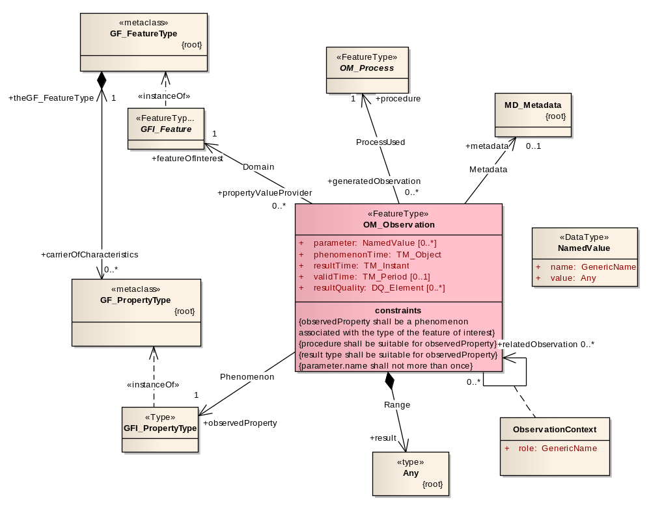
PhenomenonTime

The attribute phenomenonTime:TM_Object shall describe the time that the result applies to the property of the feature-of-interest. This is often the time of interaction by a sampling procedure or observation procedure with a real-world feature.

NOTE 1 The phenomenon time is the temporal parameter normally used in geospatial analysis of the result.
NOTE 2 If the observedProperty of an observation is ‘occurrence time’ then the result should be the same as the phenomenonTime
ResultTime

The attribute resultTime:TM_Instant shall describe the time when the result became available, typically when the procedure associated with the observation was completed For some observations this is identical to the samplingTime. However, there are important cases where they differ.

EXAMPLE 1 Where a measurement is made on a specimen in a laboratory, the phenomenonTime is the time the specimen was retrieved from its host, while the resultTime is the time the laboratory procedure was applied.
EXAMPLE 2 The resultTime also supports disambiguation of repeat measurements made of the same property of a feature using the same procedure.
EXAMPLE 3 Where sensor observation results are post-processed, the resultTime is the post-processing time, while the phenomenonTime is the time of initial interaction with the world.
EXAMPLE 4 Simulations may be used to estimate the values for phenomena in the future or past. The phenomenonTime is the time that the result applies to, while the resultTime is the time that the simulation was executed.
ValidTime

If present, the attribute validTime:TM_Period shall describe the time period during which the result is intended to be used.
NOTE This attribute is commonly required in forecasting applications.
Parameter

If present, the attributes parameter:NamedValue shall describe an arbitrary event-specific parameter. This might be an environmental parameter, an instrument setting or input, or an event-specific sampling parameter that is not tightly bound to either the feature-of-interest (6.2.2.7) or to the observation procedure. To avoid ambiguity, there shall be no more than one parameter with the same name.

NOTE Parameters that are tightly bound to the procedure may be recorded as part of the procedure description.
In some contexts the Observation::procedure is a generic or standard procedure, rather than an event-specific process. In this context, parameters bound to the observation act, such as instrument settings, calibrations or inputs, local position, detection limits, asset identifier, operator, may augment the description of a standard procedure.

EXAMPLE A time sequence of observations of water quality in a well may be made at variable depths within the well. While these may be associated with specimens taken from the well at this depth as the features-of-interest, a more common approach is to identify the well itself as the feature-of-interest, and add a “samplingDepth” parameter to the observation (Figure 7). The sampling depth is of secondary interest compared to the temporal variation of water quality at the site.
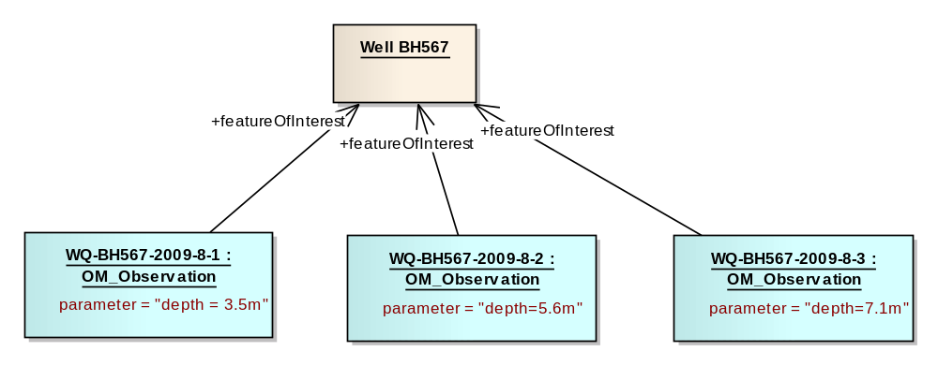
Figure 7 — (Example) Observation instances in the same well at different depths, described using the ‘parameter’ attribute
ResultQuality

If present, the attributes resultQuality:DQ_Element shall describe the quality of the result. This instance-specific description complements the description of the observation procedure, which provides information concerning the quality of all observations using this procedure. Quality of a result may be assessed following the procedures in ISO 19114:2003. Multiple measures may be provided (ISO/TS 19138:2006).

Domain

The association Domain shall link the OM_Observation to the GFI_Feature that is the subject of the observation and carries the observed property. This feature has the role featureOfInterest with respect to the observation. This feature is the real-world object whose properties are under observation, or is a feature intended to sample the real-world object, as described in Clause 8 of this International Standard. An observation instance serves as a propertyValueProvider for its feature of interest.

Phenomenon

The association Phenomenon shall link the OM_Observation to the GFI_PropertyType for which the OM_Observation:result provides an estimate of its value. The property type has the role observedProperty with respect to the observation.

The observed property shall be a phenomenon associated with the type of the featureOfInterest.

NOTE An observed property may, but need not be modelled as a property (in the sense of the General Feature Model) in a formal application schema that defines the type of the feature of interest
The observed property supports semantic or thematic classification of observations, which is useful for discovery and data fusion.

Range

The association Range shall link the OM_Observation to the value generated by the procedure. The value has the role result with respect to the observation. The type of the result is shown as Any, since it may represent the value of any feature property.
NOTE 1 OGC SWE Common provides a model suitable for describing many kinds of observation results.
The type of the observation result shall be consistent with the observed property, and the scale or scope for the value shall be consistent with the quantity or category type. If the observed property is a spatial operation or function, the type of the result may be a coverage,
NOTE 2 In some contexts, particularly in earth and environmental sciences, the term “observation” is used to refer to the result itself.
ProcessUsed

The association ProcessUsed shall link the OM_Observation to the OM_Process used to generate the result. The process has the role procedure with respect to the observation. A process might be responsible for more than one generatedObservation.
The OM_Process shall be suitable for the observed property. As a corollary, details of the observed property are constrained by the procedure used.
EXAMPLE Observed radiance wavelength is determined by the response characteristics of the sensor.
A description of the observation procedure provides or implies an indication of the reliability or quality of the observation result.

Metadata

If present, the association Metadata shall link the OM_Observation to descriptive metadata.

Constraints – consistency with domain model

The type of the feature of interest is defined in an application schema (ISO 19109:2005). This may be part of a domain model, or may be from a cross-domain model, such as Sampling Features (Clause 8).

The feature type defines its set of properties. For consistency, the feature-of-interest shall carry the observed property as part of the definition of its type (e.g. Figure 8).

EXAMPLE A feature type “Pallet” may be defined as having the attribute “mass” of type “Measure”. An observation providing the value of this property shall have observedProperty=“mass”, the result shall be of type “Measure” and the scale (unit of measure) shall be suitable for mass measurements.
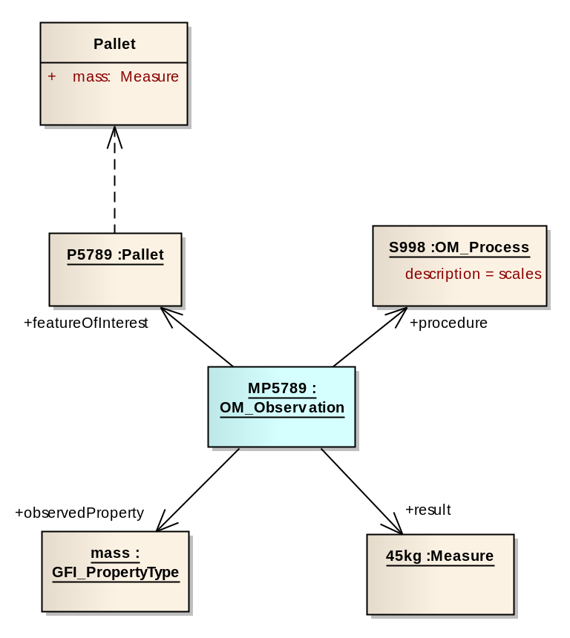
Figure 8 — (Example) An observation with consistent properties: the observed property (mass) is a phenomenon associated with the type of the feature of interest (Pallet) and the procedure and result type are also suitable
In the case of a feature property with internal structure (e.g. feature associations) the observed property may be of one component, or of a subset of elements, of the complete feature property. Hence, the observed property might not appear directly as a first order property in the type definition for the feature of interest, but shall appear within the structure of the feature type definition at some level (e.g. Figure 9).
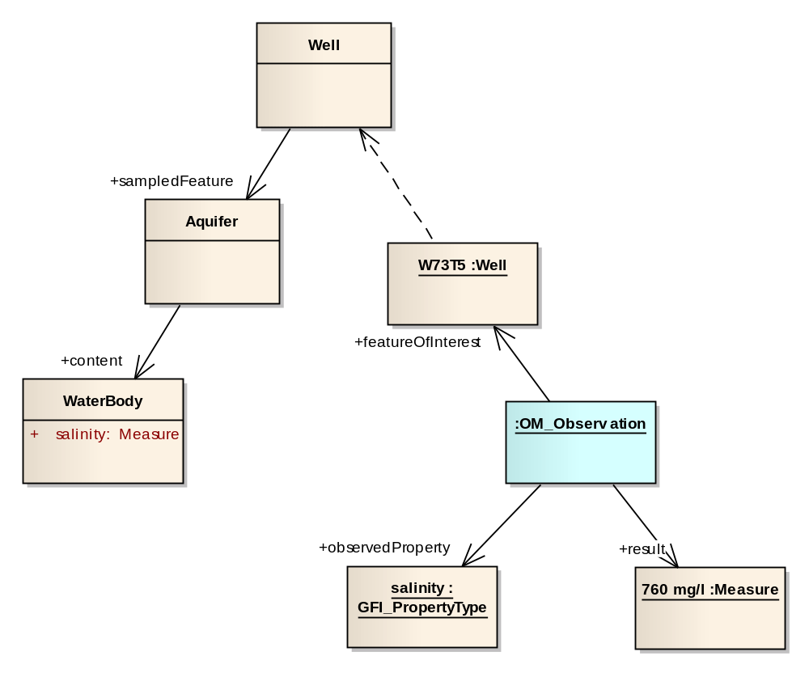
Figure 9 — (Example) An observation where the observed property is not a direct member of the type of the feature of interest
Other consistency constraints are that (a) the procedure shall be suitable for the observed property; (b) the result type shall be consistent with the observed property (e.g. Figure 4).

    - OM_Process

The class OM_Process (Figure 2) is an instance of the «metaclass» GF_FeatureType (ISO 19109:2005), which therefore represents a feature type. OM_Process is abstract, and has no attributes, operations or associations. It serves as the base class for observation processes. An instance of OM_Process is often an instrument or sensor, but may be a human observer, a simulator, or a process or algorithm applied to more primitive results used as inputs.
NOTE ISO 19115-2:2009 provides MI_Instrument, LE_Processing and LE_Algorithm, which could all be modelled as specializations of OM_Process. OGC SensorML ^{[13]} provides a model which is suitable for many observation procedures.
    - ObservationContext

General

Some observations depend on other observations to provide context which is important, sometimes essential, in understanding the result. These dependencies are stronger than mere spatiotemporal coincidences, requiring explicit representation. If present, the association class ObservationContext shall link a OM_Observation to another OM_Observation, with the role name relatedObservation for the target. It shall support one attribute.
EXAMPLES Some examples include the conditions associated with experimental replicates (e.g., experimental plots and treatments used), biotic factors (e.g., ecological community), interactions among features (e.g., predator-prey), or other temporary relationships occurring at the time of observation that are not inherent to the observed features themselves (i.e., they change over time), or the related observation may provide input to a process that generates a new result.
This association complements the Intention association which describes relationships between a sampling feature and domain features.

Role

The attribute role:GenericName shall describe the relationship of the target OM_Observation to the source OM_Observation.

    - NamedValue

General

The class NamedValue provides for a generic soft-typed parameter value. NamedValue shall support two attributes.

Name

The attribute name:GenericName shall indicate the meaning of the named value. Its value should be taken from a well-governed source if possible.
EXAMPLE When used as the value of an Observation:;parameter, the name might take values like ‘procedureOperator’, ‘detectionLimit’, ‘amplifierGain’, ‘samplingDepth’.
Value

The attribute value:Any shall provide the value. The type Any should be substituted by a suitable concrete type, such as CI_ResponsibleParty or Measure.

    - Terms and definitions

application schema

conceptual schema for data required by one or more applications
[ISO 19101:2002, definition 4.2]

coverage

feature that acts as a function to return values from its range for any direct position within its spatial, temporal or spatiotemporal domain
[ISO 19123:2005, definition 4.17]

data type

specification of a value domain with operations allowed on values in this domain
[ISO/TS 19103:2005, definition 4.1.5]

EXAMPLE Integer, Real, Boolean, String, Date (conversion of a date into a series of codes).

NOTE Data types include primitive predefined types and user-definable types. All instances of a data types lack identity.

domain feature

feature of a type defined within a particular application domain

NOTE This may be contrasted with observations and sampling features, which are features of types defined for cross-domain purposes.

Feature

abstraction of real-world phenomena
[ISO 19101:2002, definition 4.11]

NOTE A feature may occur as a type or an instance. Feature type or feature instance should be used when only one is meant.

feature type

class of features having common characteristics

measurand

particular quantity subject to measurement
[ISO/TS 19138:2006, definition 4.5]

NOTE Specialization of observable property-type.

Measure

value described using a numeric amount with a scale or using a scalar reference system
[ISO 19136:2007, definition 4.1.41]

Measurement

set of operations having the object of determining the value of a quantity
[ISO/TS 19101-2:2008, definition 4.20]

Observation

act of observing a property

NOTE The goal of an observation may be to measure or otherwise determine the value of a property

observation procedure

method, algorithm or instrument, or system of these which may be used in making an observation

observation protocol

combination of a sampling strategy and an observation procedure used in making an observation

observation result

estimate of the value of a property determined through a known procedure

property <General Feature Model>

facet or attribute of an object referenced by a name

EXAMPLE Abby's car has the colour red, where "colour red" is a property of the car instance

property-type

characteristic of a feature type

EXAMPLE cars (a feature-type) all have a characteristic colour, where "colour" is a property-type

NOTE 1 The value for an instance of a property-type may be estimated through an act of observation

NOTE 2 In chemistry-related applications, the term ‘determinand’ or ‘analyte’ is often used.
[Adapted from ISO 19109:2005]

sampling feature

feature, such as a station, transect, section or specimen, which is involved in making observations concerning a domain feature

NOTE A sampling feature is purely an artefact of the observational strategy, and has no significance independent of the observational campaign.

Value

element of a type domain
[ISO/IEC 19501:2005]

NOTE 1 A value may consider a possible state of an object within a class or type (domain).

NOTE 2 A data value is an instance of a data type, a value without identity.

NOTE 3 A value may use one of a variety of scales including nominal, ordinal, ratio and interval, spatial and temporal. Primitive datatypes may be combined to form aggregate datatypes with aggregate values, including vectors, tensors and images

Annex 5 – Terminology, including extracts from the TC 211 multilingual glossary

Data Representation System (DRS): set of rules, regulations, standards, procedures or conventions to be used to represent a data product for interchange.

Terms and definitions included in the ISO/DIS 19156 standard (observations and measurements) are reproduced in paragraph 5 of Annex 4.

Extracts from the TC 211 multilingual glossary

TERM-ID | TERM | Definition
14 | application | manipulation and processing of data in support of user requirements
15 | application schema | conceptual schema for data required by one or more applications
67 | conceptual formalism | set of modelling concepts used to describe a conceptual model
68 | conceptual model | model that defines concepts of a universe of discourse
69 | conceptual schema | formal description of a conceptual model
70 | conceptual schema language | formal language based on a conceptual formalism for the purpose of representing conceptual schemas
104 | data | reinterpretable representation of information in a formalised manner suitable for communication, interpretation, or processing
110 | data product | dataset or dataset series that conforms to a data product specification
107 | data interchange | delivery, receipt and interpretation of data
111 | data product specification | detailed description of a dataset or dataset series together with additional information that will enable it to be created, supplied to and used by another party
123 | data type | specification of a value domain with operations allowed on values in this domain
124 | dataset | identifiable collection of data
125 | dataset series | collection of datasets sharing the same product specification
168 | feature | abstraction of real world phenomena
169 | feature association | relationship that links instances of one feature type with instances of the same or a different feature type
170 | feature attribute | characteristic of a feature
854 | feature catalogue | catalogue containing definitions and descriptions of the feature types, feature attributes, and feature relationships occurring in one or more sets of geographic data, together with any feature operations that may be applied
177 | feature operation | operation that every instance of a feature type may perform
205 | geographic information | information concerning phenomena implicitly or explicitly associated with a location relative to the Earth
255 | interoperability | capability to communicate, execute programs, or transfer data among various functional units in a manner that requires the user to have little or no knowledge of the unique characteristics of those units
289 | metadata | data about data
290 | metadata element | discrete unit of metadata
291 | metadata entity | set of metadata elements describing the same aspect of data
292 | metadata schema | conceptual schema describing metadata
293 | metadata section | subset of metadata which consists of a collection of related metadata entities and metadata elements
299 | model | abstraction of some aspects of reality
355 | product specification | description of the universe of discourse and a specification for mapping the universe of  discourse to a dataset
371 | register | set of files containing identifiers assigned to items with descriptions of the associated items
508 | register manager | organization to which management of a register has been delegated by the register owner
372 | register owner | organization that establishes a register
373 | registration | assignment of a permanent, unique, and unambiguous identifier to an item
375 | registry | information system on which a register is maintained
395 | schema | formal description of a model
405 | service | distinct part of the functionality that is provided by an entity through interfaces
408 | service metadata | metadata describing the operations and geographic information available at a server
486 | universe of discourse | view of the real or hypothetical world that includes everything of interest

References

- WMO Manual on Codes (WMO No. 306) (http://www.wmo.int/pages/prog/www/WMOCodes.html)

- Procedures for amending the Manual on Codes (http://www.wmo.int/pages/prog/www/WMOCodes/Manual/Volume-I-selection/Sel1.pdf)

- Version 1.1 of the WMO core profile of the ISO Metadata standard (http://wis.wmo.int)

- Development of a WMO conceptual model of data representation- Three-level Modelling of WMO data products based on BUFR/CREX tables (http://www.wmo.int/pages/prog/www/WDM/modelling/ModelFromBUFR_V5.doc )

- Second session of the ET-ODR (Paris, November 2009) (http://www.wmo.int/pages/prog/www/WDM/ET-ODR-2/documents/ET-ODR-2-meeting_summary.ppt)

- ISO Technical Committee 211 (http://www.isotc211.org/)

- ISO TC 211 standard guide (http://www.isotc211.org/Outreach/ISO_TC%20_211_Standards_Guide.pdf)

- Open Geospatial Consortium (OGC) (http://www.opengeospatial.org/)

- WMO/OGC Memorandum of Understanding (MoU) (ftp://ftp.wmo.int/In-box/To-www/DM/20091123_OGC_WMO_MOU.pdf)

- OGC's Sensor Web Enablement (SWE) standards (http://www.opengeospatial.org/ogc/markets-technologies/swe)

- Meteorology/hydrology OGC Domain Working Groups (DWGs) (http://www.opengeospatial.org/projects/groups/wg)

- Report of the extraordinary session of CBS (Seoul, Republic of Korea, November 2006) (http://www.wmo.int/pages/prog/www/CBS/Reports/CBS-Ext06_Seoul2006/WMO-1017_en.pdf)

- Report of the Fourteenth session of CBS (Dubrovnik, Croatia, 25 March – 2 April 2009) (http://www.wmo.int/pages/prog/www/CBS/Reports/CBS-XIV_Dubrovnik2009/WMO-1040_en.pdf)

WMO Acronyms
See http://www.wmo.int/pages/themes/acronyms/index_en.html

