WORLD METEOROLOGICAL ORGANIZATION  ________  CBS EXPERT TEAM ON  INTEGRATED DATA MANAGEMENT  FOURTH MEETING  GENEVA, 1 TO 3 SEPTEMBER 2004 |  | ET-IDM-IV/Doc. 3.1(3), Rev.1  (27.VIII.2004)  ____  ITEM: 3.1  ENGLISH ONLY

Proposal for a Unified Definition of a Boundary Polygon in GML
(Submitted by Dieter Schröder)

Summary and Purpose of the Document

This document describes the possibilities to define boundary functions in GML. From these possibilities a proposal for a unified definition of boundary functions for the WMO community is presented.

ACTION PROPOSED

The meeting is invited to discuss the proposal, to select alternative coordinate systems and to make suggestions for further action.

CONTENTS
CONTENTS 2
Executive Summary 3
Section 1: Problem oriented Summary of GML 4
1.1 What is GML? 4
1.2 General structure of GML 5
1.3 Basic Geometries 5
1.3.1 Coordinate data 6
1.3.2 Line definitions 7
1.3.3 Area boundaries 8
1.3.4 Surfaces 10
1.3.5 Geometric complexes and geometric composites 13
1.3.6 Geometric aggregates 13
1.3.7 Geometric properties of features 14
Section 2: Further examples 17
2.1 FeatureCollection 17
2.2 Crossing the date-line and encompassing of poles 19
Section 3: Coordinate Reference Systems 22
Section 4: Recommendations 25
References 26

Executive Summary

The GML standard provides a good possibility for a unified and product independent definition of boundary functions. With GML simple and as well multiple connected areas can be described. The GML defined areas are stable even if a pole or the date boundary is incorporated. Above that special properties can be assigned to the defined geometric areas.
Since version 3.1.0 the GML standard provides several possibilities and assistance for specifying a coordinate reference system. Moreover it is possible to use one of the well known reference coordinate systems developed by other scientific societies. The reference coordinate system proposed here was specified from the European Petroleum Survey Group (www.epsg.org) and can be referenced by using the Uniform Resource Name (URN) "urn:EPSG:geographicCRS:4326”. This system describes the earth coordinates in latitude and longitude and is equivalent to the “WGS 84” (=World Geodetic System 1984) which is the basis of the GPS coordinates.
This paper consists of four sections: In the first section a problem oriented summary of the GML standard and structures is given. In this summary only the aspects of geometric figure definition are considered. The second section shows complex examples and and the behaviour if an area contains the date boundary and a geographic pole. The third section discusses the reference coordinate problem. In the fourth section recommendations for a unified boundary definition in the WMO community are presented.

Section 1: Problem oriented Summary of GML

1.1 What is GML?
The Geography Markup Language (GML) was developed to create a universal freely available interface via which spatial information can be exchanged. In doing so, use was made of the Extensible Markup Language (XML) with which appropriate basic structures were created. GML can therefore be understood as an XML dialect that allows individual, content-related and object-oriented data management, which both corresponds to the XML grammar and follows specific global rules. The basic elements for building a data model of this kind are held in various XML Schema files, which can be individually extended to one's own requirements by adding other schema files.
As a result of the transparent data management, GML offers a number of advantages in favour of universal use of the language. For example, it is vector-oriented so that the geographical objects contained are not tied to a particular resolution, which, for example, would be the case in the transmission of images. Definition of the elementary basic structures allows the geographical data to be displayed in a browser using the SVG graphical format (Scalable Vector Graphics), for example. Because GML transmits only the contents of maps, and not the way in which they are displayed, the symbolism and colouration of the individual elements can be individually adapted at the client end. This means that the same map can be replicated in different ways, depending on the main focus the representation is to have. In addition to the purely geographical data, one can assign any desired additional information to the objects in GML, such as a name or other characteristics, for example. The ability to use links to tie data together, allows information from external sources to be included. In the simplest case, this means that clicking on a public building within a city map could lead to that public facility's home page. As a result of the content-based depiction of data, it is also possible to select from a large supply of geo-based data, just the specific data relevant to the required representation or application. This allows, for instance, transmission times to be reduced or maps to be presented with greater clarity. As well as the storing of spatial data, GML also defines the specification of time constraints and reference points. Hence, it is possible to produce various features for a moving object with successive time constraints and differing coordinates. Similarly, the position of an object can also be defined algorithmically. Because GML is based on XML, the data can be sent to any program that has an XML interface. This standardises and makes it easier to exchange geo-based data between various applications or databases.
An example of the use of the GML format is the possibility to export geographical data from, or import it to, the relevant ESRI software. This creates the possibility not only of providing geographic data in the form of SDE data or shape files, but also of converting the latter into GML data.
Nowadays, GML data is used primarily in conjunction with Internet-based map display tools. An example of the use of GML data in an Internet-based environment is the WMS standard (Web Map Service), also specified by the OGC. With a WMS, GML data can be generated as output of various requests to the WMS and displayed with various viewers in a client (Internet browsers). A viewer of this kind based on the WMS specification is, for instance, the "NASA Web Map Viewer" (http://viewer.digitalearth.gov).
A further example of Internet-based presentation of geographical data is the Web Map Server of ESA (http://mapserv2.esrin.esa.it/map/wtf/).

1.2 General structure of GML
In order to store data with geographical reference, GML has what are called feature elements. They describe phenomena in the real world. Thus, a GML file always consists of a collection of features. All features contain sub elements, the properties. They identify the characteristics of a feature. At the same time, each feature can contain several properties, which in turn may exhibit simple information or further features as sub elements. Thus, a feature "City" may use several properties "cityMember", which in turn may contain features such as "River", "Road", "Bridge" or "Building".
Instead of specifying the features directly within the Properties, it is also possible to link to them. For example, in the properties of a bridge it is possible to describe the river that it crosses without having to redefine the river. For this purpose, an attribute gml:id can be specified for each GML, whose value is unique throughout the entire document and serves as a reference destination for references.
The conventions for GML prescribe that the element names of features are always written in upper case and the names of property elements are always in lower case. Elements defined as abstract begin with an underscore character.
As already described, GML was specified with the aid of several schema files. Together these form the namespace "gml". The XML Schema definition language represents a separate XML dialect, with which further dialects can be defined. At the same time, the GML schema files describe how the data is arranged, whereas the GML instance document contains the actual data. Usually, one writes an individual schema file for one's own application in order to specify the precise properties of the features required. In this file, one derives the types for one's own features from the predefined GML types. The basic type for _Feature Element is defined abstractly anyway, so that without the definition of separate feature types and feature elements one cannot replicate any general objects in GML.
The current version number of GML is 3.1.0. This version is basically downwards compatible with Version 3.0 and 2.0. Additionally it supports a few new elements and marks some prior elements as deprecated. New elements include coordinate reference systems (CRS) and deprecated elements affect above all to coordinate definitions.

1.3 Basic Geometries
Any given feature that describes a real object can contain within its property elements one or more items of geometric information that determine its appearance or define its boundaries. This means, for example, that street routes can be replicated or ground plans depicted.
As standard, it is already possible to specify a location and a boundedBy property for each feature, whose precise notation is described at the end of the section. The predefined aliases centerOf, position, extentOf, edgeOf, centerLineOf, multiCenterOf, multiPosition, multiCenterLineOf, multiEdgeOf, multiCoverage and multiExtentOf make it easier to define additional geometric properties of a feature. However, geometric properties can also be completely self-defined. The already predefined geometric elements that can be used in such geometric properties are all derived from a higher order element _Geometry. Figure 1 depicts the hierarchy of the available geometric elements.
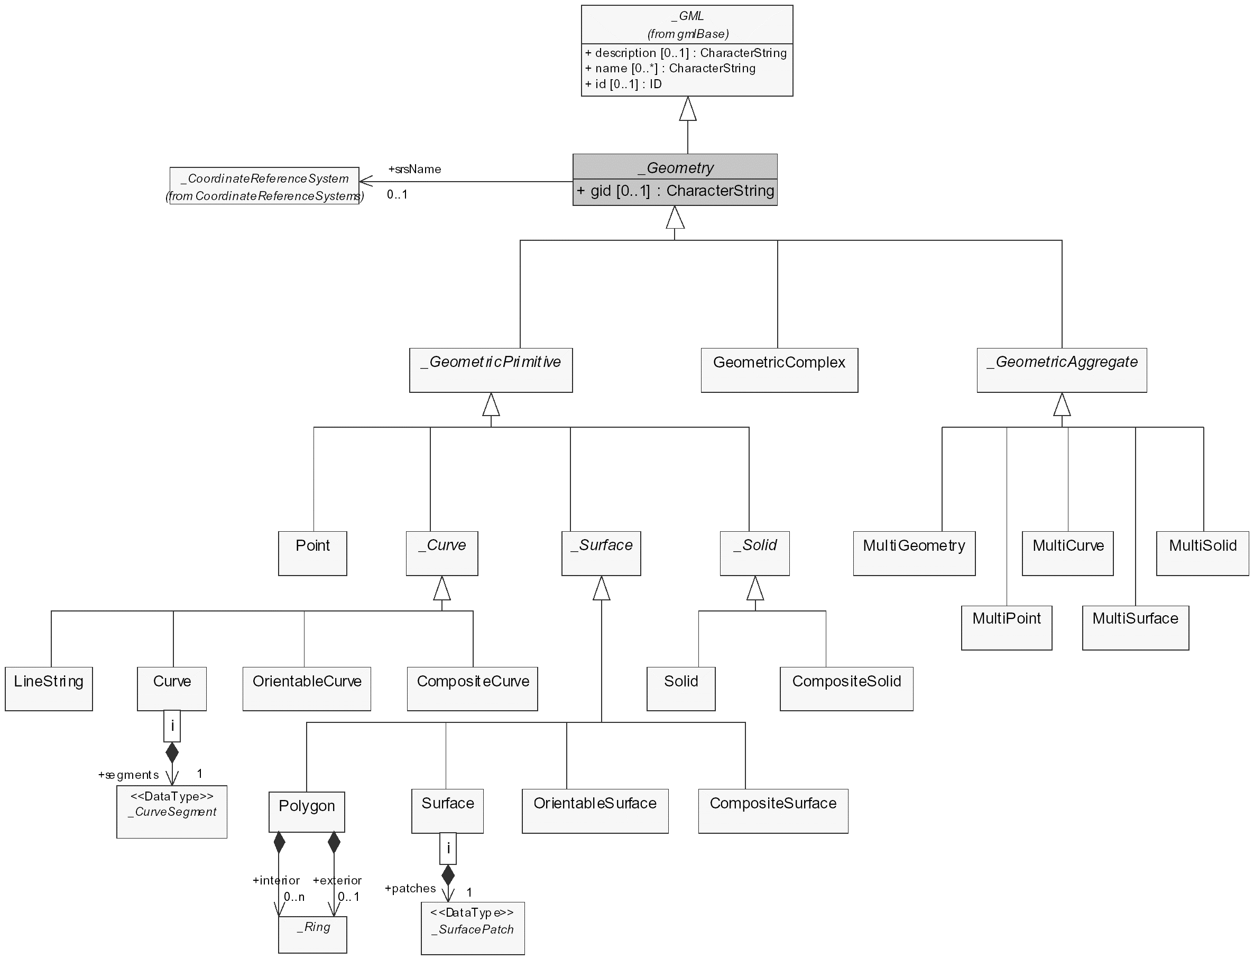
Figure 1: Object hierarchy of geometries

Various geometric primitives and complexes are defined in GML. Geometric primitives are used to represent simple structures such as points, lines, surfaces or solids, for example. Geometric complexes are composed of geometric primitives and thus enter into greater detail about the inner structure of the object described. Besides this, geometries which are of the same type but do not border one another, can be combined in a universal set. Since this brief report is oriented towards the limitations of two-dimensional areas, the text that follows ignores three-dimensional and orientable geometries.
The geometry model of GML complies with ISO 19107 ([OGCAST1]). All of the geometric structures described here are predefined in the GML schema file geometryBasic0d1d.xsd and geometryBasic2d.xsd. This provides a basic set of geometric types and elements, which can be extended in a separate schema file to include the special requirements of the particular application case.

1.3.1 Coordinate data
The specification of geometric dimensions is always done using coordinate data that relates to a specific coordinate reference system. It indicates how the coordinates are to be interpreted (coordinate system, dimensional units, reference points etc.), in what order the individual dimensions are quoted (e.g. Northing/Easting or x/y pairs) and how one can convert the coordinates from one system into those of another. The reference system can be specified for each geometric element individually, although in general it is named once within a collection of geometries. In the following examples the coordinate figures always relate to longitude and latitudes. The associated coordinate reference system (WGS 84) can be specified for the geometries using the attribute srsName="urn:EPSG:geographicCRS:4326".
The coordinates of features are always properties and essentially can be specified in three ways. These include pos, posList and PointProperty. Two more possibilities coord and coordinates are deprecated since the introduction of version 3.1.0. The individual points are represented as follows:
- pos: contains exactly one coordinate tuple whose values are separated by white spaces. Example:
<gml:pos>13.1 52.4</gml:pos>

- posList: contains a list of coordinates. The number of entries in the list is equal to the product of the dimensionality of the coordinate reference system and the number of direct positions. An optional attribute “count” allows to specify the number of direct positions in the list. If the attribute “count” is present then another attribute “srsDimension” shall be present, too. Example:
<gml:posList srsName="urn:EPSG:geographicCRS:4326" srsDimension="2" count="2">
12 48 14 49
</gml:posList >

- pointPropery: contains either a point (with pos specified) or a reference to a point that was uniquely identified previously with the attribute gml:id. Examples:
<gml:pointProperty>
<gml:Point gml:id="p1234">
<gml:pos>12 48</gml:pos>
</gml:Point>
</gml:pointProperty>

<gml:pointProperty xlink:href="#p1234"/>

1.3.2 Line definitions
_Curve constitutes the basic element for line strings. All other definitions are derived from it (see Figure 1). It is used to describe line progressions or to enclose two-dimensional surfaces.

1.3.2.1 gml:LineString
Simple line strings are composed of a number of points. They are used to reproduce unbounded structures, like the course of rivers, for example, or to mark boundary sections from which other geometries can be assembled.
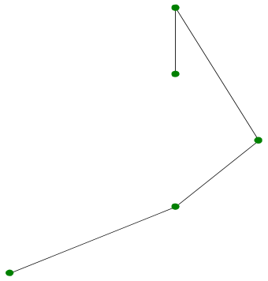
Figure 2: Line string

GML supports two different ways to specify the control points of a line string:
- a sequence of "pos" or "pointProperty" elements or
- a "posList" element, for a compact way to specify the coordinates of the control points.
The number of direct positions in the coordinates list shall be at least two and include start and end point. Note that start and end points of one line string are often identical with those of other line strings.
The example in Figure 2 can be generated using the following LineString:
<gml:LineString>
<gml:pos>12 48</gml:pos>
<gml:pos>14 49</gml:pos>
<gml:pos>15 50</gml:pos>
<gml:pos>14 52</gml:pos>
<gml:pos>14 51</gml:pos>
</gml:LineString>

1.3.2.2 gml:Curve
The Curve feature is composed of at least one Curve segment. The individual segments can have differing curvature or forms as a result of various predefined segment types. Curvatures in line strings are possible only by the definition of a Curve element with individual segments. They are specified in the segments property. Common to all Curve features is that they describe a continuous line of measurable length. At the same time, the end point of one segment is identical to the starting point of the next segment. Hence, the line string in Figure 2, for example, could be composed of one segment that contains the first point through to the fourth point and a further segment that joins the fourth and fifth points. However, LineString is better suited to fast definition of a simple line string. Segments are not derived from _Geometry and thus cannot be considered an independent Curve.

1.3.3 Area boundaries
The _Ring element is used to mark the boundaries of a surface. It is to be noted that the _Ring was not itself derived from _Geometry, and is therefore unsuitable for delimiting an entire feature (e.g. a country). As a property element of a surface, the ring's sole task is to specify its boundaries. This is usually done using the exterior and interior property elements (see Figure 1). The geometry of the feature (e.g. the country) is then determined by the surface element. GML already offers two derived elements, a simple form, the gml:LinearRing and a composite form, the gml:Ring.

1.3.3.1 gml:LinearRing
The simplest method of specifying a ring is offered by the LinearRing element. It has at least four points as its property, which are specified in a manner similar to a LineString. However, the first and last points need to be identical. An example:
<gml:LinearRing>
<gml:pos>12 48</gml:pos>
<gml:pos>14 49</gml:pos>
<gml:pos>15 50</gml:pos>
<gml:pos>14 52</gml:pos>
<gml:pos>14 51</gml:pos>
<gml:pos>12 48</gml:pos>
</gml:LinearRing>

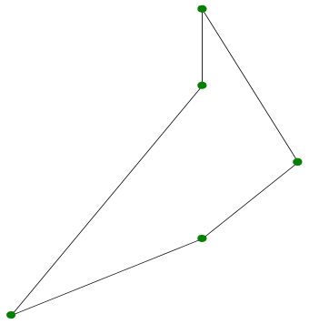
Figure 3: LinearRing

1.3.3.2 gml:Ring
The Ring element offers a somewhat more elaborate method of specifying boundaries of surfaces (not features!). It can be composed of several _Curve elements, i.e. of LineString and Curve. For this it must contain at least one curveMember property element, and the starting point of every curveMember element has to correspond to the end point of the preceding element. Since the ring is closed, this also applies for the first and last point of all curveMember elements. Because _Curve also allows curved line strings to be defined, Ring element would be the appropriate means where curve-shaped boundaries are to be described. This specification is slightly more elaborate though, and has mathematical description of the curve as a prerequisite. Therefore, LienarRing is more suitable for fast generation of surface boundaries.

1.3.4 Surfaces
_Surface represents the sole option for delimiting two-dimensional surfaces. For this, each feature can be assigned in its location property an element derived from _Surface. This can be either a simple polygon (gml:Polygon) or can be composed of so-called patches (gml:Surface).

1.3.4.1 gml:Polygon
The simplest surface that can be described without being composed of other surfaces is the Polygon. It can be defined through an outer ring (exterior) and several inner rings (interior). The bounded surface contains all areas that lie within the outer ring and outside the inner rings. It is not mandatory to specify an inner ring, so even simple surfaces can be specified. The direction of rotation of the outer ring should be defined as positive in the mathematical sense (anti-clockwise) and that of the inner ring as negative (clockwise). If one now travels along the ring in the direction of rotation, the result is that the area to the left of the line string lies within the enclosed surface, and the area to the right lies outside of it.
It is not mandatory to specify an outer boundary. For example, this is not sensible if the outer boundary cannot be specified with any degree of certainty (in the case of a belt around the equator, for example). The contents of such a polygon can easily be determined via the direction of rotation of the bounding rings.
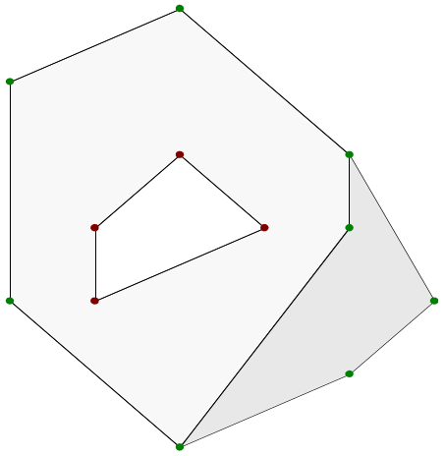
Figure 4: Two polygons

The two polygons shown in Figure 4 have contiguous surfaces. The polygon on the left has a hole within it bounded by an inner ring, whereas the polygon on the right exhibits only an outer ring. By re-using the bounding points with the help of XLinks it is possible to clarify the common boundary in the specification of the outer Ring elements:
<!-- right polygon -->
<gml:Polygon gml:id="poly01">

<gml:exterior>
<gml:LinearRing>
<gml:pointProperty>
<gml:Point gml:id="p01">
<gml:pos>12 48</gml:pos>
</gml:Point>
</gml:pointProperty>
<gml:pointProperty>
<gml:Point gml:id="p02">
<gml:pos>14 49</gml:pos>
</gml:Point>
</gml:pointProperty>
<gml:pointProperty>
<gml:Point gml:id="p03">
<gml:pos>15 50</gml:pos>
</gml:Point>
</gml:pointProperty>
<gml:pointProperty>
<gml:Point gml:id="p04">
<gml:pos>14 52</gml:pos>
</gml:Point>
</gml:pointProperty>
<gml:pointProperty>
<gml:Point gml:id="p05">
<gml:pos>14 51</gml:pos>
</gml:Point>
</gml:pointProperty>
<gml:pointProperty xlink:href="#p01"/>
</gml:LinearRing>
</gml:exterior>

</gml:Polygon>

<!-- left polygon -->
<gml:Polygon gml:id="poly02">

<gml:exterior>
<gml:LinearRing>
<gml:pos>10 50</gml:pos>
<gml:pointProperty xlink:href="#p01"/>
<gml:pointProperty xlink:href="#p05"/>
<gml:pointProperty xlink:href="#p04"/>
<gml:pos>12 54</gml:pos>
<gml:pos>10 53</gml:pos>
<gml:pos>10 50</gml:pos>
</gml:LinearRing>
</gml:exterior>

<gml:interior>
<gml:LinearRing>
<gml:posList>11 50 11 51 12 52 13 51 11 50</gml:posList>
</gml:LinearRing>
</gml:interior>

</gml:Polygon>

Should the position of the common points now change, the GML file need only be adapted in one place.
Depending on the coordinate system, it is possible that the coordinates enclose one of the poles or cross the date line. An example of this is listed later in section 2.

1.3.4.2 gml:Surface
Upon rough consideration, each Surface in turn has the external form of a polygon. Similarly to the way Curves can be composed of segments, a Surface is built from several patches. However, this is used only to specify the inner surface structure. A patch does not represent any independent surface, rather is merely a building block. If a feature specifies a location property, it must not contain any references to a patch but must always specify a complete surface. However, for fast manual generation of complete surfaces, in which the inner structure is not relevant, the specifying of individual patches represents too much effort.
Each Surface element contains a patches property, which contains all of the former's building blocks. A number of predefined elements are available as possible patches.
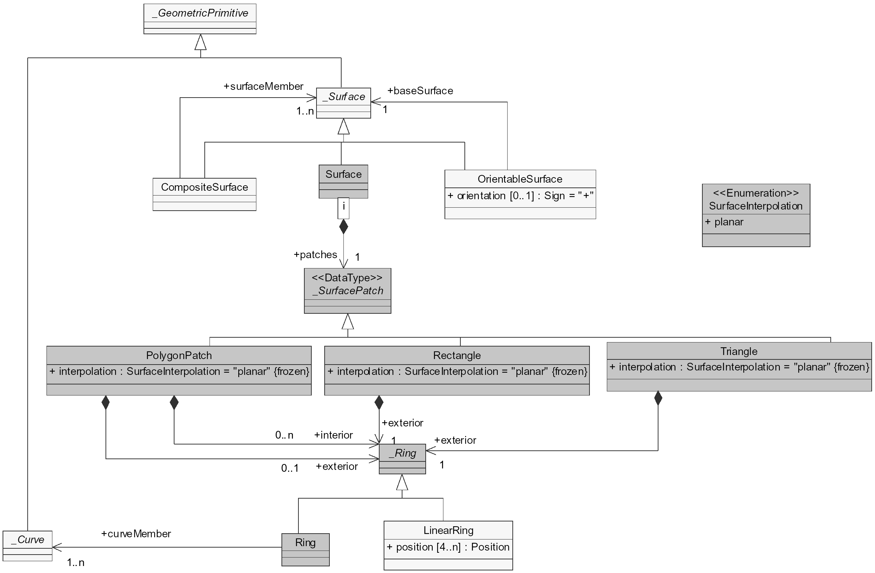
Figure 5: Surface patches

1.3.4.2.1 gml:Triangle
The simplest defined patch consists of a Triangle. Here, exterior is specified as the property element, consisting of a ring with exactly four points. It is to be noted at the same time that the last point corresponds to the first point.

1.3.4.2.2 gml:Rectangle
A Rectangle is constructed in exactly the same way as a Triangle. Here, too, the exterior property specifies the appearance. However, five points are specified in the ring it contains.

1.3.4.2.3 gml:PolygonPatch
The construction of a PolygonPatch is analogous to that of a Polygon. However, here, too, it is to be noted that it is not a complete surface but merely a patch you are dealing with.

1.3.5 Geometric complexes and geometric composites
Geometric complexes are used to describe compound geometries. To this end, the GeometricComplex feature was defined, which can contain any given number of element properties, each of which can contain a geometric primitive.
Geometric composites have exactly the same purpose, only they restrict the features contained to a particular form (e.g. to lines or surfaces). A condition for geometric composites is that the depicted composite feature is also able to be described as an individual geometric primitive. The putting together from individual features is intended to clarify the internal structure. Because, in XML, a type cannot be derived from two other types, all geometric composites were assigned with the corresponding geometric primitives. However, geometric composites can also be used anywhere where a geometric complex is required.
The polygons defined in section 1.3.4.1 can be combined in a CompositeSurface:
<gml:CompositeSurface>

<!-- right polygon -->
<gml:surfaceMember>
<gml:Polygon>
… <!-- see example in section 1.3.4.1 -->
</gml:Polygon>
</gml:surfaceMember>

<!-- left polygon -->
<gml:surfaceMember>
<gml:Polygon>
… <!-- see example in section 1.3.4.1 -->
</gml:Polygon>
</gml:surfaceMember>

</gml:CompositeSurface>

1.3.6 Geometric aggregates
Geometric aggregates are used to combine non-related geometric elements such as sets of points or non-contiguous surfaces, for example. This makes sense if, for example, various areas of precipitation are to be kept in a single feature. The following geometric aggregates are defined:
- MultiGeometry: stores any number of Geometry elements.
- MultiPoint: collects Point elements.
- MultiCurve: contains any number of unrelated Curve elements.
- MultiSurface: contains any number of unrelated Surface elements.
These elements allow specification of a number of geometryMember, pointMember, curveMember or surfaceMember properties, each of which contains an element or a reference to an element of the corresponding type. It is also possible to specify a …Members element, which comprises an array with the assembled features. However, specification of references is not permitted here. It is possible though to combine specification of an array with specification of individual …Member elements. An example of a MultiSurface can be found in section 2.1.
Geometric aggregates do not prescribe the definition of a boundary in which the contained elements lie.

1.3.7 Geometric properties of features

1.3.7.1 Extent of Features
On the basis of the predefined aliases for basic geometry (centerOf, position, edgeOf, centerLineOf, extentOf, multiCenterOf, multiPosition, multiCenterLineOf, multiEdgeOf, multiCoverage and multiExtentOf), one can attach a precise locational description to each feature, i.e. to a real object or phenomenon. These aliases provide possibilities to specify a point, a curve or a surface. By defining a special feature, any desired surface can be specified to define the exact boundaries of a feature.
Example: The area of a rainy region is to be identified in a self-defining feature PresentWeather and information about the type of rain is to be given in additional property weatherCode. This self-defining property element in the example thus represents the useful data that is to be associated with the specification of a bounded surface. Alternatively, one could also allow an XLink that points to an external data source or define further properties of a weather phenomenon. Moreover the extentOf element is referenced in this self-defining feature to enable the definition of spatial extent. Within an independent schema, the type PresentWeatherType is derived from the basic type for a feature AbstractFeatureType and additional properties are defined for the new type. A PresentWeather element is then created that uses the new type:
<complexType name="PresentWeatherType">
<complexContent>
<extention base="gml:AbstractFeatureType">
<sequence>
<element ref="gml:extentOf"/>
<element name="weatherCode" type="integer"/>
</sequence>
</extention>
</complexContent>
</complexType>

<element name="PresentWeather" type="PresentWeatherType" substitutionGroup="gml:_Feature"/>

The GML instance document with the defined data could then comprise the following sections:
<PresentWeather xmlns:gml="http://www.opengis.net/gml">

<gml:extentOf>
<gml:Polygon srsName="urn:EPSG:geographicCRS:4326" srsDimension="2">
<gml:exterior>
<gml:LinearRing>
<gml:posList count="9">12.16 50.97 12.63 51.01 12.86 51.21 13.08 51.66 13.05 51.94 12.60 51.87 12.23 51.96 11.99 51.83 12.16 50.97 </gml:posList>
</gml:LinearRing>
</gml:exterior>
</gml:Polygon>
</gml:extentOf>

<weatherCode>60</weatherCode>

</PresentWeather>

Figure 6 shows the contours of the defined weather zone.
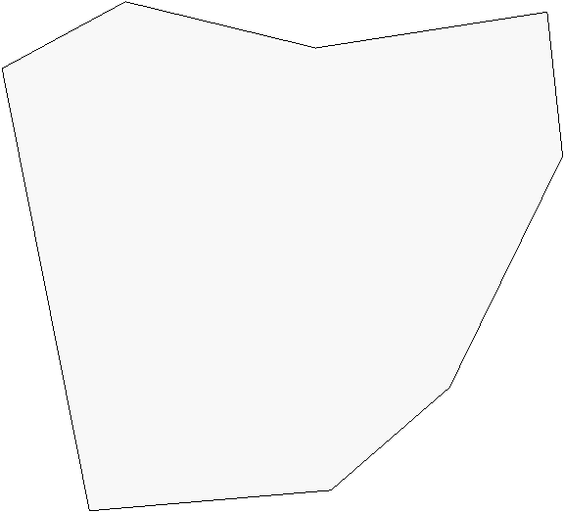
Figure 6: Example of a feature extent

1.3.7.2 gml:boundedBy
The boundedBy property is intended for mathematical computations rather than for displaying areas in maps. It serves as additional information for fast searching for features based on their location. For example, where features consist of several other features, generally an area is specified within which all the contained objects lie. The boundedBy property does not represent any surface though from which one could compose other surfaces, but rather conveys the maximum extent eastwards, northwards, westwards and southwards. For this, it contains an element Envelope that defines the area by specification of two points. These are the lowerCorner and upperCorner, which specify the respective minimum and maximum coordinates of all points contained in the feature geometry.
In the example from section 1.3.7.1, the maximum extents could be specified as follows by specifying a boundedBy property:
<PresentWeather xmlns:gml="http://www.opengis.net/gml">

<gml:boundedBy>
<gml:Envelope srsName="urn:EPSG:geographicCRS:4326" srsDimension="2">
<lowerCorner>11.99 50.97</lowerCorner>
<upperCorner>13.08 51.96</upperCorner>
</gml:Envelope>
</gml:boundedBy>

<gml:extentOf>
<gml:Polygon srsName="urn:EPSG:geographicCRS:4326" srsDimension="2">
<gml:exterior>
<gml:LinearRing>
<gml:posList count="9">12.16 50.97 12.63 51.01 12.86 51.21 13.08 51.66 13.05 51.94 12.60 51.87 12.23 51.96 11.99 51.83 12.16 50.97 </gml:posList>
</gml:LinearRing>
</gml:exterior>
</gml:Polygon>
</gml:extentOf>
<weatherCode>60</weatherCode>

</PresentWeather>

Section 2: Further examples

2.1 FeatureCollection
The following more complex example shows the use of an Envelope in order to clarify the boundaries of a FeatureCollection. Several PresentWeather features, as described in the example in section 1.3.7.1, can be combined in this way. Here, the MultiSurface element was used in order to define the separate component areas centrally. This, of course, only makes sense in the case where the component areas bear a logical relationship to one another. In an explicit defined multiExtentOf property, the respective FeatureMembers refer only to existing polygons. To specify the maximum dimensions of this FeatureCollection, the boundedBy property is required. The following schema contains the declaration of a MultiPresentWeather feature derived from a FeatureCollection.
<complexType name="MultiPresentWeatherType">
<complexContent>
<extention base="gml:FeatureCollectionType">
<sequence>
<element ref="gml:multiExtentOf"/>
</sequence>
</extention>
</complexContent>
</complexType>

<element name="MultiPresentWeather" type="MultiPresentWeatherType" substitutionGroup="gml:FeatureCollection"/>

The surfaces defined in the example are shown in Figure 7. The circumscribing of the Envelope element is drawn in here only for clarification. A conventional GML-based application would not also draw in the framing rectangle and highlighted corner points when displaying the example.
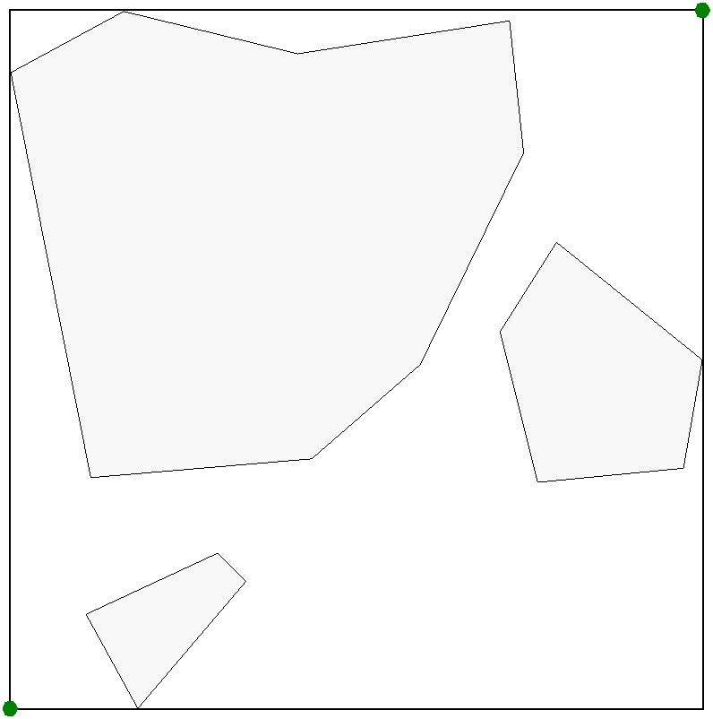
Figure 7: Example of FeatureCollection

<MultiPresentWeather>

<gml:boundedBy>
<gml:Envelope srsName="urn:EPSG:geographicCRS:4326" srsDimension="2">
<gml:lowerCorner>11.99 50.48</gml:lowerCorner>
<gml:upperCorner>13.46 51.96</gml:upperCorner>
</gml:Envelope>
</gml:boundedBy>

<gml:multiExtentOf>
<gml:MultiSurface srsName="urn:EPSG:geographicCRS:4326" srsDimension="2">
<gml:surfaceMember>
<!-- large polygon at top left -->
<gml:Polygon gml:id="poly10">
<gml:exterior>
<gml:LinearRing>
<gml:posList count="9">12.16 50.97 12.63 51.01 12.86 51.21 13.08 51.66 13.05 51.94 12.60 51.87 12.23 51.96 11.99 51.83 12.16 50.97</gml:posList>
</gml:LinearRing>
</gml:exterior>
</gml:Polygon>
</gml:surfaceMember>

<gml:surfaceMember>
<!-- small polygon on the right -->
<gml:Polygon gml:id="poly20">
<gml:exterior>
<gml:LinearRing>
<gml:posList count="6">13.03 51.28 13.15 51.47 13.46 51.22 13.42 50.99 13.11 50.96 13.03 51.28</gml:posList>
</gml:LinearRing>
</gml:exterior>
</gml:Polygon>
</gml:surfaceMember>

<gml:surfaceMember>
<!-- small polygon at bottom -->
<gml:Polygon gml:id="poly30">
<gml:exterior>
<gml:LinearRing>
<gml:posList count="5">12.15 50.68 12.43 50.81 12.49 50.75 12.26 50.48 12.15 50.68</gml:posList>
</gml:LinearRing>
</gml:exterior>
</gml:Polygon>
</gml:surfaceMember>
</gml:MultiSurface>
</gml:multiExtentOf>

<gml:featureMembers>
<PresentWeather>
<gml:extentOf xlink:href="#poly10"/>
<weatherCode>60</weatherCode>
</PresentWeather>

<PresentWeather>
<gml:extentOf xlink:href="#poly20"/>
<weatherCode>62</weatherCode>
</PresentWeather>

<PresentWeather>
<gml:extentOf xlink:href="#poly30"/>
<weatherCode>63</weatherCode>
</PresentWeather>
</gml:featureMembers>

</MultiPresentWeather>

With several related areas the FeatureCollection can be defined in exactly the same way, except that instead of the MultiSurface element, a CompositeSurface element and instead of the multiExtendOf property, an extendOf property is used.

2.2 Crossing the date-line and encompassing of poles
With maximum outer dimensions that extend beyond the date-line, it is possible that the upperCorner in the boundedBy property contains a smaller longitude than the lowerCorner.
Note that GML does not explicitly deals with such agreements. GML only provides tools for data definition. Interpretation of spatial data is to be executed by the application.
An example of crossing the date-line and encompassing of a pole is demonstrated in the following example. For this, an area in a schema file is assumed in the following definition:
<complexType name="ExampleAreaType">
<complexContent>
<extention base="gml:AbstractFeatureType">
<element ref="gml:extentOf"/>
</extention>
</complexContent>
</complexType>

<element name="ExampleArea" type="ExampleAreaType" substitutionGroup="gml:_Feature"/>

The definition derives merely the basic type without additional subelements and defines a new ExampleArea feature.
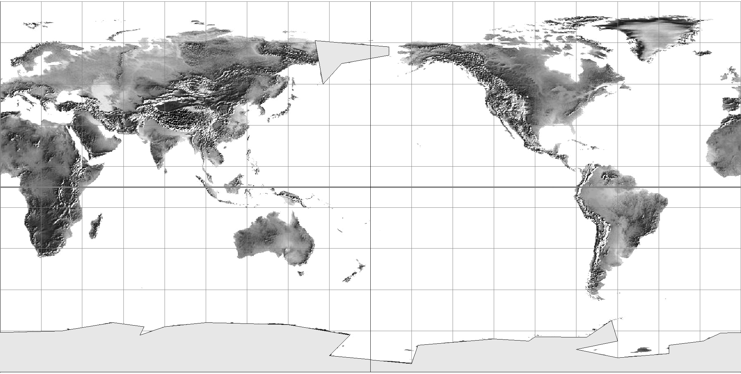
Figure 8: Polygons with crossing of pole and dateline

From the direction of rotation it is clearly defined which areas the polygons enclose.
<!-- Eastern Siberia -->
<ExampleArea xmlns:gml="http://www.opengis.net/gml">

<gml:boundedBy>
<gml:Envelope srsName="urn:EPSG:geographicCRS:4326" srsDimension="2">
<gml:lowerCorner>153 50</gml:lowerCorner>
<gml:upperCorner>-171 71</gml:upperCorner>
</gml:Envelope>
</gml:boundedBy>

<gml:extentOf>
<gml:Polygon srsName="urn:EPSG:geographicCRS:4326" srsDimension="2">
<gml:exterior>
<gml:LinearRing>
<gml:posList count="6">157 50 166 60 -171 60 –171 68 153 71 157 50</gml:posList>
</gml:LinearRing>
</gml:exterior>
</gml:Polygon>
</gml:extentOf>

</ExampleArea>

<!-- Antarctica -->
<ExampleArea xmlns:gml="http://www.opengis.net/gml">

<gml:boundedBy>
<gml:Envelope srsName="urn:EPSG:geographicCRS:4326" srsDimension="2">
<gml:lowerCorner>-180 -90</gml:lowerCorner>
<gml:upperCorner>180 -65</gml:upperCorner>
</gml:Envelope>
</gml:boundedBy>

<gml:extentOf>
<gml:Polygon srsName="urn:EPSG:geographicCRS:4326" srsDimension="2">
<gml:exterior>
<gml:LinearRing>
<gml:posList count="24">160 -82 170 -72 140 -67 100 –66
80 -68 68 -72 70 -68 55 -66 30 -70 –10 -71 –18 -75 –35 -77 –35 -81
–60 -83 –80 -79 –60 -75 –63 -65 –75 -73 –100 -73 –103 –75 –120 –74
–157 -77 –160 -86 160 82</gml:posList>
</gml:LinearRing>
</gml:exterior>
</gml:Polygon>
</gml:extentOf>

</ExampleArea>

GML is therefore suitable not only for general spatial data but also for the specification of global geometries.

Section 3: Coordinate Reference Systems
Coordinate Reference System definition data is metadata about spatial data which positions are described by coordinates. Without the Coordinate Reference System data, interpretation of coordinates is ambiguous.
GML requires a Coordinate Reference System (CRS) to be referenced when location coordinate information is given. Referencing is generally given using the srsName attribute which is provided by gml:AbstractGeometryType. This is the basis for the content models for all GML geometry elements. If no srsName attribute is given, the CRS must be specified as part of the larger context this geometry element is part of, e.g. a geometric aggregate. In this case, the CRS is implicitly assumed to take on the value of the containing object's CRS:
<gml:Point srsName="urn:EPSG:geographicCRS:4326"> …

with "urn:EPSG:geographicCRS:4326" will lead to a full definition of some CRS. For well-known references it is not required that the CRS description exists at the location the URN points to. Such a well-known CRS is helpful if spatial data had to be appropriable to several institutions. The used “urn:EPSG:geographicCRS:4326” was specified by European Petroleum Survey Group (EPSG) and is equivalent to the WGS 84. It involves an geographic 2D CRS. Like every geographic 2D CRS specified by EPSG it uses latitude and longitude to represent a point.
However, some applications need to specify their own purpose-build CRS. For that reason GML provides six schema documents and additional explanations since version 3.1.0. These schema documents are closely based on the UML package with a similar name in OGC Abstract Specification Topic 2, which is based on ISO 19111.
To define a coordinate reference system two essential elements are needed. Firstly a coordinate system, containing set of mathematical rules for specifying how coordinates are to be assigned to points, and secondly a datum, defining the position of the origin, the scale, and the orientation of the axes of a coordinate system. For example WGS 84 uses an ellipsoidal coordinate system and a geodetic datum specifying the ellipsoid. Moreover in some cases it is necessary to specify coordinate operations to define the coordinate transformation or conversion between coordinates in two different coordinate reference systems. Each CRS also inherits information about its name, aliases, version, scope, valid area and further remarks. In practice, a coordinate reference system is often referenced from a CRS dictionary.
Because there are many sophisticated possibilities to define a coordinate reference system, the GML schema documents are pretty complex, too. Geodetic survey practice usually divides coordinate reference systems into a number of sub-types. The common classification criterion for sub-typing of coordinate reference systems can be described as the way in which they deal with earth curvature. GML deals with seven sub-types:
- GeocentricCRS – 3D spatial view, witch origin is at the approximate centre of mass of the earth,
- GeographicCRS – based on an ellipsoidal approximation of the geoid,
- ProjectedCRS – an approximation of the shape of the earth’s surface by a plane, carefully controlling inherent distortion,
- EngineeringCRS – used only in a contextually local sense, divided in earth-fixed systems and systems based on a moving platform,
- ImageCRS – Engineering CRS witch is applied to images,
- VerticalCRS - used for the recording of heights or depths and
- TemporalCRS - used for the recording of time in association with any of the listed spatial coordinate reference systems.
In addition there are two coordinate reference systems that base on these sub-types:
- CompoundCRS – combines mostly a 2D CRS with a height or depth from a different CRS or adds a temporal CRS and
- DerivedCRS - defined by applying a coordinate conversion to another coordinate reference system.
To describe all these CRS in detail including their specific datums and coordinate systems is beyond the scope of this document. Therefore the following example describes the general structure of a coordinate reference system definition. It provides a sample GML instance of a CRS Dictionary, identified by EPSG codes of the common reference systems WGS 84.
<Dictionary xmlns:gml="http://www.opengis.net/gml" gml:id="exampleDictionary">
<name>WGS 84 CRS Dictionary</name>
<dictionaryEntry>
<gml:GeographicCRS gml:id="EPSG4326">
<gml:srsName>WGS 84</gml:srsName>
<gml:validArea>
<gml:description>World</gml:description>
</gml:validArea>
<gml:scope>Satellite navigation</gml:scope>
<gml:usesEllipsoidalCS>
<gml:EllipsoidalCS gml:id="EPSG6422">
<remarks>Axis order is by element order.</remarks>
<gml:csName>Ellipsoidal 2D CS</gml:csName>
<gml:usesAxis>
<gml:CoordinateSystemAxis gml:id="EPSG9901" gml:uom="urn:x-epsg:v0.1:uom:degree">
<gml:axisName>Geodetic latitude</gml:axisName>
<gml:axisAbbrev>Lat</gml:axisAbbrev>
<gml:axisDirection>north</gml:axisDirection>
</gml:CoordinateSystemAxis>
</gml:usesAxis>
<gml:usesAxis>
<gml:CoordinateSystemAxis gml:id="EPSG9902" gml:uom="urn:x-epsg:v0.1:uom:degree">
<gml:axisName>Geodetic longitude</gml:axisName>
<gml:axisAbbrev>Long</gml:axisAbbrev>
<gml:axisDirection>east</gml:axisDirection>
</gml:CoordinateSystemAxis>
</gml:usesAxis>
</gml:EllipsoidalCS>
</gml:usesEllipsoidalCS>
<gml:usesGeodeticDatum>
<gml:GeodeticDatum gml:id="EPSG6326">
<gml:datumName>World Geodetic System 1984</gml:datumName>
<gml:usesPrimeMeridian gml:id="EPSG8901">
<gml:meridianName>Greenwich</gml:meridianName>
<gml:greenwichLongitude>
<gml:angle uom="urn:x-epsg:v0.1:uom:degree">0</gml:angle>
</gml:greenwichLongitude>
</gml:usesPrimeMeridian>
<gml:usesEllipsoid>
<gml:Ellipsoid gml:id="EPSG7030">
<gml:ellipsoidName>WGS 84</gml:ellipsoidName>
<gml:semiMajorAxis gml:uom="urn:x-si:v1999:uom:metre">6378137</gml:semiMajorAxis>
<gml:secondDefiningParameter>
<gml:inverseFlatering uom="urn:x-bagug:v0.1:dictionary:ifu">298.257223563</gml:inverseFlatering>
</gml:secondDefiningParameter>
</gml:Ellipsoid>
</gml:usesEllipsoid>
</gml:GeodeticDatum>
</gml:usesGeodeticDatum>
</gml:GeographicCRS>
</dictionaryEntry>
</Dictionary>

Section 4: Recommendations
The following recommendations are proposed to use GML for a unified definition of boundary functions in the WMO community:
- For a general understanding of spatial data, a well-known coordinate reference system is needed. WMO recommends the adaption of the "urn:EPSG:geographicCRS:4326" specification of the European Petroleum Survey Group ([EPSGDB]). This system describes the earth coordinates in latitude and longitude and is equivalent to the “WGS 84” (=World Geodetic System 1984) which is the basis of the GPS coordinates.
- CRS are to be specified using GML only if they are not well-known.
- The WMO community has to define a specified schema document containing the definition for several features.
- In order to avoid ambiguity in the definitions of boundary polygons, in GML objects for the definition of boundary polygons should be restricted in the WMO community.
- For the definition of a simple boundary polygon in earth coordinates only the GML objects Polygon, LinearRing and coordinates should be used. To form more complex areas the interior and exterior feature should also be allowed (see example 1.3.4.1).
- For the definition of a multiple connected area the CompositeSurface feature should be used (see example 1.3.5).
- For the definition of a non-connected multiple area the MultiSurface feature and the FeatureCollection for not related/independent areas respectively should be used (see in example 2.1).
- For computation and map presentation purposes the boundedBy feature and the element Envelope should be allowed (see example 2.1).
- For the assignment of a weather phenomia (e.g. a precipitation field) to a defined area the extentOf and multiExtentOf aliases should be used (see example 1.3.7.1).

References
[EPSGDB] European Petroleum Survey Group: EPSG Geodesy Parameters (http://www.epsg.org). 29. Juni 2004.
[ISO19136] ISO/TC 211/WG4: CD 19136 Geographic information – Geography Markup Language. 11. Februar 2004.
[ISO19111] ISO/TC 211 Secretariat: Text of 19111 Geographic information – Spatial referencing by coordinates, as sent to the ISO Central Secretariat for registration as FDIS. 12. Juni 2002.
[OGCGML] Open GIS Consortium, Inc.: OpenGIS® Geography Markup Language (GML), Implementation Specification, Version 3.00. January 2003
[OGCAST1] Open GIS Consortium, Inc.: The OpenGIS™ Abstract Specification, Topic 1: Feature Geometry (ISO 19107 Spatial Schema), Version 5. May 2001.
[OGCAST2] Open GIS Consortium, Inc.: The OpenGIS™ Abstract Specification, Topic 2: Spatial referencing by coordinates, Version 2.0.0. 16. Oktober 2003.
[W3CXML] World Wide Web Consortium: Extensible Markup Language (XML) 1.0 (Third Edition). February 2004.
[W3CXMLS] World Wide Web Consortium: XML Schema Part 0: Primer. May 2001.

