WORLD METEOROLOGICAL ORGANIZATION  ________  CBS EXPERT TEAM ON  INTEGRATED DATA MANAGEMENT  THIRD MEETING  GENEVA, 15 TO 18 DECEMBER 2003 |  | ET-IDM-III/Doc. 3.1(5) (10.XII.2003)  ____  ITEM: 3.1  ENGLISH ONLY

OPERATIONAL IMPLEMENTATION OF THE WMO CORE METADATA PROFILE.

THE ACSYS AND CLIC PROGRAMMES EXPERIENCE.

(Submitted by Bernard Miville, International ACSYS/CliC Project Office)

Summary and Purpose of the Document

The document contains information about the implementation of the WMO Core metadata profile in a real live database of metadata for datasets related to the ACSYS and CliC WCRP programs.

ACTION PROPOSED

The meeting is invited to consider the report on this example of operation implementation of the WMO Core Metadata Profile in particular the recommendation for modification or extension to the profile.

OPERATIONAL IMPLEMENTATION OF THE WMO CORE
METADATA PROFILE.

THE ACSYS AND CLIC PROGRAMMES EXPERIENCE

by

Bernard Miville

5 December 2003

CONTENTS

1 Introduction 1
2 ADIS and CliC 1
3 Implementation of the WMO Core Metadata profile 2
3.1 Metadata standard 2
3.2 Metadata storage 2
3.3 Interface to database 3
3.4 Search capability 6
4 Exchange capability 10
5 Future plan for ADIS and DISC 10
7 Recommendations for the WCRP Data Management Plan 10
REFERENCES 12
LIST OF ACRONYMS 13

- Introduction

The International ACSYS/CliC Project Office (IACPO) is responsible for the management of 2 WCRP projects:
- ACSYS: Arctic Climate System Study (Ending the 31 of December 2003)
- CliC: Climate and Cryosphere
IACPO needed to re-organize the management of their web site and of their ACSYS Data and Information Service (ADIS). ADIS consisted of multiple static web pages containing the following:
- Web links to organization, projects, data centres related to the ACSYS program
- Metadata for datasets related to the ACSYS program
- References to papers, articles, book, proceedings, reports related to the ACSYS program.
Maintaining the web pages turn out to be increasingly difficult and the information quickly became out of date or inaccurate. The introduction of a database facilitated the maintenance of the information and web pages became dynamic avoiding the constant editing of HTML pages.
The database also permitted the introduction of search engines making it easier for the users to quickly find the information they need. The development of the Data and Information Service for CliC (DISC) was relatively easy by using a modified copy of the ADIS system.

- ADIS and CliC

ADIS: ACSYS Data and Information Service
http://acsys.npolar.no/adis/adis.php

DISC: Data and Information for CliC
http://clic.npolar.no/disc/disc.php

ADIS and DISC are more than just a metadata database, they contain the following information:
- Metadata for datasets
- References to Papers, Articles, Reports, Proceedings, Books (ADIS only)
- Web Links
- Reports
- Newsletters

All the information is stored in a relational database (MySQL¹) and everything is searchable. ADIS and DISC needed a metadata standard for describing the datasets related to the ACSYS and CliC programs. While there are many standards available (FGDC², DIF³, …), we decided to use the ISO 19115⁴ metadata standard for geographic information. We opted for WMO Core Metadata profile⁵ which is based on the ISO 19115⁴ standard.

- Implementation of the WMO Core Metadata profile
Working with metadata involves several steps:
- Use a metadata standard for the metadata structure (FGDC², DIF³, ISO 19115⁴, …)
- Store the information (Database, files, …)
- Interface to access the database for administration (editing, adding, …)
- Provide search capability for clients (Query database using SQL)
- Provide exchange capability (DIF³, XML⁸, …)

  - Metadata standard

The choice of metadata standard was easy. In May 2003, ISO made the ISO 19115 official. An increasing number of metadata centres are converting to ISO 19115 and this will make it easier to exchange metadata in the future.
Looking into the standard in more details, we found out that WMO created a Core Metadata profile based on ISO 19115. So since ACSYS and CliC are WCRP/WMO projects, the next logical step was to try to implement the WMO profile.

  - Metadata storage

After deciding in a standard for the metadata, we needed a method for storing the information. In the first version of ADIS, the metadata did not use any standards and the information was stored in individual HTML files, making it very difficult to maintain and search.
We went ahead and structure our data using the WMO Core Metadata Profile however there seemed to be unlimited methods to store metadata. Here are just a few examples:
- Write the metadata in XML format and store it in and XML database (like Xindice⁶ )
- Write metadata in XML and store it in a relational database (MySQL, Oracle) as a single field
- Write metadata in XML and save it as individual files
- Write the metadata directly in a relational database using individual tags as fields in a table
Method 1 is the most efficient method. However XML databases, at least the Open Source ones, are still fairly experimental and support is very limited. But this will become in the very near future the best method of handling metadata and the storage of the information.
Method 2 is one of the most common methods used by different metadata centres (GeoConnections⁷ in Canada for example). It consists of first writing the metadata in XML and then storing the formatted metadata in a relational database as a single field. Queries are done using specialized queries for XML documents. This method is also very efficient, however you need special software to write the metadata in XML (like XMLSpy⁹) or specialise staff to handle the XML format.
Method 3 consists of writing the metadata in XML and saving as individual files instead of using a database. With HTML indexing and a good search engine, that method would work fine but it is not as efficient as storing the information in a relational or XML database. It has the advantage of not having to buy and install a database. However you still need someone who knows how to handle XML.
Method 4 uses a relational database to store the individual information (tags) in a table. It does not involve the use of any XML but does use what the XML tags would be as the entry fields in the database table. The metadata can still be imported or exported as XML by writing the proper import/export scripts. Using that method you need someone who is capable of installing a database (commercial or Open Source) and provide an interface to input the metadata in the database (like the freely available MCC¹⁰ or phpMyAdmin¹¹ for MySQL database). Once the system is setup a non-specialised person can easily manage the metadata database. The ISO 19115 metadata standard allows unlimited fields and sub fields in its format (like contacts, links, etc.). This is fine and it should be that way but that can cause problems in typical relational database where a table has to be predefined with a certain number of fields. Extra fields can be added and never use but this is a limitation to keep in mind.
The method you choose to store the metadata will highly depend on the resources you have at your disposition. At IACPO the metadata will be maintained by an office coordinator with very limited knowledge of HTML and no knowledge of XML or databases.
We wanted to use method 1 or 2, but the reality was forcing us to make a compromise and use method 4.
So we are storing the metadata information in a relational database (using tables). It is easy to edit and there is not need to write the metadata as XML.

  - Interface to access the database

In order to maintain and edit the database we had to provide IACPO with an easy to access and simple to handle interface.

Here are the characteristics of ADIS and DISC:
- Server: Apache¹⁷ on a Linux platform (Both Open Source and Free)
- Database: MySQL (Free and Open Source, very good community support) Has XML support.
- Database Interface: phpMyAdmin (Free and Open Source). Web based interface that can be used from anywhere in the world (Figure 1 and 2).
- Script language to Query database: PHP¹² (Free and Open Source) Has XML query support.
By using this configuration, no cost was added to the operation of IACPO.
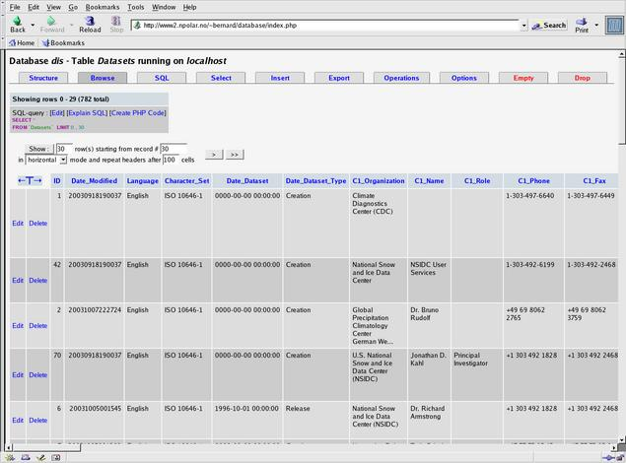
Figure 1: phpMyAdmin interface for the administration of the database

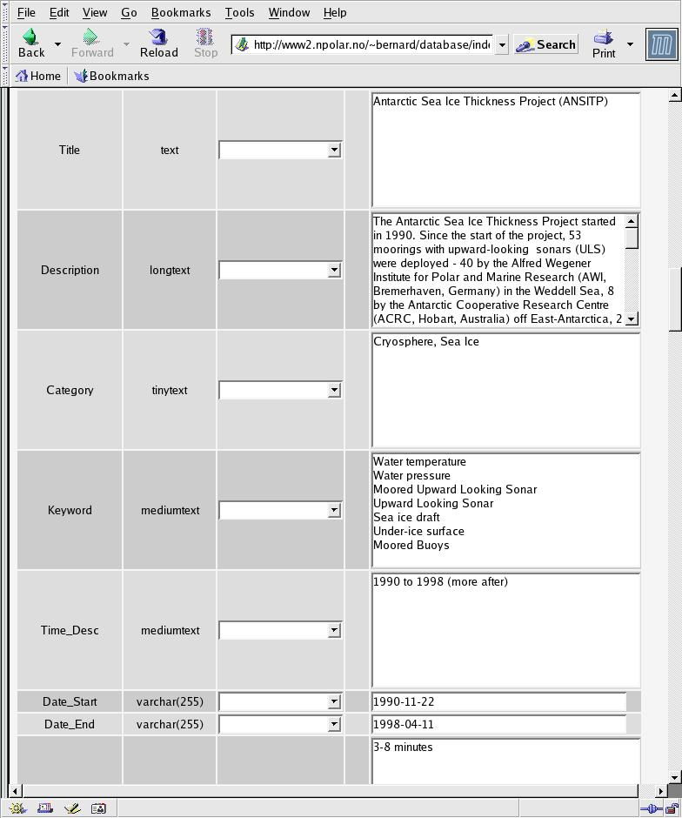
Figure 2: Editing metadata using phpMyAdmin

  - Search capability

The main reason for the creation of ADIS and DISC is to facilitate the search for information about datasets. We created a simple web interface (Figure 3) which directly queries the metadata database. The queries are done using standard SQL commands via a PHP (Hypertext Pre-Processor) script. The script receives the users request, sends it to the database using SQL. The database finds the information and the results of the query is returned to the script and send back to the user by creating a list of results in an HTML table (Figure 4). From that table the user selects which metadata he wants to see and the PHP scripts then queries the database using the metadata ID and returns the metadata in an HTML table (Figure 5).

Client | Web Server | MySQL Database | Web Server | Client
User send request using web interface  (Figure 3) | PHP Script creates SQL to be sent to database | Database receives Query and extract information | PHP receives Query results and organise results into an HTML table to be sent to the client | Client receives request in web browser  (Figures 4 and 5)

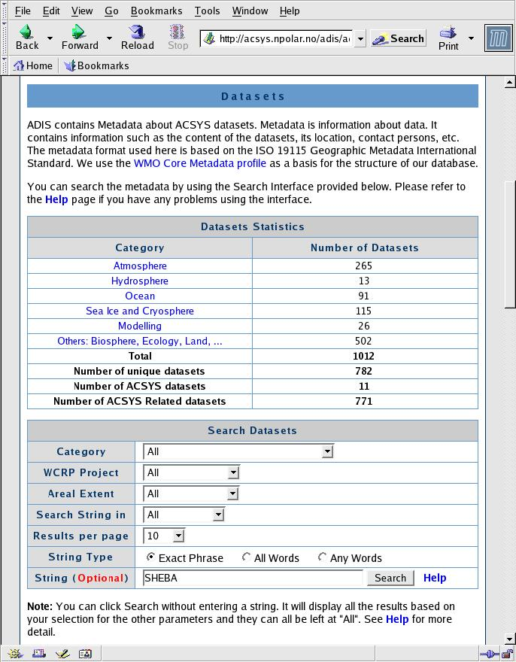
Figure 3: ADIS search interface for metadata

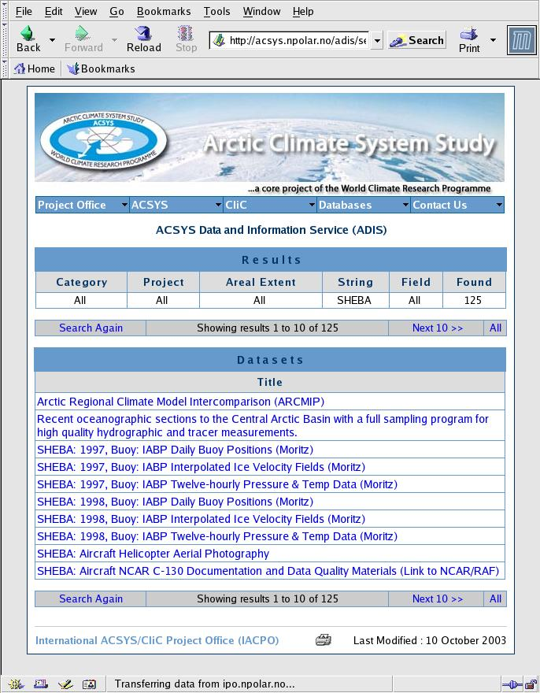
Figure 4: Listing all datasets based on query from user

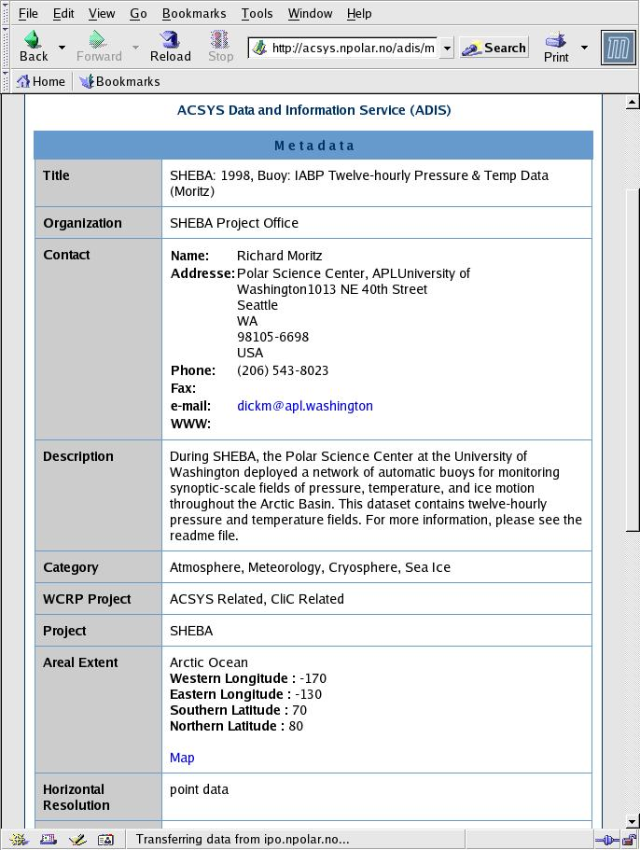
Figure 5: Metadata from one datasets as seen from a user web browser

- Exchange capability

The next step in ADIS and DISC is to provide the user with metadata in a format that can be easily parsed and exchanged. At the moment we only provide the user with the results in a table format inside their web browser. We are in the process of creating the PHP scripts that will provide the metadata in XML format using the WMO Core Metadata profile XML schema¹⁸.

- Future plan for ADIS and DISC
Many more improvement will be done on ADIS and DISC, here are a few examples:
- Provide XML import and export capability (Using WMO XML schema)
- GIS Mapserver¹³ for locating datasets and to display datasets boundaries
- Experiment with SVG¹⁴ for displaying datasets boundaries
- Making ADIS and DISC fully compliant with the WMO Core Metadata Profile. At the moment the contact address are not separated by city and street address as required by the standard.

- Metadata standard modification suggestions
Implementing the WMO Core Metadata profile was very easy and we did not have any problems with the content structure for the information. However we would like to see some extensions to the profile. Here are a few suggestions of modifications/extensions:
- Add bounding line for extent of datasets. Very useful for transect and cruises.
  - EX_GeographicBoundingLine
    - line
- Add bounding point extent for datasets. Very useful for point observations.
  - EX_GeographicBoundingPoint
    - point
- Add a Cryosphere list of keywords (Permafrost, Glacier, Iceberg, Sea Ice, …). Right now the WMO profile only includes atmosphere and ocean keywords. The profile should allow for combined keywords like sea ice and ice sheets. Should we consider other category of keywords (Ecology, Biology ???).
- Recommendations for the WCRP Data Management Plan
WCRP is planning to have its own data management plan. Hopefully there will be cooperation between the different levels within WMO especially with CBS. At the Twenty-Fourth Session of the Joint Scientific Committee meeting in Reading in March 2003, there was a document¹⁹ submitted by JPS and JOSS¹⁵. I suggest that CBS become aware of this proposal and that WCRP and CBS work together in the implementation of a viable data management plan that could be applicable to all WMO not just WCRP.
There are many aspects of data management. The main ones are:
- Data collection (Actual projects, measurement standard, real time data, analyzed data, …)
- Data storage (Datasets, Access to data, Data Centre, Data format using official standard)
- Metadata of Datasets (Metadata standard, storage, access, maintenance)
They all require resources to develop and maintain.
Data collection: Once a project is under way, the data management is usually under the control of the project team. However data collection standard, policy and data storage and availability can be suggested by WCRP via guidelines or by the dedicated Project Office or monitored and enforced by the funding agency.
Data storage: There are many data centres in the world and they can be used to store all WCRP data without adding any cost to WCRP. Funding agencies could require that the data be stored in a specific data centre and by a certain date after the project. Funding agency should be part of the system.
Metadata: The metadata for these datasets can also be stored in metadata centres (GCMD¹⁶ for example) but WCRP can not impose a metadata standard if the metadata is stored outside WCRP. Keeping track of WCRP projects would be more difficult by storing the information exclusively using external facilities. A metadata catalogue similar to the one developed for the ACSYS and CliC projects can easily be installed at WCRP. However WCRP still needs resources to implement the system and then maintain it. Typically if nobody is assigned to work on the system full time, nothing gets done!
For WCRP (and all WMO), several databases could be implemented:
- All WMO projects database
  - Title, Descriptions, Status, Contact, …
  - Web Search Engine
- All WMO datasets database
  - Metadata of Datasets (Using WMO Core Metadata Profile)
  - Web Search Engine
  - Metadata exchange, Import and Export (XML)
By having its own database, it will be easier for WMO to publicize the use of official standard for both data collection and metadata.

Data management can be very simple. It is just a matter of organization and standardization. The first step is to know what you want to do, then organize the current information and data, use a standard to describe the information and data and store the information in a database. Once you have the database everything else falls into place!!!

REFERENCES

- MySQL: http://www.mysql.com/
- FGDC: http://www.fgdc.gov/standards/standards.html
- DIF: http://gcmd.gsfc.nasa.gov/User/difguide/difman.html
- ISO 19115: http://www.isotc211.org
- WMO Core Metadata Profile:
- Xindice: http://xml.apache.org/xindice/
- Geoconnections: http://www.geoconnections.org/CGDI.cfm
- XML: http://www.w3.org/XML
- XMLSpy: http://www.xmlspy.com
- MCC: http://www.mysql.com/products/mysqlcc/index.html
- phpMyAdmin: http://www.phpmyadmin.net
- PHP: http://www.php.net
- GIS Mapserver: http://mapserver.gid.umn.edu
- SVG: http://www.w3.org/Graphics/SVG/
- JOSS: http://www.joss.ucar.edu/
- GCMD: http://gcmd.gsfc.nasa.gov/
- Apache: http://www.apache.org/
- WMO Metadata XML schema: http://www.wmo.ch/web/www/metadata/WMO19115_metadata_v0_1.xsd

LIST OF ACRONYMS

ACSYS | Arctic Climate System Study
ADIS | ACSYS data information service
CBS | Commission for Basic Systems
CliC | Climate and Cryosphere
DIF | Directory Interchange Format
DISC | Data and Information Service for CliC
FGDC | Federal Geographic Data Committee
GIS | Geographic Information System
GCMD | Global Change Master Directory
HTML | Hypertext Markup Language
IACPO | International ACSYS/CliC Project Office
ISO | International Organization for Standardization
JOSS | Joint Office for Science Support
JPS | Joint Planning Staff
MCC | MySQL Control Center
PHP | Hypertext Pre-Processor
SQL | Structured Query Language
SVG | Scalable Vector Graphics
WCRP | World Climate Research Programme
WMO | World Meteorological Organization
XML | Extensible Markup Language

