WORLD METEOROLOGICAL ORGANIZATION  _____________  COMMISSION FOR BASIC SYSTEMS  STEERING GROUP ON RADIO FREQUENCY COORDINATION  BOULDER, COLORADO, USA  15-19 JANUARY 2007 |  | CBS/SG-RFC 2007/Doc. X(X)  _______  ITEM X  ENGLISH only
Preliminary Draft New Recommendation on the Compatibility of Airport Surveillance Radars and Meteorological Radar with IMT Systems within the 2 700 – 2 900 MHz Band
(Submitted By Robert P. Leck (QSS Group Inc. for NOAA/NWS, USA)

Summary and Purpose of Document

This paper provides a compatibility analysis between Airport Surveillance Radars (ASR) and meteorological radars and IMT systems in the 2700-2900 MHz band. It describes technical matters related to the methodology, protection criteria, and mitigation techniques used to analyze potential compatibility. Additionally, this study summarizes the results of previous studies conducted within the ITU-R regarding IMT systems and the radiolocation radars operating in the 2700-2900 MHz band.

Action Proposed

This document is provided for information to the SG-RFC. The SG-RFC may wish to consider this information when discussing sharing of the 2700-2900 MHz band with IMT Systems.

 | INTERNATIONAL TELECOMMUNICATION UNION
 | RADIOCOMMUNICATION  STUDY GROUPS | Document 8F US8F06-47A rev 5  3 December 2006  English only

UNITED STATES OF AMERICA

Preliminary Draft New Recommendation on the Compatibility of Airport Surveillance Radars and Meteorological Radar with IMT Systems within the 2 700 – 2 900 MHz Band

Introduction
This U.S. contribution provides an updated compatibility analysis between airport surveillance and meteorological radars and IMT systems operating in the 2 700-2 900 MHz band. An attempt was initially made to revise the merging of several administrations’ studies that were based on different methodologies, techniques, and system characteristics. Summarizing these studies into a single document became cumbersome and no further revisions were attempted.
Proposal
The intent of this new document is to: 1) be a standalone Recommendation regarding the compatibility between airport surveillance and meteorological radars and IMT systems operating in the 2 700-2 900 MHz band, 2) present additional information which will be used as the basis of any additional studies regarding the compatibility of airport surveillance and meteorological radars and IMT systems operating in the 2 700-2 900 MHz band and 3) elevate it to a Draft New Recommendation status at the next ITU-R WP8F meeting.

Preliminary Draft New Recommendation on the Compatibility of Airport Surveillance Radars and Meteorological Radar with IMT Systems within the 2 700 – 2 900 MHz Band

The ITU-R Radiocommunication Assembly,
considering
- that Resolution 228 (WRC-03) invites ITU-R to study the spectrum requirements and potential frequency ranges suitable for the future development of IMT-2000 and systems beyond IMT-2000, and in what time frame such spectrum would be needed; "
- that ITU-R has called for sharing studies to help identify possible frequency bands to accommodate IMT systems;
- that ITU-R has identified the frequency range 2 700-2 900 MHz as a possible candidate band for sharing;
- that the aeronautical radionavigation service has primary allocation in the band 2700 -2900 MHz in all three ITU-R regions;
- that the radionavigation service is a safety service as specified by No. 4.10 of the Radio Regulations (RR) and harmful interference to it cannot be accepted;
- that ground-based meteorological radars are afforded equal status to the aeronautical radionavigation service in the band 2 700-2 900 MHz;
- that administrations have developed and deployed multiple radar systems in the 2 700-2 900 MHz band;
- that the protection of incumbent radiocommunication services is an important principle of the ITU-R;
- that interference to new radiocommunication services is to be avoided if possible;

noting
- that current ITU-R studies show that interference from IMT systems to ASR and meteorological radars will impair the operation of incumbent radar systems when co-frequency shared with IMT systems macro and micro based topologies within the 2 700 – 2 900 MHZ band;
- that current ITU-R studies show that interference from ASR and meteorological radars to IMT-2000 and IMT-Advance Systems Macro and Micro based topologies can cause damage to or hinder the operation of IMT systems when co-frequency shared with ASR and meteorological radars within the 2 700 – 2 900 MHZ band;
- that ASR radars are crucial systems that facilitate the safe and efficient operation of air travel worldwide.
- that meteorological radars provide immediate meteorological and hydrological information that is used to predict severe weather events;
- that both radar systems allocated in the 2 700-2 900 MHz band protect lives and property;
- that neither radar systems can accepts any interference;
- that a significant percentage of ASR and meteorological radars deployed throughout the 2 700 – 2 900 MHz band are close to cities and/or airports;
- that ITU-R Recommendations M.1461 contains procedures for determining the potential for interference between radars operating in the radiodetermination service and systems in other services;
- that M.1464 contains characteristics of radiolocation radars, and characteristics and protection criteria for sharing studies for aeronautical radionavigation and meteorological radars in the radiodetermination service operating in the frequency band 2 700-2 900 MHz;
- that ITU-R Report M.2039 contains characteristics of terrestrial IMT-2000 systems for frequency sharing/interference analyses;
- that Preliminary Draft New Report on Radio Aspects for the terrestrial component of IMT-2000 and systems beyond IMT-2000 addresses technical matters related to radio aspects for the future development of IMT systems;
recognizing
- the need to “coordinate” the deployment of IMT-Advanced systems over extended exclusion zones could drastically limit the deployment of IMT-systems;
- that antenna, signal propagation, target detection, and large necessary bandwidth characteristics of radar to achieve their functions are optimum in certain frequency bands;
- that the technical characteristics of radars operating in the radiodetermination service are determined by the mission of the system and vary widely even within a band;
- that many of the radio frequency characteristics of the future developments of IMT-Advanced are not fully defined;
recommends

that in the 2700-2900 MHz band, IMT-type systems not operate within the same geographical region as ASR and meteorological radars (refer to Annex 1);

ANNEX 1

Overview of the Results of Previous Co-Channel Studies of the 2 700 – 2 900 MHz Band between Airport Surveillance Radars and Met Radars and IMT-2000 and IMT-Advanced Systems

1. Scope
This study provides a compatibility analysis between Airport Surveillance Radars (ASR) and meteorological radars and IMT systems in the 2700-2900 MHz band. It describes technical matters related to the methodology, protection criteria, and mitigation techniques used to analyze potential compatibility. Additionally, this study summarizes the results of previous studies conducted within the ITU-R regarding IMT systems and the radiolocation radars operating in the 2700-2900 MHz band.
Details that describe the IMT and radar characteristics, ASR and meteorological radar interference criteria and IMT interference criteria used for the studies discussed in this document were taken from various ITU-R recommendations and are summarized in Appendix 1 to Annex 1 (Radar and IMT system characteristics, propagation scenarios, simulation methodologies and interference mitigation techniques.)
Appendix 2 to Annex 1 provides results of IMT sharing studies with ASR’s Type A, B and C as defined in ITU-R Recommendation 1464-1 within the 2 700 – 2 900 MHz Band.
Appendix 3 to Annex 1 presents results of IMT sharing studies with meteorological radars Type G as defined in ITU-R Recommendation 1464-1 within the 2 700 – 2 900 MHz Band.
Appendix 4 to Annex 1 presents results of studies that show what the impact of ARS and meteorological radar operations have upon IMT systems operating within the 2 700 – 2 900 MHz Band.

2. References
[1] Recommendation ITU-R M.1464 – Characteristics of radiolocation radars, and characteristics and protection criteria for sharing studies for aeronautical radionavigation and meteorological radars in the radiodetermination service operating in the frequency band 2 700-2 900 MHz
[2] Recommendation ITU-R M.1461 - Procedures for determining the potential for interference between radars operating in the radiodetermination service and systems in other services
[3] Recommendation ITU-R P.452-12 – Prediction procedure for the evaluation of microwave interference between stations on the surface of the Earth at frequencies above about 0.7 GHz
[4] Report ITU-R M.2039 – Characteristics of terrestrial IMT-2000 systems for frequency sharing/interference analyses.
3. Overview of the Results of Previous Studies
3.1 Exceedance of Interference Criteria Levels
3.1.1 ASR and Meteorological Radar Protection Criteria Levels
The results of co-channel sharing studies¹ between an IMT macro, micro and pico cell environment of base stations and ASR radars show that the IMT networks exceed the protection criteria for ASR radars. Additional analysis between IMT macro, micro, and pico cell environments of base stations and meteorological radars show that meteorological radar protection criteria were also exceeded.
3.1.2 IMT Interference Criteria Levels
Previous studies have shown that interference from ASR and meteorological radars into IMT systems exceed IMT protection criteria levels and, under some circumstances, can cause loss of service or damage to IMT mobile or base stations.
3.2 Required ASR and Meteorological Separation Distances
Previous studies have shown that separation distances vary as a function of cell topology, service deployment methodology and radar types. The study results outlined in Appendices 2, 3 and 4 to Annex 1 have shown that separation distances of greater than 500 km are required in order to not exceed the ASR and meteorological radar protection criteria by IMT systems.
Figure 1 illustrates the effect that increasing separation distances between an IMT service area and meteorological radar has upon I/N protection criteria when terrain variations are encountered.

FIGURE 1
I/N vs. Separation Distance
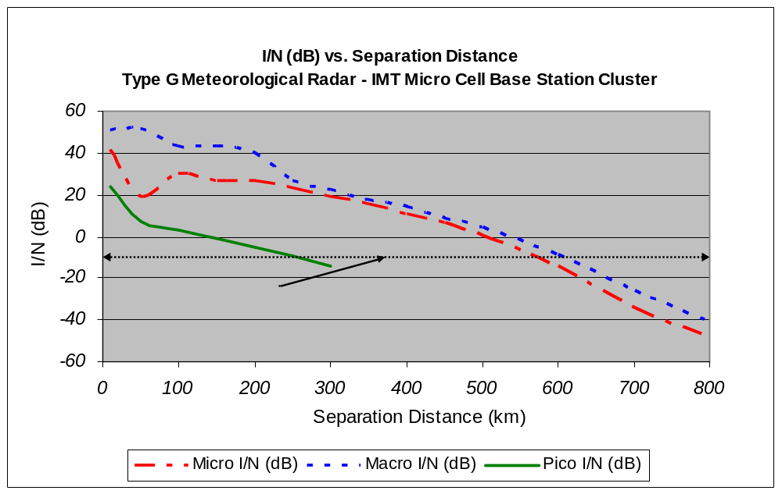
In this particular simulation, a terrain model was used that initially placed the IMT system on a relatively low lying flat plain. As the radar system was moved to the west of the IMT system, a gradual decrease in the interference level and the subsequent I/N value was noted. At around 75 km west of the IMT system, the terrain started to rise as did the interfering signal level to the radar from the IMT system. This was due to a clearing of a line of site path from the radar to the IMT system. This resulted in increased interference and I/N levels for the Macro and Micro cell topologies. (Due to its limited geographical coverage a smooth earth model was used for the pico cell topology. As a result, this topology was not impacted by the nature of the terrain.) Similar results can be expected for the ASR radars.
As can be seen in Figure 1, an acceptable I/N value (< -10 dB) for the macro cell topology was reached when the radar was 610 km away from the IMT system. An acceptable I/N value (< -10 dB) for the micro cell topology was reached when the radar was 580 km away from the IMT system. An acceptable I/N value (< -10 dB) for the pico cell topology was reached when the radar was 270 km away from the IMT system.
If one were to deploy an IMT network on a shared basis with ASR and meteorological radars in this environment, a separation distance of 600 km would be required in order to protect the meteorological radar from interference from the IMT network. Additional simulations yielded similar result for ASR radars when using this terrain model.
Terrain plays an important role in determining the separation distances required to protect radars from interference from IMT systems and cannot be ignored when conducting sharing studies. The impact of terrain from a practical perspective on the deployment of an IMT system will be problematic when viewed from a sharing perspective, requiring even larger separation distances than originally expected and creating geographical regions where co-deployment of radar and IMT systems is not feasible.
Table 1 summarizes the minimum separation distances required, to prevent IMT systems from exceeding the ITU recommended protection criteria for ASR and meteorological radars as a function of cell topologies and radar types as defined in Recommendation ITU-R M.1464.

TABLE 1
Separation Distances (km)

 | Cell Topology
Radar Type |  | Macro | Micro | Pico
Type A |  | >500 km | > 500 km | >200 km
Type B |  | >500 km | > 500 km | >200 km
Type C |  | >500 km | >500 km | >200 km
Type G |  | >500 km | > 500 km | >250 km
Note: Figure1 is indicative of the I/N values that can be expected as a function of separation distance between the various radars and IMT system cell topologies.

In general, studies have shown separation distances of <500 km between ASR and or meteorological radars and macro, micro cell IMT networks is insufficient to protect the radar’s operations. . In some cases separation distances of >600 km are required. In addition studies have shown separation distances of <250 km between ASR and or meteorological radars and pico cell IMT networks is insufficient to protect the radar’s operations.
Radars are typically operated within or near cities. Separation distances of this magnitude would preclude the deployment of all types of mobile service areas within cities. Even if such separation distances could be tolerated, regions in which sharing could take place would be severely limited due to the wide spread geographical deployment of ASR, meteorological and other radar systems. Figure 2 is an operational coverage map of one administration’s Meteorological Radar network. The range of each of the radar sites depicted in this graphic illustration is very similar to the exclusion zone ranges required to protect the individual radars from harmful IMT system interference. That being the case, the exclusions zones required to protect these radars from interference from IMT systems would overlap. As a result, the available geography in which IMT systems could be deployed would be severely limited.

FIGURE 2
Meteorological Radar Network Coverage Map

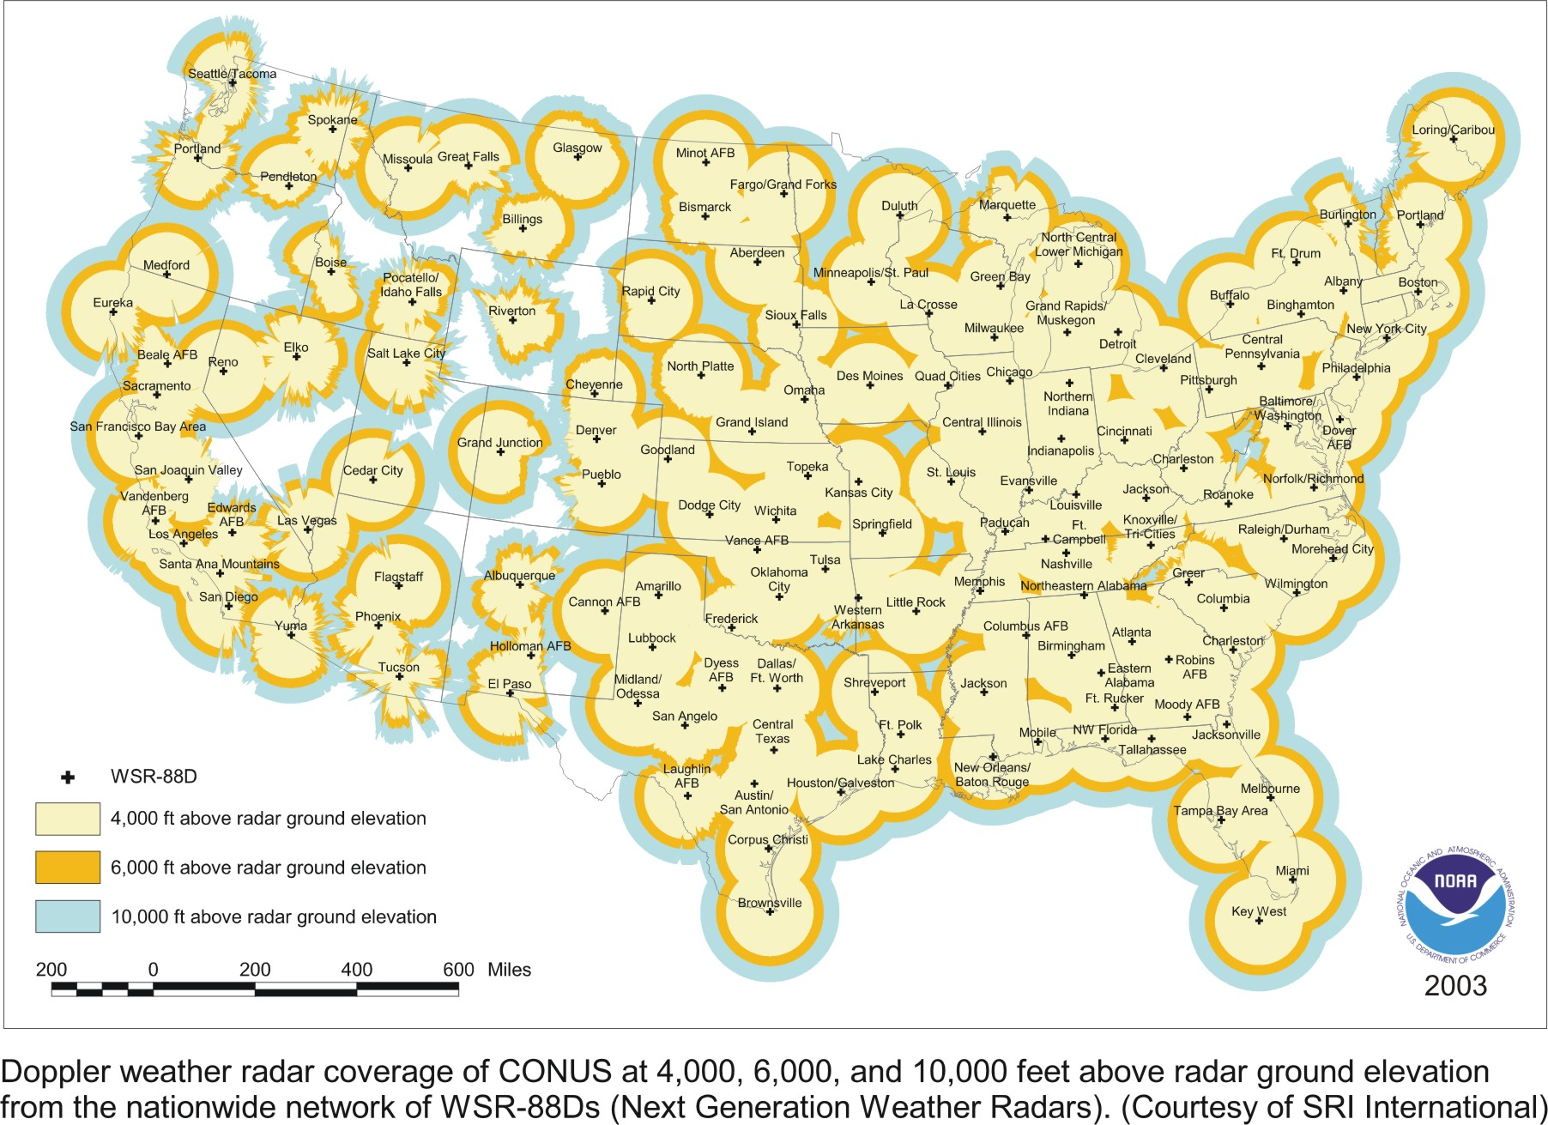

The available geography becomes even further limited when ASR radars are included in the geographical coverage analysis.

3.3 Utilization of the 2 700 – 2 900 MHz Band (Impact on IMT Systems)
The extensive use of the 2 700 – 2 900 MHZ band by ASR, meteorological and other radar systems creates an RF environment in which IMT mobile or base station receivers could be jammed, disabled, or damaged by the aggregate effect of the radar systems operating within that band. Figure 3 illustrates the spectrum of a typical urban RF environment.

The upper most line in the graphic shows frequency in megahertz on the x-axis vs. received signal level. The data presented in this graphic shows the maximum, minimum, and average measured power levels of received signals. The accumulative measurement time during the survey was typically several hours, spread uniformly over the diurnal cycle. The data represents an extremely good statistical sampling of the activity in the radio spectrum in the Los Angeles metropolitan area.

FIGURE 3
Typical Frequency Domain Representation of the 2700-2900 MHz Band within an Urban Environment (Los Angeles, California)

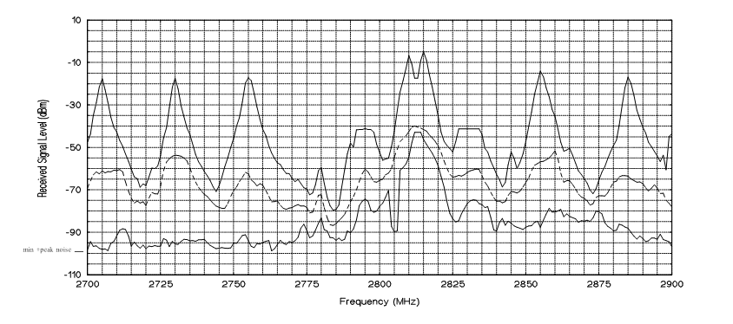

Radio Frequency characterization studies of urban environment such as the one shown in Figure 3, show that the aggregate power levels received by the IMT devices could result in loss of service to multiple mobiles and base stations, effectively disabling entire service areas. Previous studies also showed that a worst case interference scenario could result in damage to sensitive base and mobile station receiver electronics. An RF environment of this nature also negates the implementation of adjacent or off-set frequency operation.

3.4 Application of Interference Mitigation Techniques
In some sharing studies it was suggested that separation distances can be reduced through the application of interference mitigation techniques such as antenna placement, orthogonal polarizations, adaptive antennas, filtering techniques, power control, and other site engineering techniques (e.g. clutter, building penetration loss, etc.). Although these types of mitigation techniques are effective in mitigating interference between adjacent cell sites, it remains to be seen if these techniques have any effect on limiting the interference from IMT systems into radars and from radars into IMT systems.
Radar antenna tilt has also been suggested as a means of mitigating interference to IMT systems. Radar antenna tilt is not a viable interference mitigation technique. Tilt cannot be applied to ASR or meteorological radars without disabling the operational functionality of the radar system.
It has also been suggested that radars would only be interfered with for a short period of time as the radar beam passes through the service area. This is not the case. Radar target returns are processed individually in at least two dimensions, range and azimuth. Radar receiver processing in these two dimensions forms resolution "cells" which are evaluated for the presence of radar pulses returned from targets. Interfering IMT signals, even if present for only short periods of time, can corrupt these resolution cells and will cause false or lost targets. If IMT systems are co-located within multiple service areas, radars will encounter interference from many IMT base and mobile stations. The aggregate effect will be significantly worse than the reported results in the current studies, as such, the protection criteria associated with the 2 types of radars will always be exceeded. One should note that interference effects cannot be averaged over an entire rotation. Radar results must be accurate for every direction and for every distance, and it is therefore not acceptable to trade high interference in one direction for low interference in another by an averaging process. It is also possible that the aggregate IMT interference into the radar will appear as noise to the radar raising the Constant False Alarm Rate (CFAR) and causing detection loss of targets.

4. Conclusions
The overall conclusions drawn from the results of these studies with respect to effectively sharing the 2 700 – 2 900 MHz band between IMT devices and ASR, meteorological and other radar systems are:

1) The 2 700 - 2 900 MHZ band is extensively used by ASR, meteorological and other radar systems creating an environment in which:

- RF emissions from IMT transmitters would necessitate separation distances well in excess of 200 km in order to ensure that radar receiver interference criteria are not exceeded

- IMT receivers would be jammed, disabled or damaged by the aggregate RF effect of the radar systems operating in that band.

- In scenarios where the band use is limited to uni-directional (Base Station to Mobile Station) transmissions only, the IMT "victim" receivers would be the mobile stations that were communicating with various base stations throughout a given service area. The separation distances required to protect the IMT receivers would make the deployment of such a network impossible due to the effect of the interference from the radars into the IMT mobile stations.

2) The required separation distances for sharing of the band preclude the effective deployment of IMT systems. Even if such distances could be tolerated, regions in which sharing could take place would be severely limited due to the wide spread geographical deployment of ASR, meteorological and other radar systems.

3) Interference mitigation techniques currently used in IMT systems are directed at mitigating interference from other cellular systems and not from high power radars. IMT receivers can be overloaded by a single high level unwanted signal, not on the desired channel, typically in excess of -25 dBm, or multiple high-level unwanted signals whose total peak instantaneous power exceeds -25 dBm. Current IMT interference mitigation techniques would not protect the IMT mobile or base station receivers from high power radar signals. These signals, when present at the input to the IMT receivers, can result in loss of service or, in some instances, damage to the base station and or mobile unit.

4) Even if the IMT service were offset in frequency from one radar system, the IMT systems would still be interfered with by other radar systems operating at different frequencies throughout the band.

APPENDIX 1
To
ANNEX 1
Airport Surveillance Radars, Meteorological Radars and IMT System characteristics, propagation scenarios, simulation methodologies and interference mitigation techniques

1. Parameters of IMT Systems
The IMT parameters were obtained from Report ITU-R M.2039. Table 1 contains a summary of those parameters. The Adjacent Channel Leakage Ratio (ACLR) parameters were obtained from 3GPP 25.104. Where applicable, a typical IMT Wideband CDMA system channel spacing/separation of 5 MHz was chosen. . The overall assumption, however, is that apart from varying bandwidth; IMT-Advanced characteristics will be very similar to those of IMT-2000.
TABLE 1
Power and antenna characteristics of IMT Macro, Micro and Pico base stations
 | Macro BS | Micro BS | Pico BS
Output power (dBm) | 43 | 38 | 24
Antenna main beam gain (dBi) | 17 | 5 | 0
Antenna height | 30 | 5 | 1.5

The IMT parameters used in these studies were discussed and agreed upon within WP8F. In the case of Adjacent Channel Leakage Ratio (ACLR), an extension of IMT parameters was used. Table 2 contains those parameters. The channel spacing for IMT systems was selected to be 10 MHz. The output power is given as Effective Isotropically-Radiated Power (EIRP) density range, with a maximum allowed transmitted power including antenna gains and feeder losses. Power levels were set to the maximum allowed levels of 43 and 38 dBm respectively for macro and micro base stations.

TABLE 2
Power and antenna characteristics of IMT Macro and Micro
 | Macro BS | Micro BS
EIRP density range, scaled to 1 MHz bandwidth | 39 - 46 m/MHz | 15-22 dBm/MHz
Antenna main beam gain (dBi) | 17 | 5
Max transmit power + antenna gain – feeder loss (dBm) | 59 dBm | 35 dBm
Antenna height | 30m | 5m
ACLR, 1st adjacent | 45 dB | 50 dB
ACLR, 2nd adjacent | 50 dB | 50 dB

ITU-R Report M.2039 provides typical IMT technical and operational characteristics. The characteristics listed in Table 3 included various modulation techniques and IMT bandwidth parameters.
TABLE 3
Parameter | CDMA-2000  1X | CDMA-2000  3X | UWC-136  30 kHz | UWC-136  200 kHz | TD-CDMA | W-CDMA
Bandwidth (MHz) | 1.25 | 3.75 | 0.03 | 0.2 | 5.0 | 5.0
Base Stations (Type) | Macro |  | Micro |  | Pico
Transmitter Power (dBm) | 43 |  | 38 |  | 24
Antenna Gain (dBi) | 17 |  | 5 |  | 0
Antenna Height (m) | 30 |  | 5 |  | 1.5
IMT Base Station, Bandwidth and Modulation Parameters

Although ITU-R Report M.2039 specifies a pico antenna height of 1.5 m, the study took into consideration that pico base stations could also be installed inside tall buildings; as a result, an antenna height of 10 meters was used in this study. In practice, variations in pico cell antenna heights are expected; provoking the need for future further studies in order to quantify the effect of variations in antenna heights.
Table 4 contains the IMT mobile station parameters which were used for the sharing studies discussed in Annex 3 and Annex 4.

Table 4
IMT Mobile Station characteristics
Parameter | CDMA-2000 1X | CDMA-2000 3X | UWC-136 30 kHz | UWC-136 200 kHz | TD-CDMA | W-CDMA
Bandwidth (MHz) | 1.25 | 3.75 | 0.03 | 0.2 | 5.0 | 5.0
Interference Criteria | See Table 6
Antenna Gain (dBi) | 0.0
Antenna Height (m) | 1.5

2. Aeronautical Radionavigation and Meteorological Radar Parameters
Information and characteristics for the radars included in this sharing study were obtained from ITU-R Recommendation M.1461 and ITU-R Recommendation M.1464. These recommendations include information on aeronautical radionavigation (Type A-F) and meteorological (G and H) radars.
The relevant radar parameters for this study are summarized in Table 5.
TABLE 5
Radar System Characteristics
 | Aeronautical Radionavigation (Radar A) | Aeronautical Radionavigation (Radar B) | Aeronautical Radionavigation (Radar C) | Meteorological  (Radar G)
Antenna Rotation Rate (deg/sec) | 75 | 75 | 75 | 18
Radar Receiver Emission Bandwidth, 3 dB (MHz) | 5 | .653 | 15 | 0.600
Transmitter Power, P (dBw) | 62 | 61 | 44 | 57
Antenna Main Beam Gain (dBi) | 33.5 | 33.5 | 34 | 45.7
Antenna Beamwidth (degrees) | 1.35 | 1.3 | 1.45 | 0.92
Antenna Sidelobe Levels (dBi) | 7.3 | 7.3 | 9.5 | 20
Antenna Height (m) | 8 | 8 | 8 | 30

The simulation was configured to closely approximate the operation of the radar. Antenna rotation was also included since it provides one of the important radar to IMT interference details used in the analysis.
The level of interference, is defined by the protection criteria of I/N = -10 dB. An antenna height of 8 m for radar types A, B and C, and 30 m for radar type G were used in these sharing studies.
Some of the previous studies,, used radar antenna tilt as a mitigation technique. ASR radars are crucial systems that facilitate the safe and efficient operation of air travel worldwide. Meteorological radars provide immediate meteorological and hydrological information used to predict severe weather events. Both systems protect lives and property. ASR and meteorological radars cannot be limited to specific upward antenna tilt to avoid interference from IMT devices. ASR and meteorological radars require 360 degree visibility and ≤ 0 to 90 degrees of elevation to properly perform their mission. To limit the elevation and azimuth range would prevent the radars from meeting mission objectives, and in the case of meteorological radars may render them completely useless. Consequently, any results from previous studies that included radar tilt as an interference mitigation technique were excluded from this summary.
The sharing studies discussed in Appendix 2,3 and 4 to Annex 1 considered IMT mobile and base station interference into radar stations of type A, B, C, and G.
3. IMT Radio Interface Interference Criteria
ITU-R Report M.2039 provides the interference criteria for the IMT radio interfaces. The interference criteria are listed in Table 6 below.
TABLE 6
Interference Criteria for IMT Radio Interfaces
Radio Interface | Interference Criteria – Base Stations | Interference Criteria – Mobile Stations
CDMA-2000 1X | -114 dBm per 1.25 MHz | -110 dBm per 1.25 MHz
CDMA-2000 3X | -109 dBm per 3.75 MHz | -105 dBm per 3.75 MHz
UWC-136 30 kHz | -131 dBm per 30 kHz | Unknown
UWC-136 200 kHz | -123 dBm per 200 kHz | Unknown
TD-CDMA | -115 dBm per 3.84 MHz | -111 dBm per 3.84 MHz
W-CDMA | Unknown | Unknown

Because ITU-R Report M.2039 did not provide criteria for allowable percentage of interference time, it was not taken into consideration in the radar to IMT interference analysis section. This aspect needs further study.
According to Recommendation M. 1464-1, an I/N of –10 dB was used as the radar protection criteria for both the aeronautical radionavigation and meteorological radars.

The formula describing the simulation calculation of the interference from a single IMT transmitter is as follows:

I (dBW) = P_{TX} (dBW) + G_{TX} (dBi) – L_{P} (dB) + G_{RX} (dBi) – FDR (dB) (1)
where,
I = Interference at the Radar Receiver
P_{TX} = Transmitter Power of the IMT Station
G_{TX} = Antenna Gain of the IMT Station
L_{P} = Path Loss between IMT Station and Radar (Consider LOS, diffraction, troposcatter, and ducting in accordance with Rec. ITU-R P.452-12. May also include building penetration loss in case of pico cells)
G_{RX} = Antenna Gain of Radar in Direction of IMT Station
FDR = Frequency Dependent Rejection (applicable where IMT emission bandwidth is wider than the radar receiver passband).
Frequency Dependent Rejection (FDR) is comprised of two components, on-tune rejection (OTR) and off-frequency rejection (OFR). This analysis assumes that the IMT systems and the radar are operating co-channel. No adjacent channel analysis was conducted. OFR is the correction factor used when two operating frequencies are not the same, but transmitter and receiver bandwidths overlap. OFR is set to zero. OTR, the correction factor applied when the emission bandwidth is wider than the receiver bandwidth, applies when the IMT emission bandwidth exceeds the passband of the radar receiver. Refer to Recommendation ITU-R SM.337-4 for additional information on FDR, OTR and OFR.
The equations applicable to this analysis are:
FDR (dB) = OTR (dB) + OFR (dB) = OTR (dB) + 0 dB, when BW_{IMT} > BW _{RADAR} (2)
or
= 0 dB + 0 dB, when BW_{IMT} < BW _{RADAR} (3)
Using equations 1, 2 and/or 3 for each IMT to radar interference path, the total interference (I_{TOTAL}) from a network of N IMT stations can be determined. The formula for calculation of the total interference is:
I_{TOTAL} (W) = I₁ (W) + I₂ (W) + … + I_{N} (W) (4)
Where,
I_{TOTAL} = Total Interference Power at the Radar Receiver
I₁ = Interference Power from Station #1 Calculated from Equation 1 based on Path Specific Conditions
I₂ = Interference Power from Station #2 Calculated from Equation 1 based on Path Specific Conditions
I_{N} = Interference Power from Station #N Calculated from Equation 1 based on Path Specific Conditions.

4. Propagation model
The sharing analysis of interference from an IMT network into the radars was conducted using a terrain modelling simulations that included software implementation of Recommendation ITU-R- P.452-11. All propagation mechanisms that could contribute to interference in links were considered. (Line-of-sight (LOS), diffraction, troposcatter and ducting). This study used the frequency range of 2 700 – 2 900 MHz. The percentage of time that radars could be interfered with was set to .001 percent as suggested in Recommendation P. 452-11, Table 1.
5. Deployment Scenarios Studied
The predominant interfering element in an IMT network is the IMT base station. As a result, this study only examines the interference to ASR and meteorological radars from IMT macro, micro and pico base stations. In an actual deployment scenario a given service area would be made up of both base and mobile stations. Given that the interference level from base stations alone is sufficient enough to exceed both the ASR and meteorological radars protection criteria, there was no need to study the individual impact that mobile stations alone or mobile stations in conjunction with base stations would have upon ASR and meteorological radars.
  - Macro Cell Deployments
A macro cell is defined in this study to have average cell radius of 1 km as outlined in ITU-R Report M.2039. In this study, a macro cell coverage area of 75 km x 75 km was established. The interference simulations were run under two scenarios. The first scenario had the radar placed at the edge of the macro cell coverage area. The second scenario varied the distance from which the radar was offset from the macro cell area. This scenario simulates the situation where the radar is located outside the main urban area of the city (refer to Figure 1). It was assumed that one IMT base station transmitter emission for each cell was co-channel with radar receiver.

FIGURE 1

Radar Operation Outside of a City
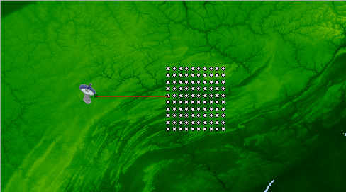
75 km
75 km
Separation
Distance

Radar
Service Area

5.2 Micro Cell Deployments
Micro cell configuration is intended to provide high-density use to vehicular and pedestrian traffic. The total micro cell service area was set to 10 km x 10 km. The micro cell service area would typically be small and limited to central city areas. Establishing an exclusion zone within a small service area (10 km x 10 km in this case) is not feasible. The probability of having a radar located in a central business district is small. Calculations were performed only in a configuration where the radar was offset from the service area (Figure 2). It was assumed that one IMT base station transmitter emission for each cell is co-channel with the radar receiver.

FIGURE 2
Radar is offset from Micro Cell Service Area
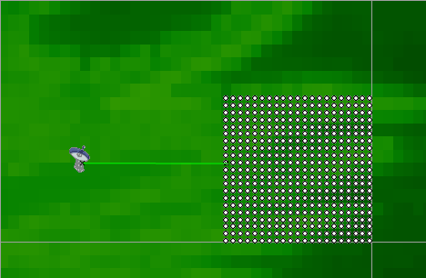
Separation Distance d
10 km
10 km
Radar
Service Area

5.3 Pico Cell Deployments
Interference from a pico-cell deployment could be modelled in many different configurations. The most basic configuration is a moderate sized, single floor building. From this basic configuration the modelling could increase to a multiple floor building and multiple buildings. A pico cell deployment would typically be small and limited to business areas. It is unlikely that an ARS or meteorological radar would be deployed within such a pico cell. For this reason, modelling with the radar offset from the pico cell area is only necessary (Figure 3). In the analysis it is assumed that one IMT base station transmitter emission for each cell is co-channel with the radar receiver.

FIGURE 3
Radar is offset from Pico Cell Service Area
Service Area

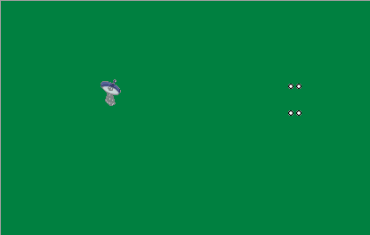
Separation Distance d
Radar
APPENDIX 2
To
ANNEX 1
Results of IMT Sharing Studies with Airport Surveillance Type A, Type B and Type C Radars within the 2 700 – 2 900 MHz Band
1. ASR Radars
The ASR radars use continuous wave (CW) pulses and frequency modulated (chirped) pulses. The 2 700 - 2 900 MHz band is viewed as the optimum band for ATC radars used for airport surveillance due to the strong balance between propagation characteristics and equipment size.
Only parabolic reflector-type antennas are used on radars operating in the 2 700-2 900 MHz band. The ATC radars have a cosecant-squared elevation pattern with a scan type of 360° in the horizontal plane. Newer generation radars using reflector-type antennas have multiple horns. Dual horns are used for transmit and receive to improve detection in surface clutter and can reduce the level of interference. The typical antenna height for the ATC radars is 8 m above the ground. The characteristics of various types of ATC radars (A, B, and C) used in these studies can be found in Table 5 of Appendix 1 to Annex 1. These radars perform airport surveillance for terminal approach control and operate in a full 360° sector on a 24-hour per day schedule. Radars A through C are typically located at all airports. Radars A and B are the current generation of radars while radar C is representative of the next generation system, which should augment and/or replace radars A and B after the year 2010. Radar D is a transportable system used for ATC at airfields where there are no existing facilities. When in use, radar D is operated 24-hours a day.

2. Interference to ASR Radars from IMT systems

2.1 ASR Radars offset from a Macro Network
Table 1 summarizes the simulation results for ASR aeronautical radionavigation radars offset from a CDMA-2000 3X network with randomly placed macro base stations. The base stations were laid out in a regular grid pattern as shown in Figure 1 of Appendix 1 to Annex 1.
Table 1
Summary of Results for ASR Radars Offset from Macro Network – Base Stations
(Interference Criteria I/N = -10 dB)

Separation Distance (km) | Percent Time Protection Criteria is Exceeded for Type A | Percent Time Protection Criteria is Exceeded for Radar Type B | Percent Time Protection Criteria is Exceeded for Radar Type C
10 | 100 | 100 | 100
50 | 100 | 100 | 100
100 | 100 | 100 | 100
150 | 100 | 100 | 100
200 | 100 | 100 | 100
300 | 100 | 100 | 100
400 | 100 | 100 | 100
500 | 100 | 100 | 100

2.2 ASR Radars Offset from a Micro Network
Simulations were run calculating interference from a base station. Table 2 summarizes the simulation results for the same radars offset from a network of CDMA-2000 3X base stations in a micro deployment.
Table 2
Summary of results for ASR Radars Offset from Micro Network - Base Stations
Interference Criteria I/N = -10 dB

Separation Distance (km) | Percent Time Protection Criteria is Exceeded for Radar Type A | Percent Time Protection Criteria is Exceeded for Radar Type B | Percent Time Protection Criteria is Exceeded for Radar Type C⁶
10 | 100 | 100 | 100
50 | 100 | 100 | 100
100 | 100 | 100 | 100
150 | 100 | 100 | 100
200 | 100 | 100 | 100
300 | 100 | 100 | 100
400 | 100 | 100 | 100
500 | 100 | 100 | 100

2.3 ASR Radar Offset from a Basic Pico Cell Network
A basic pico cell network was modelled where a single floor building was serviced with a network of 4 base stations. The cell radius was set at 30 meters. For the base station to radar interference case, the assumption was made that each cell can have one base station operating co-channel with the radar. The results in Table 5 show that even this basic configuration causes interference to the radars, eliminating the need for simulating more complex configurations with more mobiles or base stations.
Table 5
Summary of results for ASR Radars Offset from Pico Network - Base Stations
Interference Criteria I/N = -10 dB

Separation Distance (km) | Percent Time Protection Criteria is Exceeded for Radar Type A | Percent Time Protection Criteria is Exceeded for Radar Type B | Percent Time Protection Criteria is Exceeded for Radar Type C
10 | 100 | 100 | 100
20 | 100 | 100 | 100
30 | 100 | 100 | 100
45 | 100 | 100 | 100
50 | 100 | 100 | 100
60 | 100 | 100 | 100
70 | 100 | 100 | 100
80 | 100 | 100 | 100
90 | 100 | 100 | 100
100 | 100 | 100 | 100
200 | 100 | 100 | 100

3. Discussion of Results
The results of studies shown here confirm the results of previous studies that even with separation distances in excess of 500 km, the ASR radar I/N Protection Criteria as defined by the ITU cannot be met. As such, the separation distances required for sharing of the band preclude the effective deployment of IMT systems. Even if such distances could be tolerated, regions in which sharing could take place would be severely limited due to the wide spread geographical deployment of ASR, meteorological and other radar systems.

These studies have also shown that interference from IMT systems to ASR radars will impair the operation of incumbent radar systems when co-shared with IMT macro, micro and pico cell based topologies within the 2 700 – 2 900 MHZ band. Previous studies have also shown that interference from ASR to IMT macro, micro and pico based cell topologies can cause damage to or hinder the operation of IMT systems when co-shared with ASR radars within the 2 700 – 2 900 MHz band.

The overall results of the study have show that sharing of the 2 700 – 2 900 MHz band between ASR radars and IMT systems is not feasible.

APPENDIX 3
To
ANNEX 1

Results of IMT Co-Frequency Compatibility Studies with a Meteorological (Type G) Radar within the 2 700 – 2 900 MHz Band

1. Meteorological Radars
Both meteorological and ASR radars employ CW and frequency modulated (chirped) pulses within the band 2700 –2900 MHz. Many weather radars employ Doppler technology allowing measurement of storm movement in addition to measurement of precipitation conventional radars provide. By utilizing Doppler radar technology, speed and direction of motion can be calculated while tracking severe weather storms such as tornadoes, hurricanes, and violent thunderstorms. As with ATC radars, weather radars have parabolic reflector-type antennas, which scan 360° in the horizontal plane. Weather radars are typically installed with an antenna height of 30 m above the ground.
Meteorological radars were developed for high spectral efficiency and exhibit very good transmitter emission characteristics and receiver selectivity characteristics. Reduction in transmitter or receiver bandwidth is not feasible without significant degradation of radar performance.

1.1 Meteorological Radar offset from an IMT Macro Network
The simulations were run calculating interference separate from base stations. Table 1 summarizes the simulation results for a Type G meteorological radar offset from a CDMA-2000 3X network with macro base stations. The base stations were laid out in a regular grid pattern as shown in Figure 2 of Appendix 1 to Annex 1.

TABLE 1

Summary of results for a Type G Meteorological Radar Offset from Macro Network - Base Stations
Interference Criteria I/N = -10 dB

Separation Distance (km) | Percent Time Protection Criteria is Exceeded
10 | 100
50 | 100
100 | 100
150 | 100
200 | 100
300 | 100
400 | 100
500 | 100

2. Meteorological Radar Offset from an IMT Micro Network
Simulations were run calculating interference from base stations. Table 2 summarizes the simulation results for the same radars offset from a network of CDMA-2000 3X base stations in a micro deployment.

Table 2
Summary of results for Radar Offset from Micro Network - Base Stations
Interference Criteria I/N = -10 dB

Separation Distance (km) | Percent Time Protection Criteria is Exceeded
10 | 100
50 | 100
100 | 100
150 | 100
200 | 100
300 | 100
400 | 100
500 | 100

3. Meteorological Radar Offset from a Basic Pico Cell Network
Table 3 shows that the basic pico cell simulation for both mobile and base station configurations (Appendix 1 to Annex 1, Figure 2) caused interference to the radars. This result negated the need for simulating more complex configurations with additional mobiles and base stations.
Table 3
Summary of results for Meteorological Radar Offset from Pico Network - Base Stations
Interference Criteria I/N = -10 dB

Separation Distance (km) | Percent Time Protection Criteria is Exceeded
10 | 100
20 | 100
30 | 100
40 | 100
50 | 100
60 | 100
70 | 100
80 | 100
90 | 100
100 | 100
200 | 100

4. Discussion of Results

The results of these new studies confirm the results of previous studies and have shown that, even with separation distances in excess of 500 km, the meteorological radar I/N Protection Criteria as defined by the ITU cannot be met. As such, the separation distances required for sharing of the band preclude the effective deployment of IMT systems. Even if such distances could be tolerated, regions in which sharing could take place would be severely limited due to the wide spread geographical deployment of ASR, Meteorological, and other radar systems.

These studies have also shown that interference from IMT Systems to meteorological radars will impair the operation of incumbent radar systems when co-shared with IMT macro, micro and pico based topologies within the 2 700 – 2 900 MHZ band. Previous studies have shown that interference from meteorological Radars to IMT Systems macro, micro, and pico based topologies can cause damage to or hinder the operation of IMT systems when shared with meteorological Radars within the 2 700 – 2 900 MHZ band.

The overall results of the study show that sharing of the 2 700 – 2 900 MHZ band with IMT systems is not feasible.

APPENDIX 4
To
ANNEX 1
Impact of Airport Surveillance Radars and Meteorological Radar Operations upon IMT-Systems within the 2 700 – 2 900 MHz Band

1. IMT as Victim System

  - Interference from a Single Radar into IMT Network

The potential for interference from radars into IMT systems was evaluated by using the radar characteristics from Recommendation ITU-R M.1464 and monitoring the interference levels at IMT stations. The simulation ran for one hour with a time step interval of 0.1 seconds.

1.2 Macro, Micro and Pico Cell Deployments
The interference criteria for the systems in the macro, micro and pico cell deployments are all approximately equal. The criteria are different for each of the radio interfaces. The required separation distance was determined establishing a line of IMT-2000 test points along a radial extending out from the radar location. The first test point was located 55 km from the radar. The remaining 19 test points were placed at a spacing of 30 km each. The simulation was run, recording the amount of time each test point experienced interference levels exceeding the interference criteria in Table 6 of Appendix 1 to Annex 1. Since no criteria are available for W-CDMA base stations or mobiles, or UWC (Universal Wireless Communication)-136 mobiles, they were not included in the analysis. Tables 1 and 2 provide the simulation results for the aeronautical radionavigation radar into the IMT-2000 base stations and mobile respectively.

TABLE 1
Summary of interference from the Aeronautical Radionavigation
Radar into IMT-2000 Base Stations

Test Point | Separation Distance (km) | % Time CDMA-2000 1X | % Time CDMA-2000 3X | % Time UWC-136  30 kHz | % Time UWC-136 200 kHz | % Time TD-CDMA
1 | 55 | 100.0 | 100.0 | 100.0 | 100.0 | 100.0
2 | 85 | 100.0 | 42.60 | 100.0 | 100.0 | 100.0
3 | 115 | 20.00 | 17.72 | 100.0 | 100.0 | 100.0
4 | 145 | 16.58 | 14.84 | 100.0 | 100.0 | 100.0
5 | 175 | 13.72 | 12.44 | 100.0 | 100.0 | 22.20
6 | 205 | 11.31 | 9.91 | 42.21 | 43.38 | 23.37
7 | 235 | 9.11 | 6.75 | 19.30 | 19.68 | 15.96
8 | 265 | 5.79 | 4.73 | 15.98 | 16.26 | 14.05
9 | 295 | 5.22 | 4.33 | 13.41 | 13.58 | 11.96
10 | 325 | 3.56 | 2.75 | 10.68 | 10.80 | 9.59
11 | 355 | 2.40 | 1.94 | 8.29 | 8.35 | 6.54
12 | 385 | 1.42 | 1.11 | 5.41 | 5.57 | 4.61
13 | 415 | 0.82 | 0.68 | 3.67 | 3.69 | 2.89
14 | 445 | 0.60 | 0.33 | 2.71 | 2.79 | 2.12
15 | 475 | 0.26 | 0.14 | 1.00 | 1.00 | 0.75
16 | 505 | 0.08 | 0.05 | 0.64 | 0.64 | 0.51
17 | 535 | 0.04 | 0.04 | 0.42 | 0.42 | 0.35
18 | 555 | 0.00 | 0.00 | 0.07 | 0.07 | 0.06
19 | 585 | 0.00 | 0.00 | 0.02 | 0.01 | 0.01
20 | 615 | 0.00 | 0.00 | 0.10 | 0.10 | 0.08
TABLE 2
Summary of interference from the Aeronautical Radionavigation
Radar into IMT-2000 Mobile Stations
Test Point | Separation Distance (km) | % Time  CDMA-2000 1X | % Time  CDMA-2000 3X | % Time  TD-CDMA
1 | 55 | 14.48 | 12.93 | 51.23
2 | 85 | 10.79 | 9.58 | 20.63
3 | 115 | 9.05 | 6.80 | 15.15
4 | 145 | 4.96 | 3.89 | 12.27
5 | 175 | 4.29 | 3.50 | 9.00
6 | 205 | 2.93 | 2.43 | 8.55
7 | 235 | 2.07 | 1.65 | 5.26
8 | 265 | 1.25 | 0.94 | 3.73
9 | 295 | 1.04 | 0.78 | 3.28
10 | 325 | 0.53 | 0.37 | 2.05
11 | 355 | 0.30 | 0.25 | 1.35
12 | 385 | 0.08 | 0.03 | 0.80
13 | 415 | 0.07 | 0.03 | 0.39
14 | 445 | 0.01 | 0.00 | 0.19
15 | 475 | 0.00 | 0.00 | 0.05
16 | 505 | 0.00 | 0.00 | 0.04
17 | 535 | 0.00 | 0.00 | 0.00
18 | 555 | 0.00 | 0.00 | 0.00
19 | 585 | 0.00 | 0.00 | 0.01
20 | 615 | 0.00 | 0.00 | 0.00

1.3 Interference from Multiple Radars into IMT-2000
As stated in Appendix 2 to Annex 1 and Appendix 3 to Annex 1, the simulation results that co-channel operation interference can occur even with large separation distances between the Type A, B and C radars and an IMT Mobile or Base Station. Once again, the calculated distances were so large that additional investigation into the cause was warranted. In disabling and enabling the various propagation mechanisms within the propagation model, it was found that at closer distances line of sight and diffraction were the contributing propagation mechanisms, as expected. As the line-of-sight and diffraction losses increased significantly to protect the IMT station, ducting and troposcatter became the dominant propagation mechanisms. Operational experience supports these results. Occurrences of bistatic coupling (forward scattering of the radar signal into another radar) are periodically noted between co-channel radars when the antenna rotations become synchronized. The radars experiencing the bistatic coupling can be separated by many hundreds of kilometres. The propagation for the larger distances in this analysis can be likened to the bistatic coupling experienced between radars.
This analysis examines the case of multiple interference sources to both IMT-2000 base stations and mobiles. The radars considered were Radar C (aeronautical radionavigation radar) and Radar G (meteorological radar) from Recommendation ITU-R M.1464. Simulations were run with the radars operating at the appropriate angular rate of rotation and pulse repetition frequency (PRF). Pulse widths used were 5 microseconds for radar G and 100 microseconds for radar C with PRFs of 500 Hz and 1 kHz respectively. The pulse widths and PRFs used are approximations of the actual system characteristics and were used due to practical considerations of the simulation program.
The Radar and IMT system characteristics that were used in this simulation can be found in Tables 3 and 4.
Table 3
Characteristics of IMT-2000 Mobile Stations and Base Stations
Receiver Type | Base Station | Mobile
Antenna Height | 30m | 1.5m
Antenna Gain | 18 dBi | 0 dBi
Transmit Power | 20W | .125W
Receiver Noise Figure | 5dB | 9dB
Receiver Noise Level | -139dBW/MHz | -135 dBW/MHz
Table 4
Radar Characteristics (ITU-R M.1464)
 | Radar C | Radar G
Antenna Rotation Rate (deg/sec) | 75 | 18
Transmitter Power (dBW) | 44 | 57
Antenna Main Beam Gain (dBi) | 34 | 45.7
Antenna Height (m) | 8 | 30
Pulse Width | 89 | 4.7
Pulse Repetition Rate | 1050 | 452

The antenna patterns that were used in this simulation can be found in Figures 1 and 2.
Figure 1
Plot of Meteorological Radar (Radar G) antenna pattern used in analysis
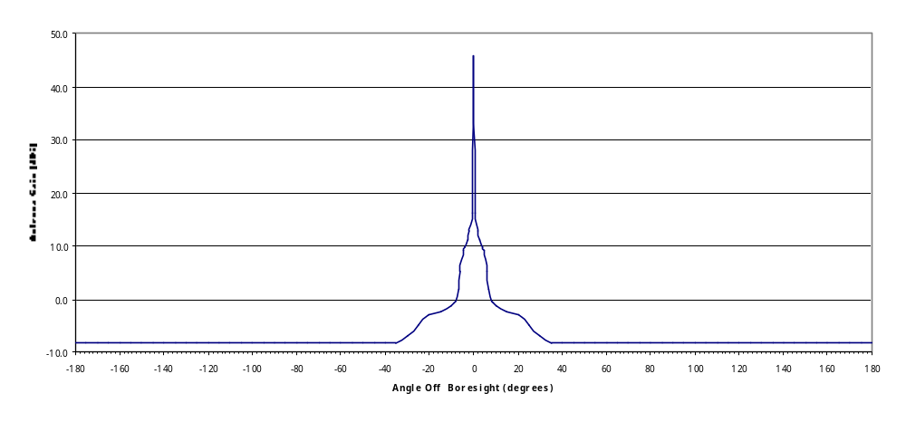
Figure 2
Plot of Aeronautical Radionavigation Radar (Radar C) antenna pattern used in analysis
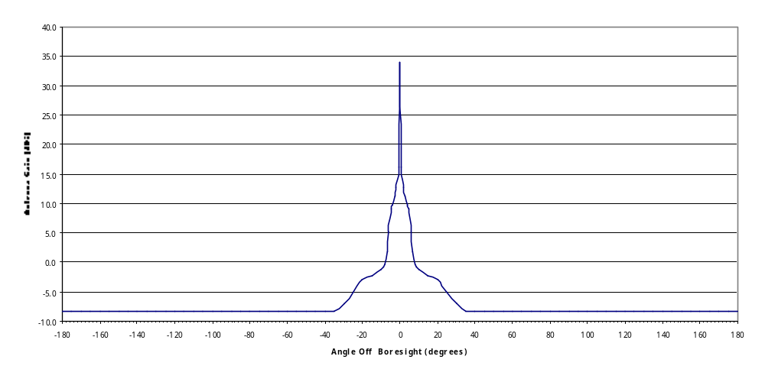
All simulations were run in both a single radar configuration and a three-radar configuration. The three-radar configuration used three radars spaced at eight kilometres illuminating IMT-2000 receivers at distances ranging from 10-150 km from these radars. The initial azimuths of the radars were 0, 90, and 180 degrees and pulse timing was offset by several pulse widths. Therefore, the antennas and transmitted pulses were not aligned at the start of the simulation in order to avoid worst-case conditions. In all cases the IMT-2000 network was set up as receive only and co-channel with the radar at 2 800 MHz. The propagation model used was ITU-R-P.452-12 configured for climate zone A2 (inland). Ducting and troposcatter were enabled. Ducting can occur but is typically not a major contributor to propagation in climate zone A2.
A three radar configuration was chosen as a “typical” situation but in many urban and suburban areas it is far from worst case. For example, an NTIA spectrum survey of the Los Angeles, CA. area (NTIA Report 97-336) shows eleven radars operating in the 2 700-2 900 MHz band with peak power ranging from –5dBm to –20dBm when measured at a test point located 40km north west of the city.

Twenty-six test points were set up as IMT-2000 receivers as shown in figure 3. The simulations were run once with the receivers set up as base stations for both the one radar and three radar configurations. The simulations were then repeated with the receivers set up as mobile stations for both the one radar and three radar configurations.
FIGURE 3
Simulation System Configuration

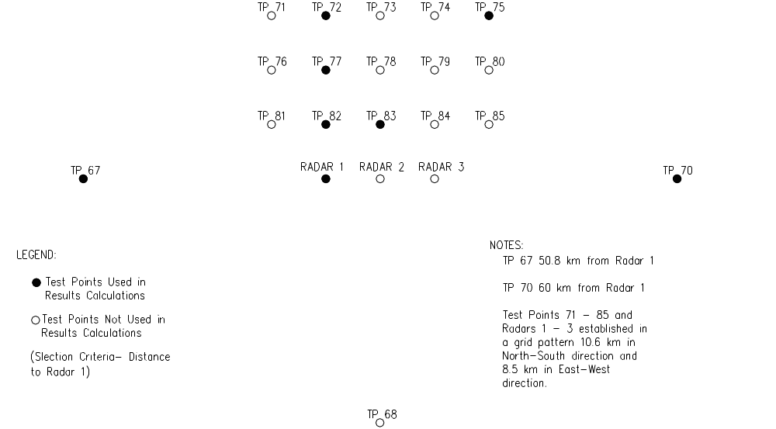

Simulation Results Data
The results of the simulation can be found in Tables 5, 6, 7 and 8. The three-radar configuration did not produce significantly different results from the single radar configuration due to the offset in azimuth and pulse timing preventing any overlap in the respective pulses at the peak antenna gains. Therefore the three radar data was not used in the interference analysis. However it should be noted that an N radar configuration would have the effect of increasing the effective PRF by a factor of N thus compounding the length of time interference would be seen at the receiver LNA.
Table 5
Simulation results of Radar G interference to IMT-2000 base stations
Test  Point | Distance to Radar1 (km) | 1 Radar  Worst I (dBW) Mean I(dBW) (std dev) |  | 3 Radars  Worst I (dBW) Mean I (dBW) (std Dev)
82 | 10.6 | -3.0 | -52.5 (5.9) | -1.5 | -56 (5.2)
83 | 13.5 | -4.5 | -54.6 (5.9) | -1.5 | -56 (5.2)
77 | 21 | -5.4 | -58.5 (5.9) | -8.4 | -61 (4.8)
72 | 32 | -14.2 | -62.2 (5.9) | -13.6 | -64 (4.7)
75 | 41.3 | -18.4 | -64.5 (5.8) | -13.2 | -65 (4.8)
67 | 50.8 | -19.2 | -67.5 (4.5) | -19.5 | -85 (14)
70 | 60 | -36.0 | -88.5 (6.9) | -15.2 | -73 (12)
Table 6
Simulation results of Radar G interference to IMT-2000 mobile stations
Test Point | Distance to Radar1(km) | 1 Radar  Worst I(dBW) Mean I(dBW) (std dev) |  | 3 Radars  Worst I(dBW) Mean I(dBW) (std Dev)
82 | 10.6 | -22.7 | -71.7 (4.4) | -24.3 | -74.5 (4.9)
83 | 13.5 | -24.5 | -73.5 (4.8) | -24 | -73 (4.7)
77 | 21 | -27.3 | -77.6 (4.5) | -28 | -79 (4.6)
72 | 32 | -31.5 | -81.3 (4.5) | -32.4 | -101 (14)
75 | 41.3 | -35 | -116 (7.3) | -42.4 | -112 (7.5)
67 | 50.8 | -40 | -126 (9) | -57.5 | -134 (12.2)
70 | 60 | -49 | -135 (10.8) | -41 | -126 (11.4)
Table 7
Simulation results of Radar C interference to IMT-2000 base stations
Test Point | Distance to Radar1(km) | 1 Radar  Worst I(dBW) Mean I(dBW) (std dev) |  | 3 Radar  Worst I(dBW) Mean I(dBW) (std Dev)
82 | 10.6 | -24.7 | -78.3 (4.7) | -25 | -81 (5.2)
83 | 13.5 | -26.7 | -80.3 (4.7) | -24 | -80 (4.8)
77 | 21 | -29.3 | -84.3 (4.7) | -30 | -85 (4.8)
72 | 32 | -33 | -88 (4.7) | -34 | -88 (4.8)
75 | 41.3 | -39 | -108 (5.8) | -35 | -96 (10.6)
67 | 50.8 | -46.5 | -119 (6.6) | -49 | -128 (10.8)
70 | 60 | -40.3 | -128 (7.9) | -42 | -119 (10.1)
Table 8
Simulation results of Radar C interference to IMT-2000 mobile stations
Test Point | Distance to Radar1 (km) | 1 Radar  Worst I(dBW) Mean I(dBW)  (std dev) |  | 3 Radar  Worst I(dBW) Mean I(dBW)  (std Dev)
82 | 10.6 | -44 | -96.3 ( 4.7) | -44 | -109 (17)
83 | 13.5 | -46.3 | -98.3 (4.7) | -43 | -98 (4.8)
77 | 21 | -48.6 | -131 (8.6) | -52 | -134 (9.5)
72 | 32 | -55.3 | -144 (9.7) | -52 | -146 (10)
75 | 41.3 | -57.3 | -154 (10.8) | -57 | -150 (10.5)
67 | 50.8 | -60.6 | -162 (12) | -66 | -166 (12.5)
70 | 60 | -56 | -166 (12.5) | -56 | -162 (12.8)

The analysis that follows is based only on the single radar data using radar one as the interference source. A seven element subset of the test points was selected based on their approximate locations at 10, 13, 20, 30, 40, 50, and 60 km distances from the location of radar one. The worst I values represent the peak I recorded at each test point and are included as a basis to determine the potential for damage to the receiver front end and for worst case over load response.
The mean value and standard deviation of I, the number of radar pulses exceeding –55 dBW at the receiver antenna connector, and the number of radar pulses exceeding 25 dB above the noise floor at the receiver antenna connector were recorded for all single radar simulations. This data set is used for all calculations in this paper.

2. Discussion of results - Interference from Radars into IMT-2000 Stations
The simulation results summarized in Tables 1 through 8 show that co-channel operation interference can occur even with large separation distances between the Type A and C radars and an IMT-2000 or IMT-Advanced Mobile or Base Station. The calculated distances were so large that additional investigation into the cause was warranted. In disabling and enabling the various propagation mechanisms within the propagation model, it was found that at closer distances line of sight and diffraction were the contributing propagation mechanisms, as expected. As the line-of-sight and diffraction losses increased significantly to protect the IMT-2000 station, ducting and troposcatter became the dominant propagation mechanisms. Operational experience supports these results. Occurrences of bistatic coupling (forward scattering of the radar signal into another radar) are periodically noted between co-channel radars when the antenna rotations become synchronized. The radars experiencing the bistatic coupling can be separated by many hundreds of kilometres. The propagation for the larger distances in this analysis can be likened to the bistatic coupling experienced between radars.

3. Potential Interference Mechanisms
Interference from radar pulses has the potential to degrade IMT-2000 receiver performance via a number mechanisms including, but not limited to, power levels significantly above the receiver noise level, LNA overload, incorrect operation of the automatic gain control (AGC), interference to signal ratios beyond the dynamic range of the analog to digital converter (ADC), filter overload, and mixer overload. A number of these interference mechanisms can produce responses that last long after the radar pulse has ended. Depending on the severity of the interference the effects can cause problems ranging from a reduction in Quality of Service to an inability to operate.
The analog sub-systems that come before (e.g. LNA, Filters and Mixers) and the digital sub systems that come after the ADC can saturate if the received signal is too strong. When these systems become saturated the overall performance of the receiver is degraded due to intermodulation and limiter effects. This can result in poor voice quality, dropped calls, inability to correctly process handovers and loss of service.
There is currently a lack of information on specific pulsed interference thresholds at which IMT-2000 and IMT-Advanced receivers are immune to the various interference mechanisms. In order to move this issue forward a number of assumptions have been made based on CDMA One and CDMA 2000 1X designs and current ITU documents.

3.1 LNA Overload and Interference Mechanisms
In Document 8F/169 it was estimated that LNA overload would occur at approximately –25dBm based on a receiver sensitivity of –105 dBm and a dynamic range of 80 dB. This is also consistent with the 1 dB compression point for LNA’s that have been used in CDMA One and CDMA 2000 1X receivers. This document also stated that interference was likely to occur at power levels within 12 to 25 dB of the IMT system’s receiver noise floor. Based on this, threshold values of 25 dB above the receiver noise floor (-114 dBW for base stations and -110 dB for mobiles) were used in the simulations to determine the percentage of the radar pulses that were likely to cause significant interference at separation distances from 10 km to 60 km. A threshold of -55 dBW was used as the point at which the LNA would become overloaded.
Tables 9 and 10 summarize the results of this simulation.
Table 9
Percentage of radar pulse exceeding levels 25 dB above the receiver noise floor
Separation  Distance (km) | Radar G to Base Station (%) | Radar G to Mobile Station (%) | Radar C to Base Station (%) | Radar C to Mobile  Station (%)
10.6 | 100 | 100 | 100 | 100
13.5 | 100 | 100 | 100 | 100
21 | 100 | 100 | 100 | 4
32 | 100 | 100 | 100 | 1.5
41.3 | 100 | 12 | 100 | 1
50.8 | 100 | 7 | 9 | 0
60 | 100 | 5 | 28 | 0
Table 10
Percentage of radar pulses exceeding –55dBW
Separation  Distance (km) | Radar G to Base Station (%) | Radar G to  MobileStation (%) | Radar C to Base Station (%) | Radar C to Mobile  Station (%)
10.6 | 46 | 1.2 | .58 | .20
13.5 | 19.4 | 1.8 | .52 | .16
21 | 8.9 | .5 | .43 | .002
32 | 4.4 | .1 | .36 | .002
41.3 | 4 | .007 | .25 | 0
50.8 | .3 | 0 | .003 | 0
60 | .3 | .009 | .002 | 0

The radar interference levels were in excess of 25 dB above the receiver noise floor for 100% of the radar pulses out to separation distances of 13 km for mobiles and 40km for base stations. For Radar G this remained true beyond 60 km. The mean values of the simulation data show the majority of the pulses greatly exceed this threshold. For example interference at the base stations exceeded 80 dB above the noise floor for radar G and 76 dB above the noise floor for radar C 68% of the time at the 10km test point.
The –55dBW threshold was exceeded by the interference from all of the radars when they were aligned with the receiving antennas and by 46% of the Radar G pulses, regardless of antenna alignment, at 10km. Worst-case interference was –3 dBW for radar G and –24.7 dBW for radar C pushing the LNA’s beyond their 1 dB compression points by 52dB and 32dB for radars E and C respectively.
While radar C rarely exceeded the –55 dBW threshold it should be noted that other ATC radars, specifically radars A and B in ITU-R M.1464 radiate 17 dB more power that radar C which would result in the –55 dBW threshold being exceeded by approximately 30% of the pulses.
To assess the true impact on BER and overall QOS the recovery time of the LNA’s needs to be determined as well as the potential for damage. The recovery time of the LNA will effectively increase the radar duty cycle as seen at the receiver and therefore the percentage of symbols that are in error. Furthermore the wide bandwidth of LNA’s will make them susceptible to interference from multiple radars greatly compounding the problem in heavily congested areas that have multiple radars operating in the 2 700-2 900 MHz band

3.1.1 Path Loss Analysis
In respect to current protection criteria levels, a simple path loss analysis provides insight into the detrimental effects that high power radars can have on the LNA in an IMT mobile handset or base station. Figures 4 and 5 illustrate the results of such an analysis for mobile handset receiver LNA at a frequency of 2 800 MHz. Figures 10 and 11 illustrate the results of such an analysis for base station receiver LNA at a frequency of 2 800 MHz

FIGURE 4
Meteorological Radar EIRP vs. IMT Mobile Protection Criteria (2800 MHz)

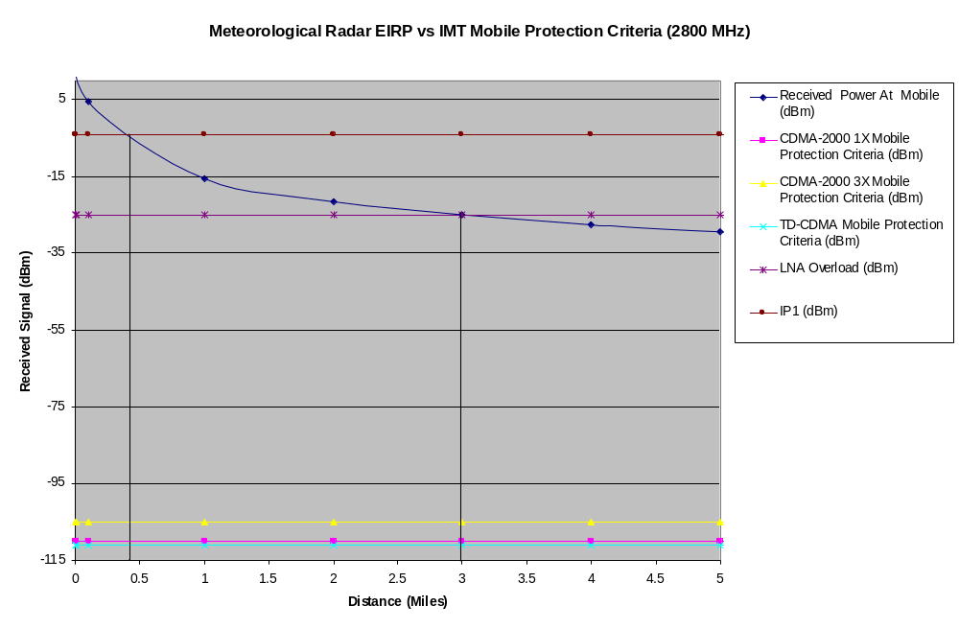

FIGURE 5
Meteorological Radar EIRP vs. IMT Base Station Protection Criteria (2800 MHz

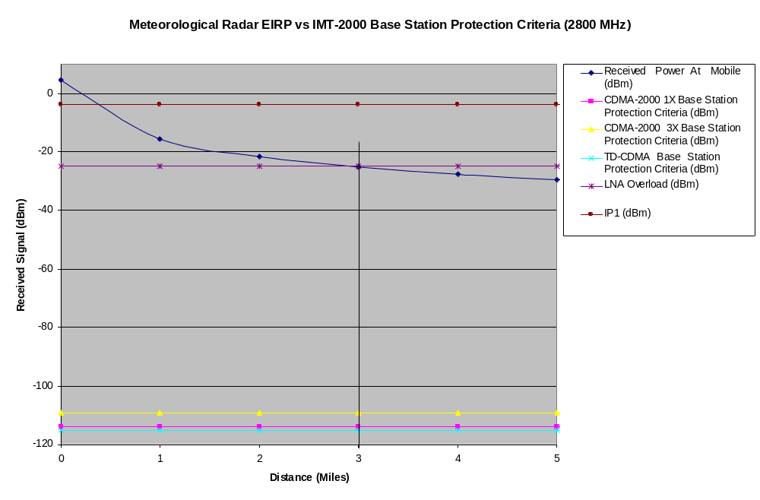

The following conclusions can be drawn from this analysis:

- At distance of less than ½ mile from the radar, the LNA in the handset will be operating at or above its 1 dB compression point level. As the mobile user moves closer to the radar, the received power at the mobile will increase to a level well beyond the 1 dB compression point desensitizing the receiver in the mobile handset.

- Typical maximum input levels to an LNA fall between 0 to 10 dBm. Operation at or above these levels will result in damage to the LNA. This occurs at a distance of .1 to .3 of a mile from the radar.

- In ITU Document 8F/169 it was estimated that LNA overload would occur at approximately -25 dBm. With this specification in mind, this analysis shows that the LNA will be overloaded at distances of less than 3 miles from the radar. The best case impact of overloading the LNA is to create harmonic related spurious signals that fall with the pass band of the mobiles receiver and result in reciprocal mixing, rendering the mobile inoperable. The user would experience dropped calls and would most likely see a No Service available indicator on the mobile.

- Depending upon the level of the received signal that is seen at the mobile, widespread jamming of IMT mobile units across multiple service areas that are within the range of the radar could occur

- These conclusions, items 1 through 4, are also applicable to IMT base station receivers.

3.1.2 IMT Protection Criteria Levels

ITU-R Report M.2039 provides the interference criteria for the IMT-2000 radio interfaces. The interference criteria are listed in Table 11 below.

TABLE 11
Interference Criteria for IMT-2000 Radio Interfaces
Radio Interface | Interference Criteria – Base Stations | Interference Criteria – Mobile Stations
CDMA-2000 1X | -114 dBm per 1.25 MHz | -110 dBm per 1.25 MHz
CDMA-2000 3X | -109 dBm per 3.75 MHz | -105 dBm per 3.75 MHz
UWC-136 30 kHz | -131 dBm per 30 kHz | Unknown
UWC-136 200 kHz | -123 dBm per 200 kHz | Unknown
TD-CDMA | -115 dBm per 3.84 MHz | -111 dBm per 3.84 MHz
W-CDMA | Unknown | Unknown

Figures 6 and 7 expand the path loss analysis to include a comparison of Meteorological Radar EIRP vs. IMT Mobile Protection Criteria at a frequency of 2 800 MHz to a distance of 100 miles.

FIGURE 6
Meteorological Radar EIRP vs. IMT Mobile Protection Criteria at a frequency of 2800 MHz
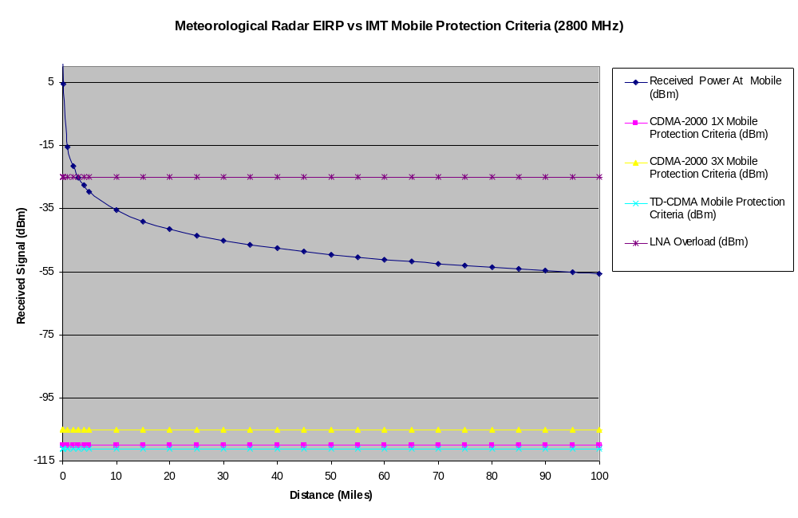

FIGURE 7
Meteorological Radar EIRP vs. IMT Mobile Protection Criteria at a frequency of 2800 MHz
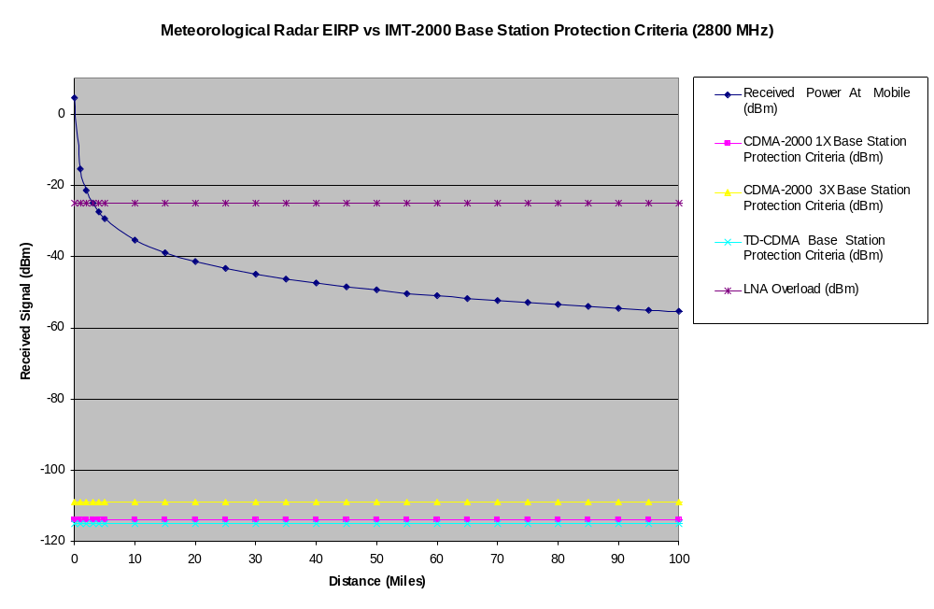

The following conclusions can be drawn from this analysis:

- The ITU specified interference protection criteria for IMT Base stations is exceeded at distances below 100 miles.

- Depending upon the level of the received signal that is seen at the base station, the affect of propagation effects (ducting, multipath, fading, terrain, etc.) could result in widespread jamming of base station units across multiple service areas that are within the range of the radar.

- These conclusions, items 1 and 2, are also applicable to IMT base station receivers.

3.1.3 Interference from Multiple Radar Systems

LNA’s typically used in base and mobile stations cover a band of frequencies that span the range of the frequencies that have been allocated to the operation of the system. Consequently, a typical LNA that might be considered for use in the 2700-2900 MHz band would most likely have a 2 700 – 2 900 MHz bandwidth.

The 2 700 – 2 900 MHz band is one that is used extensively by aeronautical radionavigation service (ARNS), meteorological and other radar systems. An NTIA spectrum survey of the Los Angeles, CA, area Figure 8 shows eleven radars operating in the 2 700-2 900 MHz band with peak power ranging from –5dBm to –20dBm when measured at a test point located 40km north west of the city.
FIGURE 8
NTIA spectrum survey of LA Area.

In such a scenario, the aggregate power levels seen by an IMT Mobile or base station receiver at the test point site could range from -9.5 dBm to 5.2 dBm.

The impact of these levels on the LNA’s would be such that:

- The ITU specified interference protection criteria for the IMT Base or Mobile stations will be exceeded by well over 100 dB.

- At distance of 40 km from the radars, the LNA in the handset will, at times, be operating at or above its 1 dB compression point resulting in the potential desensitizing of the IMT receiver and loss of service.

- Typical maximum input levels to an LNA fall between 0 to 10 dBm. Operation at or above these levels will result in damage to the LNA. At a distance of 40 km and in the presence of received signals from multiple radar systems with the pass band of the LNA, the input level to the IMT receiver could be as high as 5.3 dBm. Levels of this magnitude would most likely damage the LNA. The result could be the loss of a multiple mobiles and base stations, effectively bringing down an entire service area.

This analysis shows significant implications on mobile handsets and base stations when sharing between IMT devices and ASR, Meteorological, and other radar systems in the 2 700-2 900 MHz band is considered.

4. AGC interference mechanisms
In general Automatic Gain Control (AGC) is provided over the full dynamic range of the received signal power. In wireless environments a digital receiver often receives a signal that experiences rapid and wide variations in signal power due to channel fading and other causes (e.g. Potential interference from other systems that operate within the band.). Problems arise when a AGC circuit is required to respond to a change in frequency, as seen during the processing of an inter-frequency handover, or to a high level step function in power. A typical AGC circuit contains a control loop and relies on filtering successive signal samples. As a result, it takes a certain time period for the AGC to settle. This time is known as the AGC Settling Time. System performance becomes degraded when the AGC settling time occupies a large percentage of the total switching time.
Accurate power estimation is required for proper operation of WCDMA systems. Incorrect estimation of the signal power can severely degrade performance of the ADC scaling and the operation of the dispreading function. In severe cases timing and synchronization can be lost. Assuming that the power detection circuitry of the AGC has a fast time constant on the input (close to the chip time) and a longer time constant (greater than 10 microseconds) to facilitate average signal power estimation, it will respond fast enough to capture close to the peak of a radar interference and then decay over tens to hundreds of microseconds. Large radar pulses combined with long time constants in the AGC could render the system inoperable in cases where the power estimation has not recovered well within the duty cycle of the interfering radar. The overestimation of the signal power may cause the most severe performance degradation due to radar interference and the impact will be highly dependent upon the time constants used in the AGC designs. Table 12 summarizes the AGC power over estimation for various radar types.
Table 12
AGC power over estimation
Distance Radar to BS | Radar G into BS | Radar G into MS | Radar C into BS | Radar C into MS
10km | 45.9 dB | 6 dB | 20.1 dB | .1 dB
20km | 39.9 dB | 2.5 dB | 14.3 dB | 0 dB
30km | 36.2 dB | 1.3 dB | 10.8 dB | 0 dB
40km | 33.9 dB | .1 dB | .5 dB | 0 dB

Table 13 can be used to determine the AGC recovery time down to an acceptable over estimation level that will allow proper signal dispreading for a range of power detector time constants. For this analysis the signal levels were calculated based on a 2km separation between the mobile and the base station and a free space path loss. Mean value interference levels were used and it is assumed that the long time constant can range from 10-200 micro seconds.
Table 13
Range of AGC recovery times with a mobile station transmitting to a base station
(Received signal = 1.44e-10W, interference = single radar G mean I values from table 3)
Number of Time Constants | Interference (μW) | AGC Over Estimation (dB) | Recovery Time (μS) Tc=10μsec | Recovery Time (μS) Tc=50μsec | Recovery Time (μS) Tc=100μsec | Recovery Time (μS) Tc=200μsec
0 | 5.6
1 | 2.06 | 41.6 | 10 | 50 | 100 | 200
2 | .76 | 37.2 | 20 | 100 | 200 | 400
3 | .28 | 32.8 | 30 | 150 | 300 | 600
4 | .103 | 28.5 | 40 | 200 | 400 | 800
5 | .037 | 24.2 | 50 | 250 | 500 | 1000
6 | .014 | 19.8 | 60 | 300 | 600 | 1200
7 | .005 | 15.5 | 70 | 350 | 700 | 1400
8 | .002 | 11.2 | 80 | 400 | 800 | 1600
9 | .0007 | 6.8 | 90 | 450 | 900 | 1800
10 | .00025 | 2.5 | 100 | 500 | 1000 | 2000

Radar G at 40km Signal Strength =1.44E-10 W
(mobile to base station)
Number of Time Constants | Interference  (μW) | AGC Over Estimation (dB) | Recover Time (μS) Tc=10μsec | Recover Time (μS) Tc=50μsec | Recover Time (μS) Tc=100μsec | Recover Time (μS) Tc=200μsec
0 | .35
1 | .13 | 29.6 | 10 | 50 | 100 | 200
2 | .048 | 25.2 | 20 | 100 | 200 | 400
3 | .017 | 20.8 | 30 | 150 | 300 | 600
4 | .0065 | 16.5 | 40 | 200 | 400 | 800
5 | .0024 | 12.2 | 50 | 250 | 500 | 1000
6 | .00088 | 7.8 | 60 | 300 | 600 | 1200
7 | .00032 | 3.5 | 70 | 350 | 700 | 1400

Radar C at 10km Signal Strength =1.44E-10 W
(mobile to base station)
Number of Time Constants | Interference  (μW) | AGC Over Estimation  (dB) | Recover Time (μS) Tc=10μsec | Recover Time (μS) Tc=50μsec | Recover Time (μS) Tc=100μsec | Recover Time (μS) Tc=200μsec
0 | .0147
1 | .0054 | 15.8 | 10 | 50 | 100 | 200
2 | .002 | 11.4 | 20 | 100 | 200 | 400
3 | .00074 | 7.1 | 30 | 150 | 300 | 600
4 | .00027 | 2.7 | 40 | 200 | 400 | 800

To get an approximation of the magnitude of this interference mechanism we can assume that the AGC will sample the peak detector at least every 625 microseconds and the power adjustment cannot exceed +/- 1dB per sample period. As the recovery time approaches the period of the radar pulse, typically 1ms, the power will be constantly over estimated.
For time constants of 100 and 200 microseconds, there will be situations where the power will be over estimated at every sample resulting in a gross over estimation of the signal power, effectively rendering the system inoperable. At shorter time constants the power estimation will at best fluctuate between the signal power and plus 1dB but in most cases the power estimation will creep up in 1 dB steps over many samples and attain a level that may prevent proper dispreading of the WCDMA signal.
Exact values for the AGC time constant, power estimation sample rate, and required power estimation accuracy are needed to fully define the problem but it appears that power overestimation may be the most severe result of radar interference.

5. Filter and mixer interference mechanisms
While mixers can typically handle higher power levels than LNA’s, both have self-resonance frequencies that could potentially be excited by high power radar pulses. The nonlinear response of mixers to over load can generate a large number of spurious signals or noise pulses that can be extended by tens of microseconds due to pulse spreading in the IF filters. This will again have the effect of increasing the effective duty cycle of the interfering signals and the resulting Bit Error Rate (BER). Further study is required using actual device characteristics.

Analog to Digital Converter (ADC) interference mechanisms

The signal that is present at the input to the ADC consists of the desired signal, noise that is associated with the analog circuitry that precedes the ADC, and any interfering signals present at the receivers’ antenna. As shown in sections 5, 6, and 7, the presence of a high power interfering signal at the input to an IMT receiver, rich in spectral content, (e.g. radar pulse) can overload the IMT’s LNA drive its mixers into a non-linear mode of operation, and extend its AGC settling time. This results in degraded performance, poor voice quality, dropped calls, uncompleted handovers and, in some cases, total loss of service. The effect of strong pulses can also result in the saturation of the Analog to Digital Converter.

Assuming future IMT-receivers will use 14 bit analog to digital converters (ADC), IMT Systems will, at best, maintain the ability to resolve 84dB of dynamic range (1 part in 2¹⁴). In cases where the signal level interference is equal to or greater than the desired signal level, the desired signal will be undetectable. In cases where the ADC is saturated, the desired signals’ level will be below the resolution of the ADC and will be lost. In both cases an IMT-System would be rendered inoperable.

These studies are summarized in aattachment 5.4 of the Denver WP8F Chairman’s Report.
For purposes of this recommendation the same geographic area is defined as within a 500 km radius of a radar operating in the 2 700-2 900 MHz band.
ITU-R M.2039, ITU-R M.1464, ITU-R M.1461, ITU-R P.452-12
Due to the small geography that is associated with pico cell deployment a smooth earth model was used for those simulations.
Type A and Type C radar specification are so similar, that applying the Type A separation distances to a Type C radar is a reasonable assumption
From NTIA Report 97-336 Broadband Spectrum Survey at Los Angeles, California, May 1997
Document 8F/899 contains the agreed upon IMT parameters which were submitted to ITU-WP8F by CEPT.
Type A and Type C radar specification are so similar, that applying the Type A separation distances to a Type C radar is a reasonable assumption
Type A and Type C radar specification are so similar, that applying the Type A separation distances to a Type C radar is a reasonable assumption
Induced interference is recognized as having adverse effects on voice quality, overall performance degradation, and results in dropped calls.
2800 MHz was selected as the “test” frequency due to the fact that it is the mid-point in the 2700-2900 MHz band that is currently being studied for use as a candidate band for IMT-2000 and IMT-Advanced.
Operation at the 1 dB compression point results is a rapid decrease in gain. In addition the LNA will be operating in a non-linear region where increased levels of broadband noise will be generated; desensitizing the receiver in the mobile unit. If the input power is increased to an extreme value, the component will be destroyed.
Based upon a typical receiver sensitivity of -105 dBm and a dynamic range of 80 dB.
Reciprocal mixing results in increasing local oscillator (LO) phase noise. The increase in the LO phase noise jams the desired incoming RF rendering the handset inoperable.
Propagation effects (multipath, fading, terrain, etc.) could result in received signal levels from the radar that are higher than those predicated by path loss.
ITU-R Report M.2039 provides the interference criteria for the IMT-2000 radio interfaces.
The analysis showed that the ITU specified interference protection criteria for IMT Base and Mobile stations was actually exceeded at distances well beyond 100 miles.
NTIA Report 97-336
Operation at the 1 dB compression point results in a rapid decrease in gain. In addition, the LNA will be operating in a non-linear region where increased levels of broadband noise will be generated desensitizing the receiver in the mobile handset. In addition, the LNA can be damaged or destroyed if the input power to the device exceeds its specified maximum input level.

