WORLD METEOROLOGICAL ORGANIZATION  _____________  COMMISSION FOR BASIC SYSTEMS  STEERING GROUP ON RADIO FREQUENCY COORDINATION  Boulder, Colorado, USA  16-18 January 2007 |  | CBS/SG-RFC 2007/Doc.  _______  ITEM  ENGLISH only

Report of the Work on ITU-R
JRG- 1A/1C/8B
(Submitted By David Franc, USA)

Summary and Purpose of Document

This document provides a summary of work completed to date in ITU-R JRG 1A/1C/8B. the decisions of the JRG could impact the future development and deployment of meteorological radars.

Action Proposed
The SG-RFC may wish to review the information to ensure no other actions are required.

Report of the Work on ITU-R
JRG- 1A/1C/8B

ITU-R JRG-1A/1C/8B was formed with the objective of determining whether the 40 dB/decade roll-off slope design objective, contained in ITU-R recommendation SM.1541, can be implemented as the emission mask for all future radar systems. The current version of SM.1541 contains a mask with a roll-off of 20 dB/decade from the -40 dB bandwidth, and suggests a design objective roll-off of 40 dB/decade may be achievable in the future. Work had begun in Study Group 1 to revise Recommendation SM.1541, possibly implementing the 40 dB/decade mask as the in-force emission mask. ITU-R Working Party 8B learned of this work, asked to be included, resulting in the formation of the JRG. Study Group 1 will use input from the JRG to revise SM.1541. In addition to the decision of application of a 40 dB/decade roll-off, the JRG found many of the existing -40 dB bandwidth formulas in SM.1547 to be incorrect. The JRG has been conducting studies to determine the correct -40 dB bandwidth formulas for the various radar types.

The impact of the JRG decisions can vary. A recommendation contains no regulatory requirement unless the recommendation is incorporated by reference into the Radio Regulations, or one or more administrations or international organizations incorporate the content of the recommendation into their regulations. There is currently no WRC agenda item that would result in the radar mask contained in SM.1541 being incorporated by reference in the Radio Regulations. However the meteorological community should ensure the decisions of the JRG do not impact development and deployment of future meteorological radar (including wind profiler radar) systems.

The JRG held its fourth meeting in Mainz, Germany in November, 2006. The meeting dealt with many controversial and contentious issues. In summary, the radar community is hesitant to apply the 40 dB/decade roll off and is of the opinion that it should be applied to only radar technologies shown to be capable of meeting the requirement. Study Group 1 representatives are generally of the opinion that the 40 dB/decade should be applied to all radars by default, exempting only those radar technologies specifically shown to be incapable of meeting the requirement. The JRG will have one more meeting to conclude its work.

At the close of the fourth meeting, the JRG appeared to be moving towards applying the more stringent 40 dB/decade roll off to all simple pulsed (unmodulated pulse) radars; which would apply to most ground-based rotating Doppler and non-Doppler meteorological radars. In addition, the JRG has concluded the existing -40 dB bandwidth formula in ITU-R SM.1541 is correct for simple pulse radars. Therefore, the JRG will most likely conclude future simple pulse radars should meet a roll-off slope of 40 dB/decade from the -40 dB bandwidth, where the -40 dB bandwidth is defined in Equation 39 of Annex 8 of SM.1541 (Annex 1 to this document).

Many wind profiler radars use phase coded pulse waveforms. The direction of the JRG on phase coded radars is not as clear. At the close of the fourth meeting, no work had been completed on phase coded waveforms and there were no indication that the fifth (final) meeting would receive contributions. Therefore, it is expected that the existing -40 dB bandwidth will remain in ITU-R SM.1541. If the desires of the radar community prevail, the 40 dB/decade will not be applied to phase coded radars, including wind profiler radars. Otherwise, the 40 dB/decade roll-off will be applied as supported by the Study Group 1 representatives. The current -40 dB bandwidth formula is defined in equation 39 of SM.1541, Annex 8 (Annex 1 to this document).

The JRG will hold its last meeting in Chiswick, UK, April 24-27, 2007. The decisions of this meeting will be passed to Working Parties 1A, 1C and 8B. Working Parties 1A and 1C will commence with the revisions of SM.1541. If representatives of the meteorological community have concerns over the application of the more stringent 40 dB/decade emission mask, participation in the April JRG meeting should be considered.

ANNEX 1 to WMO SG-RFC Document-
Extract from Recommendation ITU-R SM.1541
Annex 8: “OoB domain emission limits for primary radar systems”

__________________________
Annex 8
OoB domain emission limits for primary radar systems

1 Introduction
The RR define “primary radar” as “A radiodetermination system based on the comparison of reference signals with radio signals reflected from the position to be determined”.
Terrestrial primary radars operate in the radionavigation service (air surveillance radars and navigation radars on aircraft and ships), the meteorological aids service (weather radars), and the radiolocation service (most other terrestrial radars). Space-based radars include active remote sensing satellites operating in the SRS and EESS, and other radars in the SRS.
The following limits are not applicable inside exclusive radiodetermination and/or EESS and SRS bands, but do apply at the band edges. The topic of primary radar emission limits within these exclusive service bands will be the subject of further studies.
Several categories of primary radars are not included in the OoB emission limits defined in this Annex. These include pulsed radars with rated peak power of 1 kW or less, non-pulsed radars with rated average power of 40 W or less, radars operating above 40 GHz, man-portable radars, and expendable radars on missiles. These categories of radars will also be the subject of further studies to establish the appropriate limits.
Throughout this Annex, in all formulas, bandwidth (BN, Bc, Bs, Bd, B–40) is expressed in Hertz, while pulse duration and rise/fall time are expressed in seconds.

2 Necessary bandwidth
Knowledge of the necessary bandwidth of a radar transmitter is required both for specifying the OoB domain emission limits and for specifying the boundary beyond which spurious limits apply.
Recommendation ITU-R SM.1138, to which the RR makes reference, provides formulas to be used to calculate the necessary bandwidth when required by the RR. However, the only formula applicable to radar gives results that can vary by a factor of ten based on a constant chosen by the user. Recommendation ITU-R SM.853, considering that the formulas in Recommendation ITU-R SM.1138 are incomplete, recommends numerous supplemental formulas.

2.1 Un-modulated radar pulses
Recommendation ITU-R SM.853 provides guidance for determining the necessary bandwidth (20 dB below the peak envelope value) for rectangular and trapezoidal pulses. For these systems, the necessary bandwidth BN is the smaller of:

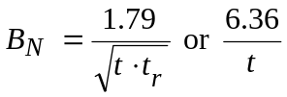 (35)

where t is the pulse duration (at half amplitude) and is the rise time, both in seconds1.

2.2 Other modulations
Necessary bandwidth formulas for frequency modulated pulse radars, frequency hopping radars, and CW radars, both un-modulated and frequency modulated are presented below. For frequency modulated pulse radars, the necessary bandwidth (20 dB bandwidth) formula exceeds the symmetrical trapezoidal pulse case (equation (35)) by twice the frequency deviation Bc2:

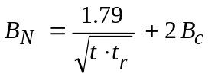 (36)
The formula for frequency hopping radars has an additional term Bs, the maximum range over which the carrier frequency will be shifted:

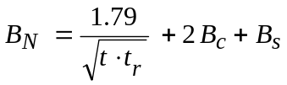 (37)

Although Recommendation ITU-R SM.1138 gives no formula under the heading of “continuous wave emission” (here meaning a carrier without modulation) a realistic value of necessary bandwidth for un-modulated continuous wave (CW) radars depends on the frequency tolerance and noise. For frequency modulated CW radars, the necessary bandwidth is twice Bd, the maximum frequency deviation:

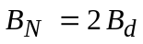 (38)

2.3 Typical values of necessary bandwidth
Table 23 below shows typical necessary bandwidths, followed by the ranges of the necessary bandwidth values, for four types of radars.
TABLE 23
Type of radar | Typical BN  (MHz) | Range of BN
Fixed radiolocation radar  Mobile radiolocation radar  Airport surveillance radar  Weather radar | 6  5.75  6  1 | 20 kHz to 1.3 GHz  250 kHz to 400 MHz  2.8 MHz to 15 MHz  250 kHz to 3.5 MHz

3 OoB domain emission limits for primary radars
A major difficulty in establishing general OoB domain emission limits for primary radars is the diversity of systems and transmitted waveforms. OoB domain emission limits for primary radars are based on the 40 dB bandwidth of the spectrum of the transmitted waveform.

3.1 Formulas for the 40 dB bandwidth
Since the ratio of the 40 dB and necessary bandwidths is not in general a constant, a formula for the 40 dB bandwidth is needed to relate the mask to necessary bandwidth. The following formulas for the 40 dB bandwidth (B–40) of primary radar transmitters have been established.
For non-FM pulse radars, including spread spectrum or coded pulse radars, the bandwidth is the lesser of:

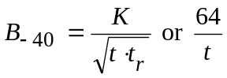 (39)
where the coefficient K is 6.2 for radars with output power greater than 100 kW and 7.6 for lower-power radars and radars operating in the radionavigation service in the 2 900-3 100 MHz and 9 200-9 500 MHz bands3. The latter expression applies if the rise time t_{r} is less than about 0.0094t when K is 6.2, or about 0.014t when K is 7.6.
For FM-pulse radars, the 40 dB bandwidth is:
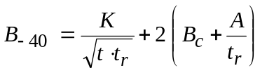 (40)
where A4 is 0.105 when K = 6.2, and 0.065 when K = 7.6.
For FM-pulse radars with frequency hopping5:
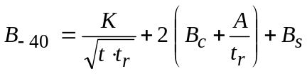 (41)
For frequency hopping radars using non-FM pulses, including spread spectrum or coded pulses:
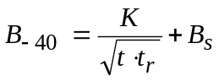 (42)
For un-modulated CW radars:
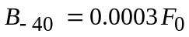 (43)
For FM/CW radars:
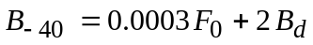 (44)
In equations (43) and (44), F0 is the operating frequency.
For radars with multiple pulse waveforms, the B–40 dB bandwidth should be calculated for each individual pulse type and the maximum B–40 dB bandwidth obtained shall be used to establish the shape of the emission mask.

4 OoB mask
Figure 30 shows the OoB mask for primary radars, specified in terms of psd and expressed in units of dBpp. The mask rolls off at 20 dB per decade from the 40 dB bandwidth to the spurious level specified in RR Appendix 36. The B–40 dB bandwidth can be offset from the frequency of maximum emission level, but the necessary bandwidth (RR No. 1.152) and preferably, the overall occupied bandwidth (RR No. 1.153), should be contained completely within the allocated band.

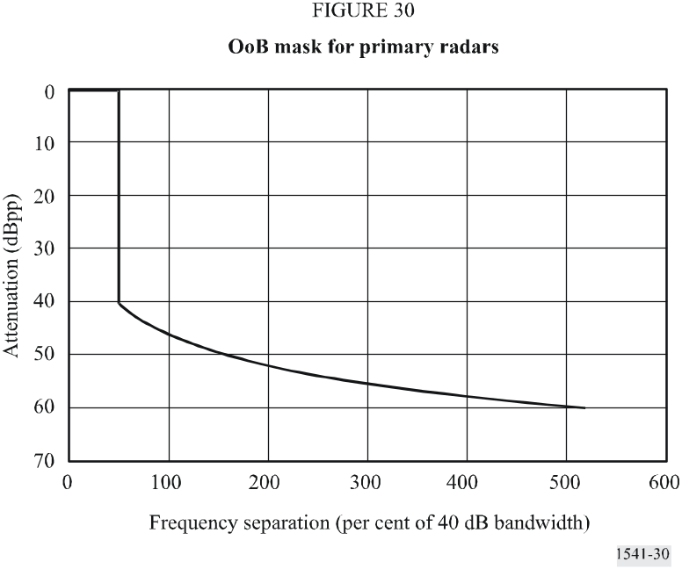

4.1 Examples of emission masks in terms of necessary bandwidth
The OoB mask in Fig. 30 can be expressed in terms of necessary bandwidth for a particular type of radar by comparing corresponding 40 dB and necessary bandwidth equations. For this example, the value of the coefficient K is 6.2 and the mask roll-off is 20 dB per decade.

4.2 Non-FM pulsed radar
For non-FM pulse radars, a comparison of equations (35) and (39) yields a B–40 to BN ratio of about 3.5, except for pulses with very short rise time. Figure 31 shows the OoB mask in terms of necessary bandwidth for this case. However, for some cases of non-FM pulse radars, including spread spectrum or coded pulse radars, the B–40 to BN ratio can be as large as seven.
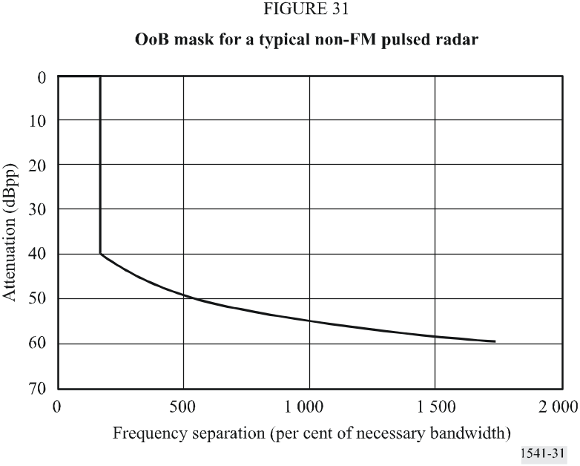

4.3 Linear FM pulsed radar
For FM pulse compression radars, the B–40 to BN ratio may be significantly less. Figure 32 shows a mask based on a trapezoidal pulse with pulse width t of 100 μs, rise time tr of 2 μs, and frequency deviation Bc of 10 MHz. Comparing equations (36) and (40) with these values and A = 0.105, B–40 and BN are essentially equal.
The relatively low values of the normalized frequency separations that appear in Fig. 32 are indicative of high compression-ratio chirped pulses.

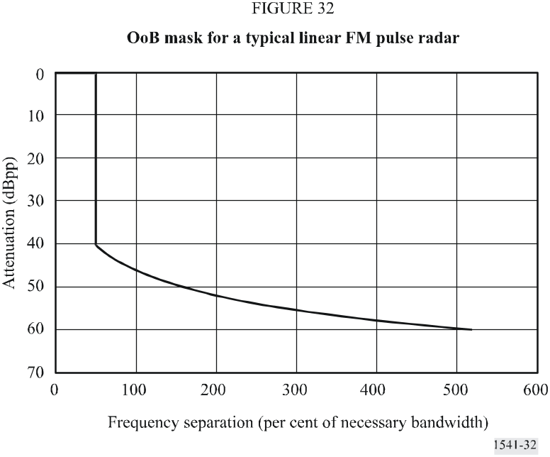

4.4 Frequency hopping radar
In terms of the necessary bandwidth, the permissible spectral expanse of a frequency hopping radar is limited because the roll-off is based on the emissions of the transmitter tuned to the outermost frequencies. Figure 33 shows a mask based on a coded pulse with a chip width t of 0.2 μs, rise time tr of 0.08 μs, and frequency hopping range Bs of 200 MHz. The mask is determined based on equations (37) and (42) with a frequency hopping range Bs of 0. Figure 33 also shows the roll-off on the lower side of the emission assuming the transmitter is tuned to the uppermost frequency.
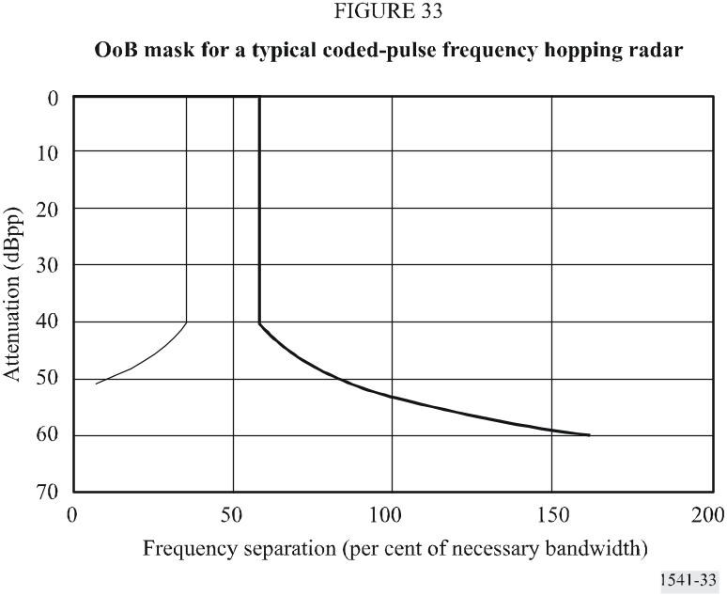

5 Boundary between the OoB and spurious domains
According to recommends 2.2 and RR Appendix 3, the spurious domain generally begins at a frequency separation equal to 250% of the necessary bandwidth, with exceptions for certain kinds of systems, including those with digital or pulsed modulation. However, it is difficult to apply the general boundary concept of 250% of the necessary bandwidth to primary radar stations in the radiodetermination and other services, such as the meteorological aids service, SRS and EESS.
For primary radar stations, the boundary between the OoB and spurious domains is defined as at the frequency where the OoB domain emission limits defined herein are equal to the spurious limit defined in Table II of RR Appendix 3.
The boundary between the OoB and spurious domains in the case of primary radars in the radiodetermination service and other relevant services can be defined as separated from the assigned frequency by 2.5 α BN, where α is a boundary correction factor depending on the total system configuration, in particular the modulation waveform and modulating technique, the radar output device, waveguide components and the antenna type and its frequency dependent characteristics. The value of α will also depend on the way the necessary bandwidth is evaluated.
The values of α corresponding to the mask in Fig. 30 can be determined by setting the 60 dB point equal to 2.5 α BN. Assuming a 20 dB per decade roll-off:
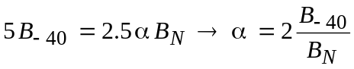 (45)
Using the examples above, α would be about 2.0 for the linear FM pulse radar and about 8.5 for the non-FM pulse radar. This equation does not apply to the frequency hopping case shown in Fig. 33.
Assuming that the necessary bandwidth is evaluated as the 20 dB bandwidth, technical information available so far has indicated that, for existing and planned primary radars, the value of α would range from 1 to 10, or more.
From the standpoint of effective use of spectrum, it can be questioned:
– whether the future primary radars will be able to meet an α value closer to 1 or not;
– whether α should be different depending on whether the boundary between the OoB and spurious domains will be inside, outside or close to a primary radar allocated band.
Further studies need to be conducted within the ITU-R to specify the definition of the necessary bandwidth to be used in the calculation of the boundary and to define the values of α for the different type of radars, missions and platforms.
For non-FM pulsed radars, in a few exceptional cases where the system architecture permits the use of filters and unusual performance trade-offs can be tolerated, the value of α may approach 1. Also, for wideband frequency agile radars, the value of α may be close to 1.5.

6 Design objective
The preceding sections of this Annex are based on the safety-net principle of OoB domain emission limits. It is recognized that further reduction of OoB emissions will enhance compatibility with other services.
Therefore, it is desirable to reduce the levels of unwanted emissions from some radar systems in the future.
The following mask, Fig. 34, is the objective for the design of future radar systems. The mask rolls off at 40 dB per decade from the 40 dB bandwidth to the spurious level specified in RR Appendix 3.
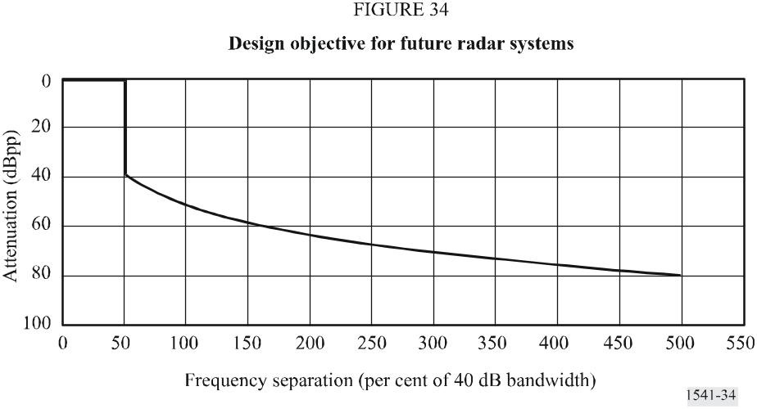
NOTE 1 – The feasibility of this mask is to be investigated in future studies within ITU-R, taking account of the practical experience of its application to some types of radar systems and technical developments in radar technology.
NOTE 2 – OoB domain emission limits within bands allocated to the radiodetermination service on an exclusive basis are the subject of further study. This study may result in a different design objective mask inside these bands.
NOTE 3 – The design objective mask is valid as such until the 2006 Radiocommunication Assembly. This is based on the understanding that these studies will lead to the revision of this Recommendation to either replace the OoB masks in the preceding sections with the design objective mask; or to include other appropriate arrangements depending on the type of radar.
NOTE 4 – Some future systems may not be able to achieve the design objective taking account of such factors as:
– radar mission (safety of life, threat, etc.),
– type and size of the platform (e.g. fixed, mobile, ship-borne, airborne, etc.),
– available technologies,
– economic considerations.

7 Measurement techniques
The most recent version of Recommendation ITU-R M.1177 provides guidance regarding the methods of measuring OoB domain emissions from radar systems.

1 The pulse duration is the time, (s) between the 50% amplitude (voltage) points. For coded pulses, the pulse duration is the interval between 50% amplitude points of one chip (sub-pulse). The rise time is the time taken (s) for the leading edge of the pulse to increase from 10% to 90% of the maximum amplitude on the leading edge. For coded pulses, it is the rise time of a sub-pulse; if the sub-pulse rise time is not discernable assume that it is 40% of the time to switch from one phase or sub-pulse to the next. When the fall time of the radar is less than the rise time, it should be used in place of the rise time in these equations. Using the smaller of the two expressions in equation (35) avoids excessively large calculated necessary bandwidth when the rise time is very short.
2 This value is the total frequency shift during the pulse duration.
3 These coefficients, K = 6.2 or 7.6 and 64, are related to theoretical values that would prevail in the case of constant frequency trapezoidal and rectangular pulses, respectively. Also, in the case of the trapezoidal pulses, the coefficient K has been increased somewhat to allow for implementing output device characteristics. For ideal rectangular pulses, the spectrum falls off at 20 dB per decade leading to a 20 dB bandwidth of 6.4/t and a 40 dB bandwidth ten times as large, i.e. 64/t. To discourage the use of pulses with abrupt rise and fall times, no margin is allowed. The spectra of trapezoidal pulses fall off firstly at 20 dB per decade and then ultimately at 40 dB per decade. If the ratio of rise time to pulse width exceeds 0.008 the 40 dB points will fall on the 40 dB per decade slope, in which case the B–40 would be: 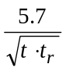 Allowance for unavoidable imperfections in implementation requires that the mask be based on values of at least: 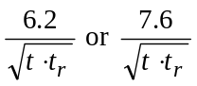 depending upon the category of radar.
4 The term A/tr adjusts the value of B–40 to account for the influence of the rise time, which is substantial when the time-bandwidth product Bct, is small or moderate and the rise time is short.
5 Equations (41) and (42) yield the total composite B–40 bandwidth of a frequency hopping radar as if all channels included within Bs were operating simultaneously. For frequency hopping radars, the OoB emission mask falls off from the edge of the 40 dB bandwidth as though the radar were a single frequency radar tuned to the edge of the frequency hopping range.
6 RR Appendix 3 specifies a spurious attenuation of 43 + 10 log (PEP), or 60 dB, whichever is less stringent. (PEP: peak envelope power.)

