WORLD METEOROLOGICAL ORGANIZATION  _____________  COMMISSION FOR BASIC SYSTEMS  STEERING GROUP ON RADIO FREQUENCY COORDINATION  GENEVA  16-18 MARCH 2006 |  | CBS/SG-RFC 2005/Doc. 3.1(1)  _______  ITEM 3.1  ENGLISH only

U.S. Contribution to ITU- Working Party 8B
Proposed Text for the Working document towards a pdnr ON Technical and operational aspects of ground Based meteorological radars

(Submitted By David Franc, USA)

Summary and Purpose of Document

This document is being submitted, by the United States of America, to the upcoming meeting of Working Party 8B. The last meeting of Working Party 8B began developing a document on technical and operational characteristics of meteorological radars. The purpose of the document is to clearly define how meteorological radars are different than other radars and provide the information necessary to conduct accurate spectrum sharing studies. This contribution adds additional text and proposes edits to the working document produced at the last Working Party 8B meeting. Work will most likely continue in Working Party 8B for at least one more meeting before this document is finalized. Depending on the final content this document may either take the form of an ITU-R Recommendation or an ITU-R Report.

Action Proposed
The SG-RFC should review this document and identify areas where additional information can be provided. Members are encouraged to contribute to this work to ensure their radar technical and operational characteristics are considered.

Source: Document 8B/TEMP/104
United States of America
Proposed Text for the Working document towards a pdnr ON Technical and operational aspects of ground Based meteorological radars

Working Party 8B received two contributions at its September 2005 meeting containing general information on Meteorological Radars. These contributions were merged to form 8B/TEMP/104. Additional work and information is needed to move the effort contained in 8B/TEMP/104 to towards a finished document. This contribution proposes additional text to be merged with TEMP/104.

1 Introduction
Ground based meteorological radars are used for operational meteorology and weather prediction, atmospheric research, and aeronautical and maritime navigation. The theory of operation and the products generated by meteorological radars are remarkably different from other radars. These differences are important to understand when evaluating the compatibility between meteorological radars and other radio services. The technical and operational characteristics of meteorological radars result in different effects from permissible interference in comparison to other radar systems. This document addresses the important technical and operational characteristics of meteorological radars, describes the products produced by meteorological radars, discusses the effects of interference on meteorological radars and explains how radar interference criteria are derived. This document is limited to ground based weather radars with rotating antennas, and does not include wind profiler radars which are also used for meteorological purposes.

2 Overview
A meteorological radar is used to sense the conditions of the atmosphere for routine forecasting, severe weather detection, wind and precipitation detection, precipitation estimates, detection of aircraft icing conditions and avoidance of severe weather for navigation. Meteorological radars are not an individual radio service within the ITU-R, but fall under the radiolocation and/or radionavigation service in the International Radio Regulations. The determination of whether
radiolocation and/or radionavigation apply depends on how the particular radar is used. A ground based meteorological radar used for atmospheric research or weather forecasting would be operated under the radiolocation service. Airborne meteorological radar on a commercial aircraft would operate under the radionavigation service. A ground based meteorological radar can also operate under the radionavigation service if, for example, it is used by air traffic control for routing aircraft around severe weather. As a result, meteorological radars could operate in a variety of allocated radiolocation and radio navigation bands as long as the use is consistent with the radio service definition. The International Radio Regulations contain three specific references to meteorological radars in the Table of Allocations. The three references are contained in footnotes associated with the bands 2 700-2 900 (5.423) MHz, 5 600-5 650 MHz (5.452) and 9 300-9 500 MHz (5.475).

2.1 Radar equation for single target
Meteorological radars do not track point targets. However, the radar equation can be adapted to be used with meteorological radars. The amount of power returned from a volume scan performed by the meteorological radar determines if weather phenomena will be detectable. The radar range equation expresses the relationship between the power returned from a target and characteristics of the particular target and the transmitting radar.
The typical point target will have the following radar equation variables:
P_{R} = Received power by the radar
P_{T} = Radar peak transmit power
A_{T} = Area of target
R = Range of target from radar
G = Gain of the transmit antenna
These variables combine to create the general radar equation for a point target:

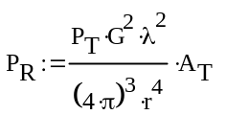

The above equation assumes isotropic radiation and an isotropic scatter. However, most targets do not scatter incident radiation isotropically and thus the backscatter cross-section, σ, of the target is necessary:
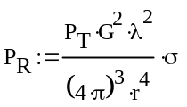

2.2 Meteorological radar equation
With the equation for a single point target derived, the next step is to edit the equation above to account for meteorological radar targets. Raindrops, snowflakes, cloud droplets are examples of an important radar class of targets known as distributed targets.
The incident radar pulse creates the transmitted resolution volume of the meteorological radar by simultaneously illuminating the volume containing weather particles. The mean power received from weather targets results in the equation below where Σσ is the sum of the backscatter cross-sections of all the particles within the resolution volume.

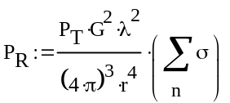

Since the volume of the radar beam continues to expand with increasing range, the radar beam includes more and more targets. The defined volume of the radar beam is equivalent to,

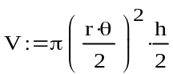

Where h = cτ is the pulse length and θ is the antenna beamwidth. By combining the general radar equation with the volume of the radar beam, the mean power returned becomes,

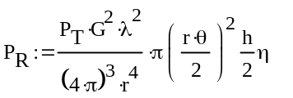

Where η denotes the radar reflectivity per unit volume. The above equation, however, assumes the antenna gain is uniform within its 3 dB limits, which is untrue. By assuming a Gaussian beam pattern, the effective volume is more appropriately defined over the radar beam pattern instead of within the 3 dB limits. Using a Gaussian beam pattern, the mean power returned becomes

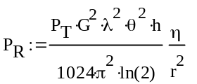

By accounting for a single spherical particle that is small compared to the radar wavelength, the backscatter cross section can be represented by σ = 64 π⁵/ λ⁴|K|²r_{o}² where K is the complex index of refraction and r_{o} represents the sphere radius. Weather particles small enough for the Rayleigh scattering law to apply are known as Rayleigh scatterers. Raindrops and snowflakes are considered Rayleigh scatterers measured to accurate approximation when the radar wavelength is between 5 cm and 10 cm, common operating wavelengths for weather radars. At a 3 cm wavelength, the approximate scattering can still be useful, but is less accurate.
For a group of spherical drops, which are small compared to the radar wavelength, the average returned power changes to

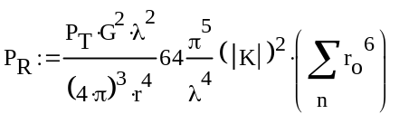

Where Σ is a summation of the spherical radius for each the weather scatterers. By allowing (D/2) ⁶ to equal r_{o}⁶, the mean power returned can be reflected in terms of drop diameters for spherical scatterers,

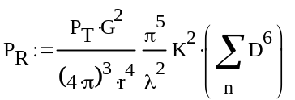

Thus for spherical scatterers that are considerably smaller than the radar wavelength, the mean power received by the weather radar is determined by the radar characteristics, range, the scatterer index of refraction (|K|²), and the diameter of the scatterer (D⁶).
Finally, the target reflectivity factor, Z, can be introduced as Z = Σ_{V} D⁶ = ∫ N(D)D⁶dD, where Σ_{V} is the summation over a unit volume and N(D)D⁶ is the number of scatterers per unit volume with diameters in dD. The final form of the l radar equation for weather radars, including the corrections made previously to represent a Gaussian beam pattern, results in,

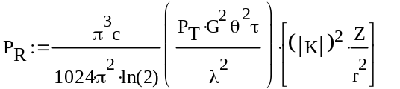

3 General meteorological radars principles
Meteorological radars carry out two types of measurements:
– precipitation measurements;
– wind measurements.
These measurements are performed over pixel grids that allow presenting cartography of the abovementioned meteorological events.
[Editors Note: An example image of weather radar returns for precipitation and wind may be inserted here.]
3.1 Example of meteorological radar operation in 2.8 GHz band
Radar G in Recommendation ITU-R M.1464 is a system representative of meteorological radars operated at frequencies around 2.8 GHz. The 0 dBz curve for this radar intersects the receiver noise level (-113 dBm) at a range of 200 km.

3.1.1 Precipitation Estimation.
Representative radars operated near 2.8 GHz use a variety of reflectivity-range (Z-R) and reflectivity- rainfall rate (Z-S) formulas for precipitation estimation. Depending o the specific algorithm, the effect of interference o operational range can vary
Example of meteorological radar operation in 5.6 GHz band

On a typical basis, radar coverage extends over 200 km presenting a pixel resolution of 1 km × 1 km. In some instances, a more detailed grid can be is presented over 250 m × 250 m pixels.
For each pixel, the radar measurements are calculated over all the pulse responses corresponding to this pixel, i.e. for each pulse pair and each range gate and then projected directly onto a Cartesian grid (see Fig. 1 below).
figure 1
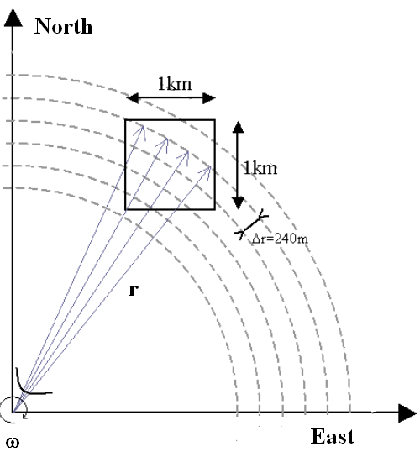

As a consequence the number of estimates per pixel varies according to the distance. These numbers are related to the mean PRF and the antenna rotation speed. On average, with a typical antenna rotation rate of 6 deg/s, a mean PRF of 333 Hz and a gate spacing of 240 m, this leads, at 10 and 100 km to respectively about 1 000 and 100 estimates for a 1 km² pixel.
The following Fig. 2 provides simplified calculation of such number of estimates versus distance for 250 m a × 250 m and 1 km × 1 km pixels that confirm that radar measurements are more sensitive at higher distances as well as for smaller pixels.
figure 2
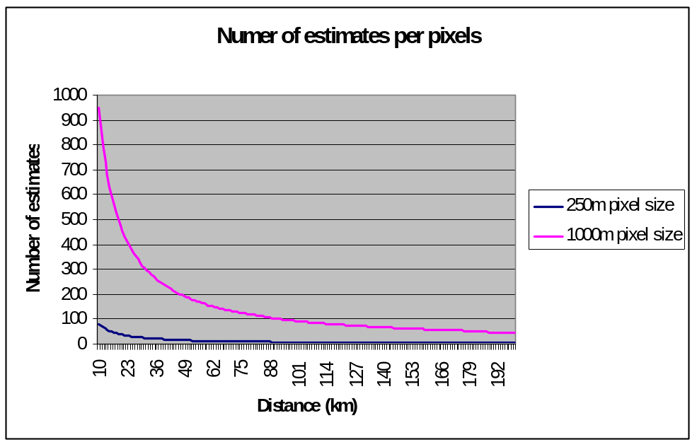

3.2.1 Precipitation measurements principle
Weather radars perform precipitation measurements that are expressed in reflectivity (dBz).
The radars deployed in the French network are calibrated in order to make coincide the level of noise of the receiver (i.e. about –113 dBm) with the 0 dBz reflectivity level at 100 km. In addition, the minimal detection level of a rain cell is fixed at 8 dBz.
The following Fig. 3 gives the relative levels (in dBz) of minimal detection (8 dBz), of a significant convective cell (60 dBz) and level equivalent to the noise of the receiver.
figure 3
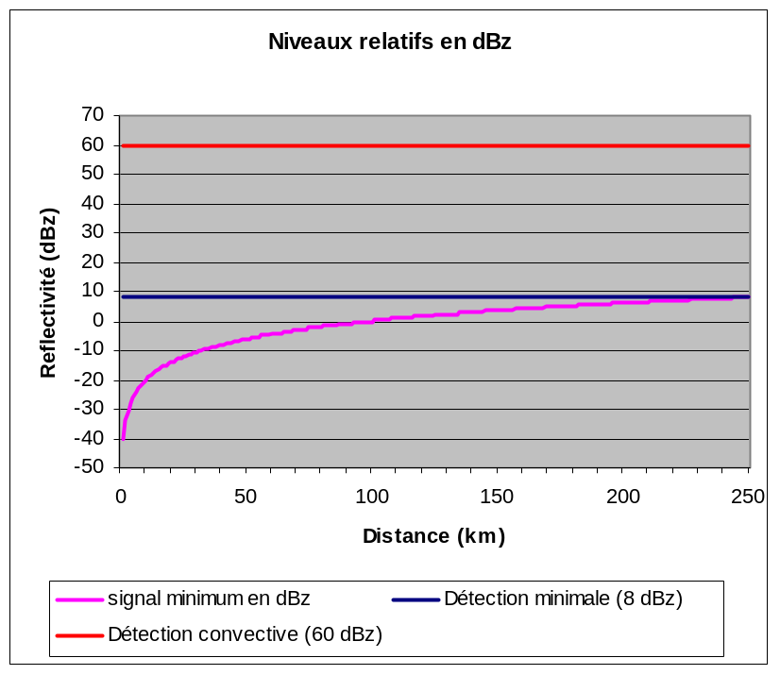
The relation power/reflectivity is given by the following formula:
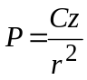
With
P = power in mW
C = constant (about 10^{–7} or –70 dB)
z = reflectivity
r = distance (m)
that gives, in dB, the following relation:
dBm = dBz + C – 20log(r)
On this basis, Fig. 4 gives, in dBm, the relative levels corresponding to the levels of reflectivity as on Fig. 3 above.
figure 4
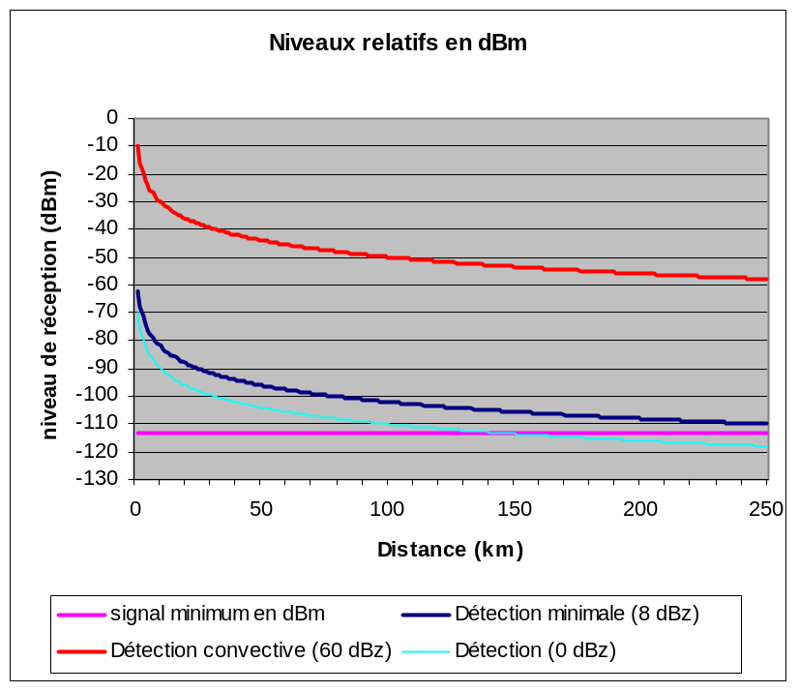

Finally, the reflectivity figures are translated in rain rate levels using the following formula (for typical rain):
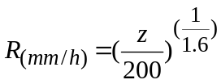
It has to be noted that this translation formula is valid for typical rain but that other formulas are defined for different precipitation types (tropical rain, snow, hail, etc.).
For a given pixel of the radar grid, the reflectivity figures for each estimate (corresponding to a pulse response and a gate) are considered in determining the following elements:
– the average (in dBz) over all estimates
– the standard deviation.
Rain cell responses are characterized by a certain variability, which is used to discriminate them from clutters using the standard deviation figure.
For the radars deployed in France, the reflectivity values are hence corrected using the following rule:
figure 5
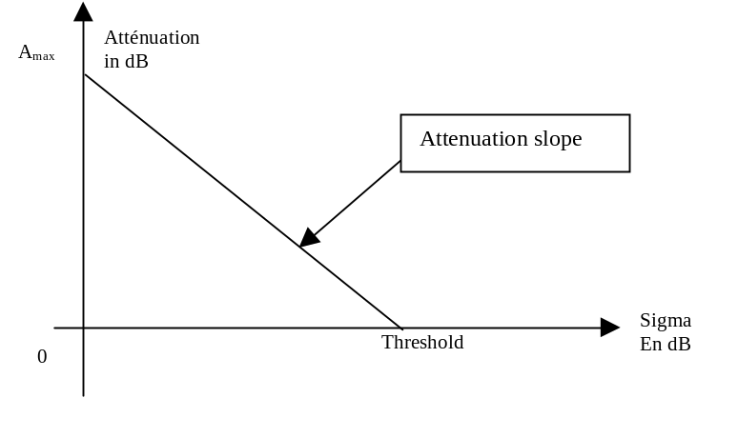

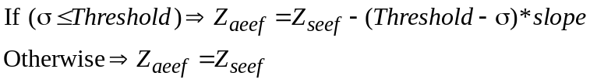
σ is the standard deviation in dB,
Z_{seef} is the reflectivity value before correction,
Z_{aeef} is the reflectivity value after correction
Slope is the attenuation slope as on Fig. XX above, given by:
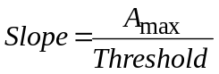
This correction algorithm is somehow empirical but the values of both the threshold and the slope are defined to ensure almost no attenuation (actually less than 5%) on meteorological signals.
Currently, the slope is fixed at 20 dB and the sigma threshold is within the range 2.3-2.7 dB. In addition, when the calculated attenuation is above 25 dB, then the resulting reflectivity is set to 0.

3.2.2 Wind measurements principle
Unlike reflectivity (in dBz), which is a measurement of intensity of the signal, wind measurements are based on Doppler detection carried out on the phase of the signal and can take place as soon as the received signal is higher than the level of noise (i.e. –113 dBm). However, in order to avoid phase detection that would be due to noise variation or non-meteorological sources, a 3 dB threshold over the noise (i.e. –110 dBm) is considered.
[Editor’s Note – It should be noted that other meteorological radars are capable of processing S/N levels down to –3 dB to –6 dB.]
It has also to be noted that such measurements are performed both under rain or clear sky conditions. In rain conditions, receiving levels are similar to those described on Fig. 2 above. Whereas under clear sky conditions, it can easily be understood that the corresponding reflectivity levels are very low and would not allow wind measurements at distances higher than roughly 30/50 km.
For each estimate (corresponding to a pulse response and a gate), the phase and reflectivity figures are considered as a vector and then, for a given pixel of the radar grid, the resulting wind vector is obtained as the combination of all single vectors.
It hence means that the phase of each estimate is balanced with the corresponding reflectivity module and that a single estimate presenting a high reflectivity (i.e. the vector module) is able to control the pixel measurement.
Then, the wind measurements are used to derive two different set of wind products:
– the radial speed over the radar grid, similar to the precipitation display,
– the Vertical Azimuth Display (VAD) for which the whole of the data (for all altitudes) in a radius of a few km or a few tens of km are integrated in order to calculate the wind profile at the vertical of the radar.

Example of meteorological radar operation in the 8-12 GHz band

Meteorological Radars that operate on a wavelength of 2.5cm to 4 cm and a frequency of 8-12 GHz are more sensitive and can detect smaller particles. These Meteorological Radars are generally used for studies on cloud development because of their ability to detect very small water particles and light precipitation. They have a typical range of 30-km for 10 dBz weather targets and operate at relatively low, 12 kW, power levels.

Networks of radars operated in the 8 – 12 GHz range are also being investigated as a means of supplementing existing weather radar systems by detecting precursors to severe weather events.

“A disadvantage of using radars operated in the 8 – 12 GHz range for weather detection is the amount of signal attenuation that can be experienced in rain. The attenuation is particularly severe in moderate-to-heavy rain, where the reflectivity factor is greater than 40 dBZ. As long as the radar can obtain a detectable signal after attenuation, velocity measurements can be made and estimates of the attenuation rate can be applied to correct the reflectivity values. Dual-polarimetric measurements can be particularly effective for correction of attenuation (e.g., Lim and Chandrasekar 2005). However, once the attenuated signal falls below the sensitivity of the radar, velocity measurements cannot be obtained and there is the possibility of becoming blind to weather hazards.” (e.g. Brewster, Fay and Junyet 2005)

Due to their lower levels of operation and projected networked operation, weather radars that operate in the 8-12 GHz band can be more susceptible to having their base products corrupted by interfering signals. As a result they may require more stringent I/N ratios in order to protect them from interfering signals. Additional analytical studies and field measurements will need to be undertaken in order to quantify the impact of localized interference on these systems and to determine the magnitude of the I/N levels that are required to protect these systems.

4 Comparison of meteorological radars to other radars
Most radars are used for detection and tracking of point targets within the radar’s detection range. In comparison, meteorological radar does not concentrate on detection of discrete targets. They measure the entire atmosphere around the radar. A return from every range bin along each radial is processed to provide a complete measurement of the atmosphere, commonly referred to as a volume scan. For this reason, the term probability of detection (p_{d}) is normally not used in characterizing meteorological radars.
As the term volume scan indicates, the radar conducts a scan of the atmospheric volume in order to build a complete representation of the atmospheric conditions. While many radars tracking discrete targets do derive information (velocity, radar cross section, etc.) from the characteristics of return pulses, it is the characteristics of the return pulses for a meteorological radar that provide almost all the information. Unless the air is absolutely clear, a meteorological radar receives and processes a return for almost all range bins along a radial.
The criteria for the operational evaluation of a typical weather radar system include; 1) technical aspects, 2) warning performance and 3) quality and reliability of derived products. Technical aspects include factors such as coverage at specific altitudes, spatial and temporal resolution, sensitivity, Doppler coverage and radar availability. Warning performance can be viewed as a somewhat objective measure but is in fact directly linked to detection capability. The quality and the reliability of the key derived products: reflectivity, mean radial velocity and spectral width impact a forecasters ability to provide hazardous weather warnings and timely and accurate forecasts .

5 Operational modes for meteorological radar
The typical Doppler meteorological radar operates in two user selectable modes: Clear Air mode and the Precipitation Mode. Clear Air mode requires the user to select it manually. The Precipitation Mode may be selected manually at any time during operation or can be automatically operated whenever the weather radar detects precipitation (based upon pre-determined values and area coverage of reflectivity). In general, meteorological radars take advantage of either or both modes.

5.1 Clear air mode
The purpose of this mode facilitates the meteorological radars ability to detect the early warning signs of precipitation activity.
There exist certain variables in low level velocity and air density that allow for detection of potential precipitation. The radar utilizes a slow scan rate coupled with a low Pulse Repetition Frequency (PRF) to employ a high sensitivity capability. This high sensitivity is ideal for very subtle changes in atmospheric conditions at long ranges. The Clear Air Mode is especially useful when there is little to no convective activity within the transmit range of the radar and is ideally suited for detecting the signs of developing thunderstorms or other types of severe weather.
The meteorological radar accomplishes the high sensitivity by employing the use of a volume coverage pattern within the Clear Air Mode. By selecting a pattern in the Clear Air Mode, the radar antenna is capable of dwelling for an extended period in any given volume of space and receives more returns, while allowing operation at a lower S/N. The use of a wide pulse width and a low PRF provides for approximately 8 dB greater echo power for a given dBz of reflectivity.

5.2 Precipitation mode
The Precipitation Mode performs a distinctly different purpose than the Clear Air Mode. The scan rate for the Precipitation Mode is a function of the elevation angle. This dependence allows for the highest number of elevation angles possible in sampling the total radar volume. The Precipitation Mode takes advantage of two Volume Coverage Patterns (VCPs) to implement two types of scan strategies. The two scan strategies are capable of sampling 14 elevation angles in five minutes or 9 elevation angles in six minutes. Weather events normally monitored in the Precipitation Mode are associated with the development of precipitation involving convective storms (rain showers, hail, severe thunderstorms, tornadoes, etc.) and large-scale synoptic systems.

6 Met radar data products
To provide a better understanding of meteorological radars for interference analysis and spectrum management two categories of meteorological radar data products must be considered, base data products and derived data products

6.1 Base data products
A Doppler meteorological radar generates three categories of base data products from the signal returns: base reflectivity, mean radial velocity, and spectrum width. From these three base products all higher-level products are generated. The base product accuracy is often specified as a primary performance requirement for radar design. Without the required accuracy at this low level, the higher-level derived product accuracy cannot be achieved. In a past ITU-R study on meteorological radars, the impact of permissible interference on the base product data was used as the metric for protection criteria (Annex 3 to ITU-R Recommendation M.1464-1). For example, a representative radar with the base data accuracies shown in Table 1 was used in a study. Testing was conducted to determine the interference-to-noise ratio that caused the radar to no longer meet its design requirements. Section 8.3 addresses the details of determining meteorological radar protection criteria.
Table 1
Representative met radar (2 700-2 900 MHz)
base data accuracy requirements
Base data product | Design accuracy requirement
Base reflectivity | <1 dB
Mean radial velocity | <1 m/s
Spectrum width | <1 m/s

6.1.1 Base reflectivity
Base reflectivity is used in multiple applications, the most important of which is rainfall rate estimation. Base reflectivity is calculated from a linear average of return power. Base reflectivity is simply the intensity of the return pulses and is critical in rainfall estimation.
Interference adds to the return pulse power to cause a bias in the reflectivity values. Reflectivity measurements can be compromised if the bias exceeds the base data accuracy requirements.

6.1.2 Mean radial velocity
Also called the Mean Doppler Velocity, the Mean Radial Velocity represents the reflectivity weighted average velocity of targets within a given volume sample it refers to the spectral density first moment; radial velocity to base data. It is usually determined from a large number of successive pulses and is calculated from the argument of the single lag complex variance. The complex covariance argument provides an estimate of the Doppler signal vector angular displacement from radar pulse to radar pulse. The displacement divided by the time interval between pulses is the Doppler vector angular velocity. The Doppler spectrum reveals the reflectivity and radar weighting distribution of velocities within the radar volume . An interference signal appearing as broadband noise has uniform probability over the complex plane and thus does not introduce a systematic rotation of the Doppler vector and does not introduce a bias in the estimate. However, the randomness of the composite signals plus interference vector due to interference increases the variance of the Doppler signal estimate.

6.1.3 Spectrum width
The term spectrum width applied to meteorological radars is different than one associated with ITU-R would assume. In met radar design, spectrum width is calculated from the single lag correlation assuming a Gaussian spectral density. It is a measure of the dispersion of velocities within the radar sample volume. It is the standard deviation of the velocity spectrum. Spectral width depends on reflectivity and velocity gradients across the pulse volume and turbulence within the pulse volume.( Doviak and Zrnic 1984) There is no averaging of samples used in spectrum width calculations. There is however an accumulation of the real and imaginary parts of the sample series, i.e. the samples taken over the radial.

6.2 Derived data products
Using the base data products the processor produces higher-level derived data products for the radar user. This document will not address the derived data products in detail as the products vary from radar user to radar user and the number of products is quite large. The important item to consider is the accuracy of the base data products needs to be maintained to ensure accuracy of the derived data products.

7 Antenna pattern and antenna dynamics
Meteorological radars typically use parabolic reflector antennas producing a pencil beam antenna pattern. Standard ITU antenna patterns for parabolic antennas are not applicable to antennas used for met radars as the generated main beam pattern is often much wider than the actual pencil beam pattern. Use of a broader antenna pattern often provides sharing results indicating more significant interference problems than an accurate antenna pattern. Future work might be necessary to define appropriate formulas for modelling meteorological radar antennas.

7.1 Volume scan antenna movement
The coverage in the horizontal and vertical to provide a volume scan is conducted by rotating the antenna in the horizontal plane at a constant elevation angle to produce an elevation cut. The antenna elevation is increased by a preset amount after each elevation cut. The lowest elevation cut is typically in the range of 0 to 1 degrees, and the highest elevation is in the 20 to 30 degree range, though some applications can use elevations up to 60 degrees. Rotation speed of the antenna varies depending on weather conditions and the product required at the time. The rotation speed as well as range of elevation, intermediate elevation steps, and pulse repetition frequency is adjusted for optimum performance. Slow antenna rotation provides a long per-radial dwell time for maximum sensitivity.
High antenna rotation speed allows the operator to generate a volume scan in a short period of time when it is desirable to cover the entire volume as quickly as possible. Variation of the elevation steps and rotation speed can result in volume scan acquisition times ranging from a minute up to 15 minutes. The long periods of time for a complete volume scan compared to other radars that rotate at a constant elevation make it necessary to run dynamic simulations much longer to obtain a statistically significant sampling of results.

7.2 Other antenna movement strategies
Meteorological radars also use other antenna movement strategies for special applications and research. Sector scans are used to get part of an elevation cut. Sector volume scans perform a volume scan for a fraction of the 360-degree azimuth where the antenna takes multiple elevations cuts. The third mode holds the antenna at a constant azimuth and elevation to monitor a specific point in the atmosphere. All three strategies allow the radar operator to concentrate on a specific part of the atmosphere. These strategies typically are not used for research but not operational met radars except for some met radars used at airports.
7.3 Antenna Patterns
Whenever possible, sharing studies should be conducted using the actual antenna pattern of the radar under study. But in cases where actual antenna pattern data is not available, a generic set of curves or formulas for deriving representative antenna characteristics would be beneficial. A market survey of antennas used in the manufacture of meteorological radars was conducted, with the goal of obtaining a representative set of data points for main-beam gain, beamwidth and sidelobe levels. The following graphs are plots of main-beam gain and beamwidth against the ratio of diameter to wavelength (D/λ) for several identified antennas. With respect to sidelobe levels and locations, insufficient data was available to identify any trends. Additional data is needed to complete this work. Other administrations are encouraged to provide data on antennas available within their country.
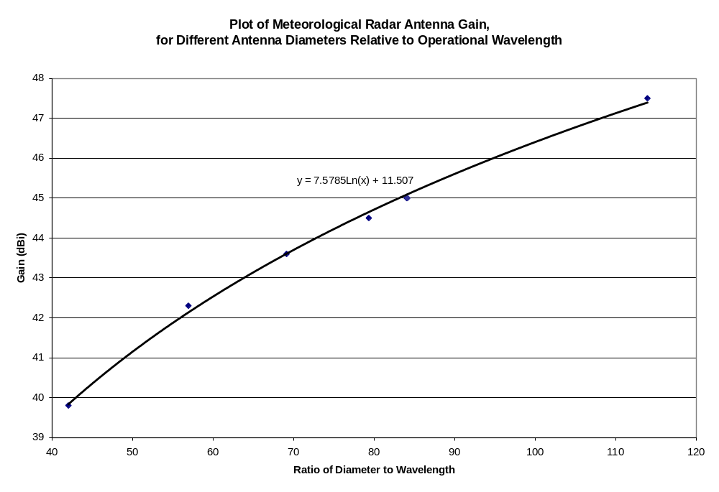
Figure 6 - Plot of meteorological radar main-beam gain for a set of commercially available antenna designs.

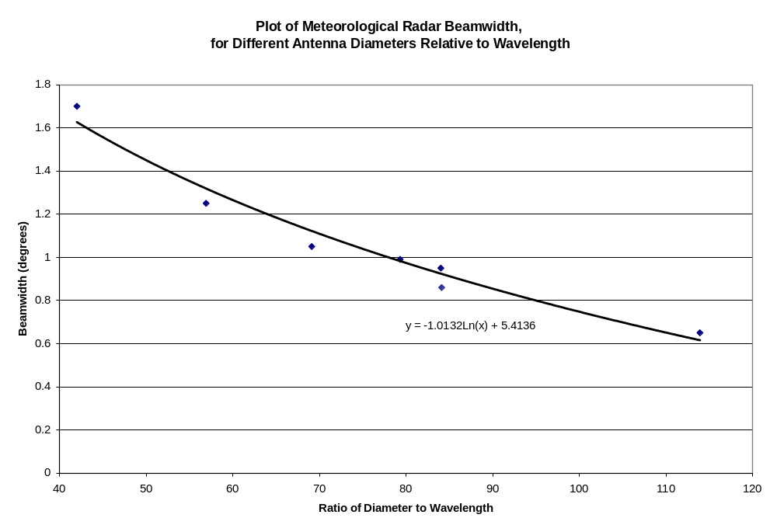
Figure 7 - Plot of meteorological radar beamwidth for a set of commercially available antenna designs

8 Effects of interference and solar noise on meteorological radars
Determining the effects of interference on radars used for detecting point targets is fairly straightforward. Testing can be accomplished by injecting simulated known targets into the radar and visually determining the interference level at which the targets are lost or false targets are generated. Visual inspection of the Derived Data Products from a met radar volume scan as displayed on an operator console does not provide obvious indication whether interference has degraded the radar’s performance. For example, if interference were to cause a 1 dB bias in the base reflectivity data, it will not be obvious on a graphical display of rainfall. However, if the interference is present for a large part of the volume scan, each and every range bin will be biased within the affected volume. The cumulative effect is a significant overestimation of rainfall in a geographic region.
All meteorological radars experience sun strobes during the periods of sunrise and sunset.
A sun strobe is caused whenever the antenna main beam aligns with the sun during a volume scan. The effect of sun strobes, in the particular case of meteorological radars, results in the total loss of data along one to two radials in the direction of the sun. It should be noted that the predictability of sun strobes may allow for the calibration in azimuth of the radars pointing direction.
The effects of the sun are undesirable, but predictable. With other forms of interference and noise the location and intensity are unknown and cannot be predicted or easily addressed through processing or operator interpretation.

Base products are affected by interference in two different ways. First, values can be biased which decreases the accuracy of the system, and second, the variance of the outputs can be affected. In the presence of interference, reflectivity is sensitive to bias, mean radial velocity is sensitive to variance errors, and spectrum width is affected by both bias and variance errors. For spectrum width, the errors due to biasing are more significant than the errors due to variance because the bias, or offset, represents a velocity measurement error while the variance represents the uncertainty of the velocities measured.

8.1 Impact of Interference on Modes of Operation
In the clear air mode, the signal to noise ratio of the returns is the lowest and the data is most vulnerable to corruption by interference. Typically when operating in clear air mode, the meteorologist is looking for the initial signs of convection as it may develop into severe weather and possibly tornadoes. Detection of convection requires the detection of fine lines caused by scatterers indicating discontinuity boundaries that initiate convection. The width of these areas of convection is often on the order of one to two radials in width, and interference along those radials would prevent detection. Therefore interference for even very brief periods of time could result in loss of detection of forming severe weather. If that information is lost along a critical radial during a volume scan, detection will be delayed on the order of 10 minutes until the volume scan returns the antenna position to that area of the atmosphere.

The Precipitation Mode is the more demanding mode in terms of communications, radar product generation, and user processing and display. For the Precipitation Mode, nearly all of the algorithms rely on the base data of reflectivity, mean velocity, and spectrum width to generate derived products for use by the operator.

8.2 Impact of Interference upon Base Products
Base products are affected by interference in two different ways. First, values can be biased which decreases the accuracy of the system, and second, the variance of the outputs can be affected. In the presence of interference, reflectivity is sensitive to bias, mean radial velocity is sensitive to variance errors, and spectrum width is affected by both bias and variance errors. For spectrum width, the errors due to biasing are more significant than the errors due to variance because the bias, or offset, represents a velocity measurement error while the variance represents the uncertainty of the velocities measured.
Reflectivity is calculated from a linear average of power. In the some meteorological radars reflectivity estimates are formed for range bins that span 250 meters in depth by one radial wide (approximately 1.0 degree in azimuth). These systems average range bins to produce a reflectivity estimate output at specified intervals. This averaging of four to one can further mitigate effects of interference occurring on a single pulse. Next generation meteorological radar systems have plans to add a "super-resolution" reflectivity product, which will eliminate the averaging and produce reflectivity estimates at 250-meter intervals. Additionally, the radial will be reduced to half (0.5-degrees), which will use only half the samples. The total affect will be to reduce the sample size by eight. Thus, interference will be more pronounced in the “super resolution” reflectivity product than in current estimates.

For Doppler moments the interference effects are non-linear. Velocity is calculated from the complex covariance argument and spectrum width from the autocorrelation. A mix of signal and interference does not scale linearly as with the average for reflectivity. These estimates result from accumulation of signal measurements consisting of both magnitude and phase angle information. Interfering sources would likely have random phases with respect to the coherent met radar signal and their contribution to the estimate accuracy is difficult to predict.
In terms of spectrum width, interference introduces both a bias and an increase in the variance of the spectrum width estimation. The bias in the estimation is more detrimental than the increase in variance.
Measurement errors need to be specified so that radar observations can be properly assimilated for numerical weather prediction. There are two related aspects to this problem: (1) errors in the original measurements within each radar pulse volume that are in part caused by interfering signals, and (2) representative of the radar data estimates used in the assimilation process. For radial velocities, the first error source depends on the strength of the return signal and the spread or width of the Doppler velocity spectrum. Spectral width in turn depends mainly on reflectivity and velocity gradients within and across the pulse volume and turbulence within the pulse volume (Doviak and Zrnic 1984). Estimation of these errors is complicated by the fact that the components needed for reliable error estimation are themselves only measured and, therefore, has inherent uncertainties.
The concept has been raised that, for a given range resolution cell, meteorological radars average multiple pulse returns over the dwell time of a radial. It has been suggested that in the case where interference occurs for a short part of the radial dwell time, the effect of the interference will be averaged with the interference-free pulse returns, thereby reducing the effects of the interference. So, in theory, if the radar is normally operating at an interference to noise ratio of well below –10 dB, but the –10 dB is violated for a short period of time (small percentage of radial dwell time), the effect of the interference will be averaged with the interference free-returns. If the –10 dB I/N is violated, but not by a high level of interference, the possible result is that the reflectivity bias of the averaged returns may stay within the design objective of the given radar. Unfortunately, this approach can only be effective if the interfering signal or signals are coherent over the dwell time. Since this does not happen often, averaging techniques may not be the most effective way of mitigating the effects of interference upon Doppler moments. However, with the exception of meteorological radars that employ spectral processing, averaging can be an effective way to mitigate interference given that the average interference over the dwell time has an I/N of less than –10 dB.

It should be concluded that interference to meteorological radars should be minimized, with the objective of mitigating or preventing all interference. Unlike communications systems that use redundancy and error correction, meteorological radars cannot reacquire lost information. However, when considering the use of radar characteristics for ITU-R sharing studies other factors do need to be considered that are addressed in the following sections.

8.3 Mathematical derivation of meteorological radar protection criteria
Annex 3 of ITU-R M.1464 provides a detailed discussion of mathematically deriving meteorological radar interference criteria. The discussion section 2 of Annex 3 is the supported by test results to validate the derivations. While it is convenient, and often done, a single protection criteria value can not be accurately applied to all meteorological radars operated in a single band. Meteorological radars are designed with varying performance objectives where those objectives are optimized for specific meteorological conditions. In reviewing section 2 of Annex 3 of ITU-R M1464, the base product accuracy and the radar minimum signal-to-noise ratio (S/N). These two values vary from radar application to radar application. The lower the minimum S/N used by the radar, the lower the required protection criteria.

Weather radars make three basic measurements, which in conjunction with operator information are used to derive the products that are used by meteorologists. The three base products from which other products are derived include: volume reflectivity, radial velocity and spectrum width.
Signal processing removes many of the effects of radar system noise from the reflectivity and spectrum width measurements; as a result, some systems can provide estimates of these products for signal levels that are below the receivers’ noise level. The radars’ operator selects the signal to noise threshold (SNR), which, in some systems, can have a range of –12 dB to 6 dB. The radar, which is used in the following examples, provides useful measurements down to an SNR of –3 dB. Interference at this signal level and above will degrade the quality of the base products. This highlights the need to establish an I/N ratio that protects the integrity of these products.
Given the technical specifications and base data accuracy requirements of any given meteorological radar one can derive the theoretical I/N’s which are is required in order to assure that the base products are not compromised in terms of bias and variance.
The following examples illustrate the calculation of threshold I/N’s for a typical meteorological radar.
8.3.1 Reflectivity Maximum I/N
Reflectivity is used in multiple applications; the most important of which is rainfall rate estimation. Reflectivity is calculated from a linear average of return power and is subject to contamination by interference as an unknown increase in the measured reflectivity. Reflectivity is seriously contaminated if the bias exceeds the system specifications. Given the Radar Systems dB Bias and S/N, the following equations can be used to calculate the I/N that is required in order to protect the integrity of the reflectivity product.

Bias in terms of I/S is given by:
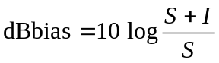
Solving for I/S yields:
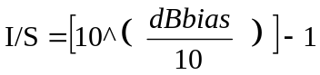

I/N is then equal to:

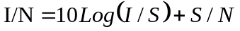

Example Calculation for a 1 dB bias and an S/N of –3 dB
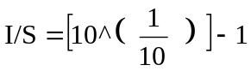
I/S = 0.26
10 log I/S = –5.8 dB
Therefore, reflectivity is biased 1 dB at an interference level 5.8 dB below the signal.
For the radar that is used in this example, the minimum signal level has an S/N of −3 dB and the maximum I/S level for the reflectivity product is −5.8 dB, therefore the maximum I/N is:

I/N = (−5.8 dB) + (−3.0 dB) = −8.8 dB

8.3.2 Radial Velocity Maximum I/N
Mean radial velocity is calculated from the argument of the single lag complex covariance. The complex covariance argument provides an estimate of the Doppler signal vector angular displacement from radar pulse to radar pulse. The displacement divided by the time interval between the pulses is the Doppler vector angular velocity.
As a broadband noise, the interference signal vector has uniform probability over the complex plane and thus does not introduce a systematic rotation of the Doppler vector and does not introduce a bias in the estimate. However, the “randomness” of the composite signals plus interference vector due to the interference increases the variance of the Doppler signal estimate.
The Doppler frequency variance, retaining all terms except those inversely proportional to the number of samples squared can be calculated as:
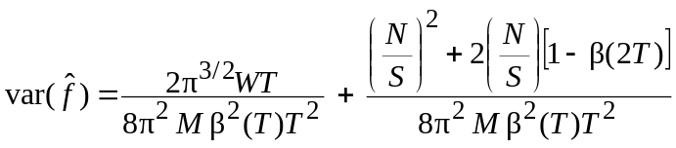
Where:
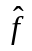: Frequency estimate (Hz)
W: standard deviation of frequency spectrum (Hz)
T: sampling interval (s)
M: number of samples in estimate
N: noise power
S: signal power
β: Signal correlation at lag T
The first term is the variance contribution due to the signal characteristics and the second term is the variance contribution due to the noise.
The frequency variances are severely compromised if the interference increases the variance by more than 50%. The uncertainty in the data degrades all velocity-based products and the velocity shear measurements in particular. (Velocity shear is a velocity difference over some distance.) A 50% increase in variance increases the reliably detected shear value approximately 25% above the severe weather event formative stage value.
An expression for I/N as a function of a percentage variance increase of a given radars benchmark parameters and S/N is given by:

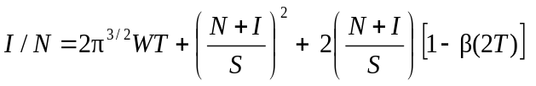

Where:

W: standard deviation of frequency spectrum (Hz)
T: sampling interval (s)
M: number of samples in estimate
N: noise power
S: signal power
β: Signal correlation at lag T.

Example Calculation for a 50% variance increase of the technical requirements benchmark parameters and an S/N = −3:

Where:
W = 80 Hz
T = 10^{–3} s
2π^{3/2}WT = 0.89
1 – β (2T) = 0.4
S = 0.5 N

Substituting and solving for I/N yields the quadratic expression:
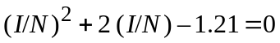
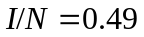
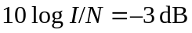
Therefore, the interference can be no greater than the minimum signal value.

8.3.3 Spectrum Width Maximum I/N
The spectrum width is calculated from the single lag correlation assuming a Gaussian spectral density. The algorithm is expressed as:
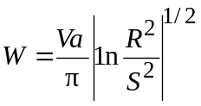
Where:
W: spectrum width (standard deviation)
Va: Nyquist velocity, 25 m/s from the radar technical requirements
R: single lag covariance power
S: signal power.
The interference signal causes both a bias and a variance increase in spectrum width estimation but the bias is more detrimental. Spectrum width is compromised when the interference-induced bias exceeds the radar technical requirement width accuracy. The I/N at which this bias level occurs can be calculated by solving for the covariance that is defined by the radars performance metric and signal power of N/2, then solving for the S + I level that produces a spectrum width that is equal to Spectrum Width base value as defined in the Radars technical specifications plus value of the spectrum width accuracy requirement.
An example calculation follows for Radar with a width accuracy requirement of less than 1 m/s at a spectrum width of 4 m/s follows. To calculate I/N, the equation above is solved for the 4 m/s and 5 m/s cases. (S/N=-3 dB)

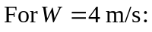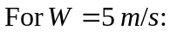
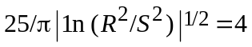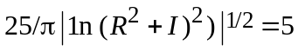
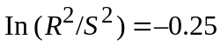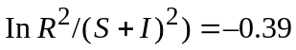
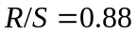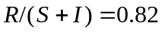
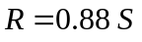
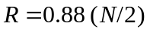
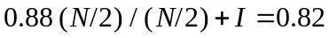
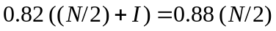
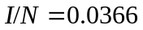
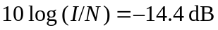

Table 2 shows the results of several I/N calculations that were based upon varying SNR’s and Spectrum Width accuracies. The results show that the theoretical I/N requirements of Meteorological Radars will vary as a function of the radars technical specifications and base data accuracy requirements..

TABLE 2 – Comparison of I/N’s for Several Hypothetical Meteorological Radars

 | RADAR A | SNR=-3dB | RADAR B | SNR= 0 dB | RADAR C | SNR= 0 dB
 | Base Data |  | Base Data |  | Base Data
 | Accuracy | Theoretical | Accuracy | Theoretical | Accuracy | Theoretical
 | Requirement | I/N | Requirement | I/N | Requirement | I/N
Reflectivity | < 1 dB | -9 dB | < 1 dB | -6 dB | < 1dB | -6 dB
Radial Velocity | < 1 m/s | -3 dB | < 1 m/s | 0 dB | < 1 m/s | 0 dB
Spectrum Width | < 1 m/s | -14.4 dB | < 1 m/s | -14.4 dB | < 2 m/s | -10.6 dB

From this observation one can conclude that the defining of an “average” I/N for meteorological radars will provide some degree of overall meteorological radar protection but would not be applicable to all meteorological radars. As a result, I/N’s would have to be computed for various meteorological radars based upon their specifications and base data accuracy requirements. In the absence of test data to determine protection criteria for specific radar, the formulas may be used to derive the protection criteria for studies where more detail is required.

8.4 Types of possible interference
Interference experienced by meteorological radars can be of different types:
– constant,
– time varying,
– pulse like.
As a first step, it is proposed to determine the impact of a constant interference corresponding to the currently agreed protection criteria, i.e. I/N = –10 dB or I/N = –6 dB and then to assess the possible protection criteria for the other interference sources to ensure a similar level of the radar performance degradation.

8.4.1 Impact of a constant interference
The currently agreed protection criteria, I/N = –10 dB or I/N = –6 dB, respectively corresponds to a noise or energy increase of 0.5 and 1 dB.
On the principle that radars are calibrated in order to make coincide the level of noise of the receiver (i.e. about –113 dBm) with the 0 dBz reflectivity level at 100 km, a noise increase changes the nominal conditions of the radar, decreasing the range of the radar.
On this basis, assuming a current coverage of meteorological radars that roughly extend up to 200 km Table 3 summarizes the losses in range and coverage versus the I/N interference and noise increase.
Table 3- Loss in range and coverage
Noise increase  (dB) | Corresponding I/N (dB) | Loss in coverage (km) | Loss in coverage  (% relative to surface)
0.5 | –10 | 11 | 11%
1 | –6 | 22 | 21%
2 | –2.3 | 42 | 38%
3 | 0 | 59 | 50%
4 | 1.8 | 75 | 61%
5 | 3.3 | 88 | 69%
6 | 4.7 | 100 | 75%
7 | 6 | 111 | 80%
8 | 7.3 | 121 | 84%
9 | 8.4 | 130 | 88%
10 | 9.5 | 137 | 90%

On the other hand, a constant interference also creates an increase of the energy received by the radar that will be considered in the reflectivity calculation.
Following description in section 2.2 above, the precipitation rate corresponding to a certain reflectivity level (in dB) is given by:

Z= AR^B

Where:

Z= Reflectivity
A = Scattering Constant
B = Rate Multiplier

And

Z= 10^.1(dBz)

Where:
dBz = Reflectivity in dB

Re-arranging terms and solving for R yields the following equation:

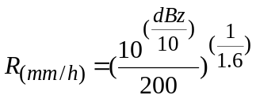
Assuming a constant energy increase, C, the resulting rain rate is:
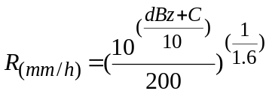
And it is easy to demonstrate that the rain rate increase in percentage is then also a constant that is given by:
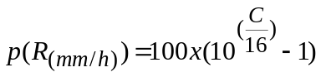

Table 4 lists typical scattering constants and rate multipliers for several types of precipitation.

TABLE 4 – Scattering Constants and Rate Multipliers For Various Precipitation Events

Variables | Stratoform Rain | Convection Rain | Snow | Hail
Scattering Constant (A) | 200 | 500 | 2000 | 2000
Rate Multiplier (B) | 1.6 | 1.5 | 2 | 1.29

Table 5 summarizes the percentage rain increase for several precipitation events.
Table 5
Noise increase (dB) | Corresponding I/N (dB) | Stratoform Rate increase (%) | Convection Rate Increase  (%) | Snow Rate Increase  (%) | Hail Rate Increase  (%)
0.5 | –10 | 7.5 | 8.0 | 5.9 | 9.3
1 | –6 | 15.5 | 16.6 | 12.2 | 19.5
2 | –2.3 | 33.4 | 35.9 | 25.9 | 42.9
3 | 0 | 54.0 | 58.5 | 41.3 | 70.8
4 | 1.8 | 77.8 | 84.8 | 58.5 | 104.2
5 | 3.3 | 105.4 | 115.4 | 77.8 | 144.1
6 | 4.7 | 137.1 | 151.2 | 99.5 | 191.8
7 | 6 | 173.8 | 192.9 | 123.9 | 248.8
8 | 7.3 | 216.2 | 241.5 | 151.2 | 317
9 | 8.4 | 265.2 | 298.1 | 181.8 | 398.5
10 | 9.5 | 321.7 | 364.2 | 216.2 | 495.9

These calculation shows that, irrespective of the rain value and precipitation type, the percentage of overestimation corresponding to a given constant energy increase is also constant and hence cannot be neglected.
Also, considering the reflectivity calculation for a given pixel that are based on the average (in dBz) over all estimates and the related standard deviation, it is worth noting that, obviously, a constant energy increase of all estimates will increase the average but will not change the standard deviation. It hence means that it would not modify the radar rain detection (i.e. a measurement not considered as a rain cell will still not be considered as such) but would only have an impact on the rain rate.
It is also interesting to note that either for the loss in coverage or the rain rate overestimation, the current agreed protection criteria of –10 dB or –6 dB represents radar performance degradation in a range of 7 to 20% that are figures generally agreed for all radiocommunication services.
In the case of Doppler measurements, the assessment of the impact of a given constant interference is somehow different and would in particular depend on how the phase of the interfering signal could modify the phase of the wanted signal.
This latter assumption is certainly not trivial to determine and will be signal and/or environmentally dependent. However, it is proposed to consider the different situations on a theoretical basis:

- Case 1: If the phase of the interfering signal detected by the radar is random, it means that the resulting vector would be statistically null, whatever would be its level. Hence, it would theoretically not have any impact on the wind measurements.

– Case 2: On the contrary, if the detected phase is not random and almost constant, it would result in a constant vector with a certain module and the impact on the wind measurement will depend on both the phase and module of such vector. However, the determination of such impact, even for a constant interference level is likely not to be easy and is hence not made at this point.
In addition, one can also assume that when the level of interference is much lower than the wanted signal, the phase of this latter is not modified whereas, on the contrary, if the interfering signal is much higher, then the phase detected by the radar will be the phase of the interfering signal. In this latter situation, the discussion on Cases 1 and 2 above will remain.
In between these two situations, i.e. when the levels of both the interfering and wanted signals are consistent, it seems quite difficult to assess which of the signal will control the phase detection.

8.4.2 Impact of pulsed interference
In case of an interfering application transmitting pulse signals and due to the principle of the rain and wind measurements that are based on average over numerous radar pulses, it seems likely that the ratio of the PRF of the met radars gates (pulse width) and the interfering source will control the impact on met radars.
On a general principle, it is assumed that this ratio can be calculated from the formula given in section 3.2 of Recommendation ITU-R SA.1280 providing the fraction of coinciding pulses between two pulses applications that will depend upon whether the desired and undesired pulse repetition frequencies are related by integer multiples (Case I) or not (Case II). The fraction of coinciding pulses, fc, is found from:
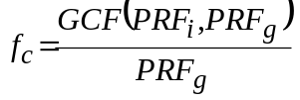 for Case I
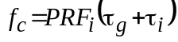 for Case II
where:
PRF_{i} : interfering pulse frequency
PRF_{g} : gate repetition frequency
GCF ( PRF_{i}, PRF_{g} ) : greatest common factor of PRF_{i} and PRF_{g}
τ_{i} : interfering pulse width
τ_{g} : gate width.
Note that when τ_{i} > τg and the desired and undesired PRFs are not related by integer multiples (Case II), f_{c} is approximately the duty cycle of the interfering pulses.
On this basis, in order to maintain the same level of degradation (about 10%) as for a constant interference where I/N_{constant} (–10 or –6 dB) applies, it is assumed that the maximum I/N related to a pulse interference could be given by:
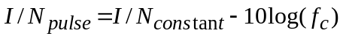
Indeed, for example, if the fraction of coinciding pulses is 0.5, meaning that one of two radar estimates will be polluted by the interference, and that the interfering signal is doubled (+3 dB) compared to the situation pertaining to an I/N = –10 dB, it is obvious that the average calculated by the radar will be the same.
On the other hand, the standard deviation will increase which will, in some cases, make a non-meteorological event taken as a rain situation. In this case also, it is assumed that a 10% degradation would be acceptable but this still to be validated and justified by calculation as well as by testing.

8.4.3 Impact of a time varying interference
The impact of a time varying interference on a meteorological radar needs to be assessed, acknowledging that such interference can also be of a pulse type.
The following figures are taken from Document 8B/149 and describe the potential interference from a SAR system to a meteorological radar.
Figure 7
Peak I/N cumulative distribution function
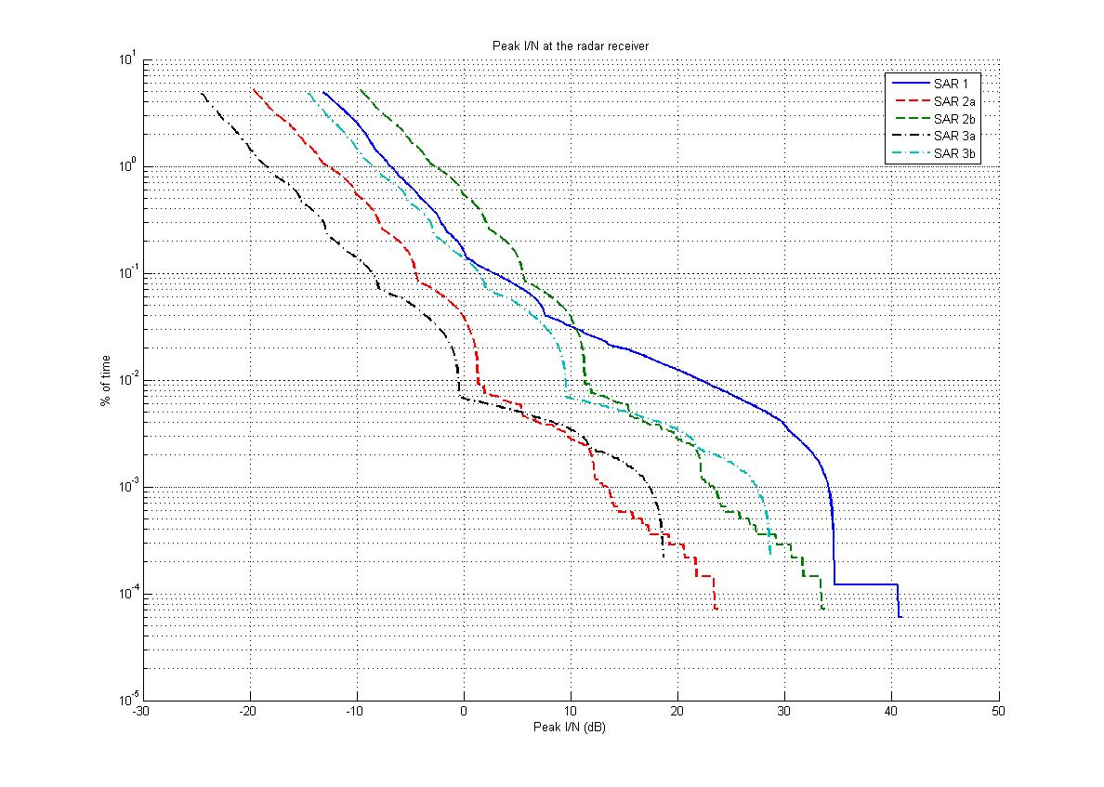
Figure 8
Peak I/N vs. time for one passage over the meteorological radar
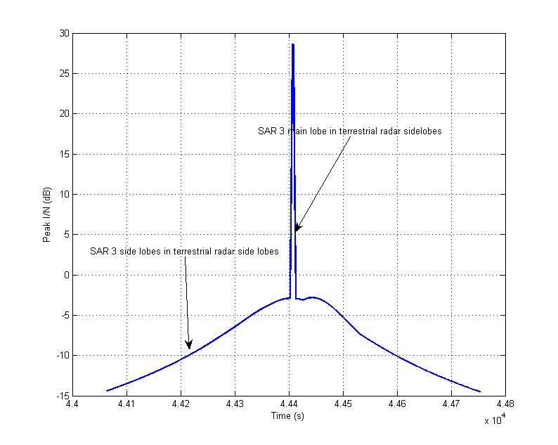
Even though these figures are still to be validated, it appears that two situations are likely to occur:
1) the first one for which a high I/N level will be produced for a short time duration which is likely to render the met radar inoperable for this time duration either in blocking the rain measurements capabilities or presenting a large overestimation of the rain rate;
2) the second one, over a larger time period (roughly 400s) for which the interference criteria will be exceeded.
It is at this stage also difficult to definitively conclude on the impact of such interference on meteorological radars but it should be assumed that, due to the short duration of pixel integration, a time varying interference is likely to present, on a short-term basis (i.e. on a pixel per pixel analysis), the same impact as for a constant interference (pulsed or not) as described in sections 3.1 and 3.2 above.
On the other hand, the time varying nature of such interference will present different impact for different pixel and different time period, which does not, seems trivial to assess.
Anyway, recognizing the need of further and detail analysis, it should be noted that an I/N level of 30 dB (without taking into account the pulse aspect of the SAR emission) that could pertain in situation 1 may produce, in a given area, a large overestimation of the instantaneous rain rate which will corrupt the long-term (1 hour up to several days) rain statistics that are used in hydrological alert processes. On a first approximation, if the impact is limited to a single pixel, it might be possible to extrapolate the correct figure from adjacent pixels. On the contrary, if several pixels are impacted, such approximation process might not be effective nor possible without presenting a risk to miss some strong meteorological events, or at least their effect and influence on the rain statistic.
On the same principle, in the second situation, the interference time duration of about 400 s that roughly corresponds to 7 radar rotations and relates to radar side lobes seems to show that a large number of pixels (and hence large geographical area) will be impacted over several occurrences that makes any pixels approximation impossible. The size of the geographical are obviously depends on the interference level that is assumed to first impact the edge of the radar coverage, but, as shown in Table 1 above, even a slight interference can present a loss in coverage of several tens %.

9 Previous tests of meteorological radar systems
Testing has previously been conducted on a meteorological radar with the objective of determining the radar’s protection criteria. The procedure and data analysis methodology is defined in detail in Annex 3 of ITU-R M.1464-1. In summary, the testing previously performed and accepted by the ITU-R involved injecting an interference signal into the receiver at a known level. The radar was allowed to perform a partial (1 or 2 antenna rotations) or full volume scan without interference present. The radar would then be reset to perform the same partial or full volume scan with the interference signal injected into the receive path using an RF combiner. The base products data for the non-interference and the interference partial or foul volume scan was stored to disk. The alternating non-interference and interference partial or full volume scans were conducted at interference signal levels providing interference to noise ratios (I/N) ranging from +6 dB to –15 dB.
Data analysis was then conducted by making an interference-free range bin to interference range bin comparison along each radial. From the regressed data, the I/N level at which the interference causes the base products accuracy to fall outside acceptable limits could be determined.
The testing provided insight into potential testing improvements. The testing documented in ITU-R M.1464-1 was performed with the radar collecting data from the atmosphere. The assumption was the atmospheric conditions would not change significantly in the 3 to 5 minutes required to perform the non-interference and interference partial or full volume scans. Data analysis revealed this assumption was not always correct.

It is important to note that, across a broader range of meteorological radars, the protection criteria may vary as each individual radar’s tolerable interference level is dependent upon the minimum signal to noise of interest, estimate bias, and variance performance requirements. A single protection criteria number has little meaning except for the particular radar for which is was derived because all radars do not have the same performance requirements.

10 Future tests
Future testing methods should examine the use of a signal acquisition and regeneration system where the radar IF or I and Q signals can be captured, digitized and stored to disk. The signals of a single interference-free volume scan can be captured and digitized.
With use of arbitrary waveform generator(s) and an RF signal generator, the digitized received radar signal can be recreated and injected into the radar receiver as many times as necessary to conduct the testing, simulating return signals from the atmosphere. Such an approach may provide identical test conditions for the non-interference and interference partial or full volume scans.
Testing with pulsed type interference and/or time-varying interference may need to be performed to assess and confirm susceptibility of meteorological radars to this type of interference.

11 Propagation models
Previous sections discuss the need to minimize the amount of permissible interference received by meteorological radars. However, it is also recognized that propagation models should be considered when performing sharing studies and the more advanced propagation models, such as ITU-R P.452 and P.526, provide the most accurate results for those studies. These advanced propagation models require use of an exceedance value other than 0.0%. Additional study is needed to better define the feasibility of using these advanced propagation models and how the result should be properly applied in sharing studies.

Future trends

Major hardware upgrades to various administrations meteorological radar systems are expected. The next improvement is likely to be polarimetric radar, which adds vertical polarization to the currently used horizontal radar waves, in order to detect exactly what is reflecting the signal back. This so-called dual polar operation allows the radar to distinguish between rain, hail and snow, while the horizontally polarized radars cannot accurately tell the difference between hail (high reflectivity) and very heavy rainfall. Rain, sleet, snow, hail, other graupel, birds, insects, and ground clutter all have different signatures in the signals, which could mark a significant improvement in forecasting winter storms and severe thunderstorms, and even in airport safety.
Additional techniques are to further improve the performance of meteorological radars are also under way. Foremost among these are various algorithms for resolving range/velocity ambiguities, speeding data acquisition, reducing the effects of artifacts, and efficient processing of signals to provide meteorological estimates that are as accurate as possible. Other endeavors include combined use of weather and profiling radars. A modest effort is devoted to studies of lightning and its hazards to determine whether its onset and termination might be predictable.
Researchers will soon begin adapting phased array radar technology for use in weather surveillance applications. The phased array will replace mechanically steered parabolic dish antennas with an electronically steered array antenna. This change will enable more flexible scanning strategies and more rapid updates of changing weather conditions. Early tests of the phased array radar system have proved promising. Phased array technology will increase fundamental understanding of storm evolution, in turn leading to improved computer models, more accurate forecasts and earlier warnings. In addition, this technology has the potential to increase the average lead-time for tornado warnings well beyond the current average of 13 minutes No changes in transmitter output power or the spectrum requirements of existing the system antennas to phased arrays. System enhancements are more economically implemented via improvements to the receiver and signal processing subsystems. Although Phased Array implementation is not anticipated within the next ten years, there is a possibility that the Phased Array upgrade (if implemented) will not reuse the existing transmitter and will change to distributed transmit/receive modules in the phased array.
A potential does exist for the deployment of CASA (Center for Collaborative Adaptive Sensing of the Atmosphere) based X-Band Weather Radar Systems within the 8000 MHz to 12000 MHz portion of the frequency spectrum. The National Science Foundation established a new Engineering Research Center for Collaborative Adaptive Sensing of the Atmosphere (CASA) in September 2003 to develop small, low-cost radars for high-resolution sensing of the lower atmosphere. Meteorological conditions in the lower troposphere are grossly under-sampled, inhibiting forecasts and model initialization in the region where storms develop. The high spatial-density CASA radars will have the potential of detecting evolving weather patterns in the region of the lower atmosphere that often lies below existing operational Doppler radar coverage (i.e., the lowest three kilometers). CASA radars will be placed on cell phone towers or other existing infrastructure with large data transmission capabilities. Unlike the existing pre-programmed radar network, the collaborative CASA radars will communicate with one another and adapt their sensing strategies in direct response to the evolving weather and changing end-user needs. These radar data can be incorporated into numerical weather prediction models for more complete data initialization.
These future trends will need to be tracked and, as technologies evolve, will have an impact on any future interference mitigation strategies and protection criteria definitions.

13 Conclusion
Ground based meteorological radars operate and process signals differently than other radars, and produce products much different than other radar types. These differences may affect how interference analyses should be conducted, how analysis results should be assessed. In summary, ground based meteorological radars use different antenna movement strategies to conduct a scan of the atmospheric volume around that radar, where a complete representation of the atmospheric conditions is measured. In comparison, most other radar types track discrete targets and are only concerned with returns for range cells that are associated with the targets. In meteorological radar, all range cells in all radials are processed.
This PDNR presents general principles and possible interference impact of different interference types on meteorological radars and as such are proposed to be incorporated in a WP 8B working document pending further information and development at future WP 8B meetings.
It certainly represents an initial and non-exhaustive assessment that will need further development, in particular, detailed calculations for the case of time varying interference.

References

“Doppler Weather Radar”, R. Doviak, D. Zrnic, D. Surmans, Proceedings of the IEEE, Vol. 67, No. 11, November 1979

ITU-R M.1464-1 ”Characteristics of radiolocation radars, and characteristics and protection criteria for sharing studies for aeronautical Radionavigation and meteorological radars in the Radiodetermination service operating in the frequency band 2 700-2 900 MHz.”, 2002

ITU-R SA1280 “Selection of active space borne sensor emission characteristics to mitigate the potential for interference to terrestrial radars operating in frequency bands 1-10 GHz”, 1997

“Assessment of NEXRAD Coverage and Associated Weather Services”, Appendix A (Criteria for the evaluation of a Weather Radar System) p65-86, National Academy Press, 1995.

“Development of Advanced Techniques on NOAA’s WSR-88D Research Radar”, Dusan Zrnic, A.Zahrai, S. Torres, I. Ivic, C.D.Curtis and V. Melnikov, 21st International Conference on Interactive Information Processing Systems for Meteorology, Oceanography and Hydrology, 2005

Initialisation and forecasting of thunderstorms: Specification of Radar Measurement Errors, L. Miller, J. Sun, 31st International Conference on Radar Meteorology, August 2003

“The difference between Doppler velocity and Real Wind Velocity in Single Scattering from Refractive Index Fluctuations”, V.I.Tatarski, A. Moschinski, NEXRAD Operations Manual NWS EHB 6-526, Boulder, Co. 2001

“How Will X-Band Attenuation Affect Tornado Detection In The CASA IP1 Radar Network?”, K.A. Brewster, E.C. Fay and F. Junyent, AMS 32nd Conference on Radar Meteorology, October 2005

____________

Information and derivation of equations in these sections is found in Chapter 11 of: “A Short Course in Cloud Physics” M. K. Yau and R. R. Rogers; 1 January 1989.
The SNR threshold is the lowest level for which the return signal is processed
The dB bias is a function of the radars calibration accuracy and equal to the standard deviation of the reflectivity estimate as specified in the radar technical requirements.
The standard deviation of frequency spectrum (Hz), the sampling interval (s) the number of samples in the estimate and the S/N are governed by the radars technical specifications and performance benchmarks.
Stratoform Rain, Convection Rain, Snow and Hail Scattering Constants and Rate Multipliers are derived from empirical measurements from the US Department of Commerce (1990), Sauvegeot (1992)

