Received: 1 September 2004
 | INTERNATIONAL TELECOMMUNICATION UNION
 | RADIOCOMMUNICATION  STUDY GROUPS | Document 7C/76-E
 | RADIOCOMMUNICATION  STUDY GROUPS | 2 September 2004
 | RADIOCOMMUNICATION  STUDY GROUPS | English only
Subject: Recommendation ITU-R SA.1165
Finland
Technical characteristics and performance criteria for radiosonde systems in the meteorological aids service

Introduction
In order to assess the performance of the state-of-art radiosonde system in the 400.15 - 406 MHz band, and to justify the performance objectives, a small number of soundings were done using both low gain (omnidirectional antenna) and high gain (directional antenna). The soundings were done at Jokioinen observatory in Southern Finland in expected high wind conditions to achieve maximum distance.
All together six soundings were done and properly received with the telemetry test system and standard radiosonde receiving system using the omnidirectional antenna. First sounding with directional antenna failed in the beginning because of the receiving system software crash. From the three soundings the test system analysis for the high gain antenna (directional) performance are not available, but the standard radiosonde receiving system program gave the data failure rates, as seen by the application program.

Experiment and data
Data system set-up, some theoretical analysis and actual performance are presented in the forms of drawings. The S/N, signal to noise ratio, and received signal power were calculated from the software radio after the FFT conversion of the received signal.
The missing data count, given in the Table 3.2, was taken from the output of the radiosonde system, and is slightly higher than the missing data frame count representing the telemetry failures. The data editing process in the radiosonde system labels data suspected for various reasons, and is in this study marked "data rejected" in the Table 3.2.
The test description in the Appendix A.1 and graphs in the Appendix A.2 are extracts from a wider test report and are edited for the purpose of this document.

Conclusions and Proposal
Based on the results presented this experiment it is obvious that the Maximum Link Range, System Minimum S/N and Link Availability Requirements for NAVAID radiosonde operated in the 400.15 - 406 MHz band with low and high gain antennas given in the Recommendation ITU-R SA.1165 are feasible and about correct. In this document the essential change proposal is to change the NAVAID system Link Availability Requirement from 99% to 98%, as shown in Table 1. This document does not take position to the RDF, GPS on the 1675-1683 MHz, Dropsonde or Rocketsonde performance.
The use of advanced signal processing methods like Reed-Solomon, process gain about 5 dB, suggest that a minimum S/N ratio of 7.3 dB is the threshold for acceptable data. For standard existing systems 12 dB is therefore a reasonable requirement. On the other hand the deviation in the received signal power suggest that even higher than 12 dB S/N as an average minimum would be needed. The concluding proposal of 12 dB as system minimum S/N is a compromise of different factors. See also Appendix A1, Chapter 4, Conclusions presented by the test team.

System | Receiver Location | Maximum Link  Range in km | System Minimum  S/N | Link Availability  Requirement
RDF in 1668.4 - 1700 MHz | Land | 250 | 12 | [80 %]
GPS system in  1675 - 1683 MHz | Land | 250 | 12 | 98%
NAVAID system, high gain antenna  in 400.15-406 MHz | Land or ship | 250 | 12 | 99% 98%
NAVAID system, low gain antenna  in 400.15-406 MHz | Land or ship | 150 | 12 | 99% 98%
Dropsonde system in  400.15 - 406 MHz | Aircraft | 350 | 12 | 99%
Rocketsonde system in  400.15 - 406 MHz | Land | 70 | 12 | 99%
Table 1 of Recommendation ITU-R SA.1165: Performance objectives of systems operated in the meteorological aids service.
APPENDIX A 1: TEST SYSTEM DESCRIPTION

1.1 Receiver specifications
The most important specifications of a receiver are the sensitivity, receiver bandwidth and the receiver phase noise. Receiver phase noise causes signal to spread. If the receiver phase noise is larger than the phase noise of the transmitting radiosonde, it becomes a limiting factor. It was measured that -120 dBm signal at ideal conditions provides an error free telemetry link for radiosonde system used in this experiment.

1.1.1 Receiver bandwidth
In the software radio used for this test, there is a three-stage decimation filter, which is used for channel selecting in the digital down converter, determines the receiver bandwidth. See Figure 1.1.
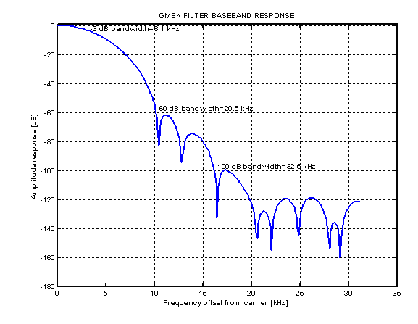
Figure 1.1
Software radio receiver bandwidth

1.1.2 Receiver phase noise
When several radiosondes are on air at the same time, the receiver phase noise is an important factor for channel separation between adjacent radiosondes. Phase noise was measured in the same test as the receiver bandwidth and it is presented in Figure 1.2. Receiver phase noise at 200 kHz from carrier is -76 dBc.
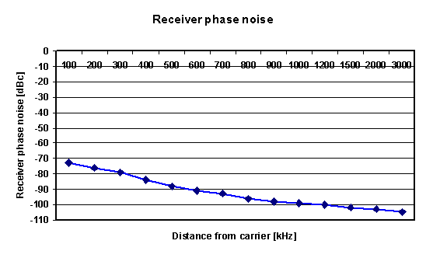
Figure 1.2
Receiver phase noise
The software radio receiver phase noise is 30 dB less than radiosonde phase noise and thus the limiting factors for the minimum channel separation are the radiosonde phase noise between two radiosondes. Table 1.1 concludes the most important specifications of the software radio.
Table 1.1
Software radio receiver specifications
Frequency range | 400-406 MHz
Modulation | GMSK
Sensitivity for an error free transmission  (in the Gaussian channel) | -120 dBm
Receiver phase noise (at 200 kHz) | -76 dBc

1.2 Antennas
There are several receiving antennas available for radiosoundings, depending on the application. The simplest antenna choice is a half-wave dipole antenna, which has an omnidirectional radiation pattern in the horizontal plane. With a directional, remote-controlled, antenna better gain is achieved, but it is large size and also more expensive. In this test an omnidirectional antenna of type Kathrein, and directional antenna RB21 were used. However, a standard sounding configuration with RS92-AGP sonde (Vaisala make) would use RM21 omnidirectional antenna.

1.2.1 Omnidirectional antenna: RM21
The omnidirectional antenna, RM21, is a half-wave dipole (Vaisala make). Like all dipole antennas the vertical radiation pattern has its maximum gain (2.15 dBi) at low elevation angles and minimum in the zenith.
The RM12 antenna consists of also an antenna filter and amplifier, and a 0.5-metre tubular mast for mounting the antenna. The antenna filter is a two-cavity coaxial band-pass filter and it has a centre frequency of 403 MHz. The 1-dB bandwidth is 6 MHz and pass-band attenuation is less than 0.5 dB and out band signal rejection is more than 20 dB. The amplifier has a gain of 15 dB and a noise figure less than 3 dB. The antenna is presented in Figure 1.3.

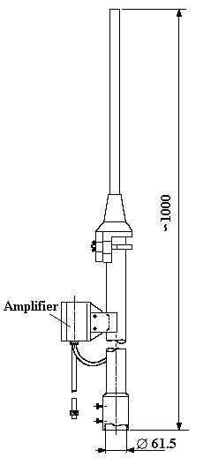
Figure 1.3
Omnidirectional antenna RM21

1.2.2 Omnidirectional antenna: Kathrein
The omnidirectional antenna type Kathrein (Kathrein-Werke KG make). It has slightly narrower radiation pattern in the vertical plane, thus a larger gain of 5 dBi. This antenna and its vertical radiation pattern are presented in Figure 1.4.
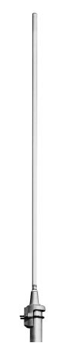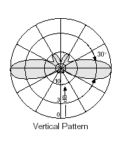
Figure 1.4
Kathrein omnidirectional antenna and its radiation pattern

Directional antenna: RB21
The directional antenna RB21 (Vaisala make) contains six corner reflectors that are interconnected with a diode switch. The receiver controls the switch to select the best element for signal reception. System consists of also a band-pass filter and a low-noise amplifier unit of 20-dB gain for compensation of cable losses. A radome protects the antenna against rain and high winds. The antenna and its radiation pattern is presented in Figure 1.5 and Figure 1.6.
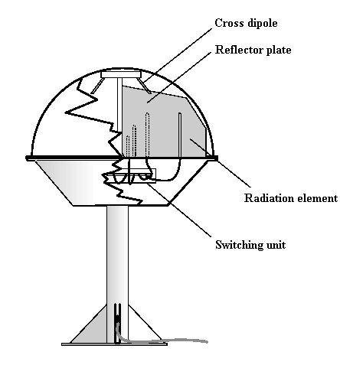
Figure 1.5
Directional antenna RB21
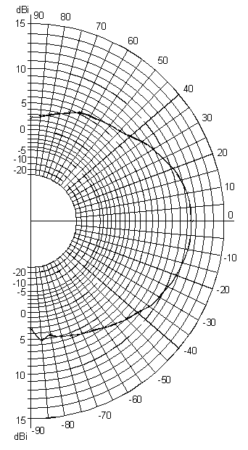
Figure 1.6
Radiation pattern of RB21 (H-plane, 12° angle)
Maximum gain of the antenna is about 11.5 dBi in the horizontal plane. The minimum in vertical plane is -1 dBi. With directional antennas pointing towards the transmitting antenna causes often a little extra loss and it can be estimated to be 3 dB at maximum.

1.3 Radiosonde characteristics
In this test the radiosonde of the type RS92-AGP (Vaisala make) was used. This radiosonde meets the ETSI EN 302054 standard for digital radiosondes. The specific features are the use of an automatic transmission power adjustment and bit error correction code (Reed-Solomon).
The transmission power of the radiosonde while in the ground and close to the receiver is about 0.1 mW and then, when reaching about an altitude of 400 meters the full power of 25 mW is turned on. This is done in order to minimize interference in the ground and to save battery power. This explains the sudden change in the SNR curves, as shown in the attached figures, in the beginning of the sounding.
A method to improve the bit-error rate (BER) performance is to use forward error correction (FEC). Coding adds bits to the data at the transmitter, which are used in the reception for error detection. The RS92-AGP radiosonde uses block coding, more specifically Reed-Solomon coding. The Reed-Solomon codes are widely used in today's digital communications like in compact disks and mobile and satellite communications.
The Reed-Solomon code is specified in the form RS(n, k), where n is the length of the codeword and k is the number of the data symbols. The encoder takes k data symbols of s bits and adds a parity symbol to make a code word of the length n. There are n-k parity symbols of s bits. In general the maximum codeword length can be calculated from n=2^{S}-1. A Reed-Solomon decoder can correct up to t symbols that contains errors in a codeword, where 2t=n-k. The code used in the radiosonde is RS(255, 231) of 8 bits and thus t=12.

2 Link budget
In evaluating system performance, the quantity of greatest interest is the signal-to-noise ratio (SNR). That is because the system design concentrates on the ability to detect the signal, with an acceptable error probability, in the presence of the noise. In a case where the signal is a modulated carrier wave, as in the radiosonde, the average carrier power-to-noise ratio (C/N) is often used. The link budget details the apportionment of transmission and reception sources, noise sources and signal attenuators. Because some of the budget parameters are statistical like the attenuation of the propagation path due to meteorological event and multipath propagation, the link budget is always estimation for the system performance. To get a sufficient power level in the reception, a required transmission power is calculated in the link budget, when the transmission distance, modulation method, desired bit-error rate (BER) and transfer rate (bit/s) are known. On the other hand with a link budget the longest possible transfer distance or some other system parameter can be calculated when the transmit power and the characteristics of the radio link are known.

2.1 Required carrier wave power-to-noise ratio
The worst acceptable BER for data transmission gives the requirements for the signal-to-noise ratio. The error performance depends on the modulation in use and the error performance of GMSK modulation is practically the same as with BPSK modulation. Thus to obtain the BER of 10⁻⁵, the symbol energy-to-noise spectral density rate, 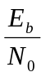, must be at least 9.6 dB on the AWGN channel (Additive White Gaussian Noise). In Figure 2.3 the different types of channels and their error probabilities versus for GMSK modulation are presented.
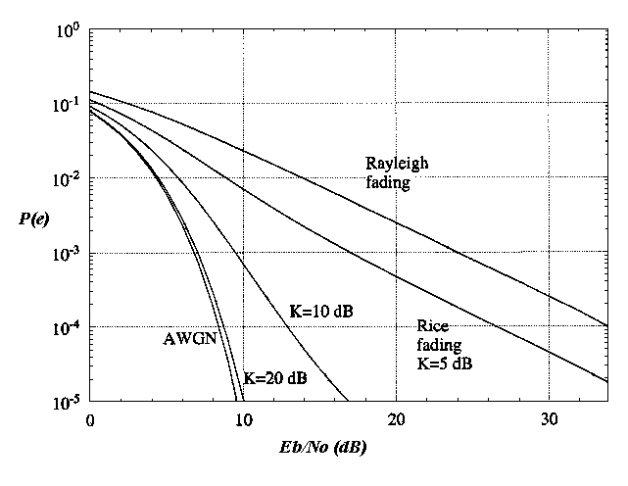
Figure 2.3
Error probability of different types of Rician channels for GMSK modulation
As it can be seen, the required gets higher as the multipath power components gets higher. On the Rayleigh fading channel, the required energy-to-noise spectral density rate is as high as 43 dB. The required carrier power-to-noise ratio in the ideal case can be calculated from the equation

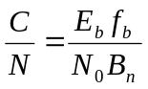, (‎0.)

where f_{b} is the transfer bit rate and B_{n} the noise bandwidth. Previously it has been determined that the bandwidth of the GMSK-signal with B_{b}T=0.5 is 6720 Hz. The bit rate used in transmission is 4800 bit/s. The signal bandwidth (B_{s}), determined by the Gaussian filter of the modulator, is the same as the bit rate, 4800 Hz. In this case the required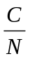-level in decibels is estimated with the following equation:

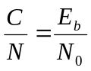(dB) - 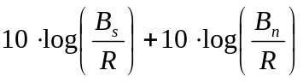 (2.2)

Thus to obtain the desired error probability, -level of 12 dB is needed, if also the Gaussian filter degradation of about 1 dB is taken into consideration. An additional -2 dB must be added to the receiver performance due to the imperfections.

2.1.1 The effect of Reed-Solomon error correction
Reed-Solomon error correction enables to use lower transmit power to obtain the same BER. The RS(255, 231)-code is able to correct 12 errors in each codeword. In each codeword there are 255*8=2040 bits, thus in 10000 bits there are 4.9 codewords, where the Reed-Solomon coding can correct 58.8 bits. Thus the error probability can be 5.9⋅10⁻³ before the error correction to obtain the total error probability of 10⁻⁵. According to Figure 2.3, on the AWGN channel, the Reed-Solomon coding enables the required-level to be 5 dB, thus 4.6 dB lower. Respectively on the Rayleigh fading channel the reduction is as high as 26.8 dB.

2.2 Link budget calculation
The product of the power supplied to the antenna and the antenna gain in a given direction relative to an isotropic antenna (dBi) gives the equivalent isotropically radiated power (EIRP). If the transmit power is 20 mW (equivalent to 13 dBm), the EIRP would be 13 dBm+1.76 dBi = 14.76 dBm. The different magnitudes affecting to the radio link are detailed in Table 2.1. The directional antenna, RB21, is used in the calculations.
The biggest uncertainties in the link budget are in the free space loss and in the transmitter antenna gain. During the ascent the radiosonde is in a constant movement and often the maximum gain of the antenna is not towards the receiver. This is probably seen as rapid changes in the received signal power level. Noise power at the reception can vary also significantly depending on the sounding location. In the link budget calculations are made with the expected minimum noise power and with the noise power estimated to be in a large city area.
Table 2.2
Link budget
Transmit power | 13 dBm (20 mW)
Transmitter antenna gain | 1.76 dBi
Free Space Loss (250 km) | -132.5 dB
Receiver antenna gain | 10 dBi
Antenna pointing error | -3 dB
Received signal power | -110.7 dBm
Noise power at reception | -126.5 dBm (in urban area) | -132.7 dBm (minimum)
Signal-to-Noise ratio | 15.8 dB | 22.0 dB
(MSK) | 14.8 dB | 21.0 dB
Gaussian filter degradation | -1 dB | -1 dB
Receiver imperfection | -2 dB | -2 dB
(GMSK) | 11.8 dB | 18 dB
Required -level (AWGN channel) | 5 dB | 5 dB
Margin | 6.8 dB | 13 dB

3 Soundings
The purpose of the soundings was to measure the signal attenuation in real conditions compared to the free space estimation and estimate the data availability. Also, the signal-to-noise ratio was a subject of interest. The soundings were performed at the meteorological station in Jokioinen, Finland.

3.1 Measurement equipment
RS92-AGP radiosondes were used in the soundings. The newest version of the software radio was used for receiving. One radiosonde was released at a time, and it was received with two different set-ups. One set-up used a directional antenna, type RB21, and the other an omnidirectional antenna, type Kathrein, for receiving. The measurement set-up is presented in Figure 3.4.
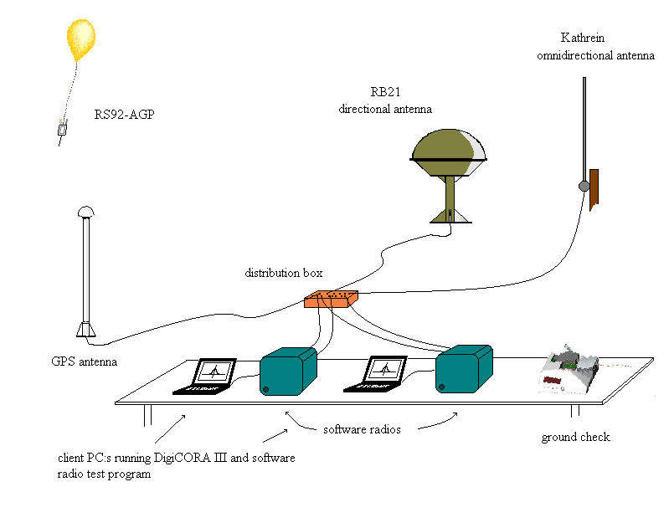
Figure 3.4
Sounding set-up for measurements
The received signal power and the signal-to-noise ratio were measured with the software radio. Both of these magnitudes are measured at the input of the analog-digital converter. This is done with the software radio test program. Its user interface is presented in Figure 3.5.

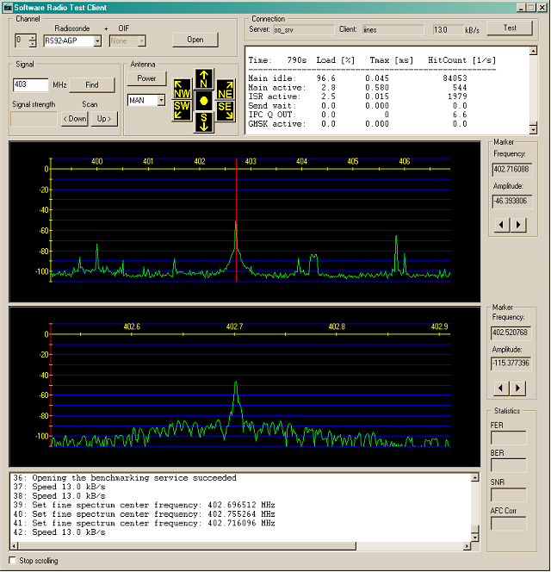
Figure 3.5
User interface of the software radio test program
In the test program, a desired frequency can be chosen and the signal's relative amplitude will be measured among a lot of other magnitudes. The test program can also show, which element RB21 is using for receiving.
The distance of the radiosonde was measured using GPS and it was obtained from DigiCORA III as an addition to the wind speed and direction data.

3.2 Measurement results
Six successful soundings were performed. All of them were received correctly with the omnidirectional antenna. Receiving with directional antenna failed short in three cases due to software software radio test program. In Table 3.3 the exact transmit power of the RS92-AGP radiosonde and the distance at the end of the each sounding are listed.

Table 3.3
Soundings performed
Sounding | Frequency (MHz) | Transmit power (mW) | Transmit power (dBm) | Range (km)
1 | 402 | 20.3 | 13.07 | 194.4
2 | 402 | 22.2 | 13.46 | 143.4
3 | 402 | 21.4 | 13.30 | 108.4
4 | 402 | 20.9 | 13.20 | 131.5
5 | 402 | 22.6 | 13.54 | 365.8 (dir.)  298.3 (omni.)
6 | 405.5 | 19.4 | 12.88 | 272.5
As can be seen, sounding no. 5 was exceptionally long, over 360 km. At this distance, the radiosonde was received only with the directional antenna. With the omnidirectional antenna the signal started to be too weak at about 270 km. Errors though occurred already earlier. The maximum range for good quality data transmission of each sounding is presented in Table 3.4.
Table 3.4
Maximum range for good data transmission
Sounding | Range of good data transmission (omni.) and rejected data frames | Range of good data transmission (dir.) rejected data frames
1 | 194.4 km (N/A) | -
2 | 95.8 km (1.67%) | -
3 | 108.4 km (0.41%) | -
4 | 131.5 km (0.71%) | 131.5 km (0.1 %)
5 | 159 km (1.05%) | 354 km (0.48%)
6 | 270 km (0.48%) | 272.5 km (0.2%)
The results of sounding no. 5 are presented more in detail in Figures 10.3-10.8. The results of the five other soundings are presented in Appendix A. In all figures it should be noted, that the full transmission power is set on automatically only about 300 s after the beginning of the sounding. In Figure 3.6 the received radiosonde signal power with the omnidirectional antenna is presented. It is also compared with the theory of the free space attenuation (red curve). Figure 3.7 presents the received signal power with the directional antenna. In Figure 3.8 the performances of the two antennas are compared.
Signal-to-Noise ratio at the receiver is presented in Figures 10.6-10.8. In Figure 10.8. S/N performances of the two antennas are compared. Below the S/N-curve, the fatal errors in data (data lost) transmission are marked.

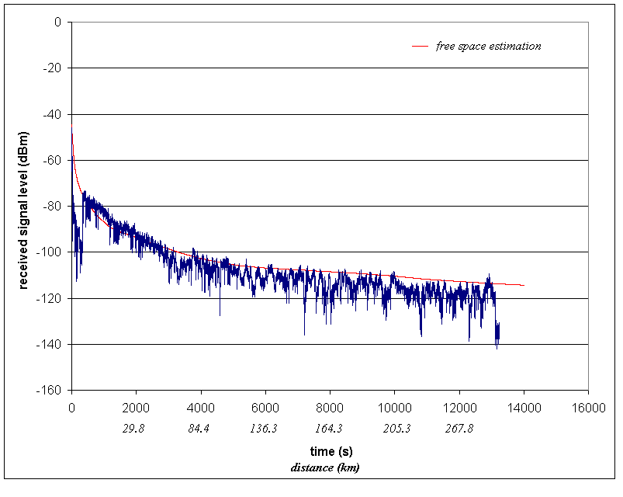
Figure 3.6
Sounding 5, Jokioinen 17.2.2003. Received signal level with Kathrein
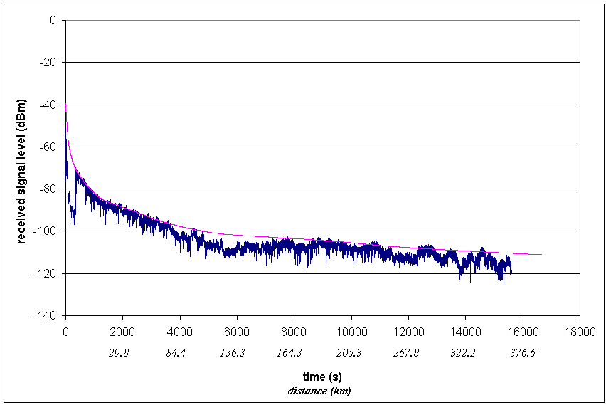
Figure 3.7
Sounding 5, Jokioinen 17.2.2003. Received signal with RB21
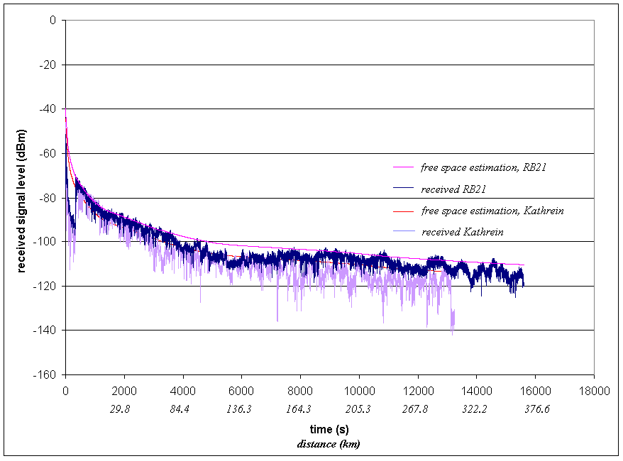
Figure 3.8
Sounding 5, Jokioinen 17.2.2003. Comparison of the received signal of RB21 and Kathrein
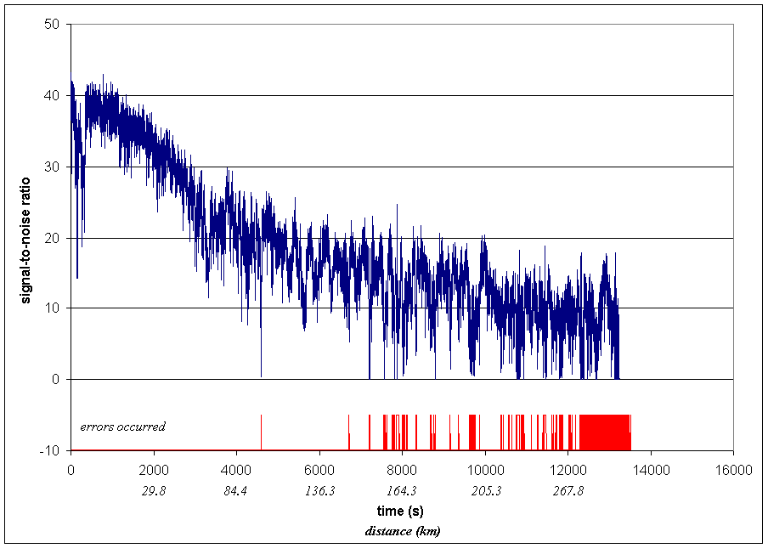
Figure 3.9
Sounding 5, Jokioinen 17.2.2003. S/N at the reception, Kathrein
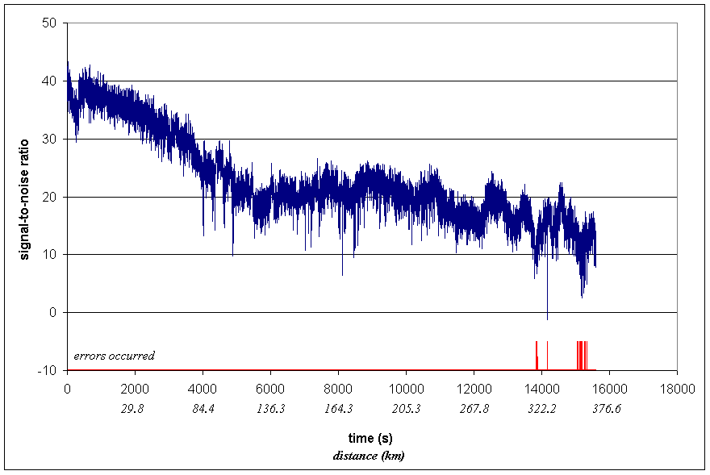
Figure 3.10
Sounding 5, Jokioinen 17.2.2003. Signal-to-Noise ratio at the reception, RB21
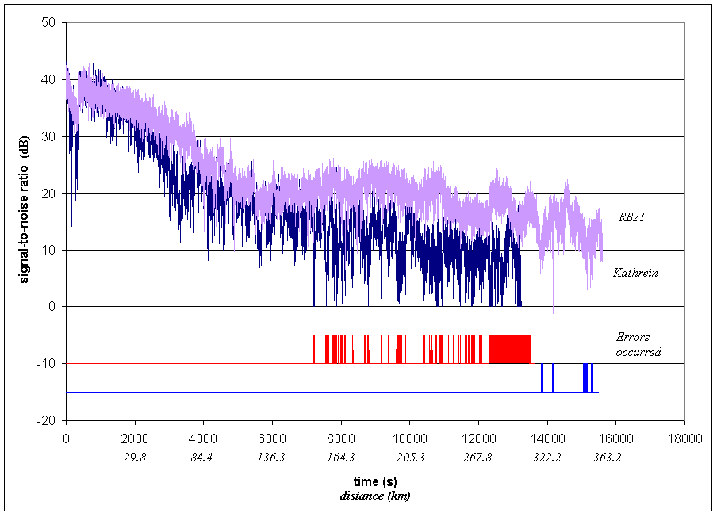
Figure 3.11
Sounding 5, Jokioinen 17.2.2003. Comparison of the signal-to-noise ratio at the reception between RB21 and Kathrein

3.3 Comparison between the results and theory
As was expected, rather large variations in the received signal power level can be noted. It can also be seen that there are more rapid changes with the omnidirectional antenna. This is very probably due to the narrower radiation pattern of the Kathrein antenna, which is more sensitive to the movements of the radiosonde during the ascent.
Multipath fading can cause over 20 dB additional loss. It is difficult to identify the exact reasons for signal level variations, but the multipath fading is the most important. The maximum negative and positive deviations of the received signal strength from the free space attenuation are listed in Table 3.3. The minimum fatal-error-free S/N value is also listed.
Table 3.5
Sounding statistics
Sounding | Max. negative deviation (dBm) |  | Max. positive deviation (dBm) |  | Min. fatal-error-free S/N (dB)
Sounding | Omni. | Dir. | Omni. | Dir. | Omni. | Dir.
1 | 28.1 | - | 6.1 | - | 7.3 | -
2 | 27.5 | - | 2.0 | - | 7.3 | -
3 | 26.3 | - | 4.0 | - | 7.7 | -
4 | 19.5 | 7.5 | 1.3 | 2.2 | 6.9 | 11.8  (no errors)
5 | 15.9 | 12.4 | 6 | 1.6 | 7.3 | 7.3
6 | 10.8 | 7.7 | 1.8 | 0.8 | 7.5 | 7.3
Average | 21.4 | 9.2 | 3.6 | 1.5 | 7.3 | 7.3

4 Conclusions
In this experiment the different phenomena affecting the state-of-art radiosonde radio channel were tested. The performance with an omnidirectional and a directional antennas were compared, too.
The transmitted signal is affected in several ways during the transmission. It is bent, scattered and reflected in the atmosphere. At 400 MHz and within the distances in the radiosonde soundings these phenomena are not very significant. The most important propagation mechanisms of the radiosonde signal are the line-of-sight propagation and multipath propagation. The latter is problematic, because it can cause fading that degrades the performance of the telemetry link. Buildings, hills, forest and other obstacles can cause diffraction and therefore fading through multipath propagation.
The received signal power required by the receiver to obtain the desired performance was estimated theoretically. To obtain a bit-error rate of 10⁻⁵ in the data transmission, the required symbol energy-to-noise level should be at least 5 dB on the AWGN channel. The biggest uncertainties in the link budget calculations are related to the noise power in the sounding location and the propagation loss of the transmitted signal.
Six sounding were performed in the meteorological station in Jokioinen. According to the results, the telemetry link worked very well with the directional antenna supporting the claim for 250 km performance with high data availability. With the omnidirectional antenna the performance was rather variable, but the claim for reasonable performance up to 150 km is feasible. One sounding was very well received until 270 km, but on the other hand some soundings had several telemetry breaks already at much shorter distances. Thus, it seems that the good telemetry range can not be guaranteed for the distances of over 150 km with the omnidirectional antenna configuration used in the test. The variations compared to the free space loss were between +6.1...-28.1 dB with the omnidirectional antenna and +2.2...-12.4 dB with the directional antenna.
In two long soundings the telemetry performance is much better in the sounding no. 6 than it is in sounding no. 5. In both soundings the flying direction at the end was rather similar; 9.3° from south to east in sounding 5 and respectively 5.6° in sounding 6. The probable reason for worse performance in the other sounding is the different multipath characteristics in these directions.
Appendix A.2 : Sounding results
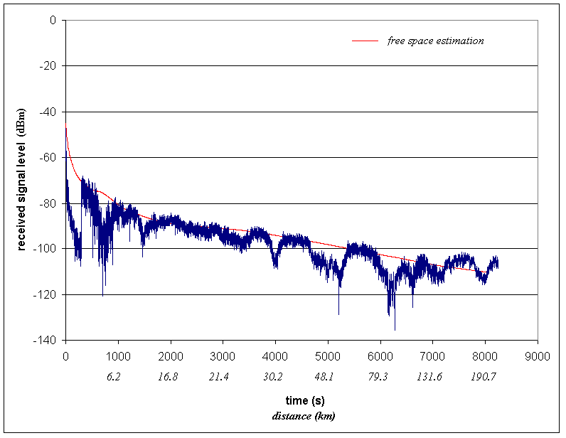
Figure A.12
Sounding 1. Received signal power, Kathrein
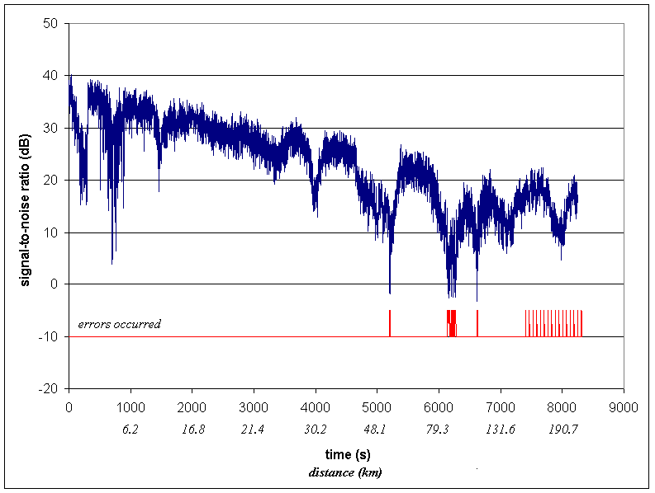
Figure A.13
Sounding 1. S/N, Kathrein
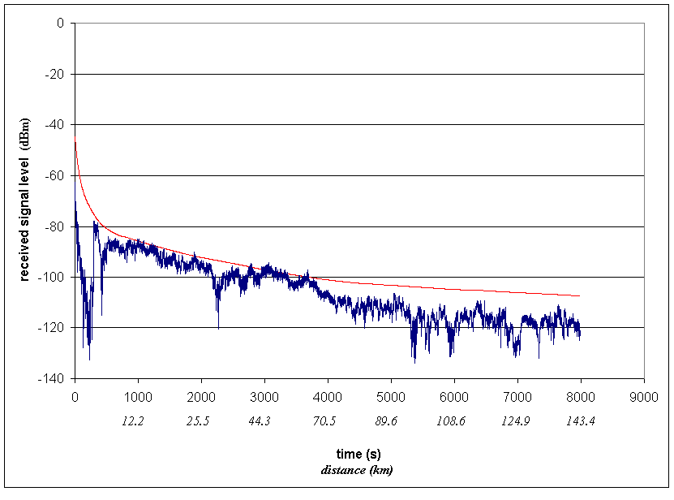
Figure A.14
Sounding 2. Received signal power, Kathrein
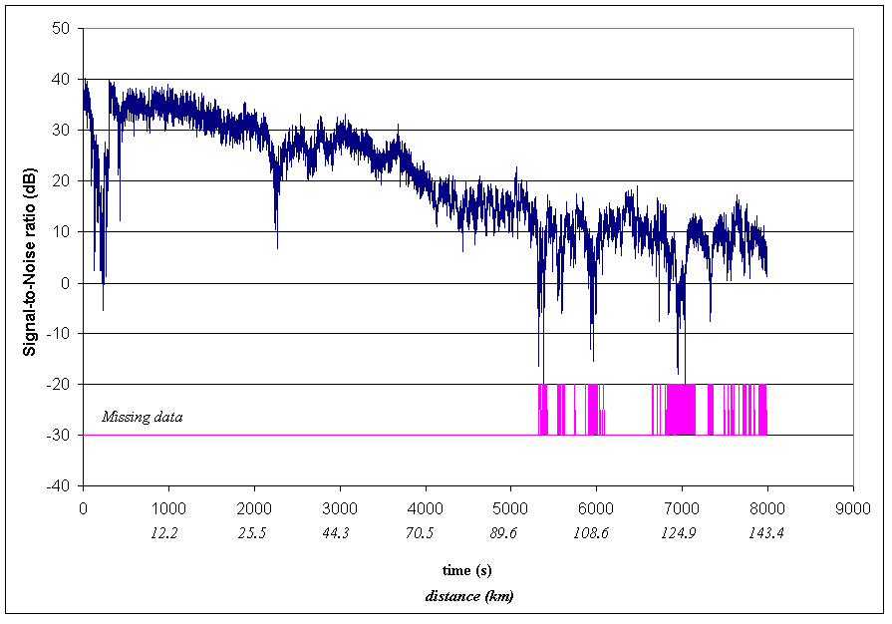
Figure A.15
Sounding 2. S/N, Kathrein
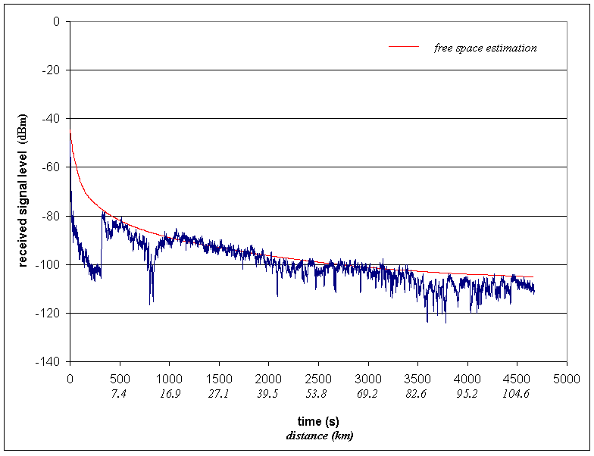
Figure A.16
Sounding 3. Received signal power, Kathrein
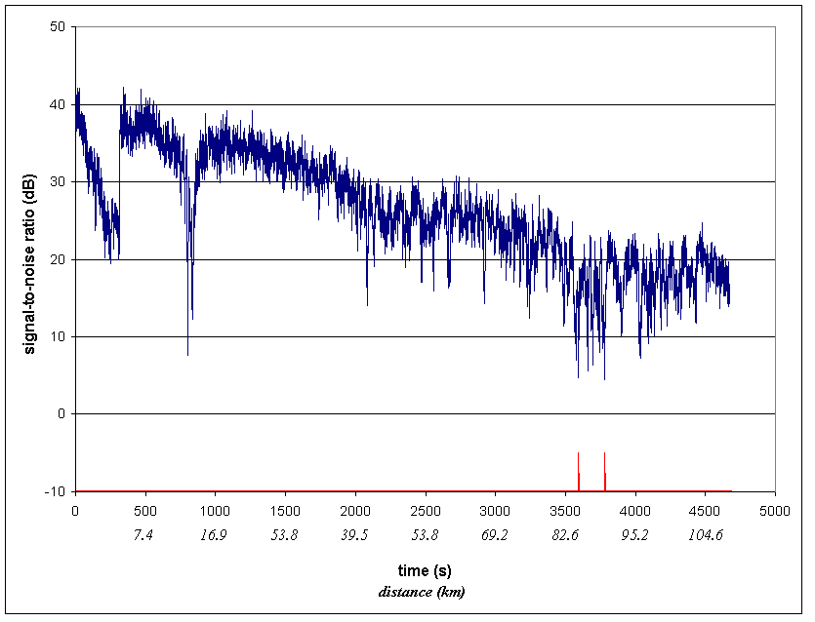
Figure A.17
Sounding 3. S/N, Kathrein
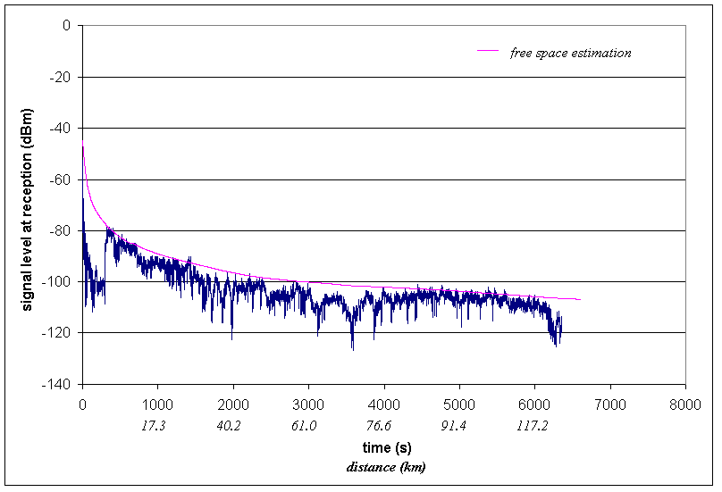
Figure A.18
Sounding 4. Received signal power, Kathrein
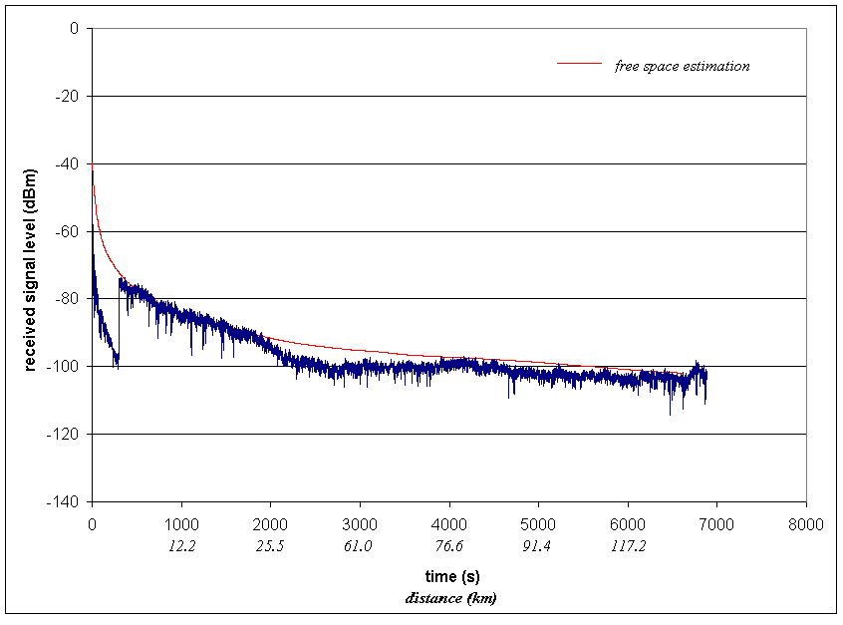
Figure A.19
Sounding 4. Received signal power, RB21
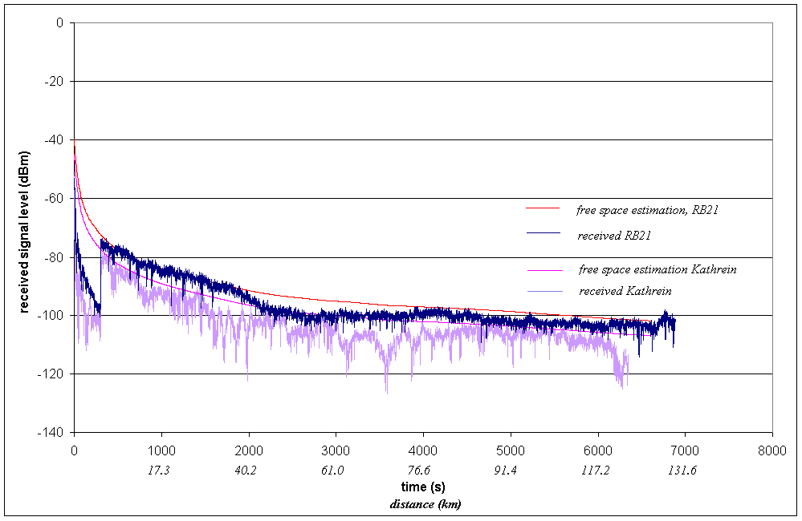
Figure A.20
Sounding 4. Received signal power comparison
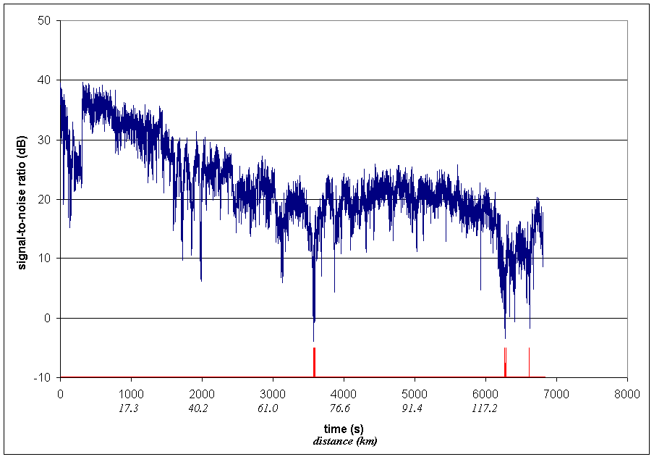
Figure A.21
Sounding 4. S/N, Kathrein
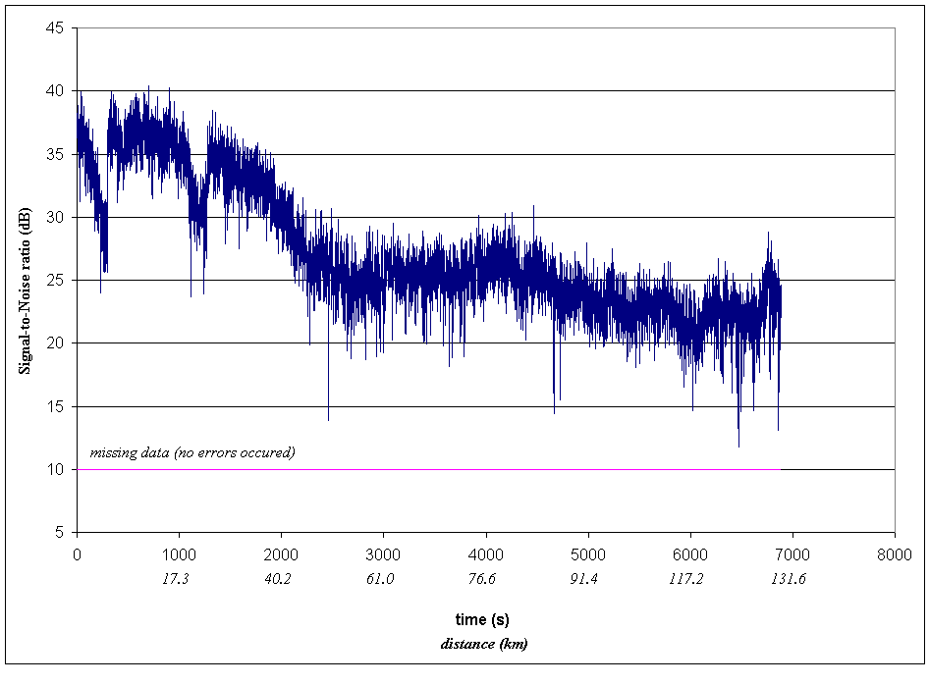
Figure A.22
Sounding 4. S/N, RB21
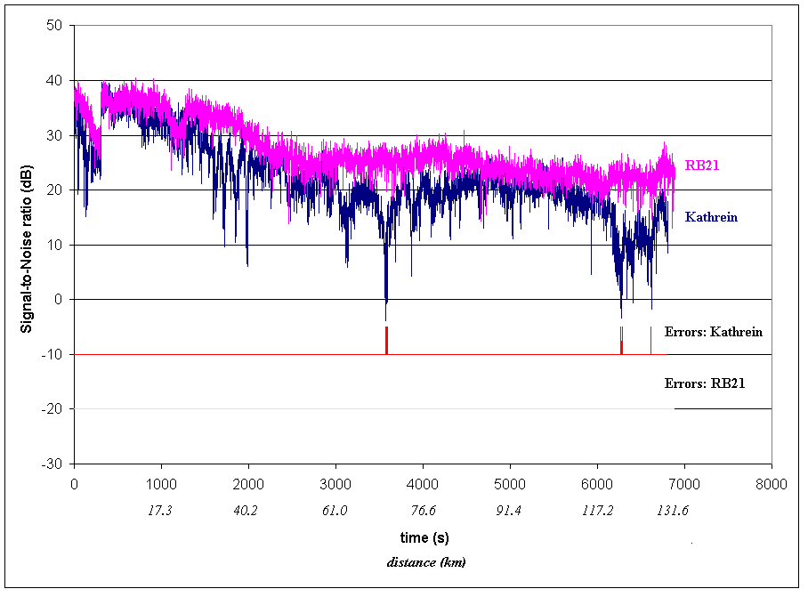
Figure A.23
Sounding 4. S/N-comparison
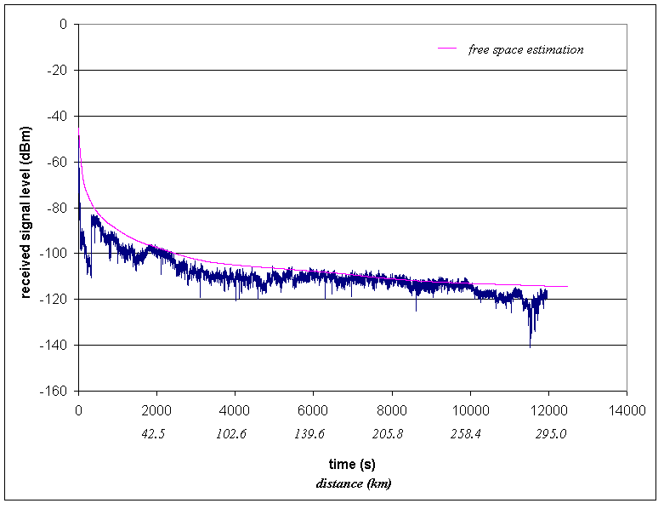
Figure A.24
Sounding 6. Received signal power, Kathrein
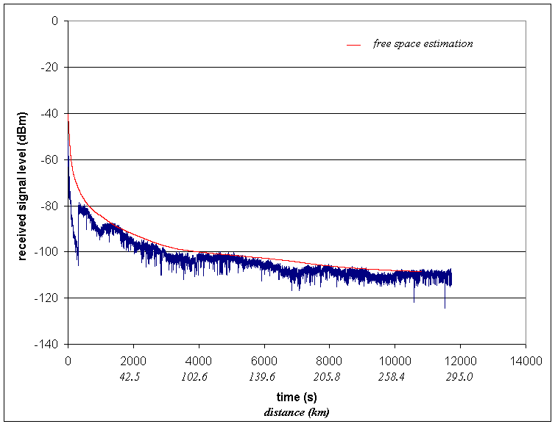
Figure A.25
Sounding 6. Received signal power, RB21
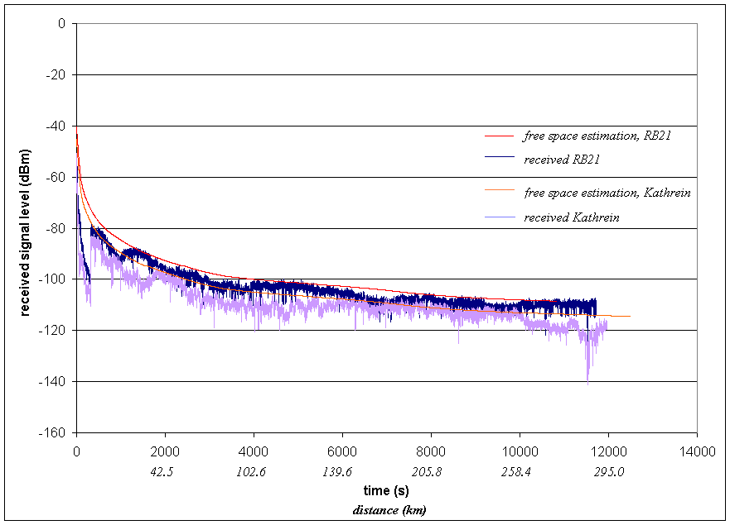
Figure A.26
Sounding 6. Received signal power comparison
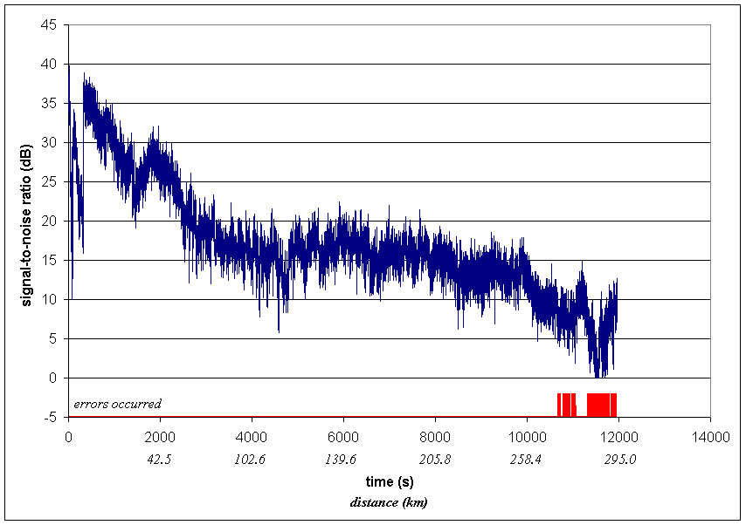
Figure A.27
Sounging 6. S/N, Kathrein
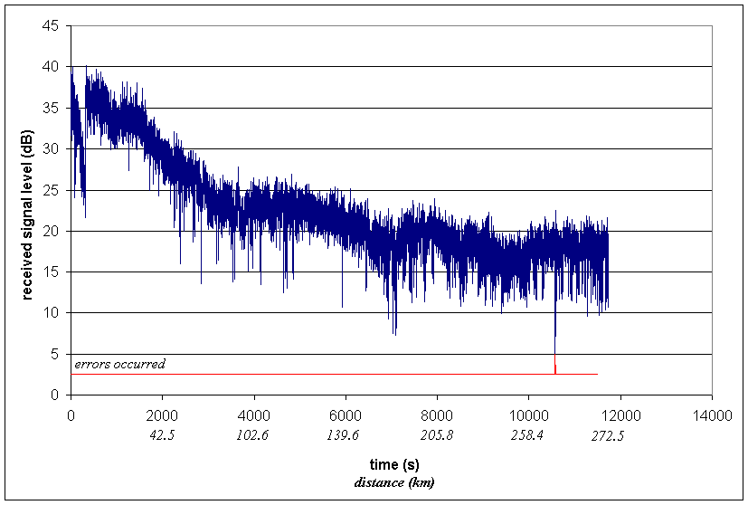
Figure A.28
Sounding 6. S/N, RB21
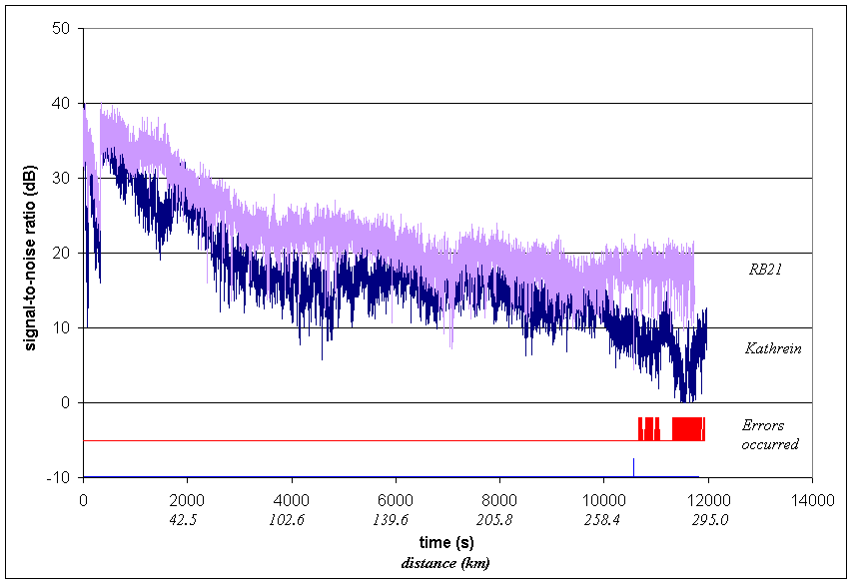
Figure A.29
Sounding 6. S/N-comparison
_________

