WORLD METEOROLOGICAL ORGANIZATION  _____________  COMMISSION FOR BASIC SYSTEMS  STEERING GROUP ON RADIO FREQUENCY COORDINATION  PERROS GUIREC, FRANCE  13-14 SEPTEMBER 2004 |  | CBS/SG-RFC 2002/Doc. 2.2(2)  _______  ITEM 2.2  ENGLISH only

U.S. Contributions to Working Party 7C on Sharing of the Band 1668.4-1700 MHz between the Co-primary Metaids Service, Metsat Service and MSS.
(Submitted By David Franc, National Weather Service, USA)

Summary and Purpose of Document

The United States plans to submit the three attached documents (Annexes 1-3) to the September ITU Working Party 7C meeting. The three attached documents follow-up on agreements made at the last Working Party 7C meeting to replace obsolete Recommendations SA.1158 and SA.1264 with a single recommendation that addresses sharing between the three co-primary services (metaids, metsat and MSS) in the band 1668.4 –1700 MHz. One document (Annex 1) is the proposed new PDNR from the United States. The other two documents (Annexes 2 and 3) are proposed ITU-R reports based on technical information taken from SA.1158 and other old ITU-R studies to support the conclusions of the proposed PDNR.
This document is also being submitted to SFCG-24 for consideration by meteorological interests that may not be present at this meeting or the Working Party 7C meeting.

Action Proposed
This document is for information to the SG-RFC.
Introduction-
The 2003 World Radiocommunication Conference (WRC-2003), after approximately 10 years of study, created a mobile-satellite service (MSS) allocation in the band 1668-1675 MHz. This allocation is co-primary with the meteorological aids (metaids) service in 1668.4 –1675 MHz and the meteorological satellite (metsat) service in 1670 –1675 MHz. ITU-R studies show that the MSS cannot operate on a co-frequency basis with the metaids or metsat services in the same geographic region. To summarize the results of the studies conducted within the ITU-R Recommendations SA.1158 and SA. 1264 were developed prior to WRC-2003 on sharing between the MSS and metsat service and between the MSS and metaids service respectively.

Sharing problems also exist between the metsat and metaids services within the band 1670-1700 MHz, where the two services are co-primary. Operational experience has shown that metaids cannot operate co-frequency with metsat downlinks in the same geographic region without interference to the metsat earth stations. As the need increases for additional metsat downlink bandwidth the interference problems become worse. For example, within the United States, metaids used to operate within 1675-1690 MHz. With the implementation of the GOES Variable (GVAR) downlink, metaids operations within 1683-1690 MHz must now be avoided. Sharing problems between the metaids and metsat services could become more problematic with the introduction of the MSS in 1668-1675 MHz and the need to expand metsat downlink bandwidths to accommodate greater sensor resolutions.

Review of the recommendations SA.1158 and SA.1264 indicates they were obsoleted due by the decisions of WRC-2003. In addition, no ITU-R recommendation exists addressing the sharing problems between the metaids and metsat services, though some studies were conducted prior to WRC-2000. The U.S. plans to submit three contributions, in the form of a Preliminary Draft New Recommendation (PDNR) and two ITU-R Reports, to the September ITU Working Party 7C meeting. The PDNR is intended to replace the existing recommendations SA.1158 and SA.1264 with a single recommendation that addresses sharing the band 1668.4-1700 MHz between the MSS, metaids and metsat services, taking into account the decisions of WRC-2003. The two reports are supporting technical information on sharing between the MSS and metsat service (based on the annexes of SA.1158), and the metaids and metsat service (based on studies considered within the ITU-R prior to WRC-2000). The PDNR, combined with the two supporting reports, is intended to provide all the information necessary for administrations to plan the use of the band 1668.4 –1700 MHz by the metaids service, metsat service and MSS. A third report would be useful to address the sharing between the MSS and metaids. However little historical information is available on those studies.

These documents are brought to the attention of the SG-RFC so the issues can be considered in preparation for the upcoming Working Party 7C meeting, and potential problems or alternate methods of resolving the issues can be discussed. These documents have not yet cleared the formal U.S. approval process, so minor changes could be made before submission to the ITU. Discussions prior to Working Party 7C will allow the meteorological users to develop a position and strategy to best protect meteorological operations before the MSS becomes part of the discussion. Annex 1 is the proposed PDNR. Annexes 2 and 3 contain the two proposed reports.
ANNEX 1-

PRELIMINARY DRAFT NEW RECOMMENDATION ITU-R SA.
[SHARING 1.7 GHz]

Frequency sharing between the meteorological aids
service, meteorological satellite service (space-to-Earth) and the mobile-satellite service (Earth-to-space) within the frequency range 1 668.4-1 700 MHz

The ITU-R had developed several recommendations addressing sharing between the Mobile-Satellite Service (MSS) and the Meteorological Aids (MetAids) and Meteorological Satellite (MetSat) services in preparation for WRC-2003 and previous WRCs. WRC-2003, based on information contained in those recommendations created an MSS allocation in 1668 – 1675 MHz, ending at least 11 years of technical work on sharing between the services. Now that WRC-2003 has taken the action to create the MSS allocation, ITU-R recommendations SA. 1264 and SA.1158 are obsolete. Due to the action of WRC-2003, a three-way sharing situation exists in the band 1668.4-1700 MHz. This PDNR is intended to replace the obsolete recommendations and address the particulars of segmenting the band and using exclusion zones to facilitate sharing between the MetAids Service, the MetSat service and the MSS. This PDNR is intended to provide guidance to administrations on the most efficient use of the band 1668.4-1700 MHz to ensure adequate access by all three services. This PDNR should be sent to WP 7B and 8D for coordination.
PRELIMINARY DRAFT NEW RECOMMENDATION ITU-R
SA.[SHARING 1.7 GHz] *
Frequency sharing between the meteorological aids
service, meteorological satellite service (space-to-Earth) and the mobile-satellite service (Earth-to-space) in the 1 668.4-1 700 MHz band
(2004)

The ITU Radiocommunication Assembly,

considering
a) that the meteorological aids (MetAids) service has a primary allocation in 1 668.4-1 700 MHz, the meteorological satellite (MetSat) service has a primary allocation in 1 670-1 710 MHz, and the mobile–satellite service (MSS) has a primary allocation in 1 668-1 675 MHz;
b) that in order to avoid interference operational experience and ITU-R studies have shown to exist between MetAids transmitters and MetSat earth stations, segmentation of the band 1670-1700 MHz has been implemented by many administrations;
c) that studies in support of the creation of the MSS allocation in 1668-1675 MHz (WRC-2003) indicate that segmentation of the band or geographic separation are the two methods to provide the MSS spectrum in this frequency range;
d) that the MetAids ground stations and MetSat earth stations and MSS earth stations can be fixed, mobile or transportable;
e) that there exist hundreds of MetAids receiving stations and that, moreover, additional similar stations, increasing spectrum usage, are foreseen in the future in the 1 668.4-1 700 MHz range (see Recommendation ITU-R SA.1165);
f) that MetAids operations which operate in the 1 668.4-1 700 MHz MetAids allocation using currently available Metaids transmitters can be accommodated within 8 MHz of spectrum with exception of stations operated by administrations identified in 5.379E;
g) that MetSat and MSS networks may include GSO or non-GSO satellites;
h) that MSS mobile earth stations (MES) could potentially transmit near a MetAids receiving station or MetSat earth station;
j) that MESs in the proximity of a MetAids or MetSat receiver will cause unacceptable levels of interference into the MetAids or MetSat receiver;
k) that in countries where MetAids stations are present in large numbers, mobile, and/or unregistered, establishment of exclusion zones around MetAids receivers is not practical;
m) that MetSat operators have agreed to separate the band 1 670-1 710 MHz into four sub-bands which are being used and are expected to continue to be used as follows:
1 670-1 683 MHz: main earth stations at fixed locations for reception of raw image data, data collection data and spacecraft telemetry from GSO meteorological satellites;
1 683-1 690 MHz: main earth stations at fixed locations for reception of raw image data, data collection and spacecraft telemetry from GSO meteorological satellites; user stations for direct readout from GSO meteorological satellites (GVAR and S-VISSR) (see Note 1);
1 690-1 698 MHz: user stations for direct readout services from GSO meteorological satellites;
1 698-1 710 MHz: user stations for direct readout services and prerecorded image data at main earth stations from non-GSO meteorological satellites;
p) that the portion 1 670-1 675 MHz of the band is used by very few main MetSat earth stations, but protection of these main stations is critical to meteorological operations;
q) that there exist thousands of MetSat earth stations in the 1683-1690 MHz and 1 690-1 710 MHz bands, many of them using small aperture antennas;
recognizing
1 that radiosondes are consumable equipment and therefore their cost is of critical importance. Hence significant increase of their cost may have an adverse impact on meteorological operations;
3 that implementation of Metaids transmitters with greater spectrum efficiency occurs as the improvements become cost effective for Metaids manufacturers and operators,
4 that the use of the band 1 668.4-1 700 MHz for MetAids operations varies worldwide and is dependent on regional MetSat operations, meteorological requirements, and national spectrum plans,
5 that synoptic data collected by these MetAids stations benefit all member administrations of the WMO World Weather Watch;
6 that prior to the WRC-2003 decision to create an MSS allocation, MetAids operations had been concentrated in 1 675-1 683 MHz in the majority of the world,

noting
a) that many administrations are not operating MetAids systems in the band 1 668.4-1 675 MHz as a result of frequency sharing constraints with other services allocated in the 1 668.4-1 675 MHz band including the radio astronomy service in the band 1 668.4-1 670 MHz;
b) that most administrations avoid MetAids frequency sharing problems with meteorological-satellite earth station receivers by operating radiosondes at frequencies between 1 675 and 1 683 MHz;
c) that sharing between the MSS and Metaids service in 1 675-1 683 MHz is not feasible (see ITU-R Report [TBD]);
d) that enhancements to MetAids equipment to improve spectrum efficiency are technically feasible, but may take years to implement and the budgetary resources to perform such enhancements may not be readily available worldwide;
e) that a few administrations as identified in 5.379E with large national MetAids networks plan to continue to use the sub-band 1 670-1 683 MHz for national MetAids operations for the foreseeable future,
recommends
1 that the band 1 668.4-1 700 MHz be segmented in the following manner in order to achieve compatibility between the MetAids service, MetSat service and MSS:
1 668.4-1 675 MHz: exclusive use by networks operating in the MSS, with the exception of metaids stations operated by administrations identified in 5.379E and MetSat main earth stations operating under 5.380A (Res. 670 (WRC-2003));
1 675-1 683 MHz: exclusive use by the MetAids service worldwide and MetSat main earth stations operating under 5.380A (Res 670(WRC-2003));
1 683-1 690 MHz: exclusive use by the MetSat service for data user stations, with exception of portions of Europe where 1683-1690 MHz is not used by the MetSat service, and is available for use by the MetAids service;
1 690-1 700 MHz: exclusive use by MetSat service for data user stations;
2 that efficient spectrum management techniques should be implemented for MetAids systems to minimize the spectrum needed for MetAids systems in the 1 668.4-1 700 MHz band so that the band 1 668.4 –1 675 MHz may be made universally available for accommodation of MSS (Earth-to-space) networks and interference to MetSat earth stations may be avoided in the band 1 683-1 700 MHz;
3 that all administrations, including those listed in 5.379E, should strive to implement MetAids systems that limit their operations in 1 675-1 683 MHz;
4 that MetSat operators should explore the use of more advanced modulation schemes and the use of other bands rather than expanding operations into bands used by the MetAids service and MSS.

ANNEX 2-
Proposed Conversion of the Annexes 1, 3, and 4 of ITU-R Recommendation SA.1158 to an ITU-R Report

The ITU-R had developed several recommendations addressing sharing between the Mobile-Satellite Service (MSS) and the Meteorological Aids (MetAids) (ITU-R SA.1264) and Meteorological Satellite (MetSat) (ITU-R SA.1158) services in preparation for WRC-2003 and previous WRCs. WRC-2003, based on information contained in these recommendations created an MSS allocation in 1668 – 1675 MHz, ending at least 11 years of technical work on sharing between the services. Now that WRC-2003 has taken the action to create the MSS allocation, ITU-R recommendations SA. 1264 and SA.1158 are obsolete. At the Spring 2004 meeting of Working Party 7C it was agreed that a new recommendation would be created to address the sharing of the band 1668.4-1700 where all three services are co-primary. That PDNR is contained in a separate US contribution. Since extensive work was completed that led to the conclusions on sharing, this document proposes to extract the technical work from SA.1158 and reproduce the work that led to the development of SA.1264, which are both proposed to be suppressed. The technical information will be used to create an ITU-R report so this extensive study work may be retained for future reference. This proposed ITU-R report will provide a detailed reference for the reader of the new PDNR to assist in understanding the complexities of sharing the band.
This document creates a portion (sections 1-4) of the text for the report by editing the existing Annex text in ITU-R SA. 1158. This approach is taken to assist the Secretariat by minimizing the amount of translation that would be required if the text were shown simply as a new document. Study Group 7 will still need to propose the suppression of SA.1158 at the next Radiocommunication Assembly. The deletion of text in this proposal does not properly address suppression of the recommendation. Section 5 is information regretted from studies submitted to the ITU-R prior to WRC-2003. This text lead to the conclusions the drove the WRC-2003 decision and is valuable for the reader to understand the decisions and the complexities of sharing between the three services.
This document should be coordinated with Working Parties 7B and 8D.

Proposed Draft New ITU-R Report: Feasibility of Sharing Between The Meteorological Satellite (MetSat) Service and the Mobile-Satellite Service (MSS) in 1 670-1710 MHz

1 Introduction

2 Sharing analysis between the MetSat service and the MSS in the frequency bands 1 670-1 675 MHz and 1 683-1 690 MHz
The ITU-R conducted an extensive series of studies regarding the potential sharing situation between the MSS and the MetSat service in the band 1 683-1 690 MHz or in the vicinity of this band. The band 1 683-1 690 MHz is mainly used by three different types of meteorological earth stations. While there are only a limited number of main MetSat earth stations deployed in all three ITU Regions, there are a large number of data user meteorological earth stations operated in Regions 2 and 3 and the locations of many of these stations are unknown. Some of them are also mobile (on ships and trucks) or transportable. During WRC-2000, it was also acknowledged that there is an increase in use of these stations in Regions 2 and 3 and that potential MSS operation should not constrain current and future development of the MetSat service.
Regarding meteorological earth stations, main stations with antenna diameters up to 15 m as well as data user stations such as GVAR and S-VISSR are operating in the band 1 683-1 690 MHz. Only a limited number of main stations operate in the band 1 670-1 675 MHz. Sharing and interference criteria for space-to-Earth data transmission systems in the Earth exploration-satellite and MestSat services have been established in a number of ITU-R Recommendations. RR Appendix 7 and Recommendation ITU-R SA.1160 were used for reference.
Recommendation ITU-R M.1184 provides information on mobile-satellite system characteristics that were used in sharing studies with other primary services in the range 1-3 GHz. As the interference to the MetSat stations is primarily determined by the amount of energy radiated towards the horizon and the troposphere, some degree of antenna discrimination will occur. Unless the MSS terminal actually operates at low elevation angles, the overall effect will be very similar to the systems using omnidirectional antennas. It has therefore been assumed that the mobile terminals operate in a way which results in very low gain, around 0 dBi, towards the horizon.
In view of the enormous differences that can arise from considering best and worst cases, it was agreed between the relevant Radiocommunication Working Parties to use MSS, MetSat and shielding characteristics which disregard best and worst cases but consider a more representative typical sharing situation with some deviations to favourable and unfavourable sharing situations.
The required separation distances are to a significant extent a function of the elevation angle and terrain shielding. The elevation angle ranges between 3° and 90° for stations receiving data from GSO satellites. Main stations will not operate at elevation angles of less than 5°. Shielding for main stations is in general quite good because of typical deployment in remote locations. However, user stations are often deployed on top of buildings with an unobstructed view of the surroundings.

2.1 System characteristics assumed for the analyses
The characteristics shown in Table 1 have been adopted to represent a range of MSS and MetSat systems. The parameter values have been chosen to represent favourable, typical and unfavourable sharing conditions, and do not necessarily represent the best-case or worst-case conditions.
TABLE 1
System parameters used in sharing studies between the MetSat service and the MSS
 | Favourable  sharing case | Typical sharing, Case 1 | Typical sharing, Case 2 | Unfavourable  sharing case
MSS characteristics
Maximum e.i.r.p. per channel (dBW) | 3.5 | 21 | 17 | 10.9
Maximum antenna gain (dBi) | 0 | 16.5 | 10 | Not applicable
Channel data rate (kbit/s) | 23.4 | 732 | 5.6 | 4.5
Allocated bandwidth (channel spacing) (kHz) | 31.24 | 200 | 12.5 | 6
Average antenna gain towards horizon (dBi) | 1 | 0 | 0 | 0
Average e.i.r.p. towards horizon (dBW) | 3.5 | 4.5 | 7 | 6.9
Average e.i.r.p. density towards horizon (dB(W/4 kHz)) | –5.4 | –12.5 | 2.1 | 5.1
Antenna height of MES above ground level (m) | 2 | 2 | 2 | 10
TABLE 1 (end)
 | Favourable  sharing case | Typical sharing, Case 1 | Typical sharing, Case 2 | Unfavourable  sharing case
MSS characteristics (Cont.)
Average obstacle height in vicinity of MES (m) | 90 | 50 | 50 | 10
Distance of obstacle to MES (km) | 10 | 10 | 10 | 5
Satellite beamwidth (degrees) | 0.7 | 1.5 | 7 | 2
Percentage of transmitting MES (%) | 60 | 75 | 75 | 90
Polarization discrimination (dB) | 3 | 3 | 3 | 3
MetSat characteristics for main stations
Antenna diameter (m) | 15 | 15 |  | 15
Antenna centre height above ground level (m) | 15 | 20 |  | 25
Minimum antenna elevation angle (degrees) | 20 | 15 |  | 10
Permissible long-term interference level (20%) (dB(W/4 kHz)) | –182 | –182 |  | –182
Permissible short-term interference level (dB(W/4 kHz)) | –178 | –178 |  | –178
Percentage of time for short-term interference⁽¹⁾ (%) | 0.011 | 0.011 |  | 0.011
Receiver bandwidth (kHz) | 5 200 | 5 200 |  | 30
Obstacle height in vicinity of main station (m) | 200 | 150 |  | 25
Distance of obstacle to main station (km) | 10 | 10 |  | 10
Typical radio climatic zone for main station | A2 | A2 |  | A1
MetSat characteristics for user stations
Antenna diameter (m) | 3.6 | 3.6 |  | 3.6
Antenna centre height above ground level (m) | 5 | 25 |  | 50
Minimum antenna elevation angle (degrees) | 20 | 15 |  | 5
Permissible long-term interference level (dB(W/4 kHz)) | –180 | –180 |  | –180
Permissible short-term interference level (dB(W/4 kHz)) | –175.3 | –175.3 |  | –175.3
Percentage of time for interference (%) | 0.025 | 0.025 |  | 0.025
Receiver bandwidth (kHz) | 6 000 | 4 200 |  | 4 200
Obstacle height in vicinity of user station (m) | 50 | 25 |  | 0
Distance of obstacle to user station (km) | 10 | 10 |  | Not applicable
Typical radio climatic zone for user station | A2 | A1 |  | A1
⁽¹⁾ This percentage applies to the aggregate interference from all MES.
Combinations of the above system assumptions should be considered. For studies addressing adjacent band interference, Recommendation ITU-R SA.1160 was taken into account regarding protection criteria for small user stations with antenna diameters between 1.2 and 2.4 m. For out-of-band emissions of MES terminals, Recommendation ITU-R M.1480 was used.

2.2 Analysis methodology

2.2.1 MES density
This section presents an analysis where, based on system parameters, a number of operating MESs are considered. Therefore, the MES distribution and density must be calculated for each of the sharing cases. The first step in the analysis is to determine the size of the spot beam projected on the Earth's surface. For simplicity, it will be assumed that the spot beam centreline is perpendicular to the Earth's surface and the surface area within the spot beam is approximately flat. Adjacent spot beams will overlap. To further simplify the analysis, the area of each spot beam will be converted to a regular hexagon. This can be done since either spot beam can service an MES within the overlap area (refer to Fig. 1). For the MES density calculation, the overlap areas may be divided evenly between the overlapping beams.

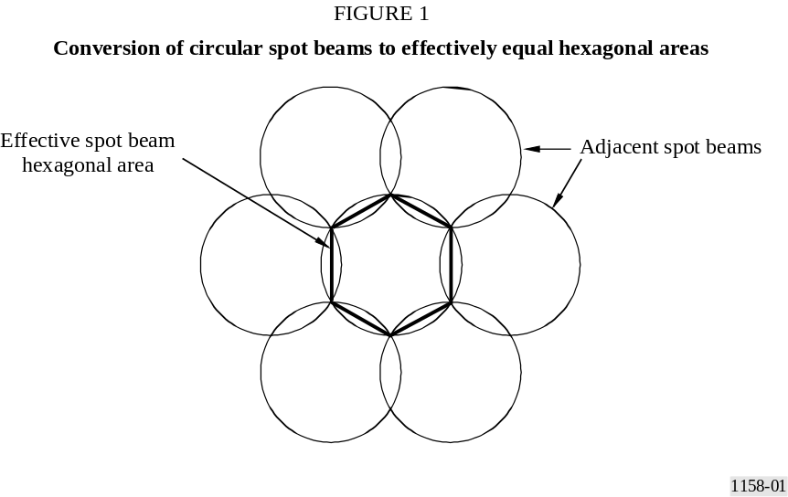

The area of the hexagon is given by:
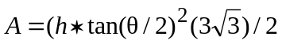
where:
h : GSO altitude (km)
: spot beamwidth (degrees).
TABLE 2
Effective square area of spot beams on Earth’s surface for cases listed in Table 1
Sharing case | Spot beam width (degrees) | Effective area  (km²) | Frequency reuse factor
Favourable Case | 0.7 | 1.25 × 10⁵ | 7
Typical Case 1 | 7.0 | 1.25 × 10⁷ | 2
Typical Case 2 | 1.5 | 5.77 × 10⁵ | 7
Unfavourable Case | 2.0 | 1.03 × 10⁶ | 7
The next step is to determine the MES density within the service area under consideration (analysis area). Since the spot beams are smaller or nearly equal to the exclusion zone sizes, the required analysis area is larger than the spot beam footprints. All three sharing cases defined in Table 1 provide the receive antenna beamwidth (satellite beamwidth), the channel spacing (allocated bandwidth) and the system loading factor (percentage of transmitting MES). From these values the transmitting MES density can be calculated. The transmitting MES density can then be used to determine the number of transmitting MES within a chosen analysis area.
The maximum number of available channels for MES that can be co-channel with the MetSat station is calculated by dividing the channel spacing into the MetSat Station bandwidth. Since channels cannot be easily reused between adjacent spot beams, the assumption was made that spot beams reusing channels must be separated by at least one spot beam. Analysis was conducted using a frequency reuse factor of 7.
One further consideration is that each sharing case has a load factor specified. Therefore, the total number of available channels per spot beam should be reduced by the load factor to provide the actual number of MES operating at any time within a spot beam.
The number of operating MESs using frequencies within a single spot beam can be calculated from:
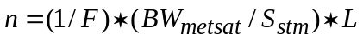
where:
F : frequency reuse factor
n : number of transmitting MESs per spot beam
BW_{metsat} : bandwidth of the MetSat receiver
S_{mes} : MES channel spacing
L : MSS system load factor.
The transmitting MES average density is calculated by dividing the number of transmitting MES per spot beam by the spot beam area:
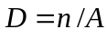
where:
D : transmitting MES density (MES/km²)
n : number of transmitting MES per spot beam
A : area of spot beam (effective square) (km²).
TABLE 3
Transmitting MES density for cases listed in Table 1
MSS system | Number of transmitting MES: n  (favourable-typical-unfavourable  main station) | Average transmitting MES density: D  (MES/10⁶ km²) | Number of transmitting MES: n  (favourable-typical-unfavourable  user station) | Average transmitting MES density: D  (MES/10⁶ km²)
MSS favourable | 14.3/17.8/0.12 | 114/142/9.83 | 16.5/14.4/17.3 | 131/115/138
MSS typical 1 | 2.23/2.79/0.02 | 3.86/4.83/0.033 | 2.57/2.25/2.7 | 4.46/3.9/4.68
MSS typical 2 | 125/156/1.08 | 9.91/12.4/0.08 | 144/126/151 | 11.4/10/12
MSS unfavourable | 74/93/0.64 | 72/91/109 | 86/75/90 | 83.6/73.1/87.7

2.2.2 MetSat station horizon antenna gain
For determination of the interference from an aggregation of MESs, it is appropriate to use an antenna gain pattern which is representative of the average side-lobe level. In order to compensate for the fact that the pattern in RR Appendix 7 is likely to overestimate the average gain of the meteorological antenna towards a potentially large number of interferers, it is considered that a combination between the pattern given in Recommendation ITU-R F.1245 and RR Appendix 7 would be more appropriate. For the MetSat stations the antenna pattern using both Recommendations ITU-R F.699 (RR Appendices 7 and 8) and ITU-R F.1245 are used. For each value of off-axis angle, the gain is taken as the average of the values given by Recommendations ITU-R F.699 and ITU-R F.1245. A single value of horizon antenna gain can be determined by taking into account the MetSat earth station elevation angle and azimuth angle. For each azimuth angle, the average horizon antenna gain is determined using the side-lobe patterns described above. Each value of horizon antenna gain (dBi) is converted to a linear power ratio and the average value determined.
The antenna gain specified in Recommendation ITU-R F.699, as well as RR Appendix 7 (and RR Appendix 8), for a ratio between the antenna diameter and the wavelength of less than or equal to 100, is determined by the following equation:
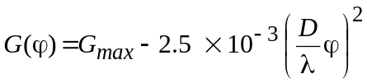 for 0 < φ < φ_{m}
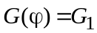 for φ_{m} φ < 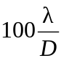
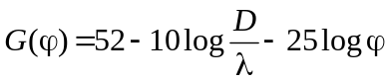 for 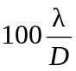 φ < 48°
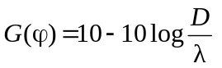 for 48° φ 180°
where:
G_{max} : maximum antenna gain (dBi)
G(ϕ) : gain (dBi) relative to an isotropic antenna
ϕ : off-axis angle (degrees)
D : antenna diameter | expressed in the same unit
λ : wavelength
G₁ : gain of the first side lobe = 2 + 15 log (D/λ)
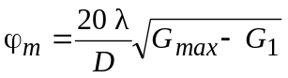 degrees
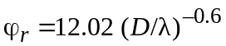 degrees
In cases where the ratio between the antenna diameter and the wavelength is less than or equal to 100, the following equation is given by Recommendation ITU-R F.1245:
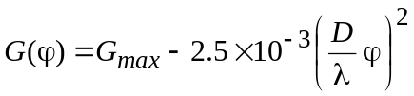 for φ < φ_{m}
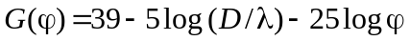 for φ_{m} φ < 48°
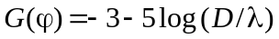 for 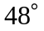 φ < 148°
For each value of off-axis angle, the gain is taken as the average of the values given by Recommendations ITU-R F.699 and ITU-R F.1245 in linear terms.
A single value of horizon antenna gain is determined by the following steps.
Step 1: Taking into account the MetSat earth station elevation angle, the off-axis angle for each azimuth angle around the MetSat earth station is determined.
Step 2: For each azimuth angle, the average horizon antenna gain is determined using the side-lobe patterns described above.
Step 3: Each value of horizon antenna gain (dBi) is converted to a linear power ratio and the average value determined.
The effective gain used in the calculations is then half of the linear sum of both components. Table 4 shows the results for the various elevation angles used in the calculations.
TABLE 4
Average mean antenna gain for meteorological stations
Elevation angle | Meteorological main station  (dBi) | Meteorological user station  (dBi)
5° (unfavourable case for user stations) | (–0.3) | 5.1
10° (unfavourable case for main stations) | –4.6 | (0.9)
15° (typical case) | –6.8 | –1.3
20° (favourable case) | –8.1 | –2.7
It is also advisable to take into account the actual antenna gain towards the tropospheric scatter medium. Recommendation ITU-R P.452 was originally developed for coordination of fixed service links where the elevation of the antenna was limited to angles close to the horizon and where the antenna gain towards the troposphere was generally decreasing with increasing elevation angle. This is not the situation for antennas with increasing gain towards higher elevation angles. The actual antenna gain of both antennas towards the troposphere should be taken into account and could be estimated as follows: A mean height of the troposphere can be assumed around 5 000 m and the mean elevation angle towards the troposphere is then determined by this height and the middle of the distance between transmitter and receiver. For the MetSat stations, the gain values in Table 4 can be interpolated to derive the mean average gain of the antenna towards the troposphere. The contribution from the MES antenna is generally much less significant because of their usually low gains and high elevation pointing angles.

2.2.3 Analysis areas
In order to model the effects of a number of MES around a MetSat station, an analysis area must be established that is sufficiently large to encompass all the MES locations that could contribute to interference.
An exclusion area is placed around the MetSat earth station at a distance d. Three concentric rings are drawn each with outer radius d (n/2 + 1) where n is the ring number.

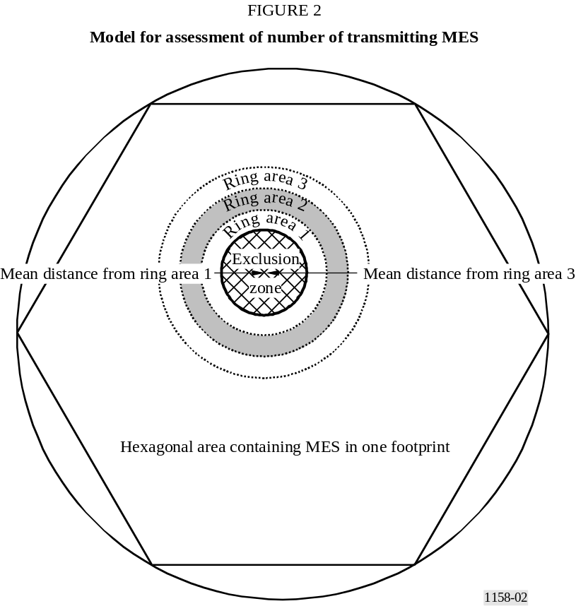

Within each ring the number of MESs is determined from the area of the ring and the average density. In typical operation, MESs will not be evenly distributed throughout the footprint but will be concentrated in areas of high demand. To account for this, the average number of MESs is multiplied by 1.5. This may not be appropriate for rings 2 and 3, if the exclusion area is a large proportion of the MSS footprint. The interference contribution from each ring is estimated by calculating the path loss to a point midway between the inner and outer radii of each ring and increasing the interference from a single MES by 10 log N_{n} where N_{n} is the number of MESs in each ring. Furthermore, to account for the possibility of MESs moving from inside the exclusion area to outside the area, it is assumed that 50% of the average number of MESs in the exclusion area transmit from the boundary. This percentage is reduced to 35% in the case of unfavourable MetSat and shielding situations as the exclusion zone is then significantly increasing.

2.2.4 Interference calculation
The propagation model is based on an implementation of Recommendation ITU-R P.452 for a latitude of 45°. For the ducting model only one MES shall be taken into account. For transmissions from the edge of the exclusion zone, the minimum number of MES to be taken into account shall be 1. The total aggregate interference within the receiver bandwidth is compared with the permissible interference level, scaled to the receiver bandwidth. The size of the exclusion zone is adjusted until the predicted interference just meets the permissible level.
For cases involving radio-climatic zone A1, it can be assumed that 50% of the propagation path falls within zone A2 in order to avoid a worst-case assumption.
Using the number of MESs within each ring and at the edge of the exclusion zone, and the propagation losses for the associated distances for the exclusion zone edge and the ring mean distance, the cumulative interference from each exclusion zone and ring can be calculated. The formula for the cumulative interference (non-ducting conditions) is:
where:
P_{e} : cumulative interference power from the MESs at the edge of the exclusion zone
P₁ : cumulative interference power from the MESs in ring 1
P₂ : cumulative interference power from the MESs in ring 2
P₃ : cumulative interference power from the MESs in ring 3.
The values for P_{e} are calculated using:
where:
e.i.r.p._{mes} : MES e.i.r.p. towards the horizon (from Table 1)
L_{e} : path loss for distance from MetSat earth station to exclusion zone edge
G_{metsat} : MetSat average antenna gain towards horizon (from Table 4)
N_{e} : number of MESs operating at exclusion zone edge
L_{pol} : polarization loss (from Table 1).
The values for P_{n}, under non-ducting conditions, are calculated using the equation below, where n is the ring number (1, 2, or 3):
where:
e.i.r.p._{mes} : MES e.i.r.p. towards the horizon (from Table 1)
L_{n} : path loss for distance from MetSat earth station to ring n mean distance
G_{metsat} : MetSat average antenna gain towards horizon (from Table 4)
N_{n} : number of MESs operating in ring n
L_{pol} : polarization loss (from Table 1).
The values for interference power, P, under ducting conditions with a single MES, are calculated using the following equation:
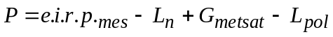
where:
e.i.r.p._{mes} : MES e.i.r.p. towards the horizon (from Table 1)
L_{n} : path loss for distance from MetSat earth station to the MES (exclusion zone radius)
G_{metsat} : MetSat average antenna gain towards horizon (from Table 4)
L_{pol} : polarization loss (from Table 1).

2.3 Summary of results

2.3.1 Summary on separation distances
Figure 3 gives an overview of the separation distances required for MetSat main and user stations obtained from four study contributions to the ITU-R. The lower triangle represents the separation distances for the favourable (F) case and the upper rectangle the separation distances for the unfavourable (U) case. The diamonds in-between are the separation distances for the typical (T) cases. The-axis identifies the type of MSS system, whether it is a system with characteristics making a favorable, typical or unfavorable sharing contribution.
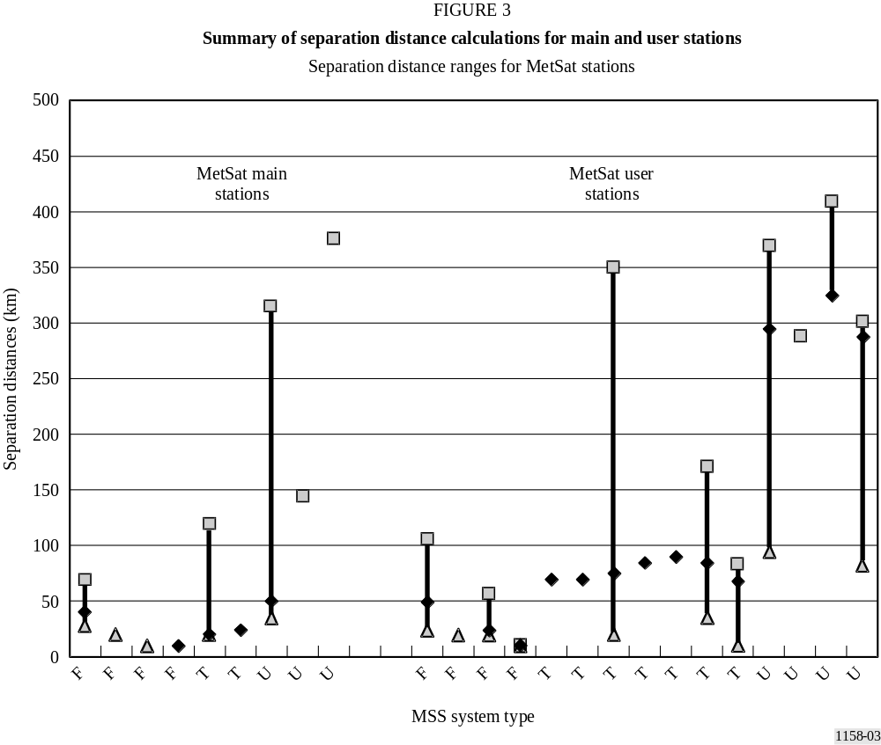

2.3.2 Summary on coordination distances
Several contributions have also been received regarding the required coordination distances. RR Appendix 7 contains the methodology and parameters to determine the coordination area for MES with respect to MetSat earth stations. Because the procedures are well established within RR Appendix 7, it is considered sufficient just to summarize the conclusions of the relevant studies. For operation of MSS in the territory of one administration, it would be necessary to coordinate with MetSat stations operated by other administrations if the MetSat earth station is located within the coordination area of the MSS terminals. The coordination area is the service area of the MES extended by the coordination distance. The available study results show that for the most favourable climatic zone, A2, the required coordination distances are often in excess of several hundred kilometres and would cause a significant coordination burden for the MSS. The extent of the coordination burden would depend on the number and location of MetSat stations affected. The problem increases for coastal areas where coordination distances above 1 000 km could be required in a few cases. Also the separation distances could increase beyond the numbers shown above. Coordination would also be required between MSS and MetSat earth stations within the territory of a given administration but would be a domestic rather than an international matter.

2.4 Conclusions regarding sharing between MetSat and MSS in the band1670-1675 MHz and 1683-1690 MHz
ITU-R has conducted several studies regarding separation distances required between MSS and MetSat earth stations, considering in particular GVAR/S-VISSR earth stations. The studies have been based on a range of MSS system characteristics and a range of different deployment scenarios of MetSat Main and GVAR/S-VISSR stations. An attempt was made to avoid best and worst-case assumptions by considering system and shielding assumptions ranging from favourable to unfavourable conditions. The studies revealed that shielding conditions had the most significant impact on the required separation distances. The following results were obtained for a range of MSS system parameters where the terms “favourable, typical and unfavourable” refer primarily to the MetSat deployment and shielding conditions. The lower separation distances are mainly due to favourable MSS parameters whereas the higher separation distances are obtained for unfavourable MSS parameters:
Table 5
 | MetSat main stations:  favourable-unfavourable MSS | GVAR/S-VISSR stations:  favourable-unfavourable  MSS parameters
Favourable conditions (km) | < 20-35 | 20-100
Typical conditions (km) | < 20-45 | 35-300
Unfavourable conditions (km) | 75-320 | 70-370
At this point in time, GVAR MetSat stations are mostly deployed in many Region 2 countries and S-VISSR MetSat stations are mostly deployed in many Region 3 countries. In Region 1 countries there are a few MetSat GVAR/S-VISSR stations. More than 15 MetSat main stations are deployed throughout all three Regions. It is expected that the MetSat service will make more extensive use of this band in the future. However, there are also transportable GVAR/S-VISSR stations in Regions 2 and 3. Exclusion zones are required but cannot be practically established around transportable earth stations that may be periodically relocated.
Sharing the band 1 683-1 690 MHz would require the establishment of geographical separation between MSS earth stations and co-frequency MetSat stations. There are currently more than 15 main earth stations operated in all three Regions and more than 400 registered data user stations operated mostly in Regions 2 and 3, with some also in Region 1. The number of registered data user stations is increasing and the actual number of existing stations is expected to be in excess of 1 000. The studies concluded that, even though feasible in some areas of the world, implementation of sharing would be subject to such practical constraints and limitations for the MSS that it should not be considered suitable for providing MSS spectrum on a global basis.
Available studies have concluded that the actual required separation distances are typically 70-105 km, but can be up to 400 km. This would in some cases cause large service areas not being available to the MSS; rendering typical features of this service such as global or regional coverage as well as unrestricted mobility, unavailable without the use of selectable frequency agility. As an additional system
burden, the MES locations would have to be determined with sufficient accuracy to comply with the required separation distances. However, there are current operational MSS systems that implement spot beam configurations (150-300 spot beams), frequency reuse and position determination capabilities. In combination with spectrum availability outside of the band 1 683-1 690 MHz, selectable frequency agility would increase the possibility of sharing this band between the MSS and MetSat service.
In addition to in-band interference in the band 1 683-1 690 MHz, the problem of adjacent band interference to thousands of meteorological earth stations operating in the band 1 690-1 698 MHz requires either a guardband below 1 690 MHz or a limitation of out-of-band emissions. Studies have shown that the out-of-band emission limits contained in Recommendation ITU-R M.1480 (and proposed revisions to this Recommendation), if extended to MESs operating in 1 683-1 690 MHz, could be adequate to protect MetSat earth stations operating above 1 690 MHz. Further study may be required.
Annex 2
TABLE 6
Information on worldwide MetSat systems
MetSat  system | Function | Frequency  (MHz) | RF bandwidth  (MHz) | e.i.r.p.  (dBW)
)
MetSat  system | Function | Frequency  (MHz) | RF bandwidth  (MHz) | e.i.r.p.  (dBW)
 | Ranging 1 | 1

3. Sharing techniques for MSS and MetSat earth stations in the 1 675-1 690 MHz frequency band
A number of techniques have been studied by the ITU-R to enhance the capability to share the radio spectrum between mobile or mobile-satellite systems and systems of other services. The basic problem addressed in these studies is that when the mobile service or MSS shares a frequency band with another service, the mobile station or the mobile-satellite earth station has been assumed to be operating anywhere in the service area of the victim system, whilst transmitting at the same frequency as the victim unit receives. Thus, these studies found that within the service area, the mobile or MSS earth station could cause harmful interference to stations of the other service.
These mobile or MSS earth stations must be assumed to be used by persons not accustomed to taking measures to avoid harmful radio interference between stations. For that reason the techniques implemented to control the magnitude of the interference within agreed-to limits must function without action being required by the user of the mobile or MSS earth station. Several such techniques that could be applied to limit the interference from a transmitting MSS earth station into a receiving MetSat earth station are described briefly here. The techniques which can be employed individually or jointly are:
– frequency assignment by location,
– beacon-actuated protection zones,
– interference avoidance by frequency selection,
– using frequencies in an MSS beam coverage area only when the MetSat earth stations are not using them (i.e., time sharing with MetSat priority).

3.1 Frequency assignment by location

3.1.1 Method of assuring adequate frequency-distance separation (for the fixed exclusion zone case)
Using an interference-free signaling channel, the mobile earth station reports its location to the network operations centre (this capability is inherent in some planned non-GSO MSS systems). Interference-free working channels are then assigned, based on a computer “look-up” table indicating the frequencies whose use will not cause interference in the reported location and a list of frequencies not already assigned in the beam coverage area. The “look-up” table is based on known location and frequency assignments for the MetSat earth stations.

3.1.2 Comments
– MSS signaling channels that will not cause harmful interference must be available for use throughout each MSS satellite coverage area.
– MSS earth stations must inherently have, or be equipped with, position determination capabilities.
– MSS earth station location must be known by the network control centre prior to being assigned a service channel.
– Software and a database for assignment based on MSS earth station location must be integrated with the provisions for other channel assignment algorithms.
– The network control computer system should be able to maintain acceptable network access delay.

3.2 Beacon-actuated protection zones

3.2.1 A flexible method of assuring adequate frequency-distance separation
A beacon transmitter is co-located with each MetSat receiving earth station to be protected with minimum acceptable frequency offsets between the beacon and the MetSat earth station receiver. The MSS earth station uses the beacon signal to determine whether it is in a restricted-frequency zone. This information is conveyed to the network operation centre, which assigns a channel that will not cause interference for use in the restricted-frequency zone when necessary.

3.2.2 Comments
– MSS signaling channels that will not cause harmful interference must be available for use throughout each MSS satellite coverage area.
– Beacons must be installed (practical only if there are a small number of receivers to be protected) at each MetSat earth station to be protected.
– MSS earth stations must be equipped with beacon-signal processing capabilities.
– MSS earth stations location (or the specific beacon zone the MSS earth station is within) must be known by the network operation centre prior to channel assignment.
– Software and a database for assignment based on MSS earth station location in relation to specific beacons must be integrated with the provisions for other channel assignment algorithms.
– The network control computer system should be able to maintain acceptable network access delay.
– The technique also may facilitate time sharing.

3.3 Interference avoidance by frequency selection

3.3.1 Method to avoid interference to MetSat earth station types with many installations
The above interference avoidance techniques are appropriate for the case where only a few MetSat earth stations are used to receive signals from a MetSat (e.g., raw image data). However, these techniques are not suitable for the case where there are hundreds or thousands of small earth stations used in meteorological data distribution, e.g., for WEFAX, high resolution picture transmission (HRPT) etc. These frequencies may be different for different MetSat systems and moreover, there may be some MetSat data distribution services that may not become ubiquitous.
These data distribution channels are generally quite narrow. Interference to these ubiquitous MetSat earth stations is avoided by having the MSS system not use the frequencies employed by the MetSat data distribution channels and a suitable guardband around them.

3.3.2 Comments
– MSS signaling channels that will not cause harmful interference must be available.
– Because the data distribution channels have a narrow bandwidth, the diminution of frequencies and capacity to an MSS system will probably be acceptable.
– For non-GSO MSS systems, their network control centres must have the capability to recognize and adopt flexible frequency assignment protocols because different MetSat systems with different coverage areas may employ different frequencies and bandwidths for their data distribution channels.
– Some parts of the world may not ubiquitously install small meteorological data distribution earth stations. MSS earth stations may be useful in such areas.

3.4 Using frequencies in an MSS beam coverage area only when the MetSat earth stations are not using them

3.4.1 Time sharing of frequencies
This is an old idea that has been in use in the MetSat field by non-GSO space stations for some time. That is, a non-GSO space station only serves a small part of the Earth’s surface at any instant of time. Thus, the same frequencies employed by the space station at that time can be employed on the rest of the world’s surface at that time. In other words, time-share the use of the frequencies at all locations on the surface of the Earth between non-GSO MetSats and MSS systems.

3.4.2 Comments
– MSS signaling channels that will not cause harmful interference must be available.
– In the case at hand, there is a potential for interference from the MetSat space stations into the receivers of the MSS space stations.
– The MSS network control centre must keep track of orbital locations and coverage of its own as well as the non-GSO MetSat space stations.
– This technique may be used in conjunction with the beacon and fixed exclusion zone methods described above.
– Good liaison channels must be established between MSS and MetSat system operators.
– For multibeam MSS systems, this method may be used on a beam-by-beam basis.

4 Sharing considerations for the sub-band 1 698-1 710 MHz
based on the time separation concept
This Annex addresses sharing aspects between the MetSat service and the MSS in the sub-band 1 698-1 710 MHz. Studies within the ITU-R concluded that sharing based on distance separation would not be feasible in this sub-band due to the very high number of receiving earth stations and their generally unknown positions. Currently around 1 000 HRPT earth stations are registered with the WMO. It is expected that this number will significantly increase in future, as this band is the prime expansion band for new non-GSO MetSat systems.
As an alternative to distance separation, the concept of time-sharing has been proposed based on some indications that a limited amount of bandwidth might be available on that basis depending primarily on the beam size of the mobile satellite. However, it was also recognized, that the continuous real-time coordination burden involving between 10 and 20 meteorological satellites operated by different administrations or international organizations coupled with disabling the use of large parts of the spectrum at irregular time intervals would not render such a sharing concept practical. It was concluded that further study would be necessary with respect to very narrow beam systems as they may have some sharing potential. Technical characteristics of MSS systems to be used for sharing studies are contained in Recommendation ITU-R M.1184.

4.1 Meteorological satellite system characteristics
Several LEO meteorological satellites are currently operating in the band 1 698-1 710 MHz. Of particular interest is the planned medium-term deployment of such systems. System characteristics have been collected from various administrations and international organizations which can be considered representative for the next series of LEO meteorological satellites already deployed or planned to be deployed within the next decade.
Some other administrations have plans for similar systems but detailed characteristics are currently not available. It may be fair to assume that in the medium- to long-term future between 20 and 25 meteorological satellites will be deployed worldwide. Most operators will have at least two satellites in orbit simultaneously. It may consequently be assumed that between 10 and 20 satellites will operate in the band 1 698-1 710 MHz at any time in the future. The possible frequency reuse will put a limit on the number of satellites and every spectral gap will sooner or later be used. Already now, careful planning is necessary in order to minimize interference.
For the purpose of this study, it was assumed that 14 satellites would use this band within the next decade. Seven satellites have been taken from the ones already operating or in the design stage with a limit of two per administration or international organization. Five additional ones are intended as placeholders for other administrations without firm plans yet or administrations possibly having more than two satellites simultaneously in orbit. The satellite characteristics used for the simulations are given in Table 6.
TABLE 6
Meteorological satellite data used for the simulation
Satellite | Orbit height  (km) | Inclination  (degrees) | Lower frequency  (MHz) | Upper frequency  (MHz)
FY-1 | 870  870 | 98.7  98.7 | 1 698  1 705.5 | 1 703  1 710
METOP | 827  827 | 98.7  98.7 | 1 698.75  1 704.75 | 1 703.25  1 709.25
SPOT | 822 | 98.7 | 1 703 | 1 705
METEOR | 1 020  1 020 | 99.6  99.6 | 1 698.5  1 703.5 | 1 701.5  1 706.5
NOAA | 850  850 | 98.7  98.7 | 1 698.75  1 704.75 | 1 703.25  1 709.25
ADMIN1-A | 840 | 98.7 | 1 698 | 1 702
ADMIN1-B | 840 | 98.7 | 1 702 | 1 706
ADMIN2-A | 840 | 98.7 | 1 702 | 1 706
ADMIN2-B | 840 | 98.7 | 1 706 | 1 710
ADMIN3 | 840 | 98.7 | 1 706 | 1 710
It shall be noted that most of these MetSat satellites transmit in addition a much wider signal to their corresponding CDA stations when in field of view. Such stations are generally located at high latitudes with contact times between 6% and 13% per orbit. MSS spot beams pointing above medium latitudes will therefore encounter additional operational constraints not covered by this study.
Meteorological satellite earth stations are normally receiving data at elevation angles above typically 5° but have to support occasionally satellite passes with lower elevation angles. It also happens frequently, that data are received until the meteorological satellite loses line-of-sight. In addition, the initial signal acquisition and data synchronization process requires some time and is normally initiated as soon as the satellite is expected to come into line-of-sight. Interference during this period can be very harmful. Furthermore, the position uncertainty of the meteorological satellite increases with the time interval between localization procedures. Some safety margin is therefore required with respect to inaccuracies regarding the orbital position of meteorological satellites. For the above reasons, it was assumed that protection of the HRPT station would be required during the entire period when the satellite is visible, i.e. for elevation angles down to 0°. This will in practice result in an operational elevation angle of approximately 5° as stipulated in Recommendation ITU-R SA.1026. Consequently, a MES shall not transmit when an HRPT station is in line-of-sight of its corresponding meteorological satellite.

4.2 Mobile-satellite system characteristics
This study is based on technical characteristics of MSS systems to be used for sharing studies. The information contained in Recommendation ITU-R M.1184 lists a number of GSO and non-GSO systems. For the GSO systems, beamwidths between 1° and 17° have to be considered with corresponding 3 dB mobile service areas ranging between 1 million km² and 217 million km². Three systems have been selected for the simulations with a minimum beamwidth of 1°, a medium beamwidth of 6° and a maximum beamwidth of 17°.
For the non-GSO mobile-satellite systems, a selection of a subset out of the eleven systems was necessary. Systems A, B and G have been chosen in order to have a representative spread of orbital heights, inclination angles and beamwidths. For these systems, the service area covered by one antenna footprint lies in the range between 180 000 km² and 8 400 000 km². Table 7 summarizes the MSS characteristics used for this study. It must be noted that systems based on code division multiple access (CDMA) utilize in general rather high chip rates which require the availability of a large portion of the bandwidth of 12 MHz.
TABLE 7
Mobile-satellite characteristics used for the simulation
 | INMARSAT-M | GSO-A | GSO-C | LEO-A | LEO-B | LEO-G
Orbit altitude (km) | 36 000 | 36 000 | 36 000 | 780 | 10 355 | 1 500
Inclination angle (degrees) | 1 | 1 | 1 | 86 | 50 | 74
Beamwidth (degrees) | 17 | 1 | 6 | 34 | 13 | 95
Number of beams | 1 | 180 | 7 | 48 | 37 | 6
RF channel spacing (kHz) | 10 | Not applicable | 6 | 42 | Not applicable | 50
Modulation bandwidth (kHz) | 8 | 8 330 | 4.7 | 32 | 2 500 | 5 800
Maximum beam size (km²) | 215 × 10⁶ | – | – | 700 000 | 1 000 000 | 8 400 000

4.3 Simulation and technical analysis
The sharing assessment is based upon a computer simulation involving 14 meteorological satellites and one mobile system satellite. The orbital heights for the meteorological satellites are between 827 km and 1 020 km with a typical inclination around 99°. The mobile system satellites are a subset of those given in Recommendation ITU-R M.1184. For the non-GSO ones, systems A, B and G were selected and for the GSO systems, systems A (GSO-A) and C (GSO-C) as well as the INMARSAT-M system (GSO-M) have been selected. The geometrical constellation is illustrated in Fig. 4.

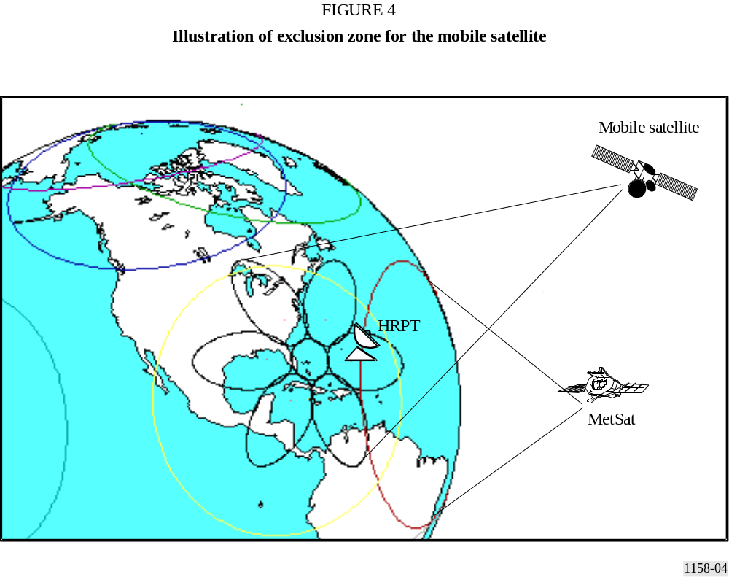

When an HRPT station is within the service area of a mobile satellite antenna beam, and when a meteorological satellite is in field of view of the HRPT, the bandwidth used by the meteorological satellite is not available for mobile terminals within the service area as long as any potential HRPT could receive data. It can be seen that in this example, the MSS footprint intersects with two service areas of meteorological satellites and that the corresponding frequency bands cannot be used. It can also be seen that the beams with some distance to the sub-satellite point covers significantly larger area resulting in a higher outage time. During the simulation, only the beam with the most northern centre point has been selected. As the simulations are very time consuming, only 24 h have been assessed with samples taken every 30 s.
From all available simulation results, the GSO system case with a 6° (two-sided) service area angle (GSO-C) has been selected as a representative case. Figure 5 shows the available spectral gaps in the full frequency range as a function of simulation time.
Figure 6 shows the total available bandwidth. It shall be noted that any given bandwidth is usually available only in several slots which are changing over time. It can be seen that the available bandwidth is rather limited and switches rapidly over time and frequency. Other mobile systems show similar results.
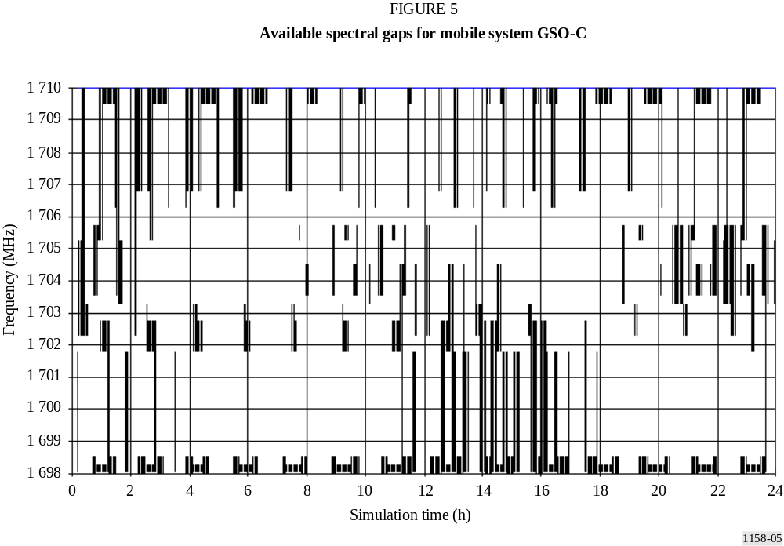

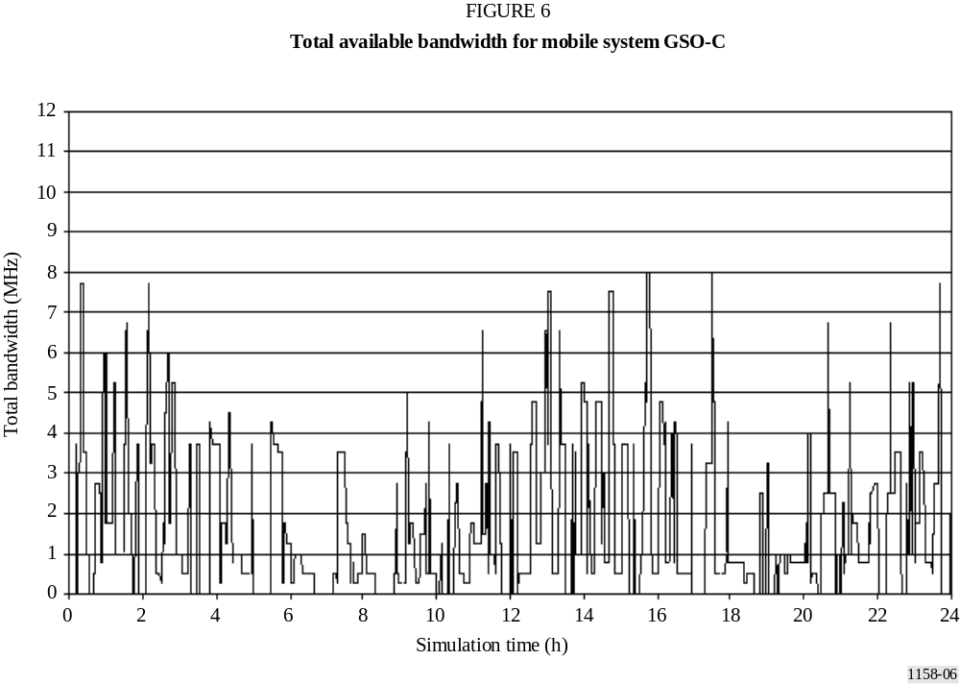

4.4 Summary
At irregular time intervals, the available bandwidth drops to zero MHz which is equivalent to a total traffic interruption. This would exclude any voice communications. Only narrow-band, short duration type of data transmissions may be feasible.
MSS systems using CDMA would not be able to operate as bandwidths of several MHz are hardly ever available.
The available bandwidth can switch within minutes between less than 1 MHz and more than 10 MHz as well as between different sub-bands within the range 1 698-1 710 MHz requiring frequent interruption and relocation of mobile frequency channels.
Continuous real-time coordination involving between 10 and 20 active MetSat satellites operated by different administrations or international organizations would be required coupled with increased requirements for rather precise orbit determination of the meteorological satellites.
All simulations are based on 14 MetSats only. In view of the rapid growth of satellite projects worldwide a significantly higher number of MetSats would result in basically no available spectrum even for very narrow-beam systems.
MSS systems with spot beams towards higher northern latitudes will encounter additional operational constraints when meteorological satellites transmit wideband signals to their corresponding CDA stations.
In view of the above results, it can be concluded that the sharing potential is very limited and complex. Considering the expected future increase of meteorological systems this sub-band cannot be considered practical for sharing between the MetSat service and the MSS.

ANNEX 3-
PRELIMINARY DRAFT NEW REPORT- Sharing betewEen the METEOROLOGICAL AIDS SERVICE AND SYSTEMS IN THE METEOROLOGICAL-SATELLITE SERVICE BETWEEN 1683 AND 1700 MHz

This document converts a study, performed in the 1998-2000 ITU-R study cycle, to an ITU-R report. In addition, the text is updated to take into account the decision of WRC-2003 with regard to Agenda Item 1.31. The information contained in this Preliminary Draft New Report supports the conclusions in the Preliminary Draft New Recommendation ITU-R SA.[Sharing 1.7 GHz][USWP 7C/44] .

1 Introduction
The meteorological aids (Metaids) and Meteorological Satellite (MetSat) services have a co-primary allocation in the band 1 670-1 700 MHz. Operational experience has shown metaids sharing the same geographic regions and spectrum as metsat earth stations cause interference to those metsat earth stations. WRC-2003 created an MSS allocation in the band 1 668.4-1 675 MHz with footnotes recommending metaids be moved to spectrum above 1 675 MHz. As a result of the WRC-2003 decision, administrations might consider moving their metaids operations so that they operate co-channel with their MetSat downlinks. This report investigates the consequences of co-channel operation and the feasibility of co-frequency sharing between the metaids and metsat services.
This document first determines the closest distance of the radiosonde to the GOES GVAR, WEFAX, DCPR, and telemetry receiving stations, without producing excessive main beam interference into these stations. The document then determines the minimum angular main beam axis offset of the radiosonde from the metsat station pointing direction that can occur without producing excessive interference when the systems are within line-of-sight distances.

2 Analysis

2.1 Distance of closest approach
The metaids interference density-to-noise density ratio at a GOES receiving station having a gain-to-temperature ratio g/t is:
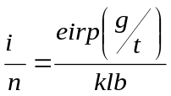
where eirp is the metaids EIRP in Watts, k is Boltzmann's constant (J/K), and l is the space loss between the metaids transmitter and the metsat station as a ratio. The receiver bandwidth, ”b,” is the larger of the metaids transmitter bandwidth or the receiver’s bandwidth expressed in Hz. In the case of this study, a 1 MHz metaids transmitter bandwidth is used. The receive system interference-free margin is:
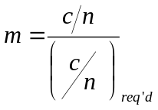
where (c/n)_{req'd} is the carrier-to-noise ratio needed to achieve the receive-system performance requirements. The interference margin goes to (1) when the value of interference power falls below the value calculated below:
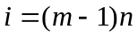
Therefore if the interference drops the margin to 0 dB (1), the minimum space loss is:
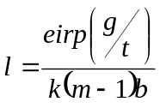
But the space loss is also:
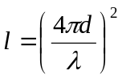
where d is the distance of the radiosonde from the station, and λ is the wavelength both in meters. The distance for which the margin drops to 1 is then:
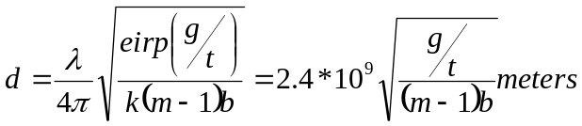
In general, the radiosonde EIRP is -4 dBW. Table 1 lists station parameters for the affected GOES downlinks, and the allowable distances of closest approach for which the amount of main beam interference is acceptable.

TABLE 1
Allowable Distance of Closest Approach
 | GVAR | WEFAX | DCPR | CDA Telemetry
Frequency (MHz) | 1685.7 | 1691.0 | 1694.5 | 1694.0
G/T (dB/K) | 15.2 | -0.3 | 26.0 | 26.0
M (dB) | 1.2 | 6.0 | 7.2 | 16.3
b (Hz) | 2.11×10⁶ | 1×10⁶ | 1×10⁶ | 1×10⁶
d (m) | 15,500 | 1330 | 23,200 | 7450
It is evident from these results that the allowable distances of closest approach are too large to permit co-channel sharing of the 1683 - 1710 MHz band, based on interference into the main beam of the receiving station.

2.2 Angular separation of the radiosonde from the station main beam
In addition of interference into the metsat station main beam, interference could occur when the angle of arrival is outside the metsat station main beam. The limits on interference will depend upon the signal discrimination of the antennas. To determine the discrimination angle the following procedure was followed:
a) The interference threshold power was calculated that made the margin go to zero. This procedure is similar to that shown in Section 2.1 above.
b) The received interference power was calculated assuming that the transmitter was in the receiver’s main beam and at the distances determined above.
c) An excess margin was calculated as the difference between the received power and the threshold. This excess margin was considered to be the amount of antenna discrimination (dB off the main beam) needed to reduce the interference power to the threshold.
d) The "Single Feed Circular Beam" antenna pattern from ITU-R Recommendation S.672-4 was used to evaluate the angle off the main beam where the interference power falls to the threshold.
e) A backlobe gain of -10 dB was assumed and if the interference power could not be rejected, it is assumed that interference could come from the full circle.

Table 2 shows the results of these calculations.

TABLE 2
Angle off the Main Beam of Meteorological-satellite Earth Station Antenna that Eliminates Harmful Interference
 | GVAR | WEFAX | DCPR | CDA Telemetry
0° elevation | ± 1.5° | ± 18° | ± 3.3° | ± 0.85°
15° elevation | ± 7.7° | ± 73° | ± 13.3° | ± 6°
30° elevation | ± 12.7° | Full Circle | ± 22° | ± 10°
45° elevation | ± 16.7° | Full Circle | ± 29° | ± 13°
60° elevation | ± 19° | Full Circle | ± 34° | ± 15°
75° elevation | ± 21.4° | Full Circle | ± 37° | ± 16.6°
90° elevation | ± 22.0° | Full Circle | ± 38° | ± 17°
The results in TABLE 2 show the balloon-borne radiosondes will interfere with the meteorological downlink data for large angles off the main beam axis when within line-of-sight of the Earth stations. Comparing the required separation distances on TABLE 1 with the visibility distances determined here indicates that the interfering signals exceed the interference threshold for the elevation ranges in Table 2 by 8.8 dB to 54.2 dB.

3 Conclusions
The co-channel sharing between metaids and metsat data downlinks is not feasible. The metaids can cause levels of interference ranging from 8.7 dB to 54.2 dB over the metsat station interference threshold when within radio line-of-sight of the Earth stations. Interference occurs over a wide range of angles off the main beam axis of the metsat Earth station antennas.

Based on the results of these calculations, MetAids operators must exercise caution when adjusting the operational frequencies of their metaids networks in response to the decision of WRC-2003. With metsat data requirements increasing, requiring wider transmission bandwidths, metsat operators must also consider the need to leave spectrum available in the band 1675-1700 for metaids operations.

Note : The study developed in 1998 does not address every metsat downlink signal that operates between 1683 and 1690 MHz. Those additional signals can be addressed in a future version of this document.

* This Recommendation should be brought to the attention of the World Meteorological Organization (WMO) and of Radiocommunication Study Group 8 (Working Party 8D).

