WORLD METEOROLOGICAL ORGANIZATION INF. 1
________________________ (22.III.2004)
_______
COMMISSION FOR BASIC SYSTEMS

JOINT MEETING OF ET-EUDCS & ET-IMTN Original: ENGLISH

BEIJING, CHINA, 10 TO 14 MAY 2004

MATERIAL ARRANGEMENTS FOR THE MEETING

Accommodation

1. At the kind invitation of the China Meteorological Administration, the joint meeting of the ET-EUDCS and ET-IMTN of CBS OPAG/ISS will be held at the National Meteorological Centre, CMA, 46 Zhongguancun Nandajie, Beijing, China, from 10 to 14 May 2004. The opening ceremony will take place at 9.30 a.m. on Monday, 10 May 2004 at the main building of the National Meteorological Centre (see Appendix A). The registration of participants will start from 9.00 a.m.

2. One meeting room will be equipped with wireless network facility, which provides Internet access for your laptop computer if you have a wireless Ethernet interface card. A couple of desktop PCs with Internet access will also be provided.

Entry requirements

3. Participants will be required to apply for a business visa to enter China for the purpose of attending the meeting. It is advisable that such an application be made as soon as possible to the nearest Chinese Embassy or Consulate.

4. Once the personal information of participants (including full name(s), nationality, organization, profession and passport number) is available to CMA, an official invitation letter from CMA will be sent to each participant for the purpose of visa application.

Electricity and Modem connections

5. The mains power supply in China is 220 V, 50Hz. If you wish to use an electric appliance, you will need an international adaptor plug, which is available locally and can be purchased. Most hotels have suitable connectors for laptop computer modems.

Currency exchange, credit cards

6. Local currency is the Chinese Yuan (RMB), with the approximate value 1 Euro = 10.02 RMB, 1 USD = 8.21 RMB (Current Mar. 19, 2004).

7. Chinese currency is decimal. Notes come in 100, 50, 20, 10, 5, 2, and 1 yuan denominations. Coins come in 10c, 20c, 50c and denominations.

- The most common credit cards (e.g. Visa, American Express, Diners, MasterCard) are accepted at hotels, banks and some stores.

Hotel accommodation and reservations

9. Special conference rates have been negotiated at a number of hotels, and delegates are invited to make bookings with the local contact points to secure these special rates (see Appendix B).

Local Transportation

10. CMA staff will pick you up at the Beijing International Airport and send you to your hotel. Please inform the local contact point of your flight numbers and arrival date at your earliest convenience. Daily transport service will be arranged to take participants from the Beijing New Century Hotel to CMA and back during the meeting.

Climate

11. Climatological features of Beijing for May:

Mean monthly maximum temperature: 26.6ºC
Mean monthly minimum temperature: 13.6ºC
Mean relative humidity: 53%
Average monthly rainfall: 34.2 mm
Average number of rainy days: 5.8

Local Contact Point

12. For any further information, please do not hesitate to contact us at the following address:

Mr. SHI Peiliang
Deputy Director-General
National Meteorological Center
China Meteorological Administration
Beijing, 100081
China
Tel: +86-10-68407074
Fax: +86-10-62175928
E-mail: shipl@cma.gov.cn

Mr. SUN Yuan
National Meteorological Center
China Meteorological Administration
Tel: +86-10-68406424
Fax: +86-10-62175928
E-mail: sunyuan@cma.gov.cn

APPENDIX A: LOCATIONS OF THE MEETING PLACE
The meeting room is located at the 8th floor of the west building(main building) of the National Meteorological Center, China Meteorological Administration.

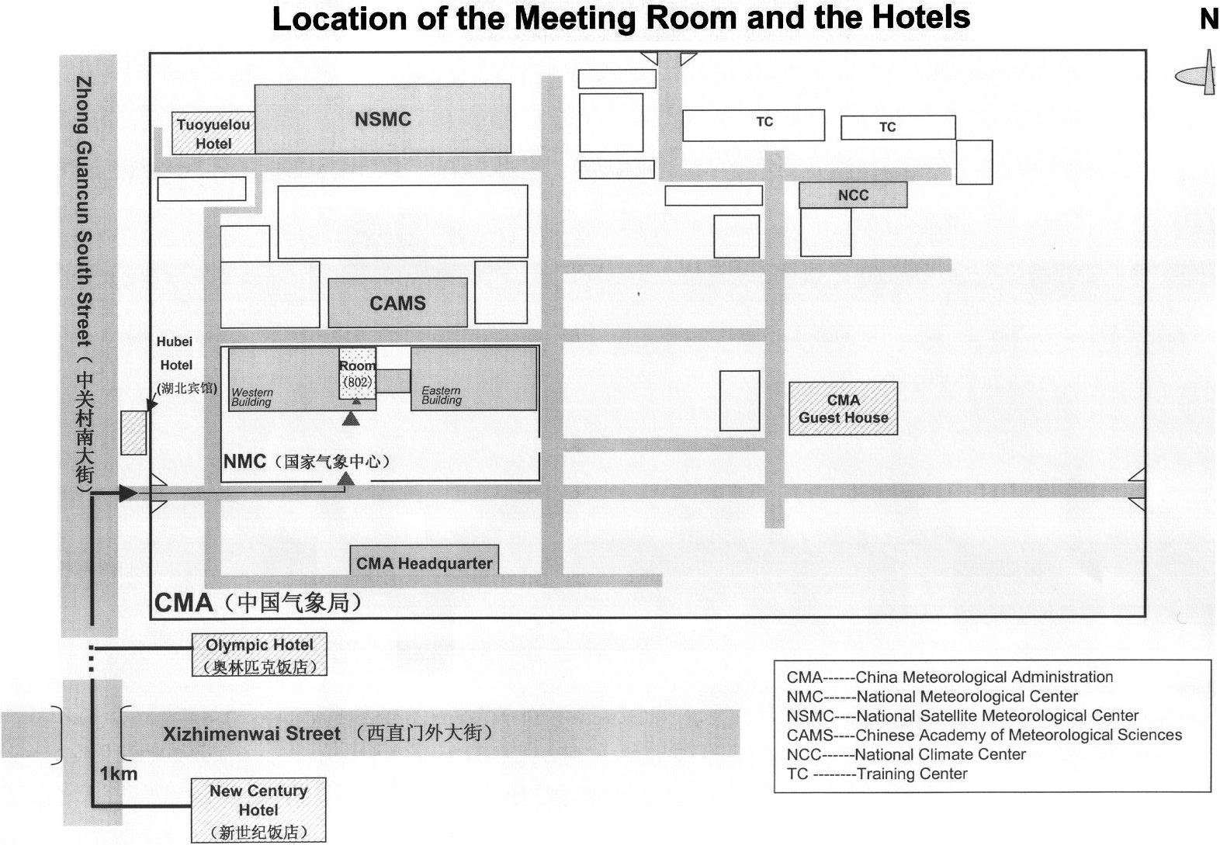

APPENDIX B:

CBS OPAG/ISS Joint meeting of ET-EUDCS & ET-IMTN

HOTEL RESERVATION FORM

Please select a hotel:
□ Beijing New Century Hotel, ★★★★★
US$80 per night,
10 min. walking from China Meteorological Administration (CMA),
http://www.newcenturyhotel.com.cn
□ Olympic Hotel, ★★★
US$43 per night, 5 min. walking from CMA;
□ Hubei Hotel, ★★★
US$47 per night, 3 min. walking from CMA;
□ CMA Guest House, ★★
US$24 per night, inside CMA.

Please indicate:
□ Standard Room, for one person: (including breakfast)
□ Standard Room, for two persons: (including two breakfasts)

Special Requests On:
Beds:
□ King-size bed in room □ Twin beds in room
Floors:
□ Non-smoking floor (limited availability)

Guest Name: ______________________________ (Mr./Mrs./Ms.)
Organization: ______________________________
Address: ____________________________________________________________
City: ______________________ Zip code: ___________ Country: ______________
Fax: ______________________ E-mail: ________________________________
Accompanied by: ______________________________
Arrival date: _____________________ Departure date: _________________
Payment will be made by : □ Credit Card: Amex/JCB/Visa/Mastercard.
Credit Card Number:________________________
□ Cash

To make reservation, please fill this form, fax or email it to the local contact points no later than 30 April 2004.

