WORLD METEOROLOGICAL ORGANIZATION  _________________________  INTER-COMMISSION COORDINATION GROUP ON THE WMO INFORMATION SYSTEM  THIRD SESSION  BEIJING, CHINA, 5-8 SEPTEMBER 2006 |  | ICG-WIS III/Doc. 3.3(1)  (5.IX.2006)  ____________  ITEM 3.1  ENGLISH only

Report on WIS VPN Pilot Project in Regions II and V

( Submitted by Hiroyuki ICHIJO (Japan) )

Summary and the Purpose of the Document

The document is to report the status and plans of WIS VPN Pilot Project in Regions II and V.

Action Proposed : The meeting is invited to review this report and to provide comments.

1. Background
"VPN Pilot Project in Regions II and V" was established in 2003 with the following fundamentals.
a) Contribution to WIS development through empirical and practical study
b) Regional collaboration supported by voluntary participation of centers under various conditions such as enough or insufficient expertise, and excellent or poor facilities
c) Bottom-up scheme by participants’ opinions and ideas

The fundamental phase for basic tests on VPN techniques was completed successfully in September 2004, and then the project has shifted to an advanced phase for further evaluation tests and practical study with thematic sub-phases tightly linked with the WIS development. Positive actions to promote the advanced phase have been taken as follows:
a) To report the outcome from the feasibility tests and evaluation to Expert Teams and conferences concerned
b) To invite potential NMCs/RTHs widely to participate in the project with WMO invitation letters
c) To promote exchanging opinions and sharing information among participants preparing mailing-list and the project web site with discussion room

Executive Council at its fifty-seventh session in 2005 urged the Secretary-General, volunteering Members and the ICG-WIS, with the support of relevant technical commissions, to develop a work plan and expedite the development of key components of WIS with a view to facilitating implementation, at least in some countries, in 2006 instead of 2008, as originally planned. In this context, various pilot projects and prototypes are expected to become semi-operational to gain valuable experience with the WIS concepts. Under such conditions, work plans of the VPN pilot project will be reviewed and refined from the view of further contribution to specific components of WIS implementation.

2. Current Status
2.1 Project participants and status of establishing their VPN links
The number of participants has increased from 11 in the fundamental phase to 14 in the advanced phase thanks to the WMO letters addressed to PRs to invite them to participate in the project. The current participant list is shown in Table 1. In addition, Thai Meteorological Department is preparing to participate in the project and a few Members are under consideration.

All participants have permanent connections to the Internet at a speed of over 512kbps as shown in Figure 1. 11 participants have already established VPN links with servers at Japan Meteorological Agency (JMA). 10 of them are by IPsec with VPN conditions and parameters in Table 2. Only Oman has a VPN connection by PPTP (Point-to-Point Tunneling Protocol) with Japan tentatively because of delay of preparing IPsec products.

Tasble 1 Participants in the advanced phase
Country, terriroty | Organization | Site
Region II
China | China Meteorological Administration | Beijing
Hong Kong, China | Hong Kong Observatory | Hong Kong
India | India Meteorological Department | New Delhi
Isramic Republic of Iran | Isramic Republic of Iran Meteorological Organization | Teheran
Japan | Japan Meteorological Agency | Tokyo
Oman | Meteorological Department | Muscat
Republic of Korea | Korea Meteorological Administration | Seoul
Saudi Arabia | Presidency of Meteorology & Enviroment | Jeddah
Vietnam | National Hydrometeorological Service | Hanoi
Region V
Australia | Bureau of Meteorology | Melbourne
Brunei Darussalam | Brunei Meteorological Service | Bandar Seri Begawan
Malaysia | Malaysian Meteorological Service Department | Kuala Lumpur
New Zealand | MetService | Wellington
Republic of Singapore | National Environment Agency | Singapore

Hong Kong
India
Iran
Korea
Oman
Saudi Arabia
Vietnam
Australia
Brunei
Malaysia
New Zealand
China
Soon established VPN-link with Japan
Established VPN-link
with Japan
Japan
Singapore
10Mbps (max)
2Mbps
4Mbps
512Kbps
2Mbps
1Mbps
100Mbps (max)
3Mbps
2Mbps
2Mbps
1Mbps
Internet
100Mbps (max)
100Mbps (max)
256Mbps (min)- 440Mbps (max)
Figure 1 Internet connectivity for the WIS VPN Pilot Project

Table 2 IPsec VPN conditions and parameters
IKE (Internet Key Exchange）
Encryption algorithm: | 3DES
Hash algorithm: | SHA
Diffie-Hellman group: | MODP 1024 bit (group2)
Lifetime: | 86400s
IPsec
Mode: | Tunnel Mode
Transform-set: | esp-3des, esp-sha-hmac
pfs: | group2 (mode1024)
peer authentication: | Pre-Shared-Key

2.2 Project web site
The project web site established in July 2005 to share information among participants is gradually improving in its contents. Especially it is expected that a discussion room would promote exchanging opinions and mutual understanding. The site basically allows the participants and authorized users to access through the VPN (IPsec, PPTP and SSL).

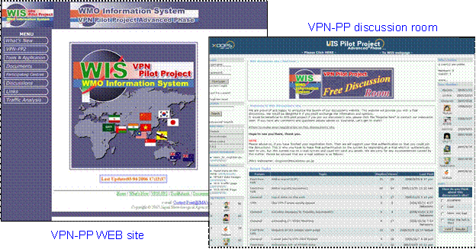

Figure 2 Top page of the project web site and its discussion room

As shown in Figure 3, some tools to observe the Internet access conditions are available in the project web site. Each participant can analyze its own Internet conditions such as traffic throughput, round trip time and statistics. The information is useful for each participant to evaluate its Internet environment.

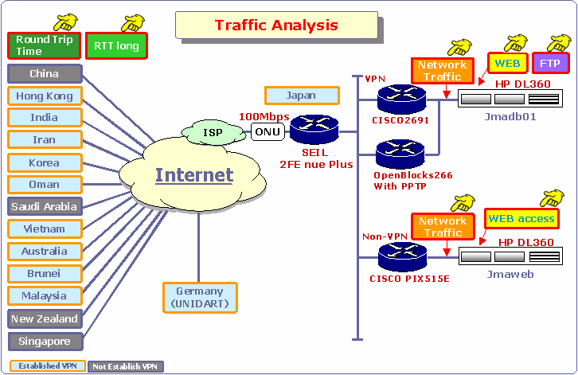
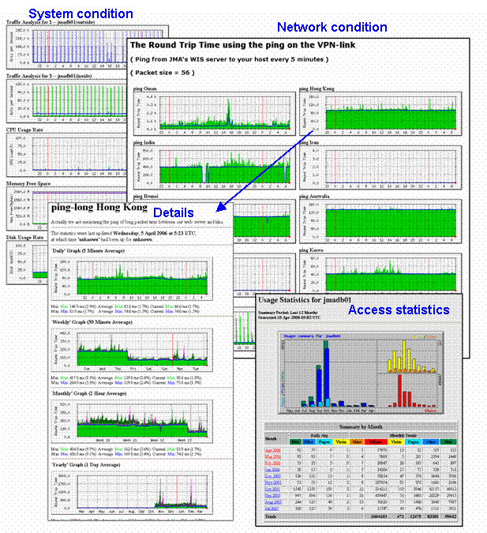
Figure 3 Instruction and monitoring views by a traffic analysis tool

2.3 Evaluation tests
Evaluation tests have been continued for practical study on optimized VPN installation and troubleshooting of implementation problems. Latest examples are shown below:

(1) Evaluation of implementation of a VPN link with PPTP.
PPTP (Point-to-Point Tunneling Protocol) is a simplified VPN technique available for mobile and PC users without any VPN products. JMA established a PPTP server and tested VPN with PPTP in cooperation with some participants. It was confirmed that authorized Windows-PC users could access easily to JMA servers through the PPTP server shown in Figure 4.

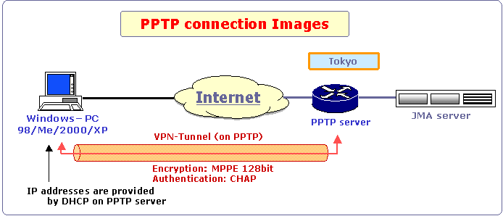

Figure 4 Evaluation test for VPN with PPTP

(2) Troubleshooting on MTU size problem
Unexpected browsing errors were observed in case of web access to a large size page through IPsec tunnel. As the result of investigation and evaluating test for troubleshooting by Hong Kong Observatory and JMA, it was found that the packet loss could be caused by a default MTU (Maximum Transmission Unit) size of 1500 octets on Ethernet interface at the server side. Reducing the MTUsize to 1350 octets solved the problem.
MTU sizing affects fragmentation of IPsec packets to the destination. A large size over 1400 octets can increase fragmentation. Fragmentation of a 1500 octet packet with DF (Don’t fragment) bit or reassemble of segmented packets at the destination causes packet loss or slower tunnel performance. Using 1400 or smaller usually prevents fragmentation. This is known as “MTU size problem”.

(3) Adjustment for higher throughput.
FTP throughput tightly relates to round trip time (RTT) and TCP window-size. There are two ways to realize higher throughput, that is, reducing RTT and expanding TCP window-size. The former is not easy though a change of Internet Service Providers (ISPs) would be a possible option. Therefore the latter is main interest. Monitoring RTT, adjusting an appropriate window -size and verifying improvement of throughput are basic procedures. Figure 5 shows an example of throughput evaluation.

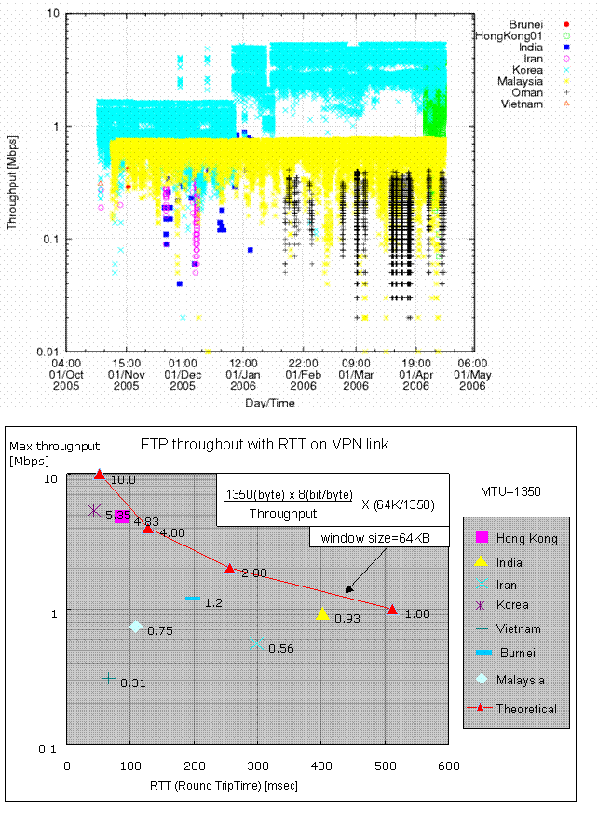
Figure 5 Example of Throughput evaluation

2.4 Thematic sub-phases
Three thematic sub-phases in the advance phase have progressed, though they are still behind schedule because of lack of human resources.

(1) Reporting observational data
Prototype web input interface was developed and tested in October 2005. Planned works are development of software for metadata creation and BUFR conversion, and improvement of the input interface considering comments from participants through a forum in the discussion room.
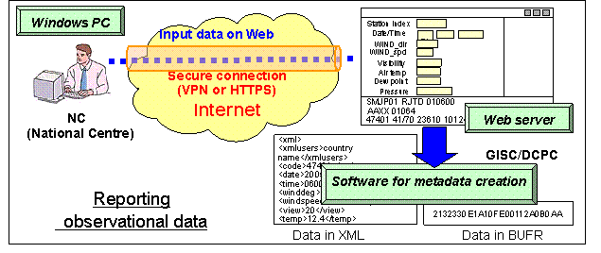

Figure 6 Outline of reporting observational data

(2) Cooperation with UNIDART (Data Portal)
In cooperation with DWD, JMA accessed to the UNIDART portal, established VPN with the portal and installed UNIDART software at JMA data server. JMA and Korea Meteorological Administration (KMA) data servers have been prepared to join the DATA GRID environment of UNIDART since February 2006. It is expected that JMA and KMA would prepare some datasets with metadata catalogue and provide them for UNIDART users.
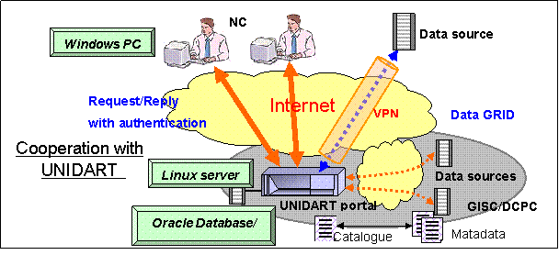

Figure 7 Outline of cooperation with UNIDART
(3) Prototype application
JMA started in preliminary data provision of MTSAT imagery data. JMA is planning to provide prototype application for visualization and manipulation of satellite and NWP products, and the data and products formatted for the application.

Updated
Application software
Prototype application
Application portal
Data portal


Internet

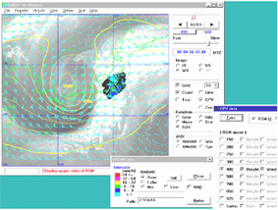

Windows PC
HTTP server
FTP servers
SATAID
NWP products
Satellite data
NC
Satellite data
Reference information

Data sources
VPN
Software updating
GISC/DCPC
Gathering data from
different data sources
Figure 8 Outline of prototype application

3. Project review and plans
3.1 Importance of project management and coordination in voluntary human resources
Entering the advanced phase, it was not easy to schedule necessary activities to promote the project. There seemed two reasons. One was imperfection of project management. The other was lack of human resources for actual technical works.
For success of the project, the following procedures will be discussed by all participants.
a) Steering the direction of the project by usual liaison among core Project Managers (PMs)
b) Periodical review of the progress and work sharing by all PMs
c) Establishment of a coordinator initiative system for each sub-phase and evaluation test
Each coordinator will be designated from all Technical Contact persons (TCs)
d) Further effort to enhance voluntary cooperation by all participants

3.2 Three contribution schemes for WIS implementation

The WIS VPN pilot project in Regions II and V will be continued by all current and new participants with keeping the initial fundamentals. Considering the WIS implementation plan, the project will enhance three contribution schemes as follows:

(1) Evaluation and troubleshooting scheme to support semi-operation components
The VPN pilot project will fill the role of a technical consulting body on VPN data communications for WIS semi-operation components in all Regions. The project continues to provide empirical outcomes and technical tips to WIS community. IPv6 test is also coordinated.

(2) Development scheme for WIS services
The project will develop prototype mechanisms at WIS application level and their partial elements and verify them through participants’ trial use. This scheme is activated as enhancement of the thematic sub-phases which are expansion activities of VPN use.

(3) Capacity building scheme for participation in WIS semi-operation
The project will provide better environment to participants so that they can gain experiences on use of VPN and WIS services on a trial basis. It is expected this scheme would introduce smooth participation in other WIS prototype components in semi-operation.
.

