WORLD METEOROLOGICAL ORGANIZATION  _________________________  COMMISSION FOR BASIC SYSTEMS  OPAG ON INFORMATION SYSTEMS & SERVICES  Implementation-coordination Team on INFORMATION SYSTEMS & SERVICES  geneva, 18 - 22 september 2006 |  | ICT-ISS 2004/Doc. 2.2  (14.IX.2006)  ____________  ITEM 2.2  ENGLISH only

STATUS OF IMPLEMENTATION OF GTS IN REGION VI

(Submitted by the Co-coordinators for ISS in RA VI)

________________________________________________________________

Summary and Purpose of Document

Review of the status of the GTS in Europe

________________________________________________________________
ACTION PROPOSED

а) To review the information presented in the document.

b) Approve the actions proposed in the document.

Status of the RMTN in Regional Association VI

- The majority of the RMTN links within the Western part of Region VI now run over RMDCN and use TCP/IP as the data transport protocol, with almost all the GTS links that use RMDCN now capable of operating at 64 kbps or greater.

- The status of the RMTN in the south-east part of Region VI still remains not quite satisfactory. This is demonstrated by the status of the centres and telecommunication circuits in this part of Region as well as by the status of national observation data collection systems in the surface observational network.

- 7 of the circuits, that are specified in the plan for the RMTN as being in the eastern part of the region, still do not exist. It is proposed that 3 of these circuits be excluded from the RMTN plan but it is planned to implement the remaining 4 circuits. Most of the circuits in this part of Region use leased analogue/digital channels or the Internet and a significant number of them are expected to migrate to the RMDCN.

- The delay, or lack of plans, by NMCs in moving the circuits to the RMDCN is attributable to the fact that, for these NMCs, the cost of leased lines is still much lower than the cost of leasing a PVC or HPLS from EQUANT. However the difference between these costs is gradually reducing. Several of the RMTN circuits, namely the Moscow-Baku , Sofia-Tirana circuits either already operate over the Internet. The NMC Damask is not connected to the GTS. The NMCs Tirana and Skopje do not have connections.

- The status of the circuits in the Central and Eastern half of the region is given at Table 1. A diagram showing the current status of the RMTN in Region VI is given at Figure 1

Regional Meteorological Data Communications Network (RMDCN)

- There are now 36 members of RA VI connected directly to the RMDCN. ECMWF and EUMETSAT are also connected. Five centres have duplicated access lines to the network for resilience. A list of the centres connected to the RMDCN is given at Table 2. Those not connected are listed at Table 3.

- Following from decisions made by the 13th session of the RA VI in 2002, four other RTHs outside RA VI are also connected to form the GTS and IMTN: China, India, Japan and Saudi Arabia. See Figure 2.

- The RMDCN has proved to be a reliable and effective means of providing an RMTN within RA VI.

- The access lines from the centres to the network range in speed from 64Kb/s to 2Mb/s for NHMSs. ECWMF accesses at 34Mb/s. PVC (Permanent Virtual Circuits) are established between centres and will support traffic at the contracted CIR (Committed Information Rate). This may be different in each direction. The network allows the CIR to be exceeded in short bursts, and this is illustrated for one particular PVC by Figure 3. Details of the PVCs between the RTHs and the NHMSs are in Table 4.

- The RMDCN is supplied by OBS (Orange Business Services, formerly known as Equant). The RMDCN contract is managed by ECMWF on behalf of RA VI.

- A modification to the RMDCN contract in 2003 gave improved basic connections to member states that were completed in 2004.

- Since then, various centres improved their links and back-up arrangements. A timetable of events over the last two years is at Table 5 and a list of the outages that occurred is at Table 6.

- Satellite broadcasting systems in Europe transferred to the DVB channels allowing to significantly increase their capacity and reliability.

Use of the Internet

- All the RTHs and NMSs have access to the Internet, with several centres enabling access to their servers for provision of data and products. A Virtual Private Network (VPN) over the Internet is being used between some centres.

- The Internet in Region VI is used for:
- Reception of additional information which does not come over the GTS;
- Provision of information within countries as well as for other NMCs;
- Arrangement of the GTS circuits or their backing up;
- Observation data collection in the national network.

Revision of the RMTN plan

- Following a joint meeting of the RMDCN Operations Committee and the RMDCN Steering Group in Moscow in 2004, approval was given to ECMWF to pursue the option of migrating the underlying network structure of the RMDCN from Frame Relay protocols to one based on the Multi Layer Packet Switching Protocol (MLPS). Pilot testing of this protocol took place during 2005 and 2006.

- There is now a project in progress to migrate all of the RMDCN network to the new protocol. This project is covered by the fourth Supplement to the contract which was agreed and signed by ECMWF on 8 May 2006. Lines are being ordered for the 40 NHMSs and two international organisations for delivery before the end of 2006. The new network will be built in parallel to the existing RMDCN and the switch-over to the new network will be done in a few days, with operational acceptance completed at the beginning of 2007.

- The new network will have a higher basic bandwidth for all members, with improved back-up facilities. Many centres will also upgrade their access connections to increase resilience.

- Initially, the new network will mirror the existing structure of specific PVCs between NHMSs, which in turn mirrored the original point-to-point links of dedicated lines in the original RMTN with inter-connected RTHs supporting NHMS in their area of responsibility.

- The migration to the new protocol will eventually allow any-to-any connections, greatly increasing the flexibility of the network, as there will be no requirement within MLPS to pre-define PVCs, as with Frame Relay. However it will increase the day-to-day traffic management challenges. Currently, the traffic volume is controlled in the current network by the CIR (Committed Information Rate) on each of the PVCs.

- MLPS as the underlying network protocol for RMDCN could also potentially provide solutions for back-up connections in the event of an outage of an RTH.

- An Ad-Hoc working group was set up to look into the content of the RA VI EUMETCast/WWW broadcast.

Data Management

- In the majority of Eastern Europe countries, the national observation data collection systems are either being upgraded, or are planned to be upgraded in the near future. These upgraded networks will employ modern technologies which will enable the cost of data collection to be reduced and will also increase reliability and timeliness. All the countries concerned require support on the part of the WMO to enable them to realise their plans within acceptable timescales. The move from the existing, expensive and inefficient, data collection methods to the new ways of data transmission from stations to telecommunication centres will require appropriate refitting of the stations within in these countries. In addition older methods of communications, such as radio telegraphy, as currently used by some countries within the Region, need replacing with more modern communications (packet radio communication, satellites, cellular communications, data communication networks). Moreover, in some countries (Georgia, Kazakhstan, Azerbaijan, Armenia) there are problems with power supply on the stations and at telecommunication centres which does not enable timely transmission of data.

- The collection of SYNOP data in Eastern and Central Europe was improved and is at the level of 95 per cent and can be considered as satisfactory. However reliability and timeliness of data collection of some countries is at a much lower level (Azerbaijan – SM 58.3%). The reasons for this situation are the inadequate status of observation/data collection systems as described above and the MSS technical status. As emphasized above, the data collection systems, especially in Eastern part of Europe, are obsolete and require or are in the process of major change.

- The TEMP data collection in this part of Europe is lower than in the rest of Europe (90%) and can be blamed on a lack of consumables and the ageing of technical observation equipment. Moreover, actual plans of observations sometimes disagree widely from those announced in Volume C1. The reason for the disagreement is late reporting of changes in sounding plans to a regional centre on the MTN and to the WMO Secretariat.

- The CLIMAT/CLIMAT-TEMP data collection is at a slightly lower level as compared with required data. One of the reasons for such a situation is a discrepancy between actual observations and information transmitted in the GTS represented in Volumes A, C1, RBSN, RBCN. Due to the actions taken by the WMO Secretariat and RTHs this situation has recently improved. Nevertheless, it is necessary to continue this work on monitoring data arrival and to make contact with those NMCs where problems with data transmission emerge. It should be noted that in fact CLIMAT-TEMP data is transmitted in the WMO GTS on the area of responsibility of the RTHs Moscow and Sofia only by the following centres: RUMS, UMMN, LZSO, YRBK, LYBM. The rest do not transmit the data specified.

- Day to day experience in Western Europe suggests that there still many badly formatted messages and bulletins causing unnecessary overheads. Also, the use of more highly automated systems seems to occasionally exacerbate the problem. These points are highlighted by a simple investigation carried out at RTH Exeter, counting the number of international rejected bulletins. See Figure 6, indicating the great variability from day to day. Further work is required to identify the root cause of these problems.

Future WMO Information System

- The future WMO Information System, as agreed by CBS, includes the concepts of Global Information System Centres to replace the roles of the RTHs, and an improved MTN to distribute the information held by the GISCs. RA VI has been involved in both the improved MTN and the development of a GISC to be sited within RA VI.

- The Co-ordination Team on the FWIS is in discussion with other WMO Commissions regarding the format required for data exchange. This includes formats such as netCDF, as well as Table Driven Code forms currently used on the GTS.

GISC

- Centres such as Moscow and Sofia are planning changes to their telecommunications and information systems to enable them to be ready for the introduction of FWIS. Also, pilot projects to test different ways of improving the operational and future WMO information system are being conducted
- The United Kingdom, France and Germany, in co-operation with EUMETSAT and ECMWF, are developing the concept of a virtual GISC (V-GISC). An ad-hoc group comprising representatives from the 3 countries and the 2 organisations is involved in a European Community sponsored project called SIMDAT to demonstrate a prototype system using various modern technologies including XML, Web Services and the WMO Core Metadata Profile. A variety of data types are being demonstrated in the system, such as synoptic, aviation, ATD and climate. The prototype will be demonstrated at CBS in Korea in November 2006, connecting to data servers in France, Germany, UK and ECMWF.
- DWD have proposed the use of XML to implement the WMO Bulletin Catalogue. The related XML schemas use the proposed WMO Core Metadata Profile.

Improved MTN

- The Improved MTN (IMTN) comprises 2 interconnected telecommunications clouds. The RMDCN is one of these Clouds, the other is the ‘Pacific Cloud’ network currently comprising links between Australia, the United Kingdom, Japan and the United States of America. A diagram showing the proposed configuration of the IMTN is given at Figure 2.

- To accommodate this proposed structure, approval was given in 2002, for centres outside RA VI to be allowed to connect into the RMDCN, for the purpose of establishing direct GTS connections to centres within RA VI. As a consequence, Japan, India and China and Saudi Arabia are now connected into RMDCN. No further progress has been made with Kenya, Senegal, Algeria and Egypt joining the RMDCN.

- Within the ‘Pacific Cloud’ (Network 1 in Figure 3), links have already been established between Australia-UK, Australia – Japan, USA - UK and USA – Japan. It is not clear whether or not the links Brasilia-Washington and Buenos Aries-Washington will be established over this network. This will depend upon the future development of the RMTN within RA III.

Migration to TCDF

- Although the situation with the planning and preparation for the migration to the TDCF in the Region is slightly improved (in general at RTHs), it still remains inadequate and additional efforts are required on fostering this process, especially at NMCs, part of which does not have plans as yet and the rest have only started to realize their plans.
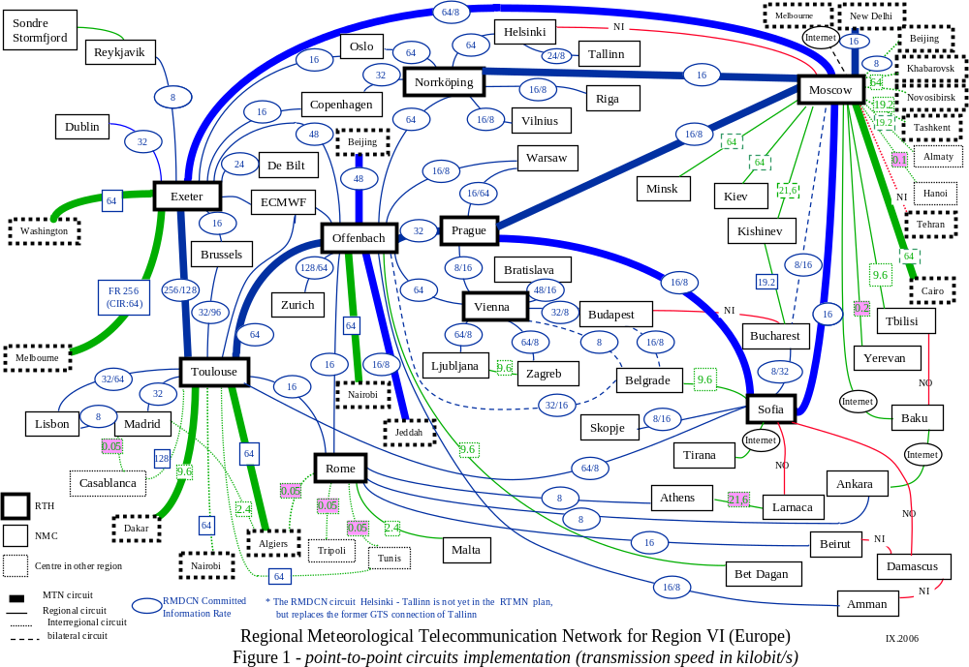
Exeter
Sofia
Melbourne
Buenos Aires
Tokyo
Beijing
Nairobi
Washington
Network I
Jeddah
Prague
Toulouse
Dakar
Algiers
Offenbach
Brasilia
Cairo
Managed
data communication network
New Delhi
Moscow
Network II
(RA VI RMDCN Ext.)

Figure 2
Table 1
№ | Circuit | Status | Speed  (Kbps) | Protocol | Data type | Future  (2006-2007)
 | Moscow –  Exeter | MTN | FR RMDCN (Equant)  CIR: Rx-64, Tx-8  Access line (backup):  Mos–256 (256 ISDN)  Exeter–512 (384 ISDN) | FTP WMO | A/N, BIN  FAX | IP/VPN MPLS (OBS)  Mos – 512 Kbps
 | Moscow –  Prague | MTN | FR RMDCN (Equant)  CIR: Rx-16, Tx-8  Access (ISDN backup):  Mos–256 (256 ISDN)  Prag–512 (384 ISDN) | FTP WMO | A/N, BIN  FAX | IP/VPN MPLS (OBS)  Mos – 512 Kbps
 | Moscow –  Sofia | MTN | FR RMDCN (Equant)  CIR: Rx/Tx –16/16  Access (ISDN backup):  Mos–256 (256 ISDN)  Sofia–256 (128 ISDN) | FTP WMO | A/N, BIN  FAX | IP/VPN MPLS (OBS)  Mos – 512 Kbps  Sofia – 512 kbps
 | Moscow –  New-Delhi | MTN | FR RMDCN (Equant)  CIR: Rx/Tx –16/16  Access (ISDN backup):  Mos–256 (256 ISDN)  ND–64 (64 ISDN) | FTP WMO | A/N, BIN | IP/VPN MPLS (OBS)  Mos – 512 Kbps
 | Moscow –  Cairo | MTN | Digital line  Tx/ Rx – 64 | FTP WMO | A/N
 | Moscow –  Norkkoping | RMTN | FR RMDCN (Equant)  CIR: Rx/Tx –16/16  Access (ISDN backup):  Mos–256 (256 ISDN)  Nork–1536 (384 ISDN) | FTP WMO | A/N, FAX  BIN | IP/VPN MPLS (OBS)  Mos – 512 Kbps
 | Moscow –  Minsk | RMTN | Digital line  Tx/Rx – 64  (Internet back-up) | TCP/IP-Socket (Special) | A/N, BIN  FAX
 | Moscow –  Kiev | RMTN | Digital line  Tx, Rx – 64  (Internet back-up) | FTP WMO | A/N, FAX  BIN
 | Moscow –  Tbilisi | RMTN | Telephone leased line  V.34 ITU  Tx/Rx – 9,6 | TCP/IP-Socket (Special) | A/N, FAX | IP/VPN MPLS (OBS)  CIR: Rx-8 Kbps Tx-16 Kbps  Access line: Mos – 512 Kbps  TCP/IP-Socket or FTP WMO
 | Moscow –  Baku | RMTN | Through Internet |  | A/N, FAX | IP/VPN MPLS (OBS)  CIR: Rx-8 Kbps Tx-16 Kbps  Access line: Mos – 512 Kbps  TCP/IP-Socket or FTP WMO
 | Moscow –  Erevan | RMTN | Telegraphic adapter  200 bod (via Rostov),  Through Internet | Async  Email,  Web-access | A/N, FAX | Telephone leased line TCP/IP-Socket or FTP WMO
 | Moscow –  Kishinev | RMTN | Telephone leased line  V.34 ITU  Tx/ Rx – 21.6 | TCP/IP-Socket (Special) | A/N, FAX
 | Moscow –  Beijing | Inter-regional | FR RMDCN (Equant)  CIR: Rx/Tx –8/8  Access (ISDN backup):  Mos–256 (256 ISDN)  BJ–256 (256 LL) | FTP WMO | A/N, FAX  BIN | IP/VPN MPLS (OBS)  Mos – 512 Kbps
 | Moscow –  Novosibirsk | Inter-regional | Digital line  Tx/ Rx – 64  (Internet back-up) | TCP/IP-Socket (Special) | A/N, BIN  FAX | Digital line  Tx/ Rx – 512  (Internet back-up)
 | Moscow –  Khabarovsk | Inter-regional | Digital line  Tx/ Rx – 64  (Internet back-up) | TCP/IP-Socket (Special) | A/N, BIN,  FAX,  Satellite images | Digital line  Tx/ Rx – 512  (Internet back-up)
 | Moscow –  Tashkent | Inter-regional | Telephone leased line  V.34 ITU  Tx/Rx –19,2  (Internet back-up) | TCP/IP-Socket (Special) | A/N, BIN  FAX | Digital line  Tx/ Rx – 64 Kbps
 | Moscow –  Almaty | Inter-regional | Telephone leased line  V.34 ITU  Tx, Rx –19,2  (Internet back-up) | TCP/IP-Socket (Special) | A/N, BIN, FAX | Digital line  Tx/ Rx – 64 Kbps
 | Moscow –  Hanoi | Inter-regional | Satellite  Telegraphic adapter  100 bod | Async | A/N
 | Moscow –  Tehran  (NO) | Inter-regional | Telegraphic adapter  100 bod | Async | A/N | Telephone leased line  TCP/IP FTP WMO  (A/N, BIN)
 | Moscow – Bucharest | bilateral | FR RMDCN (Equant)  CIR: Rx/Tx –8/16  Access line(backup):  Mos–256(256 ISDN)  Buch-128 kbps (-) | FTP WMO | All (ASCII, Binary) | RMTN  IP/VPN MPLS (OBS)  Mos – 512 Kbps
 | Moscow –  Melbourne | bilateral | Through Internet | FTP WMO | A/N, BIN | via Internet
 | Moscow –  - Helsinki (NO) | RMTN
 | Kiev – Kishinev (NO) | RMTN
 | Tbilisi –  Baku  (NO) | RMTN
 | Baku - Ankara | RMTN | Through Internet
 | Sofia - Prague | MTN | FR RMDCN (Equant)  CIR: Rx/Tx – 16/8  Access line (backup):  Sof–256(128 ISDN)  Prag–512 (384 ISDN) | FTP WMO | A/N, BIN  FAX | IP/VPN MPLS (OBS)  Sofia – Access line (NAS backup): 512 kbps (256 Kbps)
 | Sofia - Toulouse | RMTN | FR RMDCN (Equant)  CIR: Rx/Tx – 64/8  Access line(backup):  Sof–256(128 ISDN)  Toul-1M (1 M Mis Cr) | FTP WMO | A/N, BIN  FAX | IP/VPN MPLS (OBS)  Sofia – Access line (NAS backup): 512 kbps (256 Kbps)
 | Sofia - Bucharest | RMTN | FR RMDCN (Equant)  CIR: Rx/Tx – 8/32  Access line (backup):  Sof-256 Kbps(128 ISDN)  Buch: 128 kbps (-) | FTP WMO | All (ASCII, Binary) | IP/VPN MPLS (OBS)  Sofia – 512 kbps
 | Sofia – Skopje | RMTN | FR RMDCN (Equant)  CIR: Rx/Tx – 8/16  Access line(backup):  Sof–256(128 ISDN)  Skopje-64 (64 ISDN) | FTP WMO | All (ASCII, Binary) | IP/VPN MPLS (OBS)  Sofia – 512 kbps
 | Sofia - Belgrade | RMTN | Telephone leased line  V.34 ITU  Tx, Rx – 9,6 Kbps | FTP WMO | All (ASCII, Binary)
 | Bucharest –  Kishinev | RMTN | Telephone leased line  Async,PPP,  19,2 kbps (min.) | FTP | ASCII, Binary
 | Sofia - Tirana (NO) | RMTN | IPSec VPN on Internet | FTP WMO | All (ASCII, Binary)
 | Sofia – Larnaca (NO) | RMTN |  |  |  | Should be a Project for a connection of NMC Larnaca to RTH Sofia by VPN/Internet.
 | Sofia – Damascus (NO) | RMTN |  |  |  | NMC Damascus is not connected to GTS. It’s connected to AFTN (V.35). Should be a Project for a connection of NMC Damascus to RTH Sofia by VPN/Internet.
 | Larnaca – Athens | bilateral | Telephone leased line  21,6 Kbps | FTP
 | Belgrade – Vienna | bilateral | FR RMDCN (Equant)  CIR: Rx/Tx – 8/8  Access line (backup):  Belgrade -128 Kbps (-) | FTP | ASCII, Binary
 | Belgrade - Offenbach | bilateral | FR RMDCN (Equant)  CIR: Rx/Tx – 32/16  Access line (backup):  Belgrade -128 Kbps (-) | FTP | ASCII, Binary
 | Belgrade - Budapest | bilateral | FR RMDCN (Equant)  CIR: Rx/Tx – 16/8  Access line (backup):  Belgrade -128 Kbps (-) | FTP | ASCII, Binary

Table 2

Country/Site connected to RMDCN  (* outside RA-VI) |  | Access line  (bits per sec)
Austria (Vienna) | RTH | 512k
Belgium (Brussels) |  | 512k
Bulgaria (Sofia) | RTH | 256k
*China (Beijing) | *RTH | 256k x 2
Croatia (Zagreb) |  | 64k
Czech Republic (Prague) | RTH | 512k
Denmark (Copenhagen) |  | 1M
Estonia (Tallinn) |  | 64k
Finland (Helsinki) |  | 384k
France (Toulouse) | RTH | 2M x2
Germany (Offenbach) | RTH | 1M x2
Greece (Athens) |  | 384k
Hungary (Budapest) |  | 256k
Iceland (Reykjavik) |  | 64k
*India (New Delhi) | *RTH | 64k
Ireland (Dublin) |  | 384k
Italy (Rome) | RTH | 768k
*Japan (Tokyo) | *RTH | 128k
Jordan (Amman) |  | 64k
Latvia (Riga) |  | 128k
Lebanon (Beirut) |  | 64k
Lithuania (Vilnius) |  | 64k
Luxembourg (Luxembourg) |  | 384k
FYR of Macedonia (Skopje) |  | 64k
The Netherlands (De Bilt) |  | 384k
Norway (Oslo) |  | 384k
Poland (Warsaw) |  | 64k
Portugal (Lisbon) |  | 384k
Romania (Bucharest) |  | 64k
Russian Federation (Moscow) | RTH | 256k
*Saudi Arabia (Jeddah) | *RTH | 64k
Serbia-Montenegro (Belgrade) |  | 128k
Slovakia (Bratislava) |  | 128k
Slovenia (Ljubljana) |  | 128k
Spain (Madrid) |  | 2M
Sweden (Norrköping) | RTH | 1.5M
Switzerland (Zurich) |  | 512k
Turkey (Ankara) |  | 384k
*United Arab Emirates (Abu Dhabi) |  | 64k
United Kingdom (Exeter) | RTH | 512k
ECMWF (Reading) |  | 34MB x 2
EUMETSAT (Darmstadt) |  | 512k x 2

Table 3

RA-VI Members not connected to RMDCN
Albania
Armenia
Azerbaijan
Belarus
Bosnia-Herzegovina
Cyprus
Georgia
Israel
Kazakhstan
Malta
Moldova
Monaco
Syria
Ukraine

Table 4: RTH PVC connections to NHMSs (

* Outside RA-VI | RTH | PVC In  (Kb/s) | PVC  (Kb/s)
Austria
Croatia (Zagreb) |  | 64 | 8
Czech Republic (Prague) | RTH | 8 | 16
Germany (Offenbach) | RTH | 64 | 64
Hungary (Budapest) |  | 32 | 8
Serbia-Montenegro (Belgrade) |  | 8 | 8
Slovakia (Bratislava) |  | 48 | 16
Slovenia (Ljubljana) |  | 64 | 8
Bulgaria
Czech Republic (Prague) | RTH | 8 | 16
France (Toulouse) | RTH | 8 | 64
FYR of Macedonia (Skopje) |  | 16 | 8
Romania (Bucharest) |  | 32 | 8
Russian Federation (Moscow) | RTH | 16 | 16
China
Germany (Offenbach) | RTH | 48 | 48
*India (New Delhi) | *RTH | 8 | 8
*Japan (Tokyo) | *RTH | 42 | 96
Russian Federation (Moscow) | RTH | 8 | 8
Czech Republic
Austria (Vienna) | RTH | 16 | 8
Bulgaria (Sofia) | RTH | 16 | 8
France (Toulouse) | RTH | 16 | 128
Germany (Offenbach) | RTH | 32 | 32
Poland (Warsaw) |  | 16 | 8
Russian Federation (Moscow) | RTH | 16 | 8
France
Belgium (Brussels) |  | 92 | 48
Bulgaria (Sofia) | RTH | 64 | 8
Czech Republic (Prague) | RTH | 128 | 16
Germany (Offenbach) | RTH | 64 | 64
Italy (Rome) | RTH | 32 | 32
Portugal (Lisbon) |  | 64 | 32
Spain (Madrid) |  | 32 | 32
Switzerland (Zurich) |  | 32 | 32
United Kingdom (Exeter) | RTH | 128 | 384
Germany
Austria (Vienna) | RTH | 64 | 64
*China (Beijing) | *RTH | 48 | 48
Czech Republic (Prague) | RTH | 32 | 32
France (Toulouse) | RTH | 64 | 64
Greece (Athens) |  | 32 | 32
Italy (Rome) | RTH | 32 | 32
Jordan (Amman) |  | 16 | 8
Poland (Warsaw) |  | 16 | 8
*Saudi Arabia (Jeddah) | *RTH | 16 | 8
Serbia-Montenegro (Belgrade) |  | 32 | 16
Spain (Madrid) |  | 16 | 16
Sweden (Norrköping) | RTH | 64 | 64
Switzerland (Zurich) |  | 128 | 64
Turkey (Ankara) |  | 32 | 32
*United Arab Emirates (Abu Dhabi) |  | 16 | 16
United Kingdom (Exeter) | RTH | 64 | 64
EUMETSAT (Darmstadt) |  | 128 | 128
India
*China (Beijing) | *RTH | 8 | 8
*Japan (Tokyo) | *RTH | 32 | 32
Russian Federation (Moscow) | RTH | 16 | 16
Italy
France (Toulouse) | RTH | 32 | 32
Germany (Offenbach) | RTH | 32 | 32
Greece (Athens) |  | 32 | 32
Lebanon (Beirut) |  | 16 | 16
Turkey (Ankara) |  | 32 | 32
United Kingdom (Exeter) | RTH | 16 | 16
Japan
*China (Beijing) | *RTH | 96 | 48
*India (New Delhi) | *RTH | 32 | 32
Russia
Bulgaria (Sofia) | RTH | 16 | 16
*China (Beijing) | *RTH | 8 | 8
Czech Republic (Prague) | RTH | 8 | 16
*India (New Delhi) | *RTH | 16 | 16
Romania (Bucharest) |  | 16 | 8
Sweden (Norrköping) | RTH | 16 | 16
United Kingdom (Exeter | RTH | 8 | 64
Saudi Arabia
Germany (Offenbach) | RTH | 8 | 16
Sweden
Denmark (Copenhagen) |  | 32 | 32
Finland (Helsinki) |  | 64 | 64
Germany (Offenbach) | RTH | 64 | 64
Latvia (Riga) |  | 64 | 16
Lithuania (Vilnius) |  | 16 | 8
Norway (Oslo) |  | 64 | 64
Russian Federation (Moscow) | RTH | 16 | 16
United Kingdom
Belgium (Brussels) |  | 32 | 32
Denmark (Copenhagen) |  | 32 | 32
France (Toulouse) | RTH | 384 | 128
Germany (Offenbach) | RTH | 64 | 64
Iceland (Reykjavik) |  | 16 | 16
Ireland (Dublin) |  | 64 | 64
Italy (Rome) | RTH | 16 | 16
The Netherlands (De Bilt) |  | 64 | 64
Norway (Oslo) |  | 32 | 32
Portugal (Lisbon) |  | 32 | 32
Russian Federation (Moscow) | RTH | 64 | 8
Spain (Madrid) |  | 32 | 32

Figure 3: Example of traffic over PVC with CIR occasionally exceeded

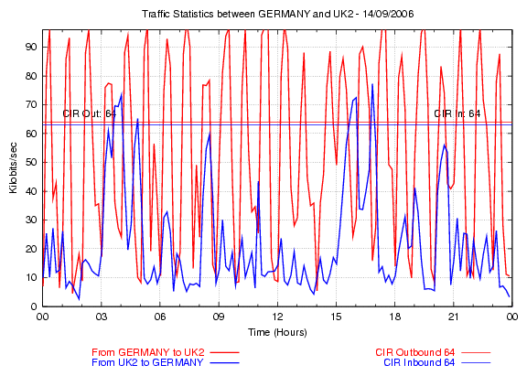
Figures 4 & 5
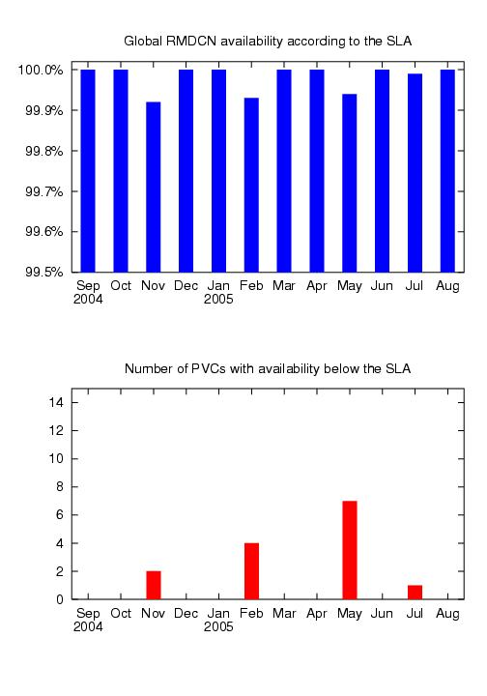

Table 5: RMDCN Significant Events over the last 2 years.
Austria-ECMWF PVCs upgrade - 02 June 2006
The Austria-ECMWF PVCs have been upgraded to 384/128kbps in/out of Vienna. The work was completed on 31 May 2006.
Spain Access Line and Backup, and Spain-ECMWF PVCs upgrades - 02 June 2006
The Spain Access Line has been upgraded to 2Mbps, the Spain ISDN Backup has been upgraded to 512kbps, and the Spain-ECMWF PVCs have been upgraded to 768/128kbps in/out of Madrid. The work was completed on 30 May 2006.
China-Japan PVC upgrade - 02 June 2006
The China-Japan PVC has been upgraded to 96/48kbps in/out of Beijing. The work was completed on 26 May 2006.
EUMETSAT Access Line and EUMETSAT-Germany PVC upgrade - 27 March 2006
The EUMETSAT Access Line has been upgraded to 512kbps and the EUMETSAT-Germany PVC has been upgraded to 128/128kbps in/out. The work was completed successfully on 23 March 2006.
Romania - Russian Federation PVC - 30 January 2006
An asymmetric PVC between Romania and Russian Federation, 16/8kbps in/out of Bucharest, was implemented on 20 January 2006 and has been tested successfully.
Russian Federation ISDN backup upgrade - 23 December 2005
The Russian Federation ISDN backup has been upgraded to 256kbps on 21 December 2005.
China-India PVC (2) - 20 December 2005
The necessary configuration corrections have been implemented, and the PVC Acceptance Tests have been completed successfully on 19 December 2005.
Russian Federation Access Line upgrade and Russian Federation- Sweden PVC implementation - 08 December 2005
The Russian Federation Access Line has been upgraded to 256kbps and a symmetric 16/16kbps Russian Federation-Sweden PVC has been implemented. The work was completed on 01 December 2005. The PVC has been tested successfully.
Latvia Access Line and Latvia-Sweden PVC upgrade - 08 December 2005
The Latvia Access Line has been upgraded to 128kbps and the Latvia-Sweden PVC has been upgraded to 64/16kbps in/out of Riga. The work was completed on 03 December 2005.
Saudi Arabia Final Acceptance - 07 July 2005
The 30-day Reliability Acceptance Test was completed successfully and the Saudi Arabia RMDCN site was accepted on 4 July 2005.
China access line upgrade and China-Russia PVC installation - 04 March 2005
The China access line has been upgraded to 256kbps and a symmetric 8kbps China-Russia PVC has been installed. The work was completed on 02 March 2005.
France-UK PVCs upgrade - 21 January 2005
The France-UK PVCs have been upgraded to 384k/128k in/out of France on 15 January 2005.
Sweden upgrades - 10 December 2004
The Sweden access line has been upgraded to 1.5Mbps and the Sweden-ECMWF PVCs have been upgraded to 1024k/128k in/out of Sweden on 9 December 2004.
Serbia and Montenegro Final Acceptance - 05 November 2004
The 30-day Reliability Acceptance Test was completed successfully and the Serbia and Montenegro RMDCN site was accepted on 4 November 2004.
India Final Acceptance - 15 October 2004
The 30-day Reliability Acceptance Test was completed successfully and the New Delhi connection to the RMDCN was accepted on 13 October 2004.
France access line upgrade - 08 October 2004
The access line of Meteo France has been upgraded to 2Mbps on 4 October 2004.
New RMDCN Member: Saudi Arabia - 01 October 2004
The Saudi Arabia Presidency of Meteorological and Environmental Protection signed the RMDCN Accession Agreement on 22 September 2004. Jeddah will have a 64kbps connection to the network and an asymmetric PVC with Offenbach, 16/8kbps in/out of Jeddah.
Luxembourg Final Acceptance - 17 September 2004
The 30-day Reliability Acceptance Test was completed successfully and the Luxembourg RMDCN site was accepted on 16 September 2004.
Table 6: RMDCN Outages over the last two years
Italy ISDN down - 01 September 2006
The Italy ISDN was down for about 1 day 3 hours between 29 and 30 August 2006 due to faulty IDB equipment. Incident solved by replacing the equipment.
Latvia running on ISDN - 25 August 2006
Latvia ran on ISDN for about 1 day 11 hours between 19 and 21 August 2006 due to last mile equipment failure.
Romania outage - 18 August 2006
Romania was down for about 20.5 hours between 16 and 17 August 2006 due to broken PTT cable.
Greece outage - 04 August 2006
Greece was down for about 5 hours on 02 August 2006 due to equipment failure at OBS node. The problem was solved by resetting the equipment.
Luxembourg outage - 02 June 2006
Luxembourg was down for 1 day and 4 hours between 31 May and 1 June 2006 to due faulty modem at customer site. The problem was solved when Orange Business Services replaced the modem.
Norway outage - 12 May 2006
Norway was down for about 5.5h on 3 May 2006 due to local PTT equipment failure.
FYR of Macedonia outage - 20 December 2005
The FYR of Macedonia was down for slightly over 24 hours between 15 and 16 December 2005 due to a strike by the local PTT employees.
Romania outage - 06 December 2005
Romania was down for about 3 days and 2 hours between 30 November and 03 Dec 2005 due to PTT last mile cable break.
Italy running on ISDN backup (2) - 10 November 2005
The Italy main line was restored at around 10 UTC on 10 November 2005. The problem was solved by repairing two cabling cabinets between the Italy site and the PTT central office.
Italy running on ISDN backup - 04 November 2005
Italy has been running on ISDN backup since 10:44 UTC on 27 October 2005 due to major PTT problem, which is currently still under investigation.
Norway outage - 07 October 2005
Norway was down for about 18 hours between 3 and 4 October 2005 due to problem at Equant node switch port. Problem solved by resetting the port.
Lithuania outage - 30 September 2005
Lithuania was down for about 16 hours between 25 and 26 September 2005 due to switch card hanging at Equant node. Problem solved by resetting the card.
Outages at ECMWF - 08 August 2005
ECMWF was down from about 07:00 to 12:30 UTC on 28 July 2005 and from about 10:15 to 12:30 UTC on 31 July 2005 due to two major power outages on site.
Outage in FYR of Macedonia - 22 July 2005
The FYR of Macedonia was down for about 8 hours between 9 and 10 July 2005 and was running on ISDN for about 34 hours between 10 and 11 July 2005 due to the site in Skopje being flooded by an unprecedented amount of rain falling in a short period of time during a storm.
Outages in Sweden - 26 May 2005
Sweden was down on several occasion between 6 and 21 May 2005, for a total outage of about 5 hours, due a problem at a switch at Equant POP. Each time a reset on the switch solved the problem.
Outage in Serbia and Montenegro - 09 March 2005
Belgrade was down for about 11.5 hours between 24 and 25 February 2005 due to loss of connectivity at Equant UMUX. The problem was solved by resetting the connections.
Outage in India - 12 November 2004
India was down from 08:43 UTC on 9 November to 07:38 UTC on 10 November 2004 because of a modem problem at Bharti premises.
Figure 6: Rejected international bulletins at RTH Exeter for one month



