WORLD METEOROLOGICAL ORGANIZATION  _________________________  COMMISSION FOR BASIC SYSTEMS  OPAG ON INFORMATION SYSTEMS & SERVICES  Implementation-coordination Team on INFORMATION SYSTEMS & SERVICES  geneva, 27 september- 1 october 2004 |  | ICT-ISS 2004/Doc. 2.2(6)  (15.IX.2004)  ____________  ITEM 2.2(6)  ENGLISH only

STATUS OF IMPLEMENTATION OF GTS IN REGION VI

(Submitted by the Co-cordinators for ISS in RA VI))

________________________________________________________________

Summary and Purpose of Document

Review of the status of the GTS in Europe

________________________________________________________________
ACTION PROPOSED

а) To review the information presented in the document.

b) Approve the actions proposed in the document.

Status of the RMTN in Regional Association VI

- The majority of the RMTN links within the Western part of Region VI now run over RMDCN and use TCP/IP as the data transport protocol, with almost all the GTS links that use RMDCN now operating at 32 kbps or greater. A modification to the RMDCN contract in 2003 gave improved basic connections to member States and also gave them the option of upgrading their links. The resulting upgrades were completed by Equant by mid-March 2004.

- The status of the RMTN in the south-west part of Region VI still remains unsatisfactory. This is demonstrated by the status of the centres and telecommunication circuits in this part of Region as well as by the status of national observation data collection systems in the surface observational network.

- 10 of the circuits, that are specified in the plan for the RMTN as being in the eastern part of the region, still do not exist. It is proposed that 5 of these circuits be excluded from the RMTN plan but it is planned to implement the remaining 5 circuits. Most of the circuits in this part of Region use leased analogue or digital channels and a significant number of them are expected to migrate to the RMDCN.

- The delay, or lack of plans, by NMCs in moving the circuits to the RMDCN is attributable to the fact that, for these NMCs, the cost of leased lines is still much lower than the cost of leasing a PVC from EQUANT. However the difference between these costs is gradually reducing. Several of the RMTN circuits, namely the Moscow-Yerevan, Kishinev, Baku , Sofia-Tirana circuits either already operate over the Internet or it is planned to do so.

- The status of the circuits in the Central and Eastern half of the region is given at Table 1. A diagram showing the current status of the RMTN in Region VI is given at Figures 1 and 2

Regional Meteorological Data Network (RMDCN)

- There are now 36 members of RA VI connected directly to the RMDCN. ECMWF and EUMETSAT are also connected. The link to Serbia and Montenegro was installed during 2004; acceptance tests have yet to be completed. Luxembourg was connected in August 2004 and has a link to ECMWF over the RMDCN, but does not have PVC connections with other NMS or RTHs. Syria is connected via Lebanon. In addition to their link to Offenbach, DWD have an RMDCN link into their Disaster recovery site. The RMDCN has proved to be a reliable and effective means of providing an RMTN within RA VI.

- Following on from decisions made by the 13th session of the Regional Association VI, in 2002, Japan, China and India are now connected into RMDCN.

- A joint meeting of the RMDCN Operations Committee and the RMDCN Steering Group was held at the ROSHydromet building in Moscow in July 2004. At the meeting approval was given to ECMWF to pursue, with Equant, the option of migrating the underlying network structure of the RMDCN from one based on Frame Relay protocols to one based on the Multi Layer Packet Switching Protocol (MLPS). Pilot testing of the use of this protocol should take place during summer 2005.

- A list of the centres connected to the RMDCN is given at Table 2

Use of the Internet

- All the RTHs and the vast majority of NMSs in the west of RA VI have access to the Internet, with several centres enabling access to their servers for provision of data and products. Tests using a Virtual Private Network (VPN) over the Internet have taken place between some centres.

- The Internet in Region VI is used for:
- Reception of additional information which does not come over the GTS;
- Provision of information within countries as well as for other NMCs;
- Arrangement of the GTS circuits or their backing up;
- Observation data collection in the national network.

Revision of the RMTN plan

- The potential migration to the use of MLPS as the underlying network protocol for RMDCN would give the potential for ad-hoc connections between centres. There is no requirement within MLPS to pre-define PVCs, as is the situation with Frame Relay. This could potentially provide solutions for back-up connections in the event of an outage of an RTH.

- An Ad-Hoc working group has been set up to look into the content of the RA VI EUMETCast/WWW broadcast.

Data Management

- In the majority of Eastern Europe countries, the national observation data collection systems are either being upgraded, or are planned to be upgraded in the near future. These upgraded networks will employ modern technologies which will enable the cost of data collection to be reduced and will also increase reliability and timeliness. All the countries concerned require support on the part of the WMO to enable them to realise their plans within acceptable timescales. The move from the existing, expensive and inefficient, data collection methods to the new ways of data transmission from stations to telecommunication centres will require appropriate refitting of both stations and centres within in these countries. In addition older methods of communications, such as radio telegraphy, as currently used by some countries within the Region, need replacing with more modern communications (packet radio communication, satellite by, via meteor tracks (traces). Moreover, in some countries (Georgia, Kazakhstan, Azerbaijan, Armenia) there are problems with power supply on the stations and at telecommunication centres which does not enable timely transmission of data.

- The collection of SYNOP data in Eastern and Central Europe is at the level of 90 per cent and can be considered as satisfactory. However reliability and timeliness of data collection of some countries is at a much lower level (Azerbaijan – SM 59.4%, SI 65.85%). The reasons for this situation are the inadequate status of observation/data collection systems as described above. As emphasized above, the data collection systems, especially in Eastern part of Europe, are obsolete and require or are in the process of major change.

- The TEMP data collection in this part of Europe is much lower than in the rest of Europe and can be blamed on a lack of consumables and the ageing of technical observation equipment. Moreover, actual plans of observations often disagree widely from those announced in Volume C1. The reason for the disagreement is late reporting of changes in sounding plans to a regional centre on the MTN and to the WMO Secretariat.

- The CLIMAT/CLIMAT-TEMP data collection is at a slightly lower level as compared with required data. One of the reasons for such a situation is a discrepancy between actual observations and information transmitted in the GTS represented in Volumes A, C1, RBSN, RBCN. Due to the actions taken by the WMO Secretariat and RTHs this situation has recently improved. Nevertheless, it is necessary to continue this work on monitoring data arrival and to make contact with those NMCs where problems with data transmission emerge.

Future WMO Information System

- The future WMO Information System, as agreed by CBS, includes the concepts of Global Information System Centres to replace the roles of the RTHs, and an improved MTN to distribute the information held by the GISCs. RA VI has been involved in both the improved MTN and the development of a GISC to be sited within RA VI.

- The Co-ordination Team on the FWIS is in discussion with other WMO Commissions regarding the format required for data exchange. This includes formats such as netCDF, as well as Table Driven Code forms currently used on the GTS.

GISC

- Centres such as Moscow and Sofia are planning changes to their telecommunications and information systems to enable them to be ready for the introduction of FWIS. Also, pilot projects to test different ways of improving the operational and future WMO information system are being conducted
- The United Kingdom, France and Germany, in co-operation with EUMETSAT and ECMWF, are developing the concept of a virtual GISC (V-GISC). An ad-hoc group comprising representatives from the 3 countries and the 2 organisations is working to develop proposals to implement such a system.
- A ‘Proof of Concept’ V-GISC is being developed for demonstration at the next meeting of CBS. DWD will host the ‘GISC portal’ and the servers that will provide the GTS ‘push’ capability, whilst the UK Met Office will host a specialised aviation server and ECMWF will host a climatological server. The link between DWD and the UK Met Office and with ECMWF will operate using VPN over the Internet. This is a ‘proof of concept’ system, and as such, it will be removed after CBS.
- DWD have proposed the use of XML to implement the WMO Bulletin Catalogue. The related XML schemas use the proposed WMO Core Metadata Profile.

Improved MTN

- The Improved MTN (IMTN) comprises 2 interconnected telecommunications clouds. The RMDCN is one of these Clouds, the other is the ‘Pacific Cloud’ network currently comprising links between Australia, the United Kingdom, Japan and the United States of America. A diagram showing the proposed configuration of the IMTN is given at Figure 3.

- To accommodate this proposed structure, approval was given in 2002, for centres outside RA VI to be allowed to connect into the RMDCN, for the purpose of establishing direct GTS connections to centres within RA VI. As a consequence, Japan, India and China are now connected into RMDCN. Saudi Arabia is considering migrating its link with Offenbach to run over the RMDCN., and Kenya has asked for updated pricing information. However, for financial reasons, Senegal and Algeria have decided not to join the RMDCN. No contact has yet been made with Egypt.

- Within the ‘Pacific Cloud’ (Network 1 in Figure 3), links have already been established between Australia-UK, Australia – Japan, USA - UK and USA – Japan. It is not clear whether or not the links Brasilia-Washington and Buenos Aries-Washington will be established over this network. This will depend upon the future development of the RMTN within RA III.

Deliverables

- It is proposed that the following requirements on the FWIS should be added:
- A reduction of costs when exchanging data and products;
- A Coordinated transition plan for all of the NMCs/NMHSs to the FWIS;
- Preparation and timely provision to NMCs/NMHSs of regulating documents, instructive materials, etc. on the matters of the transition and operation in the FWIS;
- Reliability and invariance in receiving data and products in the FWIS;
- Provision of technical and technological assistance to the NMCs/NMHSs who need it when moving to the FWIS.

Migration to TCDF

- During 2004, the WMO Secretariat issued a questionnaire to establish the status of the development of plans by NMSs and RTHs to migrate to TDCF. Of the 20 centres within Region VI that responded,
- only 2 centres had developed a plan;
- 4 had no plan, and did not say when such a plan would be available;
- and 14 expected to have a plan in place within 5 years.
However the majority of these centres were already receiving and decoding BUFR bulletins. Only 3 of these centres could not decode BUFR bulletins, and 5 centres were not already encoding bulletins in BUFR. All the centres could process GRIB bulletins

- Preparation and planning for the transition to the TDCF is inadequate especially in the Eastern part of Region. Less than 50 per cent of NMCs within this part of the Region are developing migration plans and they are only in the initial stages. A number of NMCs have no plans at all and therefore they will not be able to meet the proposed timetable. The reason for such a situation is an underestimation of this problem by the leaders of Services and lack of knowledge and specialists on this problem at the NMCs. It will be necessary to ensure that the NMCs are fully aware of the problems that they may encounter, and to encourage them to take the necessary actions.The most efficient arrangement to do this would be to hold a workshop on the problems of the transition to the TDCF.

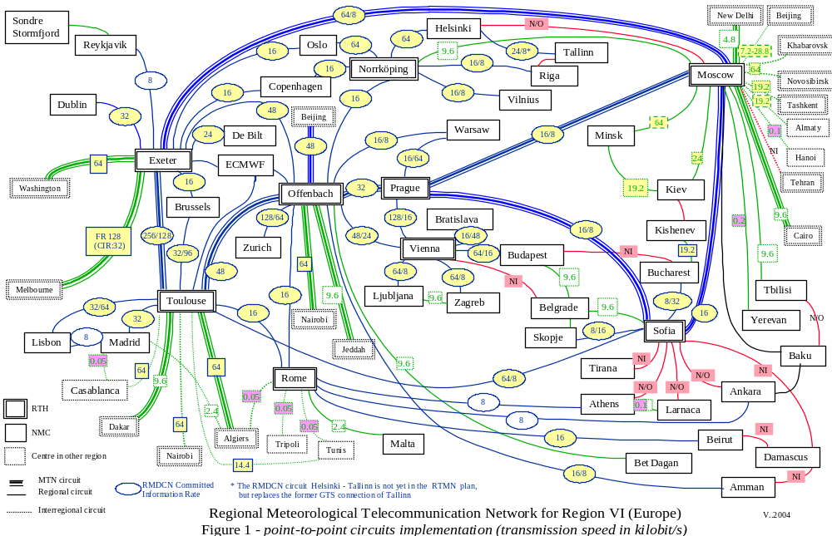

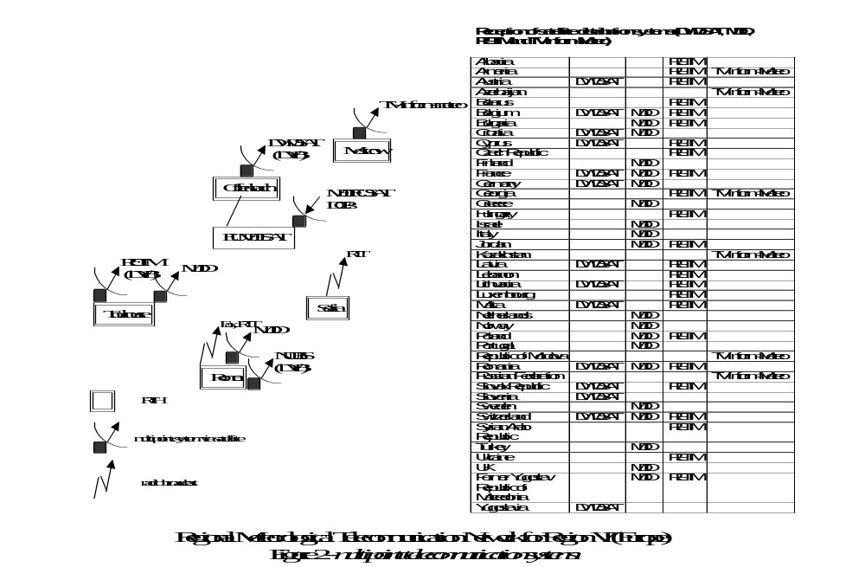
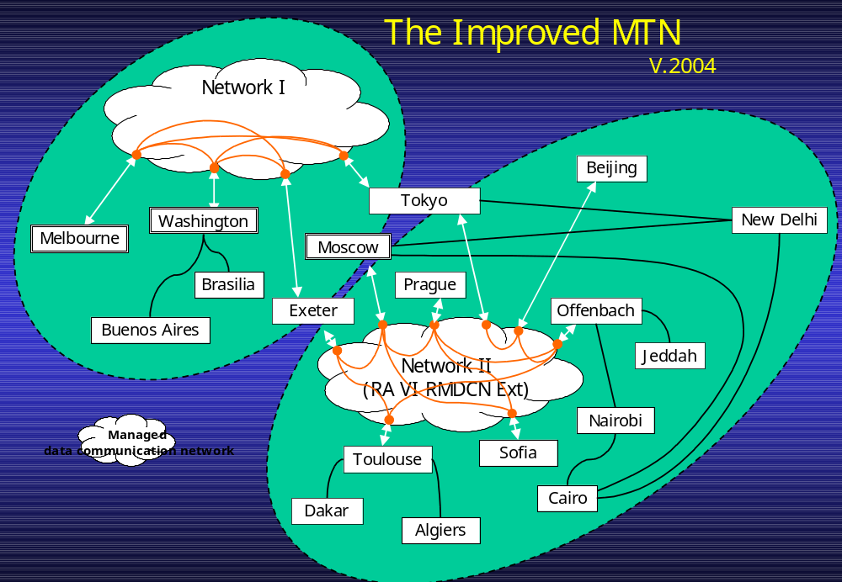

Figure 3
Table 1
№ | Circuit | Status | Speed  (Kbps) | Protocol | Data type | Future  (2004-2005)
 | Moscow –  Exeter | MTN | FR RMDCN (Equant)  CIR: Rx-64, Tx-8  Access line (backup):  Mos–128 (128 ISDN)  Exeter–512 (384 ISDN) | FTP WMO | A/N, BIN  FAX | FR RMDCN (Equant)  Access line:  Mos – 256 Kbps
 | Moscow –  Prague | MTN | FR RMDCN (Equant)  CIR: Rx-16, Tx-8  Access (ISDN backup):  Mos–128 (128 ISDN)  Prag–512 (384 ISDN) | FTP WMO | A/N, BIN  FAX | FR RMDCN (Equant)  Access line:  Mos – 256 Kbps
 | Moscow –  Sofia | MTN | FR RMDCN (Equant)  CIR: Rx/Tx –16/16  Access (ISDN backup):  Mos–128 (128 ISDN)  Sofia–256 (128 ISDN)) | FTP WMO | A/N, BIN  FAX | FR RMDCN (Equant)  Access line:  Mos – 256 Kbps
 | Moscow –  New-Delhi | MTN | Telephone leased line  V.29 ITU  Tx, Rx – 4,8 | X.25 PVC | A/N | FR RMDCN (Equant)  CIR: Rx-8 Kbps Tx-8 Kbps  Access: Mos – 256 Kbps  FTP WMO
 | Moscow –  Cairo | MTN | Telephone leased line  V.29 ITU  Tx, Rx – 9,6 | X.25 PVC | A/N | FR RMDCN (Equant)  CIR: Rx-8 Kbps Tx-8 Kbps  Access: Mos – 256 Kbps  FTP WMO
 | Moscow –  Beijing | RMTN | Telephone leased line  V.34 bis ITU  Tx, Rx – 7,2-28,8 | X.25 PVC | A/N, FAX | FR RMDCN  CIR: Rx-16 Kbps Tx-16 Kbps
 | Moscow –  Norkkoping | RMTN | Telephone leased line  V.29 ITU  Tx, Rx –9,6 | X.25 PVC | A/N, FAX | FR RMDCN (Equant)  CIR: Rx-16 Kbps Tx-16 Kbps  Access: Mos – 256 Kbps  FTP WMO
 | Moscow –  Minsk | RMTN | Digital line  Tx, Rx – 64  (Internet back-up) | TCP/IP-Socket (Special) | A/N, BIN  FAX
 | Moscow –  Kiev | RMTN | Telephone leased line  V.34 ITU  Tx,Rx –24  (Internet back-up) | FTP WMO | A/N, FAX | Digital line  Tx, Rx – 64 Kbps
 | Moscow –  Tbilisi | RMTN | Telephone leased line  V.34 ITU  Tx, Rx – 9,6 | TCP/IP-Socket (Special) | A/N, FAX | FR RMDCN (Equant)  CIR: Rx-8 Kbps Tx-16 Kbps  Access line: Mos – 256 Kbps  TCP/IP-Socket or FTP WMO
 | Moscow –  Baku | RMTN | Through Internet | TCP/IP-Socket (Special) | A/N, FAX | FR RMDCN (Equant)  CIR: Rx-8 Kbps Tx-16 Kbps  Access line: Mos – 256 Kbps  TCP/IP-Socket or FTP WMO
 | Moscow –  Erevan | RMTN | Telegraphic adapter  200 bod (via Rostov),  Through Internet | Async  Email,  Web-access | A/N, FAX | FR RMDCN (Equant)  CIR: Rx-8 Kbps Tx-16 Kbps  Access line: Mos – 256 Kbps  TCP/IP-Socket or FTP WMO
 | Moscow –  Kishinev | RMTN | Through Internet | Email,  Web-access | A/N, FAX | FR RMDCN (Equant)  CIR: Rx-8 Kbps Tx-16 Kbps  Access line: Mos – 256 Kbps  TCP/IP-Socket or FTP WMO
 | Moscow –  Novosibirsk | Inter-regional | Digital line  Tx, Rx – 64 | TCP/IP-Socket (Special) | A/N, BIN  FAX
 | Moscow –  Khabarovsk | Inter-regional | Digital line  Tx, Rx – 64 | TCP/IP-Socket (Special) | A/N, BIN,  FAX,  Satellite images
 | Moscow –  Tashkent | Inter-regional | Telephone leased line  V.34 ITU  Tx,Rx –19,2 | TCP/IP-Socket (Special) | A/N, BIN  FAX | Digital line  Tx, Rx – 64 Kbps
 | Moscow –  Almaty | Inter-regional | Telephone leased line  V.34 ITU  Tx, Rx –19,2  (Internet back-up) | FTP WMO | A/N, FAX
 | Moscow –  Hanoi | Inter-regional | Satellite  Telegraphic adapter  100 bod | Async | A/N
 | Moscow –  Tehran  (NO) | Inter-regional | Telegraphic adapter  100 bod | Async | A/N | Telephone leased line  TCP/IP FTP WMO (A/N, BIN)
 | Moscow –  Melbourne | Two-way | Through Internet | FTP WMO | A/N, BIN | VPN via Internet
 | Moscow –  - Helsinki (NO) | RMTN
 | Kiev – Kishinev (NO) | RMTN
 | Tbilisi –  Baku  (NO) | RMTN
 | Baku - Ankara | RMTN | Through Internet
 | Sofia - Prague | MTN | FR RMDCN (Equant)  CIR: Rx/Tx – 16/8  Access line (backup):  Sof–256(128 ISDN)  Prag–512 (384 ISDN) | FTP WMO | A/N, BIN  FAX
 | Sofia - Toulouse | RMTN | FR RMDCN (Equant)  CIR: Rx/Tx – 64/8  Access line(backup):  Sof–256(128 ISDN)  Toul-1M (1 M Mis Cr) | FTP WMO | A/N, BIN  FAX
 | Moscow – Bucharest | Two-way | Telephone leased line 9,6 kbps or more | x.25 | All (ASCII, Binary) | RMTN
 | Sofia - Bucharest | RMTN | FR RMDCN (Equant)  CIR: Rx/Tx – 8/32  Access line:  Buch: 128 kbps | FTP | All (ASCII, Binary)
 | Sofia - Skopje | RMTN | FR RMDCN (Equant)  CIR: Rx/Tx – 8/16  Access line(backup):  Sof–256(128 ISDN)  Skopje-64 (64 ISDN) | FTP WMO | A/N, BIN  FAX
 | Sofia - Belgrade | RMTN | Telephone leased line  V.34 ITU  Tx, Rx – 9,6
 | Bucharest –  Kishinev | RMTN | Telephone leased line  Async,PPP,19,2 kbps | FTP | ASCII, Binary | Same
 | Sofia - Tirana (NO) | RMTN |  |  |  | DRAFT of a project “NMC-Tirana connecting into the GTS via Internet” is sent to WMO
 | Sofia – Larnaca (NO) | RMTN
 | Sofia – Damascus (NO) | RMTN
 | Sofia – Athens (NO) | RMTN
 | Sofia – Ankara (NO) | RMTN
 | Bucharest –  Budapest (NO) | Not implemented | TBD | FTP | All (ASCLL, Binary) | Romania is considering this circuit, but a final decision has not been made yet

Table 2 - Countries connected to RMDCN

RA VI Centres

Austria
Belgium
Bulgaria
Croatia
Czech Republic
Denmark
Estonia
Finland
France
Germany
Greece
Hungary
Iceland
Ireland
Italy
Jordan
Latvia
Lebanon
Lithuania
Luxembourg
Macedonia (FYR of)
Netherlands
Norway
Poland
Portugal
Romania
Russia
Serbia Montenegro
Slovakia
Slovenia
Spain
Sweden
Switzerland
Syrian Arab Republic
Turkey
United Arab Emirates
United Kingdom

Non RA VI Countries

China
India
Japan

Table 2

